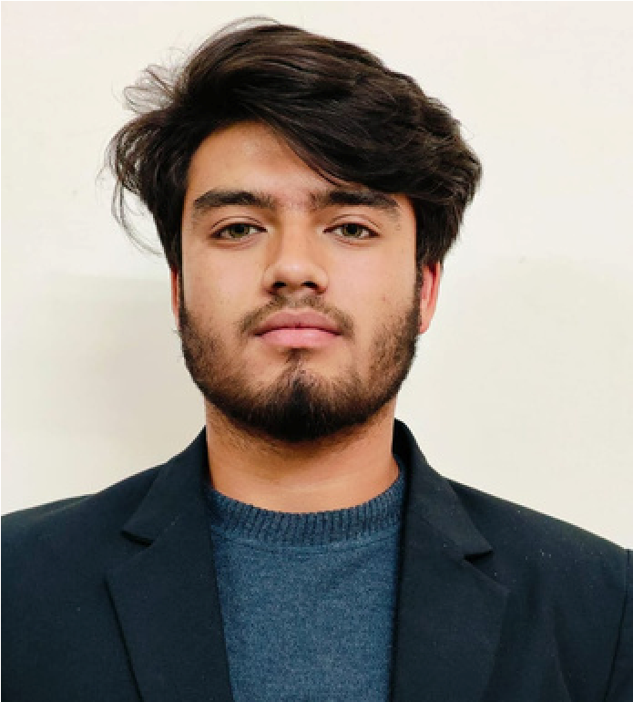
English
Hindi
A
B
O
U
T

M
E
C
O
N
T
A
C
T
E
D
U
C
A
T
I
O
N
E
X
P
E
R
I
E
N
C
E
S
K
I
L
L
S
L
A
N
G
U
A
G
E
LG
Ethical Hacking At UIT
Worked with the broader development team to support software and
application development .
Managed website design and content update to ensure functionality and visual
appeal
.
Contributed to the development and implementation of a barcode reader
system.
Intern at LG
2024

Workshop
Schooling :

Kendriya Vidyalaya Pauri , Uttarakhand
Under graduation : Uttaranchal University, Dehradun

9761860922
devashishdobhal9@gmail.com
Srinagar road pauri garhwal
Management Skills
Creativity
Coding in java , python , C

Web Developer
Critical Thinking
Leadership
DOBHAL
DEVASHISH
2023
Motivated and enthusiastic 3nd-year B.Tech student specializing in Computer Science Engineering.
I have a strong foundation in core engineering concepts, including electronics and programming
languages such as Java, Python, and C. With a keen interest in web development and a passion for
innovation, I am committed to continuous learning and personal growth.
My strong organizational and management skills, combined with creativity and leadership
qualities, have been demonstrated through active participation in various extracurricular and
team-based activities.

Btech-CSE(PURSUING)
CLASS 12 (CBSE BOARD)

2023
CLASS 10(CBSE BOARD)

2020
Garhwali
Ethical Hacking Training - Uttaranchal Institute of Technology (UIT)
Gained foundational knowledge in ethical hacking principles and

cybersecurity
practices.
Practiced
various hacking techniques in a controlled environment to understand
system vulnerabilities.

Conducted penetration testing on a local website to identify and analyze security
loopholes.

