Running api.py

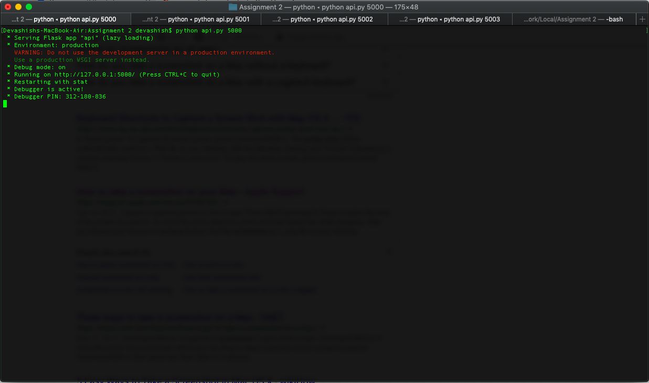

Posting by curl command “curl http://localhost:5000/api/v1/entries -X POST -d '{"xxxx":"2016,All Causes,All causes,Alabama,52466,920.40"}' -H "Content-Type: application/json"

A screenshot of a computer screen


Api.py after post

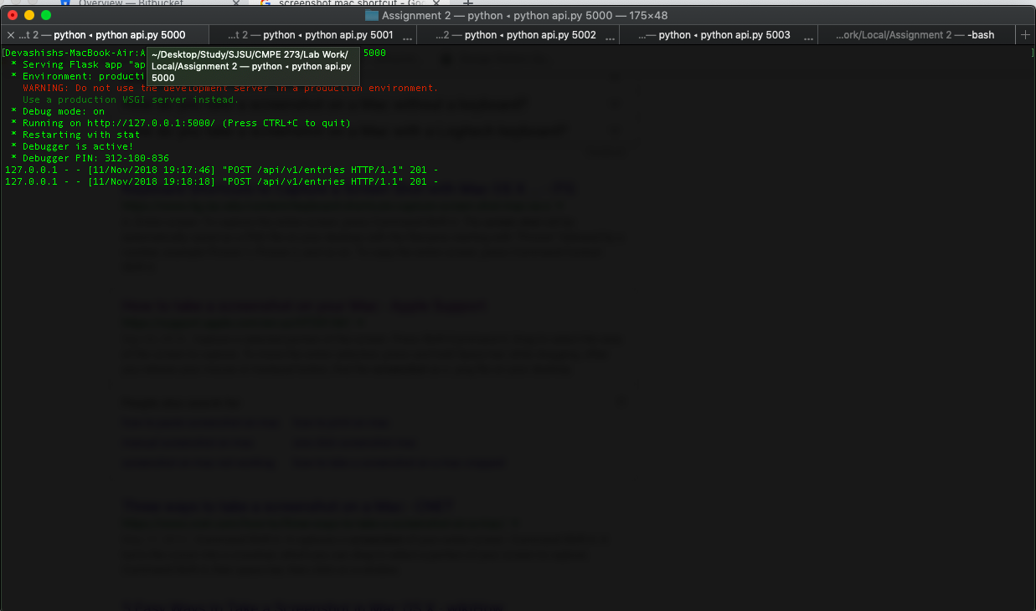

Getting by curl command “curl <http://localhost:5000/api/v1/entries>”

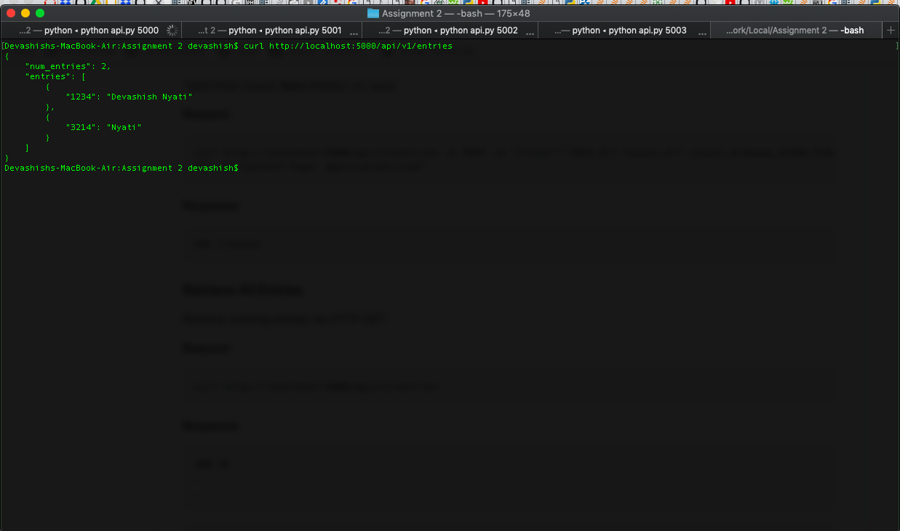

Api.py after get

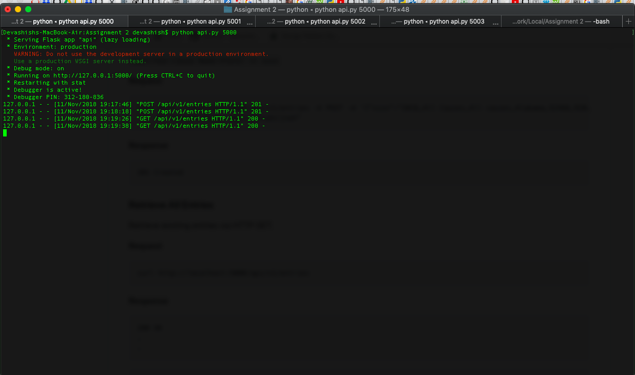

Posting using client.py.

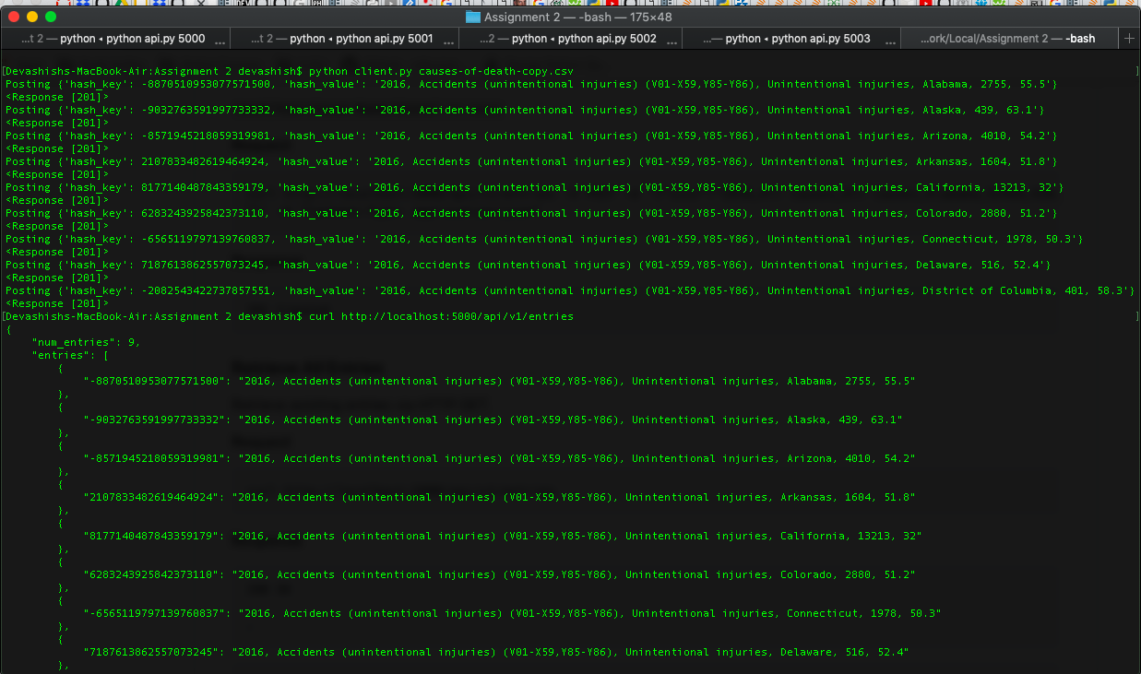

Api.py after post and get.

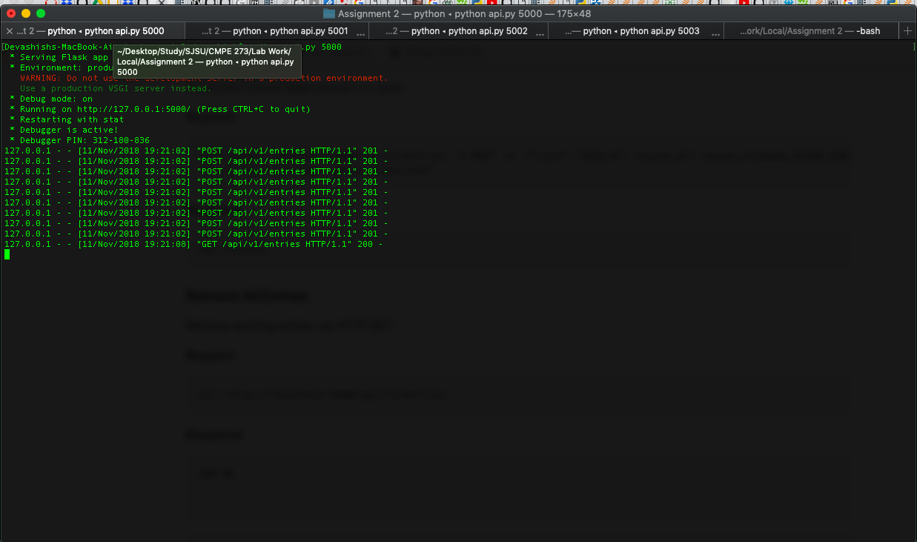

Running consistent_hashing.py

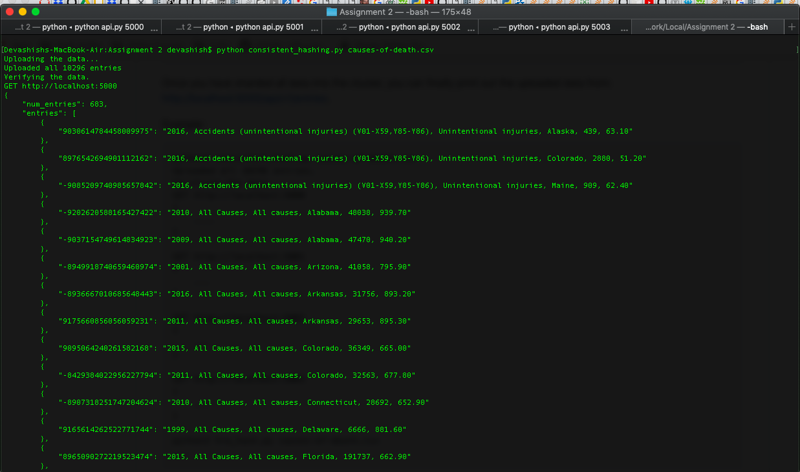

Running rendezvous_hashing.py

