**async_4phase_handshake_slave**

# Description

Allows messages to be passed asynchronously from a master to a slave by using an alternating sequence of request (req) and acknowledgement (ack) levels.

State 1: (~req,~ack) Master writes data to associated data bus

State 2: ( req,~ack) Master asserts req

State 3: ( req, ack) Slave reads data from associated data bus

State 4: (~req, ack) Master deasserts req

# Verilog Template

async_4phase_handshake_slave

async_4phase_handshake_slave_inst (

.ack(ack), // output

.clear(clear), // input

.flag(flag), // output

.req(req), // input

.reset(reset) // input

);

# Specifications

## Inputs

* clear: clears the flag and asserts ack, should be deasserted once flag is deasserted, must be deasserted before req is deasserted and then reasserted or else it will spuriously acknowledge a second transaction
* req: request signal from master to slave
* reset: required to put core into known state, clears flag and ack

## Outputs

* ack: acknowledgement signal from slave to master, asserted when req is asserted and then clear is asserted, deasserted on reset or when req is deasserted
* flag: indicates that a request from a master has arrive, cleared on reset or when both req and clear are asserted

## Waveform

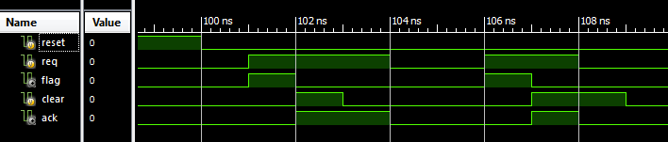

# Requirements

Language for Synthesis: Verilog 2001

Synthesis Tool: Xilinx XST 13.2

Language for Verification: Verilog 2001

Verification Tool: Xilinx ISIM 13.2

# References

[1] <http://www.cl.cam.ac.uk/~djg11/wwwhpr/fourphase/fourphase.html>

# Contact Info

Nathan Farrington

<http://nathanfarrington.com>