**async_muller_c_element**

# Description

This Muller C-element is an asynchronous latch. It is often used to indicate that two or more asynchronous cores are ready.

# Verilog Template

async_muller_c_element #(

.WIDTH(2))

async_muller_c_element_inst (

.in(in), // input [WIDTH-1:0]

.out(out) // output

);

# Specifications

## Parameters

WIDTH is the width of the input.

## Inputs

* in [WIDTH]: ready signals from other asynchronous cores

## Outputs

* out: 0 if all inputs are 0, or 1 if all inputs or 1, otherwise latches its current output

## Waveform

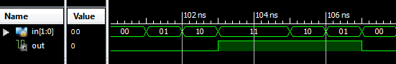

# Requirements

Language for Synthesis: Verilog 2001

Synthesis Tool: Xilinx XST 13.2

Language for Verification: Verilog 2001

Verification Tool: Xilinx ISIM 13.2

# References

[1] <https://en.wikipedia.org/wiki/C-element>

[2] <http://tams-www.informatik.uni-hamburg.de/applets/hades/webdemos/16-flipflops/70-cgate/muller-cgate3.html>

# Contact Info

Nathan Farrington

<http://nathanfarrington.com>