**sync_reset**

# Description

This module is similar to sync_signal in that it is used to cross clock domains. However, this module is specialized for active-high resets. When the asynchronous input reset signal is asserted, the reset is immediately propagated to the output. When the asynchronous input reset signal is deasserted, it takes N clock cycles for the synchronizer flip-flop pipeline to feed a zero to the output. The single parameter N gives the number of synchronization flip-flops, and hence the delay from when the asynchronous input reset signal is deasserted to when the synchronous output reset signal is deasserted.

# Verilog Template

sync_reset #(

.N(2))

sync_reset_inst (

.clk(clk), // input

.rst(rst), // input

.sync_reset_out(sync_reset_out)); // output

);

# Specifications

## Parameters

N: number of synchronization flip-flops, must be at least 2

## Inputs

* clk: clock
* rst: asynchronous, active-high reset input

## Outputs

* sync_reset_out: synchronous, active-high reset output

## Waveform

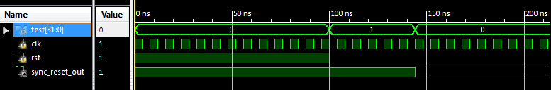

# Requirements

Language for Synthesis: Verilog 2001

Synthesis Tool: Xilinx XST 13.2

Language for Verification: Verilog 2001

Verification Tool: Xilinx ISIM 13.2

# References

[1] <http://www.fpga4fun.com/CrossClockDomain.html>

[2] <http://web.mit.edu/6.111/www/f2006/handouts/labs/lab3.html>

# Contact Info

Nathan Farrington

<http://nathanfarrington.com>