**spi_master**

# Description

This core implements a standard Serial Peripheral Interface Bus master controller. Data is latched on the rising edge of the SPI clock.

# Verilog Template

spi_master #(.WIDTH(32))

spi_master_inst (

.busy(busy), // output

.clk(clk), // input

.din(din), // input [WIDTH-1:0]

.dout(dout), // output [WIDTH-1:0]

.miso(miso), // input

.mosi(mosi), // output

.spi_clk_in(spi_clk_in), // input

.spi_clk_in_negedge(spi_clk_in_negedge), // input

.spi_clk_in_posedge(spi_clk_in_posedge), // input

.spi_clk_out(spi_clk_out), // output

.strobe(strobe) // input

);

# Specifications

## Parameters

WIDTH is the number of bits in a word. Common values are 8, 16, and 32. The default is 32.

## Inputs

* clk: clock
* din [WIDTH]: data to be transmitted to slave when strobe is asserted
* miso: Master In Slave Out
* spi_clk_in: clock synchronous to clk and used to generate spi_clk_out
* spi_clk_in_negedge: single clk tick when spi_clk_in has a negative edge
* spi_clk_in_posedge: single clk tick when spi_clk_in has a positive edge
* strobe: used to start the transmit and receive state machine

## Outputs

* busy: asserted when the core is transmitting and receiving
* dout [WIDTH]: contains data received from slave after strobe is asserted and after the deassertion of busy
* mosi: Master Out Slave In
* spi_clk_out: clock synchronous to miso and mosi and sent to the slave

## Waveform

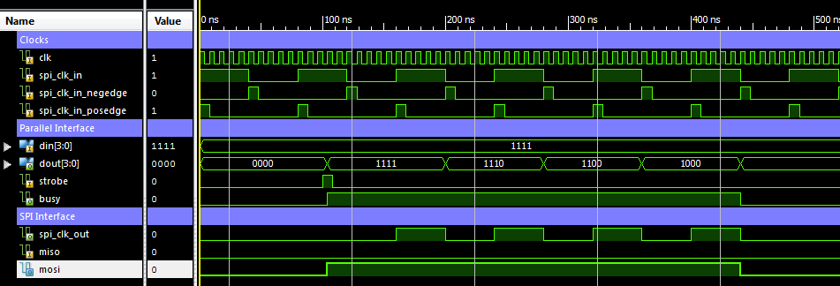

# Requirements

Language for Synthesis: Verilog 2001

Synthesis Tool: Xilinx XST 13.2

Language for Verification: Verilog 2001

Verification Tool: Xilinx ISIM 13.2

# References

[1] <https://en.wikipedia.org/wiki/Serial_Peripheral_Interface_Bus>

# Contact Info

Nathan Farrington

<http://nathanfarrington.com>