**timer**

# Description

This is a very simple timer with the number of clock ticks specified during instantiation. The timer can be armed and rearmed, and also enabled and disabled. When the timer fires, the fire output signal stays asserted until either arm is asserted or en is deasserted.

# Verilog Template

timer #(.NTICKS(10))

timer_inst (

.arm(arm), // input

.clk(clk), // input

.en(en), // input

.fire(fire) // output

);

# Specifications

## Parameters

NTICKS is the number of clock ticks to count until the timer expires. The default is 10.

## Inputs

* arm: resets the timer
* clk: clock
* en: enables the timer

## Outputs

* fire: asserted when the timer expires and when en is asserted, cleared when arm is asserted

## Waveform

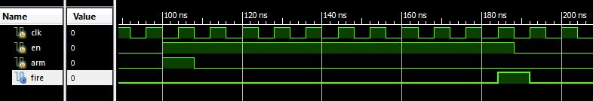

# Requirements

Language for Synthesis: Verilog 2001

Synthesis Tool: Xilinx XST 13.2

Language for Verification: Verilog 2001

Verification Tool: Xilinx ISIM 13.2

# Contact Info

Nathan Farrington

<http://nathanfarrington.com>