UNIVERSITY INSTITUTE OF COMPUTING

PROJECT REPORT
ON
E-Commerce Sales Data Analysis Sales, revenue, products, trends

Program Name: BCA(Hons)(Data Science)
Subject Name/Code: 25CAH-221

Submitted by: Submitted to:
Name: Devasis Ngangbam Name: Mrs. Preeti
UID: 25BCD10110 Designation: Assistant Professor
Section: 25BCD-2(B)

Project Report: STUDENT PERFORMANCE DATA ANALYSIS
1. TITLE PAGE
E-Commerce Sales Data Analysis Sales, revenue, products, trends
A Mini Project / Case Study
Using Pandas, NumPy, Matplotlib and Seaborn

2. AIM
To analyze e-commerce sales data using Python and data analysis libraries such as Pandas, NumPy, Matplotlib and Seaborn, with a focus on sales distribution, revenue, product performance, monthly sales trends, regional performance, customer segments, discounts and profitability.

3. OBJECTIVES
The main objectives of this project are:
- To analyze overall e-commerce sales and revenue.
- To study the distribution of sales and profit across different products.
- To compare sales performance across product categories.
- To analyze monthly sales and profit trends.
- To compare sales across different regions and customer segments.
- To clean and preprocess the dataset using Pandas.
- To calculate statistical measures such as mean, median and standard deviation.
- To visualize the analyzed data using Matplotlib and Seaborn.
These objectives support the mini-project requirements by demonstrating how Python-based data analysis can be used to understand e-commerce sales performance and identify useful business patterns.

4. PROBLEM STATEMENT
Problem Statement
E-commerce sales can vary across products, categories, regions and time periods. Understanding these variations is important for identifying popular products, evaluating revenue, examining profitability and supporting business decisions.
The purpose of this project is to analyze e-commerce sales data and identify useful patterns in:
- Sales and revenue distribution.
- Product-wise and category-wise performance.
- Monthly sales and profit trends.
- Regional and customer-segment comparisons.
- Relationships between discounts, sales and profit.
The project uses Python-based data analysis techniques to clean, analyze and visualize the dataset. The results help demonstrate how data analysis can support better understanding of sales performance and business trends.

5. DATASET DESCRIPTION
Dataset Description
The dataset contains information about e-commerce orders, products, sales, quantities, discounts, regions, customer segments and profits.
The main variables used in the dataset are:
Variable | Description
Order ID | Unique identification number of an order
Order Date | Date on which the order was placed
Region | Geographical region associated with the order
Segment | Customer segment associated with the order
Category | Main category of the product
Sub-Category | Subcategory associated with the product
Product Name | Name of the product sold
Unit Price | Price of one unit of the product before discount
Quantity | Number of units purchased
Discount | Discount applied to the transaction
Sales | Total sales value after discount
Profit | Profit or loss recorded for the transaction
The dataset contains 1,200 records and 12 original columns before data cleaning. Additional columns, including Year, Month, Month_Name, Year_Month and Profit_Margin, are created during preprocessing to support further analysis.
The numerical variables include unit price, quantity, discount, sales and profit, while the remaining variables are mainly categorical or date-related.
The dataset is a synthetic educational dataset created for this project. It is not a collection of verified transactions from an actual e-commerce retailer.
Important: In the final Word file, screenshots of df.head() and df.describe() can be inserted after running the code in Google Colab.

6. TOOLS AND TECHNOLOGIES USED
Software and Libraries
- Python
- Google Colab / Jupyter Notebook
- Pandas – Data cleaning, data manipulation and analysis
- NumPy – Numerical calculations and statistical operations
- Matplotlib – Data visualization and chart creation
- Seaborn – Statistical visualization and graphical analysis

7. COMPLETE PYTHON CODE
The complete Python code for this project is executed separately in Google Colab.
The code includes dataset loading, data inspection, data cleaning, statistical analysis, sales calculations, product comparisons and data visualization.
The dataset used is Ecommerce_Sales_Data.csv, which is uploaded to the Google Colab Files section before execution.
The code produces summary tables, statistical results and graphical visualizations that are used to interpret e-commerce sales performance. Screenshots of the code outputs and visualizations can be included in the final project report.

import pandas as pd
import numpy as np
import matplotlib.pyplot as plt
import seaborn as sns

sns.set_theme(style="whitegrid")

print("E-COMMERCE SALES DATA ANALYSIS")
print("All libraries imported successfully!")
import os

file_path = "Ecommerce_Sales_Data.csv"

if not os.path.exists(file_path):
file_path = "/content/Ecommerce_Sales_Data.csv"

if not os.path.exists(file_path):
file_path = "/Ecommerce_Sales_Data.csv"

df = pd.read_csv(file_path)

print("Dataset loaded successfully!")
print("Number of rows:", df.shape[0])
print("Number of columns:", df.shape[1])

display(df.head())
print("=" * 60)
print("DATASET OVERVIEW")
print("=" * 60)

print("\nColumn Names:")
print(df.columns.tolist())

print("\nDataset Information:")
df.info()

print("\nStatistical Summary:")
display(df.describe().round(2))

print("\nMissing Values:")
display(df.isnull().sum().to_frame("Missing Values"))
print("=" * 60)
print("DATA CLEANING AND PREPROCESSING")
print("=" * 60)

# Check duplicate records
print("Duplicate rows before cleaning:", df.duplicated().sum())

# Remove duplicate records
df = df.drop_duplicates().copy()

# Convert columns to correct data types
df["Order Date"] = pd.to_datetime(
df["Order Date"], errors="coerce"
)

numeric_columns = [
"Unit Price", "Quantity", "Discount", "Sales", "Profit"
]

for col in numeric_columns:
df[col] = pd.to_numeric(df[col], errors="coerce")

# Remove rows missing essential information
df = df.dropna(
subset=["Order Date", "Sales", "Profit", "Category"]
).copy()

# Create useful date columns
df["Year"] = df["Order Date"].dt.year
df["Month"] = df["Order Date"].dt.month
df["Month_Name"] = df["Order Date"].dt.strftime("%b")
df["Year_Month"] = df["Order Date"].dt.to_period("M").astype(str)

# Calculate profit margin
df["Profit_Margin"] = np.where(
df["Sales"] != 0,
(df["Profit"] / df["Sales"]) * 100,
np.nan
)

print("\nDuplicate rows after cleaning:", df.duplicated().sum())
print("Dataset shape after cleaning:", df.shape)

print("\nCleaned dataset preview:")
display(df.head())

print("\nMissing values after cleaning:")
display(df.isnull().sum().to_frame("Missing Values"))
print("=" * 60)
print("KEY BUSINESS METRICS")
print("=" * 60)

total_sales = df["Sales"].sum()
total_profit = df["Profit"].sum()
total_quantity = df["Quantity"].sum()
total_orders = df["Order ID"].nunique()
total_products = df["Product Name"].nunique()

profit_margin = (
total_profit / total_sales * 100
if total_sales != 0 else 0
)

print(f"Total Sales: ${total_sales:,.2f}")
print(f"Total Profit: ${total_profit:,.2f}")
print(f"Total Quantity Sold: {total_quantity:,}")
print(f"Total Orders: {total_orders:,}")
print(f"Unique Products: {total_products:,}")
print(f"Overall Profit Margin: {profit_margin:.2f}%")

print("\nSales Statistics:")
display(df["Sales"].describe().to_frame().round(2))

print("\nProfit Statistics:")
display(df["Profit"].describe().to_frame().round(2))
category_analysis = df.groupby("Category").agg(
Total_Sales=("Sales", "sum"),
Total_Profit=("Profit", "sum"),
Quantity_Sold=("Quantity", "sum")
)

category_analysis["Profit_Margin_%"] = (
category_analysis["Total_Profit"]
/ category_analysis["Total_Sales"] * 100
)

category_analysis = category_analysis.sort_values(
"Total_Sales", ascending=False
)

print("CATEGORY-WISE SALES AND PROFIT")
display(category_analysis.round(2))

# Sales chart
plt.figure(figsize=(9, 5))

sns.barplot(
data=category_analysis.reset_index(),
x="Category",
y="Total_Sales"
)

plt.title("Total Sales by Product Category")
plt.xlabel("Product Category")
plt.ylabel("Total Sales (USD)")
plt.tight_layout()
plt.show()

# Profit chart
plt.figure(figsize=(9, 5))

sns.barplot(
data=category_analysis.reset_index(),
x="Category",
y="Total_Profit"
)

plt.title("Total Profit by Product Category")
plt.xlabel("Product Category")
plt.ylabel("Total Profit (USD)")
plt.tight_layout()
plt.show()
monthly_analysis = (
df.set_index("Order Date")
.resample("MS")
.agg({
"Sales": "sum",
"Profit": "sum"
})
)

monthly_analysis.columns = [
"Total_Sales", "Total_Profit"
]

print("MONTHLY SALES ANALYSIS")
display(monthly_analysis.round(2))

plt.figure(figsize=(12, 5))

plt.plot(
monthly_analysis.index,
monthly_analysis["Total_Sales"],
marker="o"
)

plt.title("Monthly Sales Trend")
plt.xlabel("Month")
plt.ylabel("Total Sales (USD)")
plt.xticks(rotation=45)
plt.tight_layout()
plt.show()

plt.figure(figsize=(12, 5))

plt.plot(
monthly_analysis.index,
monthly_analysis["Total_Profit"],
marker="o"
)

plt.title("Monthly Profit Trend")
plt.xlabel("Month")
plt.ylabel("Total Profit (USD)")
plt.xticks(rotation=45)
plt.tight_layout()
plt.show()
product_analysis = df.groupby("Product Name").agg(
Total_Sales=("Sales", "sum"),
Total_Profit=("Profit", "sum"),
Quantity_Sold=("Quantity", "sum")
)

top_products = product_analysis.sort_values(
"Total_Sales", ascending=False
).head(10)

print("TOP 10 PRODUCTS BY SALES")
display(top_products.round(2))

plt.figure(figsize=(10, 6))

sns.barplot(
data=top_products.reset_index().sort_values("Total_Sales"),
x="Total_Sales",
y="Product Name"
)

plt.title("Top 10 Products by Sales")
plt.xlabel("Total Sales (USD)")
plt.ylabel("Product Name")
plt.tight_layout()
plt.show()
# CORRELATION HEATMAP

correlation_columns = [
"Sales",
"Profit",
"Quantity",
"Discount",
"Profit_Margin"
]

correlation_matrix = df[correlation_columns].corr()

print("CORRELATION MATRIX")
display(correlation_matrix.round(2))

plt.figure(figsize=(10, 7))

sns.heatmap(
correlation_matrix,
annot=True,
fmt=".2f",
cmap="coolwarm",
vmin=-1,
vmax=1,
linewidths=0.5
)

plt.title("Correlation Heatmap of E-Commerce Sales", fontsize=15)
plt.tight_layout()
plt.show()
# SCATTER PLOT: DISCOUNT VS PROFIT

plt.figure(figsize=(10, 6))

sns.scatterplot(
data=df,
x="Discount",
y="Profit",
hue="Category",
alpha=0.75,
s=65
)

plt.title("Discount vs Profit by Product Category", fontsize=15)
plt.xlabel("Discount Rate")
plt.ylabel("Profit (USD)")
plt.legend(title="Category")
plt.tight_layout()
plt.show()
# BOX PLOT: PROFIT BY CATEGORY

plt.figure(figsize=(10, 6))

sns.boxplot(
data=df,
x="Category",
y="Profit",
hue="Category",
legend=False
)

plt.title("Profit Distribution by Product Category", fontsize=15)
plt.xlabel("Product Category")
plt.ylabel("Profit (USD)")
plt.tight_layout()
plt.show()
# BOX PLOT: SALES DISTRIBUTION

plt.figure(figsize=(9, 5))

sns.boxplot(
data=df,
x="Sales"
)

plt.title("Distribution of E-Commerce Sales", fontsize=15)
plt.xlabel("Sales (USD)")
plt.tight_layout()
plt.show()
# E-COMMERCE SALES DATA ANALYSIS DASHBOARD

fig, axes = plt.subplots(3, 3, figsize=(22, 16))

# 1. Monthly Sales Trend
axes[0, 0].plot(
monthly_analysis.index,
monthly_analysis["Total_Sales"],
marker="o"
)
axes[0, 0].set_title("Monthly Sales Trend")
axes[0, 0].tick_params(axis="x", rotation=45)

# 2. Sales by Category
category_analysis["Total_Sales"].plot(
kind="bar", ax=axes[0, 1]
)
axes[0, 1].set_title("Sales by Category")
axes[0, 1].tick_params(axis="x", rotation=20)

# 3. Top 10 Products
top_products["Total_Sales"].sort_values().plot(
kind="barh", ax=axes[0, 2]
)
axes[0, 2].set_title("Top 10 Products by Sales")

# 4. Sales by Region
region_sales = df.groupby("Region")["Sales"].sum().sort_values()
region_sales.plot(kind="bar", ax=axes[1, 0])
axes[1, 0].set_title("Sales by Region")
axes[1, 0].tick_params(axis="x", rotation=0)

# 5. Sales by Customer Segment
segment_sales = df.groupby("Segment")["Sales"].sum()
axes[1, 1].pie(
segment_sales,
labels=segment_sales.index,
autopct="%1.1f%%",
startangle=90
)
axes[1, 1].set_title("Sales by Customer Segment")

# 6. Discount vs Profit
sns.scatterplot(
data=df,
x="Discount",
y="Profit",
hue="Category",
alpha=0.6,
ax=axes[1, 2],
legend=False
)
axes[1, 2].set_title("Discount vs Profit")

# 7. Correlation Heatmap
sns.heatmap(
correlation_matrix,
annot=True,
fmt=".2f",
cmap="coolwarm",
vmin=-1,
vmax=1,
ax=axes[2, 0]
)
axes[2, 0].set_title("Correlation Heatmap")

# 8. Sales Distribution
sns.histplot(
data=df,
x="Sales",
bins=25,
kde=True,
ax=axes[2, 1]
)
axes[2, 1].set_title("Sales Distribution")

# 9. Profit by Category
sns.boxplot(
data=df,
x="Category",
y="Profit",
hue="Category",
legend=False,
ax=axes[2, 2]
)
axes[2, 2].set_title("Profit Distribution by Category")
axes[2, 2].tick_params(axis="x", rotation=20)

# Main title and layout
fig.suptitle(
"E-COMMERCE SALES DATA ANALYSIS DASHBOARD",
fontsize=21,
fontweight="bold"
)

plt.tight_layout(rect=[0, 0, 1, 0.96])

# Save high-resolution image
plt.savefig(
"Ecommerce_Sales_Dashboard.png",
dpi=200,
bbox_inches="tight"
)

plt.show()

print("Dashboard created and saved successfully!")
from google.colab import files

files.download("Ecommerce_Sales_Dashboard.png")

8. DATA CLEANING
The following data-cleaning operations were performed:
- Checked the dataset for missing values.
- Identified and removed duplicate records.
- Converted date columns into appropriate date formats.
- Converted numerical columns into suitable numerical data types.
- Removed records missing essential analysis information.
- Created additional date-related columns for monthly and yearly analysis.
- Calculated profit margin using sales and profit values.
- Checked the dataset shape and missing values after cleaning.
These operations helped prepare the dataset for statistical analysis and visualization.

9. DATA ANALYSIS
The following analyses were performed:
- Calculation of total sales, total profit and total quantity sold.
- Calculation of unique orders and unique products.
- Statistical analysis of sales and profit values.
- Category-wise sales and profit comparison.
- Monthly sales and profit trend analysis.
- Identification of the top 10 products by sales.
- Region-wise sales analysis.
- Customer-segment sales comparison.
- Analysis of discount and profit relationships.
- Correlation between sales, profit, quantity, discount and profit margin.
- Sorting and filtering of product and sales records.
These analyses help identify sales patterns, compare product performance and understand differences in profitability across categories and business segments.

10. SCREENSHOTS
Insert screenshots of the following outputs from Google Colab:
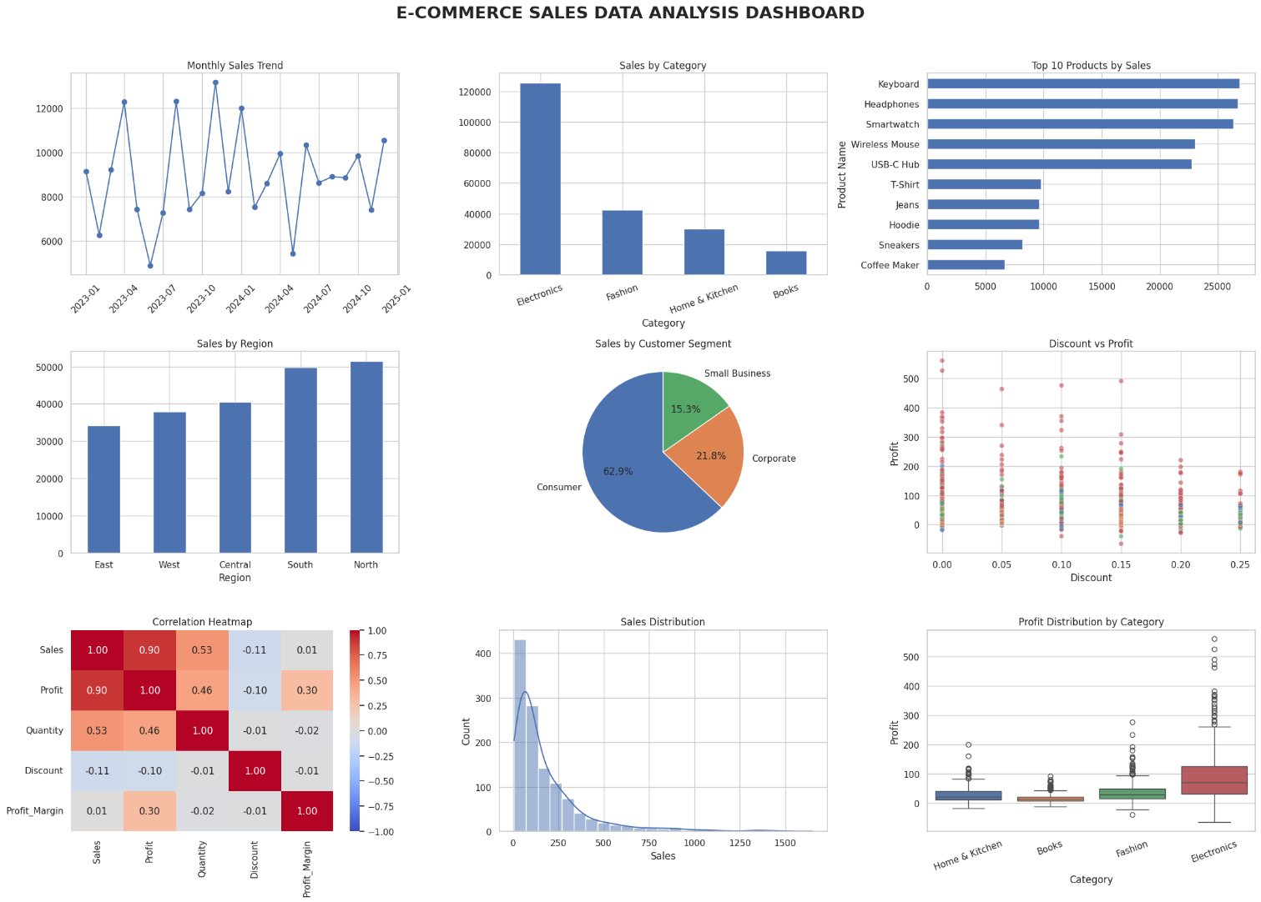The screenshots should be taken directly from the actual Google Colab outputs generated using the project dataset.

11. Git Hub Link -: https://github.com/devasisngangbam-prog/python-mini-project-25bcd10110
12. REFERENCE
Dataset file: Ecommerce_Sales_Data.csv (synthetic educational dataset created for this project).
Python libraries documentation:
- Pandas: https://pandas.pydata.org/docs/
- NumPy: https://numpy.org/doc/
- Matplotlib: https://matplotlib.org/stable/
- Seaborn: https://seaborn.pydata.org/
Google Colab: https://colab.research.google.com/

13. DATA VISUALIZATION
The following visualizations were used:
- Bar chart – To compare sales and profit across product categories and regions.
- Line chart – To analyze monthly sales and profit trends.
- Horizontal bar chart – To identify the top-selling products.
- Pie chart – To display the distribution of sales across customer segments.
- Histogram – To examine the distribution of sales values.
- Scatter plot – To investigate the relationship between discounts and profit.
- Heatmap – To visualize correlations between numerical sales variables.
- Box plot – To examine profit distribution and potential outliers across product categories.
These visualizations make the results easier to understand and help identify patterns in sales, revenue and profitability.

14. CONCLUSION
The project demonstrates how e-commerce sales data can be analyzed using Python and its data analysis libraries. The dataset was inspected and cleaned using Pandas, while NumPy was used for numerical calculations. Matplotlib and Seaborn were used to create visualizations of sales trends, product performance, regional comparisons, customer segments and profitability.
The analysis provides a structured way to examine total sales, profit, quantity sold, monthly trends and product-category performance. The scatter plot, heatmap and box plots provide additional insight into relationships between numerical variables and the distribution of profit.
Overall, the project demonstrates how data analysis and visualization can be used to understand sales performance, identify useful business patterns and support data-driven decision-making. The findings and conclusions are based on the synthetic dataset used for this educational project and should not be interpreted as verified results from a real e-commerce company.

