# Summary

#### This document has clips of code which are easy to understand and the boilerplate codes which are used frequently. This also includes the solutions to many problems I faced in implementing and common errors made while building. Hope it helps.

## Maven

Maven allows for easy dependency management of the web-app. The POM.xml contains all the data of the project like dependencies and plugins.

Maven handles version control and automatic updating of repositories on change of system. It can modify reporting and build the project to various levels of completeness.

The two major goals used were **mvn package** and **mvn deploy.**

Maven was set up with eclipse plugin for easy modifications.

### Check out the POM file used for this build.



## Spring MVC & Java

Spring provides a framework for Dependency injection and Inversion of Control.

This allows the MVC to delegate tasks to other processes without needing to know how they work and dynamically changing data.

The Model View Controller acts as a good model for client server interaction.

The Controller handles the client request and sends response. Controller is responsible for mediating between the Model and the View.

The Model contains all the business logic required for the execution of the operations. The customer does not directly interact with the model.

Views act as interfaces for the client to obtain services from the model with authentication and levels of access.

### The build structure:

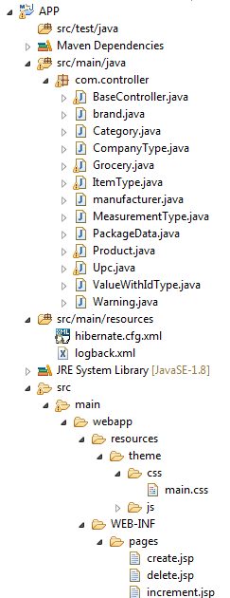

### Check out the Spring Context, application of URL Resource mapping.



## Postgres

PostgreSQL is a good SQL build for concurrency control and web-app development.

Postgres is able to handle very large amounts of traffic and specializes in concurrency control.

It makes clones of itself for each client and updates the database carefully to avoid inconsistency. It refreshes the data to prevent dirty bits and was designed for performance in net traffic.

The username/database: postgres password: sandbox

### SQL DB Architecture

Machine generated alternative text: S item_type
ò j) Columns (33
íd
( attribute
L l1 attribute_name
I  marketing_description
name
l other_description
I dryweight_measure
l dryweight_uom
height_measure
height_uom
information
I length_measure
length_uom
l netweight_measure
netweight_uom
packagesize_measure
l packagesize_uom
l1 packagetype
l1 packagetypejd
( units Jnfiackage
width_measure
width_uom
l distributor_address
I distributor_email
I distributor_name
distributor..phone
distributor_url
manufacturer_address
manufacturer_email
manufacturer_name
manufacturerfihone
manufacturer_urlMachine generated alternative text: El item_type_categories
Columns (5)
l item_type
l1 category
l1 id
type
l categoryjdMachine generated alternative text: Ê item_type_product
Columns (24)
L  item_type
L  brand
L  brandjd
country_of_origin
product_description
) directions
3 distributor
P3 distributorid
certificate
foodrelatedindicators
ingredients
kosher_code
ndc_code
nutribonaiclaims
recyde_codes
(9 temperature_type
: : [ vitaminsandminerals
LI pjd
D manufacturer
L] manufacturerid
product_sequence
product_type
warning
productjd
: ,. , .Machine generated alternative text: item_type_upcs
Columns (4)
LFIitem_type
L’ type
Lupc
1’upcJd

Machine generated alternative text: Ei manufacturer
I  Columns (2)
H H Id
I name Machine generated alternative text: brand
Columns (2)
. IJ id
name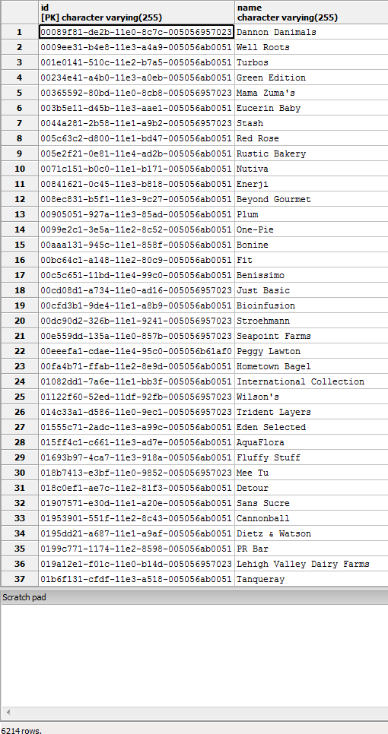 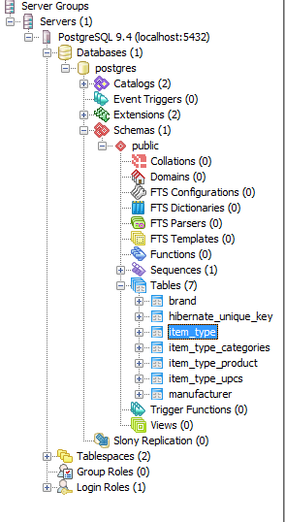

Item Data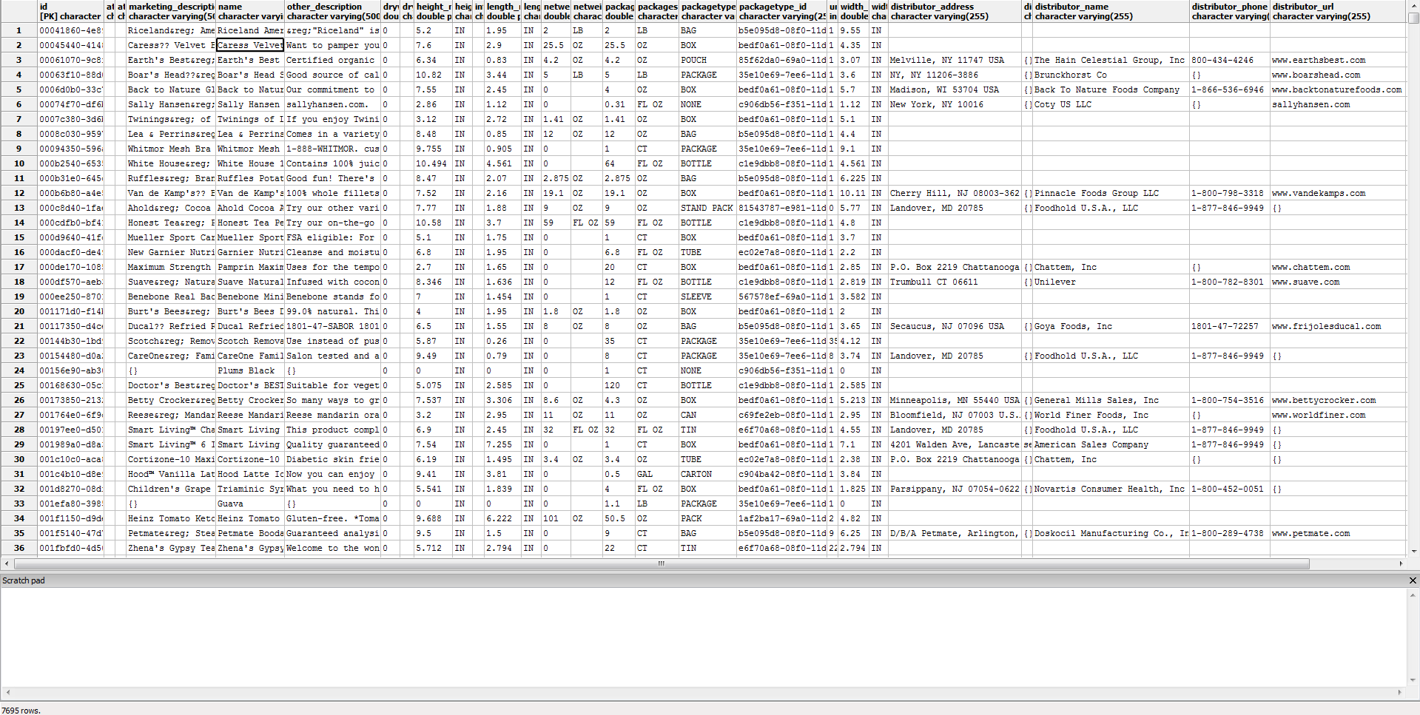

Machine generated alternative text: item_type brand brand_id country_of1 product_description directions distributor
character varying character varying(255) character vai character ii character varying(255) character varying(5000) character varying(2
1 00041860-4ee9—IRiceland 63960840-bc Riceland inerican Jazmine Rice Cooking directions on the stove: 1. Bring 2 cups water to a boil in a 3-quart heavy 3aucepan. Stir in 1 cup of rice. 2. Cover. Reduc
2 00045440—4148—ICaress c7d322ff—2USA Caress Velvet Bliss Ultra Silkening Beauty Bar — 6 CT I I
3 00061070—9c8f—IEarth’s Best c4d2fe4l—9lCanada Earth’s Best Organic Fruit Yogurt Sincothie Mixed Berry Serve at room temperature right cut cf the pouch or refrigerate for a cool refreshing treat! Refrigerate after opening, serve withirlhe Main Celesti
4 00063fl0—88d0—IBoar’s Head lOa8f2aO-5 Boar’s Head Sliced White ?merican Cheese — 120 CT Keep refrigerated. Brunc]chorst Co.
5 0006dQbO—33c7—IBack To Nature ld2a2aaO—eE Back to Nature Gluten Free White Cheddar Rice Thin Crackers Back To Nature F
6 00074f70—df6b—ISally Hansen 3b5da323—fcUSA Sally Hansen Nail Color Magnetic 903 Silver Elements Step 1: apply 1 coat of base coat. Shake magnetic nail color to activate. Remove overcap with magnet and set aside. Apply 1 coat of Coty Inc.
7 0007c380-3d6b—ITwinings of London 2dl6fcd2-a4 Twinings of London Classics Lady Grey Tea - 20 CT Brewing suggestions. Hot Tea: Pour freshly boiled water over tea bag and allow to brew for 2—4 minutes depending on desired strengtt
8 0008c030—9597—ILea & Perrins 9lbO5lcl—6e Lea & Perrins Marinade In—A—Bag Cracked Peppercorn Directions for use. Step 1 bag. Starting at the notch above the zipper closure, tear open top of bag and open zipper. Step 2 zip. Ir
9 00094350—596a—IWhitmor cd4fdfdl—9cChina Whitmor Mesh Bra Wash Bag
lo 000b2540—6535—IWhite House c69d76ll—c White House 100% Apple Juice Refrigerate after opening. Use within 10 days after opening. Eat 2—4 servings of fruit a day for good health.
li 000b3leO-645c—IRuffles 8aacccbl—2Í Ruffles Potato Chips Cheddar & Sour Cream
12 000b€b80-a4e5—IVa.n de Kamp’s 36eOdb1-4c Van de Kamp’s Fillets Beer Battered — 10 CT Keep frozen. Cooking instruction: Do not purchase if carton is open or torn. Keep frozen. For food safety and quality, cook to a teliPinnacle Foods G
13 OOOced4O-lfae—Ilhold a7d49503-eÍUSA Ahold Cocoa Almonds Foodhold U.S.A.,
14 000cdfbO-bf4l—Iflonest Tea 3246e30l—cE Honest Tea Peach White Tea Shake well — contents may settle. Refrigerate after opening.
15 000d9640—4lfc—IMueller Oab9cSf3—3€Mexico Mueller Sport Care Basic Support Level Medium Elastic Knee Easy to apply: 1. Place foot in sleeve. 2. Pull up to center over knee cap. Product care: Hand wash, cold. Do not bleach. Line dry 
16 000dacfO—de49—IGarnier Nutritionist69O23bd2-de Gamier Nutritioniste Moisture Rescue Fresh Cleansing Foam Moisten hands and face. Squeeze cleansing foam into hands and gently massage onto face. Rinse with water. Avoid eye area.
17 000del7O—lOeS—IPamprin aa2daOb2—1C Pamprin Maximum Strength Multi—Symptom Menstrual Pain RelieAdults and children 12 years and over: Take 2 caplets with water every 6 hours as needed. Do not exceed S caplets in a 24 hour pericchattem, Inc.
18 000df570—aeb3—ISuave 2fc9bc7O—OtUSA Suave Naturals Moisturizing Body Wash Creamy Tropical CoconTo use: pour a small amount onto a wet both pouf, a wash cloth, or directly into hands and treat your skin with the rich creamy lat Unilever
19 000ee2SO-8701—Ißenebone fSO2e3dl-87jUSA Benebone Mini Dogs Chew Good Real Bacon
20 001171d0-fl4b—IBurt’s Bees ba362f9l—9IUSA Burt’s Bees Daily Moisturizing Cream Sensitive Directions: use daily in the morning after cleansing with Sensitive Facial Cleanser. Gently smooth over face and neck.
¿1 00117350—d4ce—IDucal fd2aüad3—d4 Ducal Refried Red Beans Heat pouch in a water bath for 10 minutes or fry the contents as desired.
¿2 00144b30—lbd9—IScotch 357fa842—4U.S.A. Scotch Removable Clear Mounting Squares — 35 CT 1. Peel off square from clear bottom liner. 2. Apply one square to each corner on back side of object. Remove printed top liner. 3.
23 00154480-dOa2—ICareOne 863149d1-2USA CareOne Family Comb Set — 8 CT Foodhold U.S.A.,
24 00156e90—ab3O—IUSDA Produce 761853dl—5e Plums Black
¿5 00168630—OSci—IDoctor’s BEST f0687591—cE Doctor’s BEST Best Curcumin C3 Complex 1000mg Tablets — l2OSuggested adult use: take 1 tablet twice daily, with or without food. Consult a health care practitioner prior to use if you have g
¿6 00173850—2132—Ißetty Crocker c8e7296l—7C Betty Crocker Twin Pack Real Potatoes Scalloped 2 Pouches FYou will need for 4 1/2 servings (half box). 2 cups boiling water. 1/2 cup milk. 1 tablespoon margarine or butter. Oven directions:
¿7 001764e0—Ef9c—IReese cbOb98El—7EChina Reese Mandarin Oranges Segments in Light Syrup World Finer Food
28 00197ee0—d501—ISmart Living 4f8504dl—3lCanada Smart Living Charcoal Lighter Fluid Directions: Arrange charcoal brickettes in a pile in the center of the grill. Apply 1.6 f1 oz (47m1) charcoal lighter fluid per pourFoo.dhold U.S.A.,
¿9 001989a0—d8a3—ISmart Living 4f8504d1—3lChina Smart Living Oscillating Desk Fan E Inch erican Sales C
30 OOlclOcO—aca8-2Cortizone—lO lccOeell—d Cortizone—lO Anti—Itch Lotion For Diabetics’ Skin Maximum SAdults and children 2 years of age and older: Apply to affected area not more than 3 to 4 times daily. Children under 2 years of ag€Chattem, Inc.
31 OOlc4blO—d8e9—Iflood 71592221—9C Hood Latte Iced Coffee Drink Vanilla Latte Shake well — pour over ice & enjoy. Keep refrigerated. This milk is ultra—pasteurized to last longer unopened. Once opened, consume
32 001d8270—O8df—ITriaminic 8ca4cce3—O Triaminic Syrup Night Time Cold & Cough Grape 4oz May be given every 4 hours. Do not give more than 6 doses in 24 hours unless directed by a doctor. Use enclosed dosing cup only. Ke€Novartis Consume
33 OOlefa8O—3985—IUSDA Produce 761853d1—5€ Guava
34 001f1150-d9de—IHeinz 1c7cf983-e4U.S.A. Heinz Tomato Ketchup - 2 CT Shake well before first use. For best results, refrigerate after opening.
35 001f5140-47d7—IPetmate 9537c931-b Petmate Beoda Bones Steak, Bacon & Chicken Flavors — 9 CT Feeding instructions: Recommended for dogs six months of age and over. Limit your dog to one Booda Bone&reg; per day. Always monito
36 OOlfbfdO-4d50—IZhena’s Gypsy Tea f9dc5O8l-4c Zhena’s Gypsy Tea Herbal Red Tea Sachets Fire Light Chai — Brew delight. Fill kettle with fresh water and bring to a rolling boil. Pour water over 1 sachet and infuse for 3-5 minutes. Indulg€
4 W
Scratchpad )
4 b
7714 rows.

Machine generated alternative text: certifIcate foodrelatedindicators ingredients kosher_cc ndc_code nutritic recycle_codes temperature_type vitaminsandminerak
character varyinq(255) character varyinq(S000) character varyinq(S000) ________________________ _____ __________________________________ character character varyl charac character varyinq(255) character varyinq( character varyinq(5000)
‘‘ Chili Pepper, Spices, Salt, Silicon Dioxide (added to make free flowing), and Garlic. 1
‚‚
, ‘ Cauliflower, Sugar Snap Peas, Baby Cut Carrots, Water. Contains less than 1% of: Sugar, Enzyme Modified Butter, Salt, Modified Corn
, Water/Agua, Hexylene Glycol, Kaolin, Polysorbate 20, Sodium Lauroamphoacetate, PEG—40 Hydrogenated Castor Oil, Benzyl Alcohol, Xylit
V I Degerminated Yellow Corn Flour, Vegetable Oil (contains one or more of the following: Corn Oil, Cottonseed Oil, Soybean Oil, and/or 1 Shelf Stable
V,
dairyFree Almondmilk (Filtered Water, Almonds), Calcium Carbonate, Sea Salt, Carrageenan, Sunflower Lecithin, Vitamin A Palaitate, Vitamin D2, [1,13] Chilled
‘‘ Active ingredients: Imiprothrin — 0.100%. Cypermethrin — 0.100% Inert Ingredients — 99.800%.
÷
, , Active ingredients Octinoxate (Ethylhexyl Methoxycinnamate) 3 5%, Titanium Dioxide 9 5% Non medicinal ingredients, other ingredient
30 crganic Organic Grade A Nonfat Milk, Organic Sugar, Organic Grade A Cream, Organic Egg Yolks, Organic Guar Gum, Carrageenan, Natural Flavor [1,13)
, , Shelf Stable
LI Active Ingredients - Purpose: Aconitum Napellus EX HPUS - Pains in Joints, Legs. Cinchona Officinalis 3X HPUS - Pains in Limbs & Joi
V, Active Ingredients — Purpose. Eucalyptol 0.092%, Menthol 0.042% — Antigingivitis, Antiplaque. Methyl Salicylate 0.060%, Thymol 0.064
‚‚
‘‘ Peaches, Water, Ascorbic Acid, Acesulfame Potassium, Sucralose. 14 Shelf Stable
t
‘‘ Pasteurized Grapefruit Juice. 1
‘‘
‘‘ Corn Meal, Sugar, Peanut Butter [Peanuts, Dextrose, Hydrogenated Vegetable Oil (Cottonseed and Rapeseed Oil), Salt], Dextrose, Modil 1 Folate——25%
‘‘ Noodles: Wheat Flour, Water, Potato Starch, Rice Bran Oil, Salt, Acidulants (Lactic Acid, Acetic Acid), Dl Alpha Toccpherol (Anticxi Stable
‘‘ Flour (Bleached Wheat Flour, Malted Barley Flour, Niacin, Iron, Thiamin Mononitrate, Riboflavin, Folic Acid), Margarine (Contains Or Stable
‘‘ Active Ingredient (in each Caplet) — Purposes: Ibuprcfen 200mg (NSAID)* — Pain Reliever/Fever Reducer. *Nonstercidal Anti—Inflaniatc
glutenFree Black Tea, Rind of Oranges, Sweet Spice, Natural Flavor. [6,15) Stable
glutenFree Apples, Apple Juice Concentrate, Strawberry Puree, Fruit and Vegetable Juice (for Color), Natural Flavor, Ascorbic Acid (to Protect 1 Stable
‘‘ Active ingredient - Hydrocortisone 1% - Purpose - Anti-Itch. Inactive ingredients: Deionized Water, Glycerine USP, Disodium EDTA, SL 66902—229—04 Stable
‘‘ Wheat Flour, Vegetable Oil (Palm and Soybean Oil with TBHQ for freshness), Degerninated Yellow Corn Meal, Cheddar Cheese (Milk, Chec Stable
30 organic Our recipe: Cultured Pasteurized Organic Low Fat Milk, Naturally Milled Organic Sugar, Organic Strawberry Juice From Concentrate, Ne [1,13) Pantothenic Acid-6%.
30 organic Organic Macaroni Product (Organic Semolina [from Organic Wheat]); Organic Cheddar Cheese Sauce Mix (Organic Whey, Organic Skim Milk, Stable
30 organic Organic Apple Juice, Organic Apples, Organic Oats, Organic Cinnamon. No Artificial Flavors, Colors or Preservatives.
‘‘ Active Ingredient (in each Tablet) — Purpose. Calcium Carbonate USP75Omg — Antacid. Inactive Ingredients: Dextrose, Flavors, Maltoc Stable Calcium—644mg—64%DV.
glutenFree Water, Corn Syrup Solids, Partially Hydrogenated Soybean and/or Cottonseed Oil and less than 2% of Sugar, Sodium Casemate, (A Milk [1,13)
Q,
‘‘ Stable
‘‘ Sodium Sesquicarbonate, Pentasodium Triphosphate, Aloe Vera Gel, Fragrance, Sodium Lauroyl Lactylate, Isopropyl Palmitate, Mineral C
p’ Confectionery Coating (Sugar, Hydrogenated Palm Kernel Oil, Cocoa Processed with Alkali, Cocoa Powder, Soy Lecithin, Salt, Artificie [1,13)
‘‘ Made from: Unbleached Enriched Wheat Flour [Flour, Niacin, Reduced Iron, Thiamin Mononitrate (Vitamin Bi), Riboflavin (Vitamin B2), [1,13]
glutenFree Prepared White Beans, Water, Brown Sugar, Sugar, Tomato Paste, Bacon, Salt, Mustard (Water, Vinegar, Mustard Seed, Salt, Turmeric, f Shelf Stable
54973—3114—2
Shelf
Shelf
Shelf
Shelf
Shelf
Shelf
Shelf
Shelf
Shelf

Product Data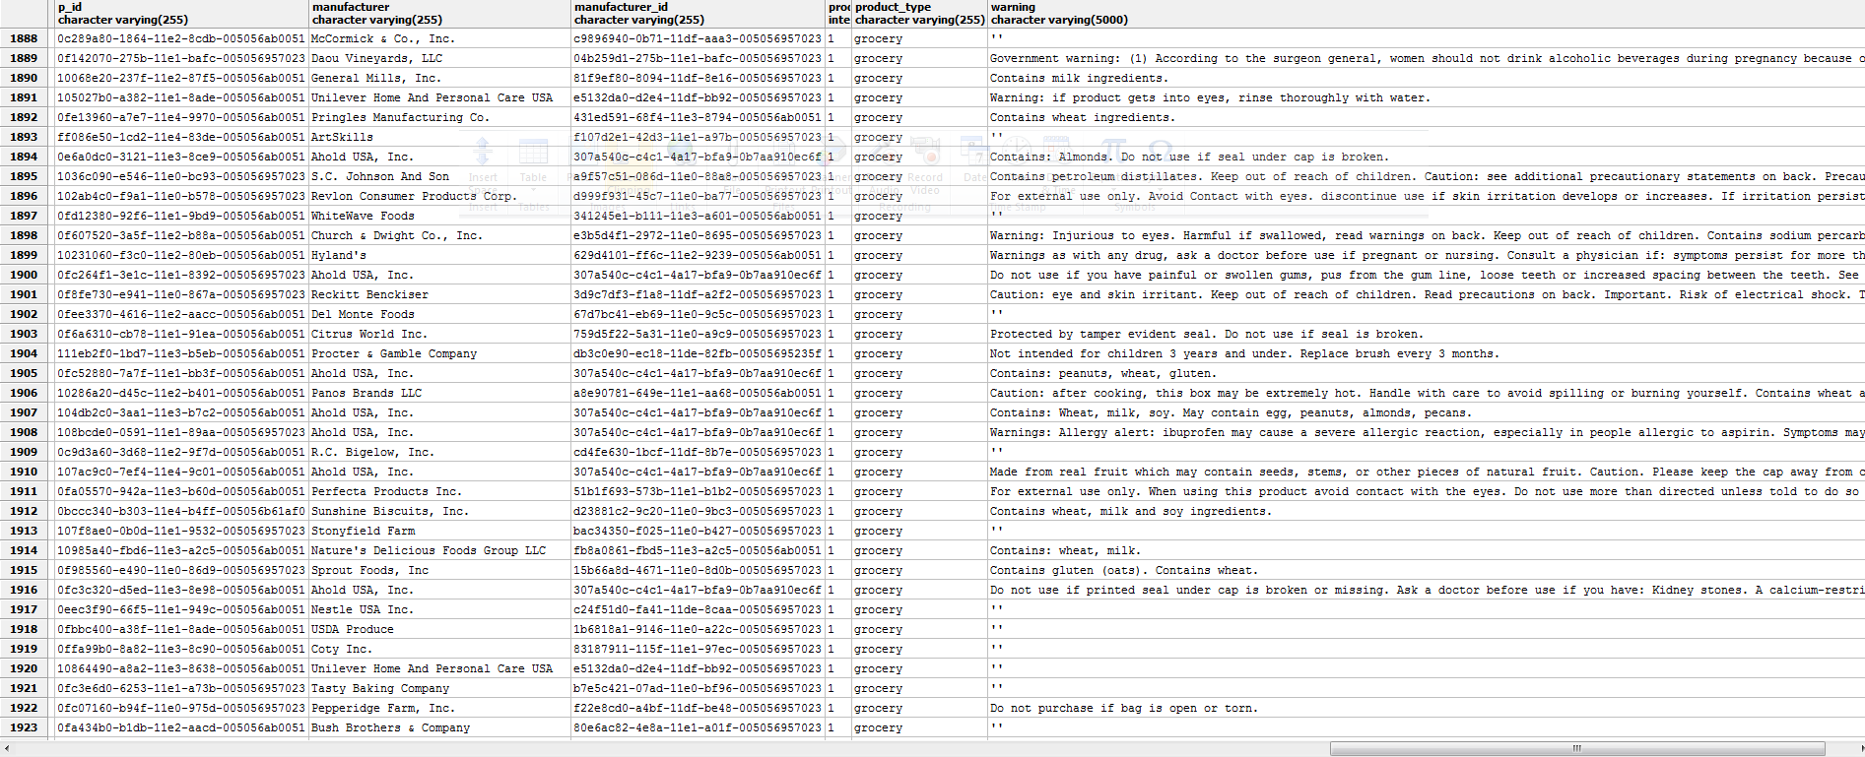

## Hibernate

Hibernate is a tool which allows us to interface the Data objects with the Database without having to explicitly define and optimize every structure upon addition of new fields.

Hibernate has libraries for dealing with necessary optimizations for improves quality of code and performance.

It is smart enough to define its own relations and tables for the Data objects with customization with Annotations from org.hibernate and JPA.

Hibernate optimizes the data flow using caches, storing session data and normalizing the tables for efficiency.

Elegant code is used to make entities and relationships with a standard of quality to prevent bad structures by the developer which could cause the data to load slower than it should. Having a small amount of elegant code allows for easy modification without affecting the rest of the code.

In system with large amount of code, it is fairly easy to cause critical damages while trying to customize the database.

The **DRY**(Don't Repeat Yourself) principle also applies in this case. Having to modify the code at all instances is wasteful of time.

Hibernate contains all the boilerplate code for databases and a smart implementation scheme which makes retrieving data as easy as putting it on hibernate.

### Hibernate Configurations



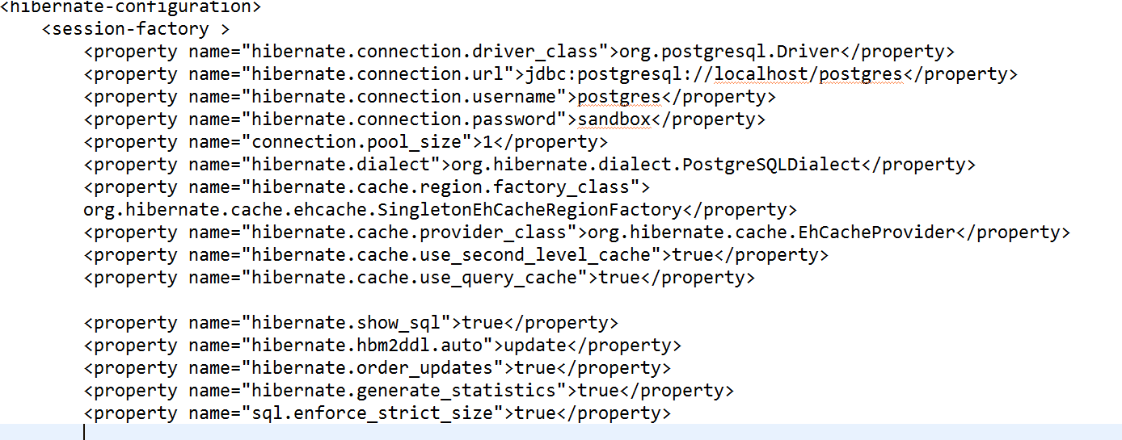

Using Annotations from org.hibernate and javax.persistance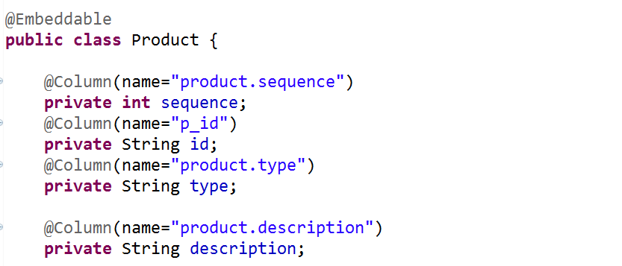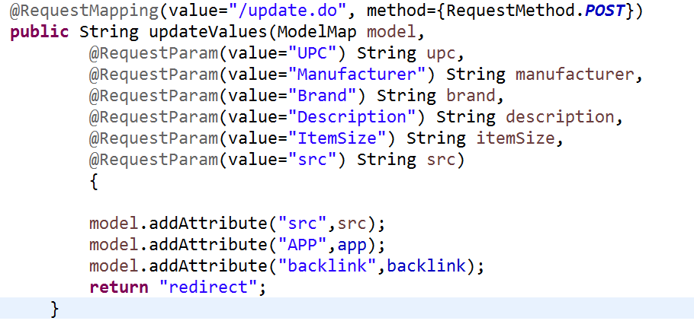Machine generated alternative text: @Embedded
@AttributeOverrides({
@AttributeOverride(name=”name”,column=@Column(name=”distributor.name”)),
@AttributeOverride(name=”address”,column=@Column(name=”distributor.address”)),
@AttributeOverride(name=”email”, column=@Column(name=”distributor . email”)),
@AttributeOverride(name=”phone”,column=@Column(name=”distributor.phone”)),
@AttributeOverride(name=”url”,column=@Column(name=”distributor.url”))
private CompanyType packageDistributor=new CompanyTypeQ;
@Embedded
@AttributeOverrides ({
@AttributeOverride(name=”name”,column=@Column(name=”manufacturer.name”)),
@AttributeOverride(name=”address”, column=@Column(name=”manufacturer. address”)),
@AttributeOverride(name=”email”,column=@Column(name=”manufacturer.email”)),
@AttributeOverride(name=”phone”,column=@Column(name=”manufacturer.phone”)),
@AttributeOverride(name=”url”, column=@Column(name=”manufacturer. un”))
private CompanyType packageManufacturer=new CompanyTypeQ;

Retrieving Search Results Using Criteria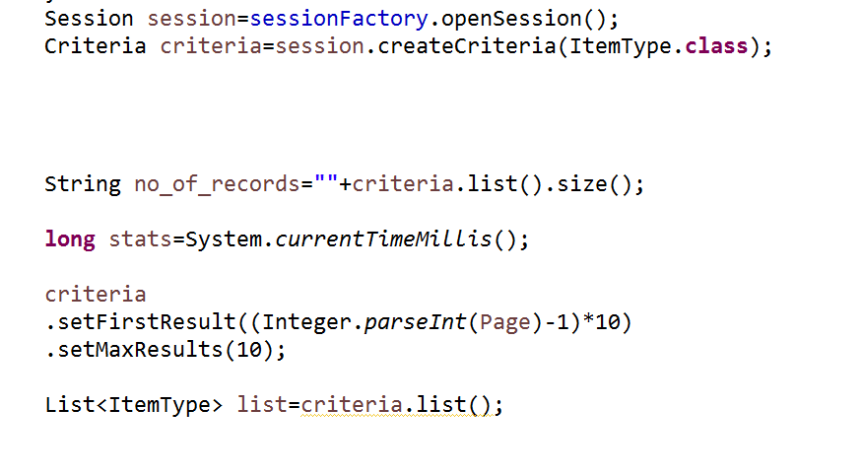

## Java Persistence API - JPA

JPA provides useful annotations to provide validity checks and useful information to Java for applying smart constraints on data which is going to be stored.

Machine generated alternative text: @Entity
@Table
public class ItemType {
@Id
private String id;
@Column
private String status;
@Column
private String name;
Co1umn(1ength=5øeø)
private String marketingDescription;
Co1umn(1ength=5øeø)
private String otherDescription;
@GenericGenerator(name=”hi-lo”, strategy=”hilo”)
@ElementCollection
Co11ectionId(co1umns=Co1umn(name=”upc_id”),generator=”hi-1o”,type=Type(type=”1ong”))
private Collection<Upc> upcs=new ArrayList<Upc>Q;

## JSP & HTML, XML

JSP stands for Java Server Pages. It allows for dynamic page loading for HTML and XML types. These pages are provided by the server to the client in response to their request. An alternative for JSP is the trending AJAX which can load data without reloading the page.

JSP pages are located in specific server locations. Different pages store different codes for data operations.

JSP provides authentication facilities and protection from data loading prematurely.

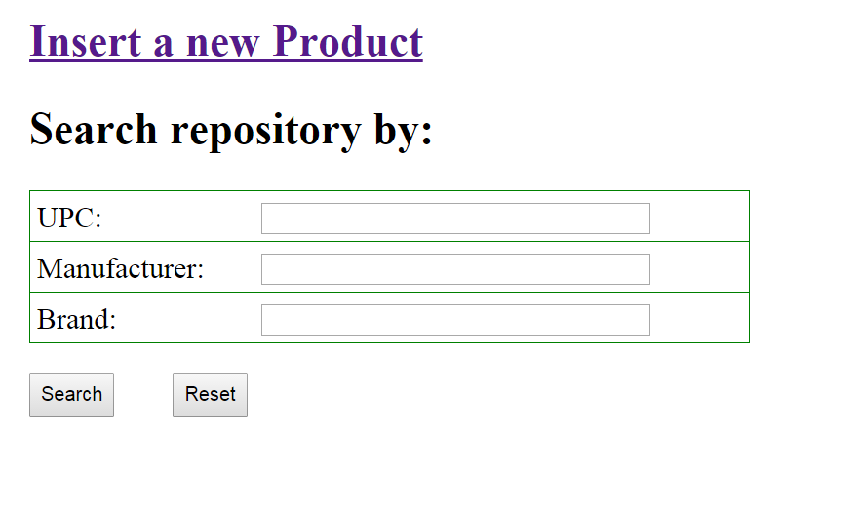

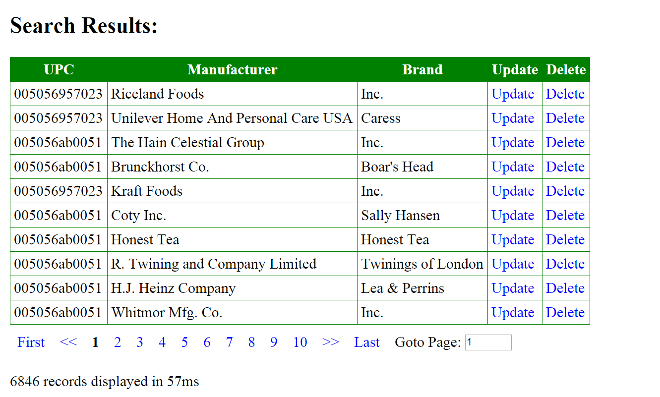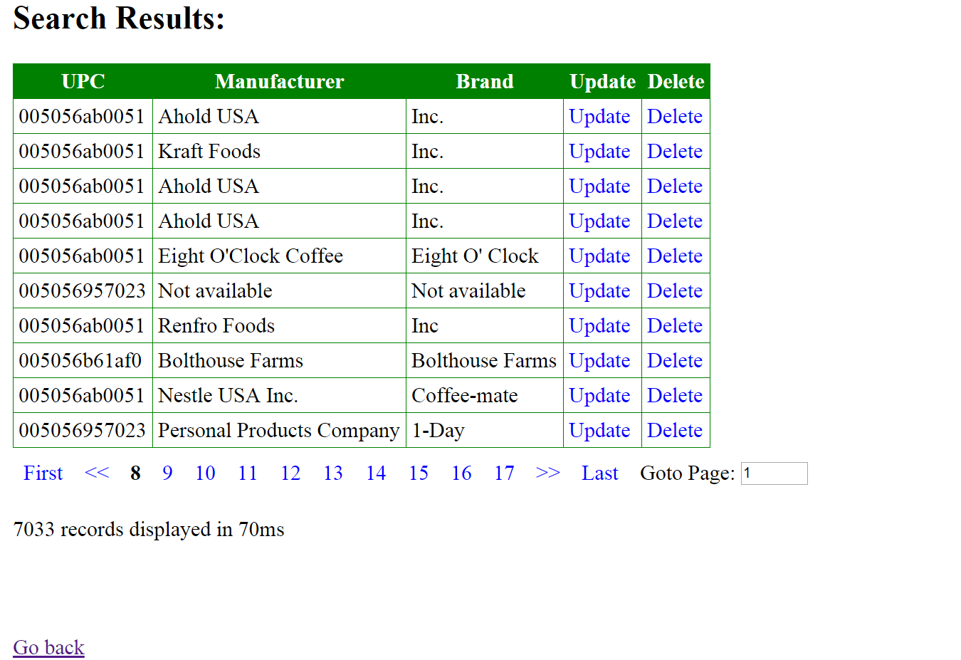

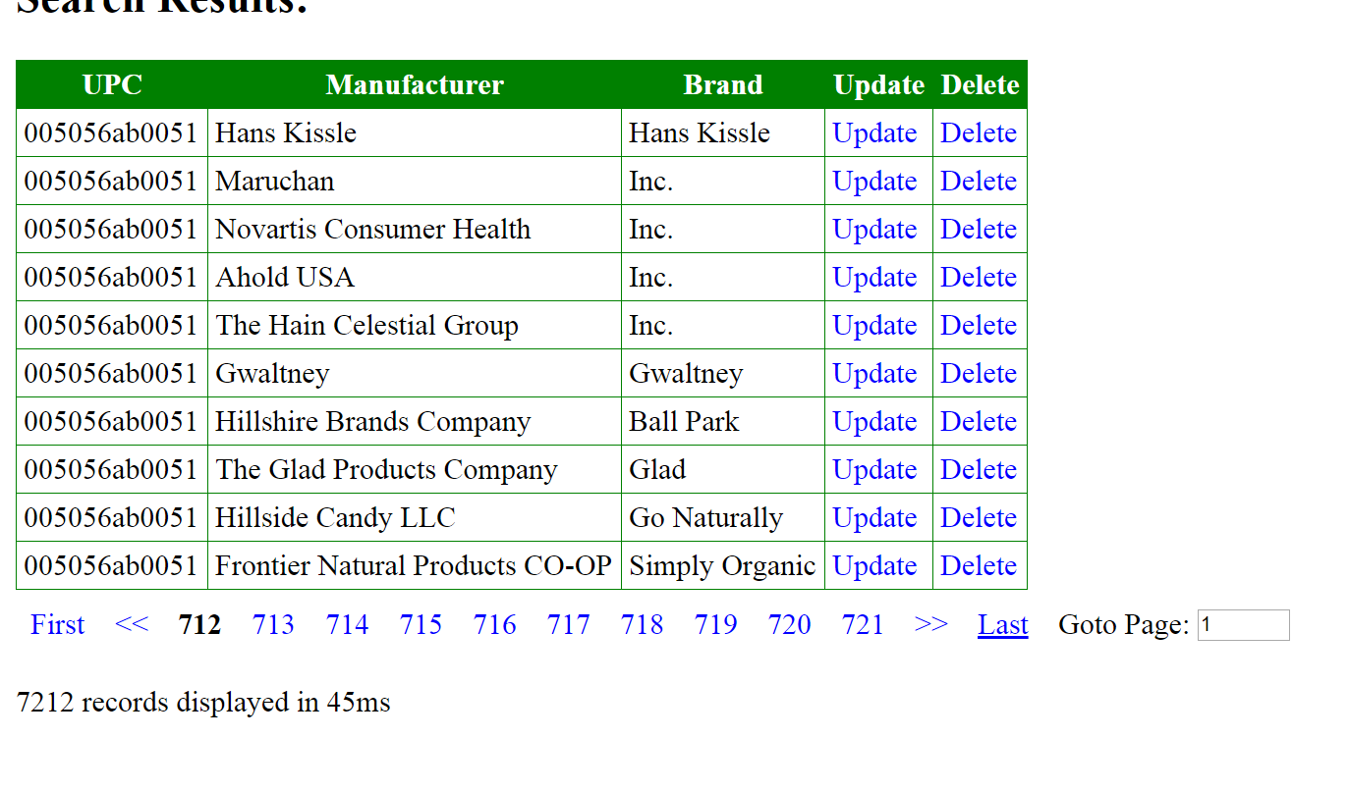

## JSTL

JSP Standard Tag library provides interfacing of JSP pages directly with the database.(Not required since we use hibernate.)

It allows for binding of data from the controller to the JSP page.

## JS and JQuery

Javascript provides scripts to dynamically interact with HTML elements, modify CSS and sending requests.

HTML forms are used to GET and POST data from the controller. JQuery allows of selection of various elements and modifying them as desired.

JS scripts can execute on Button clicks, Mouse hover events, Clicking on elements and all events in general.

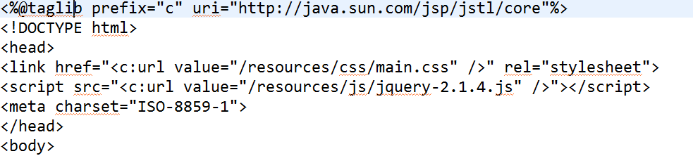

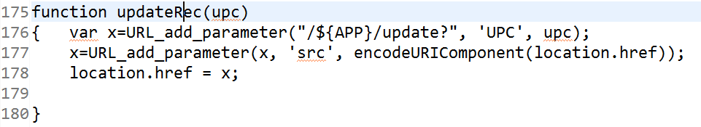

### Form Creation and its Output:

Forms are used to submit data to the Controller via URL methods like:

GET, POST, DELETE, PUT etc.

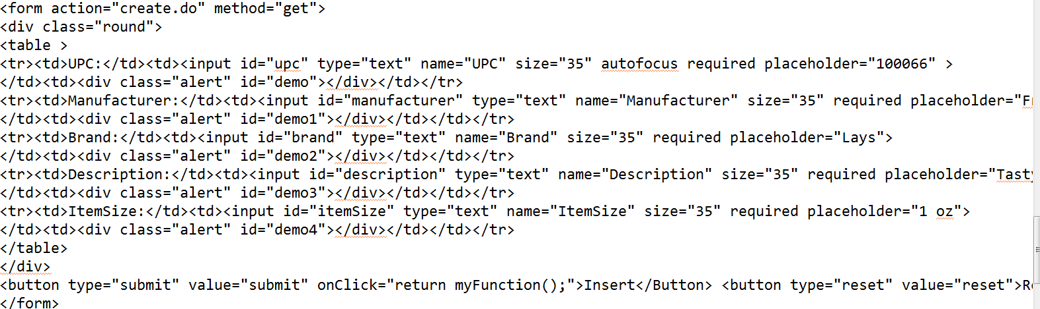

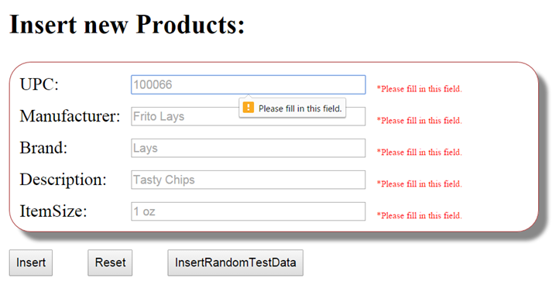

## cURL

cURL allows for sending https requests to a server and storing the received data on a file.

cURL commands for extracting data sets:

cmd> curl [www.google.com](http://www.google.com)

Outputs the HTML source of [www.google.com](http://www.google.com) to console.

cmd> curl –o C://myfolder/abc.txt www.google.com

Stores the HTML source of [www.google.com](http://www.google.com) into a file (creates if not exists.)

cmd> curl –k <https://www.google.com>

Ignores the HTTPS certificate (unsafe) and outputs the source to console.

Using curl inside JAVA:

Windows: Set the System environment variable PATH to the folder containing curl.exe(SSL version)

Linux: Install curl with -apt get

Java: Runtime.getRuntime().exec(“curl -o abc.xml www.itemmaster.com ”);

### Also see Jsoup

## JSON and Jsoup

JSON objects provide a key value pair of data, without having to worry about the data types. It can store any information and condense them into arrays and objects accordingly.

Jsoup is a parser for JSON which can convert HTTP response to HTML(UTF-8) after sending HTTP request and parse XML to JSON.

XML is static page data which needs to be stored and loaded from file. JSON objects are dynamic and do not need to be stored as file. Thus JSON provides increased interaction with virtual objects.

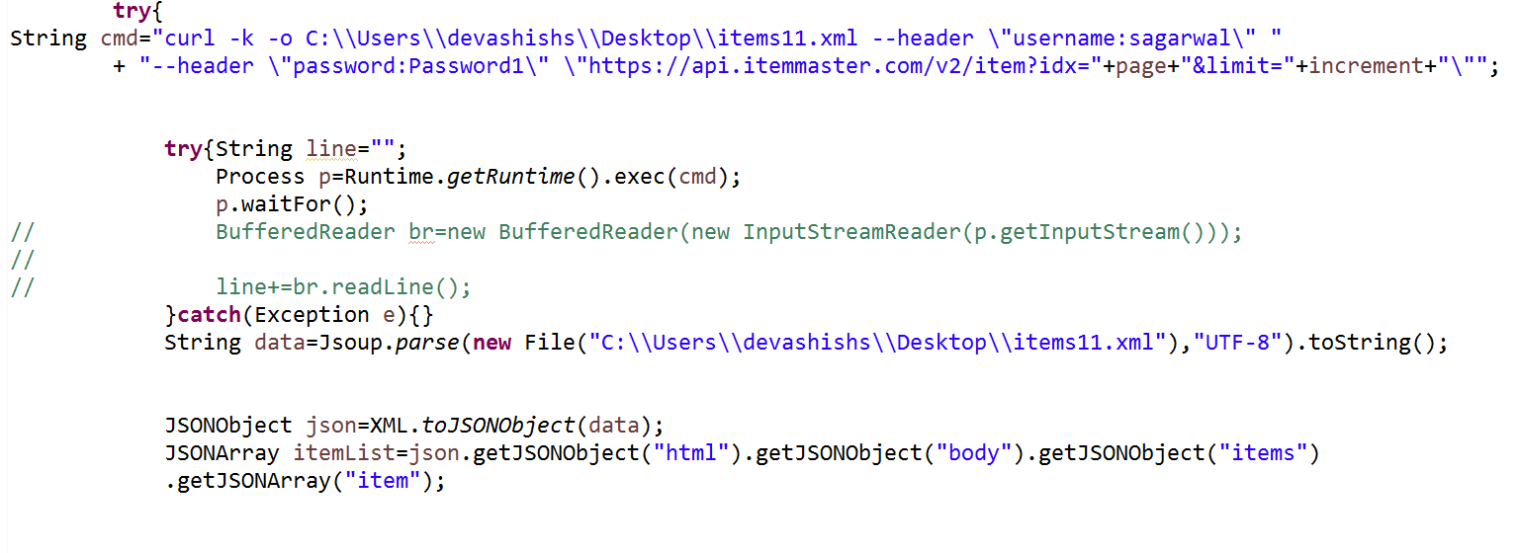

## Apache HTTP

HTTP client for handling the HTTP/HTTPS requests from the server and storing the data accordingly. It handles the certificates and validates the data.

## Instructions for usage:

<http://localhost:8080/APP/>

Is the URL for the main index page of the App.

<http://localhost:8080/APP/getItem?Page=0>

will start indexing Itemmaster from record 1. The offset is set to 50 records and is mapped by Increment variable in BaseController.

Curl.exe is required with SSL support to run this application.

It is available as MSI for windows and .exe file as well.

Be sure to check that curl is running on cmd prompt.

Easy shortcut to not changing path is to copy paste curl.exe to Windows/System32

