From: https://www.cl.cam.ac.uk/projects/raspberrypi/tutorials/os/ok03.html

Documentation on the RPI

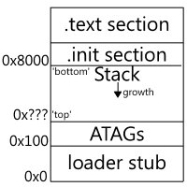

The 'ATAGs' section in the diagram is a place where information about the Raspberry Pi is stored such as how much memory it has, and what its default screen resolution is.