**Devasri B**

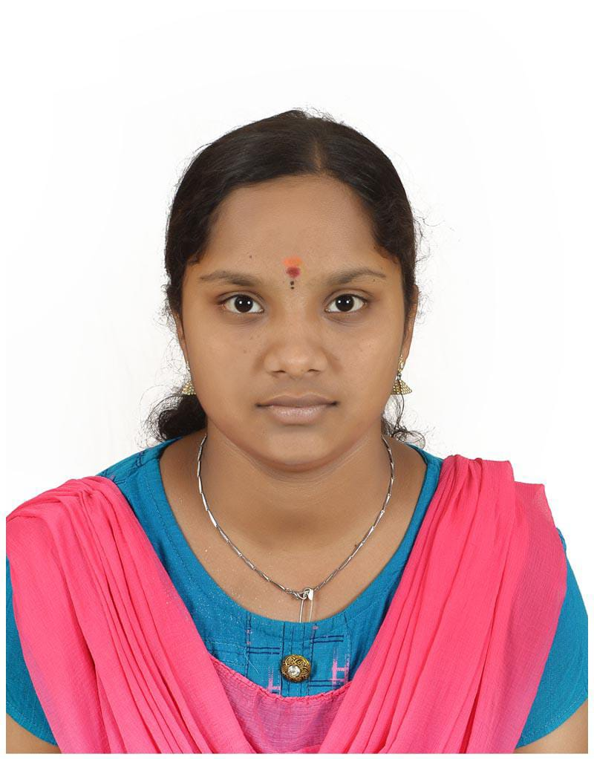

**Phone:** +919543964843

**Mail id:** [devadevasri53@gmail.com](mailto:devadevasri53@gmail.com)

**Pachapatti, Velliyanai, Karur – 639118**

**Linkedin Profile:** <https://www.linkedin.com/in/deva-devasri-45332b2a8>

**Career Objective:**

To become an expert in the field by developing my knowledge and skill for personal and professional growth.

**Academic Background:**

* Sri Amaraavathi College of Arts and Science, B.sc Computer Science
* HSC- Government Model Higher Secondary School, 60.3% 2023
* SSLC- Government Girls Higher Secondary School , All Pass 2021

**Technical Skills:**

* Python
* Web development
* Java

**Area of Interest:**

* Machine Learning
* Team Work

**Extra Curricular Activities:**

* Shot-put Athlet

**Certifications:**

* Certifications on volunteers for the Purpose of NSS
* Course Completion certificate by Infosys|Springboard on topic of Object Oriented and Fundamentals of Python Programming
* Certified from celonis for process of mining fundamentals

**Strength:**

* Helping Person
* Positiver
* Self-confidence

**Project:**

**Frontend**

I had done frontend application to create a web page for buy electronics, I had added few option make the coustomer easy and I had created the backend to connect with that.

**Declaration:**

I hereby Declare that the Information given above is true and correct to the best of my knowledge**.**

**Place :**

**Date : Signature**