PROJECT CASE STUDY
SAP Travel Management Application - RAP Model

1. Project Overview
Developed a professional, cloud-ready Travel Booking Management application on SAP Business Technology Platform (BTP) using the RESTful ABAP Programming Model (RAP). This project serves as a showcase for modern SAP development, featuring complex business logic, automated workflows, and a polished Fiori Elements interface.
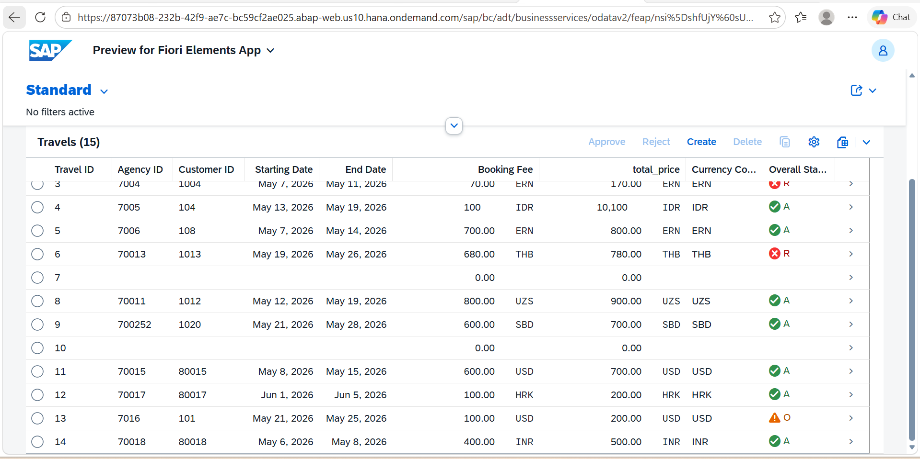

Technical Architecture & Stack
Platform: SAP BTP (ABAP Environment / Steampunk)
Development Model: RAP Managed Scenario (with Draft support)
Programming Language: ABAP for Cloud Development
Data Modeling: Core Data Services (CDS) with UI Annotations

Persistence: SAP HANA (Custom Transparent Tables)
Frontend: Fiori Elements (List Report & Object Page)

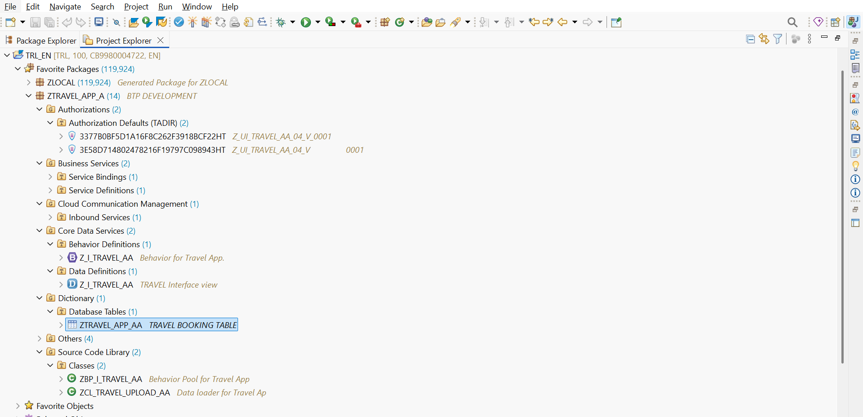

3. Key Implemented Features
▪ Early Numbering & Sequencing: Custom implementation for automatic primary key

CLASS lhc_travel IMPLEMENTATION.

METHOD earlynumbering_create.
DATA: max_travel_id TYPE ztravel_app_aa-travel_id.
SELECT MAX( travel_id ) FROM ztravel_app_aa INTO @max_travel_id.
LOOP AT entities ASSIGNING FIELD-SYMBOL(<travel>).
max_travel_id += 1.
APPEND VALUE #( %cid = <travel>-%cid
travel_id = max_travel_id ) TO mapped-travel.
ENDLOOP.
ENDMETHOD.

▪ Automated Calculations (Determinations): Logic implemented to automatically update Total Price whenever the Booking Fee is modified by the user.
METHOD calculateTotalPrice.
READ ENTITIES OF Z_I_TRAVEL_AA IN LOCAL MODE
ENTITY Travel
FIELDS ( booking_fee ) WITH CORRESPONDING #( keys )
RESULT DATA(travels).

MODIFY ENTITIES OF Z_I_TRAVEL_AA IN LOCAL MODE
ENTITY Travel
UPDATE FIELDS ( total_price last_changed_at )
WITH VALUE #( FOR travel IN travels (
%tky = travel-%tky
total_price = travel-booking_fee + 100
last_changed_at = cl_abap_context_info=>get_system_time( )
) )
REPORTED DATA(lt_reported).
ENDMETHOD.

▪ Business Validations: Integrated backend checks for travel dates (e.g., ensuring End Date is not before Start Date) to prevent incorrect data entry.
METHOD validateDates.
READ ENTITIES OF Z_I_TRAVEL_AA IN LOCAL MODE
ENTITY Travel
FIELDS ( Begin_Date End_Date ) WITH CORRESPONDING #( keys )
RESULT DATA(travels).

LOOP AT travels INTO DATA(travel).
IF travel-End_Date < travel-Begin_Date.
APPEND VALUE #( %tky = travel-%tky ) TO failed-travel.
APPEND VALUE #( %tky = travel-%tky
%msg = new_message_with_text(
severity = if_abap_behv_message=>severity-error
text = 'End Date cannot be before Begin Date!' )
) TO reported-travel.
ENDIF.
ENDLOOP.
ENDMETHOD.

▪ Custom Action Buttons: Implemented "Approve" and "Reject" functionality that updates travel status and triggers UI state changes instantly.
METHOD acceptTravel.
MODIFY ENTITIES OF Z_I_TRAVEL_AA IN LOCAL MODE
ENTITY Travel
UPDATE FIELDS ( overall_status last_changed_at )
WITH VALUE #( FOR key IN keys ( %tky = key-%tky
overall_status = 'A'
last_changed_at = cl_abap_context_info=>get_system_time( ) ) )
FAILED failed
REPORTED reported.

READ ENTITIES OF Z_I_TRAVEL_AA IN LOCAL MODE
ENTITY Travel ALL FIELDS WITH CORRESPONDING #( keys )
RESULT DATA(travels).
result = VALUE #( FOR travel IN travels ( %tky = travel-%tky %param = travel ) ).
ENDMETHOD.

METHOD rejectTravel.
MODIFY ENTITIES OF Z_I_TRAVEL_AA IN LOCAL MODE
ENTITY Travel
UPDATE FIELDS ( overall_status last_changed_at )
WITH VALUE #( FOR key IN keys ( %tky = key-%tky
overall_status = 'R'
last_changed_at = cl_abap_context_info=>get_system_time( ) ) )
FAILED failed
REPORTED reported.

READ ENTITIES OF Z_I_TRAVEL_AA IN LOCAL MODE
ENTITY Travel ALL FIELDS WITH CORRESPONDING #( keys )
RESULT DATA(travels).
result = VALUE #( FOR travel IN travels ( %tky = travel-%tky %param = travel ) ).
ENDMETHOD.

▪ Mass Data Migration: Developed a custom ABAP Console Class utilizing EML (Entity Manipulation Language) for efficient, bulk data uploads.

CLASS zcl_travel_upload_aa IMPLEMENTATION.

METHOD if_oo_adt_classrun~main.
DATA lt_travel TYPE TABLE FOR CREATE Z_I_TRAVEL_AA.

lt_travel = VALUE #(
( %cid = 'UPLOAD_01'
agency_id = '007016'
customer_id = '000101'
begin_date = '20260521'
end_date = '20260525'
booking_fee = '100.00'
currency_code = 'USD'
overall_status = 'O' )
).

MODIFY ENTITIES OF Z_I_TRAVEL_AA
ENTITY Travel
CREATE FIELDS ( agency_id customer_id begin_date end_date booking_fee currency_code overall_status )
WITH lt_travel
MAPPED DATA(ls_mapped)
FAILED DATA(ls_failed)
REPORTED DATA(ls_reported).

IF ls_failed IS NOT INITIAL.
out->write( 'Upload Failed Mama!' ).
out->write( ls_failed ).
ELSE.
COMMIT ENTITIES.
out->write( 'Data Upload Successful! Check Table now.' ).
ENDIF.

ENDMETHOD.
ENDCLASS.

4. UI/UX & Data Visualizations
The application is built on Fiori 3.0 design principles, focusing on intuitive data display and real-time feedback.

A. Semantic Color Coding (Status Criticality)

- Caption: "Figure: Implementation of semantic icons and colors. Green Tick (A) for Approved, Red Cross (R) for Rejected, and Orange Warning (O) for Open status."

B. Modern Metadata Annotations (CDS)
ABAP

case overall_status
when 'A' then 3 -- 3 = Green
when 'R' then 1 -- 1 = Red
when 'O' then 2 -- 2 = Yellow
else 0
end as OverallStatusCriticality,

@UI: { lineItem: [ { position: 80, criticality: 'OverallStatusCriticality' }, -- Idhi add chey
{ type: #FOR_ACTION, dataAction: 'acceptTravel', label: 'Approve' },
{ type: #FOR_ACTION, dataAction: 'rejectTravel', label: 'Reject' } ],
identification: [ { position: 80, criticality: 'OverallStatusCriticality' }, -- Idhi add chey
{ type: #FOR_ACTION, dataAction: 'acceptTravel', label: 'Approve' },
{ type: #FOR_ACTION, dataAction: 'rejectTravel', label: 'Reject' } ] }
overall_status,

- Caption: "UI Annotations used to link backend status logic to the frontend visualization."

C. Data Layout & Facets
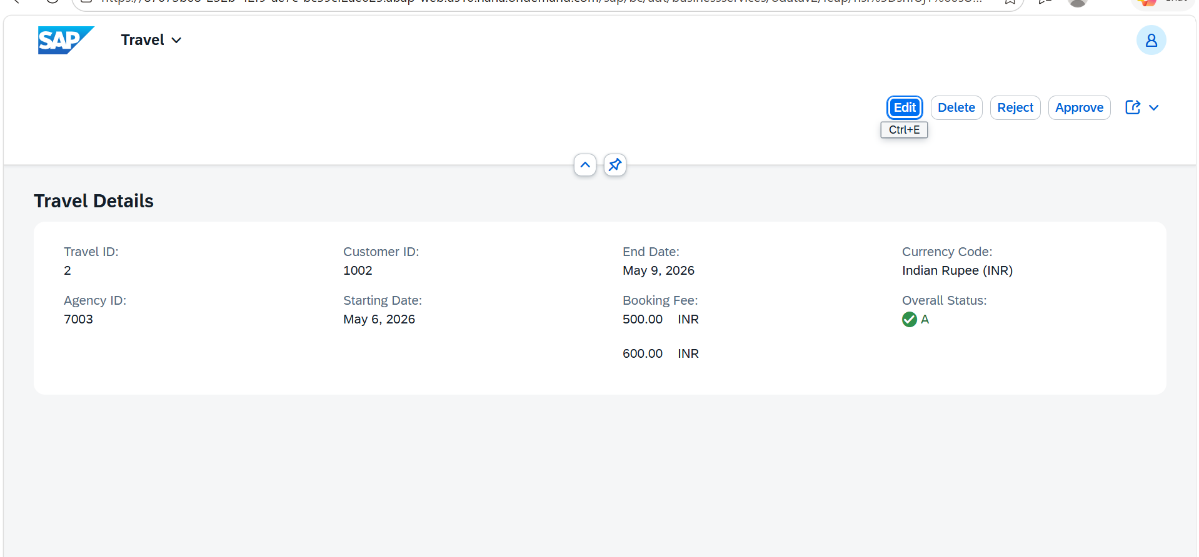
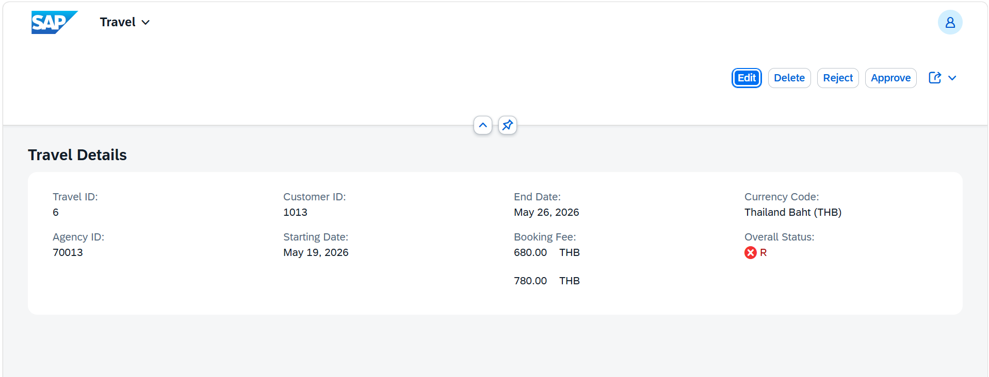
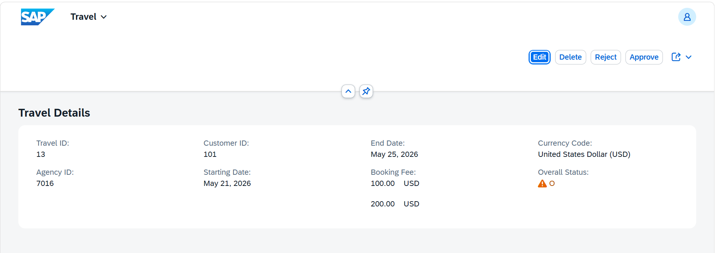
- Matter: "Organized data into logical sections using Header Facets and Identification References for better readability."

5. Project Deliverables
- Outcome: The application is fully responsive and supports all CRUD (Create, Read, Update, Delete) operations.
- Integrations: Currency Value Helps, Automated Total Price calculation, and high-integrity data validation.

Developed by ABAP RAP Professional Developer | Freelance Portfolio
Devasri V
Devasriv09@gmail.com
www.linkedin.com/in/devasri-v-b1b487311

