**PROJECT REPORT TEMPLATE**

1.**INTRODUCTION:**

**1.1 Overview**

Zoho books is a cloud-based accounting software that can help manage finances and

Accounting for businesses like Keerthi sweets. It can be used for tasks such as invoicing,

expenses tracking, inventory management, and more.

1.My project title is “preparation and maintenance for Keerthi sweets” in ZOHO Books.

2.My project duration was 28 days. I finished my project in 2 days after the starting day.

**1.2 Purpose**

1.Accounts maintained easily.

2.Time saving.

3.It is an easy way to create sales, purchase order, bills and invoices.

**2. PROBLEM DEFINITION AND DESIGN THINKING:**

**2.1 EMPATHY MAP:**

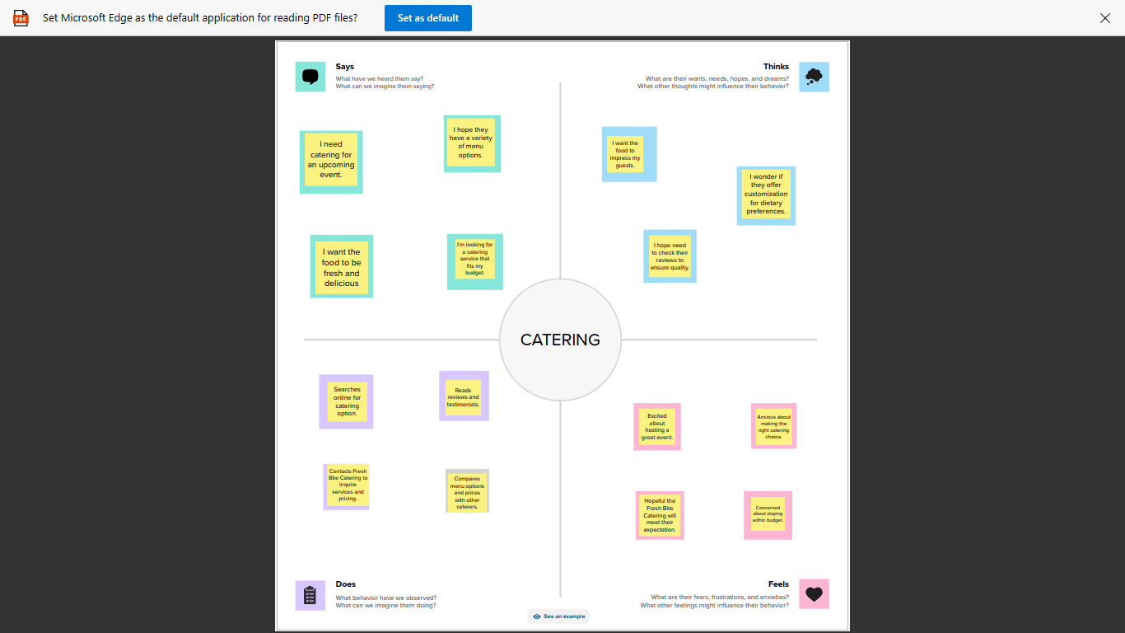

**2.2 IDEA AND BRAINSTORMING MAP:**

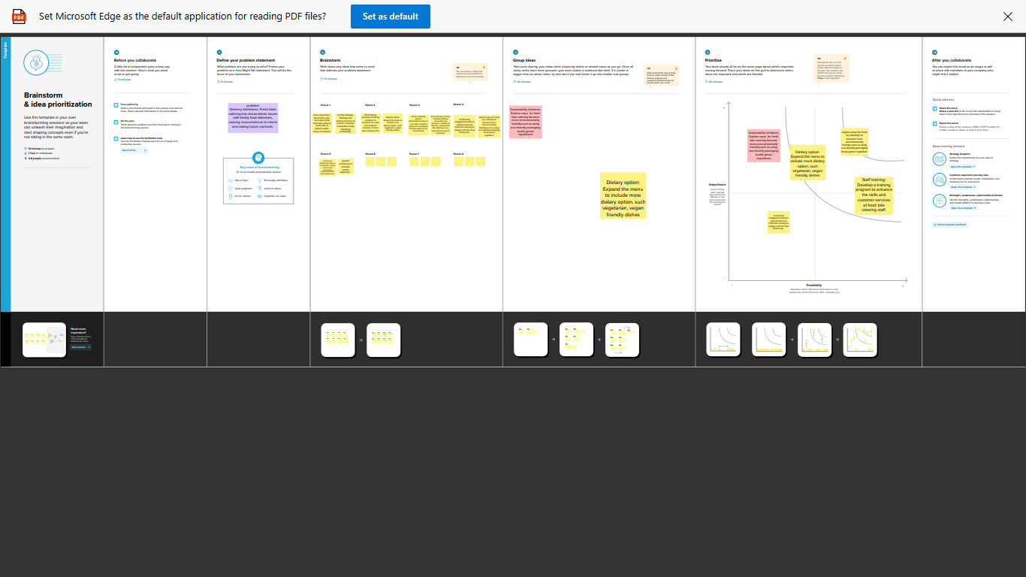

**3.RESULT**

In the result, I can find out

**ITEM CREATION**

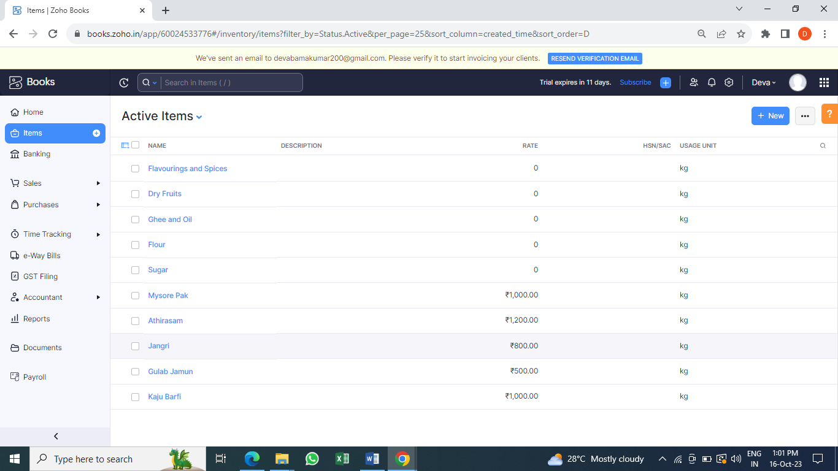

**VENDOR CREATION**

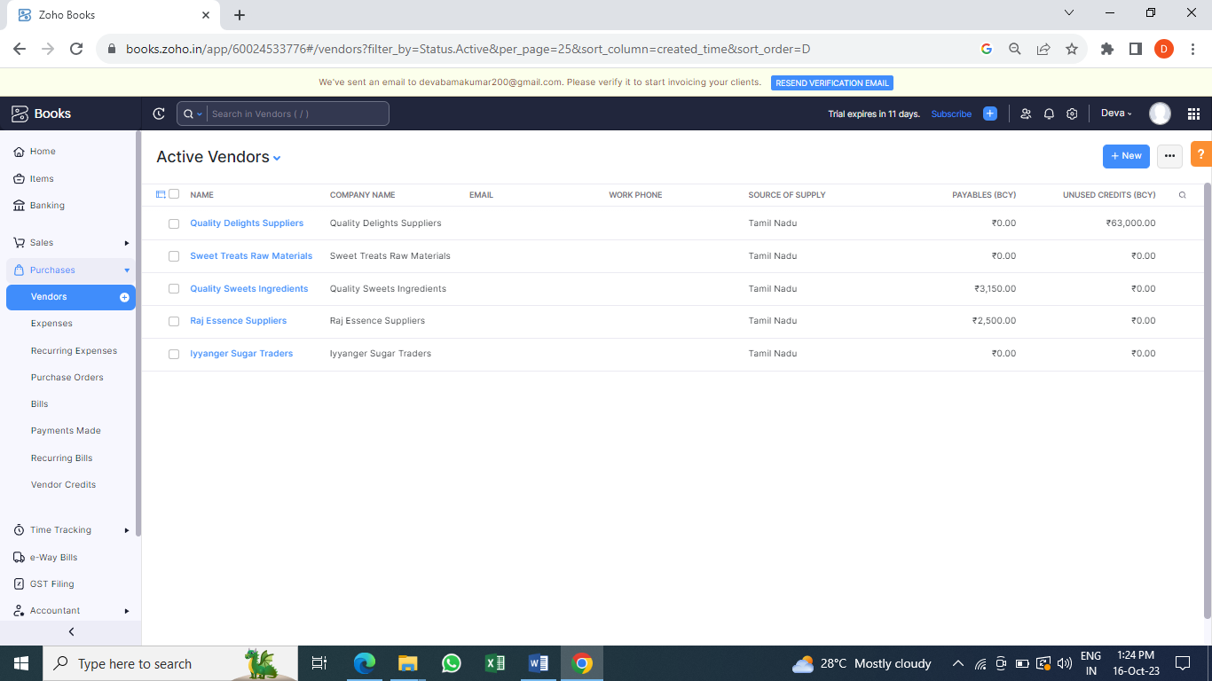

**PURCHASE ORDER**

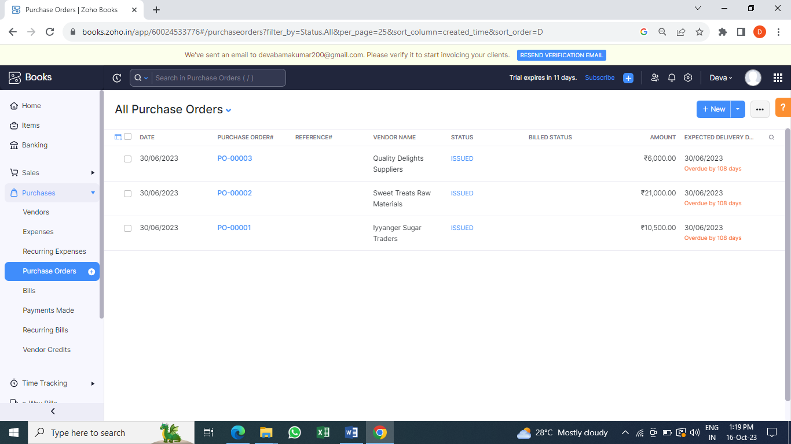

**SALES ORDER**

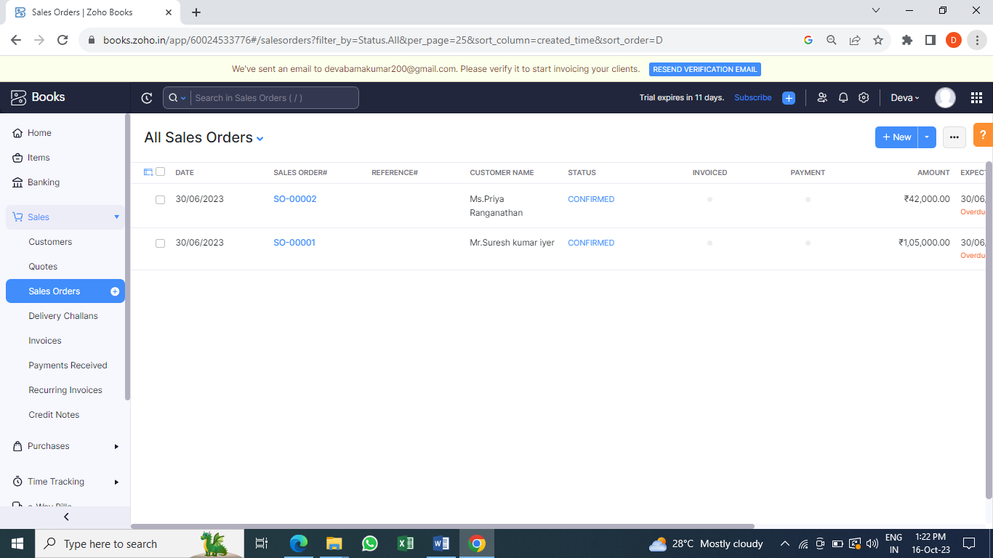

**BANK DETAILS**

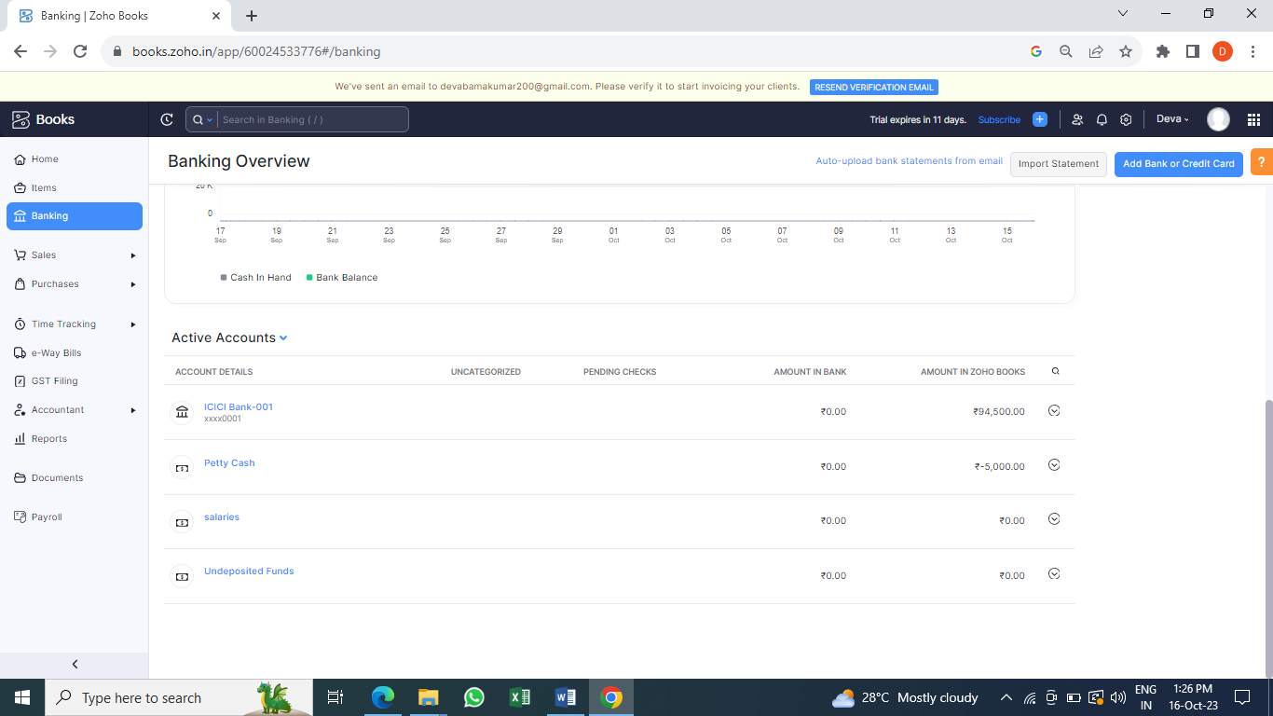

**PROFIT AND LOSS ACCOUNT**

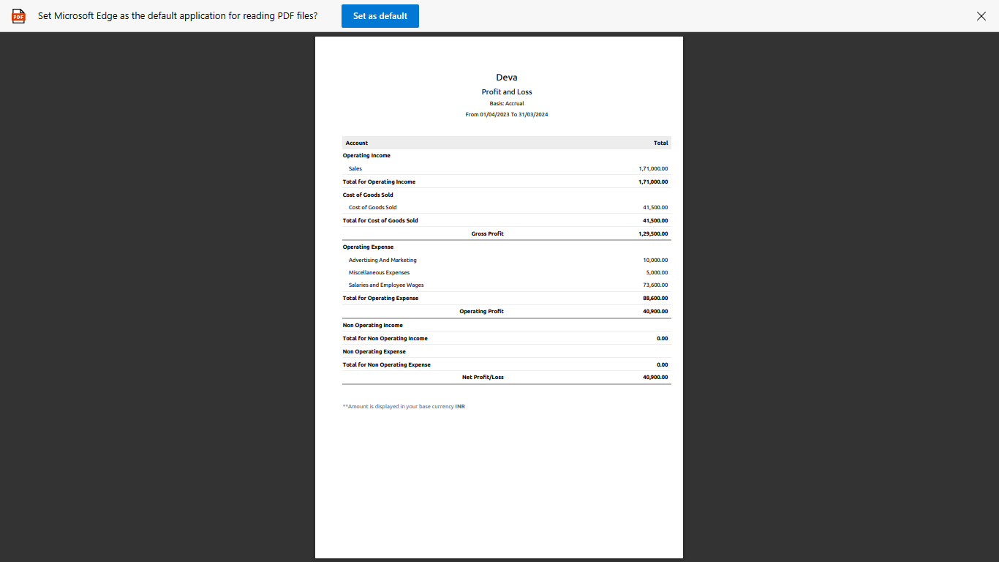

**BALANCE SHEET**

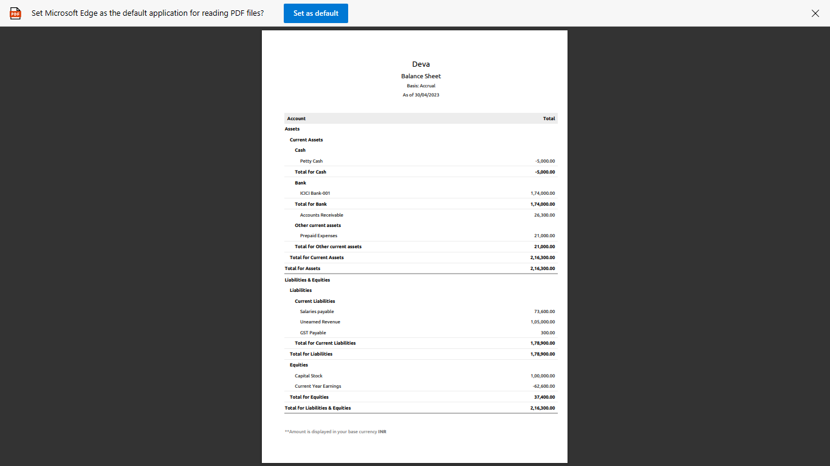

**4. ADVANTAGES AND DIS ADVANTAGES:**

**Advantages:**

1. Accounts maintained easily.
2. Time saving
3. It is an easy way to create sales, purchase order, bill and invoices.

**Disadvantages:**

1. We cannot see the and to talk over the customer.

**5.APPLICATION:**

ZOHO Books link: book.zoho.com

**6.CONCLUSION:**

1. First we open the link and we create the organization name.

2.The Zoho books page opened, First we create the items.

3.Then Sales creation and Purchase creation.

4.Now to create vendors, purchase order, bills and invoices, customers, adding bank account, new accounts and ledger, journal entries, recording banking transactions.

5.To see the reports what we can created and recorded.

**7.FUTURE SCOPE:**

1.Group scope provided complete access to all function the user can perform on the record.

2. For instance, a group scope can allow a user to read, create, update and delete records in all modules.

3. The user has access to all modules in the client ZohoCRM account.

**8. APPENDIX:**

Computer data