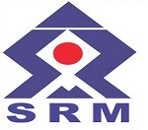 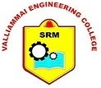

**VALLIAMMAI ENGINEERING COLLEGE**   
(A member of SRM Group of Institutions)  
SRM Nagar,Kattankulathur-603203  
Approved by AICTE, Accredited by NBA & NAAC ‘A ’Grade  
ISO 9001:2015 Certified and Affiliated to Anna University Chennai.

**DEPARTMENT OF INFORMATION TECHNOLOGY**

*Certificate*

This is to certify that “ “of

“ “has presented paperentitled “ “and won the

. Place at the National Level Technical “ ” ‘CYBORGS’ organised by VALLIAMMAI

ENGINEERING COLLEGE on .

