Oddies Product and Brand Brief
  - Product concept and visual direction
Oddies turns your story and ambitions into a map of possible lives. You start with an audio message or context you choose to share from ChatGPT. The app proposes personalized worlds, each represented by a version of the same character. Opening a world reveals a path from what you have already done to actions and milestones that could help you reach your chosen goal.

From a world to a personal path
Tap a world on the map to meet that version of you in its own setting. Open its path to see your relevant past, your current position and possible next steps. Talk with the character to clarify the goal, explore choices and adjust the route as your circumstances change.
World and version | Possible goal | Illustrative route
Quiet Peaks  The Monk | Contemplative practice or monastic life | Past practice → regular meditation → speak with a teacher → explore a retreat or community.
Midnight City  The Agent | An investigative career such as FBI agent | Relevant experience → verify official eligibility → identify gaps → prepare for selection.
Color Valley  The Artist | A creative practice or art career | Previous work → consistent practice → build a portfolio → share or exhibit work.
Idea Gardens  The Founder | Build a business | Existing idea → customer conversations → test an offer → launch and learn.

What each path shows
- Already done User-confirmed memories, experiences and achievements, with optional audio, photos or notes.
- Next action One concrete step to take now, with an editable date or reminder.
- Future milestones Suggested steps, dependencies and alternative branches. Users can change direction or combine worlds.
Career paths check current official entry requirements before proposing milestones. Future branches remain conditional scenarios; completion is confirmed by the user.

Core features
Voice and text onboarding; personalized worlds; conversational companions; editable paths and goals; a private memory archive; progress check-ins and optional reminders; export and deletion controls. Each new update can enrich your history and revise the steps ahead.

Visual identity and app typography
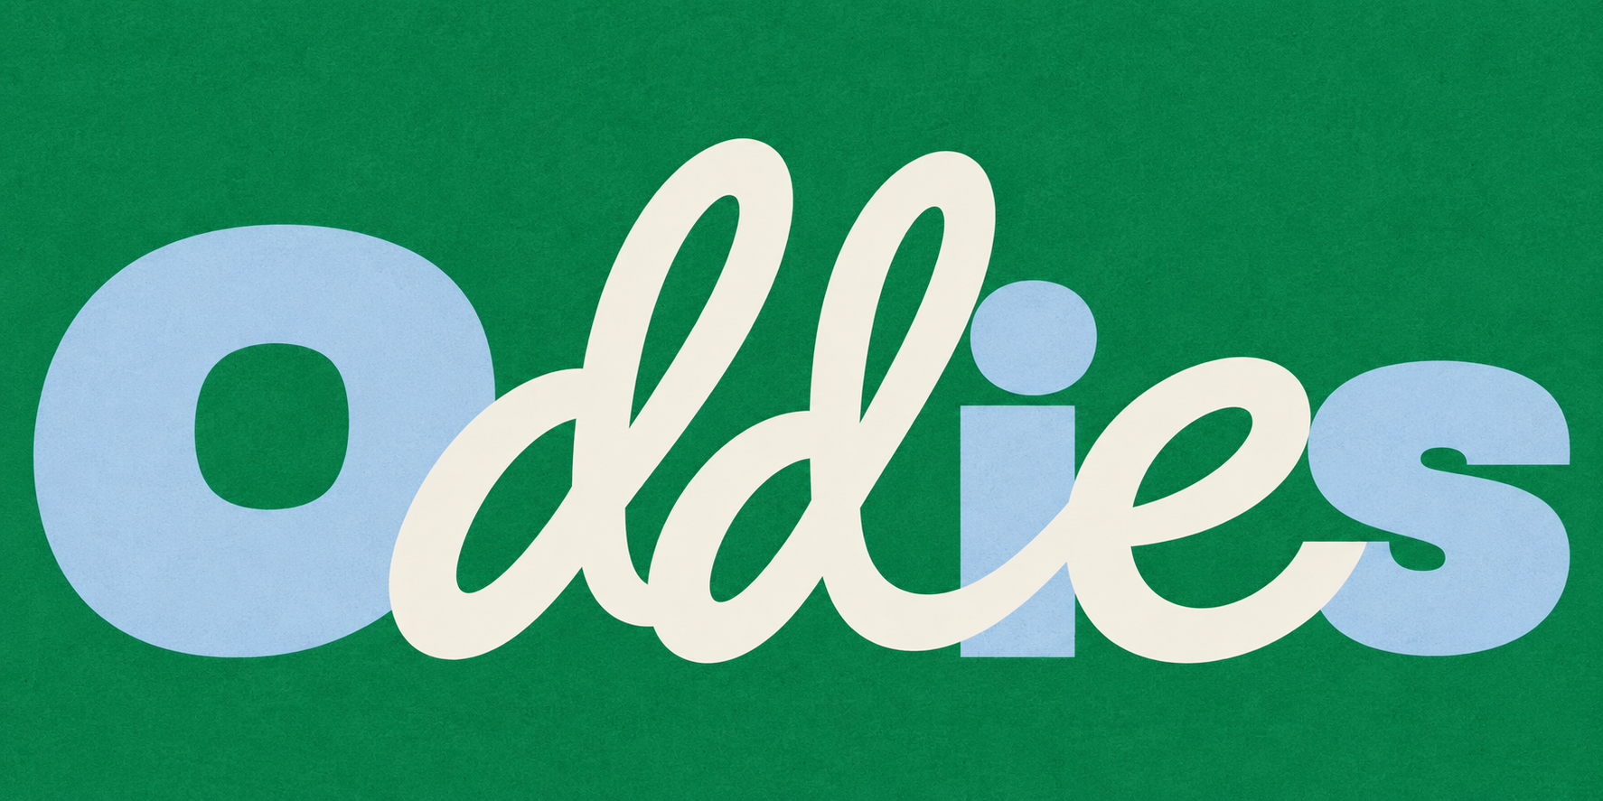

Logo style
Custom lettering combines oversized rounded block letters with flowing script. The O, i and s are powder blue; the paired d letters and e are ivory, with playful overlaps and clear spacing. The logo contains only the name Oddies. Keep the decorative lettering in the logo asset and use readable fonts for the interface.

Font system
Font | Role | Suggested weights
Nunito Sans | Primary app font for body text, buttons, labels and navigation. | 400 body  600 labels  700 buttons
Fraunces | Secondary display font for world names and large introduction titles. | 600
Custom Oddies lettering | Logo only, following the approved block and script reference. | Drawn wordmark

Color direction
Emerald | Powder blue | Ivory | Plum
#087A51 | #B3D0E6 | #F4F1E7 | #352A3D

Use emerald for brand backgrounds, powder blue for accents, ivory for calm surfaces and plum for readable text and primary controls.

World and character style
Use a warm, predominantly 2D illustrated map with four distinct worlds, winding paths and a larger central character. Add gentle grass gradients and subtle shadows beneath the worlds. Separate terrain, buildings, foliage, characters and effects into layers for animation.
Keep her face, tortoiseshell glasses, long dark hair and proportions consistent. Outfits and scenery change with each version. World accents are saffron for the Monk, navy for the Agent, coral for the Artist and lavender for the Founder. The motion direction uses quiet idle movement, blinking, talking poses and a camera transition into the selected world.

