Devayan Mandal

**CSC597 Master’s Project: The College of Saint Rose Course Enrollment System**

This document describes the User Interface for the The College of Saint Rose Course Enrollment System website.

The document is divided into the following sections:

* **Structure and Navigation:** describes the structure of the website, and the ways in which each user type (administrator, faculty and student) can navigate the website.

The overall structure of the application is relatively simple, as shown below.

A. Login Webpage:

Username, Password

Admin, Faculty, Student

1. Student Homepage

a. Profile Options

1. Faculty/Student Directory

2. Update Personal Information

3. Return to Homepage

b. Enrollment Options

1. View Class Information

2. Add Classes

3. View Classes

4. Drop Classes

5. Return to Homepage

c. Log Off

2. Faculty Homepage

a. Profile Options

1. Faculty/Student Directory

2. Update Personal Information

3. Return to Homepage

b. Class Options

1. View Class Information

2. Update Class Information

3. Return to Homepage

c. Enrollment Options

1. View Class Roster

2. Return to Homepage

d. Log Off

3. Administrator Homepage

a. User Options

b. Class Options

c. Enrollment Options

d. Log Off

* **Navigation**: Within the pages, primary navigation is provided on the top of the screen, in a horizontal list of graphical links and buttons. Pages and pop-ups are displayed in a single browser window.
* **Page Descriptions**: This part of the document contains brief descriptions of the screens for each user in the designed website.

1. **Front page**:

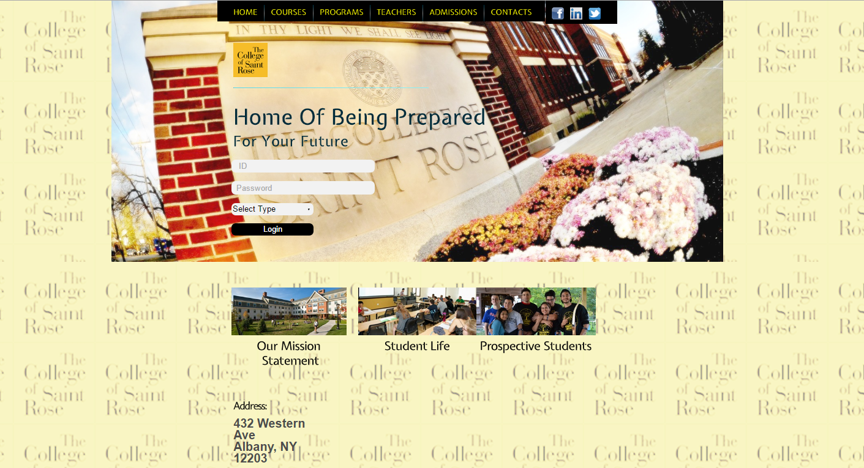

* The front page enables the user to select a profile to log into. The drop down list box element is used for this purpose.
* The front page enables the user to navigate to other related websites links, which may include college courses, programs, teachers, admissions, contact us, Facebook, LinkedIn and Twitter. A new window opens up for redirecting the user to all of the above options.
* A collage of the college logo is displayed in the background, with controlled transparency. The use of ‘repeat’ functionality was implemented in .css to achieve this effect.

1. **Student Homepage**:

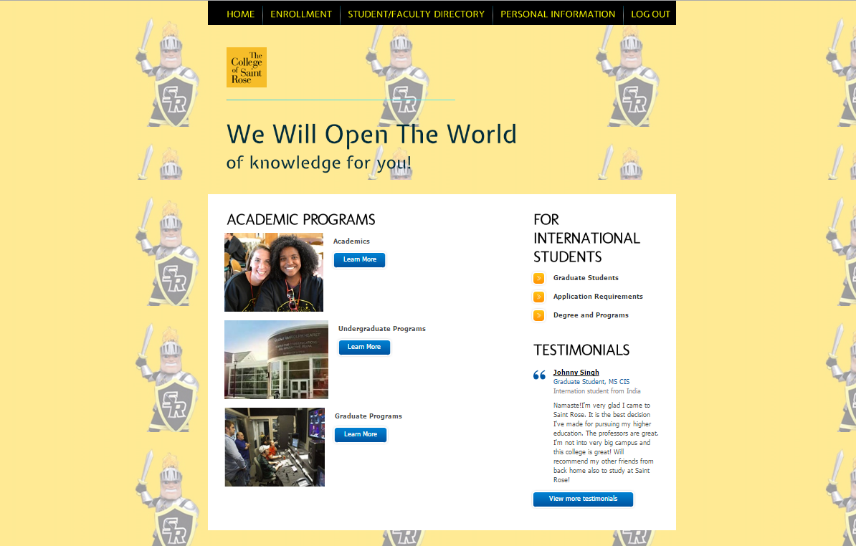

* The student homepage enables the user to navigate various options pertaining to course enrollment.
* Brighter color tones with bolded text was used in an attempt to direct the student’s attention to the webpage.
* A collage of the college logo (different from the front page, faculty page and admin page) is displayed in the background, with controlled transparency. The use of ‘repeat’ functionality was implemented in .css to achieve this effect.

1. **Faculty Homepage**:

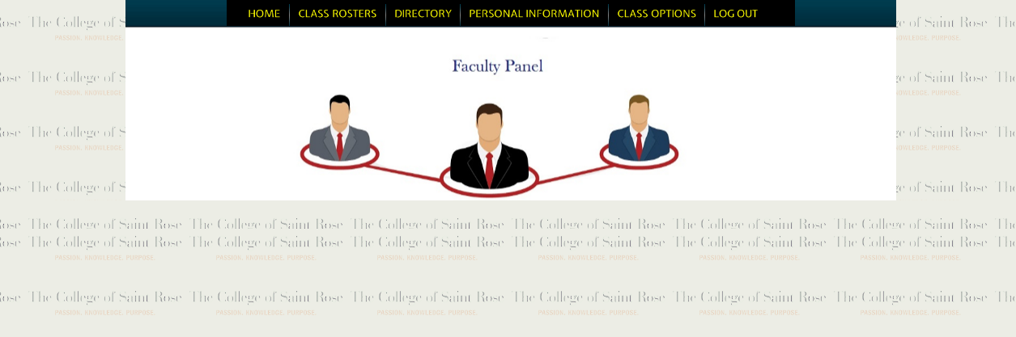

* The faculty homepage enables the user to navigate various options pertaining to class rosters, directories, personal information and class options.
* A more neutral webpage tone was used for the faculty homepage in an attempt to ensure that the user direct’s her/his attention to the pertinent enrollment options.
* A collage of the college logo (different from the front page, student page and admin page) is displayed in the background, with controlled transparency. The use of ‘repeat’ functionality was implemented in .css to achieve this effect.

1. **Administrator Homepage**:

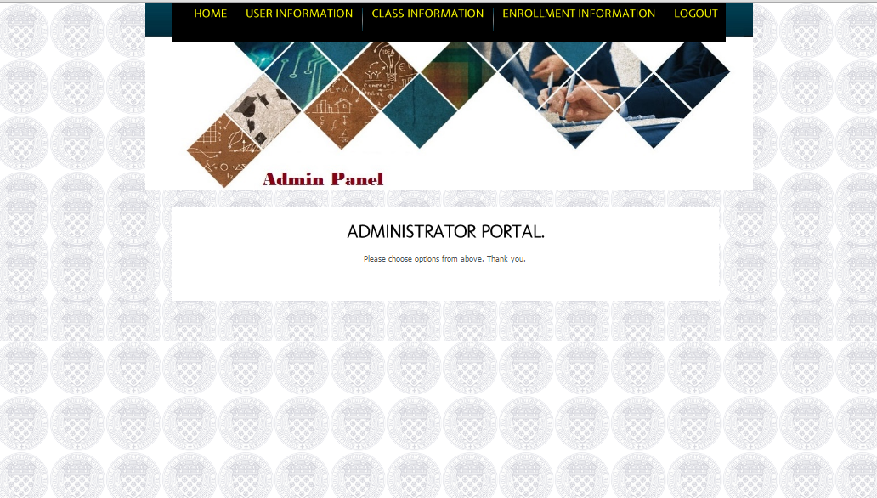

* The admin homepage enables the user to navigate various options pertaining to user information, class information and enrollment information.
* Similar to the faculty profile, a more neutral, focused webpage was created in an attempt to direct the administrator’s attention to the enrollment tasks (addition, modification, updating) at hand.
* A collage of the college logo (different from the front page, student page and faculty page) is displayed in the background, with controlled transparency. The use of ‘repeat’ functionality was implemented in .css to achieve this effect.