Kausap AI — System Design Documentation
Software Development Model, System Flowcharts, Data Flow Diagrams, Use Case Diagram, and Entity Relationship Diagram.

1. Software Development Model
The Kausap AI platform was developed using the Agile Iterative-Incremental model. The system was built in small, working increments (24+ tracked phases, from backend setup and signup flows to dark mode, security hardening, and micro-interactions), with each increment going through planning, design, development, testing, deployment, and review. Feedback from beta testers (students and counselors) fed directly into the product backlog for the next increment.
This model was chosen because mental-health requirements (clinical guardrails, counselor triage, privacy) evolved as stakeholders reviewed working builds, and because it allowed continuous delivery via CI/CD.
Stage | Activities in Kausap AI | Tools
Planning | Select phase scope from backlog; write implementation plans | Markdown plans, GitHub
Design | UI screens, REST API contracts, SQLModel database schema | Flutter widgets, FastAPI, SQLModel
Development | Flutter client and FastAPI backend, AI provider chain, clinical guardrails | Dart, Python, VS Code / Antigravity IDE
Testing | Backend test suites, E2E browser test, static analysis | Pytest scripts, Playwright, flutter analyze
Deployment | Automated web and APK builds; backend hosting | GitHub Actions, Firebase Hosting, Render
Review | Beta feedback and bug-fix cycle | Sentry monitoring, beta testing notes
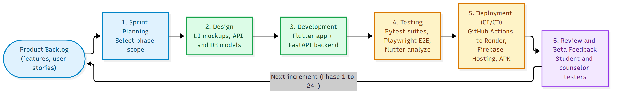
Figure 1. Agile Iterative-Incremental Development Model

2. System Flowcharts
Flowchart 1 shows the overall user journey and role-based routing (Student, Counselor, Administrator). Flowchart 2 details the AI chat pipeline with its three safety layers and multi-provider fallback chain.
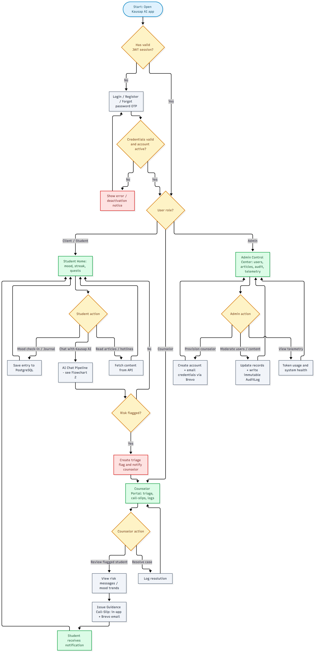
Figure 2. Main System Flowchart

2.1 AI Chat Pipeline Flowchart
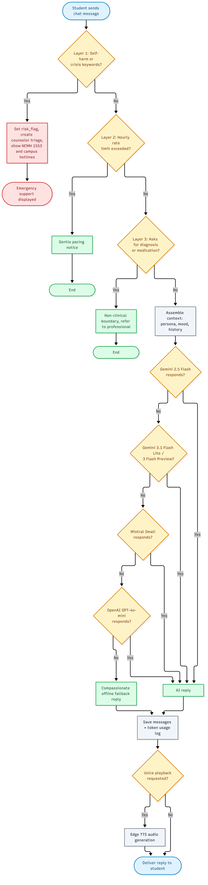
Figure 3. AI Chat Pipeline and Clinical Guardrails Flowchart

3. Data Flow Diagram

3.1 Context Diagram (Level 0)
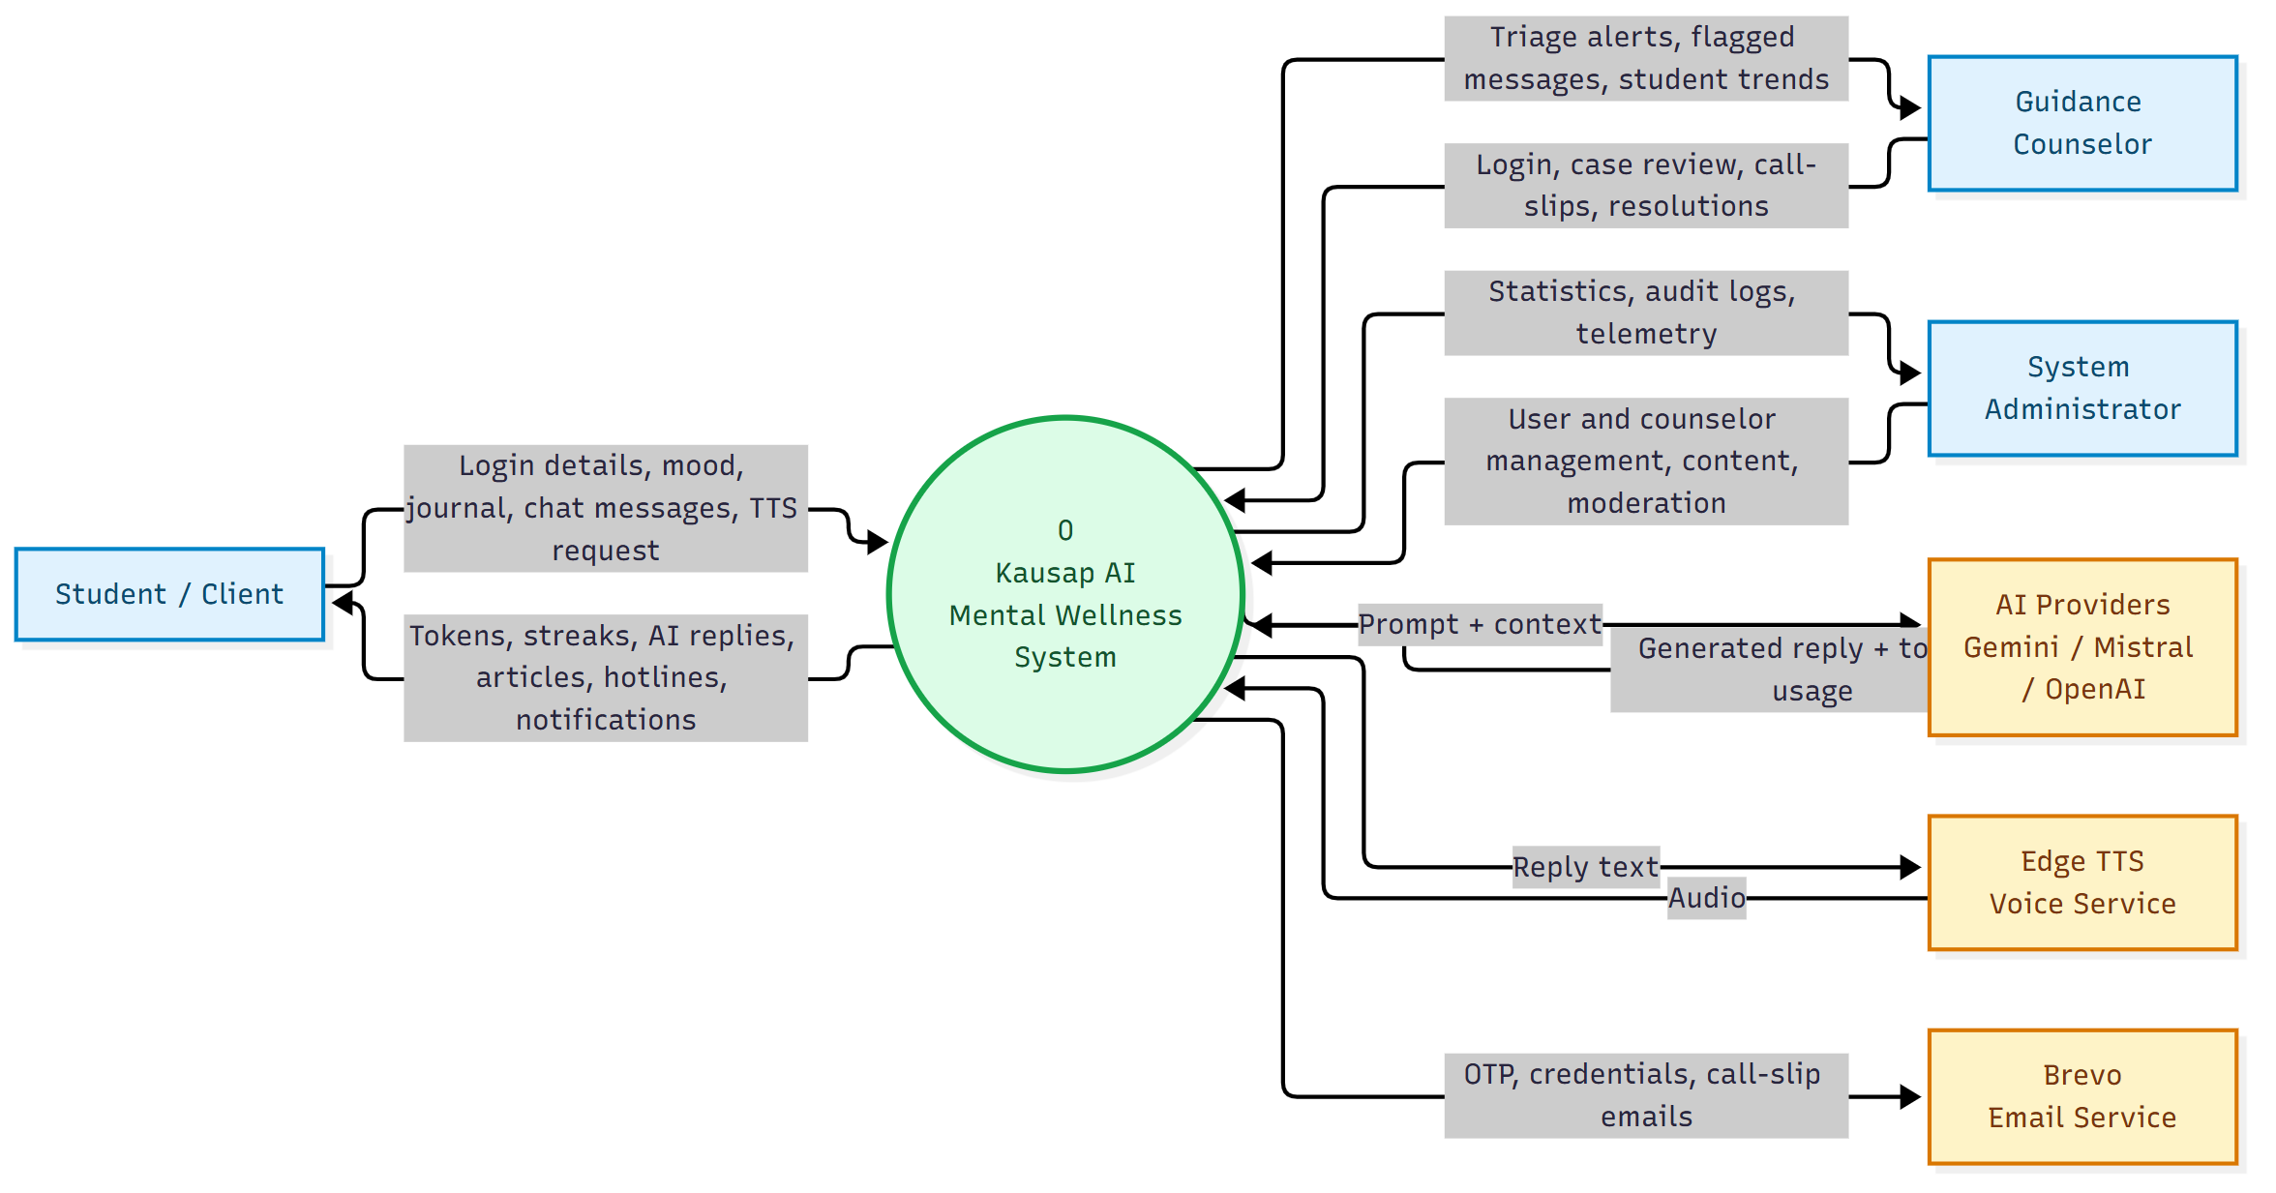
Figure 4. DFD Level 0 — Context Diagram

3.2 Level 1 Data Flow Diagram
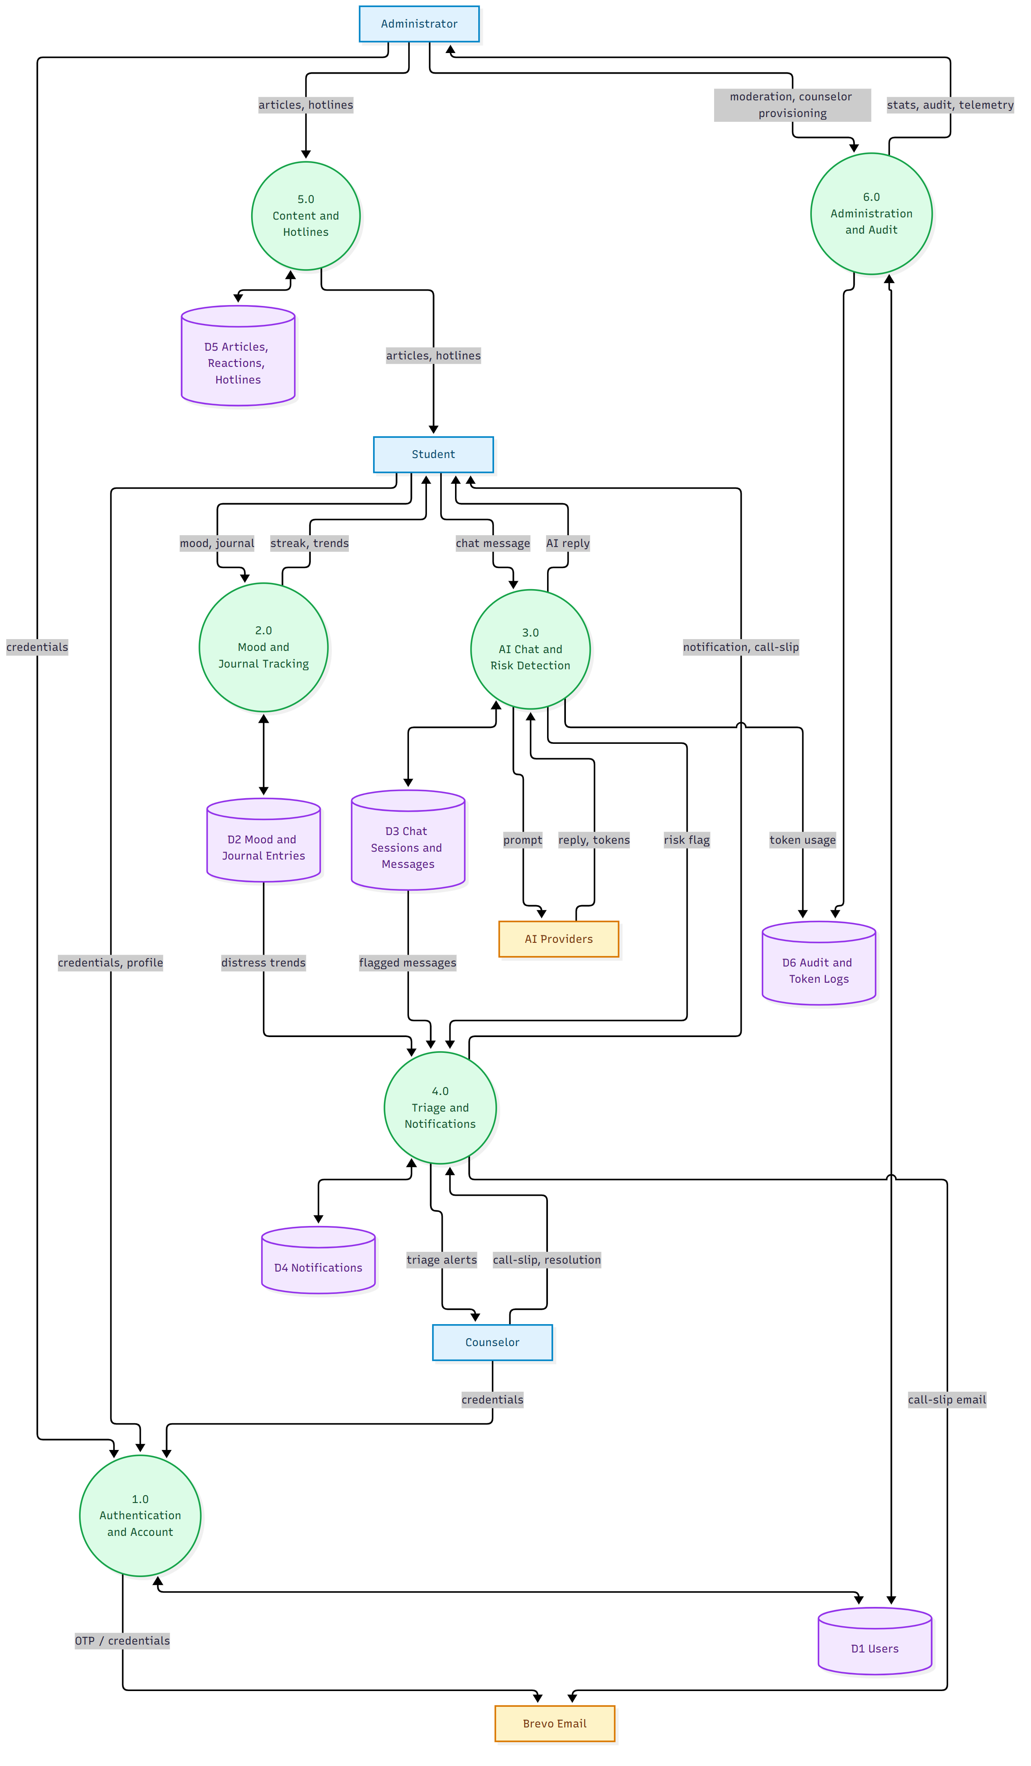
Figure 5. DFD Level 1

4. Use Case Diagram
Actors: Student/Client, Guidance Counselor, System Administrator; external actors: AI Provider and Email Service.

4.1 Student / Client
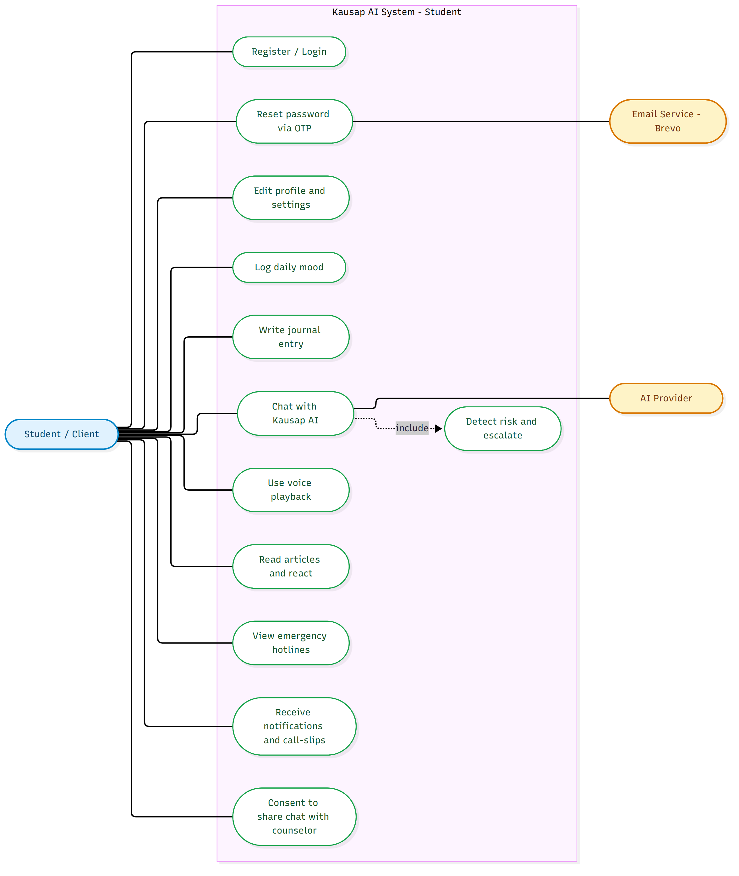
Figure 6. Use Case Diagram — Student / Client

4.2 Guidance Counselor
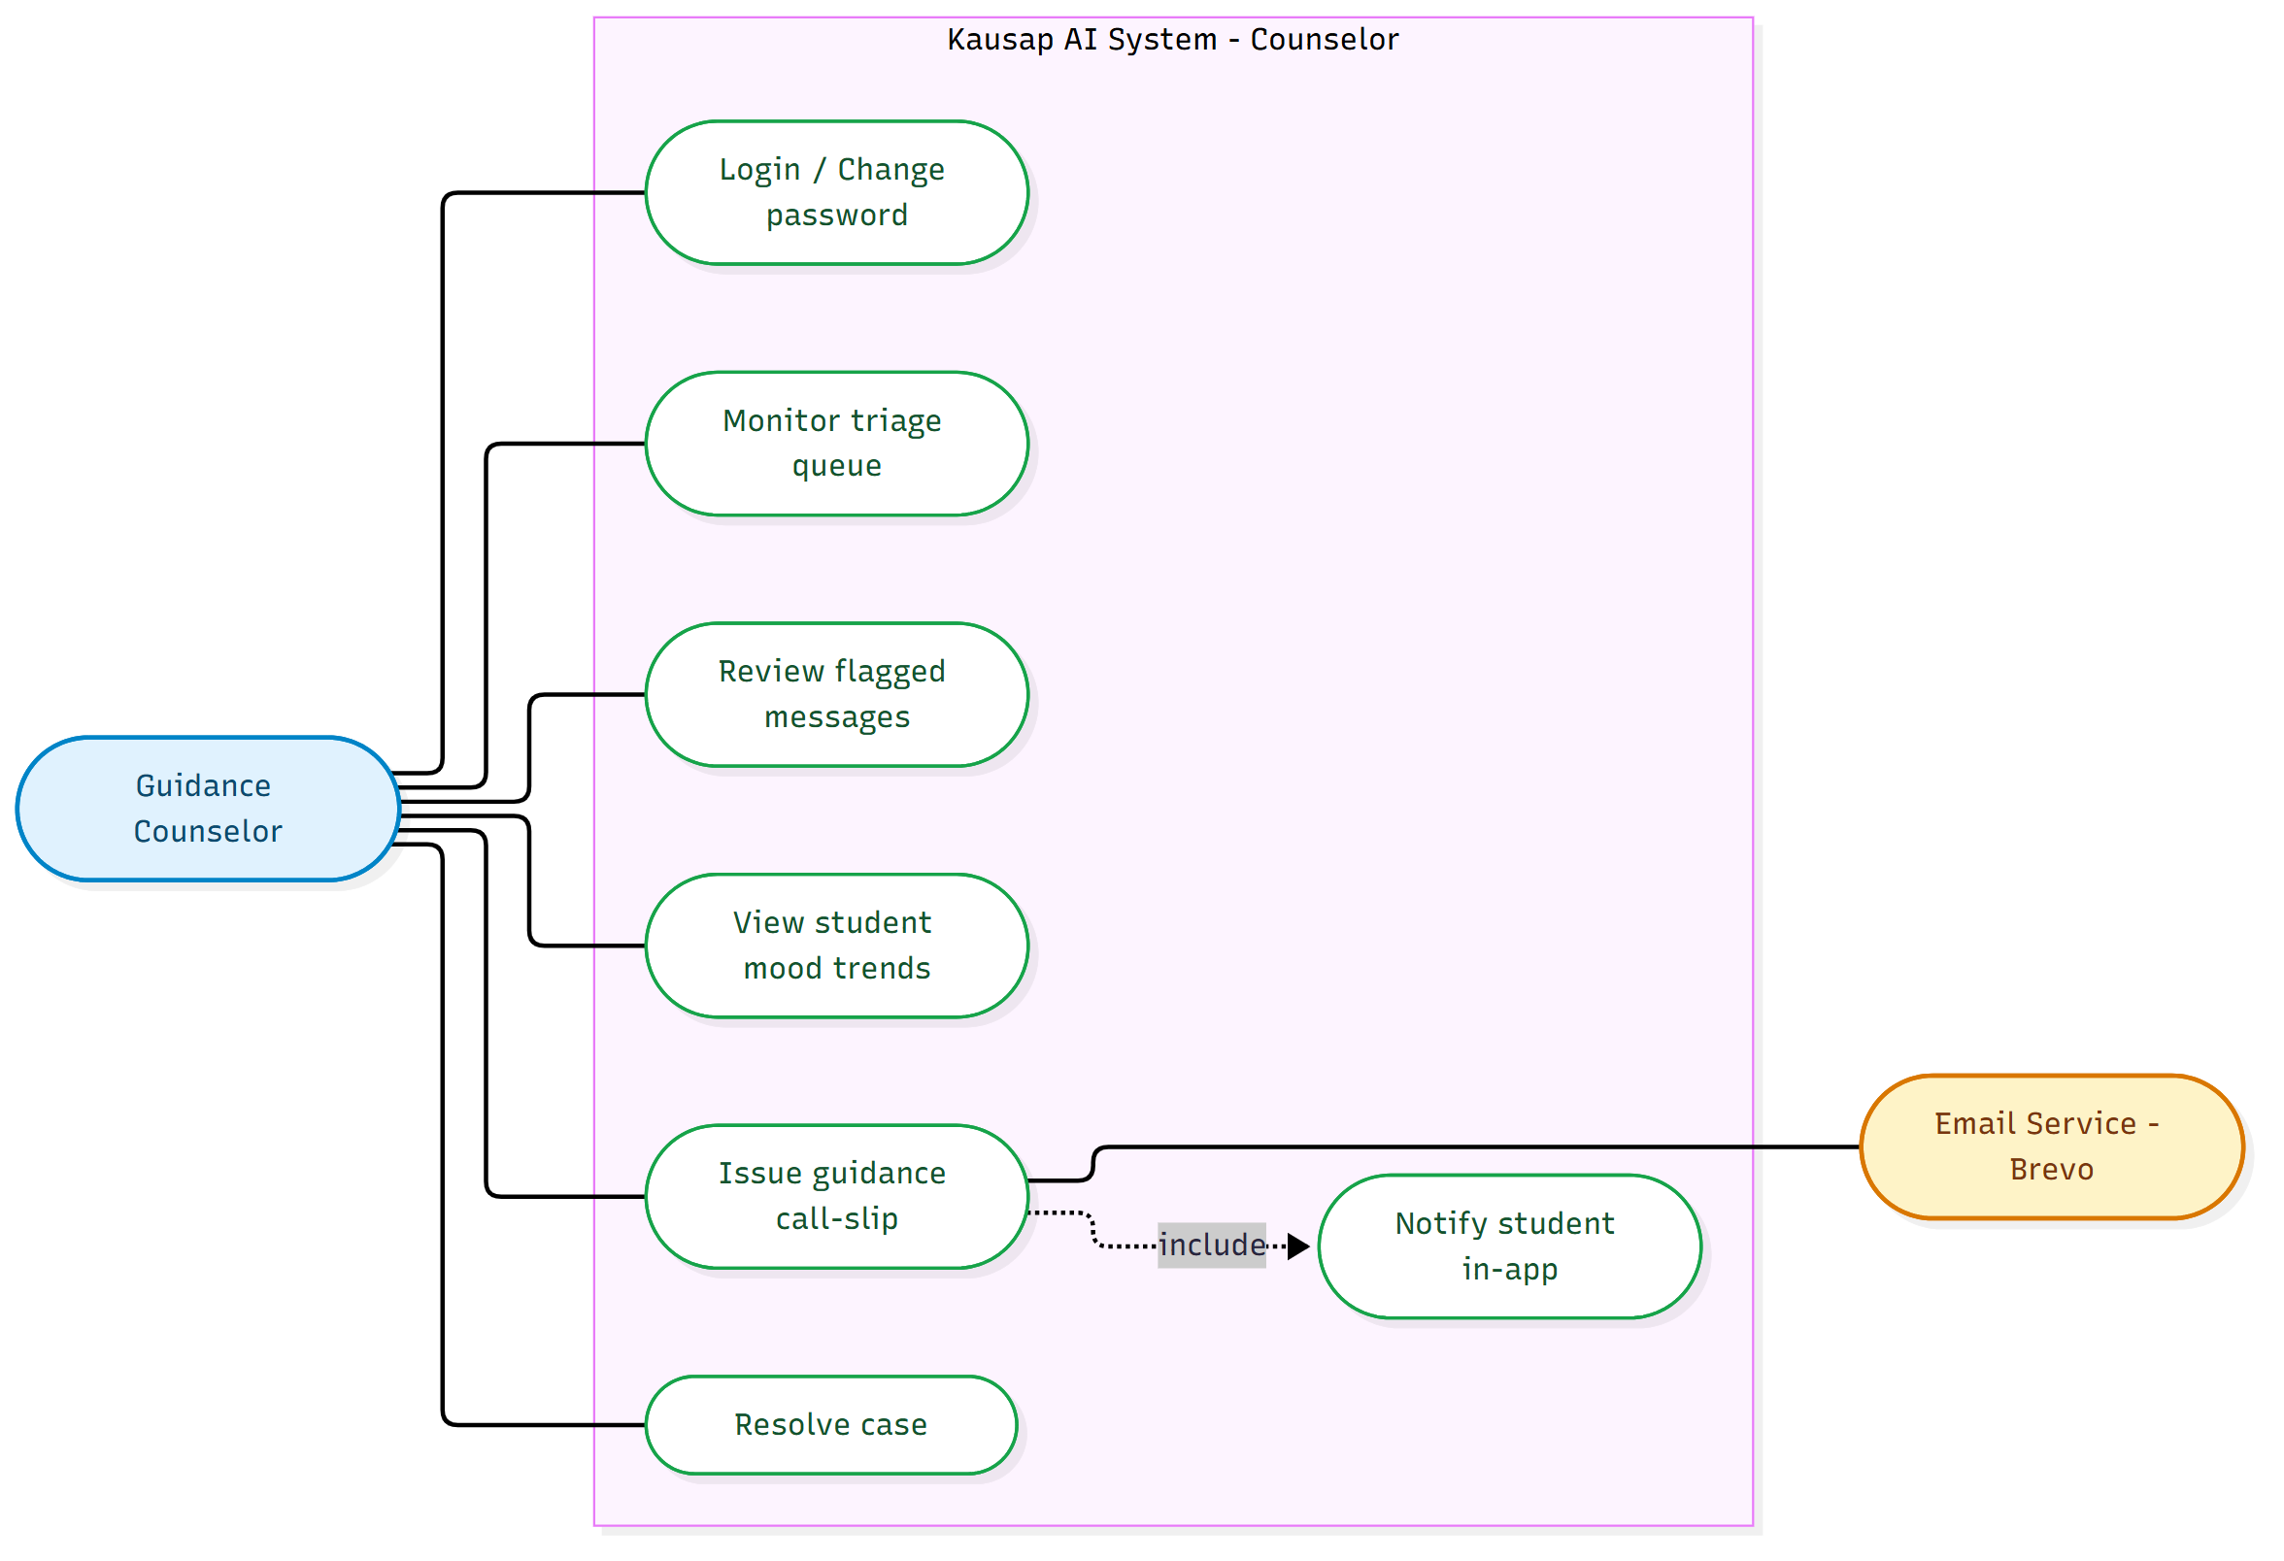
Figure 7. Use Case Diagram — Guidance Counselor

4.3 System Administrator
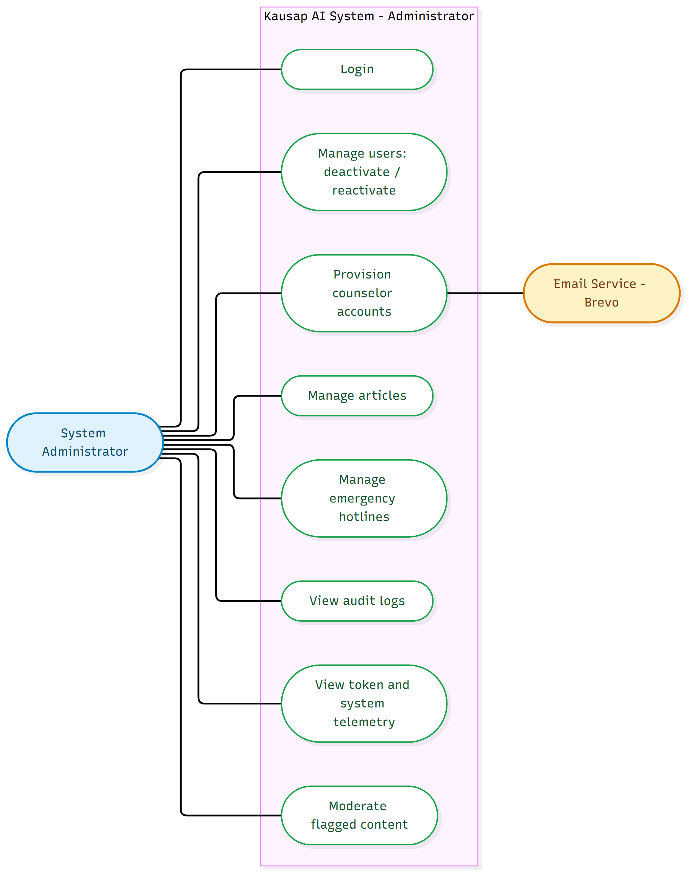
Figure 8. Use Case Diagram — System Administrator

5. Entity Relationship Diagram
Database: Neon Serverless PostgreSQL, modeled with SQLModel/SQLAlchemy.
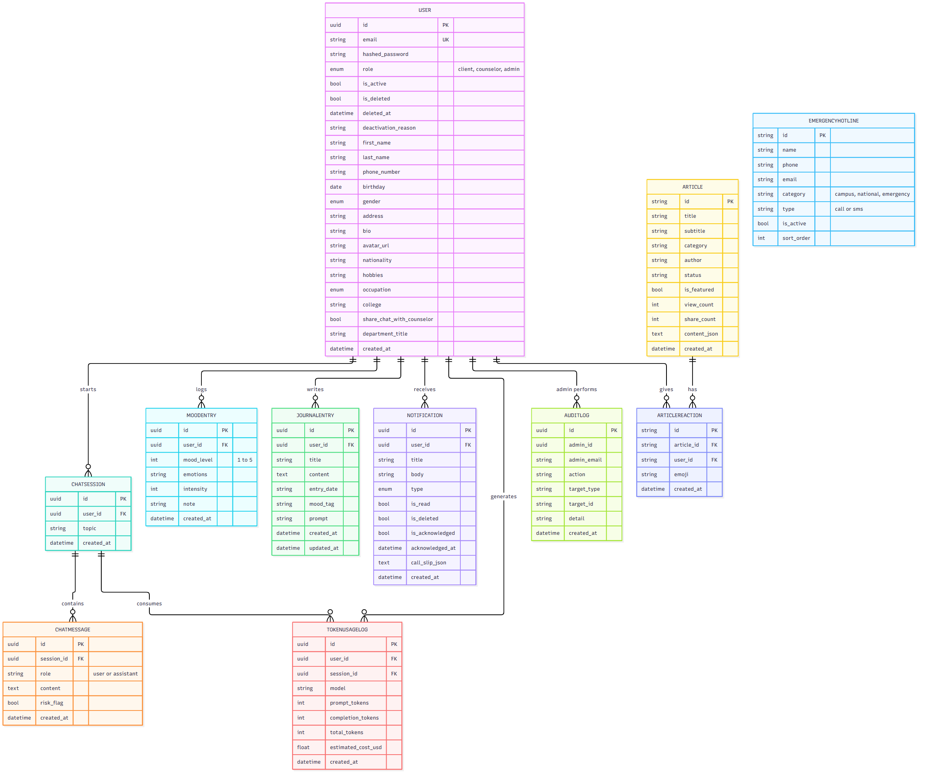
Figure 9. Entity Relationship Diagram

