1.Home
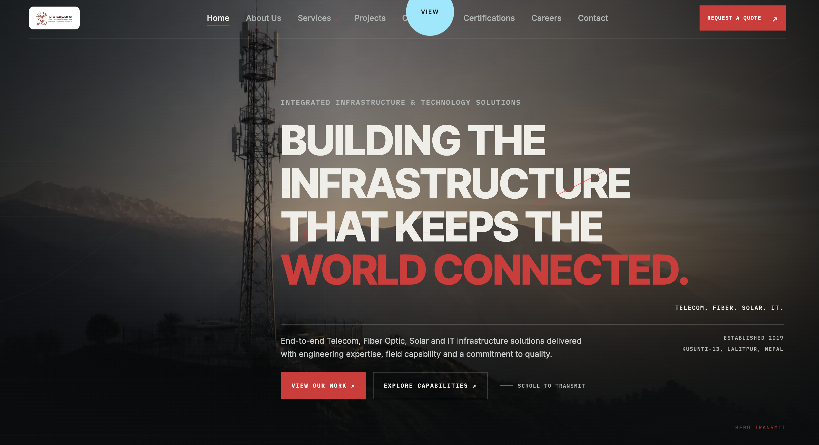

My recommedition
- Keep Normal cursher/pointer
- 1.Page backgorund -> white or light color.
- 1.BUILDING THE INFRASTRUCTURE THAT KEEPS NEPAL CONNECTED.
  - VIEW OUR WORK → EXPLORE OUR SERVICES →
- Logo should be slightly bigger
- Detele this: SCROLL TO TRANSMIT
- Delete unneccessary footer
- Keep adress limited to Lalitpur, Nepal.
- Delete Certifications Tab.

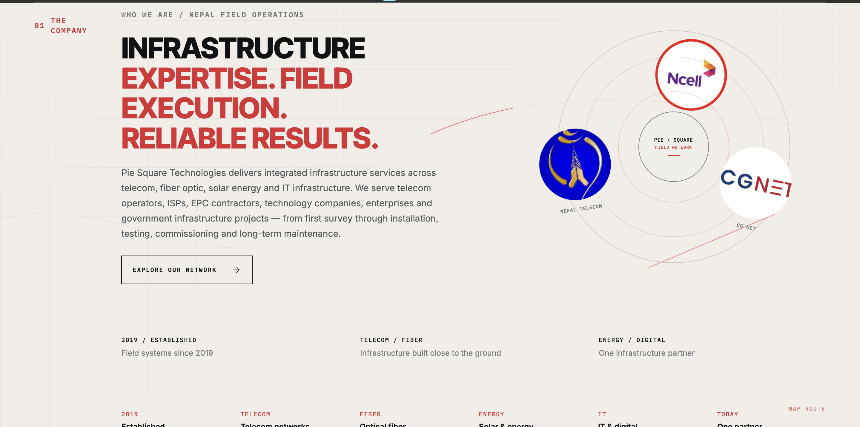

- Remove marked arrow “The company”, instead just keep WHO WE ARE and make its font bigger.

Who We Are
Pie Square Technologies delivers integrated infrastructure solutions across telecom, fiber optics, solar & renewable energy and IT. With experienced technical teams, specialized equipment, and a field-focused approach, We work with telecom operators, ISPs, EPC contractors, technology companies, enterprises and government agencies -supporting infrastructure projects from survey, installation testing, commissioning and long-term maintenance. Our focus is simple: quality execution, safe operations, timely delivery, and dependable long-term service.
- Change EXPLORE OUR NETWORK to “Learn more about us” link this to About us page.
- Remove CGNET, Nepal Telecom & Ncell logos from the orbit.

-Center: PIE SQUARE – FIELD DELIVERY NETWORK

-Around it: TELECOM | FIBER | SOLAR & ELECTRICAL | IT

-Bottom: ENGINEERING • DEPLOYMENT • COMMISSIONING • O&M

2019 / ESTABLISHED | TELECOM / FIBER | SOLAR / IT
Engineering solutions since 2019 | Built for reliable connectivity | One integrated infrastructure partner
4. 2019- Established, TELECOM - Telecom Infrastructure, Energy -Solar & Electrical, IT- IT & Digital, TODAY- One Integrated Partner

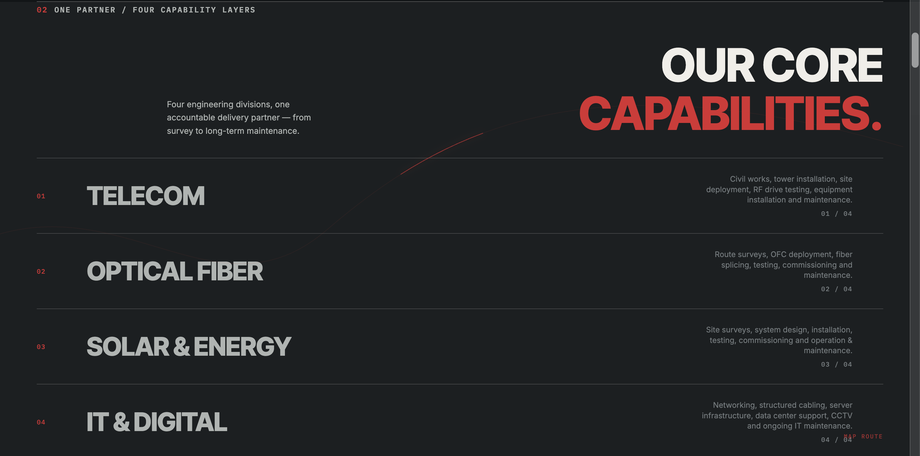

- Keep background lighter and inline with top page.
- Change “one partner/ four capability” section to WHAT WE DELIVER, make it same size as “Who we are” from above.
- Delete marked area.
- Keep the divisions like this in 2*2 and keep the same content, make it as semi-transparent as it is, keep the same link name, add some parts in each as mentioned below.
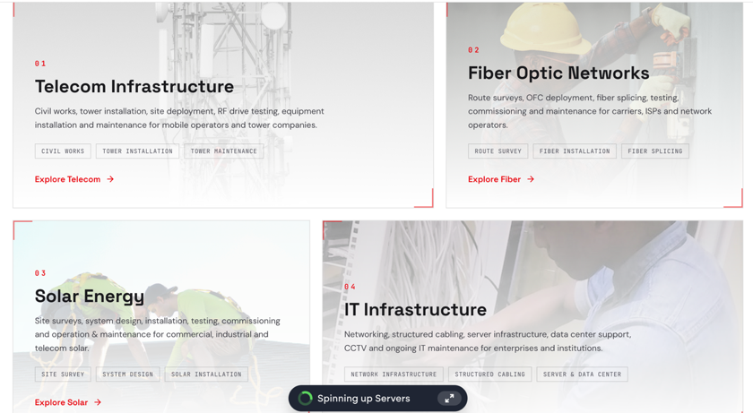

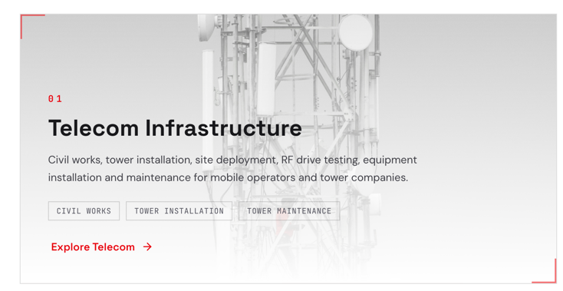

01: add one box “RF Testing” before tower maintenance.
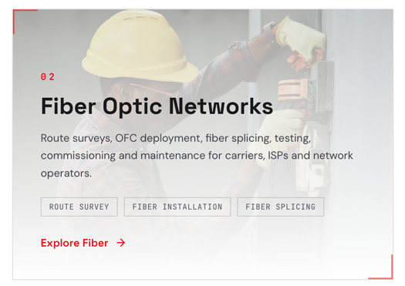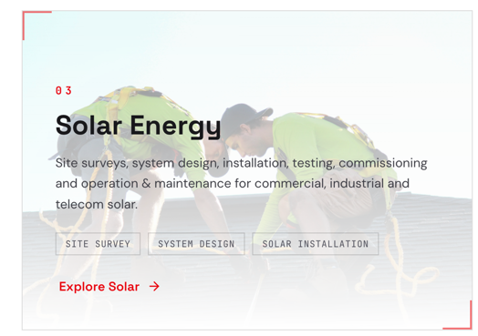
02: add one box in last “Operation and maintenance”. 03: Change heading to “Solar and Electrical” and add two boxes of “Electrical Installation” / “O & M”

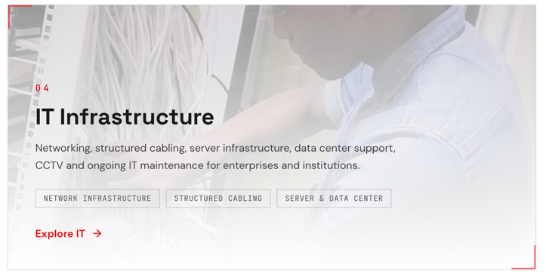

04: make following changes.
      - Change heading to “IT Solutions”
      - Change the marked area language to “Delivering reliable IT consulting, network and cloud infrastructure, CCTV and security systems, and customized software and web solutions to support secure, efficient, and connected business operations.”
      - Change boxes to: “IT Consulting & Infrastructure”, “Networking & Cloud”, “ CCTV & Security” “Software & Web Solutions”.

Add new heading : How We Deliver:
- Make it stylish, below pics are for reference:

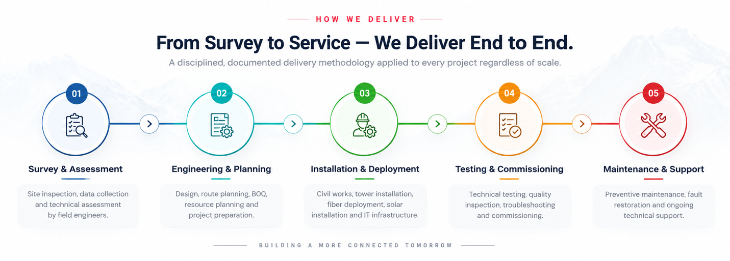

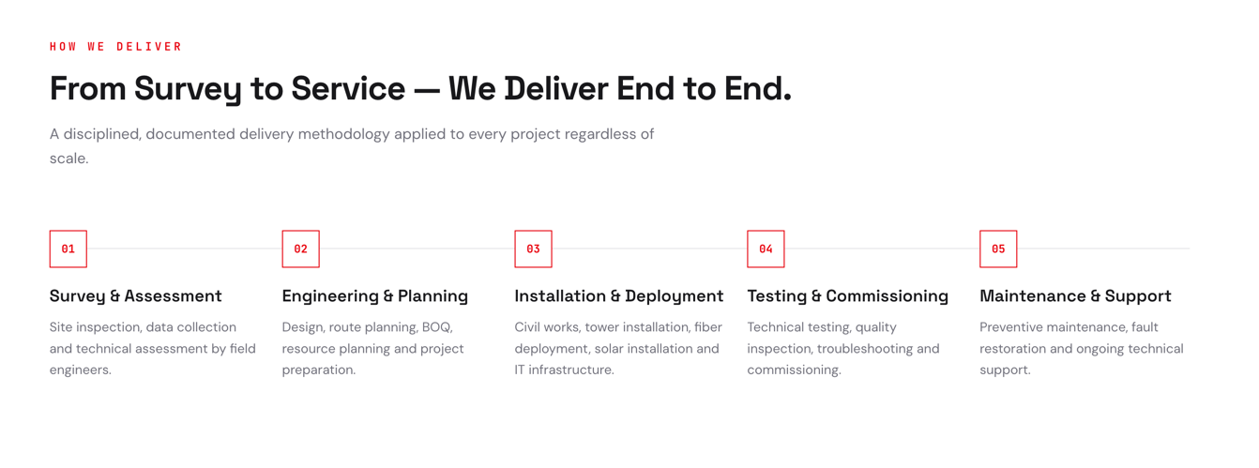

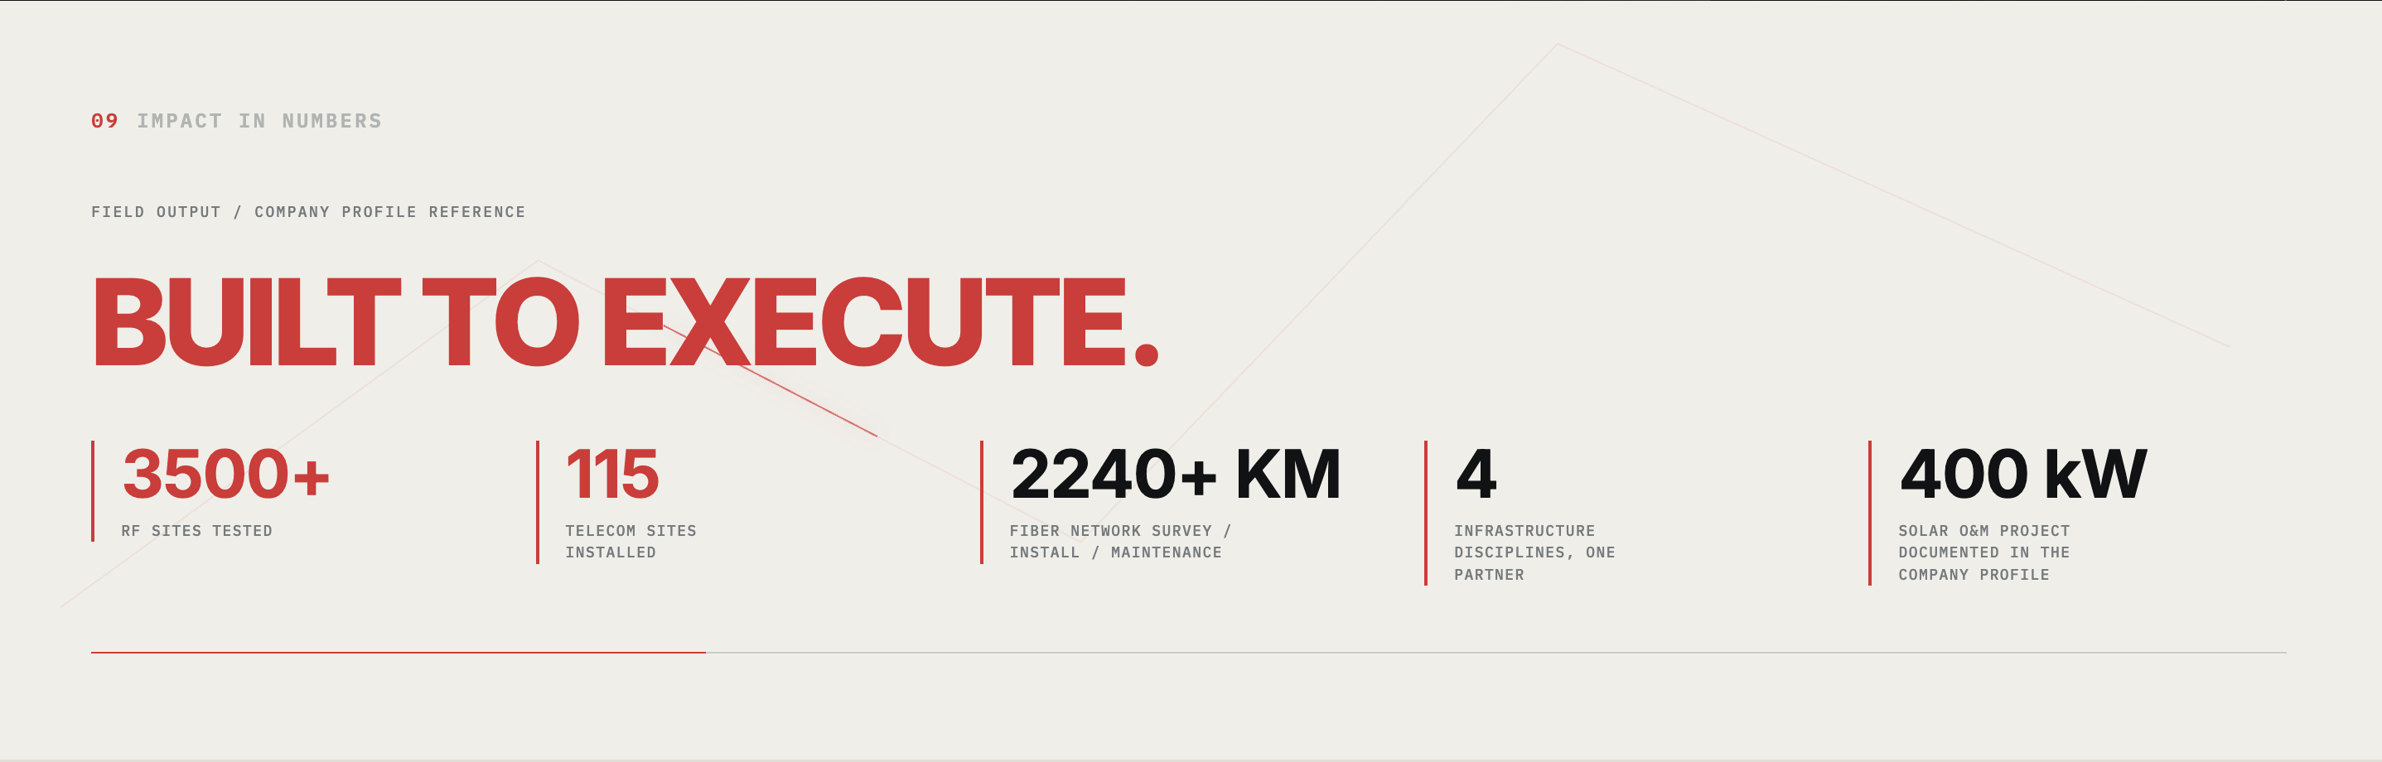

- Delete marked area.
- Keep topic “BUILT TO EXECUTE/ PROVEN IN THE FIELD”
- Put experience as -
3500+
RF SITES TESTED
SSV & Cluster Drive Testing

115
Telecome Sites Installed
Equipment Installation & Commissioning
4
NEW TELECOM TOWER SITES
Foundation • Erection • Power • Grounding • Fencing
2,240+ KM
FIBER NETWORK DELIVERY
Installation • Survey • Managed Service & LMC
400 kW
Solar O&M Capability
Annual Maintenance & Operations

Add Project Portfolio here
- Take the below pic as sample,
  - Need projects summary displayed as grids with mention of ongoing or completed.
  - Need “View all Projects” link.
  - Each project should be clickable that shows a small summary like in pic 2.
- Show these 6 projects here:
1.Telecom: STATUS: Completed
    - RF Drive Test & Network Optimization
    - Single-Site Verification & RF Optimization. [ 1,214 Sites]
    - 📍 Nepal — Terai · Mid-Hill · High-Hill · Kathmandu
    - 17 November 2019 – 20 May 2024
    - SSV · Drive Test · KPI Analysis · Site Audit · Physical RF Optimization
    - View Project →
2. Telecom: STATUS: Completed
- Cluster Drive Test & Optimization
- Cluster-Level RF Performance Testing & Optimization [62 Clusters,1,659 Sites]
- 📍 Nepal- 7 Provinces.
- 17 November 2019 – 01 August 2024
- Cluster Drive Test · KPI Analysis · Physical Verification · RF Optimization
- View Project →
3.Telecom: STATUS: Completed
    - RF Drive Test & Network Optimization
    - SSV Drive Testing & Network Verification – Ncell [381 Sites · GSM · UMTS · LTE]
    - 📍 Madhesh Province · Koshi Province · Lumbini Province
    - SSV Drive Test · Network Verification · KPI Analysis · Site Validation
    - View Project →

- FIBER: STATUS: Ongoing
      - Fiber Network Operations & Maintenance
      - Managed Fiber Network Delivery & Field Operations [1,166.731 km · 16 POPs]
      - 📍 Biratnagar · Itahari · Duhabi · Dharan · Lahan
      - April 2024 – Present
      - Network Maintenance · End user Support · Customer Connectivity · POP Support
      - View Project →
- FIBER: STATUS: Completed
- Fiber Network Deployment & ODN Implementation
- End-to-End Fiber Network Deployment [218 KM]
- 📍 Kathmandu Valley
- November 2021 – June 2023
- Fiber Deployment · ODN Installation · Splicing · Testing · Commissioning
- View Project →
- Solar and Electrical: STATUS: Ongoing
- Solar PV Operation & Maintenance
- 400 kWp Ground-Mount Solar Power Plant
- 📍 Simar, Bara, Nepal
- October 2025 – Present
- Solar PV O&M · Electrical Maintenance · Performance Monitoring · Fault Response
- View Project →

SAMPLE FORMAT IS BELOW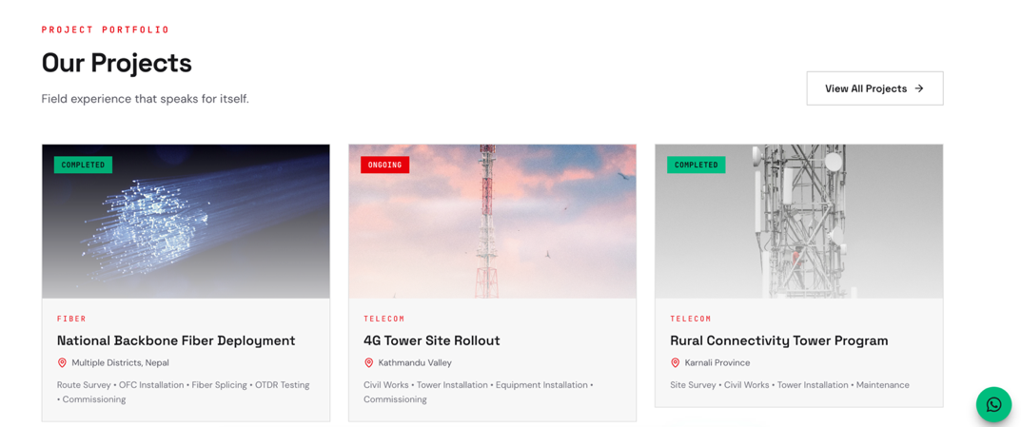

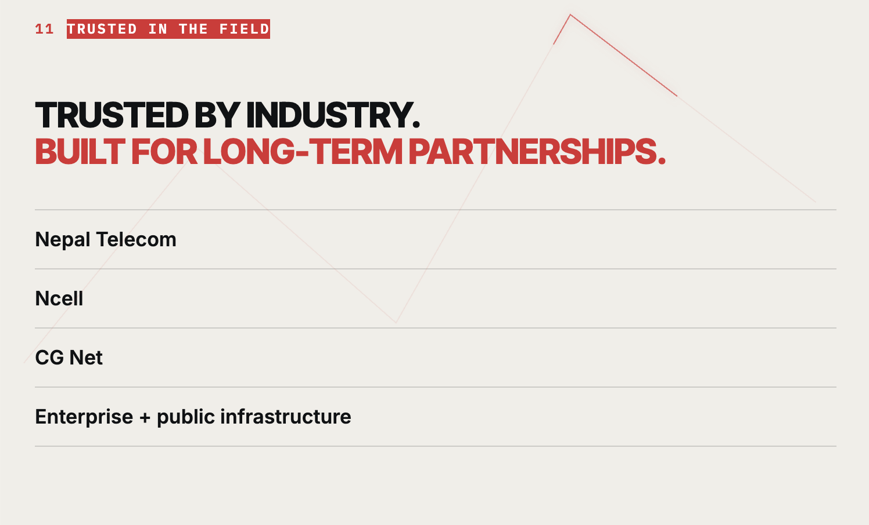
- Delete the marked field
- Change topic to: TRUSTED BY INDUSTRY
BUILT ON EXPERIENCE. TRUSTED FOR DELIVERY.

- Keep the following logos: [ Nepal Telecom logo ] [ Ncell logo ] [ CGNET logo ]
[ Surya Nepal logo ] [ ZTE logo ] [ CCS Nepal logo ] (we will provide logo)
2.Add a supporting line below logos – “Delivering reliable infrastructure and technology solutions across Nepal through trusted partnerships and proven field execution.”

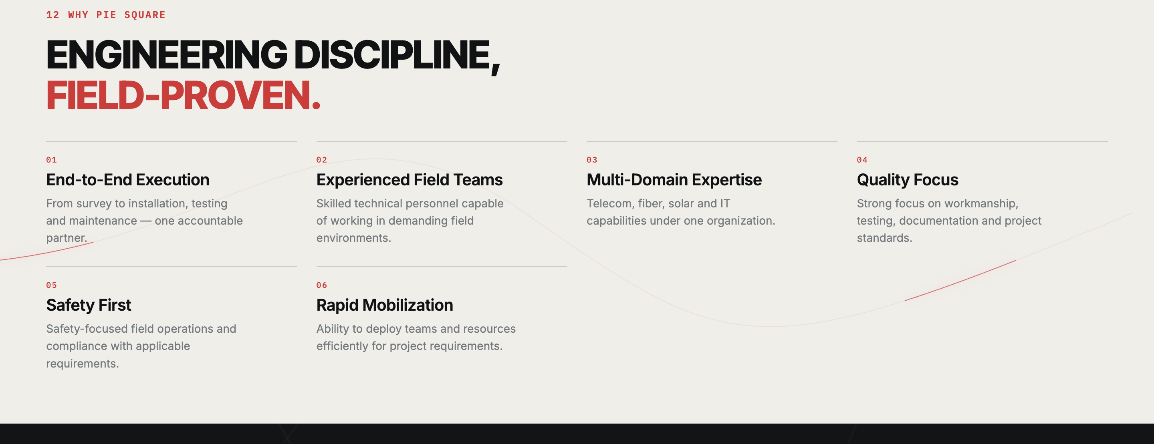

- 01: Put Multi-domain expertise part in number 1.
- 02: Expert Workforce: Highly experienced professionals with strong expertise spanning field operations, technical execution, project management, and leadership.
- 03: End-TO-End Execution: From survey, engineering and procurement to installation, testing, commissioning and O&M.
- 04: NATIONWIDE REACH-The people, resources and operational capability to deliver projects across Nepal.
- 05: QUALITY & SAFETY: Strong emphasis on workmanship, testing, documentation, safety and compliance with project requirements.
- 06: BUILT FOR PARTNERSHIPS: Responsive coordination, dependable support and a long-term approach to every client relationship.

- Add the next heading to download company profile

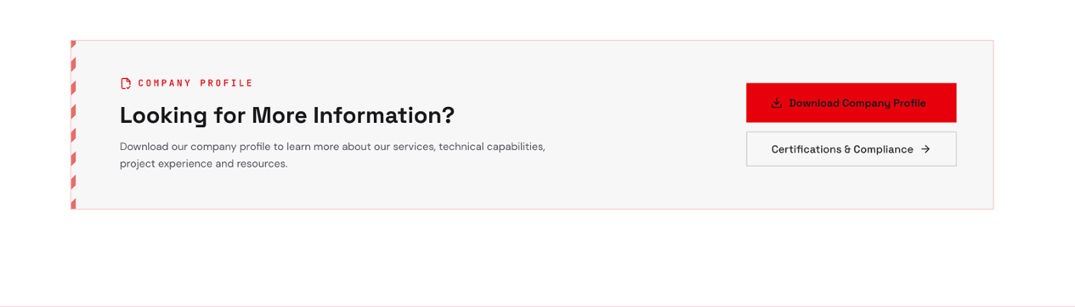

Last Page:
- Make name, number and email mandotoray and rest optional.
- Make call and whatspp link of our company float throughout the whole page in every section.

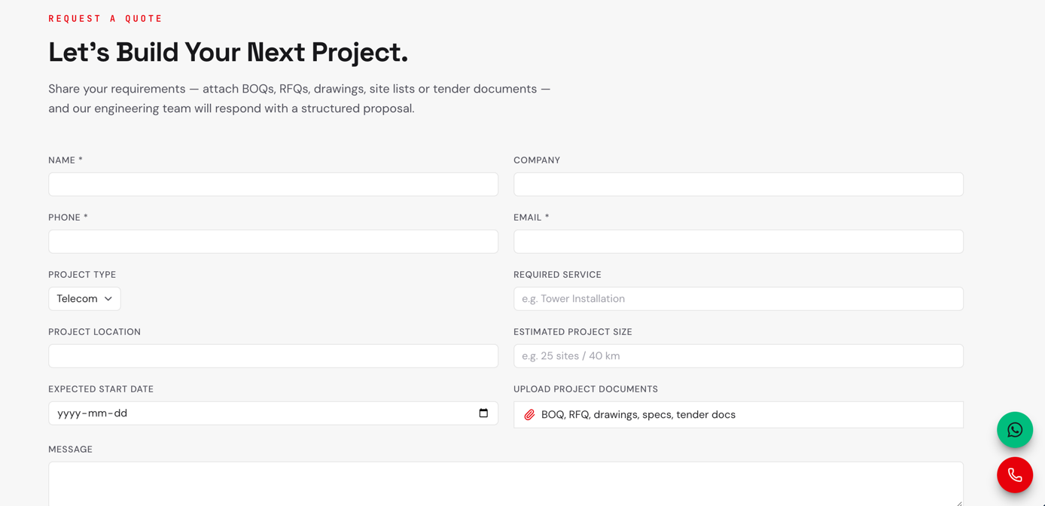
- Make this part available as footer in every header pages.
- Fb link: https://www.facebook.com/share/14rqRmyzjqT/?mibextid=wwXIfr
- Whatspp: +977 9715000715
- Call: +977 9715000715, mail address: info@piesquaretechnologies.com
