SERVICES
1. Rename 4 parts as- (after clicking it can show detail as you mentoned )
- TELECOM
- FIBER
- SOLAR & ELECTRICAL
- IT

Better show like this as attached below-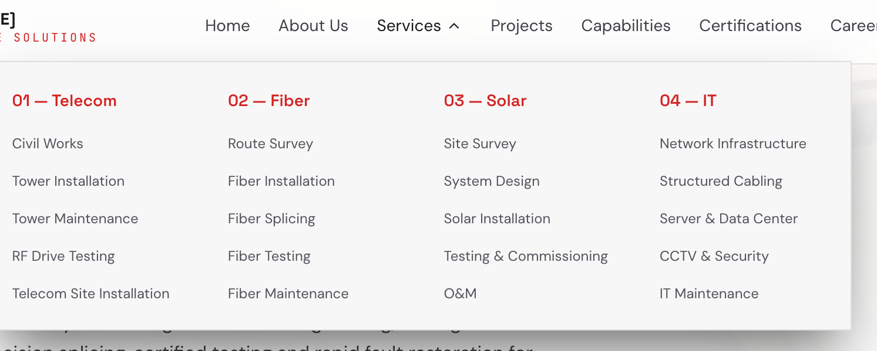

2.
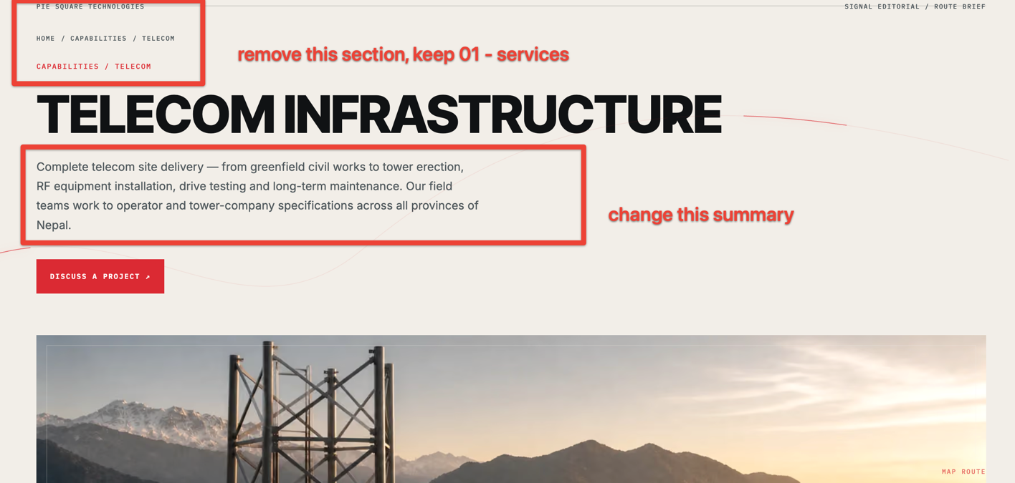Telecom Infrastructure
Complete Telecom site delivery--- covering civil works, tower installation, equipment deployment, RF drive testing, site integration, maintenance, and field support, delivered with a strong focus on safety, quality, and timely project execution across all provinces of Nepal.

- Make change as marked in below picture. Other same.
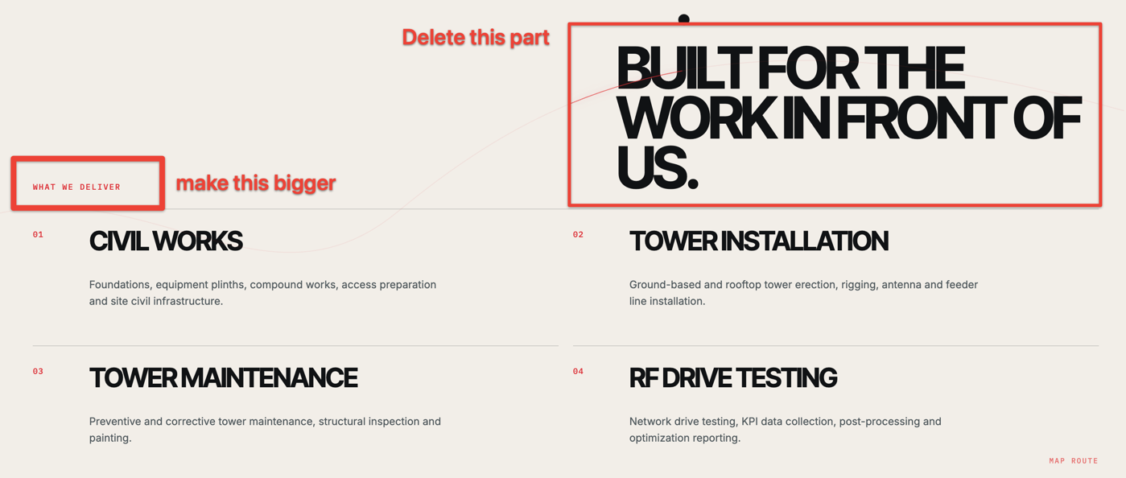

- For related project take from Project Part document.
Fiber Optics part
1.
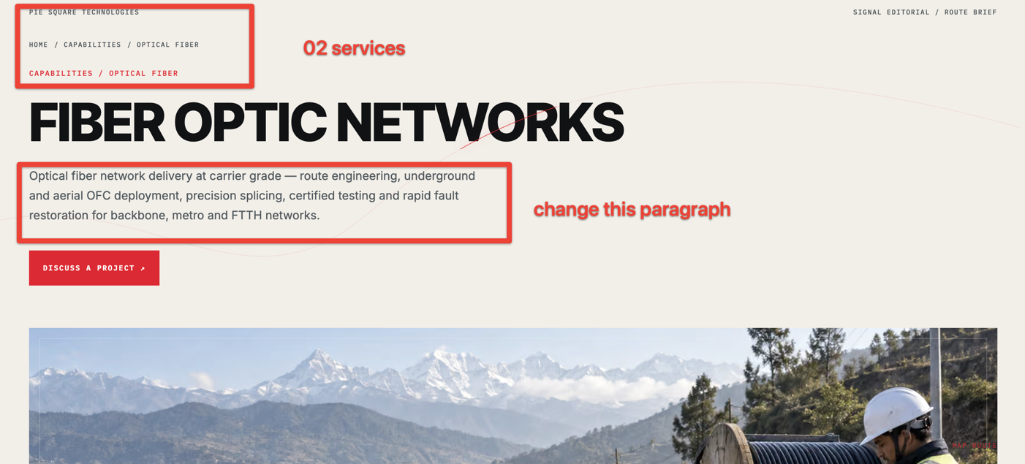
Building reliable connectivity from the ground up—from route surveying and network planning to fiber deployment, precision splicing, testing, fault restoration and maintenance, ensuring robust and high-performance optical networks.

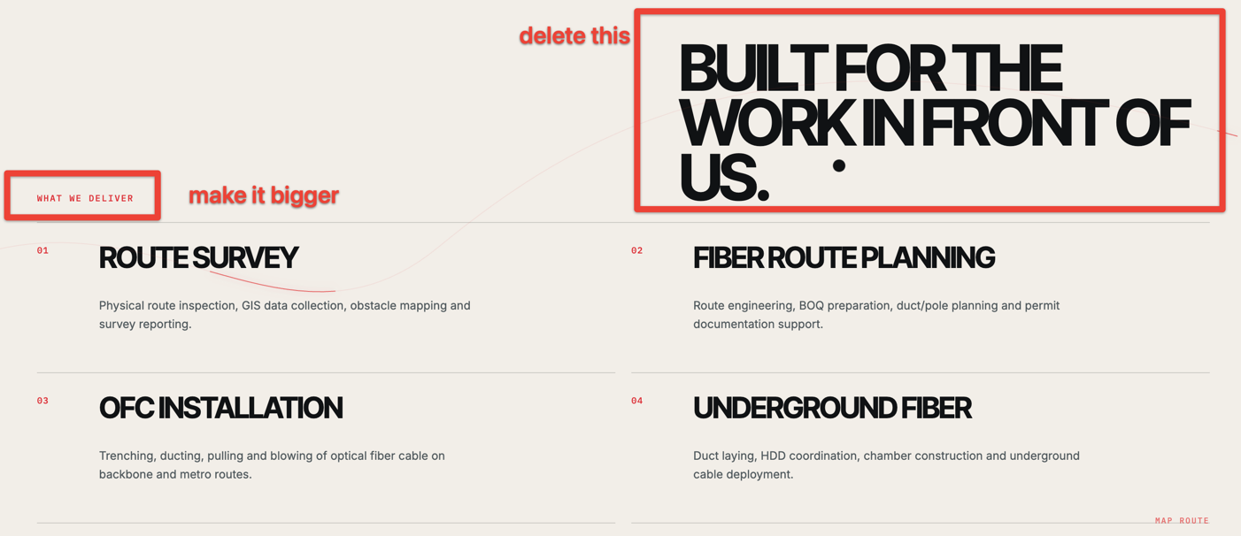

2.Make 10 points to 12 as mentiond below
01 — ROUTE SURVEY
Physical route inspection, GIS data collection, obstacle mapping and survey reporting.
02 — FIBER ROUTE PLANNING
Route engineering, BOQ preparation, duct/pole planning and permit documentation support.

03 — OFC INSTALLATION
Trenching, ducting, pulling and blowing of optical fiber cable on backbone and metro routes.

04 — UNDERGROUND FIBER
Duct laying, HDD coordination, chamber construction and underground cable deployment.

05 — AERIAL FIBER
Pole-line cable installation, lashing, ADSS deployment and pole treatment.

06 — FIBER SPLICING
Precision fusion splicing for backbone, distribution and access networks.

07 — ODF & DISTRIBUTION INSTALLATION
ODF, FDH, FDB and splitter installation, termination, dressing and labeling.

08 — FTTH & DROP FIBER
FTTH deployment, drop-cable installation, customer connections and network extensions.

09 — OTDR & LINK TESTING
Bi-directional OTDR testing, power measurement, loss-budget verification and trace analysis.

10 — FAULT LOCALIZATION
Rapid fault localization using OTDR and visible fault locators with precise dig-point reporting.

11 — TESTING & ACCEPTANCE
End-to-end fiber testing, documentation, as-built records and network acceptance.

12 — MAINTENANCE & RESTORATION
Preventive maintenance, fault response, fiber repair, restoration and service recovery.

3.Few changes in this LIFECYCLE heading.
Route Survey
Fiber Deployment
Splicing & Termination
OTDR Testing
Customer Connection

TECHNICAL SCOPE
Backbone & Access Fiber
Splicing & Termination
OTDR & Link Testing
POP & Network Integration
Fault Localization & Restoration

- for project take from project part

Solar & Electrical Part
- Change heading from solar energy to Solar & Electrical
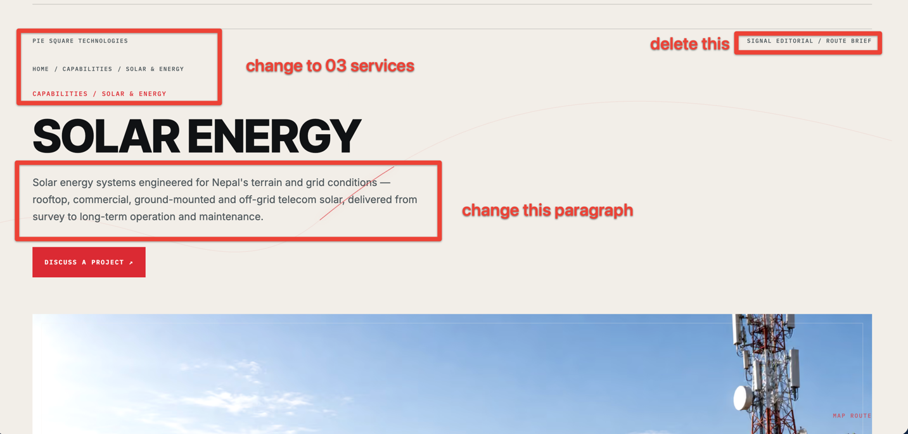

SOLAR & ELECTRICAL-
Solar and Electrical systems engineered for Nepal's terrain and grid conditions-- rooftop, commercial, ground-mounted and off-grid systems covering site assessment, system design, installation, power integration, testing, commissioning, long term operation & maintenance.

2.

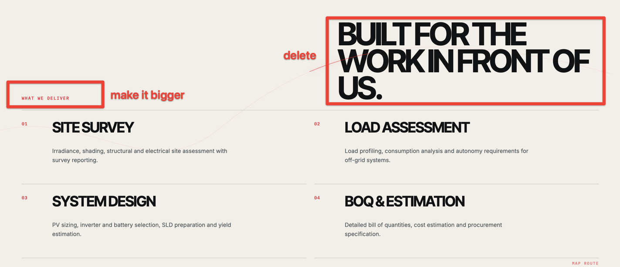

WHAT WE DELIVER
01 — SOLAR SITE SURVEY & LOAD ASSESSMENT
Solar potential, shading, structural conditions, electrical loads and site requirements.
02 — SOLAR SYSTEM DESIGN
PV sizing, inverter and battery selection, SLD preparation, system design and yield estimation.
03 — SOLAR BOQ & ESTIMATION
Detailed BOQ, cost estimation, equipment specifications and procurement support.
04 — ROOFTOP SOLAR
Residential, commercial and industrial rooftop PV systems with structural mounting and grid integration.
05 — GROUND-MOUNTED SOLAR
Ground-mounted PV plants including civil foundations, structures, array installation and electrical integration.
06 — SOLAR INSTALLATION & COMMISSIONING
Module installation, DC/AC cabling, inverter installation, testing, grid synchronization and system handover.
07 — SOLAR MONITORING & O&M
Performance monitoring, cleaning, preventive maintenance, troubleshooting and fault response.
08 — TRANSFORMER INSTALLATION
Transformer installation, cabling, protection, earthing, testing and commissioning.
09 — ELECTRICAL DISTRIBUTION
Electrical poles, distribution lines, cabling, panels, DB/MDB and associated infrastructure.
10 — TRANSMISSION & DISTRIBUTION EXPANSION
Pole erection, line extension, network expansion and associated electrical infrastructure.

11 — ELECTRICAL EQUIPMENT INSTALLATION
Switchgear, protection systems, meters, batteries and other electrical equipment.
12 — TESTING, COMMISSIONING & MAINTENANCE
Electrical testing, system energization, commissioning, preventive maintenance and fault restoration.

LIFECYCLE
Site & Load Assessment
System Design & BOQ
Installation
Testing & Commissioning
Grid Integration
O&M

TECHNICAL SCOPE
Solar PV Systems
Rooftop & Ground-Mounted Solar
Battery & Hybrid Power Systems
Transformer Installation
Electrical Distribution & Pole Erection
Transmission & Distribution Expansion
Electrical Testing & Maintenance
-For project take from project section.
IT INFRASTRUCTURE
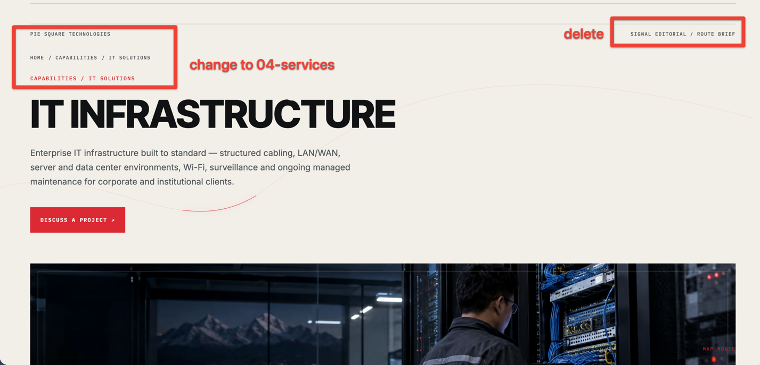

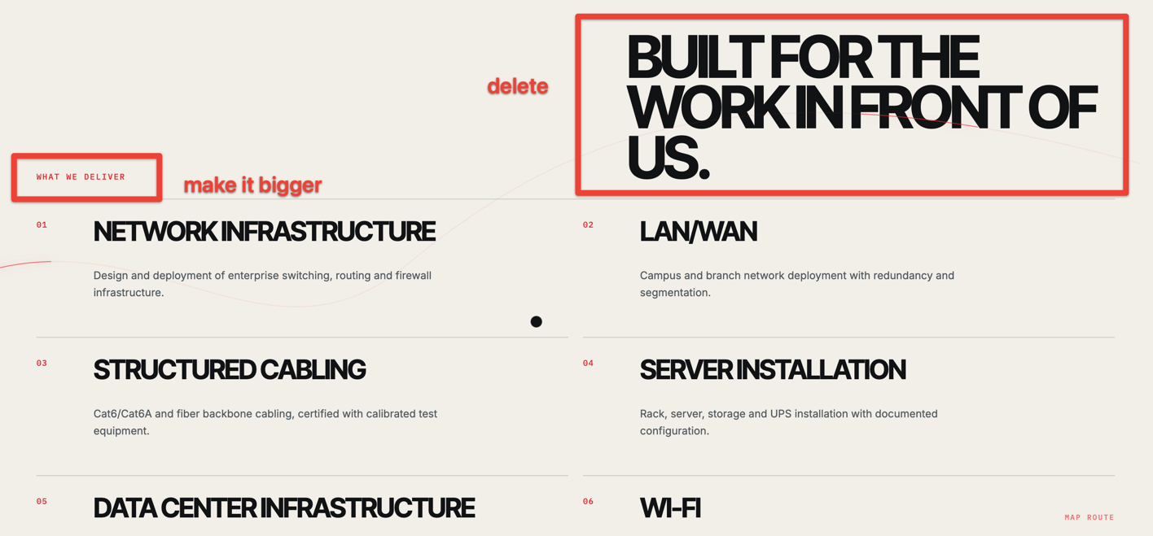

WHAT WE DELIVER
01 — Network Infrastructure
Design and deployment of switching, routing, firewall and network infrastructure.
02 — LAN/WAN
Campus, office and branch network deployment with structured connectivity and segmentation.
03 — Structured Cabling
Cat6/Cat6A and fiber backbone cabling, termination, labeling and testing.
04 — Server Installation
Server, rack, storage, UPS and related equipment installation and configuration.
05 — Data Center & Server Room Infrastructure
Racks, structured cabling, power, UPS and infrastructure coordination for server rooms and data environments.
06 — Wi-Fi Infrastructure
Enterprise and commercial Wi-Fi deployment, access point installation, configuration and coverage optimization.
07 — CCTV & Access Control
IP surveillance, NVR/VMS, access control and security system installation.
08 — IT Hardware & Systems
Supply, installation and configuration of computers, workstations, printers, peripherals and related IT equipment.
09 — Network Troubleshooting
Fault isolation, network diagnostics, performance analysis and technical resolution.
10 — IT Maintenance & Support
Preventive maintenance, system health checks, troubleshooting and ongoing technical support.

LIFECYCLE
Assessment
Design
Deployment
Configuration & Testing
Handover
Support

TECHNICAL SCOPE
IT Infrastructure & LAN/WAN
Structured Cabling & Fiber
Server & Data Center Infrastructure
Wi-Fi & Network Systems
CCTV & Access Control
IT Hardware & Technical Support

-for project take from project part

