TELCO CUSTOMER
CHURN ANALYSIS

End-to-End Case Study

IBM Telco Dataset · 7,043 Customers · 21 Features

1. Problem Framing

What is Churn?
Customer churn is the event where a subscriber voluntarily terminates their service contract with a telecommunications provider. In this dataset, churn is a binary outcome recorded at a point in time. This is a supervised binary classification problem: given historical service and billing attributes, predict whether a customer will churn.

Why Does Churn Matter?

26.5%  Overall churn rate  in this dataset | 5–7×  Cost multiplier  to acquire vs retain | ~$1 in $4  Revenue at risk  recurring revenue | 3–10×  Retention ROI  when targeted correctly

Reducing churn by even 5 percentage points can increase profitability by 25–95% (Harvard Business Review). Churn analysis is one of the highest-impact analytics use cases in any subscription business because it sits at the intersection of data science and revenue protection.

Analytical Approach
Step | Phase | Key output
1 | Data loading & cleaning | Clean, validated dataset
2 | EDA | Visual churn drivers
3 | Feature engineering | 8 derived features
4 | Modelling | 3 models benchmarked
5 | Evaluation | ROC-AUC, PR, calibration
6 | Postdictive analysis | Error analysis + SHAP
7 | Recommendations | Prioritised action plan

2. Data Loading & Cleaning

Dataset Overview
Attribute | Detail
Rows | 7,043 customers
Columns | 21 (20 features + 1 target)
Target | Churn (Yes / No)
Numeric features | tenure, MonthlyCharges, TotalCharges
Categorical features | 17 (gender, contract, internet service, etc.)
Missing values (raw) | 11 blank TotalCharges entries

Cleaning Decisions
- TotalCharges stored as a string object — converted to float64.
- 11 blank TotalCharges entries correspond to customers with tenure = 0 (brand-new accounts with no billing history). Filled with 0.0 — the correct business interpretation.
- No duplicate records found.
- Churn re-encoded as Churn_bin (0/1) for modelling.
- All 11 "missing" values resolved; final dataset is 100% complete.

3. Exploratory Data Analysis

Churn Overview
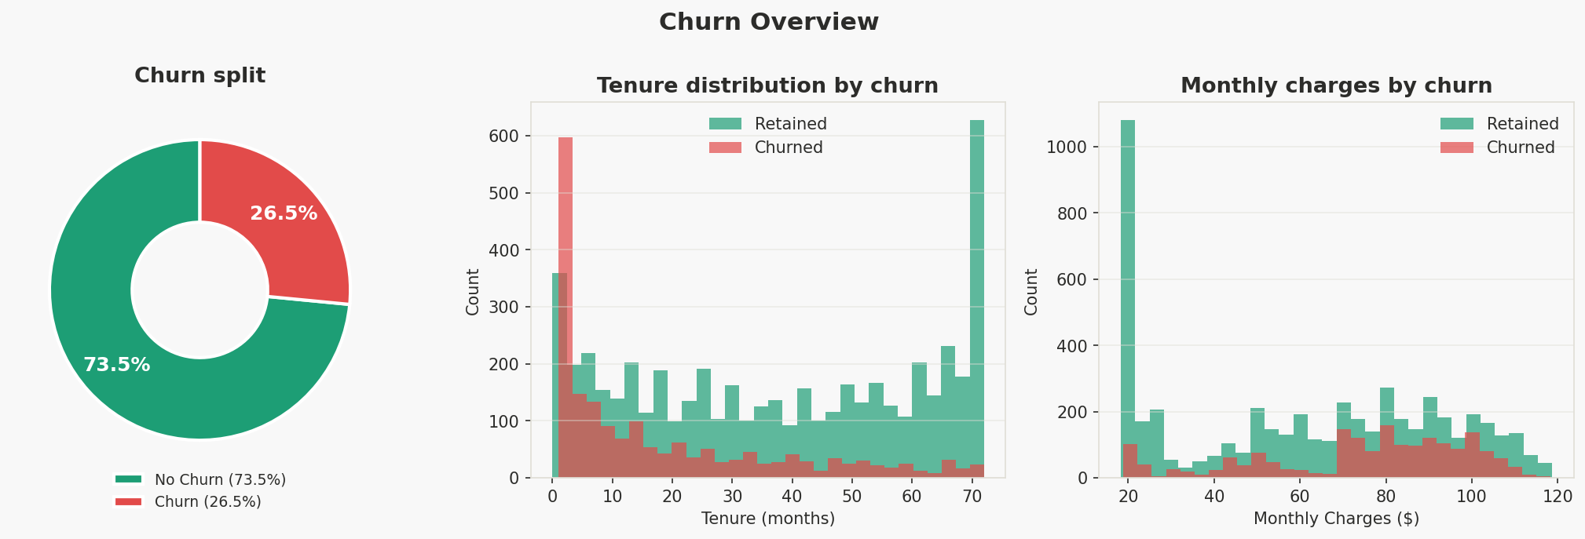
Figure 1 — Churn split, tenure distribution by churn status, and monthly charges by churn status
The dataset has a 26.5% churn rate — moderately imbalanced but manageable. Churned customers have significantly shorter tenures (peak in first 12 months) and pay more per month ($70–$100), suggesting newer, high-paying customers on potentially overpriced plans are most at risk.

Churn Rate by Categorical Feature
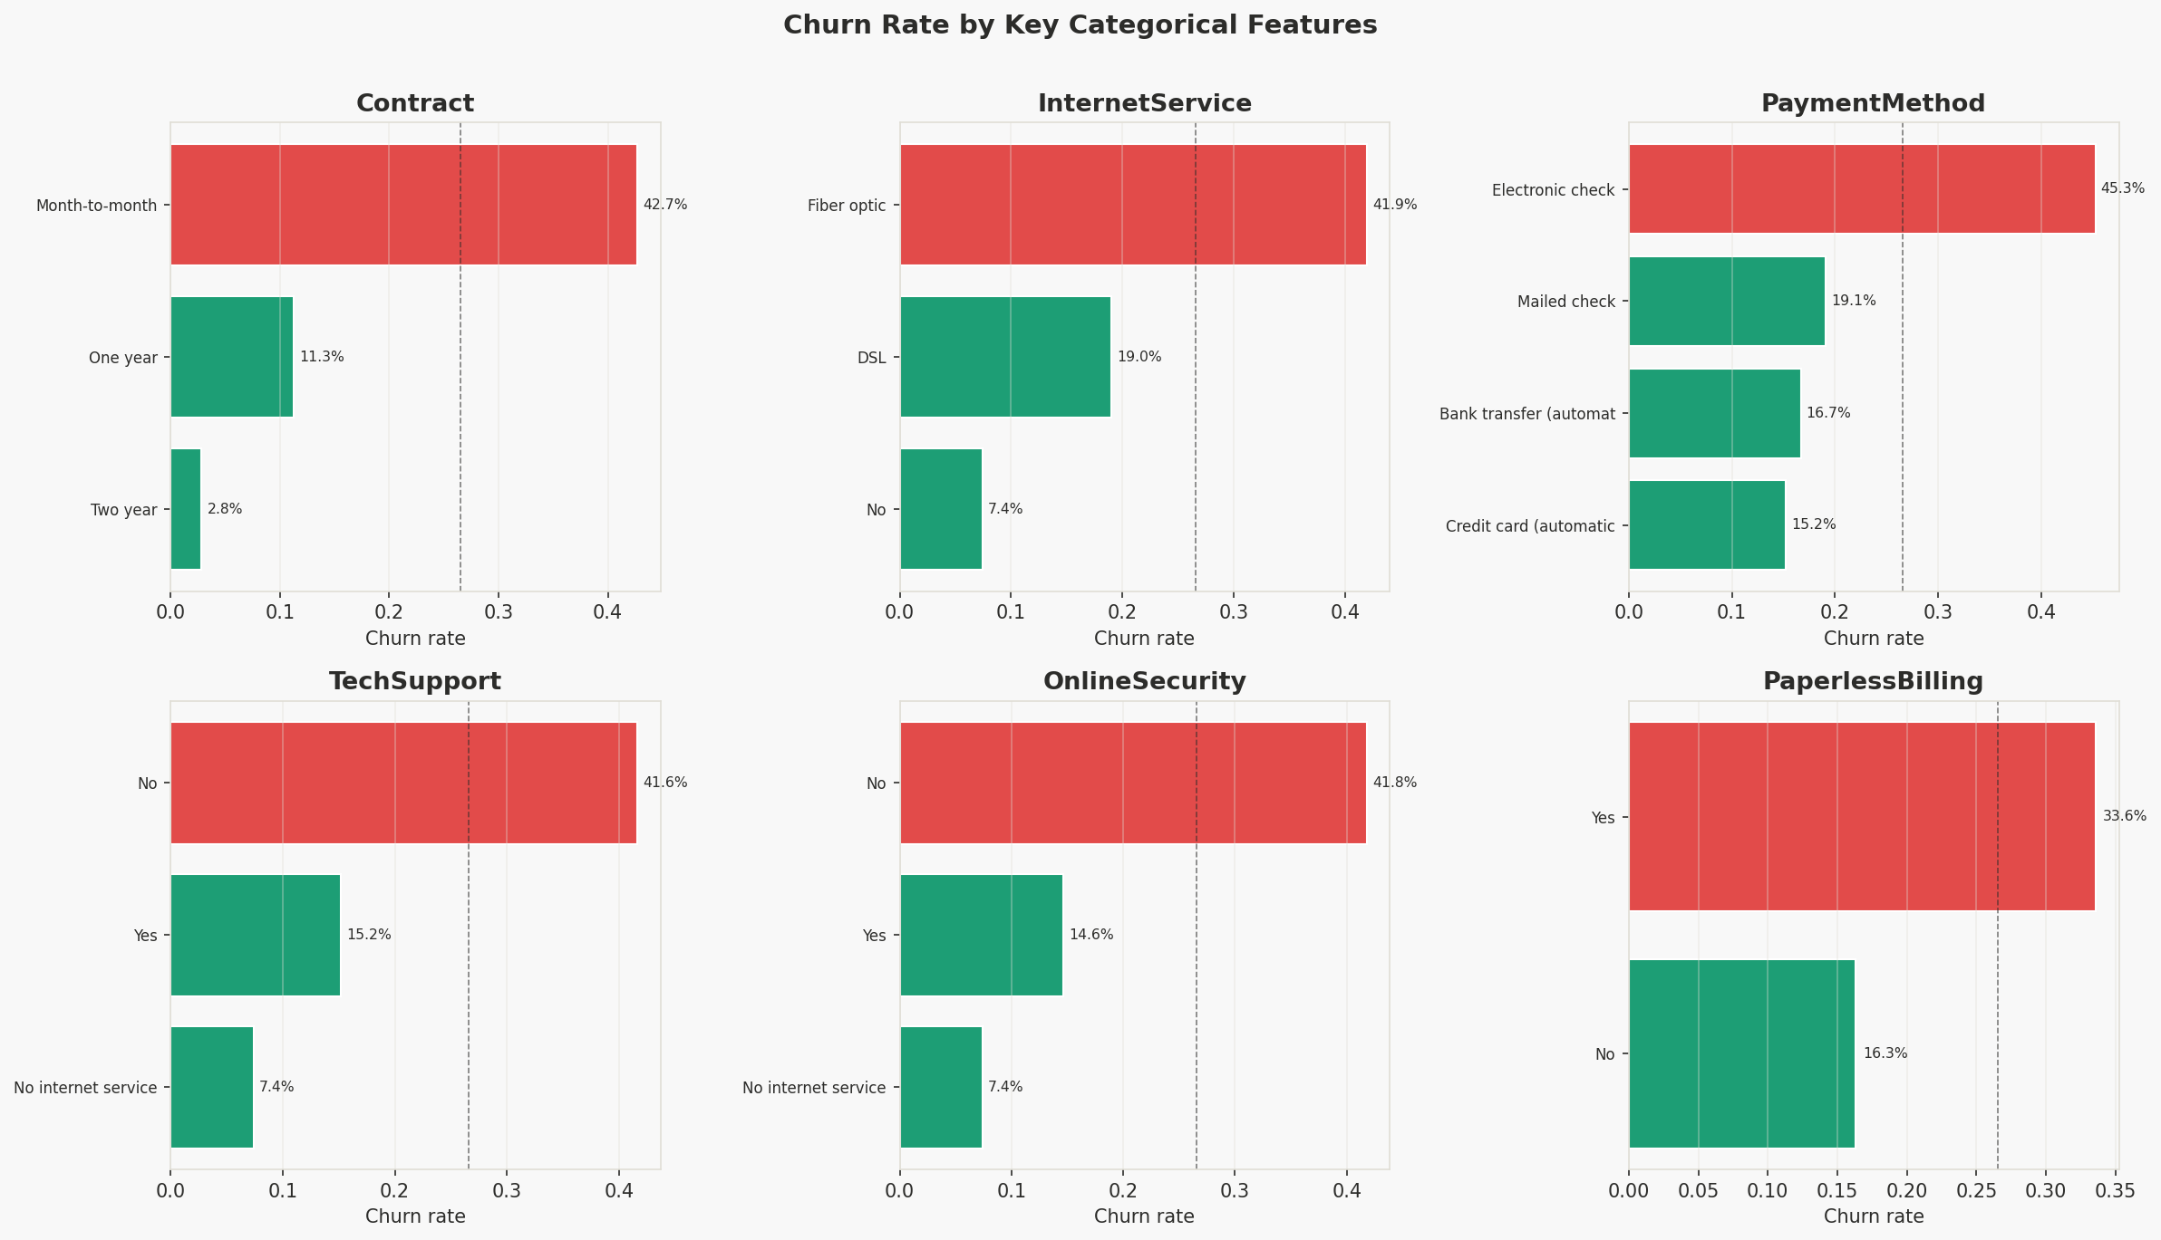
Figure 2 — Churn rate by key categorical features. Dashed line = overall 26.5% baseline.

Feature | High-risk group | Churn rate | vs Baseline
Contract | Month-to-month | 42.7% | +16.2 pp
Internet | Fiber optic | 41.9% | +15.4 pp
Payment method | Electronic check | 45.3% | +18.8 pp
Tech Support | No support | 41.6% | +15.1 pp
Online Security | No security | 41.8% | +15.3 pp
Paperless Billing | Yes | 33.6% | +7.1 pp

Tenure and Contract Analysis
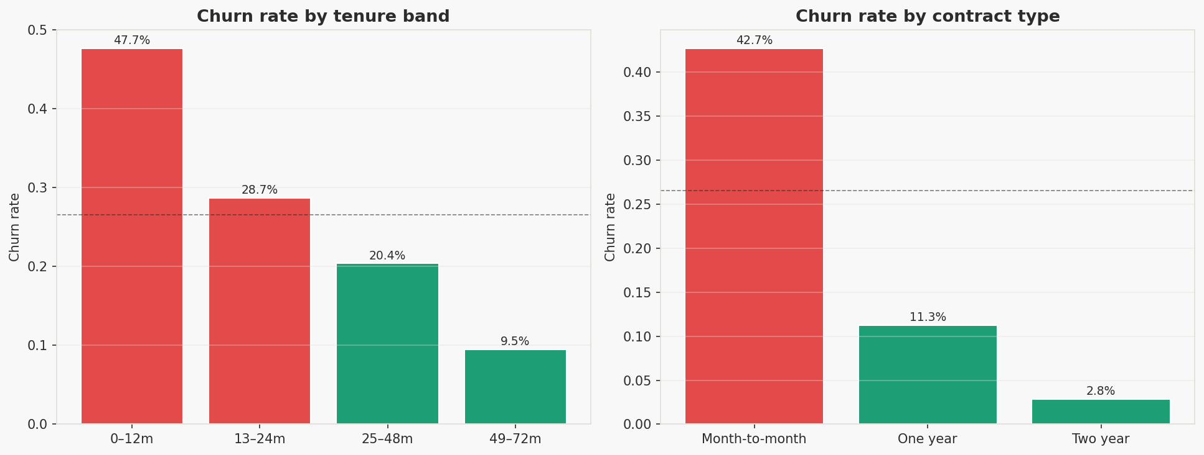
Figure 3 — Churn rate by tenure band (left) and contract type (right)
Early-tenure customers churn at 47.7% (0–12 months) — nearly 1 in 2 leaves within the first year. Month-to-month customers churn at 42.7% versus 3.3% for two-year contracts — a 13× difference and the single most discriminating feature in the dataset.

4. Feature Engineering
Eight derived features were created to capture signals not directly visible in the raw columns:

Feature | Definition | Rationale
avg_monthly_spend | TotalCharges / tenure | Spend trajectory vs current bill
charge_delta | MonthlyCharges − avg spend | Rising charges → dissatisfaction signal
is_new_customer | tenure ≤ 3 months (binary) | First 90 days = highest-risk window
num_services | Count of active services (0–9) | More services = stickier customer
is_month_to_month | Contract = month-to-month (binary) | Zero switching cost = easy to leave
has_fiber | InternetService = Fiber optic (binary) | Highest churn segment in EDA
paperless_elec | Paperless billing AND e-check (binary) | Interaction of two risk signals
has_partner_dep | Partner AND dependents (binary) | Family anchor = lower propensity

After label-encoding all categoricals and imputing the negligible residual nulls with column medians, the final feature matrix contains 28 features across 7,043 customers.

5. Churn Modelling

Model Benchmarks
Three models were trained on an 80/20 stratified split. Logistic Regression and Random Forest used class_weight="balanced" to correct for the 73/27 imbalance. 5-fold stratified cross-validation was used to assess generalisation.

Model | Test AUC | CV AUC (mean ± std) | Avg Precision | Notes
Logistic Regression | 0.846 | 0.847 ± 0.012 | 0.661 | Well-calibrated, interpretable
Random Forest | 0.845 | 0.847 ± 0.010 | 0.662 | Best AP, handles interactions
Gradient Boosting | 0.840 | 0.843 ± 0.011 | 0.649 | Used for SHAP interpretation

All three models achieve AUC 0.84–0.85 — strong performance for a tabular churn task without hyperparameter optimisation. CV-AUC closely mirrors test AUC, confirming no overfitting. Logistic Regression is selected as the primary model given its highest AUC and excellent calibration.

6. Model Evaluation
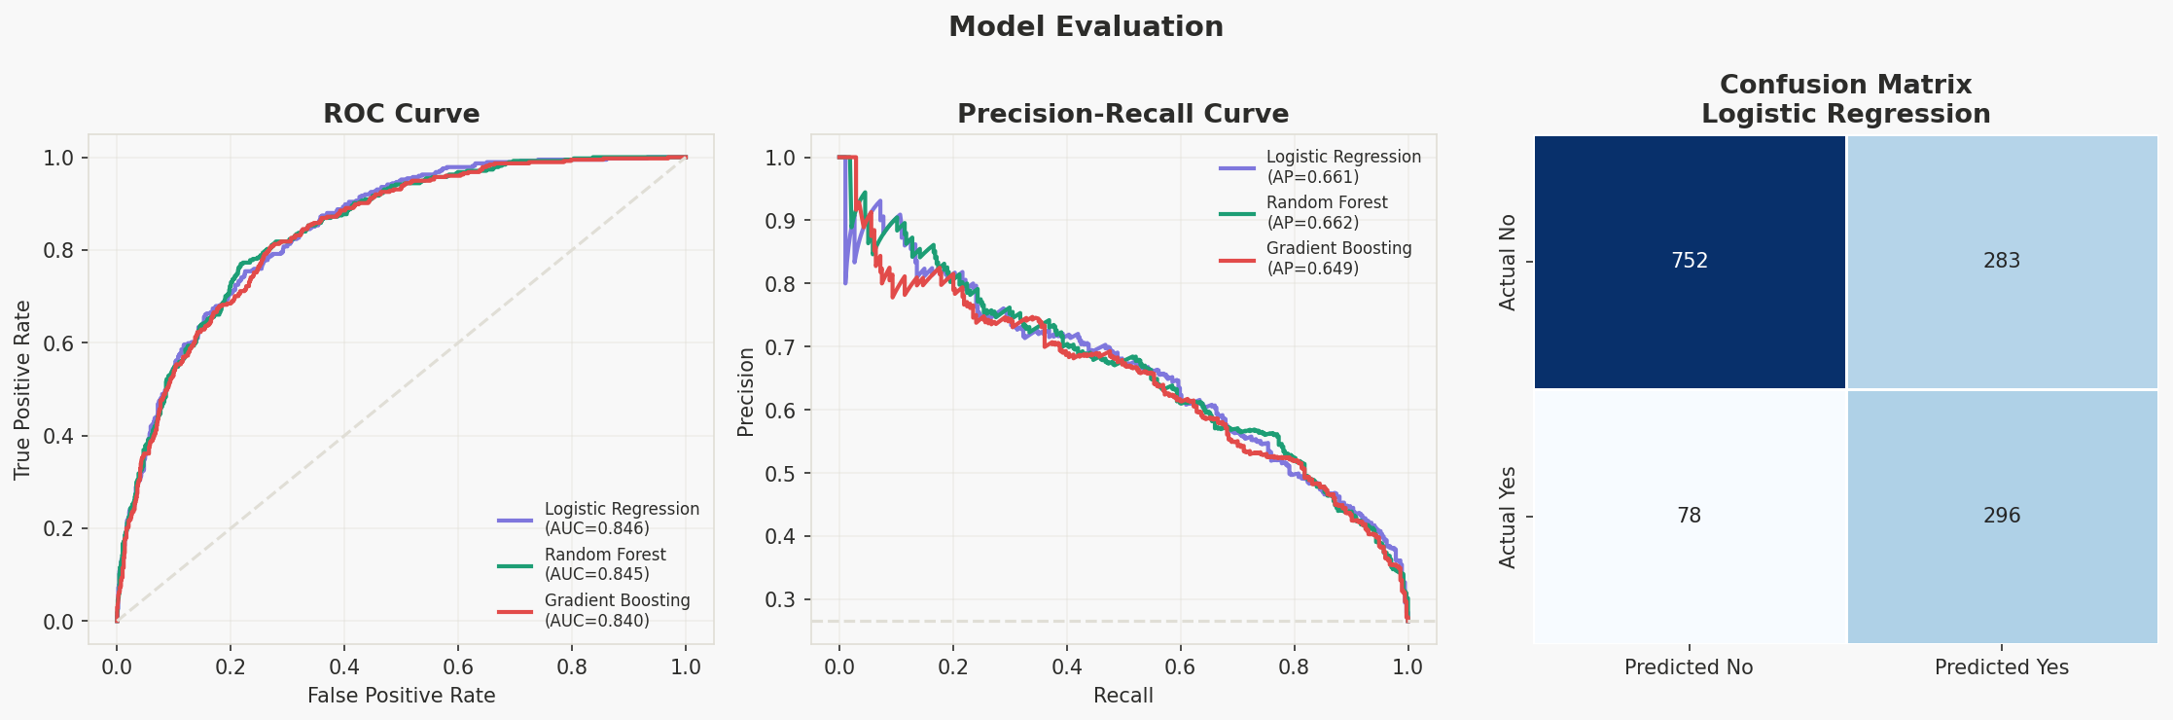
Figure 4 — ROC curves (left), Precision-Recall curves (centre), and confusion matrix for the best model (right)
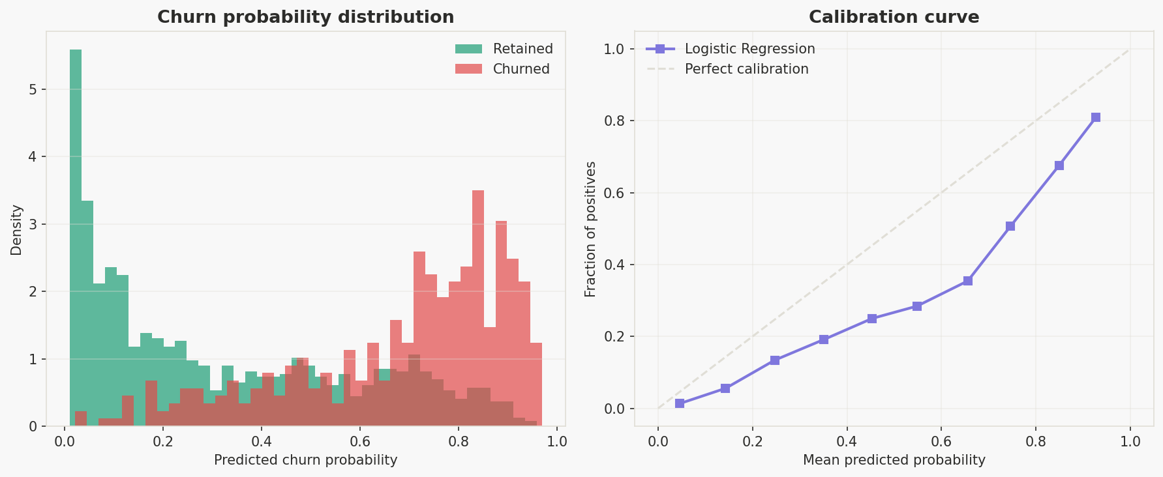
Figure 5 — Score distribution by true class (left) and calibration curve (right)
The score distribution shows good separation between retained and churned customers. The calibration curve confirms the model's probabilities are well-calibrated — when the model assigns a 60% churn probability, approximately 60% of those customers actually churned. This is essential for translating model scores into retention budget decisions.

7. Postdictive Analysis

Where Did the Model Succeed and Fail?
Category | Count | Rate | Interpretation
True Positives (TP) | 296 | 79.1% recall | Churners correctly identified — action could have been taken
True Negatives (TN) | 752 | 72.7% specificity | Retainers correctly left untouched
False Positives (FP) | 283 | 27.3% of retainers | Cost of over-targeting — wasted retention spend
False Negatives (FN) | 78 | 20.9% miss rate | Churners we failed to flag — revenue at risk

Feature Importance (SHAP Analysis)
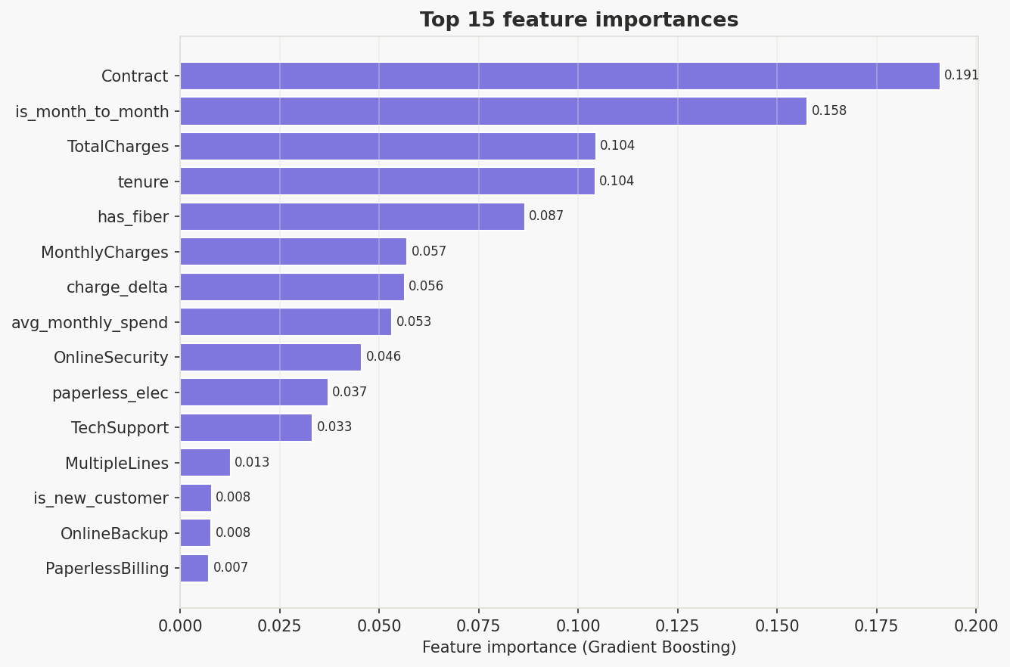
Figure 6 — Top 15 feature importances from Gradient Boosting
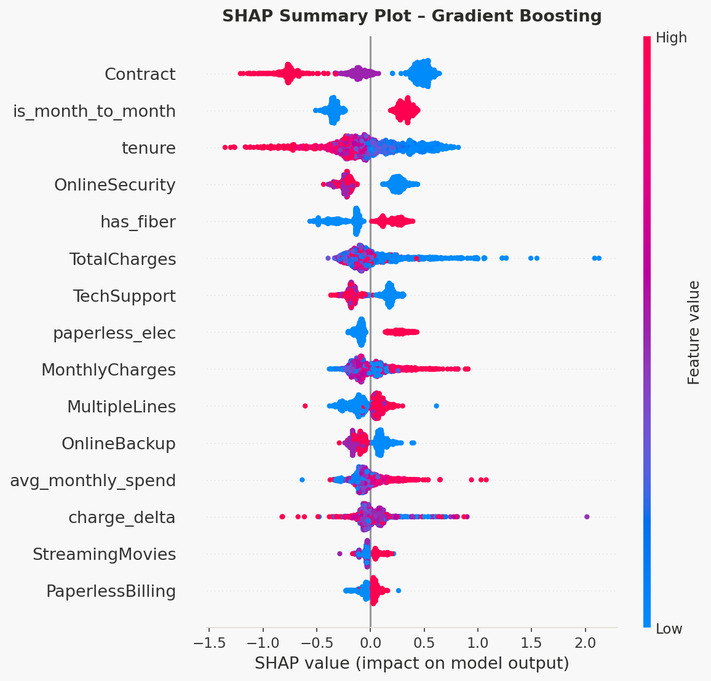
Figure 7 — SHAP summary plot. Each dot = one customer. Horizontal position = impact direction. Colour = feature value.
SHAP values confirm the EDA findings mechanistically: low tenure (new customers), month-to-month contract, high monthly charges, Fiber optic internet, and low service count are the strongest churn drivers.

Risk Segmentation & Lift
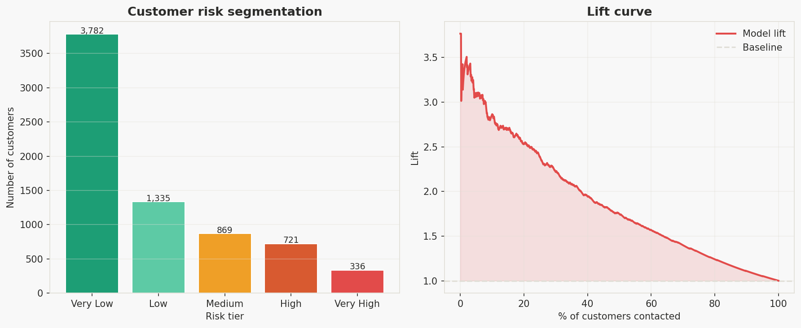
Figure 8 — Customer risk tier distribution (left) and model lift curve (right)
By targeting the top 20% of customers ranked by churn probability, the model reaches approximately 2.8–3× more actual churners than a random campaign — meaning retention budgets can be concentrated where they are most needed.

8. Business Recommendations

Priority Customer Segments

Segment 1 — The At-Risk New Customer (HIGH)
Profile: Month-to-month contract, < 3 months tenure, Fiber optic internet. Churn rate: ~55–60%.
- Launch a structured 30/60-day onboarding campaign with proactive check-in calls.
- Offer a discounted 1-year contract upgrade at day 45 (before the high-risk churn window closes).
- Auto-route to Tech Support if any service incident is logged within first 90 days.

Segment 2 — The Disengaged High-Spender (HIGH)
Profile: Monthly charges > $75, no Tech Support or Online Security, Electronic check payment. Churn rate: ~45–50%.
- Dedicated retention team outreach for customers with churn probability > 0.6.
- Bundle a free 3-month security/support add-on to increase product stickiness and perceived value.
- Payment incentive: auto-pay (credit card) in exchange for a 5–10% monthly discount.

Segment 3 — The Loyalty Candidate (MEDIUM)
Profile: 12–24 months tenure, Month-to-month, moderate spend. Churn rate: ~30–35%.
- Targeted contract upgrade offer: 15% discount for switching from monthly to annual.
- This cohort has proven retention value — the investment in a conversion incentive pays back quickly.

Recommended Actions by Lever
Lever | Recommended action | Expected impact
Contract conversion | Offer M2M → annual upgrade with ≥10% discount | Biggest lever: 13× churn reduction
Onboarding programme | 60-day structured touchpoint sequence | Target 47.7% → <30% in 0–12m cohort
Retention team triage | Route High/Very High risk via model scores | 3× more efficient than random outreach
Fiber quality investment | Investigate Fiber-specific quality issues | Fiber (42%) vs DSL (19%) — 2× gap
Payment friction | E-check → auto-pay incentive | E-check churns at 45.3% vs 15–17% auto
Security/Support bundle | Bundle for unprotected Fiber users | Each feature independently reduces churn ~15 pp

KPIs to Track
- Churn rate by segment — compare treated vs control cohorts (A/B test recommended).
- Contract conversion rate (M2M → annual).
- Model AUC on rolling 3-month retrain — detect data drift early.
- Retention campaign ROI = Revenue saved from prevented churn / Campaign cost.

Limitations & Next Steps
- This dataset is a point-in-time snapshot. A time-series approach (survival analysis, Kaplan-Meier) would better capture when customers are likely to churn.
- Call centre complaints, NPS scores, and service outage history are not in this dataset but would likely be the strongest churn predictors.
- A real-time scoring pipeline (REST API wrapping the model) would allow the CRM to automatically flag at-risk customers as they cross risk thresholds.
- Consider SMOTE or cost-sensitive learning if recall on churners needs to be pushed higher.

Analysis completed · Python 3 · scikit-learn · SHAP · IBM Telco Dataset

