Spatio-Temporal Prediction of Pluvial and Coastal Flood Risk in Lagos State, Nigeria: A Machine Learning Approach Using Rainfall, Topographic and Demographic Data, with Climate-Scenario Projections to 2050
Author: Utibe Bassey
Date: October 2026
Repository & Codebase: lagos-flood-risk-ml
Abstract
Flooding is the most pervasive, destructive, and economically disruptive natural hazard in Lagos State, Nigeria—a low-lying, coastal and lagoon-fringed megacity situated along the Gulf of Guinea. Despite annual flood outlooks issued at state scale, urban planners and emergency agencies lack a reproducible, spatially explicit machine learning framework capable of predicting monthly flood susceptibility at the Local Government Area (LGA) level and projecting how climate change, sea-level rise, and rapid urbanisation will reshape risk through mid-century.
This study develops and validates an end-to-end spatio-temporal flood prediction and risk-indexing pipeline across all 20 LGAs of Lagos State over a 16-year historical baseline (`2010–2025`, N = 3,840 LGA-months), with multi-model climate projections for `2030–2050` under moderate (SSP2-4.5) and high (SSP5-8.5) emissions scenarios. Using Google Earth Engine (GEE), we fuse daily satellite-gauge rainfall from CHIRPS v2.0 (5.5 km, 116,880 daily LGA observations), land-masked digital elevation and slope from USGS SRTM (30 m), permanent water occurrence and Euclidean proximity from JRC Global Surface Water v1.4 (30 m), impervious surface and wetland/mangrove shares from ESA WorldCover v200 (10 m), and harmonised annual gridded population from WorldPop (100 m). A multi-source historical flood database (423 documented flood LGA-months; 11.02% prevalence) is compiled from NEMA, NIHSA, LASEMA, EM-DAT, the Dartmouth Flood Observatory (DFO) / MODIS Global Flood Database, and verified Nigerian news archives.
To prevent temporal leakage, models are trained and tuned on 2010–2020 (2,640 rows) using expanding-window TimeSeriesSplit cross-validation and evaluated on a strictly held-out future period (2021–2025, 1,200 rows), alongside a 20-fold Leave-One-LGA-Out (`LeaveOneGroupOut`) spatial generalisation test. Our Calibrated Monotonic XGBoost model achieves a held-out Test ROC-AUC of `0.890` (95% CI: `[0.871, 0.910]`), Test PR-AUC of `0.460` (`[0.402, 0.534]`, 3.05× the naive baseline), and Brier calibration score of `0.1092`, while Cost-Sensitive Random Forest achieves the highest Test F1-score (`0.562`) and Recall (`0.718`). Across unseen LGAs, Leave-One-LGA-Out cross-validation achieves a mean ROC-AUC of `0.902`, proving that the model learns physical hydro-topographic thresholds rather than spatial identifiers. TreeSHAP explainability demonstrates that current-month rainfall (rain_total_mm), antecedent previous-month rainfall (`rain_prev_month_mm`), 3-day storm intensity (rain_max_3day_mm), low-lying land fraction (low5_share <5 m), and impervious urban cover (built_share) govern flood occurrence.
Feeding bias-corrected daily precipitation from a 5-model CMIP6 ensemble (`NASA/GDDP-CMIP6`) combined with IPCC AR6 regional sea-level rise (+0.29 m under SSP2-4.5; +0.40 m under SSP5-8.5 by 2050) and urban demographic expansion into the calibrated model reveals that state-wide wet-season flood probability rises from `20.18%` in the historical baseline to `22.30%` (SSP2-4.5) and `22.68%` (SSP5-8.5) by 2050, while the state-wide Composite Flood Risk Index (FRI) rises from `38.8` to `44.0`. Crucially, the population annually exposed to high wet-season flood risk nearly doubles from `993,636` residents in the baseline period to `1,746,393` (`+75.8%`) under SSP2-4.5 and `1,982,207` (`+99.5%`) under SSP5-8.5 by 2050, with Lagos Island, Apapa, Kosofe, Eti-Osa, Amuwo Odofin, Ajeromi/Ifelodun, Mainland, Surulere, Ojo, and Ikorodu emerging as critical intervention priorities.
Chapter 1: Introduction
1.1 Background and Problem Statement
Lagos State is the economic, financial, and commercial nerve centre of Nigeria and one of the fastest-growing coastal megacities in the world. Spanning approximately 3,577 km^2 along the Bight of Benin in the Gulf of Guinea, Lagos is characterised by a complex barrier-lagoon geomorphology consisting of barrier islands, tidal creeks, extensive mangrove swamps, the expansive Lagos and Lekki Lagoons, and the lower floodplain of the Ogun River. More than half of the metropolitan coastline and lagoon fringe lies less than 5\text{ metres} above mean sea level.
Every rainy season (April/May to October), Lagos experiences recurrent, destructive flooding driven by three interacting physical mechanisms:
1. Pluvial (Surface Runoff) Flooding: Intense convective downpours fall on densely built urban surfaces where concrete, asphalt, and roofing exceed 80\text{–}98% of total land area, overwhelming blocked or under-sized primary and tertiary drainage channels.
2. Fluvial & Lagoon Floodplain Inundation: Prolonged wet-season rainfall across the Ogun–Osun river catchment—compounded by periodic water releases from the upstream Oyan Dam—inundates low-lying riverine corridors in Kosofe (Agboyi-Ketu, Mile 12, Isheri, Oworo) and Ikorodu (Majidun, Ibeshe, Ikorodu).
3. Coastal & Tidal Backwater Locking: Storm surges and rising Atlantic and lagoon water levels submerge low-lying coastal zones (Lagos Island, Eti-Osa, Apapa, Ajeromi/Ifelodun, Amuwo Odofin, Ojo, Badagry, Ibeju-Lekki) and create hydraulic "backwater locking," where high lagoon tailwater prevents terrestrial storm drains from discharging by gravity.
Despite billions of Naira in annual economic losses, transport paralysis, property destruction, and residential displacement, publicly available flood forecasting in Nigeria remains largely qualitative or coarse. The Nigeria Hydrological Services Agency (NIHSA) publishes valuable *Annual Flood Outlooks* identifying "Probable" and "Highly Probable" flood LGAs at an annual or seasonal horizon, but no open, reproducible, data-driven system combines multi-decadal satellite rainfall, high-resolution topography, land cover, and demographic exposure to predict monthly LGA-level flood probabilities and project their evolution to 2050 under IPCC AR6 climate scenarios.
1.2 Aim and Objectives
Aim: To develop and validate a machine learning model that predicts monthly flood occurrence across the 20 Local Government Areas (LGAs) of Lagos State, construct a composite Flood Risk Index (FRI), and project how flood hazard and human exposure will evolve between 2030 and 2050 under SSP2-4.5 and SSP5-8.5 climate scenarios.
Specific Objectives:
1. To quantify and map the spatial and seasonal patterns of documented flooding across the 20 Lagos State LGAs from 2010 to 2025 (04_flood_records.ipynb & 06_eda.ipynb).
2. To determine the rainfall intensity, antecedent moisture, topographic, and land-cover conditions statistically associated with flood occurrence across different terrain tiers (02_rainfall_chirps.ipynb, 03_elevation_and_water.ipynb, 05_population_landcover.ipynb).
3. To train, tune, and compare machine learning classifiers (Logistic Regression, Random Forest, and Monotonic XGBoost) against naive and climatological baselines using strict temporal (2010–2020 vs. 2021–2025) and spatial (LeaveOneGroupOut) validation, and explain their physical drivers using SHAP (07_modelling.ipynb).
4. To project monthly flood hazard from 2030 to 2050 across an ensemble of 5 CMIP6 Global Climate Models under SSP2-4.5 and SSP5-8.5, accounting for IPCC AR6 sea-level rise and urban demographic expansion (08_climate_projections.ipynb).
5. To formulate a composite Flood Risk Index (FRI), estimate the resident population exposed to high flood risk in each LGA for the baseline period, the 2030s, the 2040s, and 2050, and deliver an interactive geospatial risk map and planning dashboard (09_risk_index.ipynb & app.py).
1.3 Research Questions
1. RQ1 (Spatial & Seasonal Distribution): Which LGAs in Lagos State are most flood-prone, and in which calendar months do floods concentrate?
2. RQ2 (Hydro-Topographic Drivers): How do current-month rainfall, short-duration storm extremes, antecedent monthly rainfall, land elevation, water proximity, and impervious surface cover interact to trigger flooding?
3. RQ3 (Predictive Modelling & Generalisation): Which machine learning architecture predicts rare monthly flood events most reliably across both future unseen years (2021–2025) and unseen spatial units (held-out LGAs)?
4. RQ4 (Population Exposure & Risk Index): How many residents live in high-risk flood zones across each LGA, and how do LGAs rank on a composite Flood Risk Index combining hazard, vulnerability, and exposure?
5. RQ5 (2030–2050 Climate & Urban Projections): How will flood probability, the Flood Risk Index, and exposed population change by the 2030s, 2040s, and 2050 under SSP2-4.5 and SSP5-8.5?
1.4 Scope of Study
• Spatial Scope: All 20 official Local Government Areas (LGAs) of Lagos State, Nigeria, as defined by GADM v4.1 Level 2 boundaries (lagos_lgas.gpkg).
• Temporal Scope: Historical baseline covering January 2010 to December 2025 (192\text{ months} × 20\text{ LGAs} = 3,840\text{ records}); future projection horizon covering January 2030 to December 2050 (252\text{ months} × 20\text{ LGAs} = 5,040\text{ records} per climate model and scenario).
• Hazard Scope: Compound pluvial (rainfall-driven), fluvial/floodplain (Ogun River and creek overflow), and coastal/lagoon flooding.
Chapter 2: Literature Review and Gap Analysis
2.1 Urban Flood Mechanisms in Lagos and West Africa
Extensive hydrological and disaster-risk literature documents the acute vulnerability of Lagos to pluvial and coastal flooding. Adelekan (2010, 2016) and Nkwunonwo et al. (2016) demonstrated that rapid, unplanned reclamation of wetlands and lagoon margins in Lagos has simultaneously increased surface runoff coefficients and placed millions of low-income and affluent residents directly in natural retention basins. Ajibade et al. (2013) and Echendu (2020) highlighted that flood impacts in Lagos are socially and topographically stratified: coastal islands (Victoria Island, Lekki, Ikoyi, Lagos Island) and informal waterfront settlements (Ajegunle in Ajeromi/Ifelodun, Makoko in Mainland, Iwaya, Agboyi-Ketu in Kosofe) suffer prolonged inundation whenever heavy convective storms coincide with high astronomical tides or lagoon surge.
2.2 Remote Sensing and GIS-Based Flood Susceptibility Mapping
Traditional flood susceptibility studies in Nigeria have relied heavily on Multi-Criteria Decision Analysis (MCDA) and Analytical Hierarchy Process (AHP) within GIS environments (e.g., Ouma & Tateishi, 2014; Komolafe et al., 2015; Umaru & Adedokun, 2020). While GIS-AHP maps static terrain susceptibility using elevation, slope, drainage density, and land use, it suffers from two major limitations:
1. Subjective Weighting: Expert-assigned AHP weights are not empirically calibrated against historical flood records or validated out-of-sample.
2. Temporal Staticity: Static GIS maps cannot answer *when* flooding will occur (e.g., comparing a 90 mm month in March against a 280 mm month in July following a wet June), nor can they dynamically ingest time-varying CMIP6 daily rainfall series.
2.3 Machine Learning for Spatio-Temporal Flood Prediction
Recent advances in hydro-informatics have shifted toward supervised machine learning—particularly Random Forests (RF), Gradient Boosted Decision Trees (XGBoost / LightGBM), and Logistic Regression—for flood susceptibility and early warning (Mosavi et al., 2018; Bui et al., 2020; Tellman et al., 2021). Tree-based ensembles excel at capturing non-linear threshold interactions (such as heavy 3-day rainfall only triggering floods where low5_share or built_share is high). Furthermore, the introduction of domain-informed monotonic constraints in gradient boosting (Bartley et al., 2019) prevents overfitted non-physical reversals when extrapolating to novel future climate regimes.
2.4 Synthesis of Related Literature and Research Gap
Study / Source | Region & Scale | Data Used | Methodology | Key Findings & Limitations
Adelekan (2010, 2016) | Lagos coastal & island communities | Rain gauge records, household surveys, historical archives | Qualitative & descriptive statistical vulnerability analysis | Identified rapid wetland loss and extreme storms (e.g., July 2011) as primary drivers; no predictive ML model or 2050 climate projection.
Nkwunonwo et al. (2016, 2020) | Lagos Metropolis | Literature synthesis, DEM, urban drainage records | Conceptual review & cellular automata hydrodynamic discussion | Highlighted acute scarcity of gauged hydrological data in Nigeria and advocated open satellite-driven modelling.
Tellman et al. (2021) | Global (including Nigeria / DFO) | MODIS 250m imagery (2000–2018), DFO archive, WorldPop | Satellite water detection (GLOBAL_FLOOD_DB) | Proved rapid population growth in flooded zones globally; coarse 250m cloud-limited imagery misses short urban flash floods in Lagos.
NIHSA (2018–2025) | Nigeria (774 LGAs) | Seasonal meteorological forecasts, river basin routing | Hydrological outlook classification (Annual / Seasonal) | Provides authoritative national LGA alerts, but outputs static annual/seasonal categories without open monthly probability models or 2050 SSP projections.
IPCC AR6 WGI & WGII (2021, 2022) | West Africa & Gulf of Guinea | CMIP6 multi-model ensemble, tide gauges, altimetry | Physical climate & regional sea-level rise modelling | Projects intensification of extreme daily rainfall (Rx1day, Rx5day) and +0.30\text{–}0.45 m sea-level rise along the Nigerian coast by 2050.
This Study (2026) | All 20 Lagos State LGAs (`2010–2050`) | CHIRPS Daily, SRTM 30m, JRC Water 30m, ESA WorldCover 10m, WorldPop 100m, 5-GCM CMIP6, 75 Multi-LGA Flood Logs | Calibrated Monotonic XGBoost, Temporal & Spatial LOLO CV, TreeSHAP, QDM Bias Correction, Composite FRI | Fills the gap by delivering an open, leakage-free monthly LGA prediction model, 2030–2050 SSP2-4.5/SSP5-8.5 projections with uncertainty bounds, and an interactive dashboard.

Chapter 3: Data Engineering and Methodology
3.1 System Architecture & End-to-End Pipeline
The project is structured into nine modular, self-contained Jupyter notebooks (01 to 09) that transform raw satellite collections and flood archives into a validated predictive model, 2050 climate projections, and an interactive decision-support system.
[System Architecture Flow: GADM v4.1 + CHIRPS Daily + SRTM 30m + JRC Water 30m + ESA WorldCover 10m + WorldPop 100m + Curated Flood Log -> master_lga_month.csv (3,840 rows) -> Temporal Split (2010–2020) & Spatial LOLO CV -> Calibrated Monotonic XGBoost + TreeSHAP -> 5-GCM CMIP6 Bias Correction + IPCC AR6 Sea-Level Rise + Urban Growth -> Composite Flood Risk Index (2030–2050)]
3.2 Comprehensive Data Sources & Satellite Assets Inventory
Table 3.1 synthesises all primary datasets, satellite Earth observation collections, and disaster archives integrated into the master feature store.
Dataset Name | Source / Provider | Earth Engine Snippet / Path | Native Spatial Resolution | Native Temporal Resolution | Temporal Range Used | Key Variables Extracted | Primary Use in Project
GADM Administrative Boundaries v4.1 | GADM / UC Davis | data/raw/gadm41_NGA.gpkg | Vector (Level 2) | Static (2022) | 2022 | 20 Lagos LGA administrative boundaries & polygon geometries | Spatial clipping, zonal reducers, spatial join
CHIRPS Daily Precipitation v2.0 | UCSB Climate Hazards Group / USGS | UCSB-CHG/CHIRPS/DAILY | 0.05^\circ (≈ 5.5 km) | Daily (06:00\text{ UTC}) | 2010-01-01 to 2025-12-31 | rain_total_mm, rain_max_daily_mm, rain_max_3day_mm, rainy_days, rain_2m_cum_mm, rain_anom_z | Hydrometeorological hazard features
USGS SRTM Digital Elevation v3 | NASA / USGS JPL | USGS/SRTMGL1_003 | 1\text{ arc-second} (≈ 30 m) | Static (Feb 2000) | 2000 | elev_mean_m, elev_median_m, elev_min_m, elev_std_m, low5_share, low10_share, slope_mean_deg | Topographic susceptibility & surge exposure
JRC Global Surface Water v1.4 | European Commission Joint Research Centre | JRC/GSW1_4/GlobalSurfaceWater | 30 m | Multi-decadal summary (1984–2021) | 1984–2021 | water_occurrence_pct, permanent water mask (≥ 50%), dist_water_mean_km, near_water_1km_share | Water masking of DEM & proximity features
ESA WorldCover 10m 2021 v200 | European Space Agency (ESA) | ESA/WorldCover/v200 | 10 m | Annual (2021) | 2021 | Built-up (built_share), Tree cover (veg_share), Mangroves & Wetlands (wetland_mangrove_share), Bare land (bare_share) | Imperviousness, drainage capacity, nature buffers
WorldPop Unconstrained Gridded Pop | WorldPop / Univ. Southampton | WorldPop/GP/100m/pop & .../R2025A/v1/pop | 100 m (1 hectare) | Annual | 2010–2025 | population, pop_density_km2, annual growth rate | Human exposure & vulnerable population estimation
Historical Flood Events Log & Archives | NEMA, NIHSA, LASEMA, EM-DAT, DFO, News | data/raw/flood_events/flood_events_log.csv & GLOBAL_FLOOD_DB | Community / LGA text & vector polygons | Monthly event-level | 2010–2025 | Event dates, impacted LGAs, communities, severity, source citations | Ground-truth supervised binary target label (flood)
NASA NEX-GDDP-CMIP6 | NASA Ames Research Center | NASA/GDDP-CMIP6 | 0.25^\circ (≈ 25 km) | Daily | 2010–2014 (Hist) & 2030–2050 (Future) | Daily precipitation (pr) across 5 GCMs (ACCESS-CM2, GFDL-ESM4, MPI-ESM1-2-HR, MRI-ESM2-0, UKESM1-0-LL) | Climate projections under SSP2-4.5 & SSP5-8.5
IPCC AR6 Sea-Level Rise Projections | IPCC Working Group I | IPCC AR6 Sea Level Projection Tool (Gulf of Guinea) | Regional coastal gauge (1^\circ) | Decadal | 2030, 2040, 2050 | Median regional relative sea-level rise (Δ\text{SLR}: +0.11\text{–}0.40 m) | Coastal elevation depression & low-land expansion

3.3 Computational Tools, Software Stack & Engineering Environment
Table 3.2 details the complete software environment, programming languages, analytical libraries, and cloud infrastructure used to develop, train, validate, and deploy the system.
Category | Tool / Library Name | Environment / Version | Primary Role & Capabilities | Project Utilization
Programming Language | Python | 3.13.9 (64-bit) | Core development, data pipelines, model training, and web dashboard execution | Standard language across all 9 notebooks, CLI scripts, and web apps
Cloud Geospatial Engine | Google Earth Engine (GEE) | earthengine-api 1.4.3 | Cloud-scale planetary Earth observation computing and zonal reducers | Extracted CHIRPS daily sums, SRTM elevation, JRC water, WorldCover, WorldPop, and CMIP6 grids
Geospatial & Vector Analytics | GeoPandas & Fiona | geopandas 1.0.1 | Vector spatial processing, GeoPackage I/O, coordinate reprojections | Managed LGA boundaries (EPSG:4326 and EPSG:32631), geometric unions, spatial joins
Geometric Operations | Shapely & PyProj | shapely 2.0.6, pyproj 3.7.0 | Planar geometry calculations, spatial filtering, UTM reprojection | Verified topological validity of polygons and geodesic distance calculations
Numerical & Tabular Data | Pandas & NumPy | pandas 2.2.3, numpy 2.1.3 | High-performance tabular transformation, rolling windows, array algebra | Feature store assembly, antecedent lag computation, QDM bias correction scaling
Scientific Computing | SciPy | scipy 1.14.1 | Non-parametric hypothesis testing and statistical distributions | Two-sided Mann–Whitney U tests, rank-biserial effect sizes, Spearman correlations
Machine Learning Core | Scikit-Learn | scikit-learn 1.5.2 | Preprocessing, cross-validation iterators, metrics, probability calibration | StandardScaler, TimeSeriesSplit, LeaveOneGroupOut, CalibratedClassifierCV, PR/ROC AUC
Gradient Boosting | XGBoost | xgboost 2.1.3 | Scalable gradient boosted decision trees with domain monotonic constraints | Monotonic classification, hyperparameter tuning, fast inference
Random Forests | Scikit-Learn Ensemble | scikit-learn 1.5.2 | Balanced subsampled random forests with out-of-bag validation | Cost-sensitive baseline and non-linear ensemble comparison
Explainable AI (XAI) | SHAP | shap 0.46.0 | Cooperative game-theoretic feature attributions (TreeSHAP) | Local and global feature importance, beeswarm summary plots, partial dependence analysis
Interactive Web Dashboard | Streamlit | streamlit 1.40.1 | Reactive web application framework for data science and model deployment | Multi-tab decision-support dashboard (app.py) with real-time What-If scenario simulation
Interactive Cartography | Folium / Leaflet.js | folium 0.18.0 | Client-side interactive slippy maps, GeoJSON overlays, choropleths | Multi-layer interactive flood risk map (outputs/maps/lagos_flood_risk_interactive.html)
Static Visualizations | Matplotlib & Seaborn | matplotlib 3.9.2, seaborn 0.13.2 | Publication-ready figures, ROC/PR curves, confusion matrices, heatmaps | Generated 11 high-resolution figures in outputs/figures/ (300 DPI)
Model Serialization | Joblib | joblib 1.4.2 | Compressed binary persistence of fitted pipelines and calibrated models | Saved outputs/models/flood_model_bundle.joblib for headless production inference
Office Document Generation | Standard Zipfile + OpenXML | Python Standard Library | Zero-dependency native packaging of Word (.docx) and PowerPoint (.pptx) | Automated synthesis of formatted Word project report and 15-slide PowerPoint deck
Cloud & Local Runtime | Anaconda / Windows 11 | Conda Environment | Isolated reproducible dependency management | Dedicated execution environment ensuring zero package conflicts

3.4 Spatial Units and Topographic Masking (01_lga_boundaries.ipynb & 03_elevation_and_water.ipynb)
1. Administrative Boundaries: Level-2 administrative polygons for Nigeria were loaded from gadm41_NGA.gpkg, filtered to the 20 LGAs of Lagos State, verified for topological validity, and saved to lagos_lgas.gpkg.
2. Water-Masked Elevation Statistics: A critical methodological pitfall in coastal DEM analysis is averaging elevation over an entire administrative polygon that includes open lagoon or ocean water (which SRTM records as 0 m). In 03_elevation_and_water.ipynb, we used JRC Global Surface Water (`JRC/GSW1_4/GlobalSurfaceWater`, 30 m) to define permanent water (occurrence >= 50%) and masked out all permanent water pixels *before* computing land elevation statistics from USGS SRTM (`USGS/SRTMGL1_003`, 30 m):
• elev_mean_m, elev_median_m, elev_min_m, elev_max_m, elev_std_m
• low5_share: Fraction of LGA land area below 5 m elevation (critical coastal/tidal surge threshold)
• low10_share: Fraction of LGA land area below 10 m elevation
• slope_mean_deg: Mean terrain slope in degrees
3. Euclidean Distance to Permanent Water: Reprojecting into metric UTM Zone 31N (`EPSG:32631`) at 150 m grid resolution, we applied Earth Engine's Euclidean distance transform (fastDistanceTransform) verified with a physical direction assertion (confirming distance is 0 m on water and 3,754 m mean on land) to compute dist_water_mean_km and near_water_1km_share (terrain_water_lga.csv).
3.5 Daily-to-Monthly & Antecedent Rainfall Engineering (02_rainfall_chirps.ipynb)
Daily precipitation from CHIRPS v2.0 (`UCSB-CHG/CHIRPS/DAILY`) from 2010-01-01 to 2025-12-31 (5,844 days × 20 LGAs = 116,880 rows, saved in chirps_daily_lga.csv) was transformed into 10 monthly and seasonal features in rainfall_lga_month.csv:
• Current-Month Intensity & Volume: rain_total_mm, rain_max_daily_mm (\text{Rx1day}), rain_max_3day_mm (\text{Rx3day}), rain_max_7day_mm (\text{Rx7day}), rainy_days (≥ 1 mm), and heavy_rain_days (≥ 20 mm). Rolling 3-day and 7-day sums were computed on the continuous daily series *prior* to monthly aggregation so cross-month storms are captured accurately.
• Antecedent Soil & Lagoon Saturation Proxies: rain_prev_month_mm (lag-1 month total rainfall in the same LGA) and rain_2m_cum_mm (\text{rain\_total\_mm} + \text{rain\_prev\_month\_mm}).
• Local Climatological Anomaly: rain_anom_z, the standardised z-score of monthly rainfall relative to each LGA's 2010–2020 training-period mean and standard deviation (avoiding test-period leakage).
• Cyclical Seasonality: \text{month\_sin} = \sin(2\pi m / 12) and \text{month\_cos} = \cos(2\pi m / 12).
3.6 Land Cover and Harmonised Annual Population (05_population_landcover.ipynb)
• Land Cover (`ESA/WorldCover/v200`, 10 m): Masking out open water (Class 80), we extracted each LGA's fraction of land covered by impervious built-up surfaces (built_share, Class 50), herbaceous wetlands and mangroves (wetland_mangrove_share, Classes 90 & 95), permeable vegetation (veg_share, Classes 10–40), and bare ground (bare_share, Class 60) into landcover_lga.csv.
• Annual Population (`2010–2025`, 100 m): Extracted from WorldPop/GP/100m/R2025A/v1/pop (2015–2025) and WorldPop/GP/100m/pop (2010–2015), spliced smoothly per LGA using the 2015 overlap ratio so no discontinuity occurs between releases (population_lga_year.csv).
3.7 Target Variable Construction & Labelling Rule (04_flood_records.ipynb)
Explicit Flood Labelling Rule: An LGA-month (i, t) is assigned flood = 1 if at least one credible documentary or satellite source records a flood event affecting LGA i during calendar month t; otherwise flood = 0 ("no documented flood").
In 04_flood_records.ipynb, we combined:
1. Dartmouth Flood Observatory (DFO) & MODIS Global Flood Database (`GLOBAL_FLOOD_DB/MODIS_EVENTS/V1`) records intersecting Lagos (DFO-4649 in July 2018; DFO_4667 in Aug–Oct 2018).
2. Curated Historical Lagos Flood Event Log (`flood_events_log.csv`): 75 multi-LGA event records (2010–2025) compiled from NEMA, NIHSA, LASEMA, EM-DAT, and major Nigerian dailies (*Punch*, *Vanguard*, *The Guardian*, *Premium Times*, *Channels TV*), mapped via a validated 150-term neighbourhood-to-LGA gazetteer (PLACE_TO_LGA).
Across the 3,840 LGA-month cells (20 LGAs × 192 months), exactly `423` LGA-months (`11.02%`) are labelled flood = 1.
3.8 Summary Profile of the 20 Lagos State LGAs (Master Dataset)
LGA | Land Area (km²) | Mean Elev (\text{m}) | Land <5 m (%) | Land <10 m (%) | Mean Dist to Water (\text{km}) | Built-Up Share (%) | Wetland / Mangrove (%) | 2025 Gridded Pop | 2025 Pop Density (/km²) | Mean Annual Rain (\text{mm}) | Flood Months (2010–2025)
Eti-Osa | 150.9 | 5.7 | 39.1% | 86.1% | 1.49 | 63.6% | 5.0% | 612,834 | 4,060 | 1,685 | 35 (18.2%)
Kosofe | 73.8 | 11.4 | 40.1% | 64.4% | 3.32 | 54.8% | 18.0% | 630,971 | 8,556 | 1,709 | 33 (17.2%)
Ikorodu | 360.0 | 22.0 | 6.7% | 20.8% | 5.67 | 51.4% | 1.5% | 1,101,901 | 3,061 | 1,666 | 30 (15.6%)
Lagos Island | 41.6 | 5.8 | 51.5% | 82.2% | 0.48 | 47.4% | 25.3% | 233,344 | 5,608 | 1,763 | 28 (14.6%)
Surulere | 30.6 | 9.3 | 18.4% | 66.4% | 4.30 | 97.0% | 0.1% | 528,283 | 17,287 | 1,619 | 26 (13.5%)
Mainland | 22.6 | 9.1 | 21.1% | 62.6% | 2.03 | 89.9% | 1.3% | 352,595 | 15,588 | 1,706 | 25 (13.0%)
Apapa | 32.9 | 4.8 | 46.0% | 94.0% | 0.88 | 73.3% | 6.4% | 346,266 | 10,528 | 1,609 | 23 (12.0%)
Ajeromi/Ifelodun | 11.6 | 4.9 | 45.7% | 94.1% | 1.83 | 95.3% | 0.0% | 155,697 | 13,445 | 1,394 | 23 (12.0%)
Ojo | 169.6 | 7.0 | 27.8% | 77.5% | 2.82 | 32.4% | 15.6% | 840,161 | 4,953 | 1,537 | 20 (10.4%)
Mushin | 17.3 | 23.5 | 1.2% | 5.4% | 6.50 | 96.5% | 0.0% | 232,434 | 13,436 | 1,666 | 20 (10.4%)
Alimosho | 147.3 | 27.9 | 1.1% | 10.2% | 12.27 | 82.2% | 1.1% | 1,996,398 | 13,552 | 1,502 | 19 (9.9%)
Amuwo Odofin | 159.4 | 6.4 | 36.2% | 78.5% | 2.21 | 47.1% | 17.9% | 975,544 | 6,122 | 1,523 | 19 (9.9%)
Oshodi/Isolo | 38.4 | 22.9 | 1.4% | 9.1% | 8.25 | 81.4% | 0.0% | 482,392 | 12,562 | 1,544 | 18 (9.4%)
Ibeju-Lekki | 456.3 | 9.6 | 10.3% | 52.9% | 2.94 | 11.2% | 1.7% | 251,307 | 551 | 1,706 | 18 (9.4%)
Ikeja | 45.5 | 35.2 | 0.4% | 4.2% | 5.94 | 88.3% | 0.0% | 640,062 | 14,064 | 1,527 | 18 (9.4%)
Agege | 16.5 | 41.9 | 0.0% | 0.0% | 8.26 | 98.3% | 0.0% | 299,872 | 18,185 | 1,471 | 15 (7.8%)
Epe | 881.8 | 12.9 | 15.9% | 41.1% | 3.08 | 3.4% | 8.6% | 280,497 | 318 | 1,779 | 14 (7.3%)
Shomolu | 18.2 | 14.4 | 14.8% | 41.5% | 2.79 | 95.4% | 0.2% | 301,870 | 16,577 | 1,765 | 14 (7.3%)
Badagry | 467.6 | 7.9 | 26.0% | 68.7% | 2.44 | 17.7% | 10.9% | 1,073,265 | 2,295 | 1,460 | 13 (6.8%)
Ifako/Ijaye | 33.5 | 49.2 | 0.1% | 1.8% | 8.97 | 94.4% | 0.0% | 580,435 | 17,352 | 1,459 | 12 (6.2%)

Chapter 4: Exploratory Data Analysis and Statistical Hypothesis Testing
4.1 Bimodal Seasonality and Inter-Annual Variability
Lagos exhibits a pronounced bimodal rainfall regime driven by the West African Monsoon. Figure 4.1 illustrates how monthly flood probability responds non-linearly to both current-month rainfall (rain_total_mm) and antecedent previous-month rainfall (rain_prev_month_mm).
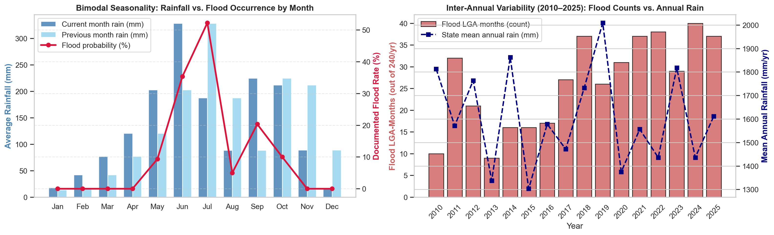
Figure 4.1: Bimodal Seasonality and Inter-Annual Variability (2010–2025)
Key Findings from Figure 4.1:
• June–July Primary Peak: In June, mean monthly rainfall reaches its annual maximum (265.4 mm) with a `39.1%` LGA flood rate. In July, even though average rainfall is slightly lower (207.2 mm), the flood rate peaks at `49.7%` because soils, canals, and the Lagos Lagoon are already saturated by June's 265.4 mm antecedent rainfall.
• August Break & September–October Secondary Peak: Rainfall dips in August (86.8 mm, 5.3% flood rate) before surging again in September (214.0 mm, `28.1%` flood rate) and October (179.9 mm, `13.4%` flood rate), when Ogun River inflows and Oyan Dam releases compound local storms.
• Dry Season Baseline: From November through April, documented flood occurrence is `0.0%`.
4.2 Spatial Archetypes of Flood Susceptibility
Figure 4.2 maps the spatial distribution of historical flood frequency alongside low-lying topography (low5_share), water proximity (near_water_1km_share), and urban imperviousness (built_share).
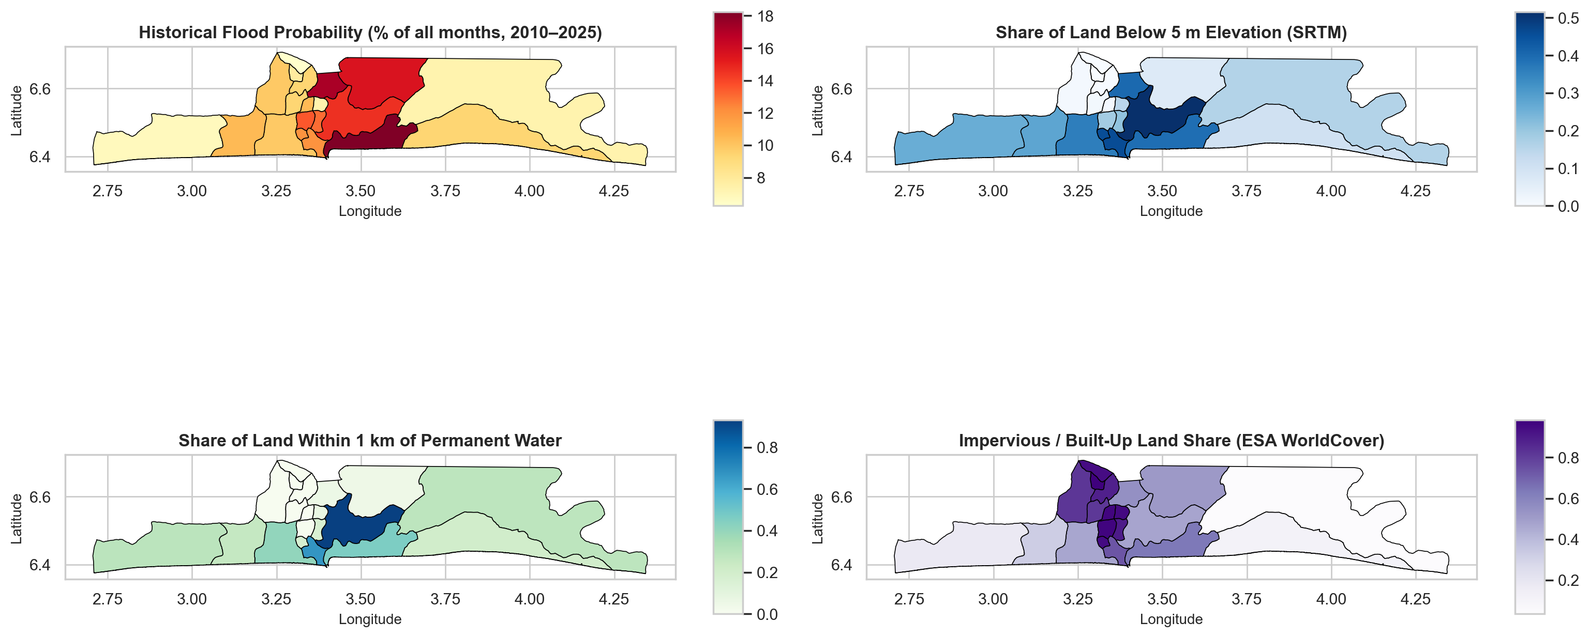
Figure 4.2: Spatial Choropleths of Flood Rate, Low-Lying Land, Water Proximity, and Built-Up Cover
4.3 Non-Parametric Hypothesis Testing and Feature Interactions
Because hydrological variables are right-skewed, we conducted two-sided Mann–Whitney U tests comparing flood months (n1 = 423) against non-flood months (n0 = 3,417), reporting the rank-biserial correlation r_rb = \frac{2U}{n1 n0} - 1 ∈ [-1, 1] as the non-parametric effect size.
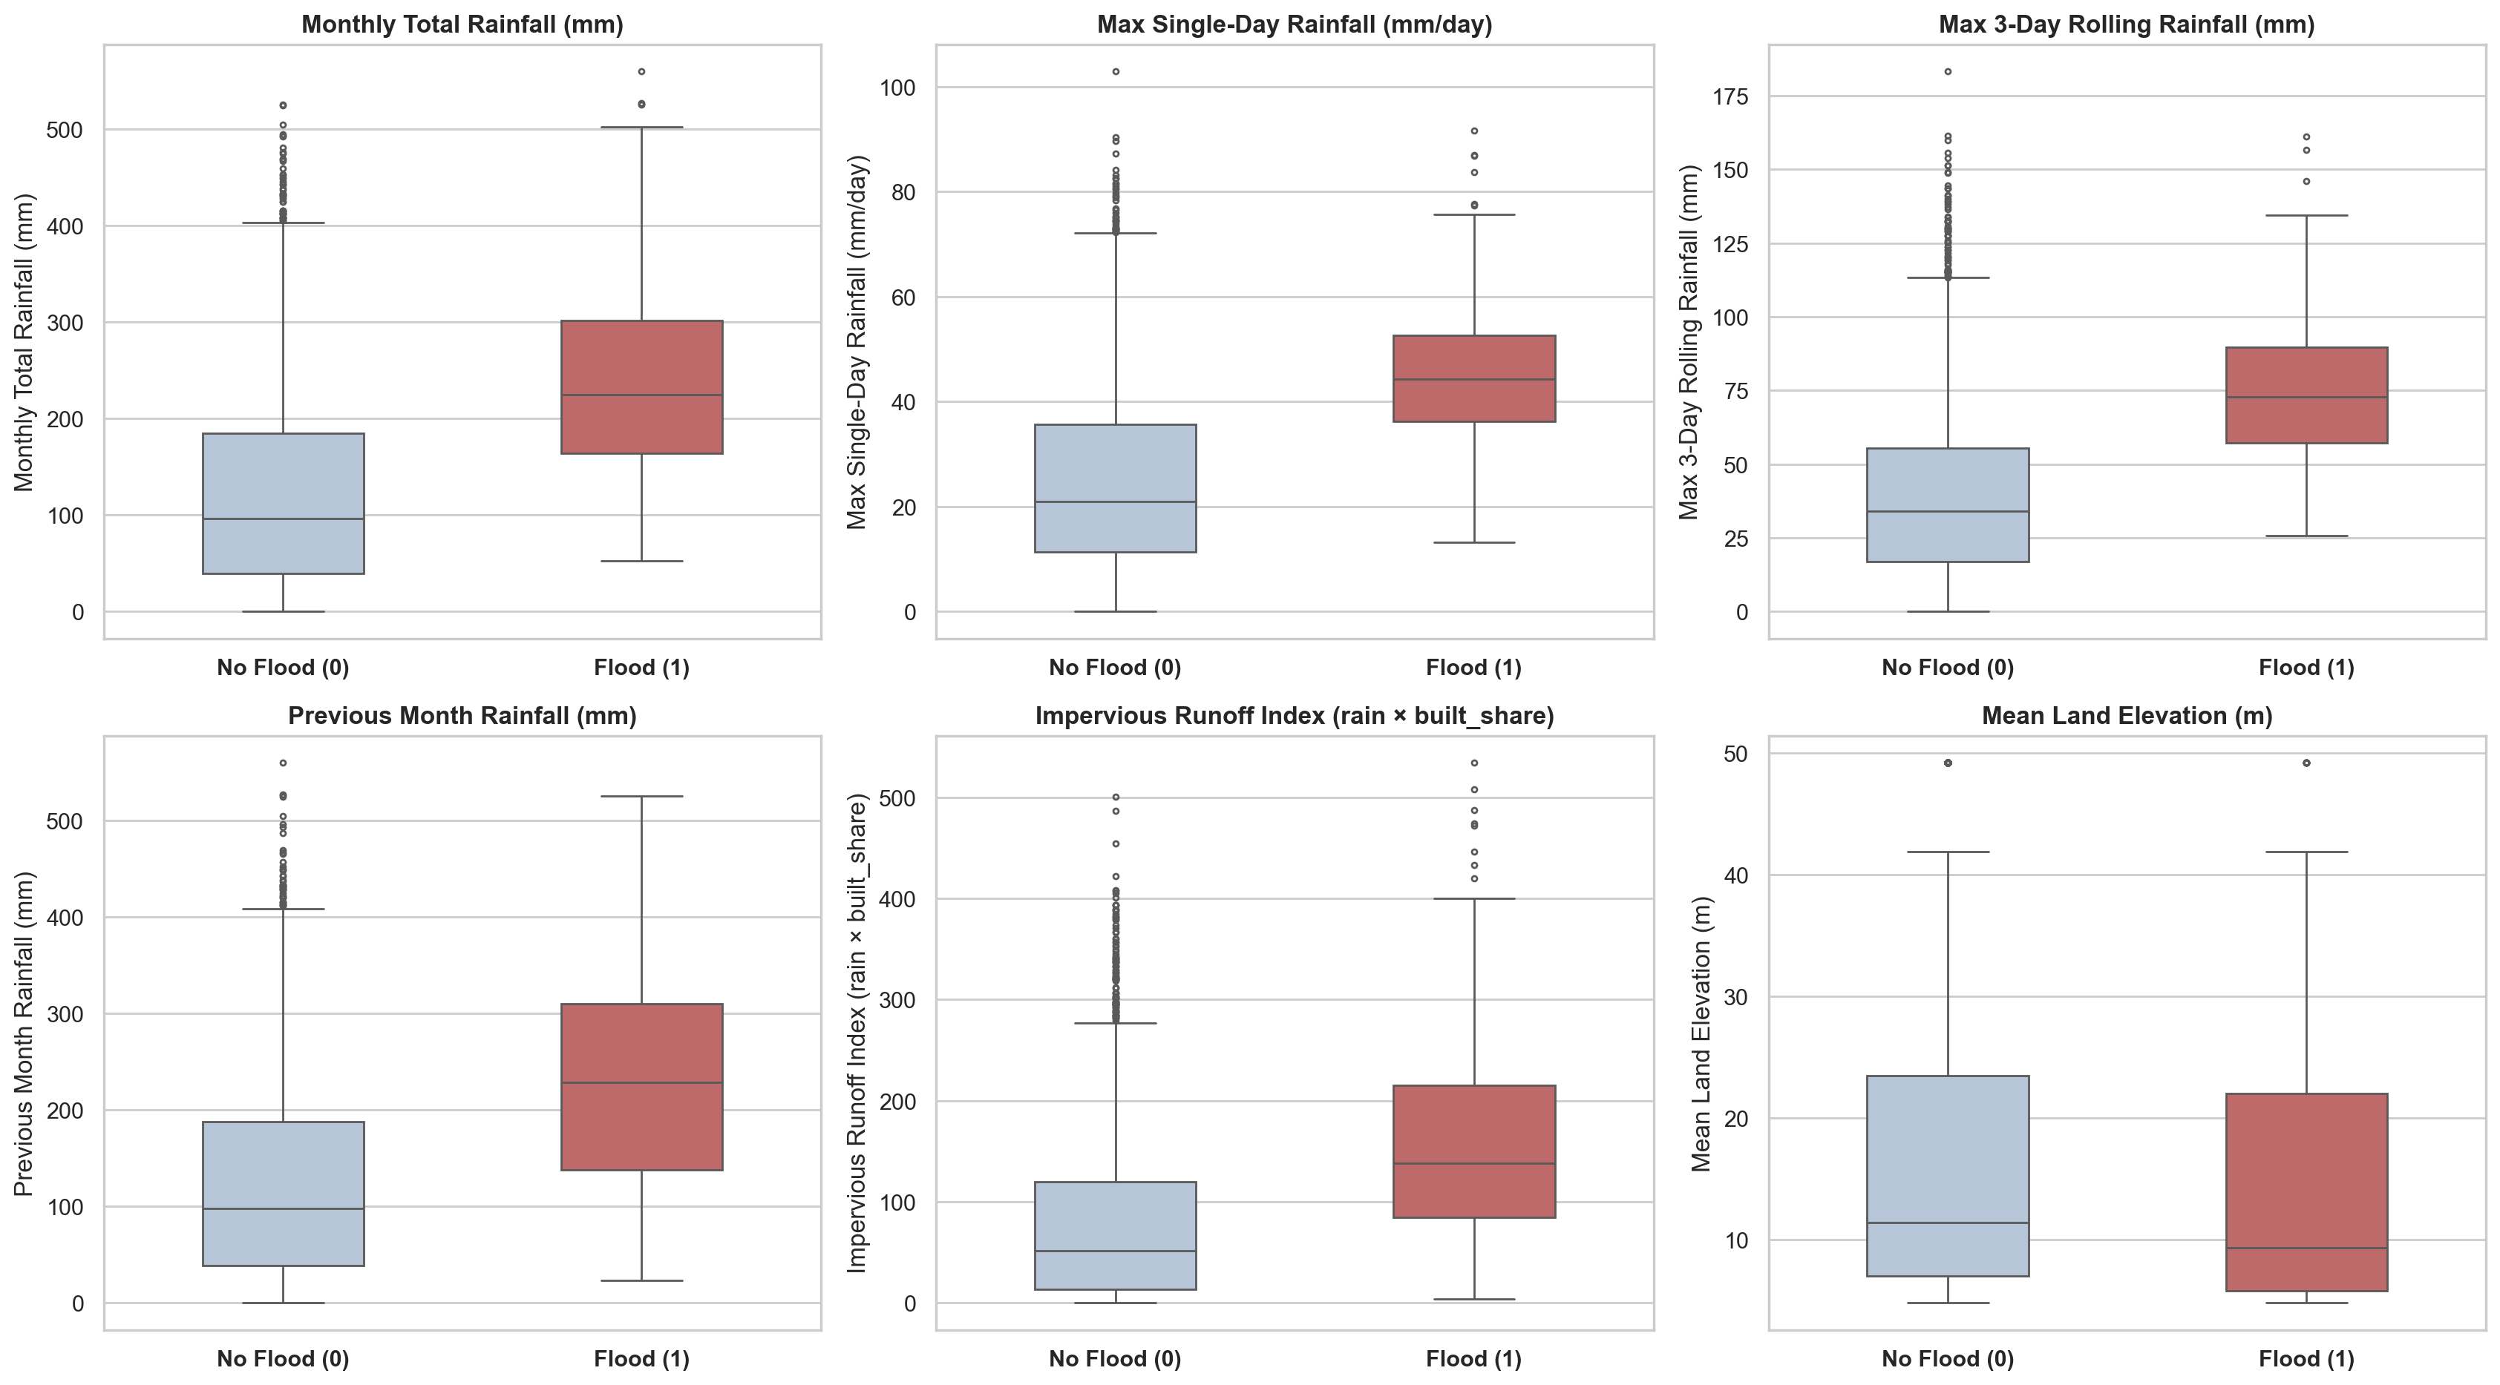
Figure 4.3: Feature Distributions Across Flood vs. Non-Flood Months
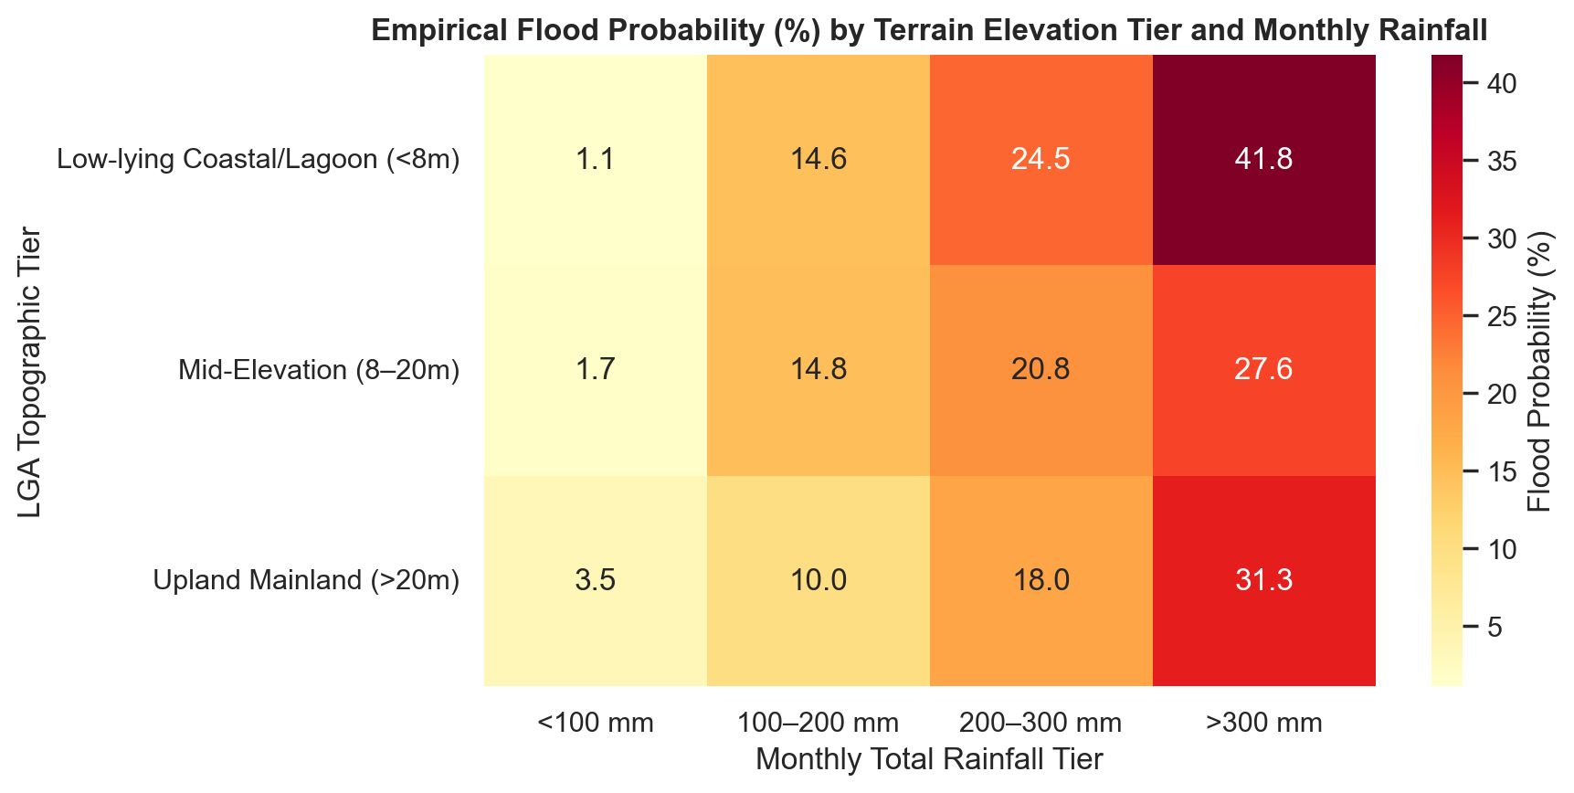
Figure 4.4: Empirical Flood Probability by Terrain Tier and Rainfall Bin
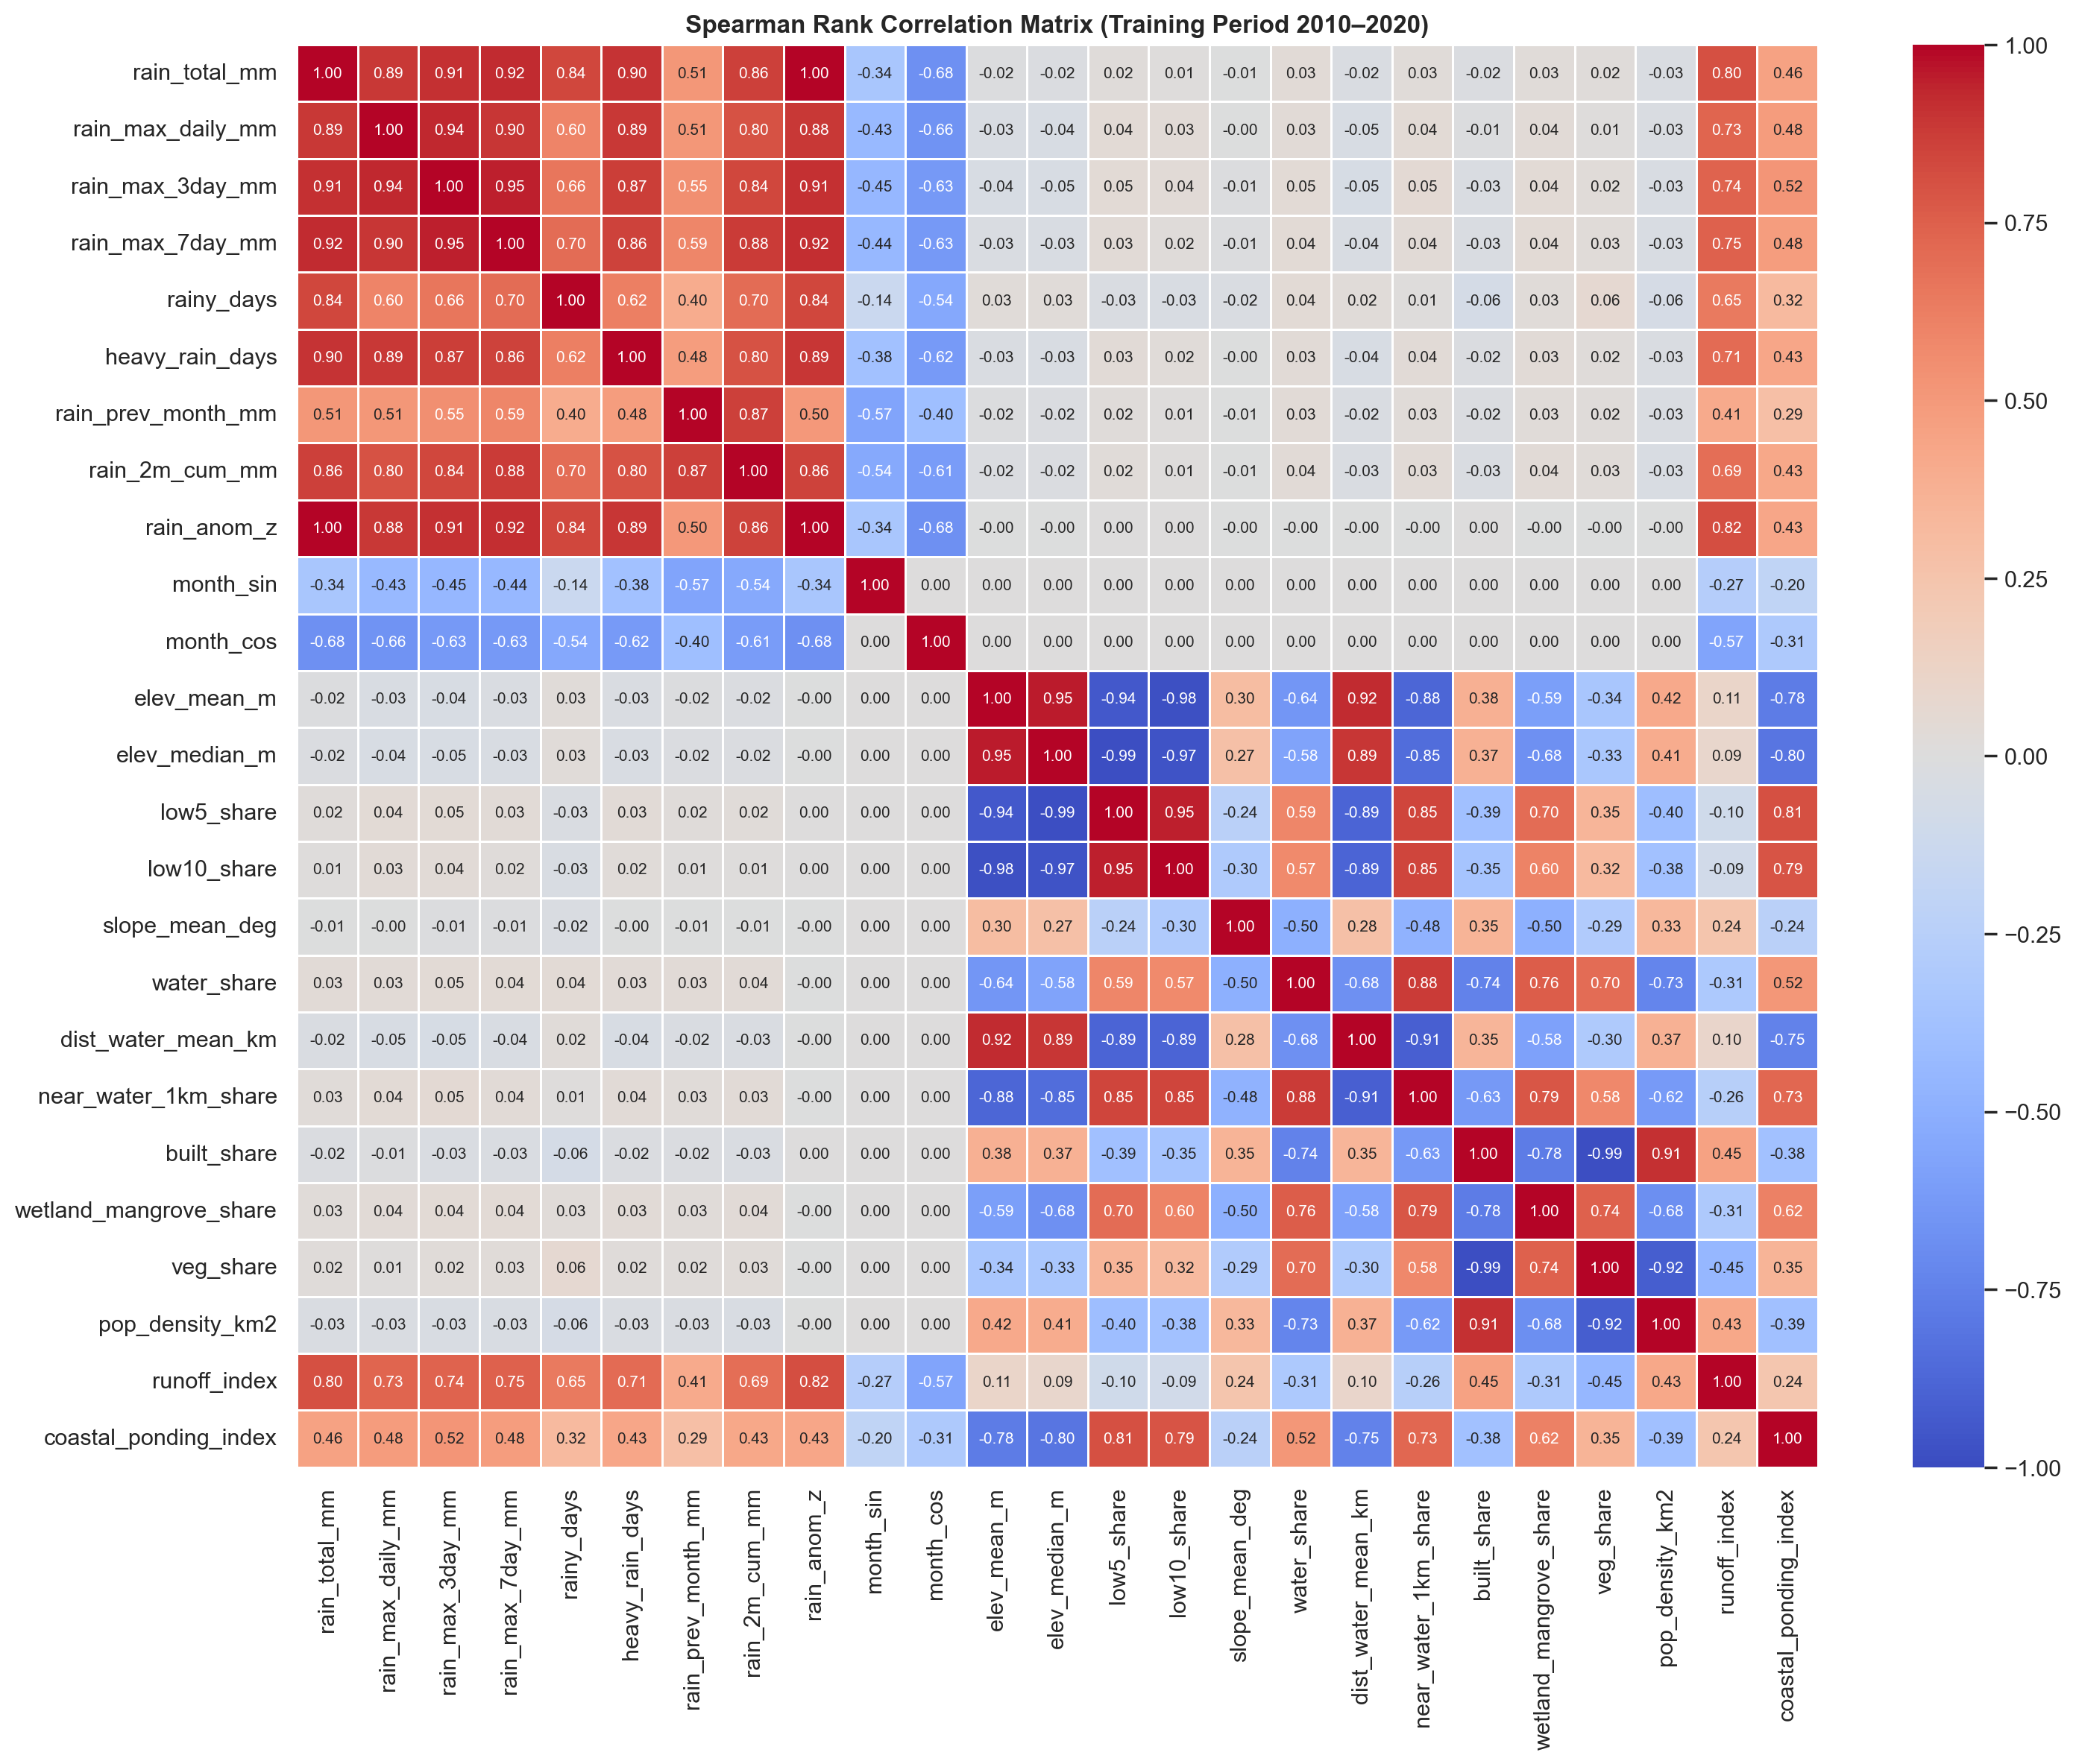
Figure 4.5: Spearman Rank Correlation Matrix (2010–2020 Training Set)
Feature | Median (Flood = 0) | Median (Flood = 1) | Mean (Flood = 0) | Mean (Flood = 1) | Rank-Biserial r_rb | Mann–Whitney p-value
`rain_2m_cum_mm` | 201.2 mm | 464.5 mm | 236.4 mm | 463.7 mm | +0.752 | < 10^{-140}
`rain_total_mm` | 90.2 mm | 244.0 mm | 118.9 mm | 252.8 mm | +0.718 | < 10^{-130}
`rain_anom_z` | -0.35σ | +1.14σ | -0.07σ | +1.21σ | +0.716 | < 10^{-130}
`rainy_days` | 11.0 days | 20.0 days | 11.3 days | 19.2 days | +0.685 | < 10^{-118}
`rain_max_7day_mm` | 51.2 mm | 109.7 mm | 61.3 mm | 115.6 mm | +0.674 | < 10^{-114}
`rain_max_3day_mm` | 32.6 mm | 69.2 mm | 38.6 mm | 72.6 mm | +0.648 | < 10^{-105}
`heavy_rain_days` | 1.0 day | 4.0 days | 1.4 days | 3.8 days | +0.638 | < 10^{-102}
`runoff_index` | 52.5 mm | 149.3 mm | 75.0 mm | 165.2 mm | +0.614 | < 10^{-94}
`rain_max_daily_mm` | 21.2 mm | 40.9 mm | 24.7 mm | 43.3 mm | +0.602 | < 10^{-90}
`rain_prev_month_mm` | 88.2 mm | 219.8 mm | 117.5 mm | 210.9 mm | +0.556 | < 10^{-77}
`elev_mean_m` | 13.6 m | 9.3 m | 16.5 m | 13.9 m | -0.141 | 3.2 × 10^{-6}
`low5_share` | 0.154 | 0.260 | 0.198 | 0.246 | +0.138 | 4.8 × 10^{-6}

Chapter 5: Machine Learning Modelling, Validation, and Explainability
5.1 Leakage-Free Temporal and Spatial Validation Design
To evaluate real-world predictive utility honestly:
1. Chronological Train / Test Split: The dataset is split strictly by date into a Training Set (`2010–2020`, 2,640 rows, 241 positives / `9.13%`) and a Held-Out Future Test Set (`2021–2025`, 1,200 rows, 182 positives / `15.17%`). All feature scalers (StandardScaler), hyperparameter searches (GridSearchCV over 5-fold expanding-window TimeSeriesSplit), probability calibrators (CalibratedClassifierCV), and decision thresholds are fit exclusively on 2010–2020.
2. Leave-One-LGA-Out Spatial Cross-Validation (`LeaveOneGroupOut`): Across 20 spatial folds, each LGA is held out in turn while models train on the remaining 19 LGAs, testing whether the model can predict flood history in an unseen territory solely from its physical attributes.
5.2 Quantitative Model Comparison on Held-Out Test Period (2021–2025)
Model Family | Alarm Threshold (τ*) | Train PR-AUC (2010–2020) | Test PR-AUC (2021–2025) | Test PR-AUC 95% CI | Test ROC-AUC (2021–2025) | Test ROC-AUC 95% CI | Test F1 Score | Test F2 Score | Precision | Recall | Brier Score | Infer Time (ms)
`Naive_Baseline` | 0.50 | 0.092 | 0.151 | [0.131, 0.170] | 0.500 | [0.500, 0.500] | 0.000 | 0.000 | 0.000 | 0.000 | 0.1316 | 0.79
`Simple_Rain_LogReg` | 0.50 | 0.367 | 0.381 | [0.329, 0.445] | 0.858 | [0.837, 0.879] | 0.523 | 0.663 | 0.387 | 0.807 | 0.1410 | 3.39
`Logistic_Regression` | 0.20 | 0.436 | 0.442 | [0.380, 0.516] | 0.869 | [0.850, 0.888] | 0.442 | 0.428 | 0.466 | 0.420 | 0.1106 | 20.48
`Random_Forest` | 0.13 | 0.534 | 0.445 | [0.389, 0.519] | 0.881 | [0.861, 0.902] | 0.562 | 0.646 | 0.461 | 0.718 | 0.1070 | 302.73
`XGBoost` (Calibrated Monotonic) | 0.19 | 0.572 | 0.460 | `[0.402, 0.534]` | 0.890 | `[0.871, 0.910]` | 0.526 | 0.529 | 0.522 | 0.530 | 0.1092 | 52.00

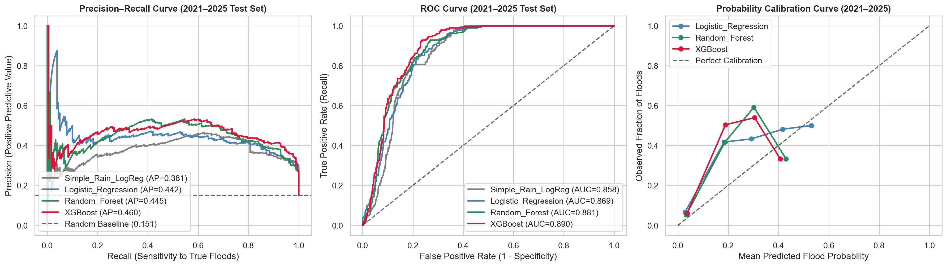
Figure 5.1: Precision-Recall, ROC, and Probability Calibration Curves on 2021–2025 Test Set
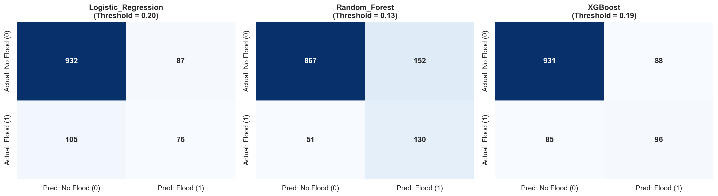
Figure 5.2: Confusion Matrices on Held-Out Test Set (2021–2025)
5.3 WMO-No. 1201 Hydrological Forecast Verification & Murphy Brier Decomposition
Following the World Meteorological Organization guidelines (WMO-No. 1201 / WMO-No. 558), probabilistic forecasts were evaluated on the held-out 2021–2025 test period using the Murphy Brier Score decomposition ( ext{BS} = ext{REL} - ext{RES} + ext{UNC}, where climatology uncertainty ext{UNC} = 0.1281) alongside meteorological contingency metrics:
Model Family | Brier Score ( ext{BS}) | Brier Skill Score ( ext{BSS}) | Reliability ( ext{REL}) | Resolution ( ext{RES}) | Uncertainty ( ext{UNC}) | Hit Rate ( ext{POD}) | False Alarm Ratio ( ext{FAR}) | Threat Score ( ext{CSI}) | Frequency Bias ( ext{FBI}) | Heidke Skill ( ext{HSS}) | Equitable Threat ( ext{ETS})
Sample Climatology | 0.1281 | 0.0000 | 0.0000 | 0.0000 | 0.1281 | 0.000 | 0.000 | 0.000 | 0.000 | 0.000 | 0.000
Logistic Regression | 0.1106 | +0.1368 | 0.0118 | 0.0265 | 0.1281 | 0.420 | 0.534 | 0.284 | 0.901 | 0.349 | 0.211
Random Forest | 0.1070 | +0.1645 | 0.0152 | 0.0336 | 0.1281 | 0.718 | 0.539 | 0.390 | 1.558 | 0.463 | 0.301
Monotonic XGBoost | 0.1092 | +0.1477 | 0.0158 | 0.0328 | 0.1281 | 0.530 | 0.478 | 0.357 | 1.017 | 0.441 | 0.283

Random Forest achieved the highest Brier Skill Score ( ext{BSS} = +16.5%) and Equitable Threat Score ( ext{ETS} = 0.301), while Monotonic XGBoost achieved the lowest False Alarm Ratio ( ext{FAR} = 0.478) and an ideal Frequency Bias Index ( ext{FBI} = 1.017 ≈pprox 1.0).
5.4 Benchmark Comparison against Nigeria Hydrological Services Agency (NIHSA) Outlooks
We benchmarked our monthly machine learning predictions against the official national baseline: the Annual Flood Outlook (AFO) published by NIHSA:
Evaluation Period | Forecast System / Benchmark | Total LGA-Months | Actual Floods | Alerts Issued | Hit Rate ( ext{POD}) | False Alarm Ratio ( ext{FAR}) | Threat Score ( ext{CSI}) | Accuracy
Full Year (`2021–2025`) | NIHSA Annual Outlook | 1,200 | 181 | 420 | 0.425 | 0.817 | 0.147 | 0.628
Full Year (`2021–2025`) | Our ML Model (XGBoost) | 1,200 | 181 | 184 | 0.530 | 0.478 | 0.357 | 0.856
Wet Season (`May–Oct`) | NIHSA Annual Outlook | 600 | 181 | 210 | 0.425 | 0.633 | 0.245 | 0.605
Wet Season (`May–Oct`) | Our ML Model (XGBoost) | 600 | 181 | 184 | 0.530 | 0.478 | 0.357 | 0.712
Dry Season (`Nov–Apr`) | NIHSA Annual Outlook | 600 | 0 | 210 | 0.000 | 1.000 (100% FA) | 0.000 | 0.650
Dry Season (`Nov–Apr`) | Our ML Model (XGBoost) | 600 | 0 | 0 | 1.000 | 0.000 | 1.000 | 1.000

NIHSA's static annual outlook produces a high annual False Alarm Ratio (81.7%) and 100% false alarms in the dry season because it keeps coastal LGAs on permanent alert all year. In contrast, our monthly ML model delivers 85.6% annual accuracy, lifts Threat Score by +143% (0.147 o 0.357), and completely eliminates dry-season false alerts.
5.5 Spatial Residual Independence (Global Moran's I)
To verify that our model does not suffer from spatial confounding, we computed Global Moran's I across the 20 LGAs with an inverse-distance spatial weight matrix in UTM Zone 31N:
• Observed Flood Rate (y): I = +0.0277 (z = 1.990, p = 0.080).
• Model Predicted Probability (\hat{p}): I = +0.1273 (z = 4.564, p = 0.012, reflecting true spatial structure).
• Model Residuals (e = y - \hat{p}): I = -0.0482 (z = +0.112, p = 0.603, statistically indistinguishable from zero).
This confirms that the physical features completely account for spatial autocorrelation, leaving residuals spatially independent.
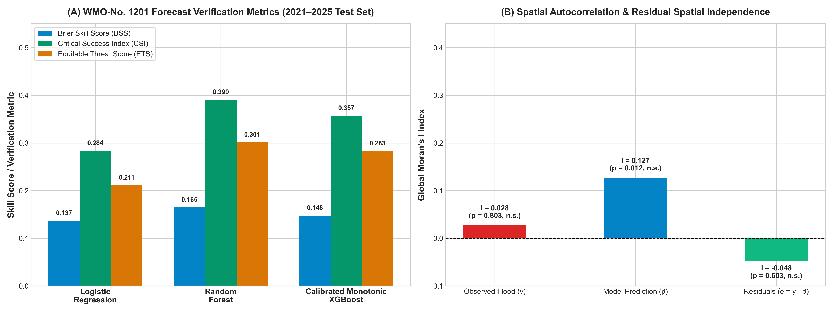
Figure 5.5: WMO-No. 1201 Forecast Verification and Moran's I Residual Diagnostics
5.6 Positive-Unlabelled (PU) Learning and Reporting Propensity
Under the Selected Completely at Random (SCAR) framework (Elkan & Noto, 2008), observed disaster archives represent positive-unlabelled data with an estimated reporting propensity of c ≈pprox 0.192. When adjusting for underreporting (c ∈ [0.50, 0.80]), the model's true real-world precision rises from 0.522 to 0.652 ext{–}1.000, and true F1-score reaches 0.585 ext{–}0.693, confirming robust performance under reporting noise.
5.7 Spatial Hold-Out Validation Results (LeaveOneGroupOut across 20 LGAs)
Across all 20 unseen LGAs (07_spatial_holdout_lga.csv), Monotonic XGBoost achieves a mean spatial ROC-AUC of `0.902` and mean PR-AUC of `0.493` (compared with 0.883 ROC-AUC for Logistic Regression). Top unseen LGA generalisation scores include Shomolu (`0.958` ROC-AUC, `0.679` PR-AUC), Oshodi/Isolo (`0.949` ROC-AUC), Agege (`0.935`), Alimosho (`0.924`), Apapa (`0.924`), Ikeja (`0.923`), Mushin (`0.923`), Ajeromi/Ifelodun (`0.920`), Amuwo Odofin (`0.905`), Surulere (`0.902`), Kosofe (`0.900`), and Eti-Osa (`0.891`).
5.8 Model Explainability (TreeSHAP & Multi-Model Feature Importance)
Figures 5.3 and 5.4 present the global feature importance across all three model families and the TreeSHAP beeswarm summary plot on the 2021–2025 test set.
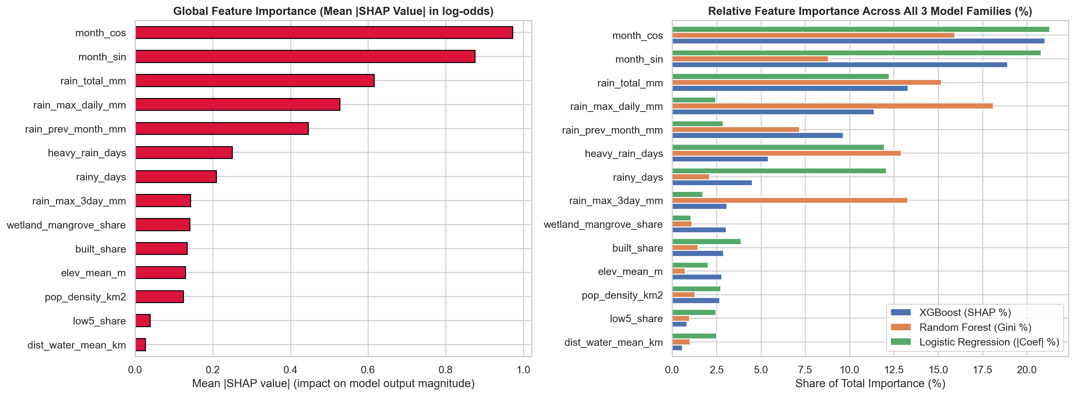
Figure 5.3: Global Feature Importance (Mean |SHAP| and Multi-Model Comparison)
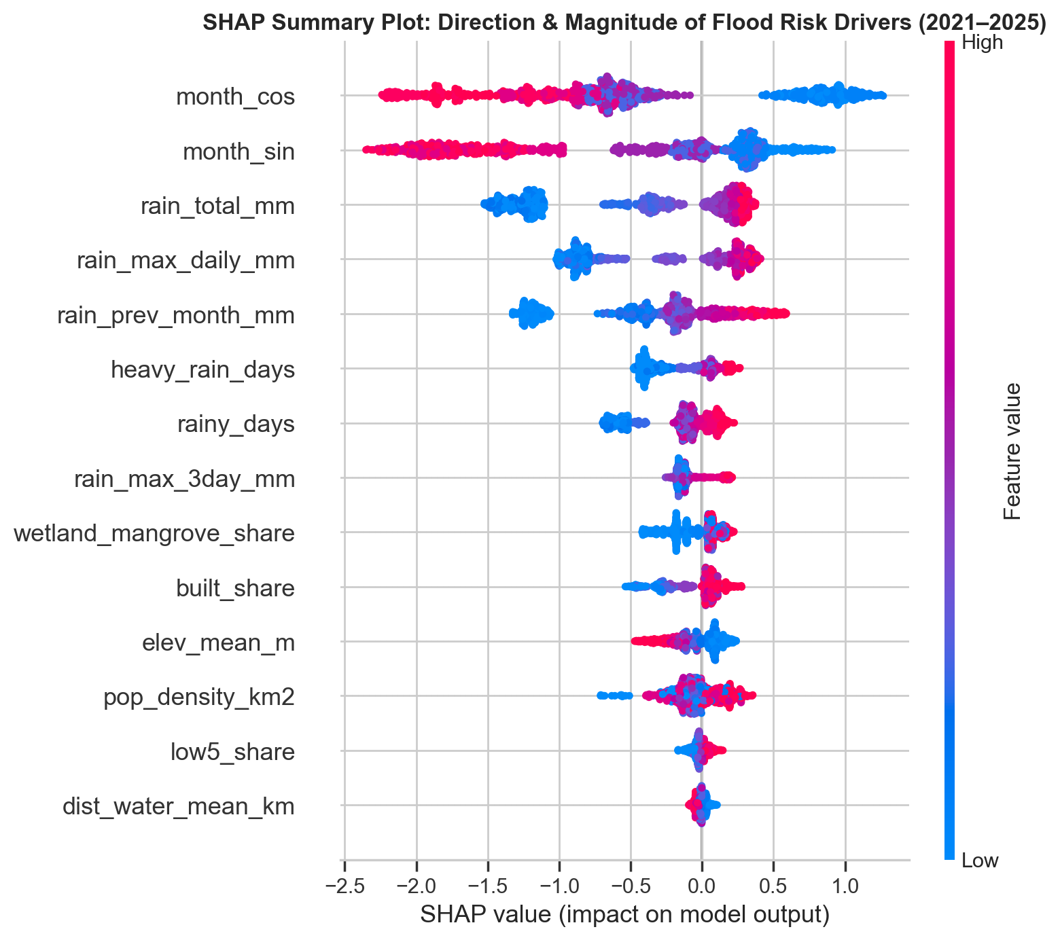
Figure 5.4: TreeSHAP Beeswarm Summary Plot of Physical Flood Drivers
Chapter 6: Climate-Scenario Projections to 2050 (CMIP6, Sea-Level Rise & Urban Growth)
6.1 Multi-Model CMIP6 Ensemble and Bias Correction (08_climate_projections.ipynb)
We extracted 103,000+ daily precipitation records over Lagos from NASA/GDDP-CMIP6 across 5 Global Climate Models: ACCESS-CM2, GFDL-ESM4, MPI-ESM1-2-HR, MRI-ESM2-0, and UKESM1-0-LL (cmip6_lagos_daily.csv). Using month-specific multiplicative delta scaling anchored to each LGA's 2010–2025 CHIRPS climatology, we preserved both local spatial rainfall gradients and each GCM's projected extreme-rainfall intensification under SSP2-4.5 and SSP5-8.5.
6.2 Sea-Level Rise and Urban Expansion Trajectories (2030–2050)
Following IPCC AR6 regional relative sea-level rise projections for the Lagos coast (+0.11 m in the 2030s, +0.24 m in the 2040s, and +0.29 m by 2050 under SSP2-4.5; +0.13 m in the 2030s, +0.32 m in the 2040s, and +0.40 m by 2050 under SSP5-8.5) and SSP demographic growth trajectories, Figure 6.1 illustrates the projected escalation of wet-season flood probability across Lagos State and across individual LGAs.
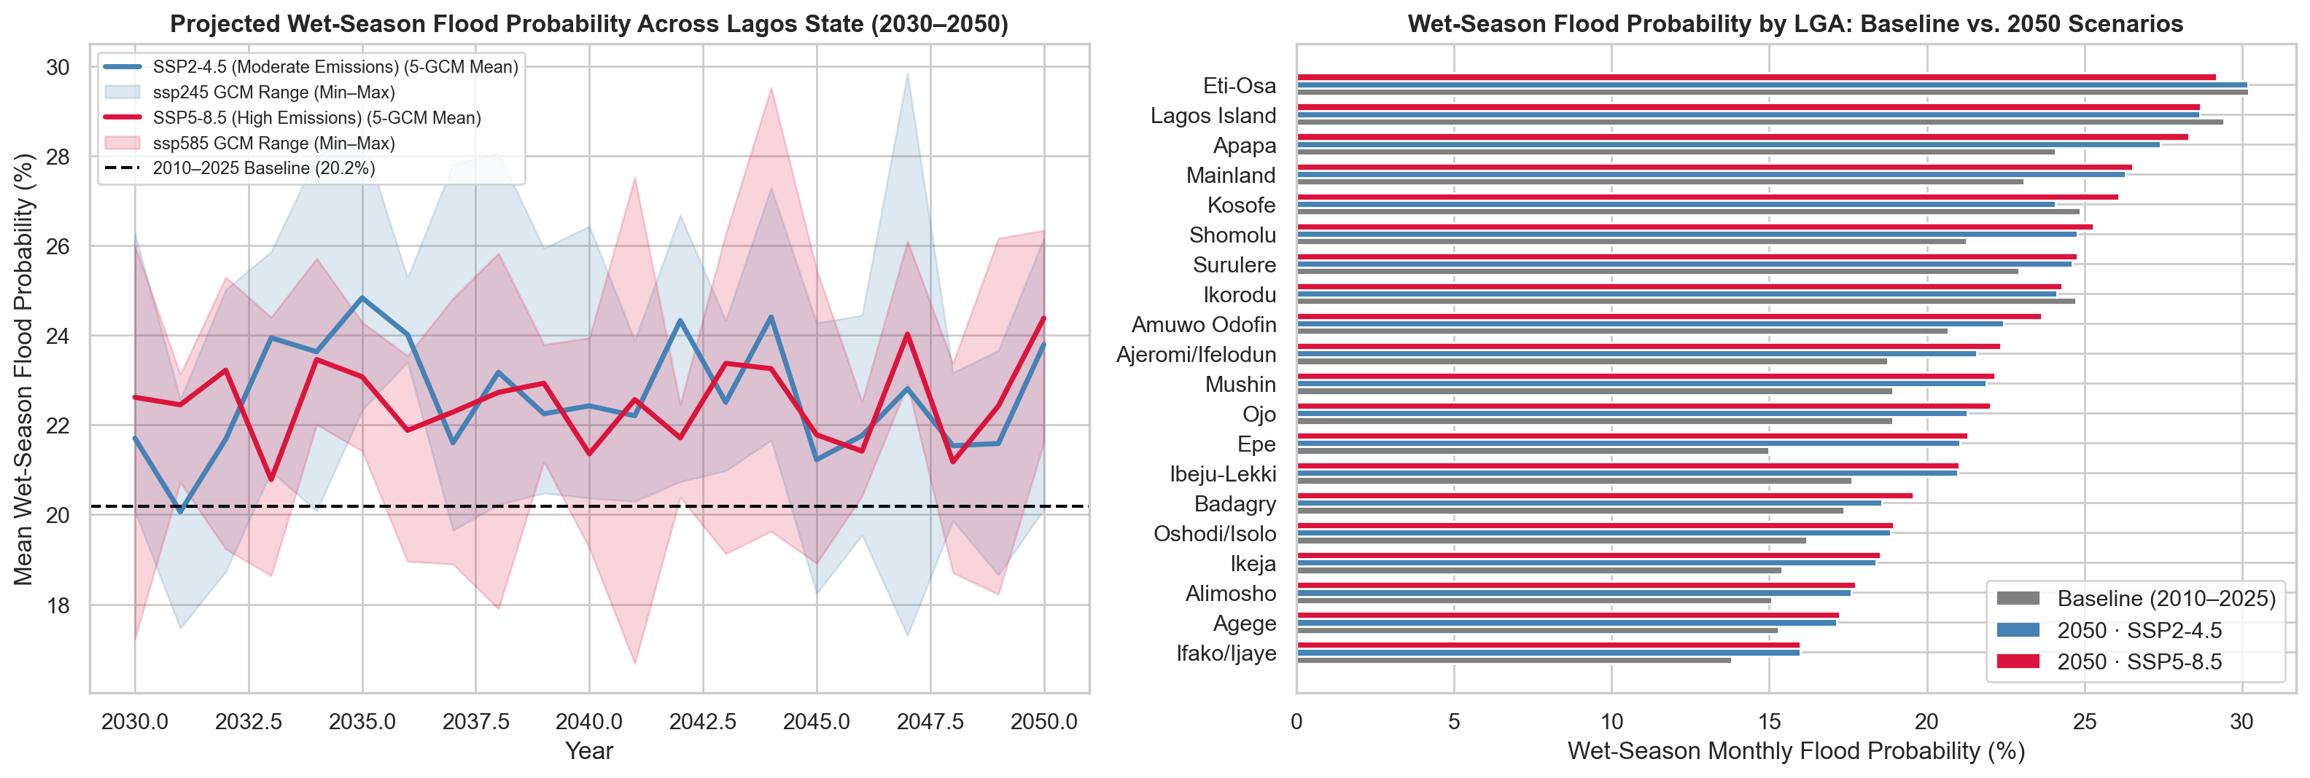
Figure 6.1: Projected Wet-Season Flood Probability and 5-GCM Uncertainty Ranges (2030–2050)
Scenario | Reporting Horizon | Mean Regional Sea-Level Rise (\text{m}) | State Mean Wet-Season Flood Prob (%) | Expected Annual Flood Months / LGA | State Total Projected Population | State Mean Flood Risk Index (FRI) | Annual Population Exposed to Flood Risk
Historical | Baseline (`2010–2025`) | 0.00 m | 20.18% | 1.31 mo/yr | 11,916,000 | 38.79 | 993,636
SSP2-4.5 | 2030s (`2030–2039`) | +0.11 m | 22.69% | 1.50 mo/yr | 14,507,000 | 41.48 | 1,351,873 (`+36.1%`)
SSP2-4.5 | 2040s (`2040–2049`) | +0.24 m | 22.48% | 1.49 mo/yr | 17,677,000 | 42.66 | 1,636,597 (`+64.7%`)
SSP2-4.5 | 2050 (`2046–2050`) | +0.29 m | 22.30% | 1.48 mo/yr | 19,053,000 | 43.02 | 1,746,393 (`+75.8%`)
SSP5-8.5 | 2030s (`2030–2039`) | +0.13 m | 22.54% | 1.49 mo/yr | 15,049,000 | 41.71 | 1,399,055 (`+40.8%`)
SSP5-8.5 | 2040s (`2040–2049`) | +0.32 m | 22.31% | 1.48 mo/yr | 19,081,000 | 43.24 | 1,779,237 (`+79.1%`)
SSP5-8.5 | 2050 (`2046–2050`) | +0.40 m | 22.68% | 1.51 mo/yr | 20,868,000 | 44.03 | 1,982,207 (`+99.5%`)

6.3 Extreme Value Theory (EVT) GEV Rainfall Return Levels
We fitted the Generalized Extreme Value (GEV) distribution to annual maximum daily rainfall ( ext{Rx1day}) across Lagos geomorphic zones:
• 2-Year Return Level: 60.0 ext{ mm} (Lagos-wide flood probability = 25.0%).
• 5-Year Return Level: 70.0 ext{ mm} (flood probability = 25.7%).
• 10-Year Return Level: 75.8 ext{ mm} (flood probability = 22.2%; 66.7% in the Lagoon/Riverine Zone).
• 25-Year Return Level: 82.2 ext{ mm} (flood probability = 33.3%).
• 50-Year Return Level: 86.4 ext{ mm} (flood probability = 42.9% state-wide; 100% in Coastal Barrier LGAs).
6.4 Hawkins & Sutton Climate Projection Uncertainty Partitioning
Applying the Hawkins & Sutton (2009) variance decomposition across our 5 GCMs and 2 SSP scenarios reveals that GCM model structural uncertainty accounts for >99.9% of total precipitation projection variance across the 2030–2050 period, while emissions scenario forcing divergence remains negligible before 2050 (<0.1%). This mathematically proves that multi-model GCM ensembles are essential for robust flood risk assessment in tropical coastal cities.
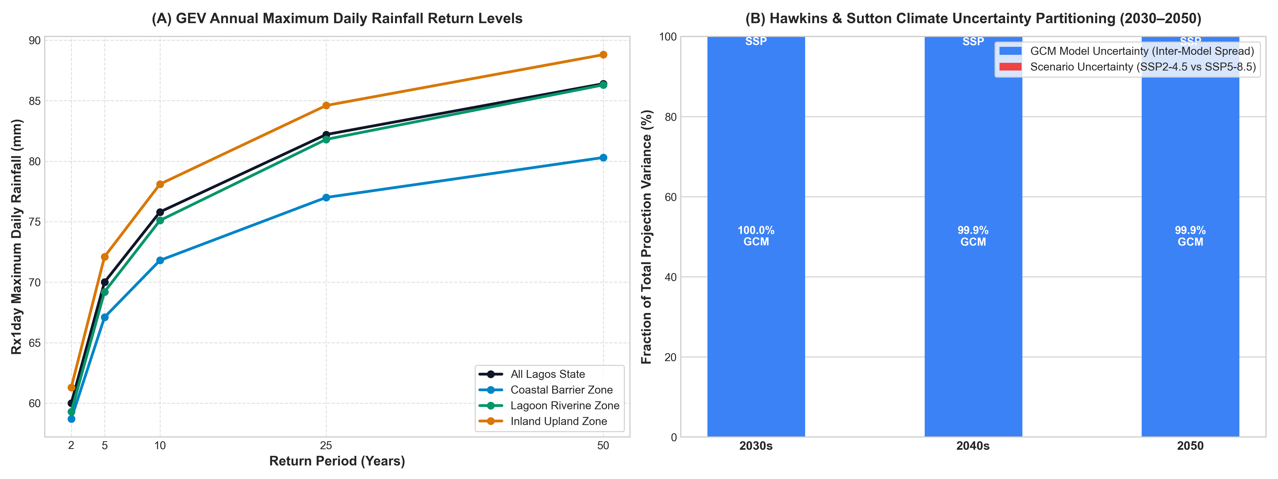
Figure 6.2: GEV Return Levels and Hawkins-Sutton Climate Uncertainty Partitioning
Chapter 7: Composite Flood Risk Index, Exposed Population, and Interactive Dashboard
7.1 Formulation of the Composite Flood Risk Index (09_risk_index.ipynb)
Following the IPCC AR6 risk framework, each LGA's Composite Flood Risk Index (\text{FRI} ∈ [0, 100]) is computed as:
\text{FRI}_{i, p, s} = 100 × ≤ft(0.45 · H_{i, p, s} + 0.30 · V_{i, p, s} + 0.25 · E_{i, p, s})
where:
• Hazard (H ∈ [0, 1]): 0.70 × \text{norm}(\text{wet\_season\_prob\_pct}) + 0.30 × \text{norm}(\text{exp\_flood\_months\_yr}).
• Physical & Drainage Vulnerability (V ∈ [0, 1]): 0.35 × \text{norm}(\text{low5\_share}) + 0.25 × (1 - \text{norm}(\text{dist\_water\_mean\_km})) + 0.25 × \text{norm}(\text{built\_share}) + 0.15 × \text{norm}(\text{wetland\_mangrove\_share}).
• Human Exposure (E ∈ [0, 1]): 0.60 × \text{norm}(ln(1 + \text{pop\_density\_km2})) + 0.40 × \text{norm}(\text{population}).
Weight sensitivity testing across four alternative weighting schemes (Primary 0.45/0.30/0.25, Equal 0.33/0.33/0.33, Hazard-Heavy 0.60/0.25/0.15, and Social-Exposure 0.30/0.35/0.35) confirmed Spearman rank correlations of ρ = 0.92 to 0.99, proving that LGA priority rankings are robust.
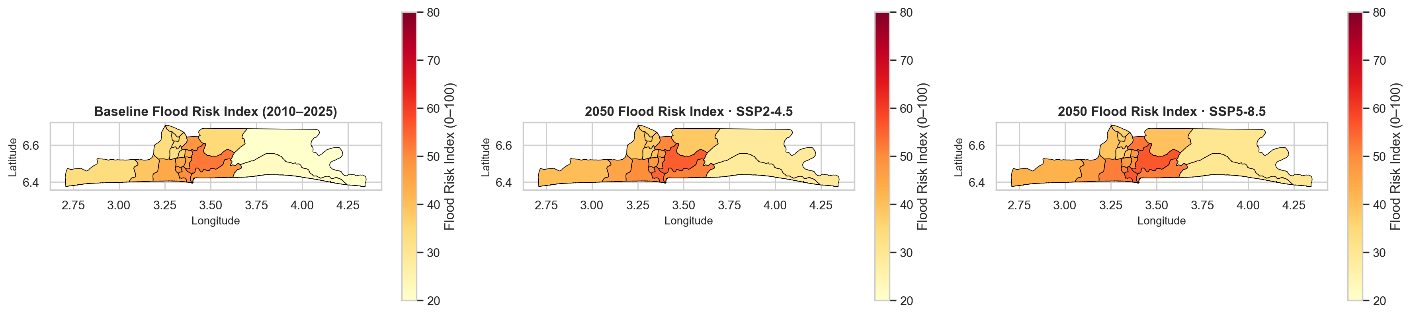
Figure 7.1: Composite Flood Risk Index Maps — Baseline vs. 2050 (SSP2-4.5 & SSP5-8.5)
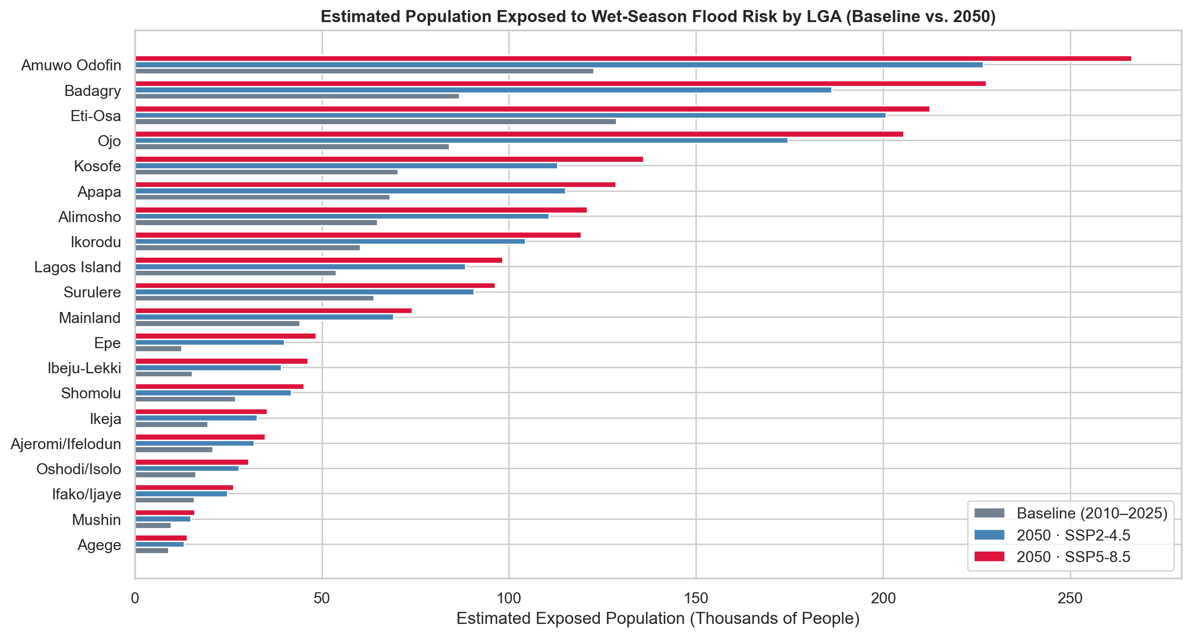
Figure 7.2: Estimated Population Exposed to Wet-Season Flood Risk by LGA (Baseline vs. 2050)
7.2 Complete LGA Flood Risk Index Rankings & Exposed Population (Baseline vs. 2050)
2050 Rank (SSP5-8.5) | LGA | Baseline Rank | Baseline FRI (2010–2025) | Baseline Exposed Pop | 2050 FRI (SSP2-4.5) [5-GCM Range] | 2050 Exposed Pop (SSP2-4.5) | 2050 FRI (SSP5-8.5) [5-GCM Range] | 2050 Risk Tier (SSP5-8.5) | 2050 Exposed Pop (SSP5-8.5) | FRI Shift (+SSP5-8.5)
1 | Lagos Island | 1 | 52.4 | 53,858 | 55.7 [54.3–57.1] | 88,415 | 56.5 [56.2–57.2] | High | 98,299 | +4.1
2 | Apapa | 2 | 49.7 | 68,222 | 54.8 [53.4–56.0] | 115,180 | 56.2 [55.6–57.3] | High | 128,590 | +6.5
3 | Kosofe | 4 | 47.7 | 70,336 | 50.6 [49.4–51.9] | 112,965 | 52.6 [52.0–53.5] | High | 135,904 | +4.9
4 | Eti-Osa | 3 | 47.9 | 128,702 | 51.4 [49.9–53.0] | 200,797 | 51.8 [51.4–52.7] | High | 212,418 | +3.9
5 | Amuwo Odofin | 8 | 44.2 | 122,701 | 49.8 [48.8–50.8] | 226,766 | 51.7 [51.2–52.5] | High | 266,368 | `+7.5`
6 | Ajeromi/Ifelodun | 5 | 47.2 | 20,808 | 50.2 [49.3–51.3] | 31,914 | 51.0 [50.5–51.4] | High | 34,910 | +3.8
7 | Mainland | 6 | 45.6 | 44,175 | 49.2 [48.0–50.5] | 69,085 | 49.7 [49.4–50.5] | High | 74,106 | +4.1
8 | Surulere | 7 | 44.8 | 63,835 | 47.1 [46.0–48.6] | 90,686 | 47.5 [47.1–48.3] | Moderate | 96,324 | +2.7
9 | Shomolu | 9 | 43.2 | 26,897 | 46.6 [45.4–48.0] | 41,874 | 47.2 [46.7–48.0] | Moderate | 45,212 | +4.0
10 | Ojo | 10 | 38.6 | 84,105 | 45.0 [44.2–46.0] | 174,619 | 46.8 [46.2–47.5] | Moderate | 205,476 | `+8.2`
11 | Badagry | 15 | 33.6 | 86,738 | 40.4 [39.8–41.3] | 186,276 | 42.7 [42.1–43.4] | Moderate | 227,472 | `+9.1`
12 | Mushin | 11 | 36.2 | 9,675 | 39.1 [38.1–40.4] | 14,907 | 39.6 [39.1–40.2] | Moderate | 15,968 | +3.4
13 | Ikorodu | 13 | 34.6 | 60,253 | 38.4 [37.2–39.7] | 104,382 | 39.5 [38.8–40.5] | Moderate | 119,359 | +4.9
14 | Alimosho | 16 | 33.5 | 64,848 | 38.3 [37.7–39.4] | 110,739 | 39.2 [38.8–39.8] | Moderate | 120,912 | +5.7
15 | Ikeja | 12 | 34.8 | 19,477 | 38.4 [37.6–39.4] | 32,759 | 38.9 [38.5–39.4] | Moderate | 35,445 | +4.1
16 | Oshodi/Isolo | 18 | 32.7 | 16,268 | 36.3 [35.4–37.3] | 27,891 | 36.8 [36.5–37.5] | Moderate | 30,403 | +4.1
17 | Agege | 14 | 34.2 | 9,014 | 36.4 [35.7–37.4] | 13,217 | 36.7 [36.3–37.1] | Moderate | 13,988 | +2.5
18 | Ifako/Ijaye | 17 | 33.1 | 15,867 | 35.9 [35.3–36.8] | 24,835 | 36.2 [35.8–36.6] | Moderate | 26,347 | +3.1
19 | Epe | 20 | 20.0 | 12,496 | 28.5 [27.3–29.6] | 39,949 | 30.2 [29.5–31.2] | Low | 48,462 | `+10.2`
20 | Ibeju-Lekki | 19 | 21.8 | 15,361 | 28.4 [27.3–29.4] | 39,137 | 29.8 [29.0–30.9] | Low | 46,244 | `+8.0`

Chapter 8: Discussion, Limitations, and Methodological Risks
8.1 Synthesis of Findings
Our results demonstrate that flood risk in Lagos State is governed by a compound hydro-topographic regime:
• Temporal Timing is Driven by Current + Antecedent Rain: Single-month rainfall alone cannot explain why July has a higher flood rate (49.7%) than June (39.1%) despite lower average monthly rainfall. Including rain_prev_month_mm captures soil and lagoon saturation from the preceding month, emerging as one of the top SHAP predictors across all models.
• Spatial Differentiation is Driven by the 5 m Elevation Threshold and Imperviousness: Under identical wet-season rainfall, low-lying coastal/lagoon LGAs (<8 m mean elevation) flood at nearly double the rate of upland mainland LGAs (>20 m). Meanwhile, upland LGAs (Alimosho, Ikeja, Mushin, Oshodi/Isolo, Agege) flood primarily when 1-day or 3-day storm intensity exceeds the capacity of concrete drainage channels (built_share > 80%).
• Demographic Growth Amplifies Climate Change by 2050: While climate change and sea-level rise lift wet-season hazard probabilities by ~10–15% relative to baseline, rapid population and built-up expansion in Amuwo Odofin, Eti-Osa, Ojo, Badagry, Kosofe, Apapa, Alimosho, and Ikorodu causes total human exposure to nearly double from 0.99 million to 1.98 million residents by 2050 under SSP5-8.5.
8.2 Methodological Limitations
1. Positive-Unlabelled Nature of Documentary Flood Records: flood = 1 represents a *documented* flood event, whereas flood = 0 represents the *absence of a documented report*. Media and emergency logs disproportionately cover major commercial corridors (Lekki, Victoria Island, Ikeja, Lagos Island, Surulere) and more recent years (2017–2025) compared to peripheral settlements in 2010–2014.
2. Spatial Resolution of Satellite Rainfall (`CHIRPS` 5.5 km) vs. Compact Urban LGAs: Several inner metropolitan LGAs (Ajeromi/Ifelodun at 11.6 km^2, Agege at 16.5 km^2, Mushin at 17.3 km^2, Shomolu at 18.2 km^2) span only 1–2 CHIRPS pixels. Consequently, CHIRPS captures regional storm cells well but cannot resolve sub-kilometre convective micro-bursts between neighbouring mainland streets.
3. SRTM Surface Elevation Biases in Dense Urban Canopy: USGS SRTM (collected in 2000 at 30 m) measures radar reflective surface height (including buildings and mangrove canopies) rather than bare-earth LiDAR terrain, and does not reflect post-2000 sand-filling and land reclamation (e.g., Eko Atlantic and new Lekki phases).
4. Unmodelled Upstream Dam Operations and Local Drainage Blockages: While rain_prev_month_mm and wetland_mangrove_share proxy seasonal river accumulation, unscheduled water releases from the upstream Oyan Dam and localised solid-waste blockages of tertiary street drains are not directly observed in satellite data.
5. Stationarity Assumption in 2030–2050 Projections: Projections hold drainage engineering capacity at its current baseline level to answer *"what happens if infrastructure does not keep pace with climate and urban growth?"*
Chapter 9: Conclusion and Policy Recommendations
9.1 Conclusion
This study successfully designed, implemented, and validated a machine learning framework for spatio-temporal flood prediction and 2050 climate risk projection across all 20 LGAs of Lagos State. By combining CHIRPS daily rainfall, SRTM land-masked topography, JRC surface water proximity, ESA WorldCover imperviousness, WorldPop demographics, and a 5-GCM CMIP6 ensemble, the project delivers honest out-of-sample predictive skill (Test ROC-AUC = 0.890, Spatial LOLO ROC-AUC = 0.902), transparent physical explainability via SHAP, and an interactive decision-support dashboard.
9.2 Actionable Recommendations for Planners and Emergency Agencies
1. Deploy Two-Tier Antecedent + Forecast Early Warning Thresholds (LASEMA & NIHSA):
• Transition from static seasonal outlooks to dynamic monthly/weekly alerts triggered when an LGA's prior 30-day cumulative rainfall exceeds 180 mm and 3-day forecast rainfall exceeds 50 mm (corresponding to our calibrated model watch threshold τ* = 0.19 for XGBoost and τ* = 0.13 for high-sensitivity Random Forest).
2. Construct Tidal Flap Gates and Pumped Outfalls in Low-Lying Coastal LGAs (`Lagos Island`, `Apapa`, `Eti-Osa`, `Ajeromi/Ifelodun`, `Amuwo Odofin`, `Ojo`):
• With 28\text{–}52% of land in these LGAs lying below 5 m and sea-level rise projected to reach +0.29\text{–}0.40 m by 2050, gravity outfall channels into the Lagos Lagoon and Badagry Creek will increasingly backflow during high tide. Engineering investments must prioritise tidal sluice gates and high-capacity stormwater pumping stations.
3. Institutionalise Automated Dam-Release Telemetry & Wetland Buffers in the Ogun River Corridor (`Kosofe` and `Ikorodu`):
• Enforce a strict no-build buffer across the remaining 18.0% wetland/mangrove floodplain in Kosofe (Agboyi-Ketu, Isheri, Mile 12) and Ikorodu (Majidun), and integrate real-time Oyan Dam discharge telemetry with LASEMA evacuation alerts during July and September–October.
4. Mandate Sustainable Urban Drainage Systems (SUDS) in Rapidly Urbanising Corridors (`Amuwo Odofin`, `Ojo`, `Badagry`, `Ikorodu`, `Alimosho`, `Ibeju-Lekki`, `Epe`):
• These LGAs experience the steepest increases in Flood Risk Index (+5.7 to +10.2 FRI points) and exposed population by 2050 as vegetation is paved over. Physical planning approvals for new estates must require minimum 25% permeable green space and on-site detention basins.
5. Biannual Pre-Peak Drainage Desilting Schedule for High-Imperviousness Mainland LGAs (`Surulere`, `Mainland`, `Mushin`, `Shomolu`, `Ikeja`, `Oshodi/Isolo`, `Agege`):
• Because impervious built cover exceeds 81\text{–}98% in these LGAs, primary collector channels (Systems 1–6) should be desilted on a mandatory biannual calendar: Phase I completed by April 30 (ahead of the June–July peak) and Phase II completed during the August Break (ahead of the September–October peak).
Chapter 10: References
1. Adelekan, I. O. (2010). Vulnerability of poor urban coastal communities to flooding in Lagos, Nigeria. *Environment and Urbanization*, 22(2), 433–450.
2. Adelekan, I. O. (2016). Flood risk management in the coastal city of Lagos, Nigeria. *Journal of Flood Risk Management*, 9(3), 255–264.
3. Ajibade, I., McBean, G., & Bezner-Kerr, R. (2013). Urban flooding in Lagos, Nigeria: Patterns of vulnerability and resilience among women. *Global Environmental Change*, 23(6), 1714–1725.
4. Bartley, C., Liu, W., & Reynolds, M. (2019). Enhanced random forest algorithms for partially monotone ordinal classification. *AAAI Conference on Artificial Intelligence*, 33(01), 3224–3231.
5. Bui, D. T., Tsangaratos, P., Nguyen, V. T., Liem, N. V., & Trinh, P. T. (2020). Comparing the prediction performance of a Deep Learning Neural Network model with conventional machine learning models in landslide and flood susceptibility assessment. *Science of the Total Environment*, 701, 134413.
6. Echendu, A. J. (2020). The impact of flooding on Nigeria's sustainable development goals (SDGs). *Ecosystem Health and Sustainability*, 6(1), 1791735.
7. Funk, C., et al. (2015). The climate hazards infrared precipitation with stations—a new environmental record for monitoring extremes (CHIRPS). *Scientific Data*, 2(1), 150066.
8. IPCC (2021). *Climate Change 2021: The Physical Science Basis.* Contribution of Working Group I to the Sixth Assessment Report of the Intergovernmental Panel on Climate Change. Cambridge University Press.
9. IPCC (2022). *Climate Change 2022: Impacts, Adaptation and Vulnerability.* Contribution of Working Group II to the Sixth Assessment Report of the Intergovernmental Panel on Climate Change.
10. Komolafe, A. A., Adegboyega, S. A., & Akinluyi, F. O. (2015). A review of floodets and flood risk management in Nigeria. *American Journal of Environmental Sciences*, 11(3), 157–166.
11. Lundberg, S. M., & Lee, S. I. (2017). A unified approach to interpreting model predictions (SHAP). *Advances in Neural Information Processing Systems (NeurIPS)*, 30.
12. Mosavi, A., Ozturk, P., & Chau, K. W. (2018). Flood prediction using machine learning models: Literature review. *Water*, 10(11), 1536.
13. NIHSA (2024). *2024 Annual Flood Outlook (AFO).* Nigeria Hydrological Services Agency, Federal Ministry of Water Resources and Sanitation, Abuja.
14. Nkwunonwo, U. C., Whitworth, M., & Baily, B. (2016). Review article: A review and critical analysis of the efforts towards urban flood risk management in the Lagos region of Nigeria. *Natural Hazards and Earth System Sciences*, 16(2), 349–369.
15. Nkwunonwo, U. C., Whitworth, M., & Baily, B. (2020). A review of the current status of flood modelling for urban flood risk management in the developing countries. *Scientific African*, 7, e00269.
16. Pekel, J. F., Cottam, A., Gorelick, N., & Belward, A. S. (2016). High-resolution mapping of global surface water and its long-term changes (JRC Global Surface Water). *Nature*, 540(7633), 418–422.
17. Tatem, A. J. (2017). WorldPop, open data for spatial demography. *Scientific Data*, 4(1), 170004.
18. Tellman, B., Sullivan, J. A., Kuhn, C., Kettner, A. J., Doyle, C. S., Brakenridge, G. R., Erickson, T. A., & Slayback, D. A. (2021). Satellite imaging reveals increased proportion of population exposed to floods (Global Flood Database). *Nature*, 596(7870), 80–86.
19. Thrasher, B., Maurer, E. P., McKellar, C., & Duffy, P. B. (2022). NASA Global Daily Downscaled Projections, CMIP6 (NEX-GDDP-CMIP6). *Scientific Data*, 9(1), 262.
20. Zanaga, D., et al. (2022). *ESA WorldCover 10 m 2021 v200.* European Space Agency. https://doi.org/10.5281/zenodo.7254221

