Calibrated genome scans find recurrent gene loss in marine and subterranean mammals
Meher Afzoon¹ and Devendra K. Biswal¹*
¹ [Department], North-Eastern Hill University, Shillong, Meghalaya, India. *Corresponding author: [email address].
Preprint. Not peer reviewed.

Abstract
Genes that change repeatedly in lineages that independently evolved a trait can reveal its genetic basis, but convergence screens rarely measure how often they are wrong. We built a test that learns its null model from all genes, requires each signal to survive the removal of any single origin and models annotation error in gene-loss calls, and measured its false-call rate on 500 control traits. Across 15,703 genes in 115 mammals, convergence was detected only as gene loss. Marine mammals repeatedly lost 48 genes, mostly for smell, taste and skin; for 36, no single lineage’s loss explained the pattern. PON1 was inactivated once in cetaceans and at least three times in pinnipeds. Subterranean mammals lost 15 genes, mostly of the lens and retina, all passing this check. Echolocating and high-altitude mammals showed no convergent loss robust to how uncertain losses were coded, and an apparent hypoxia signal reflected life underground.

Main
When unrelated lineages evolve the same trait, each origin is a natural replicate of one evolutionary experiment. If the same genes change in every origin, that repetition is evidence that they underlie the trait. Whole-genome alignments of hundreds of mammals now allow such tests genome-wide [1,2], and screens for convergent rate shifts [3–5], convergent amino-acid substitutions [6,7] and convergent gene losses [8,9] have been applied to echolocation [6], life in water [3,10,11], life underground [12] and life at high altitude [13].
These screens are hard to trust because their error rates are rarely measured on real genomes. Branch lengths estimated from sequences carry correlated errors, one lineage with an unusual rate can mimic convergence across several, shared ancestry makes neighbouring lineages dependent, and gene losses inferred from genome assemblies include annotation errors that cluster in some species and genes. The history of echolocation shows the cost: convergence in the hearing gene prestin is well supported [14,15], but a reported genome-wide signal [6] did not hold against appropriate null models [16,17]. The comparative literature also stresses questions that convergence screens rarely ask: how many independent origins are needed, when a change happened, and which of several correlated traits explains it [18].
We built a test whose false-call rate can be checked on the genomes it is applied to, and applied it to three traits central to studies of mammalian convergence: echolocation, life in the sea and tolerance of low oxygen (Fig. 1). Under calibrated testing, convergence at the level of whole genes was detected only as gene loss, in the two traits that make functions redundant; echolocation and high altitude left no gene-level signal that was robust to how losses were coded, although our rate tests are conservative and could miss modest shifts.

Results

A convergence test that is checked on real genomes
The test (Fig. 2) works on four layers per gene: nucleotide and protein rates and the contrast between them on each branch, and gene loss in each species. Rather than assuming a null covariance from the tree, it learns the covariance of each layer from all genes, so that shared ancestry, lineage-specific rate jumps and estimation error are absorbed. A gene counts as convergent only if its signal survives the removal of each origin in turn (leave-one-origin-out), so no single lineage can create a call. For gene loss, P values come from genomes simulated from a fitted model of irreversible loss with annotation error that varies by species and by gene. Every analysis is repeated on 100 matched control traits, in which every call is false. Each layer is tested, and its false discovery rate controlled at q = 0.1, separately: a gene is a convergent loss when the loss test is significant, and a convergent rate shift when the rate test (which combines the three rate layers) is. A combined score that merges both is reported only as a summary; because a lost gene has no rate data in the species that lost it, this score rarely adds evidence (it called none of the marine losses and 10 of the 15 subterranean losses).
On simulated codon alignments with lineage-specific rate jumps, the final test made at most two false calls per genome without convergence and kept its realised false discovery rate (FDR) at 0.00–0.01 across 10 simulated phylogenies, while naive, permutation-based, Brownian-model and covariance-only tests reached 0.19–0.91 once rate jumps were present (Extended Data Fig. 1). RERconverge’s parametric test [4,5] was calibrated without rate jumps but not with them (FDR 0.43–0.75); with 10,000 permulations [19] on all genes its FDR was 0.24, 0.04 and 0.15 at the three intensities (one simulated genome each), whereas the final test made no false call at any intensity, at about 11 CPU-hours per genome against seconds (Extended Data Fig. 2). On genomes simulated from the loss model fitted to the real data, the loss test’s false discovery proportion averaged 0.019 (at most 0.067) with power of 0.29–0.89 depending on the number of origins and the share of each origin that lost the gene, whereas a test that ignored phylogeny called up to 69% false genes (Fig. 3a–f); in 15 simulated genomes without convergent loss, it made one false call in total. The final test stayed calibrated with 100 or 400 species, with 0.5–10% of genes convergent and under gene-tree discordance (mean FDR 0.010 or less in every setting, at most 0.05 in any one of five trees; at most one false call per genome without convergence; Extended Data Fig. 3). At moderate effect, its power fell from 0.77 with 0.5% of genes convergent to 0.64 with 5% and 0.38 with 10%, probably because so much convergent signal enters the covariance learned from all genes (Supplementary Notes 1–7).
Simulations share the model’s assumptions, so calibration was judged on the real genomes. Two of the loss nulls we built failed this check: a parametric test (5.1 false calls per control trait) and a model with one annotation-error rate per species, which made 28 false calls in one control trait of ten single-species origins (Fig. 3g; Supplementary Notes 8 and 9). Annotation errors cluster in some genes as well as some species; allowing for both removed the failures. Across the 500 control traits of the five analyses, 3% had any rate-layer call (95% interval 2–5%), 13% any loss call (10–16%) and 9% any call of the combined test (7–12%) (Fig. 4b). Across all genes of the control traits, gene-loss P values were close to uniform (4.1–4.8% below 0.05) and rate P values conservative (0.2–0.9% below 0.05; Extended Data Fig. 4). A control trait produced on average 0.08–0.22 false loss calls, and 0.66 for high altitude, where one control trait made 33 calls; its origins were the elephant and the two camels, among the genomes with the most annotated losses (Supplementary Note 10). These numbers measure how often a trait without convergence yields at least one call, a family-wise error rate; they are not the false-discovery proportion among our calls, which was estimated in the simulations above.

Convergence was detected only as gene loss
We analysed 15,703 genes in 115 mammals from the Zoonomia alignment [1] and TOGA orthology [20] (Fig. 1), with traits defined before testing: marine mammals (3 origins: cetaceans, including two river dolphins that live in fresh water; pinnipeds, which breed on land or ice; and the manatee), life underground (6 origins), high altitude (4 origins) and echolocation (3 origins). No analysis produced a convergent rate shift. Gene loss was convergent in marine mammals (48 genes) and in subterranean mammals (15 genes) (Fig. 4a,d,e; Supplementary Table 1). To judge each loss independently of the test, we tabulated the inactivating mutations TOGA reports (Supplementary Table 2). Of the 63 losses, 48 carry a stop codon, frameshift, splice-site mutation or deleted exon in every origin where they are lost, 9 in at least two origins, and 6, all olfactory receptor or skin genes of marine mammals, in only one. Of the 48 marine losses, 28 occur in all three marine origins and 20 in two; each subterranean loss occurs in three to six of the six origins. Leave-one-origin-out makes every call depend on more than one origin, but its P value is calibrated against genomes with no association anywhere. We therefore asked of each call whether a real loss in one origin alone, with chance losses and annotation errors elsewhere, could reproduce it: for each origin in turn, its observed states were kept and the rest simulated 10,000 times at background loss rates (Methods). All 15 subterranean losses passed at P < 0.01 (8 at P < 0.001), as did 36 of the 48 marine losses (3 at P < 0.001; Supplementary Table 1). The marine losses are less secure because one of the three origins is a single species, the manatee, in which one annotation error can complete the pattern. These per-gene P values are not corrected for the number of genes tested. Twenty-one of the 63 losses had been reported before in at least some of these lineages, among them PON1, TAS1R3, CALHM1, GBA3, KLK8, the keratins KRT1 and KRT10, and the lens genes CRYBA4, CRYGS and BFSP1; 19 olfactory, trace-amine and keratin-family genes had been reported only as part of losses of whole gene families, and LGSN only as accelerated evolution; for the remaining 22 we found no earlier report (Supplementary Table 1). The recovery of known losses supports the test, and the new candidates rest on the sequence evidence above. Counting only TOGA’s confident losses, with uncertain losses treated as missing, kept 17 of the 48 marine and 11 of the 15 subterranean calls. It added 11 marine calls, mostly skin, taste and smell genes (ADGRF3, B3GNT3, BPIFA2, KCNMB3, KRT77, KRT82, LRRC27, OR4Q3, TAAR9, TACR2, TAS2R4), and 15 subterranean calls that are almost all eye genes (for example ABCA4, CRYBA1, CRYBB1, IMPG1 and RTBDN); under this coding 4–16% of 100 control traits per analysis gave any loss call (Supplementary Note 11). Calls that survive this coding, carry inactivating mutations in every origin where the gene is lost and pass the per-gene check form a high-confidence core of 8 marine genes (ANKRD23, GNAT3, HTRA4, MYBPHL, OR51I1, PON1, PTGR1 and TAS1R3) and 10 subterranean genes (BFSP1, CRYGS, LACTBL1, LCTL, LGSN, MPP4, RGS11, ROM1, RSKR and TPD52L3; Supplementary Table 1). The marine calls it dropped include losses reported before, such as KLK8, KRT1, KRT10, GSDMA and SLC4A9, so uncertain losses often mark real ones. Under this coding DEAF1 was no longer called, and echolocation gained 41 calls, although only 4% of its control traits gave any call. None is a hearing gene: they are olfactory, taste, immune, skin and eye genes; 20 are lost in only two of the three origins (17 in the two bat lineages but no toothed whale), and 15 lost in all three origins pass the per-gene check. We treat them as candidate losses shared by echolocating lineages for reasons other than echolocation itself, such as diet or sensory ecology (Supplementary Note 11). Under the main coding, echolocating mammals had no call, and high-altitude mammals one, DEAF1, which passes the per-gene check (P = 0.003) but is lost in only two species and is more likely an annotation error than a real loss of an essential transcription factor (Fig. 4f,g). These negatives are limited by power: in simulations with three origins and about five trait species, comparable to the four single-species high-altitude origins, the loss test found 29–76% of convergent losses depending on the share of each origin that lost the gene (Fig. 3), so some convergent losses at high altitude could have been missed.
None of the genes of interest fixed in advance was called: prestin (SLC26A5) and other hearing genes for echolocation, and EPAS1, EGLN1, HIF1A and neuroglobin for high altitude. Their known adaptations are local, a few convergent amino-acid sites in prestin [14,15] and regulatory or coding variants in EPAS1 and EGLN1 [21,22], and whole-gene tests are not expected to see them. These negative results therefore bound what gene-level tests can detect; they do not show that these traits lack molecular convergence.

Marine mammals lost genes for smell, taste, skin and detoxification
The 48 marine losses comprise 17 olfactory and trace-amine receptors, four taste genes, eight skin genes, five muscle genes, six genes of detoxification and metabolism and eight others (Supplementary Table 1; Extended Data Fig. 5). They are enriched in olfactory signalling (16 genes, 4.1 times the number expected, q = 0.0002) [23] and in sweet, bitter and umami taste (19 times expected, q = 0.02) against a null that keeps each gene’s overall frequency of loss across mammals (Extended Data Fig. 6). Placing the losses on their pathways shows how taste was lost (Extended Data Fig. 7). The sweet and umami receptors TAS1R1 and TAS1R2 are gone in 17 of 18 marine species but also in many terrestrial carnivores, so they are not marine-specific [24]. The calls fall on the shared receptor subunit TAS1R3, the bitter receptor TAS2R1, gustducin (GNAT3; lost in 15 marine species and no other) and the transmitter-release channel CALHM1 (9 marine species, no other), whereas the signalling enzymes that taste shares with other tissues are intact in every marine species.
The losses are a small, repeated subset of each lineage’s own losses: 1,342 genes are lost in every cetacean with data, 695 of them not in the hippopotamus, against 48 shared convergent losses (Extended Data Fig. 8). Their timing matches each lineage’s history (Extended Data Fig. 5; Supplementary Note 12). In cetaceans, two-thirds of the losses are shared by all 12 species and date to the stem lineage; in pinnipeds, most arose later and independently within the group.
PON1, which hydrolyses organophosphates and oxidized lipids, shows how one convergent call is built (Fig. 5). It is lost in 16 of the 18 marine species and in no other species [25]. The cetaceans with data at these sites share the same two 1-bp deletions and the same mutated splice acceptor, so PON1 was lost once in their common ancestor. The pinnipeds share no mutation: the sea lion carries two frameshifts, the monk seal and the Weddell seal different stop codons, and the walrus and northern elephant seal an intact reading frame, so, if inactivating mutations are not reverted, PON1 was inactivated at least three times independently within pinnipeds after they entered the sea. A shared earlier decline in function, followed by lineage-specific lesions, cannot be excluded from coding sequence alone. The manatee carries yet other frameshifts. Apart from exon 4, deleted in the pygmy sperm whale, all nine exons remain in place in every lineage (Extended Data Fig. 8d): the gene decayed mainly by small mutations, not by deletion.

Underground, the eye was dismantled but core phototransduction genes stayed intact
The 15 subterranean losses are concentrated in the eye: five are genes elevated in the human retina (8.8 times expected, q = 0.008) and four are annotated to lens development (92 times expected, q = 0.0005; Fig. 6c,d). Eye-gene regression in subterranean mammals has been described before [12,26]; here it emerges from a genome-wide scan with no eye gene specified in advance. The lens gene LGSN, the strongest call (P = 5 × 10⁻⁹), is lost in six subterranean species and no other. Its frameshifts differ between the golden mole, the Damara mole-rat and the blind mole-rat, whereas the two moles share one inherited from their common ancestor (Fig. 6b).
The pathway map shows which parts of the eye were lost (Fig. 6a). The lens is dismantled more broadly than the calls alone show: three further crystallins, aquaporin 0 and a second beaded-filament protein are lost in two to four of the eight species. In contrast, rhodopsin, rod transducin (GNAT1), the phosphodiesterase subunit PDE6A and the channel subunit CNGA1 are intact or partly intact in all eight species, as are the receptor and channel of ON bipolar cells (GRM6, TRPM1); PDE6B is lost only in the eastern mole and CNGB1 is an uncertain loss in two species, while the disc-rim protein ROM1 and the bipolar-cell regulators RGS11 and CABP5 are lost. Eye regression therefore removed lens and image-processing genes, while the coding sequences of the core phototransduction genes remained intact. This is consistent with, but does not show, light sensitivity persisting after vision is lost; expression and function were not studied here.
Repeating the analysis on subsets of origins showed that power depends on how many lineages share the phenotype, not on the number of origins (Extended Data Fig. 9). With all four blind lineages, 14 or 15 of the 15 losses were recovered, with or without the two sighted subterranean lineages (the tuco-tuco and the mole vole, whose eye genes are intact). With three blind lineages, 9–11 were recovered without the sighted lineages but only 1–5 with both, because each sighted lineage is an origin in which the eye genes stay intact.

An apparent hypoxia signal came from darkness
Tolerance of low oxygen is often studied by grouping high-altitude and subterranean mammals. Treated as one trait, they shared 11 convergent losses, nine of them eye genes, all passing the per-gene check (P < 0.004). When both habitats were fitted together, the eye-gene losses were explained by life underground (median partial effect on loss probability +0.62) and not by high altitude (−0.04; Fig. 4c), and high-altitude species alone yielded no credible call (Supplementary Note 13). Likewise, the marine losses were explained by the marine trait (+0.63) and not by semi-aquatic life (−0.004; Extended Data Fig. 5d). A screen that reported these genes as hypoxia genes would have been calibrated and still wrong.

Discussion
Under a test calibrated on real genomes, detectable whole-gene convergence in mammals appeared where traits are regressive and not where they are adaptive. Marine mammals converged on losing genes for chemical senses, skin and detoxification, and burrowing mammals on losing the lens and parts of the retina; echolocating and high-altitude mammals shared no convergent rate shift, and no loss that held under both codings of uncertain losses.
Gene loss leaves a clear, binary mark in every lineage that loses a gene, and relaxed constraint can remove the same gene independently many times; conversely, genes that are essential are rarely lost anywhere across hundreds of mammals [9,27,28]. Adaptive change is usually narrower, at a few sites or in regulatory variants [14,15,21,22], which a whole-gene test averages away. The rate layers were also conservative by design: with three origins, leave-one-origin-out asks any two origins to carry the signal alone. The silence of the rate layers is therefore a statement about the resolution of gene-level tests, not about the absence of adaptive convergence. A site-level layer for convergent substitutions [7,29] could be added to the same framework and calibration.
The losses also record how regression proceeds. In cetaceans, most shared losses date to the stem lineage; in pinnipeds, which still breed on land, the same genes were lost later and repeatedly, PON1 at least three times. Underground, lens genes and image-processing genes were lost while the core phototransduction genes remained intact, which suggests, but does not show, which functions persist in blind subterranean mammals. Losses of PON1 in particular may leave marine mammals vulnerable to organophosphate pollutants [25].
Two results bear on how convergence studies should be designed. First, what converges is not always what was defined: the hypoxia trait’s signal came from darkness, and splitting traits into their ecological components, as here, and fitting correlated traits together are simple safeguards. Second, power depends on the number of lineages that share the phenotype; including lineages that carry the habitat but not the phenotype, such as sighted burrowers, dilutes the signal.
Calibration has to be checked on real data. Each loss null we tried looked reasonable in principle, and two failed on matched control traits; simulated benchmarks could not have revealed this, because the simulator shares the model’s assumptions. We therefore report control-trait calibration for every analysis and suggest it as a standard for convergence screens.
The study has limits. Several marine calls are neighbouring members of gene clusters (for example OR5H1, OR5H14 and OR5H15, several OR51 genes, and the type II keratins KRT1 and KRT79), whose losses may share one deletion or event and are then not independent; counts of called genes therefore overstate the number of independent losses. Gene status relies on one annotation method and the human reference, so genes absent from human are not tested. The species set is limited to the Zoonomia tree, and some trait species could not be used. A few calls in two species, such as DEAF1, a developmental transcription factor of the kind that is rarely lost [27], are probably annotation errors, and even with 100 control traits per analysis, at least one false loss call occurred in 13% of control traits, above the nominal 10% and most often in lineages with many annotated losses; which calls are made also depends on how uncertain losses are coded. The method scales to the full Zoonomia alignment and to further layers, such as accelerated non-coding elements [30], which would test whether convergence that is invisible in coding genes lies in their regulation.

Methods

Pipeline overview
Each gene is tested layer by layer against a null covariance learned from the whole genome, and is called convergent only if its shift survives the removal of any single origin. Control trait sets run through the same steps to measure false calls.

Molecular layers from branch-length estimates
For each gene g, branch lengths were estimated on the fixed species-tree topology with IQ-TREE 2 [31]: GTR on the codon alignment (nucleotide rate) and LG on the translated alignment (protein rate). Three layers were derived for every branch b:
- Nucleotide rate: log(ℓ_{nt} + 1/n_{nt}), where n_{nt} is the number of aligned nucleotide sites.
- Protein rate: log(ℓ_{aa} + 1/n_{aa}), with n_{aa} the number of codons.
- Protein–nucleotide rate contrast: protein rate minus nucleotide rate. It cancels changes in overall rate and rises when amino-acid changes accumulate faster than nucleotide changes, as under relaxed or positive selection, but it is not dN/dS: the two branch lengths come from different substitution models (GTR on codons, LG on proteins), not from the synonymous and non-synonymous components of one codon model.
The pseudo-count of one substitution per alignment stabilises the variance of short branches, which are often estimated as zero. Each layer was then centred per branch by subtracting its mean across genes, giving relative rates in the sense of RERconverge [4,5]. Mean rather than median centring was used because log branch lengths of short branches are strongly skewed; median centring left a bias of +0.35 in null z-scores. The two branches adjacent to the root cannot be separated in an unrooted estimate and were excluded.

Trait foregrounds and independent origins
A branch was assigned to the foreground when every species below it carries the trait (RERconverge’s clade = "all"). Each maximal trait-carrying clade is one independent origin. The foreground indicator f is 1 on foreground branches and 0 elsewhere, and an origin index records which origin each foreground branch belongs to.
Control trait sets, used for calibration, were drawn only from lineages without the trait. They match the observed trait in number of origins, in clade size (within one species) and in clade age (stem age within a factor of 1.5, widened stepwise if fewer than five candidate clades qualified). Matching on age matters: young clades consist of short, noisy branches. In one simulated tree the trait clades had a median branch length of 0.039, against 0.129 for clades matched on size alone.

Generalised least squares with a genome-learned null covariance
For gene g and one layer, the vector of branch values y_{g} (length B) was modelled as
with a gene-specific scale s_{g} and a covariance Σ shared by all genes. Because every gene evolves on the same tree, Σ was estimated from the genome: each gene’s vector was centred and scaled to unit standard deviation, and Σ was the sample covariance of these vectors across genes, plus a ridge of 10⁻⁶ times its mean diagonal. This single matrix absorbs phylogenetic structure, clade-level rate jumps, branch-specific estimation noise and correlated estimation errors between neighbouring branches. A Brownian-motion kernel captures only the first of these. The estimate requires many more genes than branches (here 600–3,000 genes for 118–396 branches).
After whitening with the Cholesky factor of Σ, β_{g} was estimated by least squares and tested with a one-sided Wald t statistic (B − 2 degrees of freedom), mapped to a z-score, for faster evolution on the foreground.
Truly convergent genes inflate Σ along f and make the test conservative. We report results with Σ learned from all genes, which is valid but slightly conservative; its sensitivity to the share of convergent genes is shown in Extended Data Fig. 3. Three corrections (trimming the strongest genes, soft EM removal of fitted shifts, and a rank-one correction from excess covariance between branches of different origins) were tested and rejected: the first two became anticonservative and the third was unstable.

Leave-one-origin-out test, combination across layers and FDR
Convergence means a repeated shift in independent lineages, so a shift confined to one lineage should not be called. For each origin i, the GLS test was repeated with that origin’s branches removed from the data and from Σ (not reassigned to the background), giving p_{g,−i}. The gene-level p-value is
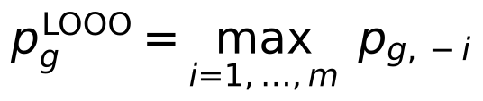
This is an intersection–union test: its null hypothesis is that, for at least one origin, no foreground shift remains once that origin is removed. It rejects only if the signal remains whichever origin is dropped. It therefore guards against a signal created by a single lineage, but it does not require a shift or loss in every origin: with three origins, two that carry the signal can suffice. For every call we report how many origins carry it (Supplementary Table 2).
The per-layer leave-one-origin-out p-values were combined across the three layers with the Cauchy combination test (ACAT [32]), which remains valid under arbitrary dependence between layers. Genome-wide false discovery rate was controlled with the Benjamini–Hochberg procedure [33] at q = 0.10.

Convergence signatures with learned effect directions
For genes detected by the test above, a signature describes which layers shifted. The per-layer GLS z-scores z_{g} (pooled over origins) have null correlation R_{g}, estimated from the cross-layer correlation of each gene’s whitened GLS residuals and shrunk 10% toward the genome mean. Following mash [34], the true effect vector μ_{g} was given the prior
The patterns U_{k} were (i) the seven canonical on/off patterns of three layers and (ii) rank-one patterns u uᵀ from directions learned by spherical k-means on genes whose largest |z| was at least 4. Scales w ran over 1, 2, 3, 5, 8, 12, 20 and 30. Mixture weights were fitted by EM with a Dirichlet pseudo-count of 10 on the null. Each gene was assigned its most probable pattern; a learned direction marked a layer active when its loading exceeded 0.3. The number of learned directions was fixed in advance at 2^L − 1 (seven for three layers), following mash’s practice of over-specifying patterns and letting EM shrink unused ones.

Sequence-level simulations
Species trees were pure-birth (Yule) trees scaled to a root-to-tip depth of 0.8 expected codon substitutions. Trait clades were drawn as non-overlapping clades of 4–12 species. Codon alignments were simulated with IQ-TREE 2.3.6 AliSim [35] under the Goldman–Yang model [36] (κ = 2). Each gene received:
- a length of 300–1,500 codons (log-normal around 500);
- a background ω drawn log-normally around 0.15 (range 0.01–0.9);
- a gene-wide rate multiplier (log-normal, σ = 0.5);
- phylogenetic confounding: rate jumps on K_{g} ~ Poisson(3c) random clades, each multiplying all branch lengths inside the clade by a log-normal factor (σ = 0.7), with intensity c = 0, 1 or 2;
- gene-tree discordance (sensitivity runs only): the alignment was simulated on a gene tree derived from the species tree by a Poisson number (mean 10 or 40) of nearest-neighbour interchanges, placed preferentially on short internal branches, while branch lengths were still estimated on the species tree.
Convergent genes (2% of the genome unless stated) received, on foreground branches only, one of three kinds of shift: a selection shift (ω multiplied by m_ω through branch-specific AliSim models, branch lengths unchanged; 40% of convergent genes), a rate shift (foreground branch lengths multiplied by m_{r}; 30%), or both (30%). Effect sizes were weak (m_ω = 1.5, m_{r} = 1.2), moderate (2, 1.35) or strong (3, 1.5). Branch lengths were then re-estimated with IQ-TREE on the true topology.
Designs were paired: for each tree and confounding level one null genome was simulated, and the same randomly chosen genes were replaced by convergent genes for each effect size or number of origins, so that all methods analysed identical data. The main benchmark used 10 Yule trees of 200 species with five origins and 3,000 genes; sensitivity runs varied the tree size (100 and 400 species), the share of convergent genes (0.5%, 5% and 10%) and gene-tree discordance, with five trees each at confounding 1.

Comparator methods
All comparators were given the same layers and the same Benjamini–Hochberg threshold (q = 0.10).
- Naive test: Welch t comparing foreground and background branches of the nucleotide relative rate, treating branches as independent; this mirrors the statistic underlying RERconverge.
- Naive Fisher: the naive test on each layer, combined with Fisher’s method.
- Control-lineage permutation: the naive statistic standardised by its mean and standard deviation over 100 age- and size-matched control foregrounds (our implementation, not RERconverge’s permulations [19]).
- Brownian phylogenetic LMM: for each gene and layer, y = b₀ + βf + u + e with u ~ N(0, h²K), e ~ N(0, s²I), K the shared-path-length kernel of the tree; REML over a 31-point grid of h²/s² using a single eigendecomposition of K [37], Wald test on β, layers combined by ACAT.
- Learned-covariance GLS: the model above without leave-one-origin-out, layers combined by ACAT.
- RERconverge 0.3.0 (github.com/nclark-lab/RERconverge, commit 682ac34), run with getAllResiduals(transform = "sqrt", min.sp = 10, norm = "scale"), foreground2Tree(clade = "all"), tree2Paths and correlateWithBinaryPhenotype(min.pos = 2, weighted = "auto"). Two-sided P values were converted to one-sided values for faster foreground evolution using the sign of Rho. Permulations used getPermsBinary (permmode “cc”) and permpvalcor, either on the 150 genes with the smallest parametric P (1,000 permulations) or on all genes (10,000 permulations, rate-jump intensity 1 only; 100 permulations cannot reach genome-wide significance). ggtree, used by RERconverge only for plotting, was made optional (patch in the repository).

Genome-wide data and traits
Coding alignments came from TOGA’s multiple codon alignments [20] against the human hg38 reference (17,439 genes). Species were chosen by fixed rules before any test (scripts/toga_select_species.py): species in the Zoonomia 447-way tree [1] only, one assembly per species (highest 1:1-ortholog coverage), coverage ≥ 0.85, all bats and cetaceans passing, a backbone of the best-covered species from each other order, and no shrews, tenrecs or solenodons (some echolocate). Trait species were then added by name. The final set has 115 species (Fig. 1).
For each gene, species with exactly one sequence of the chosen assembly were kept; genes needed ≥ 80% of the species and ≥ 50 codon columns with ≥ 4 ungapped sequences. Branch lengths were fitted with IQ-TREE 2 on the pruned Zoonomia topology (GTR+G4 on codons, LG+G4 on the translated protein). Each master-tree branch received a value only when it mapped one-to-one onto a branch of the gene’s pruned tree; otherwise it was missing.
Traits were defined from taxonomic lineage before testing:
Trait | Trait species | Independent origins | Kept out of control sets
Echolocation | 16 echolocating bats, 9 toothed whales | 3 | none
Marine | marine mammals: cetaceans (including the boutu and the Yangtze river dolphin, which live in fresh water), pinnipeds, manatee | 3 | semi-aquatic species (otters, beaver, muskrat, hippopotamus; the polar bear is not among the 115 species)
Hypoxia, subterranean | African mole-rats, tuco-tuco, blind mole-rat, mole vole, two moles, golden mole | 6 | diving mammals, high-altitude species
Hypoxia, high altitude | wild yak, Tibetan antelope, American pika, alpaca | 4 | diving mammals, subterranean species
Hypoxia, combined | both groups | 10 | diving mammals
Species absent from the Zoonomia tree (snow leopard, domestic yak, Przewalski’s gazelle, Iberian mole, bamboo rat) were not used. Genes of interest were fixed before testing: 18 hearing genes for echolocation, 19 reported marine losses or shifts, and EPAS1, EGLN1, HIF1A, HBB, HBA1, HBA2, NGB and CYGB for hypoxia.

Gene-loss layer
Gene status per species came from TOGA’s ortholog classification (loss_summ_data.tsv; scripts/toga_loss_matrix.py). A gene took the status of its most intact transcript. It was coded lost (1) for lost (L) or uncertain loss (UL), intact (0) for intact (I) or partially intact (PI), and missing otherwise. Genes needed ≥ 2 lost and ≥ 2 intact species, a filter blind to the trait.
The loss layer uses the same model as the rate layers, fitted across species instead of branches. The species × species covariance is learned from the loss patterns of all genes. It absorbs shared ancestry and assembly quality: a species with many spurious losses gets a large variance and is down-weighted. The foreground indicator marks trait species. The leave-one-origin-out test is unchanged, so a loss counts as convergent only when it is shared by at least two independent origins.
Rate and loss evidence were tested and FDR-controlled separately. A combined p-value (ACAT of the rate and loss p-values, each capped at 0.99) was used for the signature model; without the cap, a rate p-value of 1 for a gene with no rate data in the trait lineages cancels its loss evidence.

Simulation null for gene loss
The GLS p-value is not calibrated on 0/1 data: losses are inherited down whole clades, and on 20 marine control sets it produced 5.1 false calls per set. Loss p-values therefore come from a simulated null (mlconv/loss.py). In the model, each gene is present at the root and is lost along a branch of length t with the probability below, and never regained:
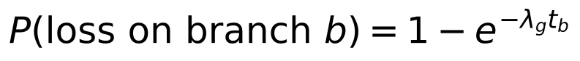
An intact gene g in species s is reported lost with probability min(e_{s} · κ_{g}, 0.5). Here e_{s} is the species’ false-loss rate, estimated as the fraction of genes lost in s and in no other species among genes with at most one loss, and κ_{g} ∈ {1, 2, 4, …, 64} is a gene fragility: long or hard-to-assemble genes are misannotated as lost more often. Lost genes are reported intact with probability 0.001. Each gene’s rate λ_{g} and fragility κ_{g} were the joint maximum-likelihood values on a grid (60 log-spaced rates from 0.01 to 100 losses per tree length, seven fragilities), computed for all genes at once by Felsenstein pruning [38]. Simulations keep each gene’s observed missing-data pattern. The calls did not depend on the resolution of the null or on the tail extrapolation: with 500 or 1,000 simulated genomes instead of 100, or with the generalized Pareto tail fitted to 100 or 500 instead of 250 null values, the same 48 marine and 15 subterranean genes were called in every run. P values below about 10⁻⁶ rest on the tail extrapolation and varied between runs (for LGSN from 10⁻²¹ to 10⁻⁸), so they should be read only as very small. With 1,000 genomes, four further marine genes reached the threshold (B3GNT3, BPIFA2, FMO1, OR51B6; P ≈ 0.0004 in both runs).
Per-gene check against single-origin losses. The loss P value tests the global null of no association in any origin. The hypothesis that a leave-one-origin-out call rejects is wider: convergence fails if at most one origin truly lost the gene. For each called gene and each origin j, we therefore simulated 10,000 replicates in which the species of origin j keep their observed states and all other species are simulated under the loss model, with loss rate and fragility re-estimated from the non-trait species only. The leave-one-origin-out statistic was computed with the covariance learned from the real data, and P_{j} is the share of replicates reaching the observed statistic, with a generalized Pareto tail when fewer than ten did (capped at the empirical value). Replicates with fewer than two losses carry no evidence and count as zero. The gene’s intersection-union P value is the largest P_{j}. This check was run only for genes called under the global null, so it can remove calls but not add them (code: scripts/convergence_toga.py, –loss-test iut).
For each trait configuration, 100 genomes were simulated and analysed exactly as the real data, including the testability filter and a covariance re-learned per replicate. Null statistics were pooled within ten bins of fitted loss rate. A gene’s p-value is the fraction of pooled null statistics at or above its own. When fewer than ten exceed it, the tail is extrapolated with a generalized Pareto distribution fitted to the 250 largest null values [39]. The 100 matched control traits on real data, analysed the same way, check the result. As a sensitivity analysis, every trait was rerun counting only TOGA’s confident losses (L), with uncertain losses (UL) treated as missing.

Timing of losses, correlated traits and model checks
Timing. Under the irreversible-loss model, a node was taken as lost when every observed species below it was lost. For each convergent gene and each origin, the loss was classed as before the origin (the origin and its sister lineage both lost), at the origin (all observed species of the origin lost, the sister lineage not), within the origin (some but not all lost), or intact (scripts/extra_analyses.py). For origins of one species, “at the origin” means anywhere on that species’ terminal branch.
Correlated traits. To ask which of two correlated traits explains a loss, the species loss matrix was regressed on both trait indicators at once, with the genome-learned species covariance and an intercept. The partial effect of a trait is the GLS-adjusted difference in loss probability between species with and without it, holding the other trait fixed. Pairs were subterranean versus high altitude, and marine versus semi-aquatic (otters, beaver, muskrat, hippopotamus). Partial effects are descriptive; calibrated tests are those above.
Model checks. The fitted species false-loss rates were compared with assembly contig and scaffold N50, terminal branch length and distance to the human reference (Spearman correlation). Twenty genomes simulated from the fitted loss model were compared with the observed data in the number of species losing each gene and the share of genes lost per species (Extended Data Fig. 10).
Number of origins. For the subterranean trait (six origins), every subset of three, four and five origins was analysed with the calibrated loss test (50 simulated genomes per subset; scripts/origin_subsampling.py). Species of the dropped origins were set to missing, and the loss model was fitted once on the full data.
Mutations behind the losses. For the marine calls, TOGA’s per-species tables of inactivating mutations and projected exon coordinates were downloaded for the 18 marine species and 12 terrestrial relatives (scripts/marine_detail.py). Mutations on the orthologous projection were placed on the reference coding sequence. Reference exon lengths were taken from the projection shared by the terrestrial relatives, which was identical in cattle, pig, hippopotamus, dog and cat (1,068 bp in nine exons for PON1). Mutations that TOGA masks (near exon ends, or compensated by a nearby frameshift) are shown but were not used by TOGA to call the loss. Per origin, genes were counted that were lost in at least one species, lost in every species with data, and of those, not lost in every species of the sister lineage.
Codon alignments of single losses. TOGA’s multiple codon alignments contain intact orthologs only. For PON1 and LGSN, the pairwise human–query codon alignments were therefore streamed for each species, and the projection with the most aligned codons was kept (scripts/alignment_detail.py). Query codons opposite reference gaps were dropped, so columns follow the human coding sequence. TOGA replaces codons disrupted by a frameshift with XXX; these are shown as frameshifted codons, without their bases. For the volcano plots (Fig. 4d–g), the effect size of each gene is the share of trait species in which it is lost minus the share in all other species with data. Functional groups were assigned by hand from gene names and known functions (Supplementary Table 1).
Tissue, pathway and GO enrichment. Three annotation sources were used (scripts/function_enrichment.py): tissue expression from the Human Protein Atlas consensus data (nTPM in 50 human tissues) [40], Reactome pathways [41] and Gene Ontology biological-process annotations, propagated to parent terms through is_a and part_of relations [42]. A gene was counted as elevated in a tissue when its expression there was at least 1 nTPM and at least four times its mean over all tissues, following the Human Protein Atlas rule for tissue-enhanced genes. The background was all genes tested by the loss layer for the trait. Genes that are often lost across mammals, such as olfactory receptors and tissue-specific genes, would appear enriched among any set of loss calls, so the null kept loss frequency: each called gene was replaced by a random tested gene from the same of 20 bins of total losses across the 115 species. The number of null genes in a term is then a sum of independent Bernoulli variables, and its exact upper tail (Poisson-binomial) gives the p-value. Terms with 5 to 1,000 background genes were eligible; terms with fewer than two called genes were not tested and entered the Benjamini–Hochberg correction with p = 1, so the correction spans all 50 tissues, 1,866 Reactome pathways and 6,302 GO terms.

Statistics and reproducibility
All tests are one-sided for faster evolution or loss on the foreground. False discovery rates were controlled with the Benjamini–Hochberg procedure at q = 0.10 per layer and trait. Calibration was measured on 100 matched control traits per analysis (500 in total; exact binomial 95% intervals), on simulated genomes (rate layers: Extended Data Figs 1–3; loss layer: Fig. 3) and by origin subsampling (Extended Data Fig. 9). No data were excluded after testing; species and genes were selected by rules fixed before any test. All analyses are deterministic given the random seeds recorded in the scripts.

Data availability
All input data are public: TOGA orthology, loss classifications, inactivating mutations and codon alignments for the human hg38 reference [20] (genome.senckenberg.de/download/TOGA), the Zoonomia 447-species tree [1], Human Protein Atlas consensus tissue expression [40], Reactome pathways [41] and Gene Ontology annotations [42]. Derived data (species sets, the gene-loss matrix, per-gene results for every trait, control-trait calls, benchmark tables and Supplementary Table 1) are in the GitHub repository below; per-gene branch lengths (77 MB) will be deposited on Zenodo with a DOI at submission. [DOI to be added.]

Code availability
All code is at github.com/devbioinfo/Trait_github: the mlconv package (genome-learned GLS, leave-one-origin-out test, signatures, loss model and simulation null) and the scripts that select species, download data, estimate branch lengths, build the loss matrix, run each analysis and benchmark, and draw each figure. A versioned release will be archived on Zenodo. [DOI to be added.]

Acknowledgements
[To be added by the authors: funding, if any, and computing resources.]

Author contributions
[To be confirmed by the authors. Suggested: M.A. and D.K.B. conceived the study; M.A. performed the analyses and wrote the first draft; D.K.B. supervised the work; both authors revised and approved the manuscript.]

Competing interests
The authors declare no competing interests. [Authors to confirm.]

Use of AI tools
An AI assistant (Claude, Anthropic) was used to write analysis code, run analyses and draft text and figures under the authors’ direction. The authors checked all code, results and text and take responsibility for the content. [Authors to confirm the wording against the journal’s current policy.]

References
- Zoonomia Consortium. A comparative genomics multitool for scientific discovery and conservation. Nature 587, 240–245 (2020).
- Christmas, M. J. et al. Evolutionary constraint and innovation across hundreds of placental mammals. Science 380, eabn3943 (2023).
- Chikina, M., Robinson, J. D. & Clark, N. L. Hundreds of genes experienced convergent shifts in selective pressure in marine mammals. Mol. Biol. Evol. 33, 2182–2192 (2016).
- Kowalczyk, A. et al. RERconverge: an R package for associating evolutionary rates with convergent traits. Bioinformatics 35, 4815–4817 (2019).
- Partha, R., Kowalczyk, A., Clark, N. L. & Chikina, M. Robust method for detecting convergent shifts in evolutionary rates. Mol. Biol. Evol. 36, 1817–1830 (2019).
- Parker, J. et al. Genome-wide signatures of convergent evolution in echolocating mammals. Nature 502, 228–231 (2013).
- Fukushima, K. & Pollock, D. D. Detecting macroevolutionary genotype–phenotype associations using error-corrected rates of protein convergence. Nat. Ecol. Evol. 7, 155–170 (2023).
- Hiller, M. et al. A “forward genomics” approach links genotype to phenotype using independent phenotypic losses among related species. Cell Rep. 2, 817–823 (2012).
- Sharma, V. et al. A genomics approach reveals insights into the importance of gene losses for mammalian adaptations. Nat. Commun. 9, 1215 (2018).
- Foote, A. D. et al. Convergent evolution of the genomes of marine mammals. Nat. Genet. 47, 272–275 (2015).
- Huelsmann, M. et al. Genes lost during the transition from land to water in cetaceans highlight genomic changes associated with aquatic adaptations. Sci. Adv. 5, eaaw6671 (2019).
- Partha, R. et al. Subterranean mammals show convergent regression in ocular genes and enhancers, along with adaptation to tunneling. eLife 6, e25884 (2017).
- Qiu, Q. et al. The yak genome and adaptation to life at high altitude. Nat. Genet. 44, 946–949 (2012).
- Liu, Y. et al. Convergent sequence evolution between echolocating bats and dolphins. Curr. Biol. 20, R53–R54 (2010).
- Li, Y., Liu, Z., Shi, P. & Zhang, J. The hearing gene Prestin unites echolocating bats and whales. Curr. Biol. 20, R55–R56 (2010).
- Thomas, G. W. C. & Hahn, M. W. Determining the null model for detecting adaptive convergence from genomic data: a case study using echolocating mammals. Mol. Biol. Evol. 32, 1232–1236 (2015).
- Zou, Z. & Zhang, J. No genome-wide protein sequence convergence for echolocation. Mol. Biol. Evol. 32, 1237–1241 (2015).
- Cornwallis, C. K. & Griffin, A. S. A guided tour of phylogenetic comparative methods for studying trait evolution. Annu. Rev. Ecol. Evol. Syst. 55, 181–204 (2024).
- Saputra, E., Kowalczyk, A., Cusick, L., Clark, N. & Chikina, M. Phylogenetic permulations: a statistically rigorous approach to measure confidence in associations in a phylogenetic context. Mol. Biol. Evol. 38, 3004–3021 (2021).
- Kirilenko, B. M. et al. Integrating gene annotation with orthology inference at scale. Science 380, eabn3107 (2023).
- Yi, X. et al. Sequencing of 50 human exomes reveals adaptation to high altitude. Science 329, 75–78 (2010).
- Simonson, T. S. et al. Genetic evidence for high-altitude adaptation in Tibet. Science 329, 72–75 (2010).
- Hayden, S. et al. Ecological adaptation determines functional mammalian olfactory subgenomes. Genome Res. 20, 1–9 (2010).
- Jiang, P. et al. Major taste loss in carnivorous mammals. Proc. Natl Acad. Sci. USA 109, 4956–4961 (2012).
- Meyer, W. K. et al. Ancient convergent losses of Paraoxonase 1 yield potential risks for modern marine mammals. Science 361, 591–594 (2018).
- Emerling, C. A. & Springer, M. S. Eyes underground: regression of visual protein networks in subterranean mammals. Mol. Phylogenet. Evol. 78, 260–270 (2014).
- Liao, C., Ye, R., Ivankovic, F. et al. The landscape of gene loss and missense variation across the mammalian tree informs on gene essentiality. Nat. Genet. (2026). doi:10.1038/s41588-026-02783-9
- Olson, M. V. When less is more: gene loss as an engine of evolutionary change. Am. J. Hum. Genet. 64, 18–23 (1999).
- Rey, C., Guéguen, L., Sémon, M. & Boussau, B. Accurate detection of convergent amino-acid evolution with PCOC. Mol. Biol. Evol. 35, 2296–2306 (2018).
- Hu, Z., Sackton, T. B., Edwards, S. V. & Liu, J. S. Bayesian detection of convergent rate changes of conserved noncoding elements on phylogenetic trees. Mol. Biol. Evol. 36, 1086–1100 (2019).
- Minh, B. Q. et al. IQ-TREE 2: new models and efficient methods for phylogenetic inference in the genomic era. Mol. Biol. Evol. 37, 1530–1534 (2020).
- Liu, Y. & Xie, J. Cauchy combination test: a powerful test with analytic p-value calculation under arbitrary dependency structures. J. Am. Stat. Assoc. 115, 393–402 (2020).
- Benjamini, Y. & Hochberg, Y. Controlling the false discovery rate: a practical and powerful approach to multiple testing. J. R. Stat. Soc. B 57, 289–300 (1995).
- Urbut, S. M., Wang, G., Carbonetto, P. & Stephens, M. Flexible statistical methods for estimating and testing effects in genomic studies with multiple conditions. Nat. Genet. 51, 187–195 (2019).
- Ly-Trong, N., Naser-Khdour, S., Lanfear, R. & Minh, B. Q. AliSim: a fast and versatile phylogenetic sequence simulator for the genomic era. Mol. Biol. Evol. 39, msac092 (2022).
- Goldman, N. & Yang, Z. A codon-based model of nucleotide substitution for protein-coding DNA sequences. Mol. Biol. Evol. 11, 725–736 (1994).
- Lippert, C. et al. FaST linear mixed models for genome-wide association studies. Nat. Methods 8, 833–835 (2011).
- Felsenstein, J. Evolutionary trees from DNA sequences: a maximum likelihood approach. J. Mol. Evol. 17, 368–376 (1981).
- Knijnenburg, T. A., Wessels, L. F. A., Reinders, M. J. T. & Shmulevich, I. Fewer permutations, more accurate P-values. Bioinformatics 25, i161–i168 (2009).
- Uhlén, M. et al. Tissue-based map of the human proteome. Science 347, 1260419 (2015).
- Milacic, M. et al. The Reactome Pathway Knowledgebase 2024. Nucleic Acids Res. 52, D672–D678 (2024).
- The Gene Ontology Consortium. The Gene Ontology knowledgebase in 2023. Genetics 224, iyad031 (2023).
- Benjamini, Y. & Heller, R. Screening for partial conjunction hypotheses. Biometrics 64, 1215–1222 (2008).

Figures
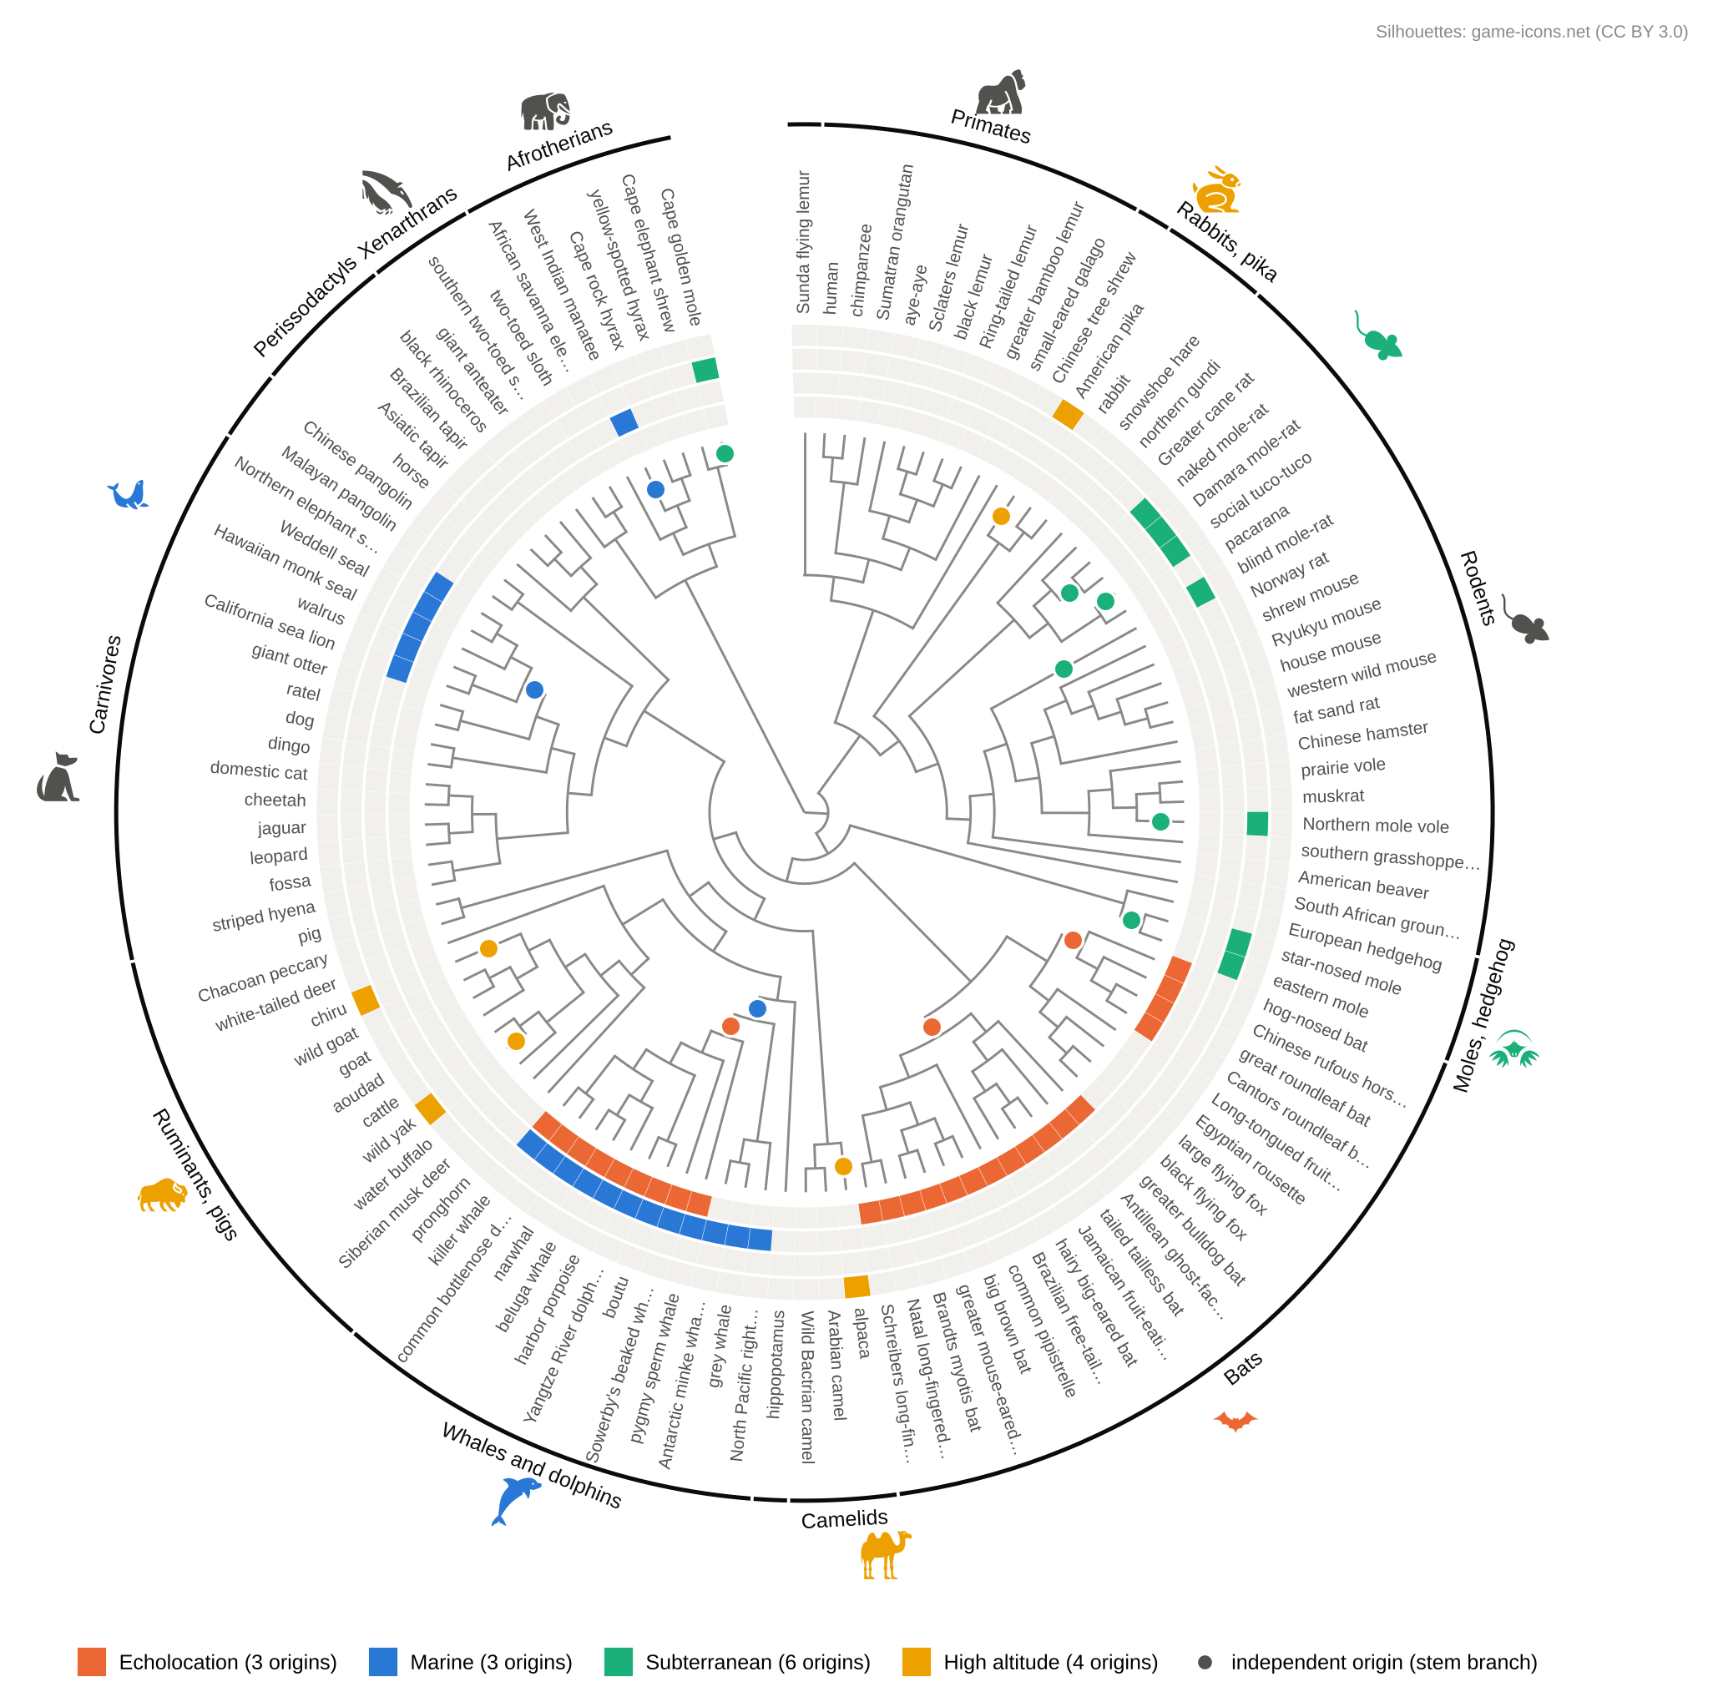
Fig. 1 | The 115 mammals studied and the independent origins of four traits. Species tree pruned from the Zoonomia 447-way tree [1], drawn as a cladogram (branch lengths not to scale). Rings, from inside out: echolocation (orange; echolocating bats and toothed whales), marine (blue; cetaceans, including two river dolphins, pinnipeds, manatee), life underground (green; African mole-rats, tuco-tuco, blind mole-rat, mole vole, two moles, golden mole) and high altitude (yellow; wild yak, Tibetan antelope, American pika, alpaca). Dots mark the stem branch of each independent origin: 3 for echolocation, 3 for marine life, 6 for life underground and 4 for high altitude. Outer arcs group species by order or major clade (labels for groups of three or more species). Long common names are shortened. Silhouettes mark major groups (game-icons.net, CC BY 3.0); grey silhouettes sit at the centre of their group and coloured ones at the species of that group with the trait (for example, the bat marks the echolocating bats but not the three fruit bats, the camel the alpaca, the bison the wild yak and Tibetan antelope, the rabbit the American pika, and the green rodent the African mole-rats).
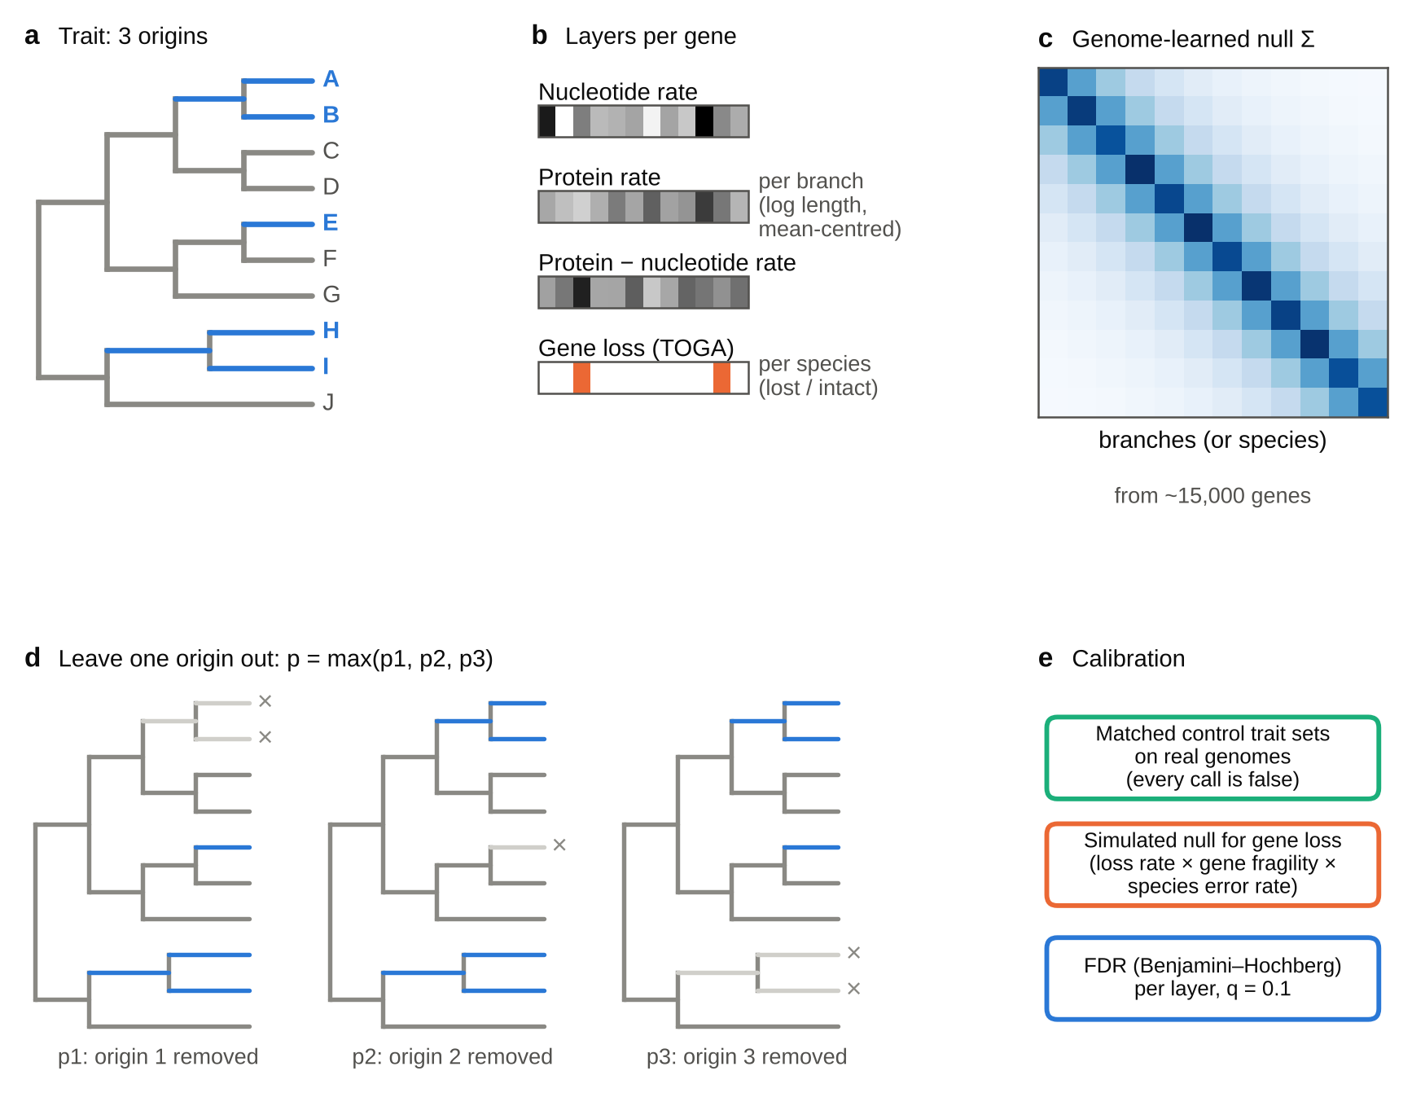
Fig. 2 | A convergence test whose calibration is checked on the genomes it is applied to. a, A trait with three independent origins. Foreground branches (blue) are those whose descendants all carry the trait. b, For each gene, three rate layers are measured per branch (log nucleotide and protein branch lengths, mean-centred across genes; rate contrast = protein − nucleotide), and a loss layer per species from TOGA’s ortholog classification. c, The null covariance Σ of each layer is learned across all genes; it absorbs shared ancestry, lineage-specific rate jumps, estimation noise and, for gene loss, assembly quality. Each gene is tested by generalised least squares. d, Leave one origin out: the test is repeated with each origin removed (grey, ×) and the largest P value is kept, so no single lineage can produce a call. e, Loss P values come from a null simulated from a fitted model of irreversible loss and annotation error; every analysis is repeated on matched control trait sets; false discovery rate is controlled per layer at q = 0.1. Schematic; values in b and c are illustrative.
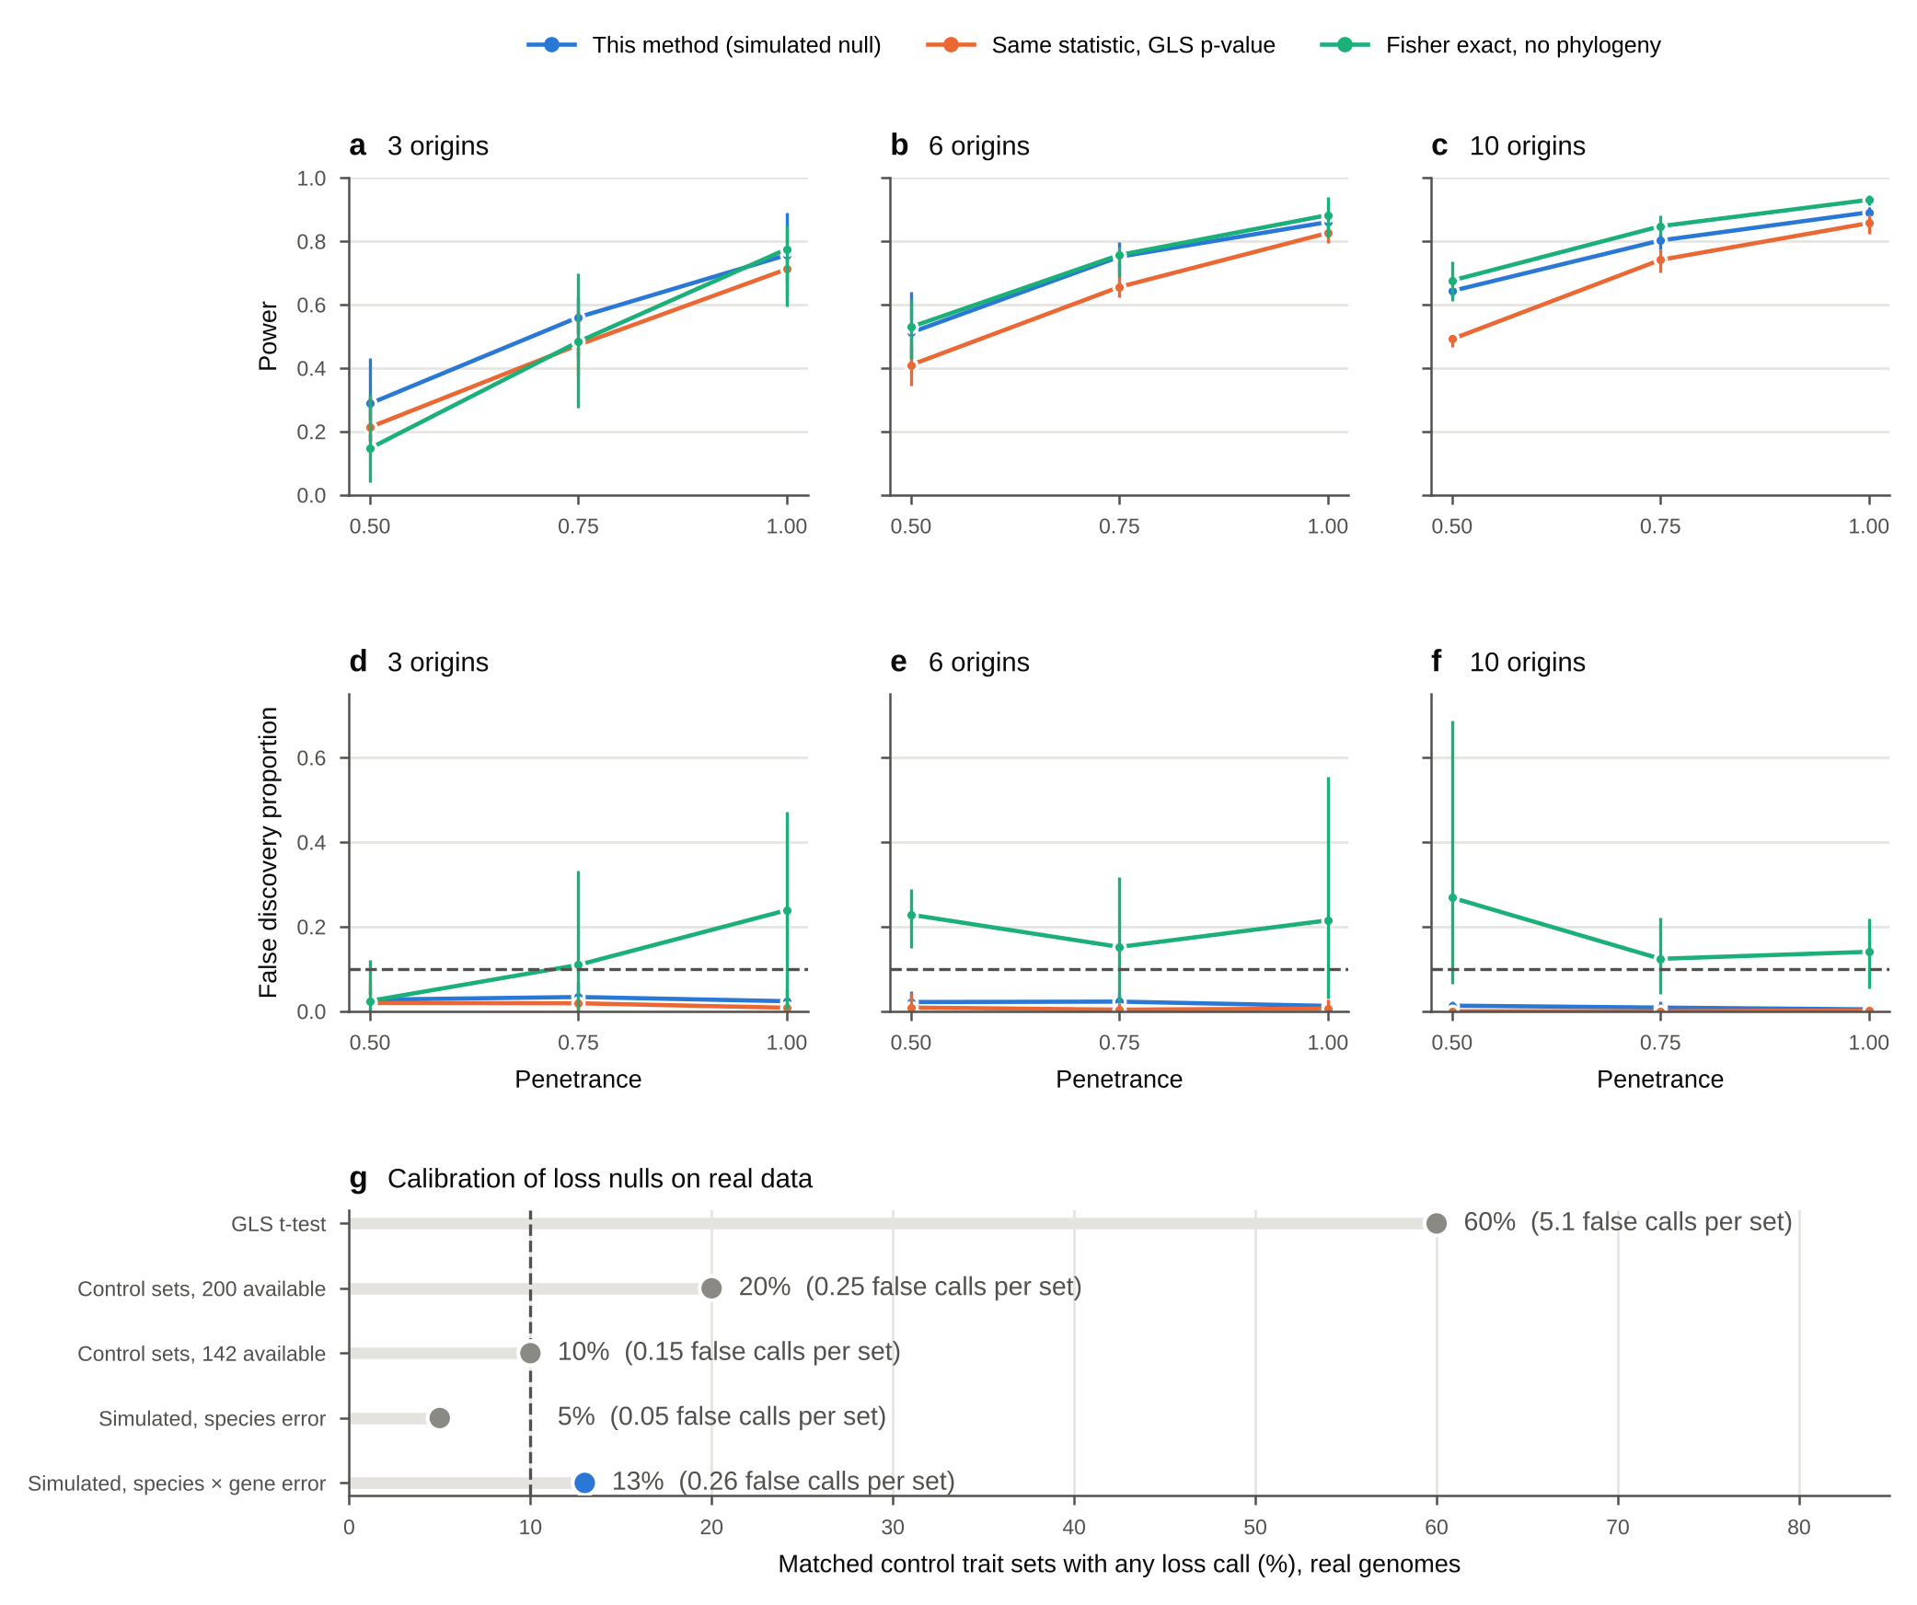
Fig. 3 | A simulated null with species and gene error rates calibrates the gene-loss test. a–f, Genomes simulated on the real 115-species tree from the loss model fitted to the TOGA loss matrix (12,851 genes; each gene’s loss rate and fragility, each species’ false-loss rate and each gene’s missing data kept). In 2% of genes, each origin of a random trait (3, 6 or 10 clades of 1–4 species) loses the gene on its stem branch with probability set by the penetrance. a–c, Power; d–f, false discovery proportion; dashed line, q = 0.1. Points, mean over five replicate genomes per setting; bars, range. Blue, this method (simulated null, 100 replicates per analysis); orange, the same leave-one-origin-out statistic with its parametric GLS P value; green, one-sided Fisher exact test of lost versus intact in trait versus other species, ignoring phylogeny. g, Calibration on real genomes: share of matched control trait sets with at least one loss call (20 per analysis for the earlier nulls; 100 per analysis, 500 in all, for the final null) (mean false calls per set in brackets), for the successive loss nulls tried. GLS t-test, marine trait, 101 species; pooled statistics from 200 or 142 other control sets, marine, 101 and 105 species; simulated null with species error only, marine, 105 species; final simulated null with species × gene error (blue), pooled over the five analyses on 115 species. Dashed line, nominal 10%.
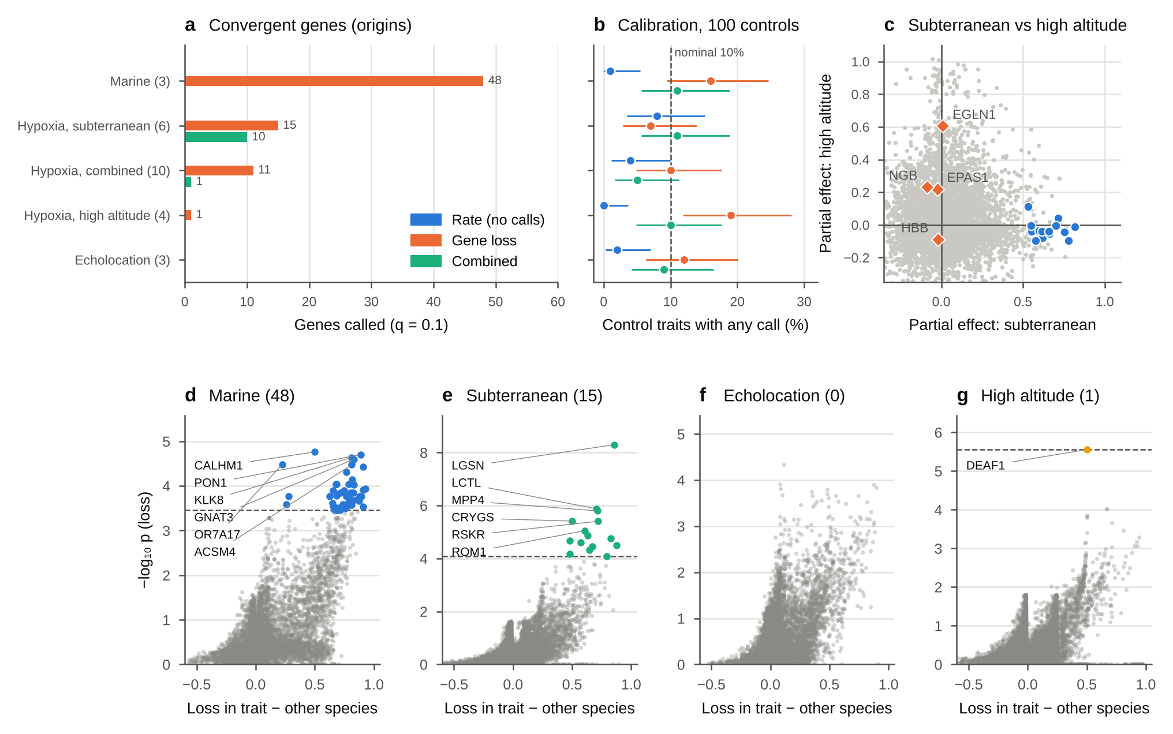
Fig. 4 | Marine and subterranean mammals converged on losing genes; echolocating and high-altitude mammals did not (main coding). 115 mammals; 15,703 genes tested for rate shifts and 12,851 for loss. a, Genes called at q = 0.1 per trait and layer (independent origins in brackets); no rate-layer calls. b, Calibration: share of 100 matched control traits per analysis with at least one call; bars, exact 95% intervals; dashed line, nominal 10%; rows as in a. c, Partial effects of life underground and of high altitude on gene loss, from a GLS of the species loss matrix on both traits with the genome-learned covariance. Grey, all testable genes; blue, the 15 subterranean losses; orange, hypoxia genes of interest. EGLN1’s high-altitude effect comes from one species (the wild yak). d–g, All tested genes for each trait: x, share of trait species in which the gene is lost minus the share in all other species; y, −log10 P of the calibrated loss test. Coloured points, calls at q = 0.1 (number in brackets); dashed line, the weakest call; up to six calls are labelled.
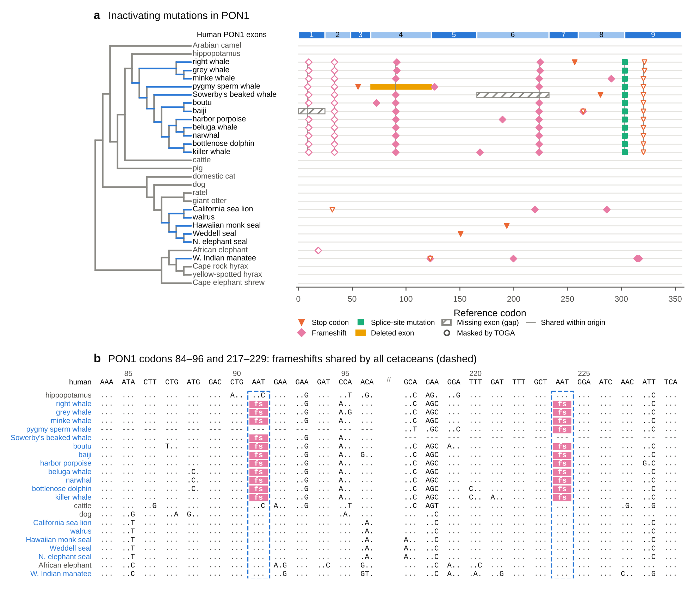
Fig. 5 | PON1 was inactivated once in cetaceans and several times in pinnipeds. a, Inactivating mutations in PON1 reported by TOGA, placed on the nine reference exons (top bar; x axis in reference codons) for the 18 marine species (blue branches) and 12 terrestrial relatives. Orange triangles, stop codons; pink diamonds, frameshifting insertions or deletions; green squares, splice-site mutations; yellow bars, deleted exons; hatched bars, exons missing because of assembly gaps (missing data, not loss). Open symbols are mutations TOGA masks when calling a loss. Grey vertical lines join the same mutation in two or more species of one origin. b, Codon alignment of PON1 in two windows (exon 4, codons 84–96; exon 6, codons 217–229) for the 18 marine species (blue names) and four relatives. Dots, bases identical to human; letters, differences; dashes, codons not aligned (exon deleted or missing); pink, codons disrupted by a frameshift (TOGA reports them as XXX). Dashed boxes mark the frameshifts shared by all cetaceans with data.
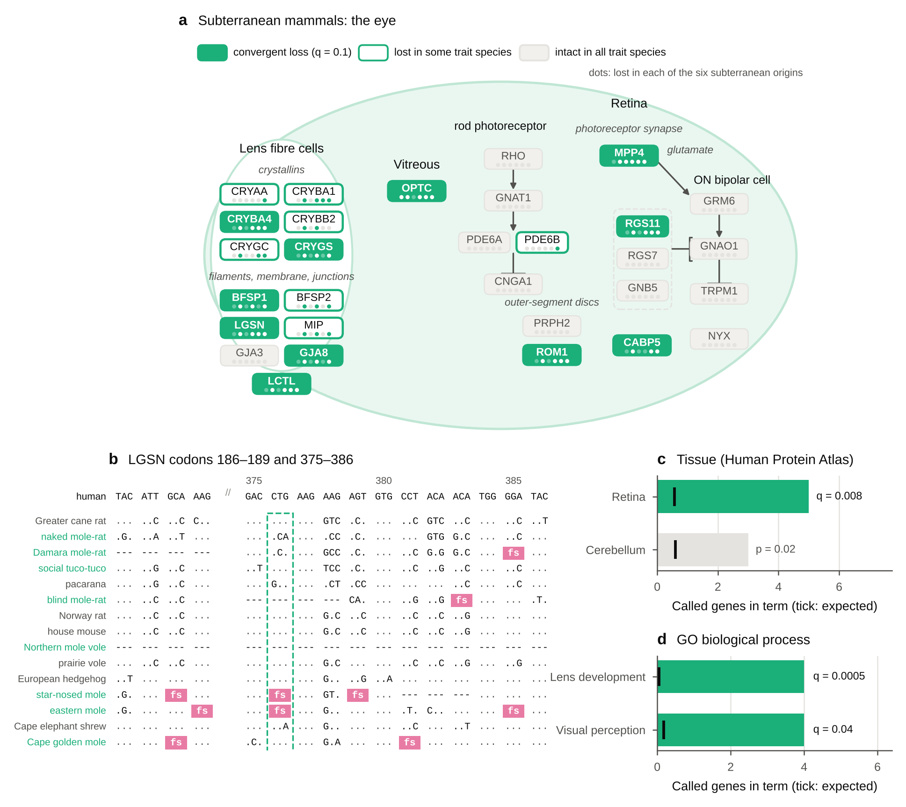
Fig. 6 | Underground, the lens and image-processing genes were lost and core phototransduction genes remained intact. a, Canonical eye pathways (schematic; interactions from the literature, not inferred here) with each gene coloured by our data: filled, convergent loss at q = 0.1; outlined, lost in at least one subterranean species but not called; grey, intact in all subterranean species with data. Dots under each gene mark the six origins in tree order, filled where the gene is lost in at least one species. Lens fibre-cell crystallins, beaded filaments (BFSP1, BFSP2), lengsin (LGSN), aquaporin 0 (MIP), connexins (GJA3, GJA8) and LCTL; vitreous opticin (OPTC); rod phototransduction (RHO, GNAT1, PDE6A, PDE6B, CNGA1), disc-rim proteins (PRPH2, ROM1) and the photoreceptor synapse (MPP4); ON bipolar-cell signalling (GRM6, GNAO1, TRPM1, NYX), its GTPase-activating complex (RGS11, RGS7, GNB5) and CABP5. Arrows, activation; bars, inhibition. b, Codon alignment of LGSN (codons 186–189 and 375–386) for the eight subterranean species (green names) and seven relatives, as in Fig. 5b; the dashed box marks the frameshift shared by the two moles. c, d, Enrichment of the 15 subterranean losses among genes elevated in human tissues (Human Protein Atlas [40]; c) and among Gene Ontology biological processes [42] (d). Bars, called genes in the term; black ticks, number expected when each called gene is replaced by a random tested gene lost equally often across the 115 mammals; coloured, q < 0.1 after correction over all eligible terms; grey, uncorrected P shown.

Extended Data figures
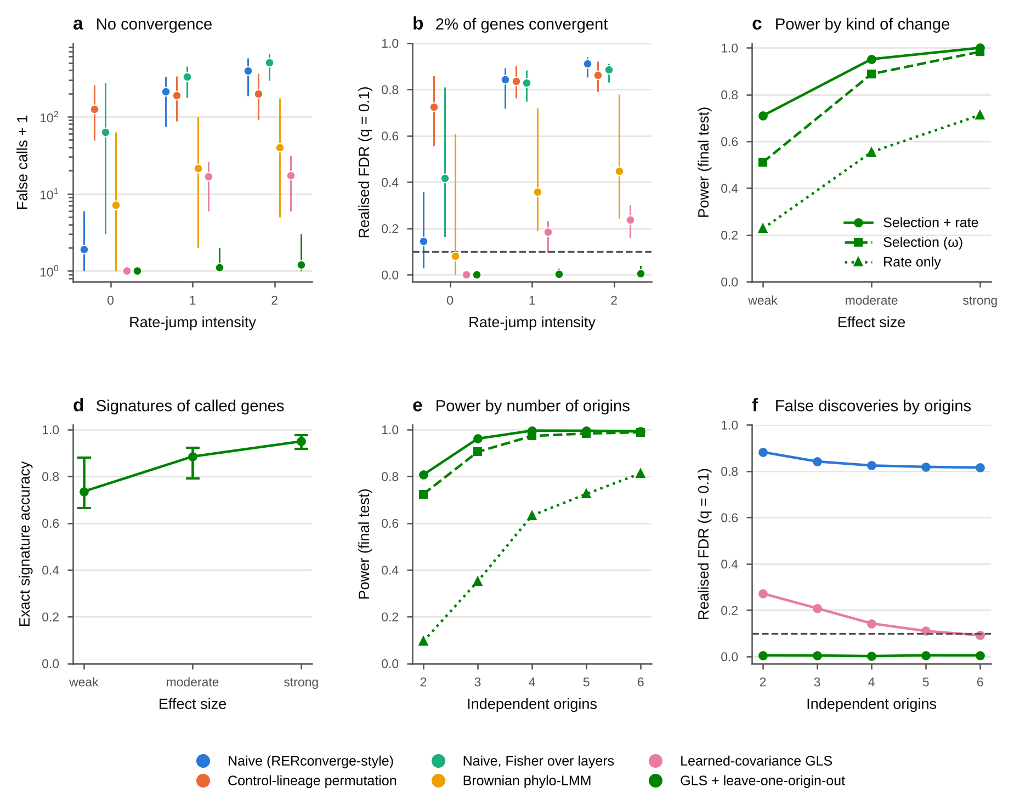
Extended Data Fig. 1 | The rate layers stay calibrated under lineage rate jumps and estimation error. Codon alignments simulated with IQ-TREE AliSim (GY model) on Yule trees of 200 species, 3,000 genes per genome; branch lengths re-estimated with IQ-TREE. Rate-jump intensity sets how strongly single lineages change rate (confounding). a, False calls (plus one, log scale) in genomes with no convergence. b, Realised false discovery rate when 2% of genes converge in five origins; dashed line, q = 0.1. c, Power of the final test (GLS with leave-one-origin-out) by kind of convergent change and effect size (weak: ω ×1.5, rate ×1.2; moderate: ×2, ×1.35; strong: ×3, ×1.5). d, Exact accuracy of the inferred convergence signature among called genes; points, mean over the 10 trees; bars, range across trees. e, f, Power and realised false discovery rate by number of independent origins (2–6). Colours denote methods (key); in c and e, line style and marker denote the kind of change. In a and b, points show the mean over 10 simulated trees and bars the range across trees, offset horizontally by method; e and f show means over 10 replicate trees.
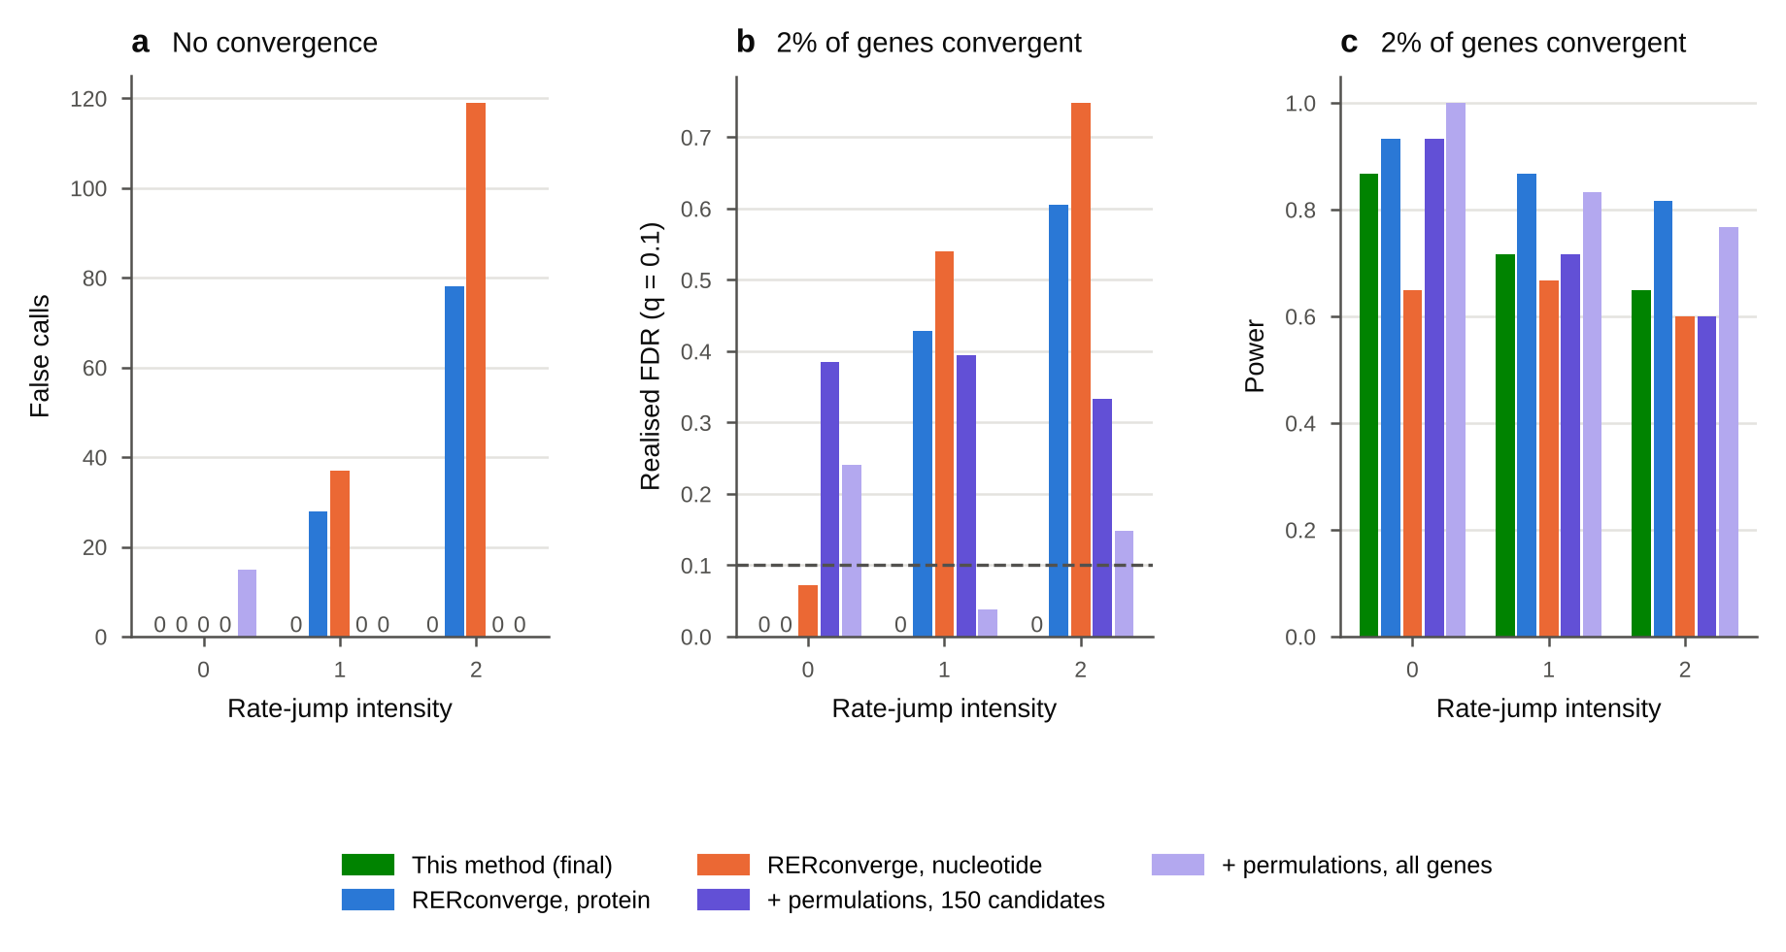
Extended Data Fig. 2 | RERconverge’s parametric test makes false calls when single lineages change rate; permulations on all genes reduce but do not remove the excess. AliSim genomes (3,000 genes) on 200-species trees at three levels of rate-jump intensity. RERconverge 0.3.0 was run on IQ-TREE protein or nucleotide gene trees (binary trait, clade = “all”). a, False calls in genomes with no convergence. b, Realised false discovery rate and c, power when 2% of genes converge (moderate effect); dashed line, q = 0.1. Bars of height zero are labelled 0. Green, this method (final test); blue and orange, RERconverge on protein and nucleotide trees; violet, RERconverge on protein trees with 1,000 permulations on the 150 genes with the smallest parametric P; light violet, with 10,000 permulations on all genes, run on separate genomes of the same design at each intensity, on which the final test made no false calls (power 0.97, 0.83 and 0.72).
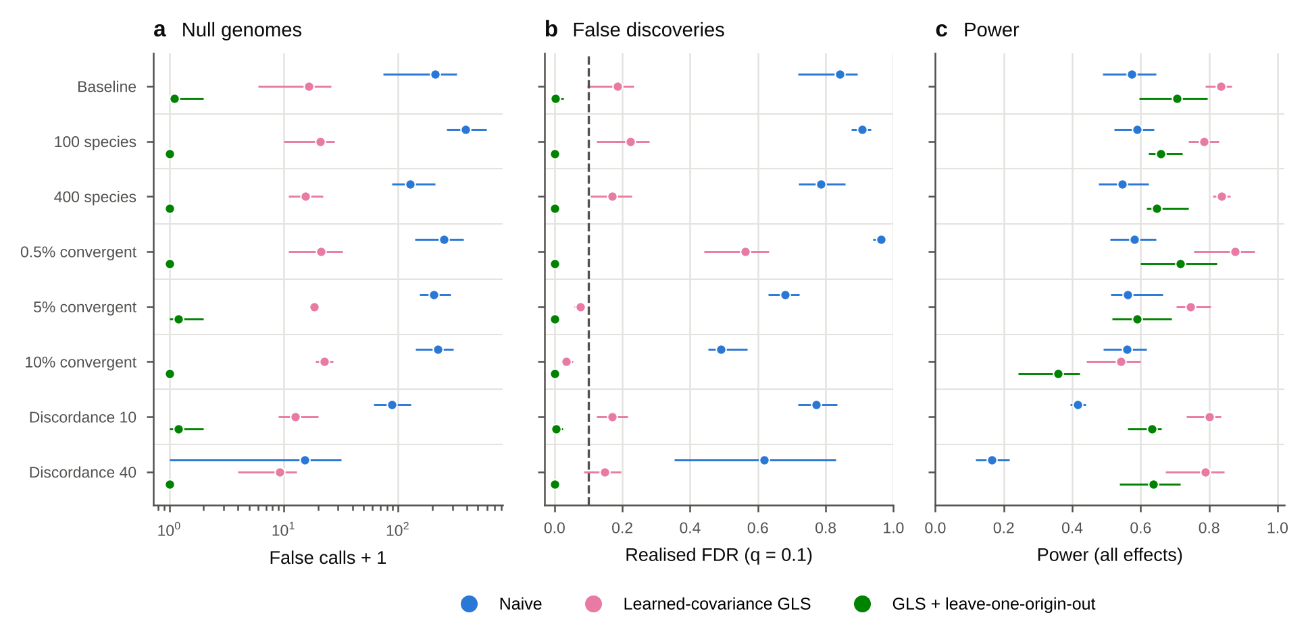
Extended Data Fig. 3 | The final test stays calibrated across tree sizes, shares of convergent genes and gene-tree discordance. AliSim genomes as in Extended Data Fig. 1 at rate-jump intensity 1, changing one setting at a time from the baseline (200 species, 2% of genes convergent, no gene-tree discordance; 10 trees): tree size (100 or 400 species), share of convergent genes (0.5%, 5% or 10%) and gene-tree discordance (Poisson mean of 10 or 40 nearest-neighbour interchanges per gene); five trees per setting. a, False calls (plus one, log scale) in genomes with no convergence. b, Realised false discovery rate; dashed line, q = 0.1. c, Power over all effect sizes and kinds of change. Points, mean over trees; bars, range across trees. Blue, naive test; pink, learned-covariance GLS; green, final test (GLS with leave-one-origin-out).
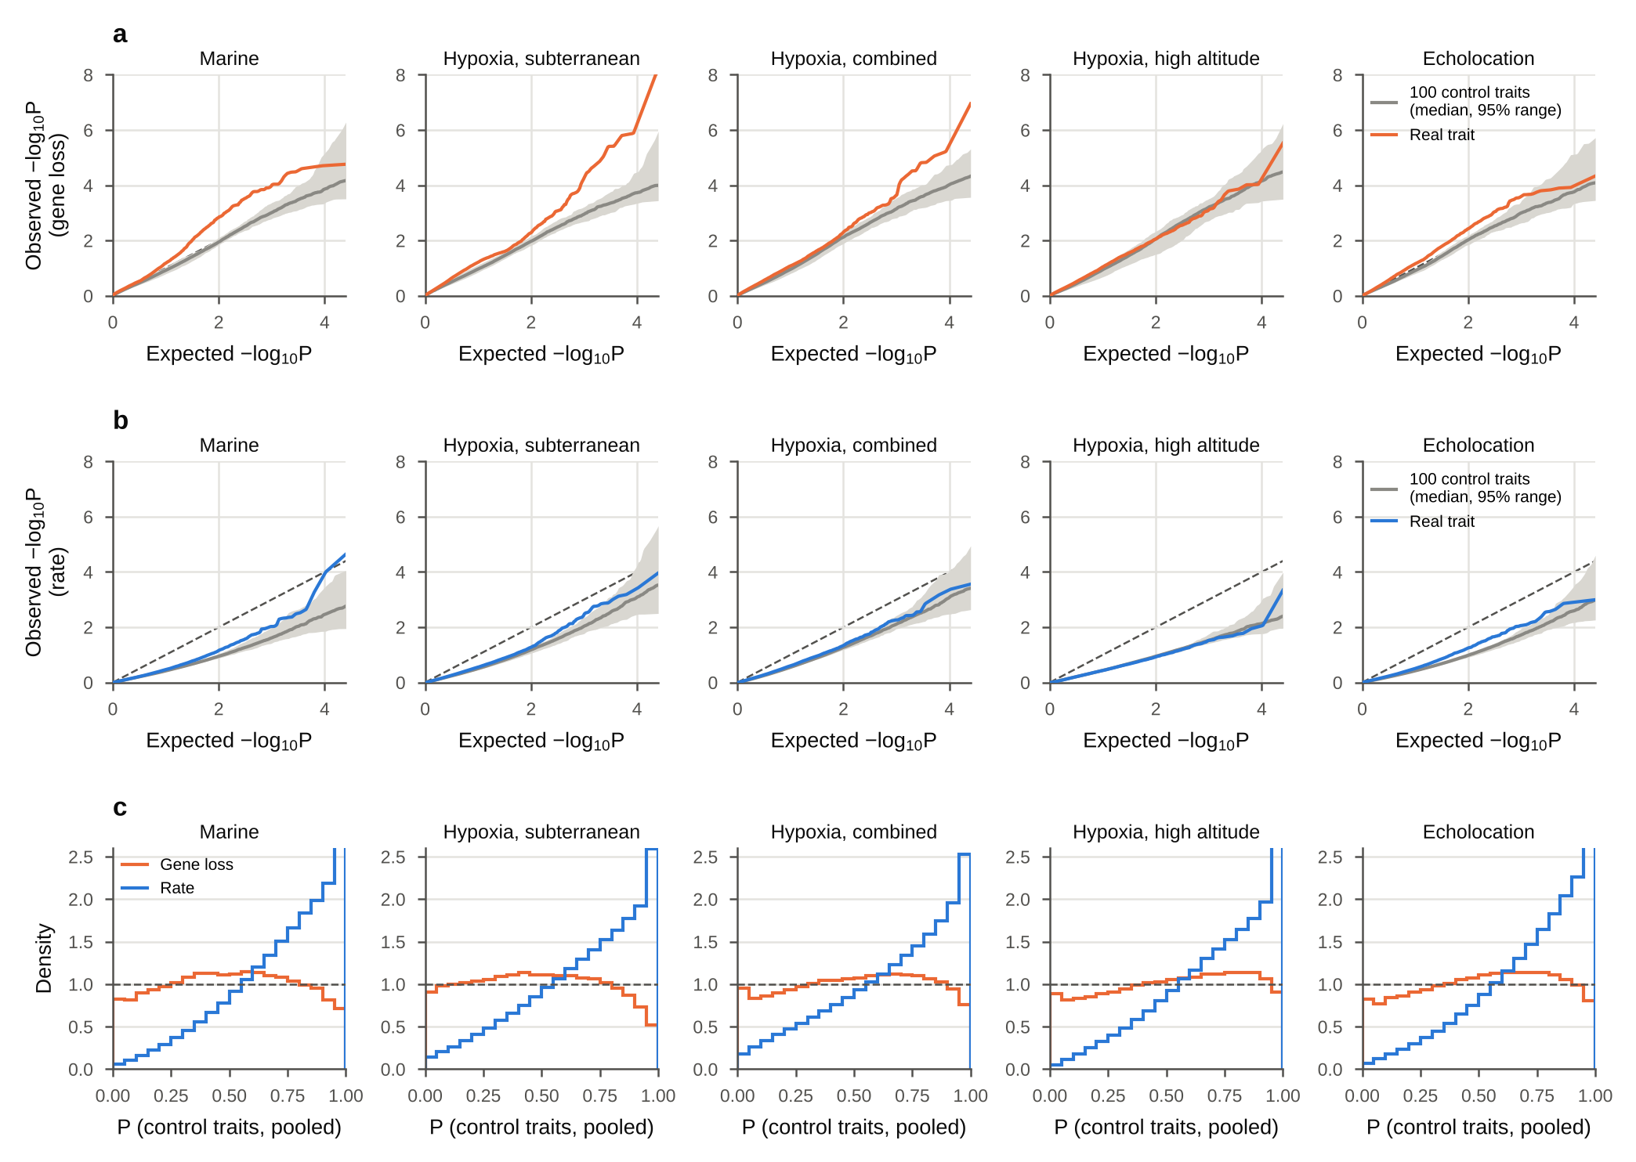
Extended Data Fig. 4 | P values in the matched control traits. a, b, Quantile–quantile plots of gene-loss (a) and rate (b) P values against the uniform distribution, for each analysis. Grey line and band, median and 95% range over the 100 control traits at each rank; coloured line, the real trait; dashed line, equality. c, Histograms of the pooled P values of the 100 control traits (20 bins; density 1 is uniform).
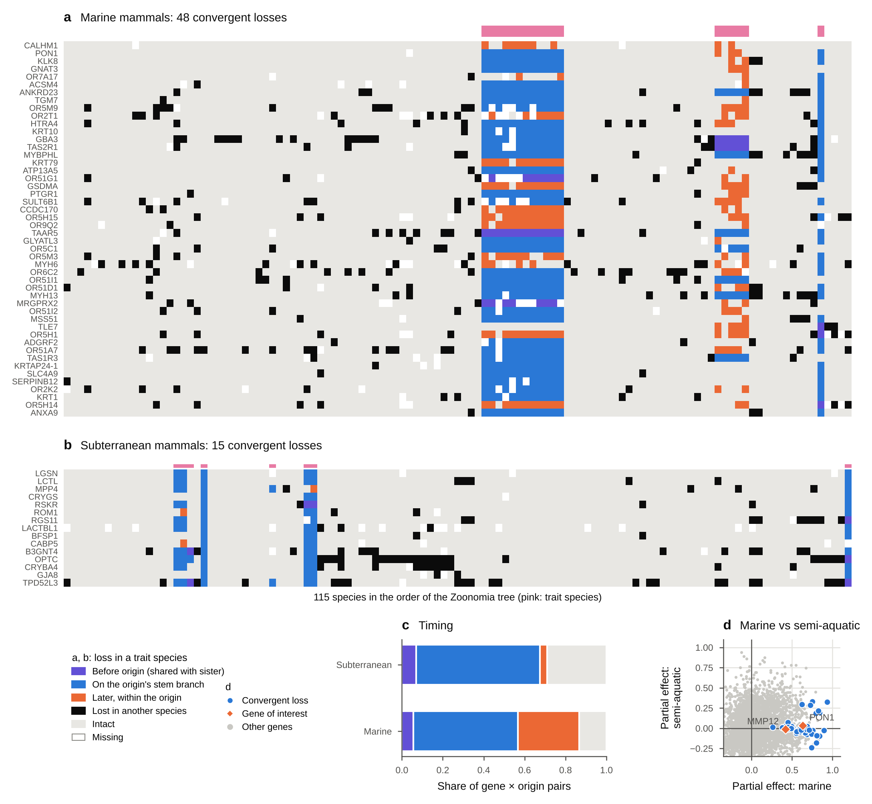
Extended Data Fig. 5 | Which species lost each convergent gene, and when the loss arose in each origin. a, The 48 marine losses; b, the 15 subterranean losses. Columns are the 115 species in the order of the pruned Zoonomia tree; pink bars mark trait species. A loss (TOGA lost or uncertain loss) in a trait species is coloured by its timing in that origin, inferred under the irreversible-loss model: violet, lost before the origin (shared with its sister lineage); blue, lost on the origin’s stem branch (all observed species of the origin lost); orange, lost later within the origin (some species). Black, lost in another species; grey, intact (intact or partially intact); white, missing. For origins of one species (manatee, tuco-tuco, blind mole-rat, mole vole, golden mole), the stem branch is the terminal branch. c, Share of gene × origin pairs in each timing class. d, Partial effects of the marine trait and of semi-aquatic life on gene loss (as in Fig. 4c). Grey, all testable genes; blue, the marine losses; orange, genes of interest.
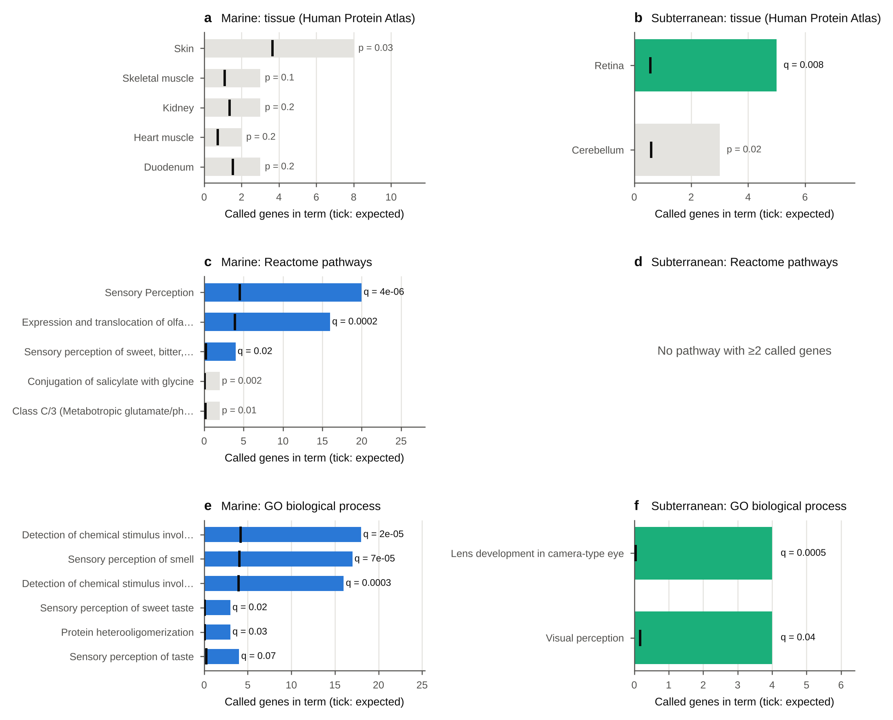
Extended Data Fig. 6 | Tissue, pathway and GO enrichment of the convergent losses. Bars, number of called genes in each annotation term; black ticks, number expected when each called gene is replaced by a random tested gene lost equally often across the 115 mammals. Coloured bars are terms significant after Benjamini–Hochberg correction over all eligible terms (q < 0.1); grey bars are shown with their uncorrected P. a, b, Tissues in which genes are elevated (Human Protein Atlas consensus expression, 50 human tissues) [40] for marine (a) and subterranean (b) losses; only tissues with at least two called genes are shown. c, d, Reactome pathways [41]; no pathway contains two or more subterranean losses. e, f, Gene Ontology biological processes [42] (terms with at most 450 genes; for terms with the same called genes, the most specific is shown).
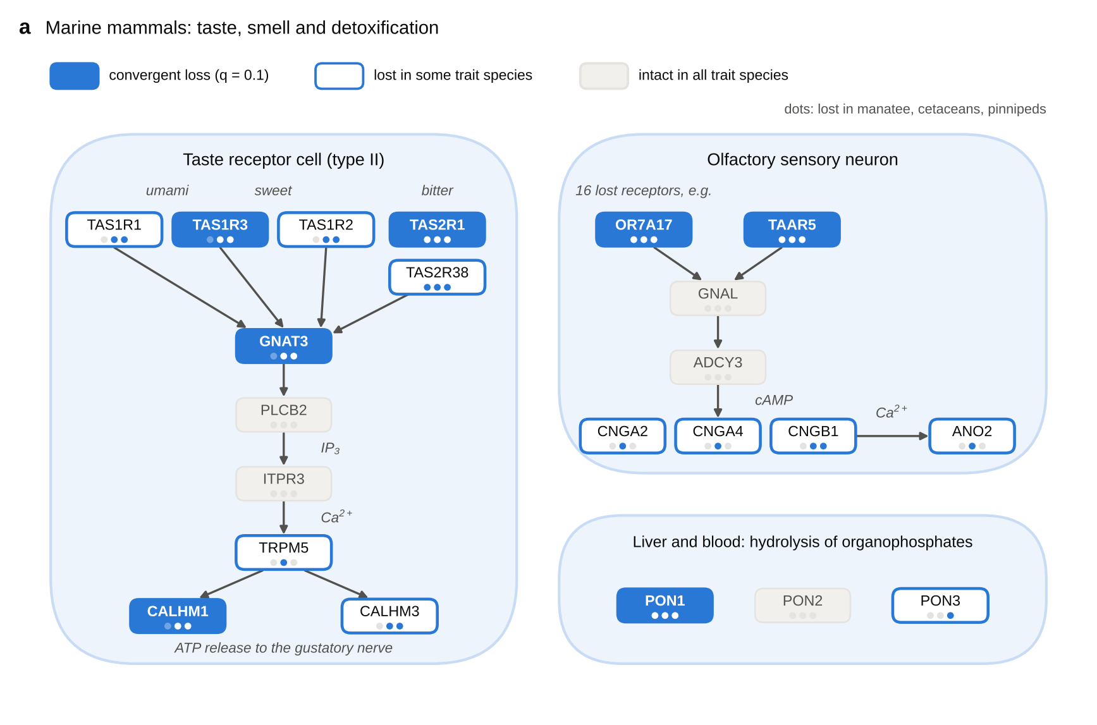
Extended Data Fig. 7 | Which parts of taste, smell and detoxification were lost in marine mammals. Canonical pathways (schematic; interactions from the literature) coloured as in Fig. 6a; dots mark the manatee, cetacean and pinniped origins. Type II taste receptor cell: sweet, umami and bitter receptors signal through gustducin (GNAT3), phospholipase Cβ2 (PLCB2), the IP₃ receptor (ITPR3) and TRPM5 to ATP release through CALHM1 and CALHM3. Olfactory sensory neuron: odorant and trace-amine receptors (16 lost olfactory receptors are represented by OR7A17) signal through Gαolf (GNAL), adenylyl cyclase 3 (ADCY3), the cyclic-nucleotide-gated channel (CNGA2, CNGA4, CNGB1) and the chloride channel ANO2. Paraoxonases PON1–3.
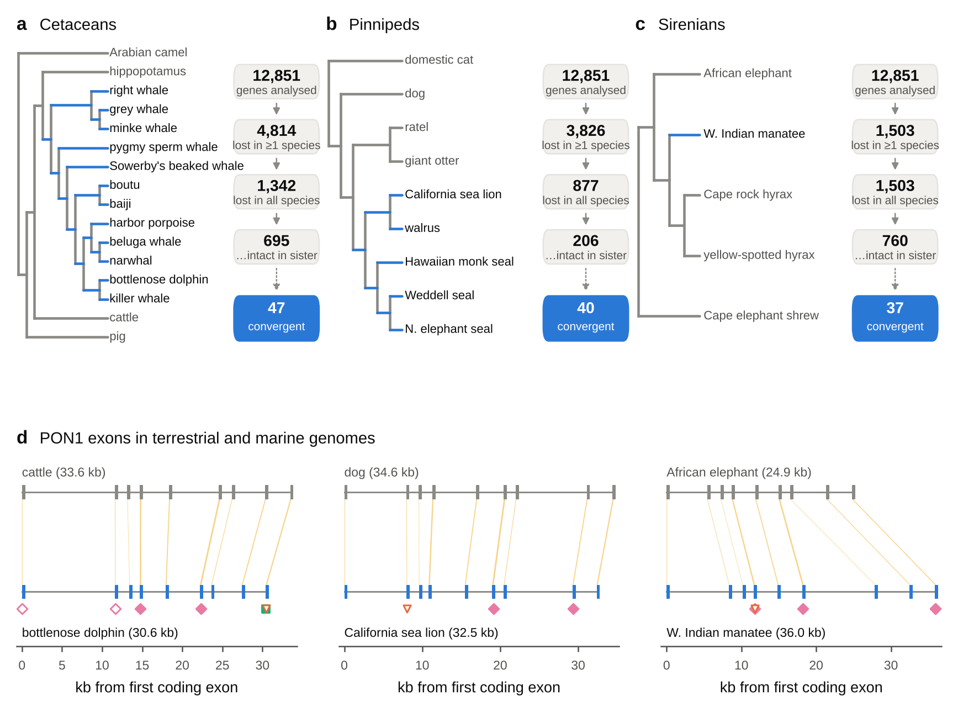
Extended Data Fig. 8 | Marine gene losses per lineage and the PON1 locus. a–c, Each marine origin with its closest terrestrial relatives in the study (cladograms; marine branches in blue). Boxes count genes, out of 12,851 analysed, that are lost in at least one species of the origin, lost in every species with data, and of those intact in the sister lineage; the blue box gives the number of the 48 convergent genes lost in at least one species of the origin. d, PON1 exons in the genome of a terrestrial relative (top, grey) and a marine species (bottom, blue) for each origin, with orthologous exons joined (yellow). Coordinates in kb from the first coding exon, in the direction of transcription; locus lengths in brackets. Mutations in the marine genome are shown below it with the symbols of Fig. 5a. Exon coordinates and mutations are TOGA projections of the human hg38 annotation [20].
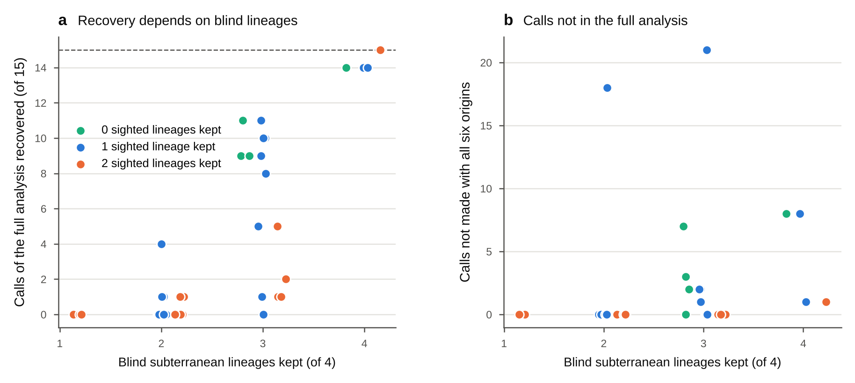
Extended Data Fig. 9 | The loss test needs lineages that share the phenotype, not just more origins. The subterranean analysis was repeated on every subset of three, four and five of its six origins (41 subsets); species of dropped origins were set to missing, and the fitted loss model and 50 simulated genomes per subset were used as in the full analysis. a, Number of the 15 losses called with all six origins that are called again, against the number of blind lineages kept (blind mole-rat, golden mole, African mole-rats, moles). Colour, number of sighted subterranean lineages kept (tuco-tuco, mole vole): green none, blue one, orange two. Dashed line, all 15. b, Calls made in a subset but not with all six origins. Points are jittered horizontally.
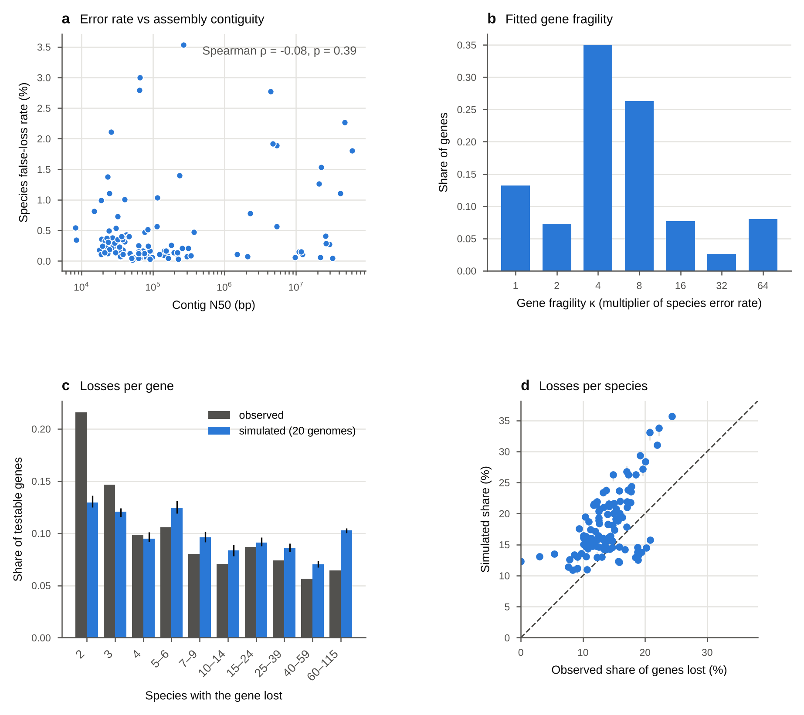
Extended Data Fig. 10 | The gene-loss model: data quality and goodness of fit. a, Fitted species false-loss rate against assembly contig N50 (114 species; human reference excluded). b, Distribution of fitted gene fragility κ, the factor by which a gene’s false-loss probability exceeds its species’ rate. c, Number of species in which each testable gene is lost, observed (grey) and in 20 genomes simulated from the fitted model (blue; bars, range). d, Share of genes lost per species, observed against simulated (bars, range over 20 genomes); dashed line, equality.

Supplementary Information

Supplementary Note 1. Standard models are miscalibrated on sequence-derived rates
A Brownian phylogenetic mixed model is calibrated when branch values are simulated from it, but not when they are estimated from simulated sequences. On AliSim genomes with no convergent genes (80 species, 600 genes), its per-layer false-positive rate at α = 0.05 was 0.10–0.14 for the two rate layers.
Three features of estimated rates break the model:
- Unequal noise. Estimation noise is much larger on short branches; the spread of a branch’s value across genes was strongly anticorrelated with its true length (Spearman ρ = −0.83).
- Correlated errors. Estimates of neighbouring branches trade off against each other.
- Rate jumps. Clade-wide rate changes are discontinuous rather than Brownian.
Per-branch weighting and a gene-by-branch measurement-error model did not remove the excess: null z-scores kept a standard deviation of 1.15–1.32 instead of 1.
Learning the null covariance from the genome restored calibration. With the same data, GLS gave false-positive rates of 0.038–0.053 across the three layers, and null z-scores had a standard deviation of 0.99–1.03 for each of 60 control trait sets as well as for the observed trait. In the main benchmark (10 trees of 200 species, 3,000 genes) the learned-covariance test held its false-positive rate at 0.049, 0.051 and 0.055 at confounding 0, 1 and 2, while the Brownian model reached 0.046, 0.070 and 0.080.

Supplementary Note 2. Rate jumps in single lineages cause false discoveries that only a repetition test removes
Correct calibration at α = 0.05 did not guarantee FDR control. With 2% convergent genes (80 species, 3 origins, 1,500 genes), GLS on the nucleotide rate layer had a realised FDR of 0.41 at q = 0.10, and 0.43 even when Σ was learned from a separate genome with no convergence. The excess came from the extreme tail: a rate jump that happens to fall on one trait clade produces a large z-score without any repeated shift. The rate contrast, which cancels overall rate changes, was largely immune (FDR 0.00–0.15).
Requiring the signal to survive the removal of each origin removed these false discoveries. In the realistic design (200 species, 5 origins, 3,000 genes, 2% convergent, 2 trees), per-layer GLS had FDR 0.21 (nucleotide rate), 0.05 (protein rate) and 0.00 (rate contrast); with leave-one-origin-out all three were 0.00. A Benjamini–Heller partial-conjunction test [43] over per-origin effects gave the same protection with lower power when origins were small, and was not pursued.

Supplementary Note 3. Only the final test controls false discoveries across confounding levels
In the main benchmark (Extended Data Fig. 1a–d; 10 trees of 200 species, 5 origins, 3,000 genes; results/final_benchmark.csv and results/robustness/main_tree*.csv), the final test made false calls in only 2 of the 30 genomes without convergence (at most 2 calls). Its realised FDR was 0.000, 0.003 and 0.007 at confounding 0, 1 and 2, and at most 0.06 in any single genome. Every other method exceeded the 0.10 target once lineage-specific rate jumps were present.
Method | False calls per null genome (conf 0 / 1 / 2) | Realised FDR (conf 0 / 1 / 2) | Power (weak / moderate / strong)
Naive | 0.9 / 210 / 395 | 0.15 / 0.84 / 0.91 | 0.43 / 0.60 / 0.64
Control-lineage permutation | 124 / 189 / 199 | 0.73 / 0.84 / 0.86 | 0.42 / 0.54 / 0.60
Naive Fisher over layers | 63 / 327 / 504 | 0.42 / 0.83 / 0.89 | 0.86 / 0.98 / 0.99
Brownian phylogenetic LMM | 6.2 / 20 / 39 | 0.08 / 0.36 / 0.45 | 0.67 / 0.93 / 0.98
Learned-covariance GLS | 0 / 16 / 16 | 0.00 / 0.19 / 0.24 | 0.70 / 0.91 / 0.96
Final (GLS + leave-one-origin-out) | 0 / 0.1 / 0.2 | 0.000 / 0.003 / 0.007 | 0.49 / 0.81 / 0.91
Power is reported for every method, but it is only meaningful where FDR is controlled. The final test’s power depended on the kind of convergence: selection shifts were found at 0.51, 0.89 and 0.98 (weak, moderate, strong), combined selection and rate shifts at 0.71, 0.95 and 1.00, and rate-only shifts at 0.23, 0.55 and 0.71. Power fell with confounding (0.88, 0.70 and 0.63 at levels 0, 1 and 2), the cost of refusing to call shifts confined to one lineage.
The control-lineage permutation baseline was inflated even without confounding (false-positive rate 0.13). Its per-gene null moments come from a limited pool of matched clades, so they underestimate the variance; this is a property of our implementation and not evidence about RERconverge’s permulations, which are assessed below.

Supplementary Note 4. Selection shifts are detectable with two origins; rate-only shifts need more
With the trait placed on 2 to 6 nested origins of each of 10 trees (Extended Data Fig. 1e,f; strong effect, confounding 1; results/origins_power.csv), the final test controlled false discoveries at every number of origins: FDR ≤ 0.01 and at most 0.3 false calls per null genome on average. Without leave-one-origin-out, learned-covariance GLS had FDR 0.27 with 2 origins, falling to 0.09 with 6; the naive test had FDR 0.82–0.88 throughout.
Origins | Power (all) | Selection shift | Rate shift only | Selection + rate
2 | 0.56 | 0.72 | 0.09 | 0.81
3 | 0.76 | 0.90 | 0.35 | 0.96
4 | 0.88 | 0.97 | 0.63 | 1.00
5 | 0.90 | 0.98 | 0.72 | 0.99
6 | 0.94 | 0.99 | 0.81 | 0.99
Changes in selection pressure were detected at 72–81% power even with two origins and at 90% or more with three, whereas rate-only convergence required four or more origins to exceed 60% power. For traits with few independent origins, such as laryngeal echolocation in mammals (two to four, depending on the bat phylogeny), the method is therefore expected to detect selection-type convergence but to miss much rate-only convergence.

Supplementary Note 5. Convergence signatures
The signature model was developed on one tree and tested on a second tree simulated after the rule for the number of learned directions had been fixed (results/signatures/evaluation.txt). Exact accuracy is the share of correctly detected convergent genes whose predicted set of active layers matched the simulation (selection shift: protein rate and rate contrast; rate shift: nucleotide and protein rate; both: all three).
Method | Tree A (development) | Tree B (held out)
Learned directions (k = 2^L − 1) | 0.90 | 0.98
Per-layer rule (p < 0.05) | 0.78 | 0.86
On/off configuration model (EBCM) | 0.80 | 0.42
Detection on both trees gave 92 true calls and no false calls. Without information about the simulation, both trees learned the same three directions (loadings on nucleotide rate, protein rate, rate contrast): rate shift ≈ (0.84, 0.55, 0.0), selection shift ≈ (0.1, 0.55, 0.82) and both ≈ (0.5, 0.65, 0.6). Tree B also learned a negative rate direction (−0.83, −0.55, −0.05), which absorbs lineages that slowed down; such genes are not called convergent. In the main benchmark, signature accuracy for detected genes was 0.74, 0.88 and 0.95 at weak, moderate and strong effects.

Supplementary Note 6. Comparison with RERconverge
RERconverge was run on the same simulated genomes (1 tree of 200 species, 5 origins, 3,000 genes, moderate effect; results/rerconverge_compare.csv).
Method | False calls, null genome (conf 0 / 1 / 2) | Realised FDR (conf 0 / 1 / 2) | Power (conf 0 / 1 / 2)
RERconverge, nucleotide trees | 0 / 37 / 119 | 0.07 / 0.54 / 0.75 | 0.65 / 0.67 / 0.60
RERconverge, protein trees | 0 / 28 / 78 | 0.00 / 0.43 / 0.61 | 0.93 / 0.87 / 0.82
RERconverge, protein trees + 1,000 permulations on 150 candidates | 0 / 0 / 0 | 0.39 / 0.39 / 0.33 | 0.93 / 0.72 / 0.60
RERconverge, protein trees + 10,000 permulations on all genes (separate genomes) | 15 / 0 / 0 | 0.24 / 0.04 / 0.15 | 1.00 / 0.83 / 0.77
Final pipeline | 0 / 0 / 0 | 0.00 / 0.00 / 0.00 | 0.87 / 0.72 / 0.65
Without lineage-specific rate jumps, RERconverge on protein trees was calibrated and slightly more powerful than the final pipeline (0.93 against 0.87). With rate jumps, its parametric test lost FDR control (0.43–0.75). The final pipeline made no false calls in any of the six genomes. Permulations [19] run only on the 150 genes with the smallest parametric P removed all false calls on genomes without convergence, yet with 2% convergent genes 18–35 non-convergent genes were called (FDR 0.33–0.39). Run on all genes with 10,000 permulations (one genome per rate-jump intensity), RERconverge had FDR 0.24, 0.04 and 0.15 at intensities 0, 1 and 2, with power 1.00, 0.83 and 0.77, and made 15 false calls on the intensity-0 genome without convergence. On the same genomes the final pipeline made no false call (power 0.97, 0.83 and 0.72). Permulations on all genes thus reduce the excess of the candidate-only design but do not remove it. The number of permulations matters: with 100, the smallest attainable P value (about 0.02) lies above the Benjamini–Hochberg threshold for 3,000 genes, and no gene was called. Permulations on all genes took about 11 CPU-hours per genome, against seconds for the final test, which in addition provides the gene-loss layer, convergence signatures and control-trait calibration on real genomes.

Supplementary Note 7. Calibration on real gene trees (pilot)
The protein gene trees distributed with RERconverge (mamTreesSub: 1,000 genes, 62 mammals) were used; the 761 genes present in all 62 species were analysed (118 branches after excluding root edges). The single layer was the log protein branch length with a pseudo-count of 0.001, mean-centred per branch. Echolocation was coded in two origins: vespertilionid bats (Eptesicus fuscus, Myotis davidii, M. lucifugus) and toothed whales (Tursiops truncatus, Orcinus orca). One hundred distinct control trait sets were drawn as pairs of non-echolocating clades matched in size and age; any gene called for a control set is a false call by construction.
Method | Mean false calls per control set | Control sets with any call | Most calls in one set | Echolocation calls
Naive | 73.8 | 100% | 170 | 12
RERconverge (parametric) | 0.85 | 22% | 17 | 0
Learned-covariance GLS | 0.75 | 43% | 9 | 0
Final pipeline | 0 | 0% | 0 | 0
The naive test called 12 genes for echolocation, well inside the 74 false calls it made on average for control traits, which illustrates on real data the problem raised by Thomas and Hahn [16].

Supplementary Note 8. Calibrating a gene-loss test needs a model of annotation error
Each step below was judged on matched control trait sets of the real genomes, where every call is false.
Null for the loss layer | Data | Trait calls | Control sets: mean false calls | with any call
GLS t-test, no correction | marine, 101 species | 42 | 5.1 | 60%
200 other control trait sets, pooled by number of losses | marine, 101 species | 14 | 0.25 | 20%
same, only 142 distinct control sets available | marine, 105 species | 1 | 0.15 | 10%
Simulated losses, species error rate only | marine, 105 species | 53 | 0.05 | 5%
Simulated losses, species error rate × gene fragility | all five traits, 115 species | 0–48 | 0.26 (pooled; 0.08–0.66 by trait) | 13% (pooled; 7–19% by trait)
The GLS t-test assumes roughly continuous data; clade-inherited 0/1 losses violate it badly. A null from other control trait sets is valid but depends on how many distinct sets the tree offers; with few, the same clade-specific losses recur across sets and the null becomes conservative (PON1: p = 2 × 10⁻⁴ instead of 6 × 10⁻¹⁰). The simulated null first assumed one false-loss rate per species, which held for three origins but failed for ten single-species origins (28 false calls in one hypoxia control set). Letting false-loss rates also vary by gene removed them and left the trait results unchanged in substance (marine 48 calls instead of 53; the same leading genes).

Supplementary Note 9. Fit of the loss model; assembly statistics do not predict annotation error
Fitted species false-loss rates ranged from 0.02% to 3.5% (median 0.21%). They were not explained by contig N50 (Spearman ρ = −0.08, p = 0.39), scaffold N50 (ρ = 0.17, p = 0.07), distance to the human reference (ρ = 0.15, p = 0.11) or terminal branch length (ρ = 0.12, p = 0.21) (Extended Data Fig. 10a). Most genes (87%) had a fragility above 1 (Extended Data Fig. 10b). Genomes simulated from the fitted model had too few genes lost in exactly two species (12.9% against 21.6% observed) and too many lost in 60 or more (10.3% against 6.5%), and they overestimated each species’ share of lost genes by 4.1 percentage points (Extended Data Fig. 10c,d). These misfits pull in opposite directions: too many simulated losses widen the null, but too few genes lost in exactly two species could make shared losses look rarer than they are. The direction of the net bias therefore cannot be read from the fit, and calibration was judged directly on control traits (Fig. 4b).

Supplementary Note 10. Calibration on 500 matched control traits
Each analysis was repeated on 100 control traits matched to the real trait in number of origins, clade size and clade age; every call they produce is false. The calls for the real traits were identical to those of the initial runs with 20 control traits.
Analysis | Any rate call | Any loss call | Any combined call | Mean false loss calls per control trait | Loss calls, real trait
Marine | 1% (0–5%) | 16% (9–25%) | 11% (6–19%) | 0.20 | 48
Subterranean | 8% (4–15%) | 7% (3–14%) | 11% (6–19%) | 0.08 | 15
Combined hypoxia | 4% (1–10%) | 10% (5–18%) | 5% (2–11%) | 0.12 | 11
High altitude | 0% (0–4%) | 19% (12–28%) | 10% (5–18%) | 0.66 | 1
Echolocation | 2% (0–7%) | 12% (6–20%) | 9% (4–16%) | 0.22 | 0
All 500 | 3% (2–5%) | 13% (10–16%) | 9% (7–12%)
Exact binomial 95% intervals in brackets. The share of control traits with any loss call is a family-wise error rate and is somewhat above the nominal 10%. The expected number of false calls per trait, however, is small compared with the calls for marine and subterranean mammals. One high-altitude control trait made 33 calls; its origins were the African elephant (2,945 annotated losses), the two camels (2,379 and 2,498), a bat and the human reference, against a median of 1,688 losses per species. Lineages with unusually many annotated losses are therefore where the loss null is least reliable. Marine species carry many annotated losses (median 2,321, the 84th percentile of species), so a further set of 100 marine control traits was drawn among lineages whose species carry as many annotated losses as the marine species (within 30%): 20% had any loss call (13–29%) and the mean was 0.23 false loss calls per control trait, against 16% (9–25%) and 0.20 for the unmatched marine controls. Matching on annotated losses therefore raised the false-call rate only slightly, and the same 48 marine genes were called.
Because every call in a control trait is false, the P values of all genes across the control traits show the null distribution each test actually has (Extended Data Fig. 4). Gene-loss P values were close to uniform: pooled over the 100 control traits of each analysis, 4.1–4.8% were below 0.05, 0.9–1.3% below 0.01 and 0.09–0.16% below 0.001, against 5%, 1% and 0.1% expected. Rate P values were strongly conservative (0.2–0.9% below 0.05), as expected from requiring a signal in every leave-one-origin-out test; the rate test therefore has little power to find modest convergent shifts. For marine, subterranean and combined hypoxia, the gene-loss P values of the real trait depart above the band spanned by the control traits, whereas for high altitude and echolocation they stay within it (results/extra/control_null_pvalues.csv).

Supplementary Note 11. Counting only confident losses
TOGA classifies a gene as lost (L) or as an uncertain loss (UL) when the evidence is weaker. The main analysis counts both as lost. Here every trait was rerun counting only L, with UL treated as missing data, and checked on 100 matched control traits. The calls were the same as in an earlier run with 20 control traits. Across the 500 control traits, 10% gave any loss call (exact 95% interval 8–13%): 6% for marine, 11% subterranean, 16% high altitude, 14% combined hypoxia and 4% echolocation, with 0.04–0.23 false loss calls per control trait.
Analysis | Calls, L and UL | Calls, L only | Called in both
Marine | 48 | 28 | 17
Subterranean | 15 | 26 | 11
Combined hypoxia | 11 | 6 | 6
High altitude | 1 | 0 | 0
Echolocation | 0 | 41 | 0
The 17 marine and 11 subterranean genes called under both codings are the basis of the high-confidence core (Supplementary Table 1). The 31 marine genes not called with L only include losses documented before in these lineages (KLK8, KRT1, KRT10, GSDMA, SLC4A9, TGM7, TAS2R1), so uncertain losses often mark real losses, here mainly in pinnipeds. The 15 subterranean genes added with L only are almost all eye genes (ABCA4, CRYBA1, CRYBB1, GJA10, GJE1, IMPG1, RBP7, RTBDN, SLC16A8 and others), which strengthens the eye result. DEAF1, the single high-altitude call, was not called with L only, which supports its interpretation as an annotation error. Echolocation gained 41 calls with L only, although only 4% of its control traits gave any call. Under the main coding these genes are often uncertain losses in non-echolocating species (median five), which makes their losses look less specific. Twenty-one are lost in all three origins and 20 in two (17 of these in the two bat lineages but no toothed whale); 28 pass the per-gene check, 15 of them lost in all three origins (APCS, ATP1A4, FABP12, IGKV2D-28, IGKV2D-30, IL36A, KRTAP21-2, LDLRAD2, LMAN1L, OR13F1, OR5K3, OR6P1, SLURP1, TIGD6, ZNF793). None is a hearing gene; they include olfactory and taste receptors (TAS1R1, already reported lost in bats and toothed whales), immune genes and skin genes. Because the result depends on how uncertain losses are coded and points to ecology shared by bats and toothed whales rather than to hearing, we list these genes as candidates (`results/audit/Lonly100_echolocation`) and do not count them among the convergent losses.

Supplementary Note 12. Timing of the convergent losses per origin
Origin | Species | At origin | Later, within origin | Before origin | Intact
Cetaceans | 12 | 32 | 12 | 3 | 1
Pinnipeds | 5 | 7 | 31 | 2 | 8
Manatee | 1 | 34* | – | 3 | 10
African mole-rats | 2 | 10 | 2 | 0 | 3
Moles | 2 | 13 | 1 | 1 | 0
Blind mole-rat | 1 | 15* | – | 0 | 0
Golden mole | 1 | 11* | – | 3 | 0
Tuco-tuco | 1 | 1* | – | 2 | 12
Mole vole | 1 | 2* | – | 0 | 10
Counts of genes; * one species, so “at origin” means anywhere on its terminal branch. Genes without data in an origin are omitted. Among the hypoxia genes of interest, only EGLN1 had a large high-altitude partial effect (+0.61); it is lost in one species (the wild yak) and unobserved in two others, which is why the leave-one-origin-out test did not call it.

Supplementary Note 13. Genes of interest for echolocation and high altitude
Gene | Trait | Rate P | Loss P
SLC26A5 (prestin) | Echolocation | 0.45 | 0.15
TMC1 | Echolocation | 0.031 | 0.55
LOXHD1 | Echolocation | 0.021 | 0.98
OTOF | Echolocation | 0.61 | 0.055
EPAS1 | High altitude | 0.63 | 0.78
EGLN1 | High altitude | not tested | 1.0
HIF1A | High altitude | 0.67 | not tested
HBA2 | High altitude | not tested | 0.06
NGB | High altitude | 0.89 | 0.12
“Not tested” means the gene failed the filters for that layer. The smallest P values genome-wide were 0.001 (rate) and 5 × 10⁻⁵ (loss) for echolocation, and 2 × 10⁻⁴ (rate) for high altitude, all above the FDR threshold.

Supplementary Table 1. The 63 convergent losses
One row per gene: trait, functional group (assigned by hand), loss P value, number of trait and other species that lost the gene, number of origins with a loss, and prior literature: whether the loss was named before in these lineages, in some of them, or only as part of a gene-family reduction, with references. The literature search covered published abstracts and main texts, gene by gene; supplementary gene lists of earlier surveys (for example refs 9 and 11) and the Gene Loss database may name further genes. File: results/extra/supplementary_table1_convergent_losses.csv.

Supplementary Table 2. Sequence evidence for each convergent loss
For each of the 63 losses: the number of origins, the number of origins in which at least one trait species lost the gene, and the number in which at least one lost species carries an unmasked inactivating mutation (stop codon, frameshift, splice-site mutation) or a deleted exon on TOGA’s orthologous projection. Missing exons caused by assembly gaps are not counted as evidence. The table also gives the number of trait species classified lost (L), uncertain loss (UL), intact and missing, and counts of each kind of lesion. Evidence tiers were defined before the table was computed:
- A: lesion-supported loss in every origin with a loss, and in at least two origins (48 genes: 35 marine, 13 subterranean).
- B: lesion-supported loss in at least two origins, but not in every origin with a loss (9 genes: 7 marine olfactory and trace-amine receptors; CRYBA4 and B3GNT4).
- C: lesion-supported loss in fewer than two origins (6 genes: OR2T1, OR51G1, OR9Q2, OR51I2, KRT1, KRTAP24-1).
Across trait species that lost a called gene, 69% were classified L and 31% UL. Files: results/extra/loss_evidence_by_gene.csv and loss_evidence_by_species.csv.

