Calibrating genome-wide convergence screens on the genomes they analyse
Ruchishree Konhar¹, Meher Afzoon² and Devendra Kumar Biswal²,³*
¹ National Network Project @ Biodiversity Informatics Centre, North-Eastern Hill University, Shillong, Meghalaya 793022, India. ² Department of Zoology, North-Eastern Hill University, Shillong, Meghalaya, India. ³ Bioinformatics Centre, North-Eastern Hill University, Shillong, Meghalaya, India. *Corresponding author: devbioinfo@gmail.com. ORCID iDs: R.K. 0000-0003-1147-1054; M.A. 0009-0008-1197-603X; D.K.B. 0000-0003-1093-7166.
Preprint. Not peer reviewed.

Abstract
Genome-wide screens for convergent evolution associate genes with traits that evolved repeatedly, but their false-call rates are inferred from simulations that share the method’s assumptions. We present a convergence test calibrated on the genomes it analyses. It combines generalised least squares with a null covariance learned from all genes, an intersection–union requirement that every signal survive the removal of any independent origin, a simulated gene-loss null with species- and gene-specific annotation error, and empirical calibration of the complete pipeline on matched control traits, most held out until the method was fixed. In sequence simulations it controlled false discoveries under lineage-specific rate shifts where standard models did not. Across 15,703 genes in 115 mammals and four traits, it found no convergent rate shifts but recurrent gene losses in subterranean and marine mammals; ocular genes dominated the subterranean losses under every coding. Empirical calibration makes the reliability of each convergence call measurable.

Main
When a trait evolves independently in several lineages, each origin is a natural replicate, and genes that change repeatedly across origins are candidates for its genetic basis [1–3], whether through identical substitutions, different changes in the same gene or the loss of the same function [2,4]. With hundreds of mammalian genomes now aligned [5–7], the question can be asked of every gene at once, and it becomes a computational one: an association problem across species, with species as samples, genes as features and a phylogeny that makes every sample dependent on the others.
Three families of methods have been built for it: tests for convergent shifts in evolutionary rate [8–10], for convergent amino-acid substitutions [11,12] and for convergent gene loss [13,14]. Gene loss is attractive computationally as well as biologically, because an inactivated gene is a discrete, repeatable event that marks a dispensable function [15,16]. These methods have produced a large catalogue of candidate genes for life in water [8,17,18], underground [19], at high altitude [20] and with biosonar [21,22], alongside gene-level cases such as paraoxonase 1 in marine mammals [23], the decay of smell, taste and vision [24–26] and hypoxia genes in highland humans [27,28].
What these screens rarely report is how often they would make a call if there were nothing to find. Three properties of the data make this rate hard to predict. Species are not independent samples [29]. Branch lengths estimated from sequences carry correlated errors, and a single lineage with an unusual rate can mimic convergence across several. Gene losses inferred from genome assemblies contain annotation errors concentrated in particular species and particular genes [14,30]. A null model that omits any of these will be miscalibrated, and simulations that share its omissions will not reveal it. Echolocation shows the consequence: a genome-wide signal of convergent substitutions [11] did not survive appropriate null models [31,32]. Phylogenetic permutations improve calibration [33] but are costly at genome scale and still assume that the trait is the only structure its lineages share.
Comparative biology also asks questions that a single P value cannot answer: how many origins are needed, when each change occurred and which of several correlated traits it reflects [34]. A screen can be calibrated and still credit a signal to the wrong trait. The difficulty grows with scale. Gene-loss classifications now cover hundreds of mammalian genomes [30,35], and the number of model-based methods for convergent substitutions and rate shifts continues to grow [36,37], yet their error rates are typically established on simulated data generated under the assumptions of the method being tested.
Here we treat calibration as a quantity to be measured on the data, not assumed. We developed a convergence test with four components. First, generalised least squares with a null covariance learned from all genes replaces an assumed Brownian-motion kernel, designed to absorb shared ancestry, lineage-specific rate jumps and correlated estimation error in one matrix that is estimated once and reused. Second, convergence is defined as replication: a leave-one-origin-out intersection–union test requires every signal to survive the removal of any origin, and an explicit composite null, simulated per gene, tests whether a single origin explains each called loss. Third, gene-loss evidence is calibrated against a generative null, an irreversible-loss model whose annotation error is the product of species and gene components, fitted to all genes jointly by vectorised pruning. Fourth, the complete pipeline, including covariance learning, null simulation and multiple-testing correction, is rerun on matched control traits, most of them held out until the method was fixed, so that its false-call rate is measured on the same genomes as its discoveries. We benchmarked the test on paired sequence simulations against naive tests, a phylogenetic mixed model and RERconverge, and on 500 control traits from real genomes.
Applied to 15,703 genes in 115 mammals from the Zoonomia alignment and TOGA annotations [5,30], for echolocation, marine life, subterranean life and high altitude (Fig. 1), the calibrated test found no convergent rate shifts but recurrent gene losses in subterranean and marine mammals. The measurement of calibration then graded these calls: ocular genes dominated the subterranean losses under every coding, and the lens gene LGSN, with CRYGS close to the threshold, retained support against single-origin explanations after genome-wide adjustment, whereas the marine set depended on how uncertain losses were coded and on a residual misfit of the loss model in marine species. Calibration measured on the data thus turns a list of candidates into a list with known reliability.

Results

A convergence framework evaluated on empirical genomes
The test (Fig. 2) works on four layers per gene: nucleotide and protein rates and the contrast between them on each branch, and gene loss in each species. Rather than assuming a null covariance from the tree, it learns the covariance of each layer from all genes, so that shared ancestry, lineage-specific rate jumps and estimation error are absorbed. A gene counts as convergent only if its signal survives the removal of each origin in turn (leave-one-origin-out), so no single lineage can create a call. For gene loss, P values were obtained from genomes simulated from a fitted model of irreversible loss with annotation error that varies by species and by gene. Every analysis is repeated on 100 matched control traits, treated as null configurations. Each layer is tested, and its false discovery rate controlled at q = 0.1, separately: a gene is a convergent loss when the loss test is significant, and a convergent rate shift when the rate test (which combines the three rate layers) is. A combined score that merges both is reported only as a summary; because a lost gene has no rate data in the species that lost it, this score rarely adds evidence (it called none of the marine losses and 10 of the 15 subterranean losses).
On simulated codon alignments with lineage-specific rate jumps, the final test made at most two false calls per genome without convergence and kept its realised false discovery rate (FDR) at 0.00–0.01 across 10 simulated phylogenies, while naive, permutation-based, Brownian-model and covariance-only tests reached 0.19–0.91 once rate jumps were present (Extended Data Fig. 1). RERconverge’s parametric test [9,10] was calibrated without rate jumps but not with them (FDR 0.43–0.75); with 10,000 permulations [33] on all genes its FDR was 0.24, 0.04 and 0.15 at the three intensities (one simulated genome each), whereas the final test made no false call at any intensity, at about 11 CPU-hours per genome against seconds (Extended Data Fig. 2). On genomes simulated from the loss model fitted to the real data, the loss test’s false discovery proportion averaged 0.019 (at most 0.067) with power of 0.29–0.89 depending on the number of origins and the share of each origin that lost the gene, whereas a test that ignored phylogeny called up to 69% false genes (Fig. 3a–f); in 15 simulated genomes without convergent loss, it made one false call in total. The final test stayed calibrated with 100 or 400 species, with 0.5–10% of genes convergent and under gene-tree discordance (mean FDR 0.010 or less in every setting, at most 0.05 in any one of five trees; at most one false call per genome without convergence; Extended Data Fig. 3). At moderate effect, its power fell from 0.77 with 0.5% of genes convergent to 0.64 with 5% and 0.38 with 10%, probably because so much convergent signal enters the covariance learned from all genes (Supplementary Notes 1–7).
Simulations share the model’s assumptions, so calibration was judged on the real genomes. Two of the loss nulls we built failed this check: a parametric test (5.1 false calls per control trait) and a model with one annotation-error rate per species, which made 28 false calls in one control trait of ten single-species origins (Fig. 3g; Supplementary Notes 8 and 9). Annotation errors cluster in some genes as well as some species; allowing for both removed the failures. Across the 500 control traits of the five analyses, 3% had any rate-layer call (95% interval 2–5%), 13% any loss call (10–16%) and 9% any call of the combined test (7–12%) (Fig. 4b). Across all genes of the control traits, gene-loss P values were close to uniform (4.1–4.8% below 0.05) and rate P values conservative (0.2–0.9% below 0.05; Extended Data Fig. 4). A control trait produced on average 0.08–0.22 false loss calls, and 0.66 for high altitude, where one control trait made 33 calls; its origins were the elephant and the two camels, among the genomes with the most annotated losses (Supplementary Note 10). Controls 21–100, analysed only after the null was fixed, gave the same rate of loss calls as controls 1–20, used during its development (13% and 13%; Fig. 3g), although the high-altitude analysis gave a call in 21% of its held-out controls (Supplementary Note 14). The fitted model leaves a residual misfit in the number of losses per species that is largest in marine species (Supplementary Note 9). These numbers measure how often a trait without convergence yields at least one call, a family-wise error rate; they are not the false-discovery proportion among our calls, which was estimated in the simulations above.

The primary analysis detected candidate convergence through gene loss
We analysed 15,703 genes in 115 mammals from the Zoonomia alignment [5] and TOGA orthology [30] (Fig. 1), with traits defined before testing: marine mammals (3 origins: cetaceans, including two river dolphins that live in fresh water; pinnipeds, which breed on land or ice; and the manatee), life underground (6 origins), high altitude (4 origins) and echolocation (3 origins). No analysis produced a convergent rate shift. The loss test identified 48 candidate convergent losses in marine mammals and 15 in subterranean mammals (Fig. 4a,d,e; Supplementary Table 1). These are phenotype-associated loss candidates under the primary coding and the fitted null. We report the evidence for them in three nested tiers, each with its own interpretation: the primary screen; a high-confidence intersection of independent lines of evidence; and support against single-origin explanations after genome-wide correction.
To judge each loss independently of the test, we tabulated the inactivating mutations TOGA reports (Supplementary Table 2). Of the 63 losses, 48 carry a stop codon, frameshift, splice-site mutation or deleted exon in every origin where they are lost, 9 in at least two origins, and 6, all olfactory receptor or skin genes of marine mammals, in only one. Of the 48 marine losses, 28 occur in all three marine origins and 20 in two; each subterranean loss occurs in three to six of the six origins. Counting only TOGA’s confident losses, with uncertain losses treated as missing, kept 17 of the 48 marine and 11 of the 15 subterranean calls. It added 11 marine calls, mostly skin, taste and smell genes (ADGRF3, B3GNT3, BPIFA2, KCNMB3, KRT77, KRT82, LRRC27, OR4Q3, TAAR9, TACR2, TAS2R4), and 15 subterranean calls that are almost all eye genes (for example ABCA4, CRYBA1, CRYBB1, IMPG1 and RTBDN); under this coding 4–16% of 100 control traits per analysis gave any loss call (Supplementary Note 11). Because uncertain classifications become missing data, this coding is not simply a stricter version of the primary test. Calls that survive it, carry inactivating mutations in every origin where the gene is lost and pass the uncorrected per-gene check described below form a high-confidence core of 8 marine genes (ANKRD23, GNAT3, HTRA4, MYBPHL, OR51I1, PON1, PTGR1 and TAS1R3) and 10 subterranean genes (BFSP1, CRYGS, LACTBL1, LCTL, LGSN, MPP4, RGS11, ROM1, RSKR and TPD52L3; Supplementary Table 1). The core records agreement between lines of evidence; it is not a separately calibrated error-rate tier. The marine calls it dropped include losses reported before, such as KLK8, KRT1, KRT10, GSDMA and SLC4A9, so uncertain losses often mark real ones.
Leave-one-origin-out makes every call depend on more than one origin, but its P value is calibrated against genomes with no association anywhere. We therefore asked of each call whether a real loss in one origin alone, with chance losses and annotation errors elsewhere, could reproduce it: for each origin in turn, its observed states were kept and the rest simulated at background loss rates, and the largest P value over origins was retained (Methods). With 10,000 replicates, all 15 subterranean losses passed at P < 0.01 (8 at P < 0.001), as did 36 of the 48 marine losses (3 at P < 0.001; Supplementary Table 1); these per-gene P values are not corrected for the number of genes tested. The marine losses are less secure because one of the three origins is a single species, the manatee, in which one annotation error can complete the pattern. For a genome-wide correction, every loss-tested gene not called by the primary screen was assigned P = 1, which can only make the procedure more conservative, and the Benjamini–Hochberg procedure was applied across all 12,851 loss-tested genes to Monte Carlo P values computed from replicate counts alone (Methods; Supplementary Note 14). With 1,000,000 replicates per gene and origin, two lens genes remained at q = 0.1: LGSN, for which no replicate reached the observed statistic in any origin (P = 1.0 × 10⁻⁶, adjusted 0.013), and CRYGS (P = 1.3 × 10⁻⁵, adjusted 0.084), which lies close to the threshold and does not pass at the upper 95% Monte Carlo bound of its P value. MPP4 (P = 3.7 × 10⁻⁵, adjusted 0.16) did not remain. No marine gene did either: the smallest marine P values, PON1 (4 × 10⁻⁵) and GNAT3 (8 × 10⁻⁵), lay above the Benjamini–Hochberg threshold at every rank. Under the confident-loss and uncertain-as-intact codings, which test about 5,430 genes each and so apply less strict thresholds, the same correction retained 9 and 8 subterranean genes; LGSN, CRYGS, LCTL, RSKR, BFSP1, CRYBA1, ABCA4 and DDIT4L were retained under both, mostly lens and retinal genes. LGSN and CRYGS were the only genes retained under all three codings (Supplementary Note 14). The ocular theme was therefore stable across codings, whereas individual genes beyond LGSN were not.
Twenty-one of the 63 losses had been reported before in at least some of these lineages, among them PON1, TAS1R3, CALHM1, GBA3, KLK8, the keratins KRT1 and KRT10, and the lens genes CRYBA4, CRYGS and BFSP1; 19 olfactory, trace-amine and keratin-family genes had been reported only as part of losses of whole gene families, and LGSN only as accelerated evolution; for the remaining 22 we found no earlier report in a gene-by-gene but non-exhaustive search (Supplementary Table 1). Recovery of known losses is consistent with the test but is not independent evidence of its error rate; the 22 candidates without earlier reports rest on the sequence evidence above and remain to be validated independently of TOGA. Under the confident-loss coding, echolocation gained 41 calls, although only 4% of its control traits gave any call, and DEAF1 was no longer called. None of the echolocation calls is a hearing gene: they are olfactory, taste, immune, skin and eye genes; 20 are lost in only two of the three origins (17 in the two bat lineages but no toothed whale), and 15 lost in all three origins pass the per-gene check. As for the coding-sensitive calls of the other traits, we treat them as candidates (Supplementary Note 11): the absence of hearing genes does not show that they arise for reasons other than echolocation, and explanations such as diet or sensory ecology are hypotheses that we did not test. Under the main coding, echolocating mammals had no call, and high-altitude mammals one, DEAF1, which passes the per-gene check (P = 0.003) but is lost in only two species and is more likely an annotation error than a real loss of an essential transcription factor (Fig. 4f,g). These negatives are limited by power: in simulations with three origins and about five trait species, comparable to the four single-species high-altitude origins, the loss test found 29–76% of convergent losses depending on the share of each origin that lost the gene (Fig. 3), so some convergent losses at high altitude could have been missed.
None of the genes of interest fixed in advance was called: prestin (SLC26A5) and other hearing genes for echolocation, and EPAS1, EGLN1, HIF1A and neuroglobin for high altitude. Their known adaptations are local, a few convergent amino-acid sites in prestin [21,22] and regulatory or coding variants in EPAS1 and EGLN1 [27,28], and whole-gene tests are not expected to see them. These negative results therefore bound what gene-level tests can detect; they do not show that these traits lack molecular convergence.

Marine loss candidates include genes associated with smell, taste, skin and detoxification
The 48 marine losses comprise 17 olfactory and trace-amine receptors, four taste genes, eight skin genes, five muscle genes, six genes of detoxification and metabolism and eight others (Supplementary Table 1; Extended Data Fig. 5). They are enriched in olfactory signalling (16 genes, 4.1 times the number expected, q = 0.0002) [24] and in sweet, bitter and umami taste (19 times expected, q = 0.02) against a null that keeps each gene’s overall frequency of loss across mammals (Extended Data Fig. 6). Placing the losses on their pathways shows how taste was lost (Extended Data Fig. 7). The sweet and umami receptors TAS1R1 and TAS1R2 are gone in 17 of 18 marine species but also in many terrestrial carnivores, so they are not marine-specific [25]. The calls fall on the shared receptor subunit TAS1R3, the bitter receptor TAS2R1, gustducin (GNAT3; lost in 15 marine species and no other) and the transmitter-release channel CALHM1 (9 marine species, no other), whereas the signalling enzymes that taste shares with other tissues are intact in every marine species.
The losses are a small, repeated subset of each lineage’s own losses: 1,342 genes are lost in every cetacean with data, 695 of them not in the hippopotamus, against 48 shared convergent losses (Extended Data Fig. 8). Their timing matches each lineage’s history (Extended Data Fig. 5; Supplementary Note 12). In cetaceans, two-thirds of the losses are shared by all 12 species and date to the stem lineage; in pinnipeds, most arose later and independently within the group.
PON1, which hydrolyses organophosphates and oxidized lipids, shows how one convergent call is built (Fig. 5). It is lost in 16 of the 18 marine species and in no other species [23]. The cetaceans with data at these sites share the same two 1-bp deletions and the same mutated splice acceptor, so PON1 was lost once in their common ancestor. The pinnipeds share no mutation: the sea lion carries two frameshifts, the monk seal and the Weddell seal different stop codons, and the walrus and northern elephant seal an intact reading frame, so, if inactivating mutations are not reverted, PON1 was inactivated at least three times independently within pinnipeds after they entered the sea. A shared earlier decline in function, followed by lineage-specific lesions, cannot be excluded from coding sequence alone. The manatee carries yet other frameshifts. Apart from exon 4, deleted in the pygmy sperm whale, all nine exons remain in place in every lineage (Extended Data Fig. 8d): the gene decayed mainly by small mutations, not by deletion.

Subterranean loss candidates are enriched for ocular genes
The 15 subterranean losses are concentrated in the eye: five are genes elevated in the human retina (8.8 times expected, q = 0.008) and four are annotated to lens development (92 times expected, q = 0.0005; Fig. 6c,d). Eye-gene regression in subterranean mammals has been described before [19,26]; here it emerges from a genome-wide scan with no eye gene specified in advance. The lens gene LGSN, the strongest call (P = 5 × 10⁻⁹), is lost in six subterranean species and no other. Its frameshifts differ between the golden mole, the Damara mole-rat and the blind mole-rat, whereas the two moles share one inherited from their common ancestor (Fig. 6b).
The pathway map shows which parts of the eye were lost (Fig. 6a). The lens is dismantled more broadly than the calls alone show: three further crystallins, aquaporin 0 and a second beaded-filament protein are lost in two to four of the eight species. In contrast, rhodopsin, rod transducin (GNAT1), the phosphodiesterase subunit PDE6A and the channel subunit CNGA1 are intact or partly intact in all eight species, as are the receptor and channel of ON bipolar cells (GRM6, TRPM1); PDE6B is lost only in the eastern mole and CNGB1 is an uncertain loss in two species, while the disc-rim protein ROM1 and the bipolar-cell regulators RGS11 and CABP5 are lost. Eye regression therefore removed lens and image-processing genes, while the coding sequences of the core phototransduction genes remained intact. This is consistent with, but does not show, light sensitivity persisting after vision is lost; expression and function were not studied here.
Subsampling origins associated recovery with the number of blind lineages retained (Extended Data Fig. 9). With all four blind lineages, 14 or 15 of the 15 full-analysis candidates were recovered, with or without the two sighted subterranean lineages, the tuco-tuco and mole vole. These analyses measure recovery of the original candidate set; they do not isolate the effect of origin number on general statistical power.

The combined hypoxia analysis primarily recovered subterranean eye gene losses
High-altitude and subterranean mammals are sometimes grouped because both experience reduced oxygen availability. When these habitats were treated as one trait, the analysis identified 11 candidate recurrent losses, nine involving eye genes; all passed the additional single-origin check at P < 0.004. In a descriptive GLS model containing both habitat indicators, these eye-gene losses had larger partial effects for subterranean life (median +0.62) than for high-altitude life (−0.04; Fig. 4c). High-altitude species alone yielded no candidate robust to loss coding (Supplementary Notes 11 and 13). Similarly, the marine candidates had larger partial effects for the marine indicator (+0.63) than for the semi-aquatic indicator (−0.004; Extended Data Fig. 5d). These comparisons suggest that grouping habitats can obscure the ecological association underlying a signal; they do not establish its causal mechanism.

Discussion
Genome-wide association across species faces the same problem as association within species: without a calibrated null, a screen reports structure, not signal. Here we built a convergence test whose false-call rate is measured on the genomes it analyses, and showed what such a test finds. Across 15,703 genes in 115 mammals and four traits, it detected no convergent rate shift and a convergent gene-loss signal only in marine and subterranean mammals; within these, ocular genes dominated the subterranean losses under every coding, and the lens gene LGSN, with CRYGS close to the threshold, retained support against single-origin explanations after genome-wide adjustment, whereas the marine set depended on how uncertain losses were coded.
Four methodological lessons generalise beyond this application. First, a null covariance learned from all genes was designed to absorb sources of dependence that a Brownian-motion kernel does not represent, including clade-level rate jumps and correlated estimation errors between neighbouring branches, and, together with the leave-one-origin-out requirement, kept the rate layers calibrated across levels of confounding in sequence simulations where naive tests and a Brownian phylogenetic mixed model were not (Extended Data Figs 1 and 3; Supplementary Notes 1–3). Second, defining convergence as replication turns a vague requirement into a testable one: leave-one-origin-out is an intersection–union test, and its complement, the explicit composite null that a single origin carries the loss, can be simulated directly. Third, the generative null must contain the error process of the data. Two loss nulls that looked reasonable failed on matched control traits, one with 28 calls in a single control trait, until annotation error was modelled as a product of species and gene components. Fourth, calibration is an empirical quantity. Running the complete pipeline on matched control traits, including covariance learning, null simulation and multiple-testing correction, and holding out most of these controls until the method was fixed, turned calibration from an assumption into a measurement.
The measurement was informative in both directions. It showed that a call was made in 13% of control traits, above the nominal 10% (21% for held-out high-altitude controls), and that false calls concentrated in lineages with many annotated losses. It exposed a residual misfit of the loss model that is largest in marine species, which carry more losses than the fitted error model explains, and it showed that the marine call set changes when uncertain losses are recoded, whereas the subterranean eye-gene signal persists (Supplementary Notes 9 and 14). A screen that reports these sensitivities alongside its discoveries allows a reader to grade each call; one that reports only the calls does not.
The framework also answers questions that standard screens leave open. Joint models of correlated traits showed that most candidates of a combined hypoxia analysis were eye genes of subterranean species, so a composite trait can attribute a signal to the wrong mechanism [34]. Origin subsampling showed that the recovery of the subterranean losses depended on which origins were retained as well as on how many. State-based mapping placed each loss relative to the stem of its origin, distinguishing apparently single ancestral inactivations, as in cetaceans, from patterns consistent with repeated ones, as for PON1 in pinnipeds. Biologically, convergence at the level of whole genes was regressive: functions lost underground and at sea, not new functions gained, which is consistent with the binary, repeatable signature of gene loss [14,15,35] and with the narrower, site-level or regulatory nature of most adaptive change [21,22,27,28].
The approach is computationally practical at genome scale. The covariance is estimated once and reused through sub-matrices for every leave-one-origin-out test, loss rates and fragilities of all genes are fitted jointly by vectorised pruning, and the control-trait and simulation analyses are independent, so they parallelise trivially. The same design accepts further layers without change to its calibration logic: site-level convergent substitutions [12,36], accelerated non-coding elements [37] or loss calls from other annotation pipelines. It also makes sensitivity measurable in the same way as calibration. Here, sensitivity was quantified in simulations and checked against independently documented losses, such as PON1 in marine mammals and ocular genes in subterranean lineages; traits with well-characterised convergent losses, such as tooth-enamel loss in baleen whales, pangolins and anteaters, can serve as dedicated positive controls, so that power on real genomes becomes a reported quantity alongside the false-call rate.
Several limitations remain. Control traits cannot guarantee that every control lineage is biologically null, and their calibration need not transfer exactly to the focal traits. The loss layer inherits the annotation method and the human reference, so genes absent from human are untested, and neighbouring cluster genes, such as several olfactory receptors and type II keratins, may share one deletion, so counts of calls overstate the number of independent events. No adjustment was made across the five analyses and two codings, so study-wide FDR control at 10% was not established. The rate tests are conservative, and modest convergent shifts may be missed.
More broadly, convergence screens are increasingly applied to hundreds of genomes and many traits [5–7,35]. As their scale grows, so does the number of calls that structure, error and chance alone can produce. Measuring that number on the data at hand, rather than assuming it from simulation, is a small computational cost that changes what such screens can claim.

Methods

Design rationale and overview
The analysis was built around one principle: every claim of convergence is accompanied by an estimate, made on the same genomes, of how often the same procedure reports convergence when none exists. Five components implement it (Fig. 2).
- A genome-learned null. Each gene’s branch or species values are tested by generalised least squares against a covariance matrix estimated from all genes. The matrix is designed to absorb shared ancestry, clade-level rate jumps, branch-specific estimation noise and correlated errors between neighbouring branches, of which a Brownian-motion kernel models only the first.
- Convergence as replication. A gene is called only if its signal survives the removal of each independent origin in turn, an intersection–union test. Each called loss is then tested against the explicit composite alternative that a single origin carries it.
- An error-aware gene-loss null. Loss evidence is calibrated against genomes simulated under an irreversible-loss model fitted to the data, in which false losses depend jointly on the species (assembly and annotation quality) and on the gene (fragility), and each gene keeps its observed pattern of missing data.
- Empirical calibration. The complete pipeline, including covariance learning, simulation of the null and multiple-testing correction, is rerun on 100 matched control traits per analysis. Controls 21–100 of each analysis were analysed only after the method was fixed, and the confident-loss coding was calibrated on its own 100 control traits.
- Decomposition of each signal. For every call we report the number of origins carrying it, the timing of the loss relative to each origin, its attribution between correlated traits and the effect of removing origins, so that a call is a documented pattern rather than a single P value.
Rules for choosing species, genes, traits, control traits and genes of interest were fixed before any test.

Molecular layers from branch-length estimates
For each gene g, branch lengths were estimated on the fixed species-tree topology with IQ-TREE 2 [38]: GTR on the codon alignment (nucleotide rate) and LG on the translated alignment (protein rate). Three layers were derived for every branch b:
- Nucleotide rate: log(ℓ_{nt} + 1/n_{nt}), where n_{nt} is the number of aligned nucleotide sites.
- Protein rate: log(ℓ_{aa} + 1/n_{aa}), with n_{aa} the number of codons.
- Protein–nucleotide rate contrast: protein rate minus nucleotide rate. This contrast is intended to reduce shared rate variation and to highlight changes in protein evolution relative to nucleotide evolution. It is not dN/dS: its components are branch lengths estimated under different substitution models rather than synonymous and nonsynonymous components of a codon model. The degree to which shared rate variation is removed must therefore be assessed empirically.
The pseudo-count of one substitution per alignment stabilises the variance of short branches, which are often estimated as zero. Each layer was then centred per branch by subtracting its mean across genes, giving relative rates in the sense of RERconverge [9,10]. Mean rather than median centring was used because log branch lengths of short branches are strongly skewed; median centring left a bias of +0.35 in null z-scores. The two branches adjacent to the root cannot be separated in an unrooted estimate and were excluded.

Trait foregrounds and independent origins
A branch was assigned to the foreground when every species below it carries the trait (RERconverge’s clade = "all"). Each maximal trait-carrying clade is one independent origin. The foreground indicator f is 1 on foreground branches and 0 elsewhere, and an origin index records which origin each foreground branch belongs to.
Control trait sets, used for calibration, were drawn only from lineages without the trait. They match the observed trait in number of origins, in clade size (within one species) and in clade age (stem age within a factor of 1.5, widened stepwise if fewer than five candidate clades qualified). Matching on age matters: young clades consist of short, noisy branches. In one simulated tree the trait clades had a median branch length of 0.039, against 0.129 for clades matched on size alone.

Generalised least squares with a genome-learned null covariance
For gene g and one layer, the vector of branch values y_{g} (length B) was modelled as
with a gene-specific scale s_{g} and a covariance Σ shared by all genes. Because every gene evolves on the same tree, Σ was estimated from the genome: each gene’s vector was centred and scaled to unit standard deviation, and Σ was the sample covariance of these vectors across genes, plus a ridge of 10⁻⁶ times its mean diagonal. This single matrix is intended to absorb phylogenetic structure, clade-level rate jumps, branch-specific estimation noise and correlated estimation errors between neighbouring branches. A Brownian-motion kernel models only the first of these; how completely the learned matrix captures the others was assessed in simulations rather than assumed (Extended Data Figs 1–3). The estimate requires many more genes than branches (here 600–3,000 genes for 118–396 branches).
After whitening with the Cholesky factor of Σ, β_{g} was estimated by least squares and tested with a one-sided Wald t statistic (B − 2 degrees of freedom), mapped to a z-score, for faster evolution on the foreground.
Truly convergent genes can inflate Σ along the foreground direction, reducing sensitivity. We learned Σ from all genes and assessed the resulting calibration and power in simulations, including sensitivity to the fraction of convergent genes (Extended Data Fig. 3). These results do not provide a general validity guarantee for other data-generating processes. Three attempted corrections—trimming the strongest genes, soft EM removal of fitted shifts and a rank-one correction based on excess covariance between branches of different origins—were rejected because they were anticonservative or unstable.

Leave-one-origin-out test, combination across layers and FDR
Convergence means a repeated shift in independent lineages, so a shift confined to one lineage should not be called. For each origin i, the GLS test was repeated with that origin’s branches removed from the data and from Σ (not reassigned to the background), giving p_{g,−i}. The gene-level p-value is
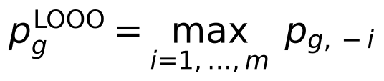
This is an intersection–union test: its null hypothesis is that, for at least one origin, no foreground shift remains once that origin is removed. It rejects only if the signal remains whichever origin is dropped. It therefore guards against a signal created by a single lineage, but it does not require a shift or loss in every origin: with three origins, two that carry the signal can suffice. For every call we report how many origins carry it (Supplementary Table 2).
The leave-one-origin-out P values from the three rate layers were combined using the Cauchy combination test (ACAT [39]). The calibration of this combination was assessed under the dependence structures represented in the benchmarks. The Benjamini–Hochberg procedure [40] was applied at q = 0.10 within each trait to the combined rate P values. Gene-loss P values were adjusted separately.

Convergence signatures with learned effect directions
For genes detected by the test above, a signature describes which layers shifted. The per-layer GLS z-scores z_{g} (pooled over origins) have null correlation R_{g}, estimated from the cross-layer correlation of each gene’s whitened GLS residuals and shrunk 10% toward the genome mean. Following mash [41], the true effect vector μ_{g} was given the prior
The patterns U_{k} were (i) the seven canonical on/off patterns of three layers and (ii) rank-one patterns u uᵀ from directions learned by spherical k-means on genes whose largest |z| was at least 4. Scales w ran over 1, 2, 3, 5, 8, 12, 20 and 30. Mixture weights were fitted by EM with a Dirichlet pseudo-count of 10 on the null. Each gene was assigned its most probable pattern; a learned direction marked a layer active when its loading exceeded 0.3. The number of learned directions was fixed in advance at 2^L − 1 (seven for three layers), following mash’s practice of over-specifying patterns and letting EM shrink unused ones.

Sequence-level simulations
Species trees were pure-birth (Yule) trees scaled to a root-to-tip depth of 0.8 expected codon substitutions. Trait clades were drawn as non-overlapping clades of 4–12 species. Codon alignments were simulated with IQ-TREE 2.3.6 AliSim [42] under the Goldman–Yang model [43] (κ = 2). Each gene received:
- a length of 300–1,500 codons (log-normal around 500);
- a background ω drawn log-normally around 0.15 (range 0.01–0.9);
- a gene-wide rate multiplier (log-normal, σ = 0.5);
- phylogenetic confounding: rate jumps on K_{g} ~ Poisson(3c) random clades, each multiplying all branch lengths inside the clade by a log-normal factor (σ = 0.7), with intensity c = 0, 1 or 2;
- gene-tree discordance (sensitivity runs only): the alignment was simulated on a gene tree derived from the species tree by a Poisson number (mean 10 or 40) of nearest-neighbour interchanges, placed preferentially on short internal branches, while branch lengths were still estimated on the species tree.
Convergent genes (2% of the genome unless stated) received, on foreground branches only, one of three kinds of shift: a selection shift (ω multiplied by m_ω through branch-specific AliSim models, branch lengths unchanged; 40% of convergent genes), a rate shift (foreground branch lengths multiplied by m_{r}; 30%), or both (30%). Effect sizes were weak (m_ω = 1.5, m_{r} = 1.2), moderate (2, 1.35) or strong (3, 1.5). Branch lengths were then re-estimated with IQ-TREE on the true topology.
Designs were paired: for each tree and confounding level one null genome was simulated, and the same randomly chosen genes were replaced by convergent genes for each effect size or number of origins, so that all methods analysed identical data. The main benchmark used 10 Yule trees of 200 species with five origins and 3,000 genes; sensitivity runs varied the tree size (100 and 400 species), the share of convergent genes (0.5%, 5% and 10%) and gene-tree discordance, with five trees each at confounding 1.

Comparator methods
All comparators were given the same layers and the same Benjamini–Hochberg threshold (q = 0.10).
- Naive test: Welch t comparing foreground and background branches of the nucleotide relative rate, treating branches as independent; this mirrors the statistic underlying RERconverge.
- Naive Fisher: the naive test on each layer, combined with Fisher’s method.
- Control-lineage permutation: the naive statistic standardised by its mean and standard deviation over 100 age- and size-matched control foregrounds (our implementation, not RERconverge’s permulations [33]).
- Brownian phylogenetic LMM: for each gene and layer, y = b₀ + βf + u + e with u ~ N(0, h²K), e ~ N(0, s²I), K the shared-path-length kernel of the tree; REML over a 31-point grid of h²/s² using a single eigendecomposition of K [44], Wald test on β, layers combined by ACAT.
- Learned-covariance GLS: the model above without leave-one-origin-out, layers combined by ACAT.
- RERconverge 0.3.0 (github.com/nclark-lab/RERconverge, commit 682ac34), run with getAllResiduals(transform = "sqrt", min.sp = 10, norm = "scale"), foreground2Tree(clade = "all"), tree2Paths and correlateWithBinaryPhenotype(min.pos = 2, weighted = "auto"). Two-sided P values were converted to one-sided values for faster foreground evolution using the sign of Rho. Permulations used getPermsBinary (permmode “cc”) and permpvalcor, either on the 150 genes with the smallest parametric P (1,000 permulations) or on all genes (10,000 permulations, on separate genomes of the same design, one per rate-jump intensity; 100 permulations cannot reach genome-wide significance). Comparisons are paired within each genome set; with one genome per intensity, the all-gene permulation comparisons illustrate rather than establish relative performance. ggtree, used by RERconverge only for plotting, was made optional (patch in the repository).

Genome-wide data and traits
Coding alignments came from TOGA’s multiple codon alignments [30] against the human hg38 reference (17,439 genes). Species were chosen by fixed rules before any test (scripts/toga_select_species.py): species in the Zoonomia 447-way tree [5] only (tree file hg38.447way.scientificNames.nh distributed with the 447-way alignment; the pruned 115-species tree is master_paper.nwk in the data deposit), one assembly per species (highest 1:1-ortholog coverage), coverage ≥ 0.85, all bats and cetaceans passing, a backbone of the best-covered species from each other order, and no shrews, tenrecs or solenodons (some echolocate). Trait species were then added by name. The final set has 115 species (Fig. 1; Supplementary Table 3).
For each gene, species with exactly one sequence of the chosen assembly were kept; genes needed ≥ 80% of the species and ≥ 50 codon columns with ≥ 4 ungapped sequences. Branch lengths were fitted with IQ-TREE 2 on the pruned Zoonomia topology (GTR+G4 on codons, LG+G4 on the translated protein). Each master-tree branch received a value only when it mapped one-to-one onto a branch of the gene’s pruned tree; otherwise it was missing.
Traits were defined from taxonomic lineage before testing:
Trait | Trait species | Independent origins | Kept out of control sets
Echolocation | 16 echolocating bats, 9 toothed whales | 3 | none
Marine | marine mammals: cetaceans (including the boutu and the Yangtze river dolphin, which live in fresh water), pinnipeds, manatee | 3 | semi-aquatic species (otters, beaver, muskrat, hippopotamus; the polar bear is not among the 115 species)
Hypoxia, subterranean | African mole-rats, tuco-tuco, blind mole-rat, mole vole, two moles, golden mole | 6 | diving mammals, high-altitude species
Hypoxia, high altitude | wild yak, Tibetan antelope, American pika, alpaca | 4 | diving mammals, subterranean species
Hypoxia, combined | both groups | 10 | diving mammals
Species absent from the Zoonomia tree (snow leopard, domestic yak, Przewalski’s gazelle, Iberian mole, bamboo rat) were not used. Genes of interest were fixed before testing: 18 hearing genes for echolocation, 19 reported marine losses or shifts, and EPAS1, EGLN1, HIF1A, HBB, HBA1, HBA2, NGB and CYGB for hypoxia.

Gene-loss layer
Gene status per species came from TOGA’s ortholog classification (loss_summ_data.tsv; scripts/toga_loss_matrix.py). A gene took the status of its most intact transcript. It was coded lost (1) for lost (L) or uncertain loss (UL), intact (0) for intact (I) or partially intact (PI), and missing otherwise. Genes needed ≥ 2 lost and ≥ 2 intact species, a filter blind to the trait.
For the loss layer, GLS was fitted across species rather than branches, using a species covariance matrix estimated from genome-wide loss patterns. This covariance can account for some variation associated with shared ancestry and annotation quality, although it does not identify these sources separately or guarantee their removal. The foreground indicator marks trait species. Leave-one-origin-out statistics were then calibrated using the simulated loss null described below; a further conditional check assessed single-origin explanations for selected candidates.
Rate and loss evidence were tested and FDR-controlled separately. A combined p-value (ACAT of the rate and loss p-values, each capped at 0.99) was used for the signature model; without the cap, a rate p-value of 1 for a gene with no rate data in the trait lineages cancels its loss evidence.

Simulation null for gene loss
The GLS p-value is not calibrated on 0/1 data: losses are inherited down whole clades, and on 20 marine control sets it produced 5.1 false calls per set. Loss p-values therefore come from a simulated null (mlconv/loss.py). In the model, each gene is present at the root and is lost along a branch of length t with the probability below, and never regained:
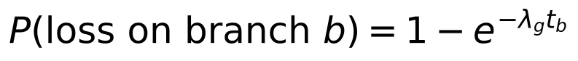
An intact gene g in species s is reported lost with probability min(e_{s} · κ_{g}, 0.5). Here e_{s} is the species’ false-loss rate, estimated as the fraction of genes lost in s and in no other species among genes with at most one loss, and κ_{g} ∈ {1, 2, 4, …, 64} is a gene fragility: long or hard-to-assemble genes are misannotated as lost more often. Lost genes are reported intact with probability 0.001. Each gene’s rate λ_{g} and fragility κ_{g} were the joint maximum-likelihood values on a grid (60 log-spaced rates from 0.01 to 100 losses per tree length, seven fragilities), computed for all genes at once by Felsenstein pruning [45]. Simulations keep each gene’s observed missing-data pattern. The calls did not depend on the resolution of the null or on the tail extrapolation: with 500 or 1,000 simulated genomes instead of 100, or with the generalized Pareto tail fitted to 100 or 500 instead of 250 null values, the same 48 marine and 15 subterranean genes were called in every run. P values below about 10⁻⁶ rest on the tail extrapolation and varied between runs (for LGSN from 10⁻²¹ to 10⁻⁸), so they should be read only as very small. With 1,000 genomes, four further marine genes reached the threshold (B3GNT3, BPIFA2, FMO1, OR51B6; P ≈ 0.0004 in both runs).
Per-gene check against single-origin losses. The loss P value tests the global null of no association in any origin. The hypothesis that a leave-one-origin-out call rejects is wider: convergence fails if at most one origin truly lost the gene. For each called gene and each origin j, we therefore simulated 10,000 replicates in which the species of origin j keep their observed states and all other species are simulated under the loss model, with loss rate and fragility re-estimated from the non-trait species only. The leave-one-origin-out statistic was computed with the covariance learned from the real data, and P_{j} is the share of replicates reaching the observed statistic, with a generalized Pareto tail when fewer than ten did (capped at the empirical value). Replicates with fewer than two losses carry no evidence and count as zero. The gene’s intersection-union P value is the largest P_{j}. This check was run only for genes called under the global null, so it can remove calls but not add them (code: scripts/convergence_toga.py, –loss-test iut).
For each trait configuration, 100 genomes were simulated and analysed exactly as the real data, including the testability filter and a covariance re-learned per replicate. Null statistics were pooled within ten bins of fitted loss rate. A gene’s p-value is the fraction of pooled null statistics at or above its own. When fewer than ten exceed it, the tail is extrapolated with a generalized Pareto distribution fitted to the 250 largest null values [46]. The 100 matched control traits on real data, analysed the same way, check the result. As a sensitivity analysis, every trait was rerun counting only TOGA’s confident losses (L), with uncertain losses (UL) treated as missing.

Timing of losses, correlated traits and model checks
Timing. Under the irreversible-loss model, a node was provisionally classified as lost when all observed descendants were classified as lost. For each candidate gene and trait origin, loss was classified as preceding the origin when both the origin and its sister lineage were lost, mapping to the origin stem when all observed members of the origin were lost but the sister lineage was not, or occurring within the origin when only some members were lost (scripts/extra_analyses.py). These categories are state-based mappings rather than estimates of the time of functional inactivation. For single-species origins, the stem category spans the terminal branch.
Correlated traits. To ask which of two correlated traits explains a loss, the species loss matrix was regressed on both trait indicators at once, with the genome-learned species covariance and an intercept. The partial effect of a trait is the GLS-adjusted difference in loss probability between species with and without it, holding the other trait fixed. Pairs were subterranean versus high altitude, and marine versus semi-aquatic (otters, beaver, muskrat, hippopotamus). Partial effects are descriptive; calibrated tests are those above.
Model checks. The fitted species false-loss rates were compared with assembly contig and scaffold N50, terminal branch length and distance to the human reference (Spearman correlation). Twenty genomes simulated from the fitted loss model were compared with the observed data in the number of species losing each gene and the share of genes lost per species (Extended Data Fig. 10).
Number of origins. For the subterranean trait (six origins), every subset of three, four and five origins was analysed with the calibrated loss test (50 simulated genomes per subset; scripts/origin_subsampling.py). Species of the dropped origins were set to missing, and the loss model was fitted once on the full data.
Mutations behind the losses. For the marine calls, TOGA’s per-species tables of inactivating mutations and projected exon coordinates were downloaded for the 18 marine species and 12 terrestrial relatives (scripts/marine_detail.py). Mutations on the orthologous projection were placed on the reference coding sequence. Reference exon lengths were taken from the projection shared by the terrestrial relatives, which was identical in cattle, pig, hippopotamus, dog and cat (1,068 bp in nine exons for PON1). Mutations that TOGA masks (near exon ends, or compensated by a nearby frameshift) are shown but were not used by TOGA to call the loss. Per origin, genes were counted that were lost in at least one species, lost in every species with data, and of those, not lost in every species of the sister lineage.
Codon alignments of single losses. TOGA’s multiple codon alignments contain intact orthologs only. For PON1 and LGSN, the pairwise human–query codon alignments were therefore streamed for each species, and the projection with the most aligned codons was kept (scripts/alignment_detail.py). Query codons opposite reference gaps were dropped, so columns follow the human coding sequence. TOGA replaces codons disrupted by a frameshift with XXX; these are shown as frameshifted codons, without their bases. For the volcano plots (Fig. 4d–g), the effect size of each gene is the share of trait species in which it is lost minus the share in all other species with data. Functional groups were assigned by hand from gene names and known functions (Supplementary Table 1).
Tissue, pathway and GO enrichment. Three annotation sources were used (scripts/function_enrichment.py): tissue expression from the Human Protein Atlas consensus data (nTPM in 50 human tissues) [47], Reactome pathways [48] and Gene Ontology biological-process annotations, propagated to parent terms through is_a and part_of relations [49]. A gene was counted as elevated in a tissue when its expression there was at least 1 nTPM and at least four times its mean over all tissues, following the Human Protein Atlas rule for tissue-enhanced genes. The background was all genes tested by the loss layer for the trait. Genes that are often lost across mammals, such as olfactory receptors and tissue-specific genes, would appear enriched among any set of loss calls, so the null kept loss frequency: each called gene was replaced by a random tested gene from the same of 20 bins of total losses across the 115 species. The number of null genes in a term is then a sum of independent Bernoulli variables, and its exact upper tail (Poisson-binomial) gives the p-value. Terms with 5 to 1,000 background genes were eligible; terms with fewer than two called genes were not tested and entered the Benjamini–Hochberg correction with p = 1, so the correction spans all 50 tissues, 1,866 Reactome pathways and 6,302 GO terms.

Computational implementation and reproducibility
The method is implemented in the Python package mlconv (NumPy and SciPy), with one script for each analysis and figure (Code availability). Three choices keep it tractable at genome scale. The null covariance is learned once from all genes, and each leave-one-origin-out test uses the corresponding sub-matrix, so the m + 1 tests per gene need no re-estimation. Loss rates and fragilities of all genes are fitted jointly by vectorised Felsenstein pruning over a fixed grid. The simulated loss null re-learns the covariance in every replicate, so the null distribution includes the uncertainty of the estimated covariance. Every analysis writes its command line, parameters, random seeds and software versions next to its outputs, with summary files giving, for each trait and coding, the numbers of genes, species and origins tested, the calls and the control-trait calibration. Versions used for the final analyses included Python 3.11, NumPy 2.4, SciPy 1.17, pandas 3.0, IQ-TREE 2.3.6 and RERconverge 0.3.0 (commit 682ac34). Quality-control comparisons of the fitted loss model with the observed data are given in Extended Data Fig. 10 and Supplementary Note 9.

Statistics and reproducibility
All tests are one-sided for faster evolution or loss on the foreground. False discovery rates were controlled with the Benjamini–Hochberg procedure at q = 0.10 within each family: the combined rate P values (15,699 genes with rate P values) and the loss P values (12,851 genes with at least two lost and two intact species), separately for each trait and each loss coding. No adjustment was made across the five analyses, the two codings or the follow-up checks, so study-wide FDR control at 10% was not established. Genes failing these filters were not tested and are reported as not tested, not as negative. For the intersection–union check, every loss-tested gene received p′ equal to its intersection–union Monte Carlo P value, computed from replicate counts as (k + 1)/(n + 1) without tail extrapolation, if it was called under the global null, and p′ = 1 otherwise. Because p′ is never smaller than the intersection–union P value the gene would have received had it been checked, p′ is a valid P value under the composite null whatever the screening step selected, and the Benjamini–Hochberg procedure was applied to p′ across all loss-tested genes; as in the primary analysis, its validity under dependence between genes assumes positive dependence. The intersection–union P values were themselves checked by simulation with zero, one, two or three origins carrying a true loss (Supplementary Note 14): with a true loss in one origin, 4.0–4.3% of P values fell below 0.05 and 1.0–2.0% below 0.01. Calibration was measured on 100 matched control traits per analysis (500 in total; exact binomial 95% intervals), on simulated genomes (rate layers: Extended Data Figs 1–3; loss layer: Fig. 3) and by origin subsampling (Extended Data Fig. 9). No data were excluded after testing; species and genes were selected by rules fixed before any test. All analyses are deterministic given the random seeds recorded in the scripts.

Data availability
All input data are public: TOGA orthology, loss classifications, inactivating mutations and codon alignments for the human hg38 reference [30] (genome.senckenberg.de/download/TOGA), the Zoonomia 447-species tree [5], Human Protein Atlas consensus tissue expression [47], Reactome pathways [48] and Gene Ontology annotations [49]. Derived data (species sets, the gene-loss matrix, per-gene results for every trait, control-trait calls, benchmark tables and Supplementary Tables 1–3), together with per-gene branch lengths, the null P values of every control trait, the robustness and review analyses and all figures, are deposited on Zenodo (https://doi.org/10.5281/zenodo.23858426) and are also in the GitHub repository below.

Code availability
All code is at github.com/devbioinfo/Trait_github: the mlconv package (genome-learned GLS, leave-one-origin-out test, signatures, loss model and simulation null) and the scripts that select species, download data, estimate branch lengths, build the loss matrix, run each analysis and benchmark, and draw each figure. The version used for this article (release v1.0.0) is archived on Zenodo (https://doi.org/10.5281/zenodo.23862248).

Acknowledgements
We thank the Department of Biotechnology (DBT)-sponsored Bioinformatics Centre at North-Eastern Hill University, Shillong, for providing computational facilities used in this study. We also acknowledge BIODIVERSITY INFORMATICS: North-east India Bio—Bank of Codes Network (NIBBCoNet): BIC at North-Eastern Hill University, Shillong (BT/PR40248/BTIS/137/13/2021) and the National Network Project @ Biodiversity Informatics Centre (BT/PR40263/BTIS/137/80/2023), NEHU, for institutional support.

Author contributions
R.K.: data curation, formal analysis, methodology, scripts and coding, visualization, writing – review and editing. M.A.: validation, writing – review and editing. D.K.B.: conceptualization, data curation, formal analysis, investigation, methodology, project administration, resources, software, supervision, validation, writing – original draft, writing – review and editing.

Competing interests
The authors declare no competing interests.

Use of AI tools
An AI assistant (Claude, Anthropic) was used to write analysis code, run analyses and draft text and figures under the authors’ direction. The authors checked all code, results and text and take responsibility for the content.

References
- Losos, J. B. Convergence, adaptation, and constraint. Evolution 65, 1827–1840 (2011).
- Stern, D. L. The genetic causes of convergent evolution. Nat. Rev. Genet. 14, 751–764 (2013).
- Rosenblum, E. B., Parent, C. E. & Brandt, E. E. The molecular basis of phenotypic convergence. Annu. Rev. Ecol. Evol. Syst. 45, 203–226 (2014).
- Storz, J. F. Causes of molecular convergence and parallelism in protein evolution. Nat. Rev. Genet. 17, 239–250 (2016).
- Zoonomia Consortium. A comparative genomics multitool for scientific discovery and conservation. Nature 587, 240–245 (2020).
- Christmas, M. J. et al. Evolutionary constraint and innovation across hundreds of placental mammals. Science 380, eabn3943 (2023).
- Sackton, T. B. & Clark, N. Convergent evolution in the genomics era: new insights and directions. Phil. Trans. R. Soc. B 374, 20190102 (2019).
- Chikina, M., Robinson, J. D. & Clark, N. L. Hundreds of genes experienced convergent shifts in selective pressure in marine mammals. Mol. Biol. Evol. 33, 2182–2192 (2016).
- Kowalczyk, A. et al. RERconverge: an R package for associating evolutionary rates with convergent traits. Bioinformatics 35, 4815–4817 (2019).
- Partha, R., Kowalczyk, A., Clark, N. L. & Chikina, M. Robust method for detecting convergent shifts in evolutionary rates. Mol. Biol. Evol. 36, 1817–1830 (2019).
- Parker, J. et al. Genome-wide signatures of convergent evolution in echolocating mammals. Nature 502, 228–231 (2013).
- Fukushima, K. & Pollock, D. D. Detecting macroevolutionary genotype–phenotype associations using error-corrected rates of protein convergence. Nat. Ecol. Evol. 7, 155–170 (2023).
- Hiller, M. et al. A “forward genomics” approach links genotype to phenotype using independent phenotypic losses among related species. Cell Rep. 2, 817–823 (2012).
- Sharma, V. et al. A genomics approach reveals insights into the importance of gene losses for mammalian adaptations. Nat. Commun. 9, 1215 (2018).
- Olson, M. V. When less is more: gene loss as an engine of evolutionary change. Am. J. Hum. Genet. 64, 18–23 (1999).
- Albalat, R. & Cañestro, C. Evolution by gene loss. Nat. Rev. Genet. 17, 379–391 (2016).
- Foote, A. D. et al. Convergent evolution of the genomes of marine mammals. Nat. Genet. 47, 272–275 (2015).
- Huelsmann, M. et al. Genes lost during the transition from land to water in cetaceans highlight genomic changes associated with aquatic adaptations. Sci. Adv. 5, eaaw6671 (2019).
- Partha, R. et al. Subterranean mammals show convergent regression in ocular genes and enhancers, along with adaptation to tunneling. eLife 6, e25884 (2017).
- Qiu, Q. et al. The yak genome and adaptation to life at high altitude. Nat. Genet. 44, 946–949 (2012).
- Liu, Y. et al. Convergent sequence evolution between echolocating bats and dolphins. Curr. Biol. 20, R53–R54 (2010).
- Li, Y., Liu, Z., Shi, P. & Zhang, J. The hearing gene Prestin unites echolocating bats and whales. Curr. Biol. 20, R55–R56 (2010).
- Meyer, W. K. et al. Ancient convergent losses of Paraoxonase 1 yield potential risks for modern marine mammals. Science 361, 591–594 (2018).
- Hayden, S. et al. Ecological adaptation determines functional mammalian olfactory subgenomes. Genome Res. 20, 1–9 (2010).
- Jiang, P. et al. Major taste loss in carnivorous mammals. Proc. Natl Acad. Sci. USA 109, 4956–4961 (2012).
- Emerling, C. A. & Springer, M. S. Eyes underground: regression of visual protein networks in subterranean mammals. Mol. Phylogenet. Evol. 78, 260–270 (2014).
- Yi, X. et al. Sequencing of 50 human exomes reveals adaptation to high altitude. Science 329, 75–78 (2010).
- Simonson, T. S. et al. Genetic evidence for high-altitude adaptation in Tibet. Science 329, 72–75 (2010).
- Felsenstein, J. Phylogenies and the comparative method. Am. Nat. 125, 1–15 (1985).
- Kirilenko, B. M. et al. Integrating gene annotation with orthology inference at scale. Science 380, eabn3107 (2023).
- Thomas, G. W. C. & Hahn, M. W. Determining the null model for detecting adaptive convergence from genomic data: a case study using echolocating mammals. Mol. Biol. Evol. 32, 1232–1236 (2015).
- Zou, Z. & Zhang, J. No genome-wide protein sequence convergence for echolocation. Mol. Biol. Evol. 32, 1237–1241 (2015).
- Saputra, E., Kowalczyk, A., Cusick, L., Clark, N. & Chikina, M. Phylogenetic permulations: a statistically rigorous approach to measure confidence in associations in a phylogenetic context. Mol. Biol. Evol. 38, 3004–3021 (2021).
- Cornwallis, C. K. & Griffin, A. S. A guided tour of phylogenetic comparative methods for studying trait evolution. Annu. Rev. Ecol. Evol. Syst. 55, 181–204 (2024).
- Liao, C., Ye, R., Ivankovic, F. et al. The landscape of gene loss and missense variation across the mammalian tree informs on gene essentiality. Nat. Genet. (2026). doi:10.1038/s41588-026-02783-9
- Rey, C., Guéguen, L., Sémon, M. & Boussau, B. Accurate detection of convergent amino-acid evolution with PCOC. Mol. Biol. Evol. 35, 2296–2306 (2018).
- Hu, Z., Sackton, T. B., Edwards, S. V. & Liu, J. S. Bayesian detection of convergent rate changes of conserved noncoding elements on phylogenetic trees. Mol. Biol. Evol. 36, 1086–1100 (2019).
- Minh, B. Q. et al. IQ-TREE 2: new models and efficient methods for phylogenetic inference in the genomic era. Mol. Biol. Evol. 37, 1530–1534 (2020).
- Liu, Y. & Xie, J. Cauchy combination test: a powerful test with analytic p-value calculation under arbitrary dependency structures. J. Am. Stat. Assoc. 115, 393–402 (2020).
- Benjamini, Y. & Hochberg, Y. Controlling the false discovery rate: a practical and powerful approach to multiple testing. J. R. Stat. Soc. B 57, 289–300 (1995).
- Urbut, S. M., Wang, G., Carbonetto, P. & Stephens, M. Flexible statistical methods for estimating and testing effects in genomic studies with multiple conditions. Nat. Genet. 51, 187–195 (2019).
- Ly-Trong, N., Naser-Khdour, S., Lanfear, R. & Minh, B. Q. AliSim: a fast and versatile phylogenetic sequence simulator for the genomic era. Mol. Biol. Evol. 39, msac092 (2022).
- Goldman, N. & Yang, Z. A codon-based model of nucleotide substitution for protein-coding DNA sequences. Mol. Biol. Evol. 11, 725–736 (1994).
- Lippert, C. et al. FaST linear mixed models for genome-wide association studies. Nat. Methods 8, 833–835 (2011).
- Felsenstein, J. Evolutionary trees from DNA sequences: a maximum likelihood approach. J. Mol. Evol. 17, 368–376 (1981).
- Knijnenburg, T. A., Wessels, L. F. A., Reinders, M. J. T. & Shmulevich, I. Fewer permutations, more accurate P-values. Bioinformatics 25, i161–i168 (2009).
- Uhlén, M. et al. Tissue-based map of the human proteome. Science 347, 1260419 (2015).
- Milacic, M. et al. The Reactome Pathway Knowledgebase 2024. Nucleic Acids Res. 52, D672–D678 (2024).
- The Gene Ontology Consortium. The Gene Ontology knowledgebase in 2023. Genetics 224, iyad031 (2023).
- Benjamini, Y. & Heller, R. Screening for partial conjunction hypotheses. Biometrics 64, 1215–1222 (2008).

Figures
[image: Fig. 1]
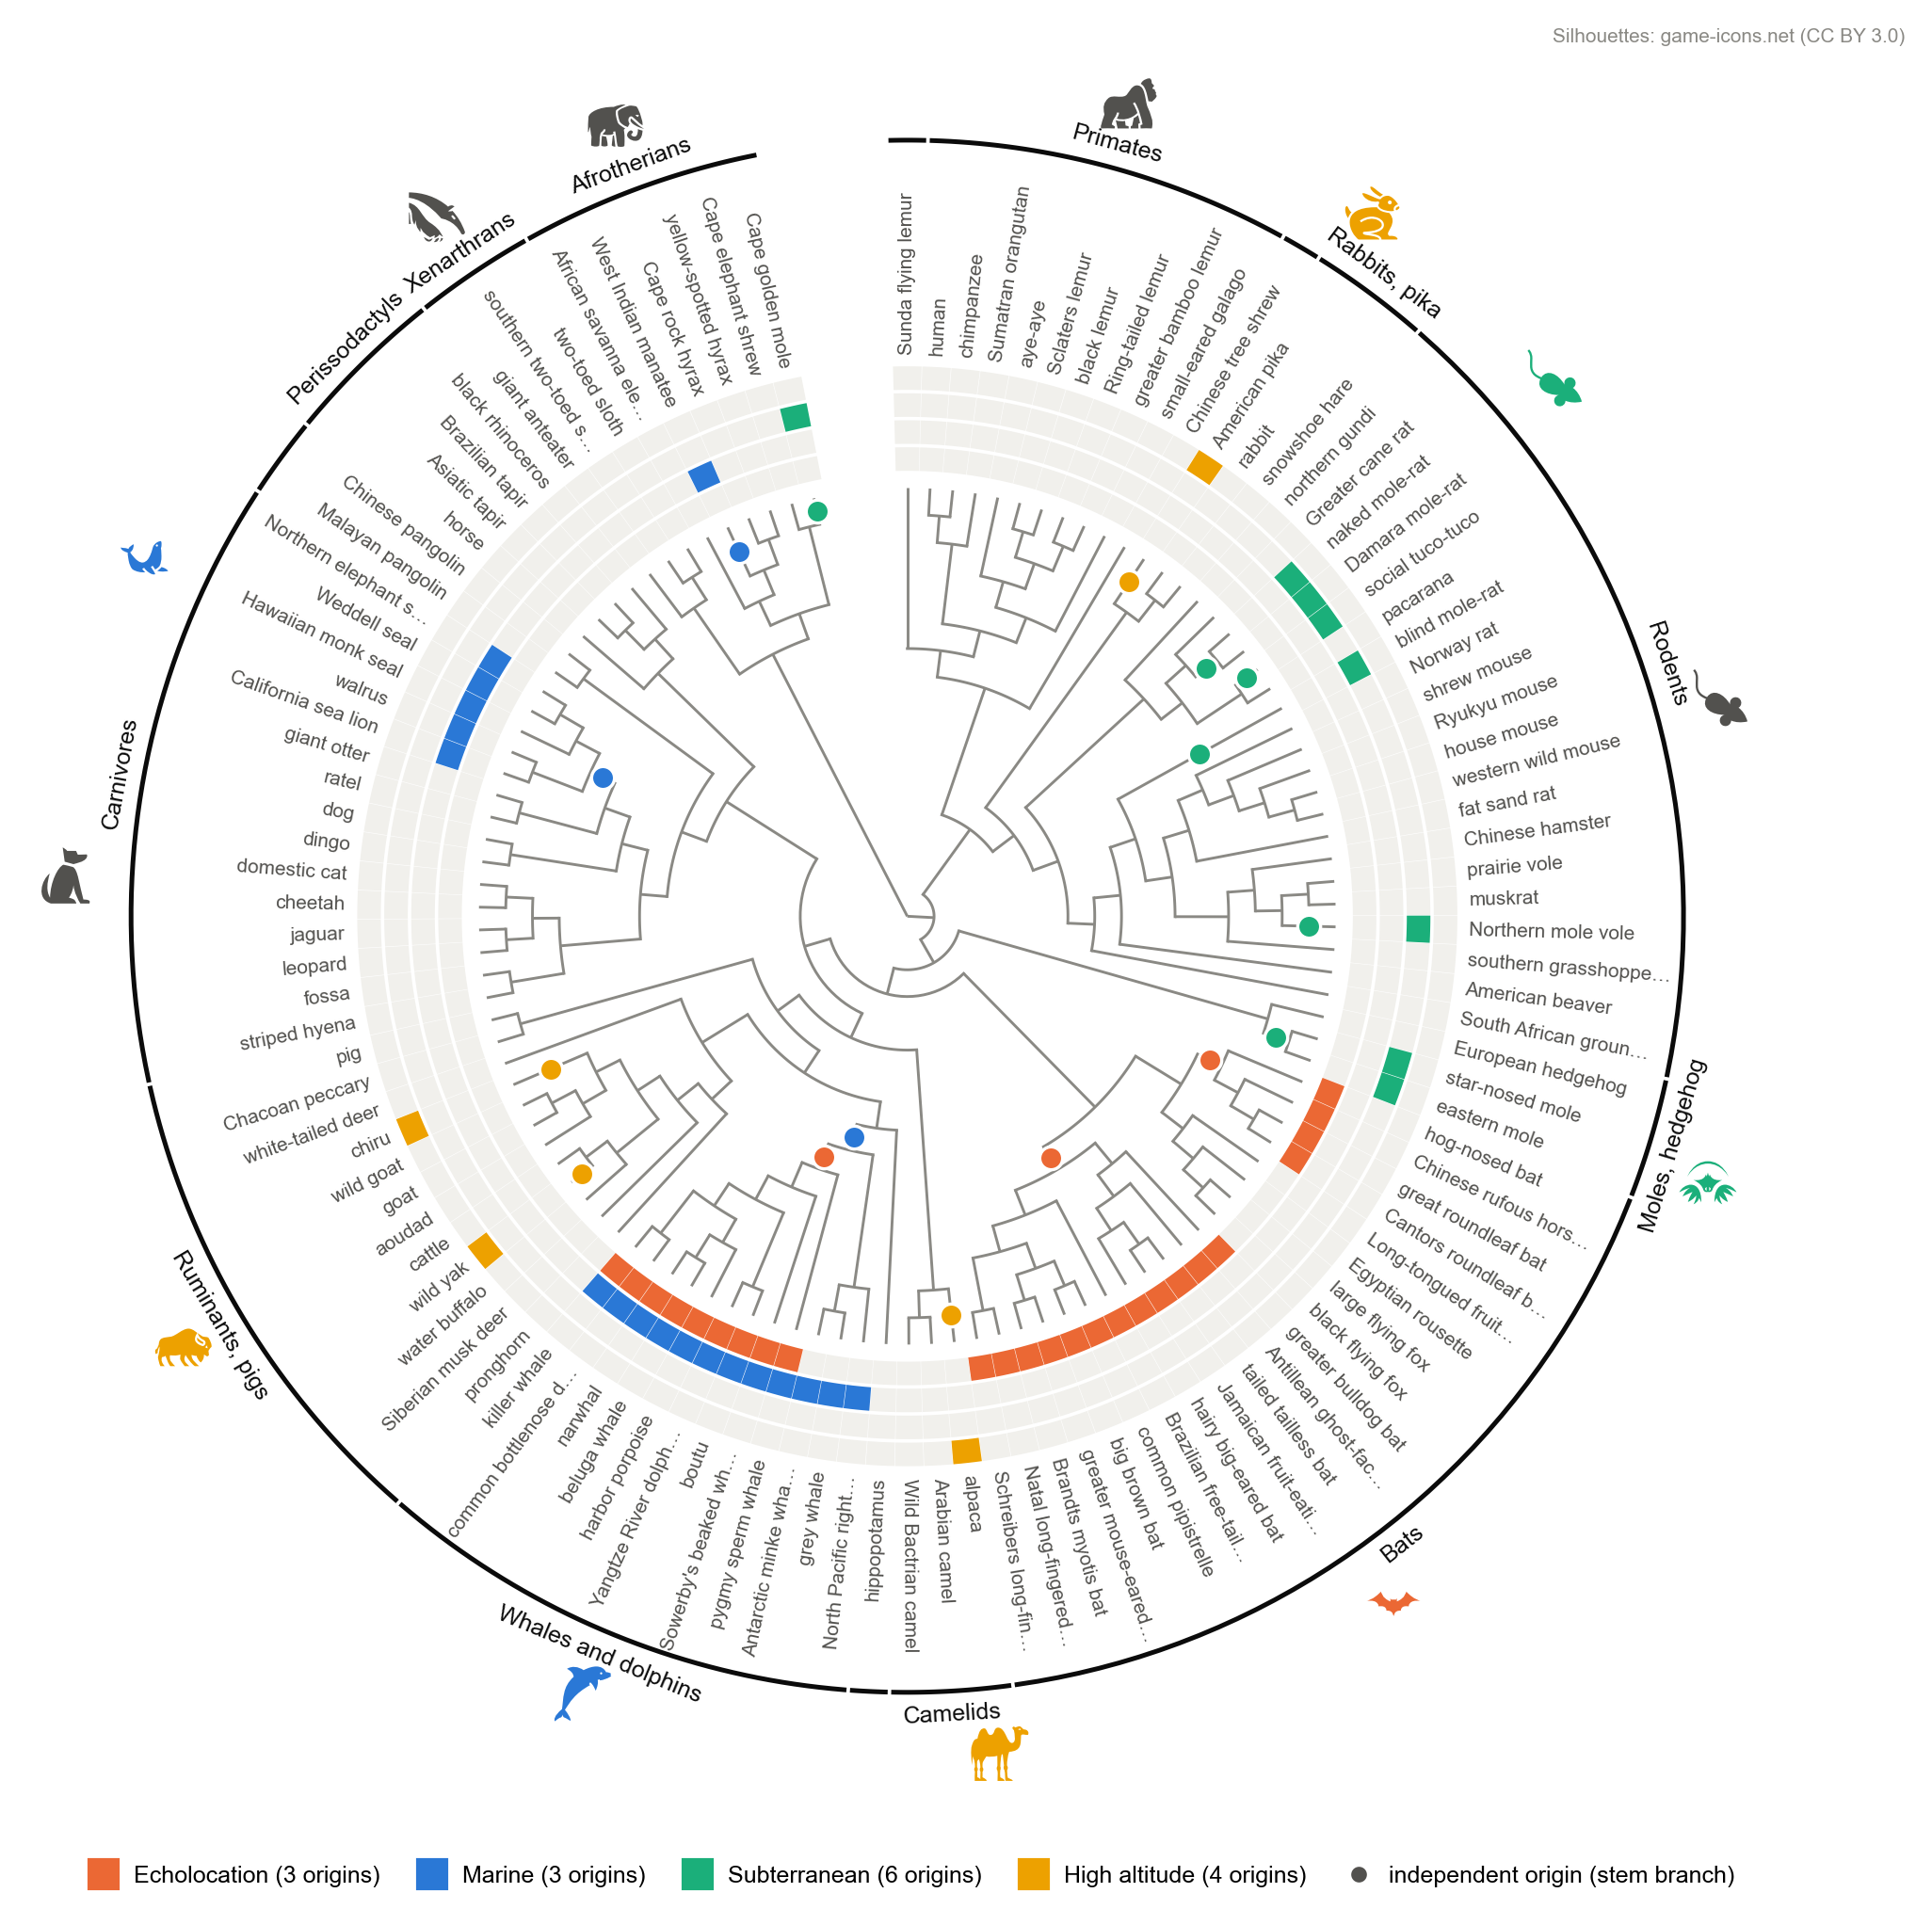
Fig. 1 | The 115 mammals studied and the independent origins of four traits. Species tree pruned from the Zoonomia 447-way tree [5], drawn as a cladogram (branch lengths not to scale). Rings, from inside out: echolocation (orange; echolocating bats and toothed whales), marine (blue; cetaceans, including two river dolphins, pinnipeds, manatee), life underground (green; African mole-rats, tuco-tuco, blind mole-rat, mole vole, two moles, golden mole) and high altitude (yellow; wild yak, Tibetan antelope, American pika, alpaca). Dots mark the stem branch of each independent origin: 3 for echolocation, 3 for marine life, 6 for life underground and 4 for high altitude. Outer arcs group species by order or major clade (labels for groups of three or more species). Long common names are shortened. Silhouettes mark major groups (game-icons.net, CC BY 3.0); grey silhouettes sit at the centre of their group and coloured ones at the species of that group with the trait (for example, the bat marks the echolocating bats but not the three fruit bats, the camel the alpaca, the bison the wild yak and Tibetan antelope, the rabbit the American pika, and the green rodent the African mole-rats). Silhouettes are generic group markers, not depictions of the species. The placement of the echolocation origins in bats follows one hypothesis of how laryngeal echolocation evolved; it is an input to the analysis, not a result.
[image: Fig. 2]
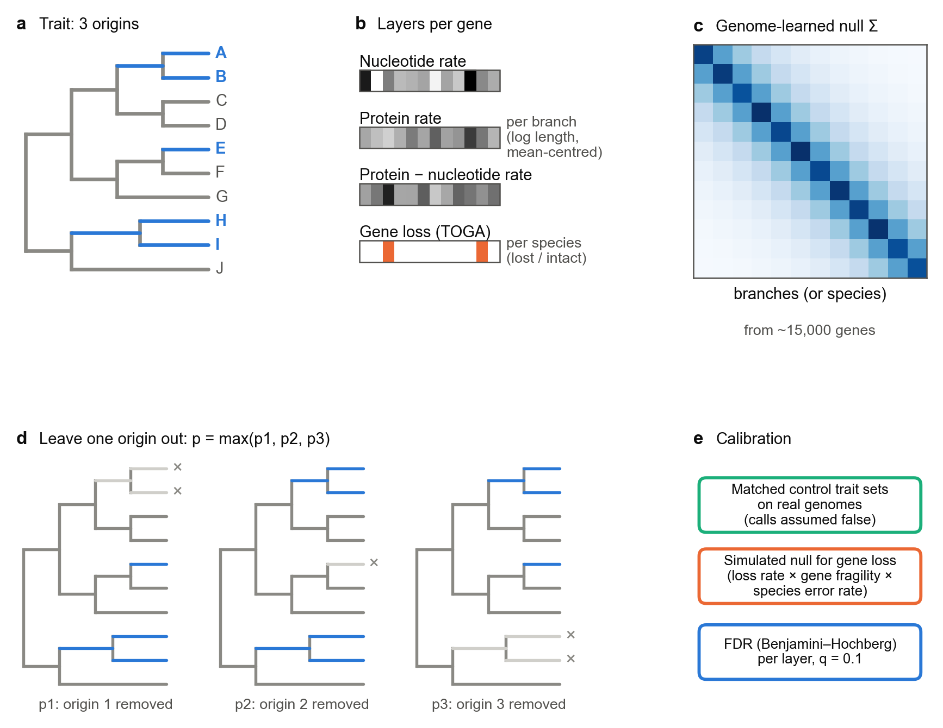
Fig. 2 | A convergence framework evaluated with simulations and matched empirical controls. a, A trait with three origins. Foreground branches are those whose descendants all carry the trait. b, Each gene contributes three branch-rate layers and a species-level loss layer. c, A covariance matrix estimated across genes is used in GLS to model shared variation. d, Leave-one-origin-out analysis repeats the test after removing each origin and retains the largest P value. This evaluates robustness to origin removal; the additional conditional check addresses single-origin loss explanations. e, Loss statistics are calibrated against a fitted irreversible-loss and annotation-error model. Matched control-trait configurations provide empirical diagnostics. The Benjamini–Hochberg procedure is applied at q = 0.1 separately to rate and loss evidence within each trait. The schematic values are illustrative.
[image: Fig. 3]
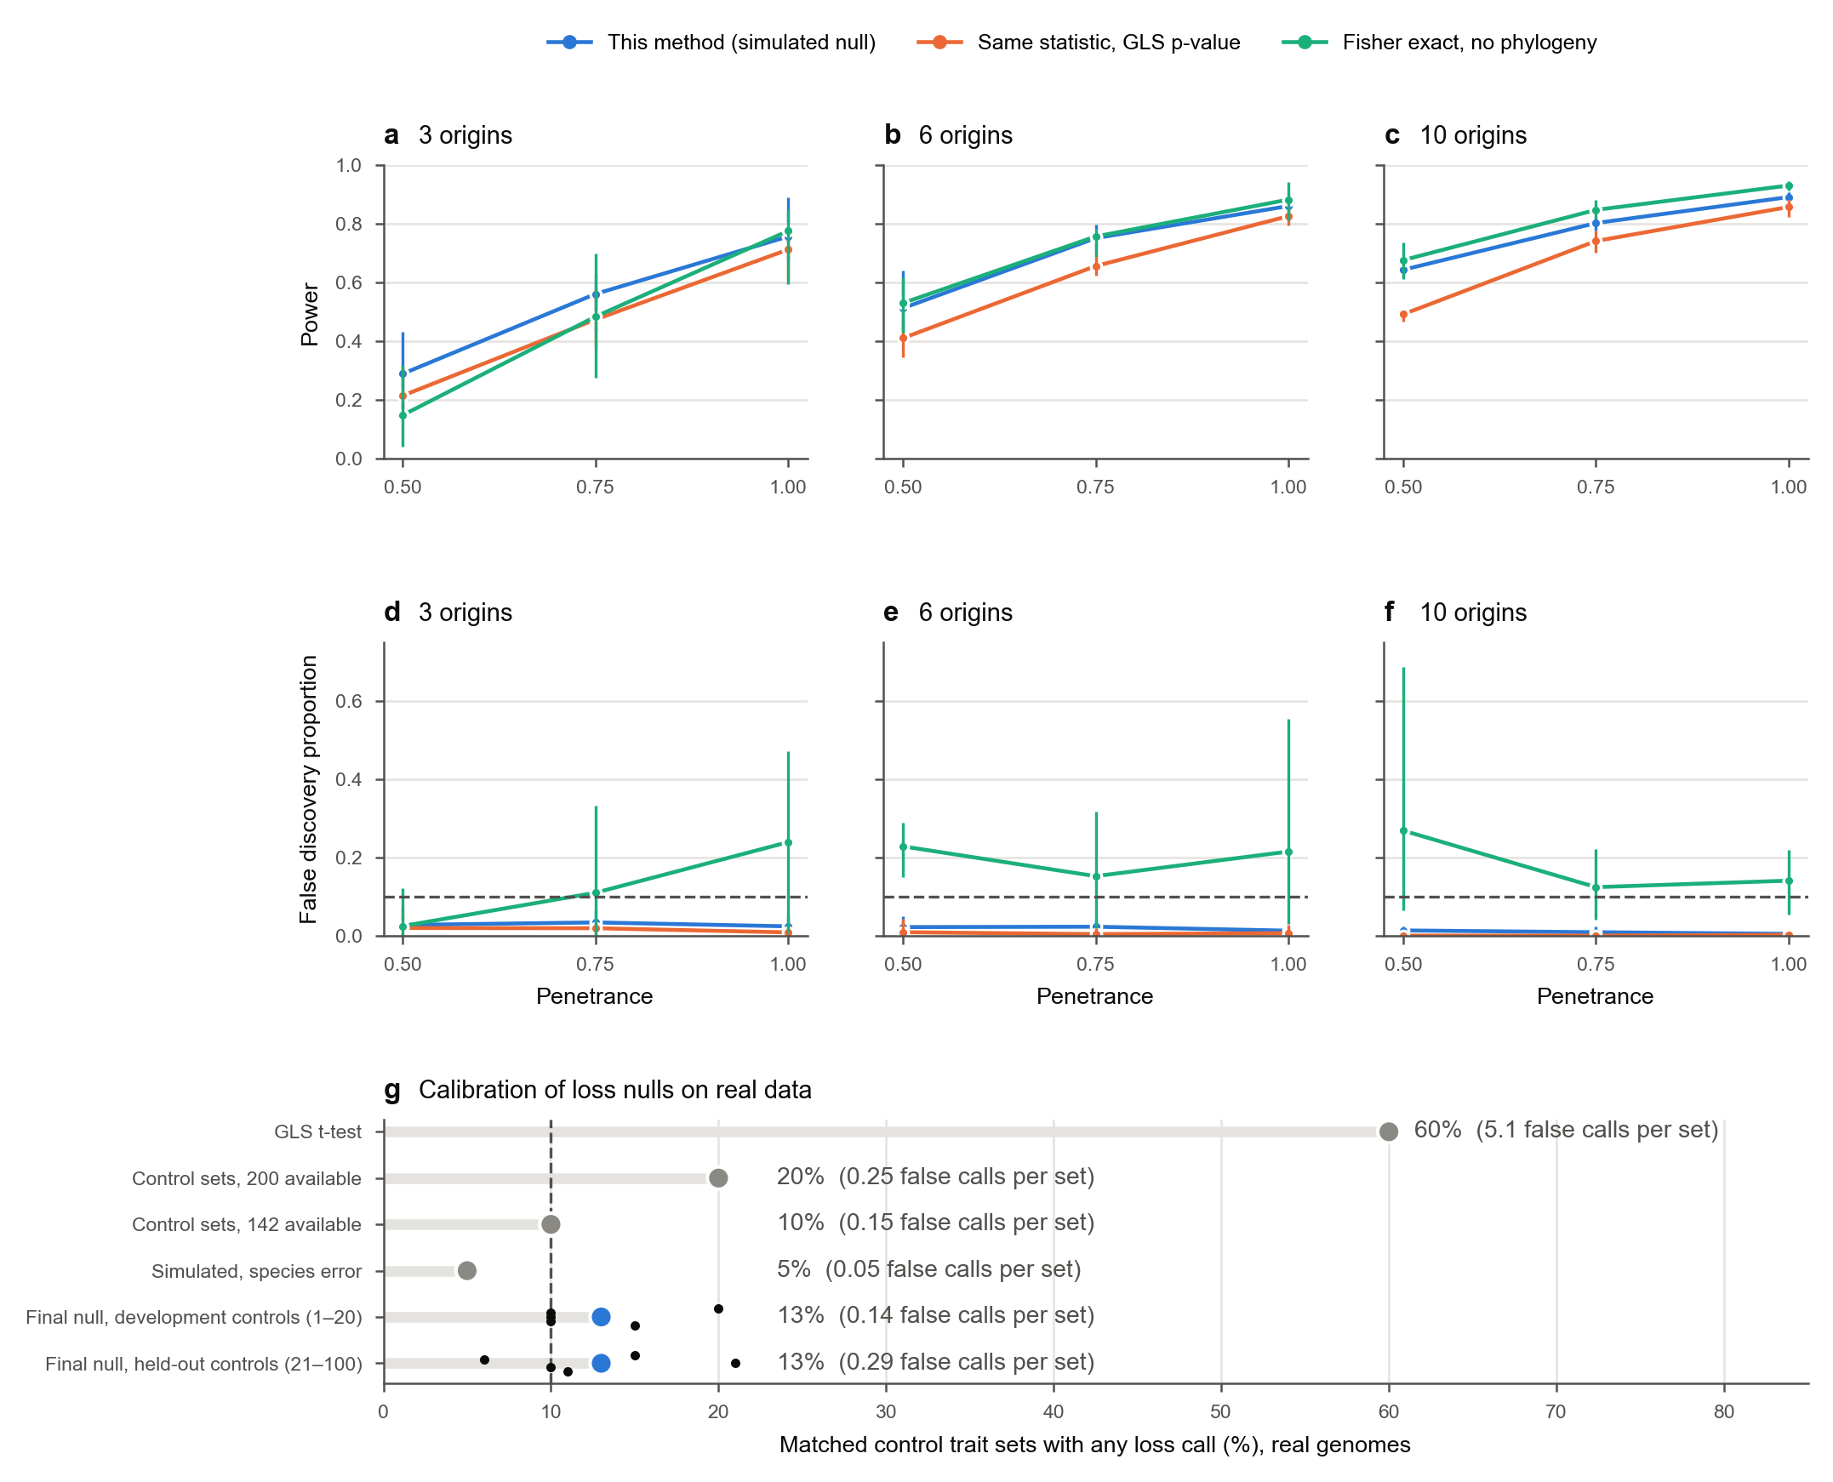
Fig. 3 | A simulated null with species and gene error rates calibrates the gene-loss test. a–f, Genomes simulated on the real 115-species tree from the loss model fitted to the TOGA loss matrix (12,851 genes; each gene’s loss rate and fragility, each species’ false-loss rate and each gene’s missing data kept). In 2% of genes, each origin of a random trait (3, 6 or 10 clades of 1–4 species) loses the gene on its stem branch with probability set by the penetrance. a–c, Power; d–f, false discovery proportion; dashed line, q = 0.1. Points, mean over five replicate genomes per setting; bars, range. Blue, this method (simulated null, 100 replicates per analysis); orange, the same leave-one-origin-out statistic with its parametric GLS P value; green, one-sided Fisher exact test of lost versus intact in trait versus other species, ignoring phylogeny. g, Calibration on real genomes: share of matched control trait sets with at least one loss call (20 per analysis for the earlier nulls; 100 per analysis, 500 in all, for the final null) (mean false calls per set in brackets), for the successive loss nulls tried. GLS t-test, marine trait, 101 species; pooled statistics from 200 or 142 other control sets, marine, 101 and 105 species; simulated null with species error only, marine, 105 species; final simulated null with species × gene error (blue), on 115 species, shown separately for the development controls (1–20, used while the null was built) and the held-out controls (21–100, first analysed after it was fixed); bars, pooled over the five analyses; black dots, each analysis. Dashed line, nominal 10%. Panel g records the development history of the loss null on differing species sets and numbers of control traits; it is not a paired benchmark.
[image: Fig. 4]
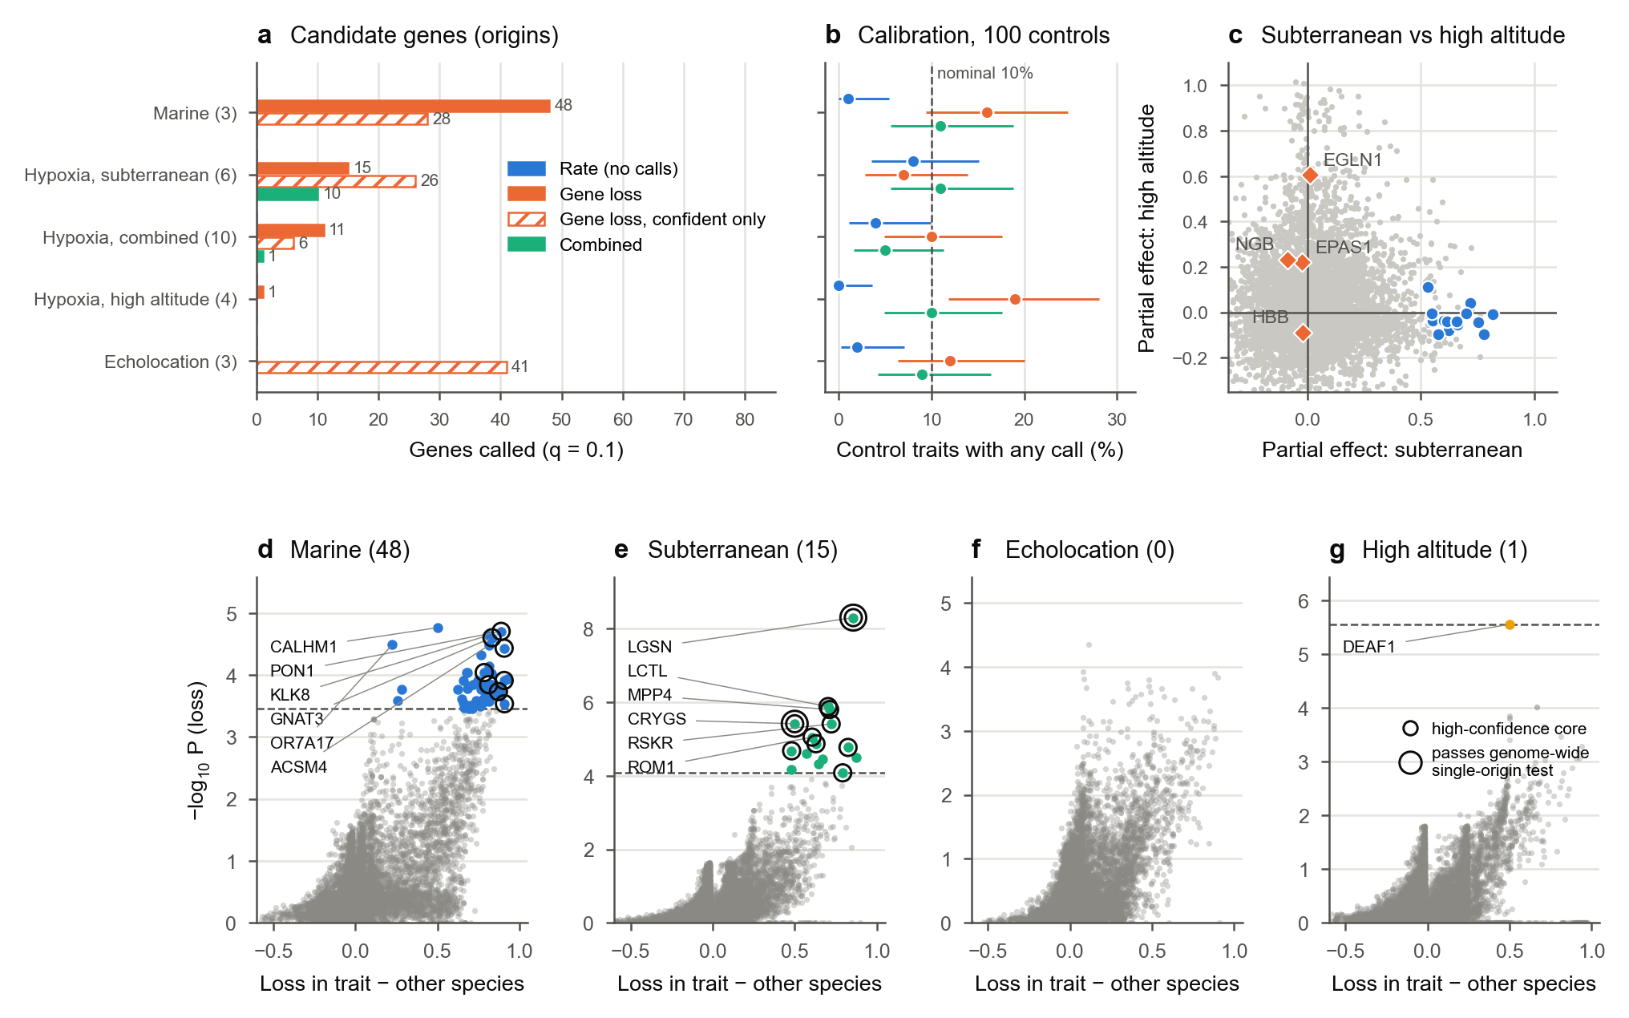
Fig. 4 | Candidate recurrent losses under the primary coding. Analyses include 115 mammals, 15,703 rate-tested genes and 12,851 loss-tested genes. a, Candidate counts at q = 0.1 within each trait and evidence family; origin counts are shown in brackets. Hatched bars, calls when only confident losses (TOGA class L) are counted (Supplementary Note 11). No rate-shift candidates were detected. b, Proportion of 100 matched control-trait configurations with at least one call; bars show binomial intervals, whose interpretation assumes independent configurations. The dashed line marks 10% as a reference, not an unconditional FDR estimate for the focal traits. c, Descriptive partial GLS effects of subterranean and high-altitude indicators; grey, all testable genes; blue, subterranean candidates; orange, prespecified hypoxia genes. d–g, Unadjusted difference in loss frequency between focal and other species against −log10 P; the difference is descriptive, and significance comes from the covariance-based test. Coloured points are candidates; small rings mark the high-confidence core and large rings the genes significant after genome-wide correction of the single-origin check (LGSN and, close to the threshold, CRYGS); the dashed line denotes the P value of the weakest candidate and is not a universal fixed significance threshold.
[image: Fig. 5]
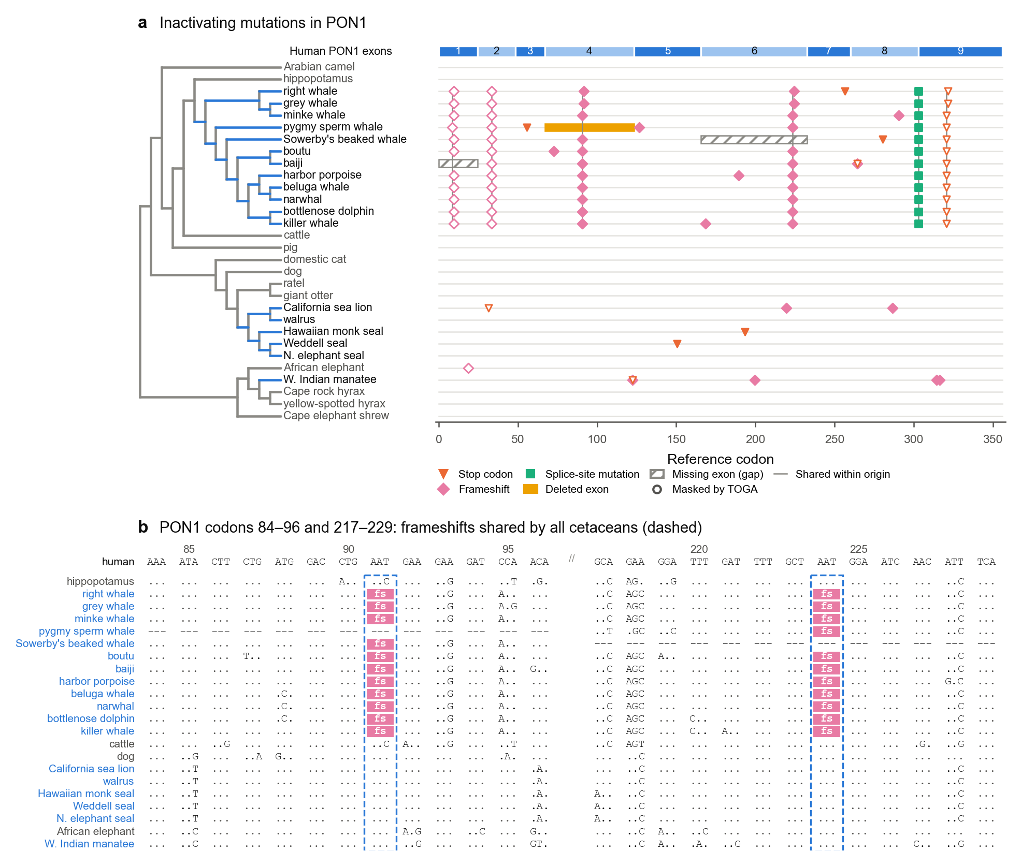
Fig. 5 | PON1 was inactivated once in cetaceans and several times in pinnipeds. a, Inactivating mutations in PON1 reported by TOGA, placed on the nine reference exons (top bar; x axis in reference codons) for the 18 marine species (blue branches) and 12 terrestrial relatives. Orange triangles, stop codons; pink diamonds, frameshifting insertions or deletions; green squares, splice-site mutations; yellow bars, deleted exons; hatched bars, exons missing because of assembly gaps (missing data, not loss). Open symbols are mutations TOGA masks when calling a loss. Grey vertical lines join the same mutation in two or more species of one origin. b, Codon alignment of PON1 in two windows (exon 4, codons 84–96; exon 6, codons 217–229) for the 18 marine species (blue names) and four relatives. Dots, bases identical to human; letters, differences; dashes, codons not aligned (exon deleted or missing); pink, codons disrupted by a frameshift (TOGA reports them as XXX). Dashed boxes mark the frameshifts shared by all cetaceans with data. Shared lesions indicate one inactivation in a common ancestor; different lesions in related species indicate separate inactivation histories. These are different claims: the figure supports the first for cetaceans and the second for pinnipeds.
[image: Fig. 6]
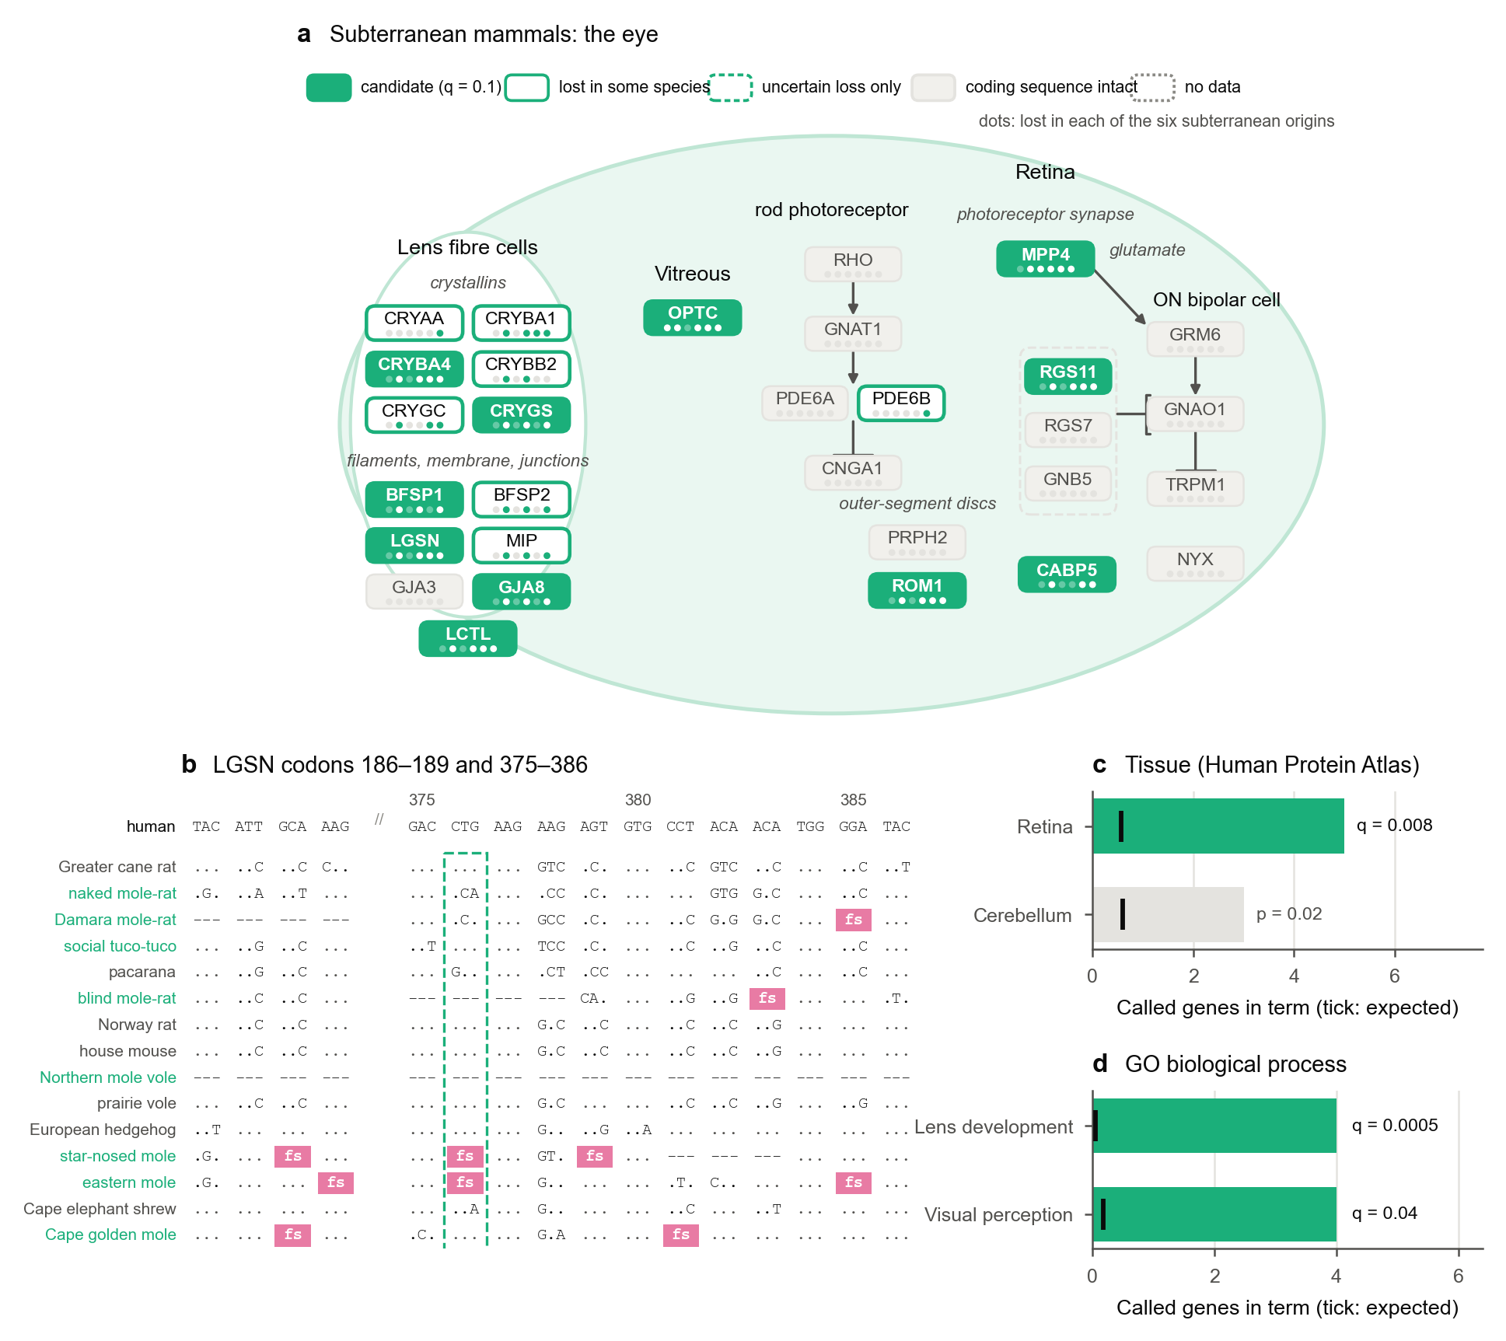
Fig. 6 | Underground, the lens and image-processing genes show evidence of loss while selected core phototransduction genes retain coding sequence. a, Canonical eye pathways (schematic; interactions from the literature, not inferred here) with each gene coloured by our data: filled, candidate loss at q = 0.1; solid outline, lost (TOGA L) in at least one subterranean species but not called; dashed outline, uncertain loss (UL) only; pale, coding sequence intact in all subterranean species with data; dotted outline, no data. An intact coding sequence does not show that the gene is functional. Dots under each gene mark the six origins in tree order, filled where the gene is lost in at least one species. Lens fibre-cell crystallins, beaded filaments (BFSP1, BFSP2), lengsin (LGSN), aquaporin 0 (MIP), connexins (GJA3, GJA8) and LCTL; vitreous opticin (OPTC); rod phototransduction (RHO, GNAT1, PDE6A, PDE6B, CNGA1), disc-rim proteins (PRPH2, ROM1) and the photoreceptor synapse (MPP4); ON bipolar-cell signalling (GRM6, GNAO1, TRPM1, NYX), its GTPase-activating complex (RGS11, RGS7, GNB5) and CABP5. Arrows, activation; bars, inhibition. b, Codon alignment of LGSN (codons 186–189 and 375–386) for the eight subterranean species (green names) and seven relatives, as in Fig. 5b; the dashed box marks the frameshift shared by the two moles. c, d, Enrichment of the 15 subterranean losses among genes elevated in human tissues (Human Protein Atlas [47]; c) and among Gene Ontology biological processes [49] (d). Bars, called genes in the term; black ticks, number expected when each called gene is replaced by a random tested gene lost equally often across the 115 mammals; coloured, q < 0.1 after correction over all eligible terms; grey, uncorrected P shown. Enrichment is supporting annotation, not evidence of loss.

Extended Data figures
[image: Extended Data Fig. 1]
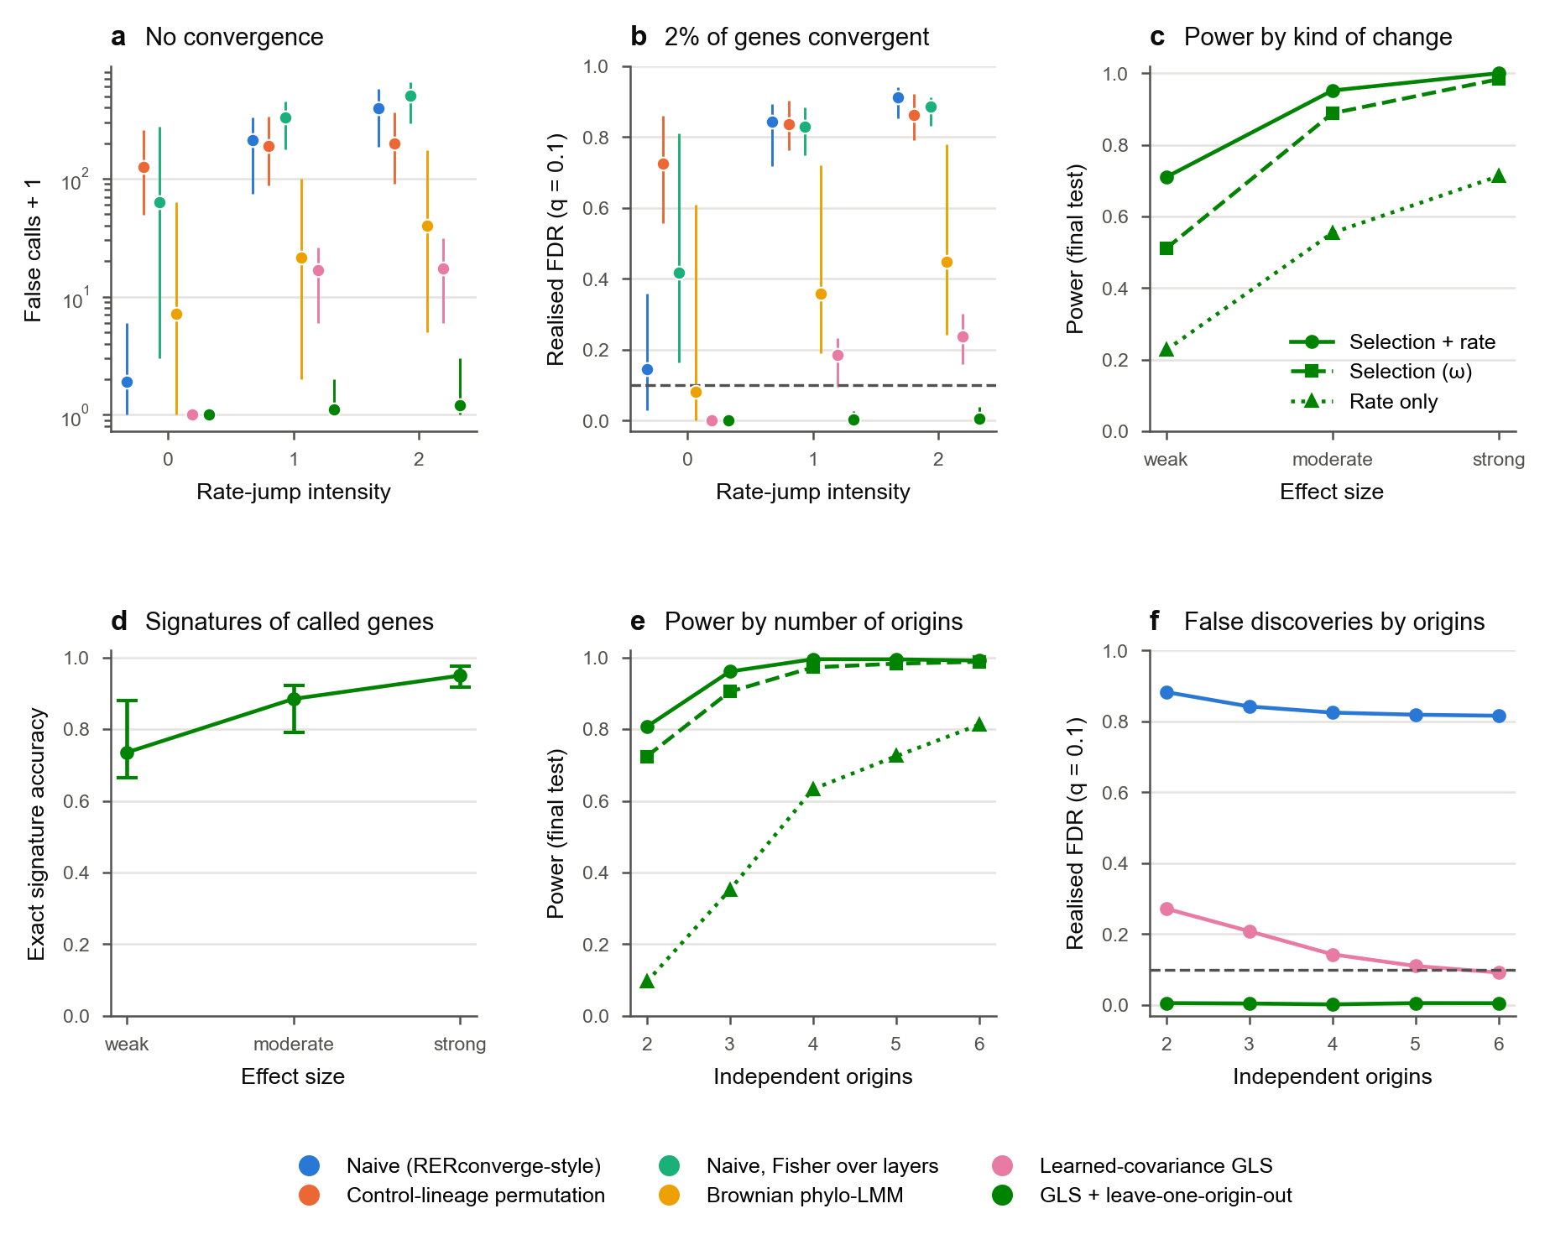
Extended Data Fig. 1 | The rate layers stay calibrated under lineage rate jumps and estimation error. Codon alignments simulated with IQ-TREE AliSim (GY model) on Yule trees of 200 species, 3,000 genes per genome; branch lengths re-estimated with IQ-TREE. Rate-jump intensity sets how strongly single lineages change rate (confounding). a, False calls (plus one, log scale) in genomes with no convergence. b, Realised false discovery rate when 2% of genes converge in five origins; dashed line, q = 0.1. c, Power of the final test (GLS with leave-one-origin-out) by kind of convergent change and effect size (weak: ω ×1.5, rate ×1.2; moderate: ×2, ×1.35; strong: ×3, ×1.5). d, Exact accuracy of the inferred convergence signature among called genes; points, mean over the 10 trees; bars, range across trees. e, f, Power and realised false discovery rate by number of independent origins (2–6). Colours denote methods (key); in c and e, line style and marker denote the kind of change. In a, b and d, points are means over 10 simulated trees (3,000 genes each) and bars the range across trees, offset horizontally by method; c, e and f show means over the same 10 trees.
[image: Extended Data Fig. 2]
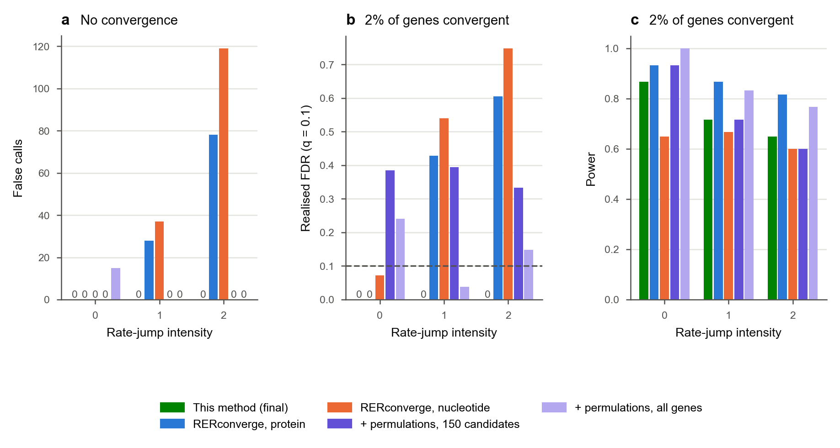
Extended Data Fig. 2 | RERconverge comparisons in the simulated rate jump benchmark. AliSim genomes (3,000 genes) on 200-species trees at three levels of rate-jump intensity. These are single-genome comparisons: each method was run on one simulated genome per intensity, so no range across replicates is shown. RERconverge 0.3.0 was run on IQ-TREE protein or nucleotide gene trees (binary trait, clade = “all”). a, False calls in genomes with no convergence. b, Realised false discovery rate and c, power when 2% of genes converge (moderate effect); dashed line, q = 0.1. Bars of height zero are labelled 0. Green, this method (final test); blue and orange, RERconverge on protein and nucleotide trees; violet, RERconverge on protein trees with 1,000 permulations on the 150 genes with the smallest parametric P; light violet, with 10,000 permulations on all genes, run on separate genomes of the same design at each intensity, on which the final test made no false calls (power 0.97, 0.83 and 0.72).
[image: Extended Data Fig. 3]
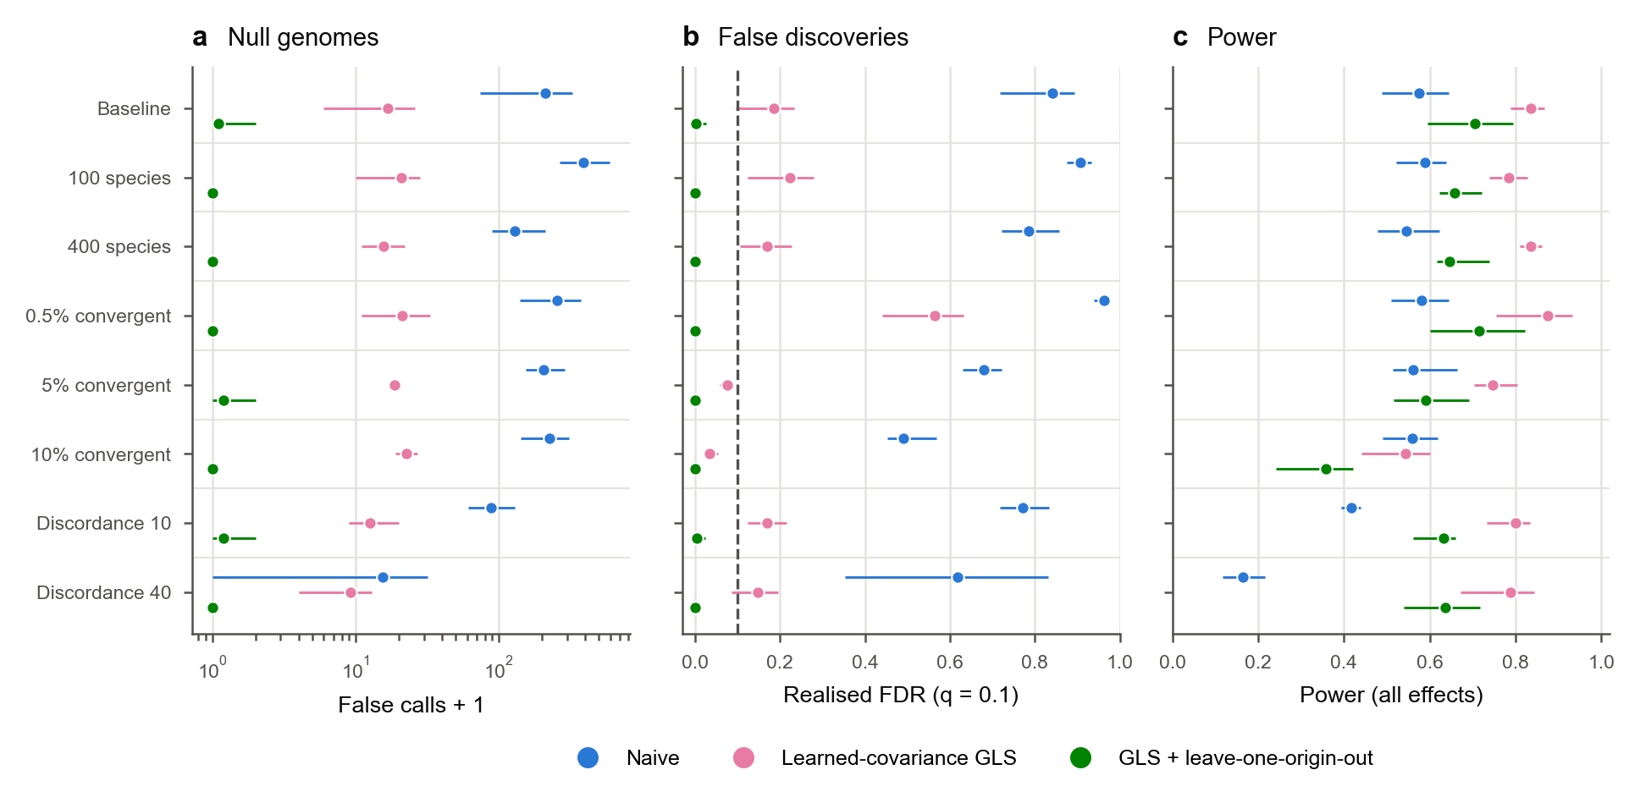
Extended Data Fig. 3 | The final test stays calibrated across tree sizes, shares of convergent genes and gene-tree discordance. AliSim genomes as in Extended Data Fig. 1 at rate-jump intensity 1, changing one setting at a time from the baseline (200 species, 2% of genes convergent, no gene-tree discordance; 10 trees): tree size (100 or 400 species), share of convergent genes (0.5%, 5% or 10%) and gene-tree discordance (Poisson mean of 10 or 40 nearest-neighbour interchanges per gene); five trees per setting. a, False calls (plus one, log scale) in genomes with no convergence. b, Realised false discovery rate; dashed line, q = 0.1. c, Power over all effect sizes and kinds of change. Points, mean over trees (10 for the baseline, 5 for the other settings; 3,000 genes each); bars, range across trees. Blue, naive test; pink, learned-covariance GLS; green, final test (GLS with leave-one-origin-out).
[image: Extended Data Fig. 4]
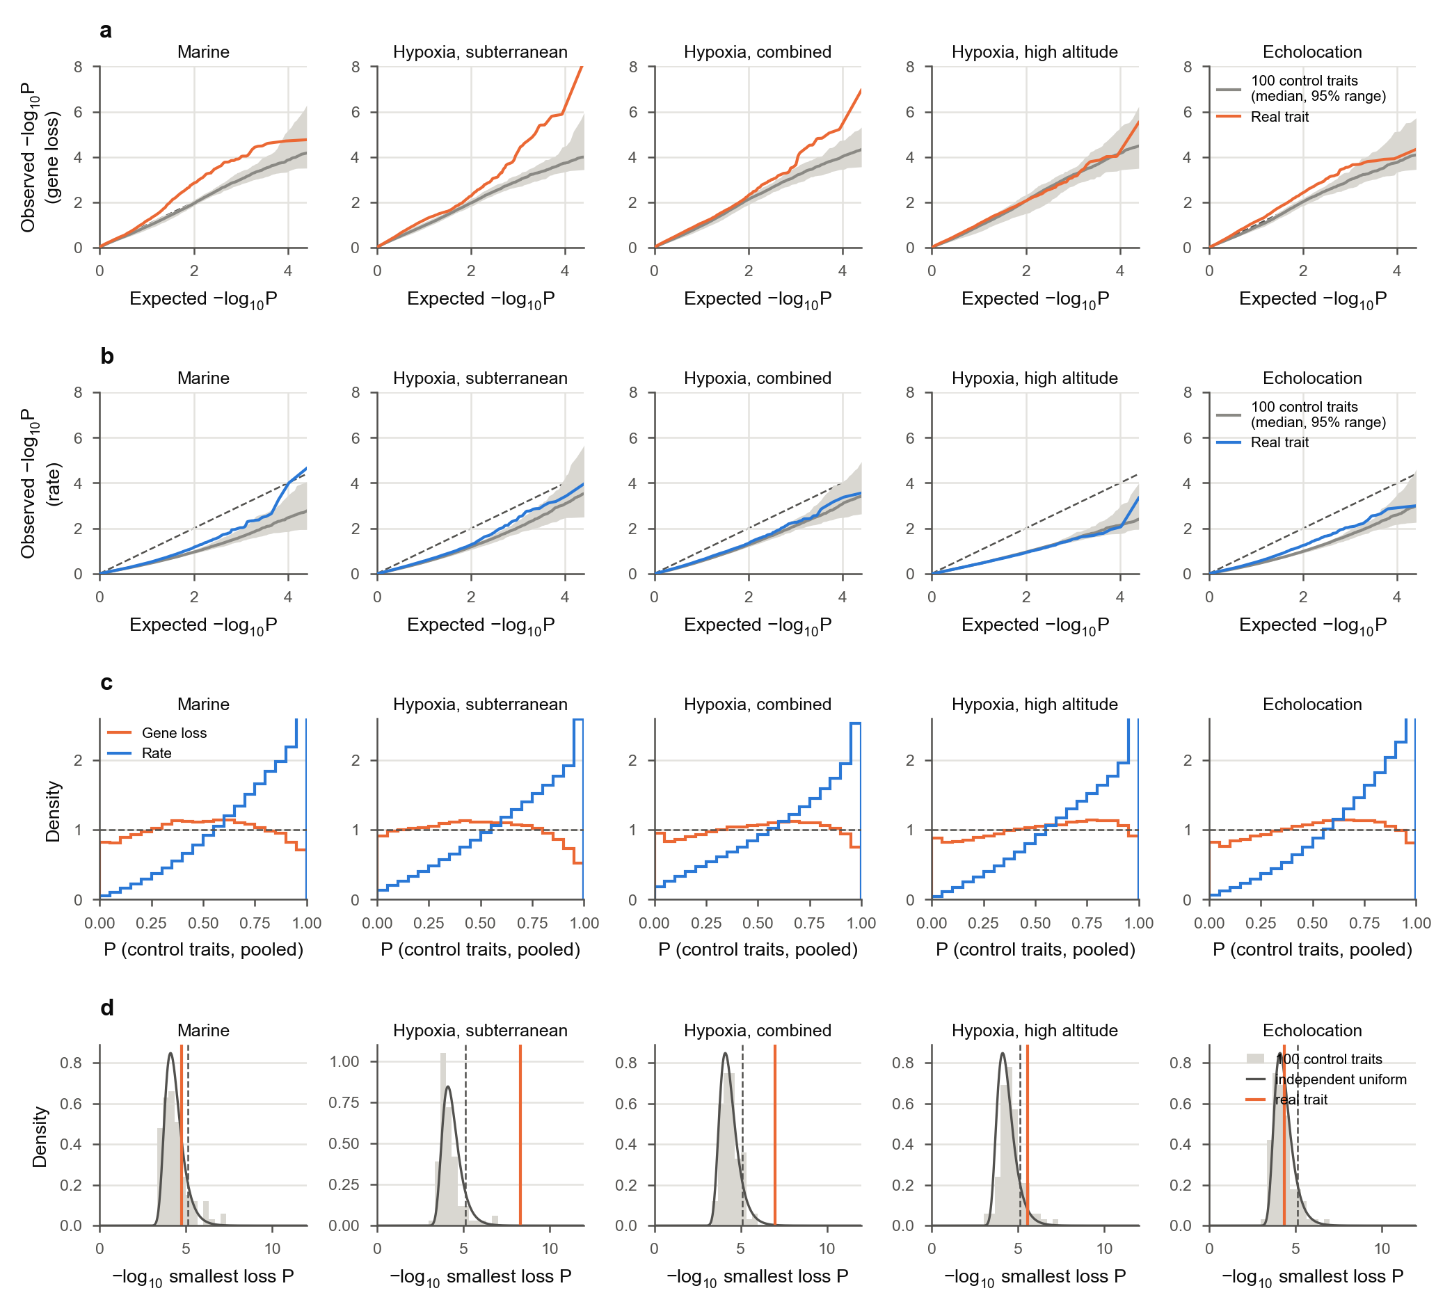
Extended Data Fig. 4 | P values in the matched control traits. a, b, Quantile–quantile plots of gene-loss (a) and rate (b) P values against the uniform distribution, for each analysis. Grey line and band, median and 95% range over the 100 control traits at each rank; coloured line, the real trait; dashed line, equality. c, Histograms of the pooled P values of the 100 control traits (20 bins; density 1 is uniform). d, The smallest loss P value of each of the 100 control traits (grey histogram), with the density expected if the gene P values were independent and uniform (line), the Benjamini–Hochberg threshold for a single call at q = 0.1 (dashed) and the smallest P of the real trait (orange).
[image: Extended Data Fig. 5]
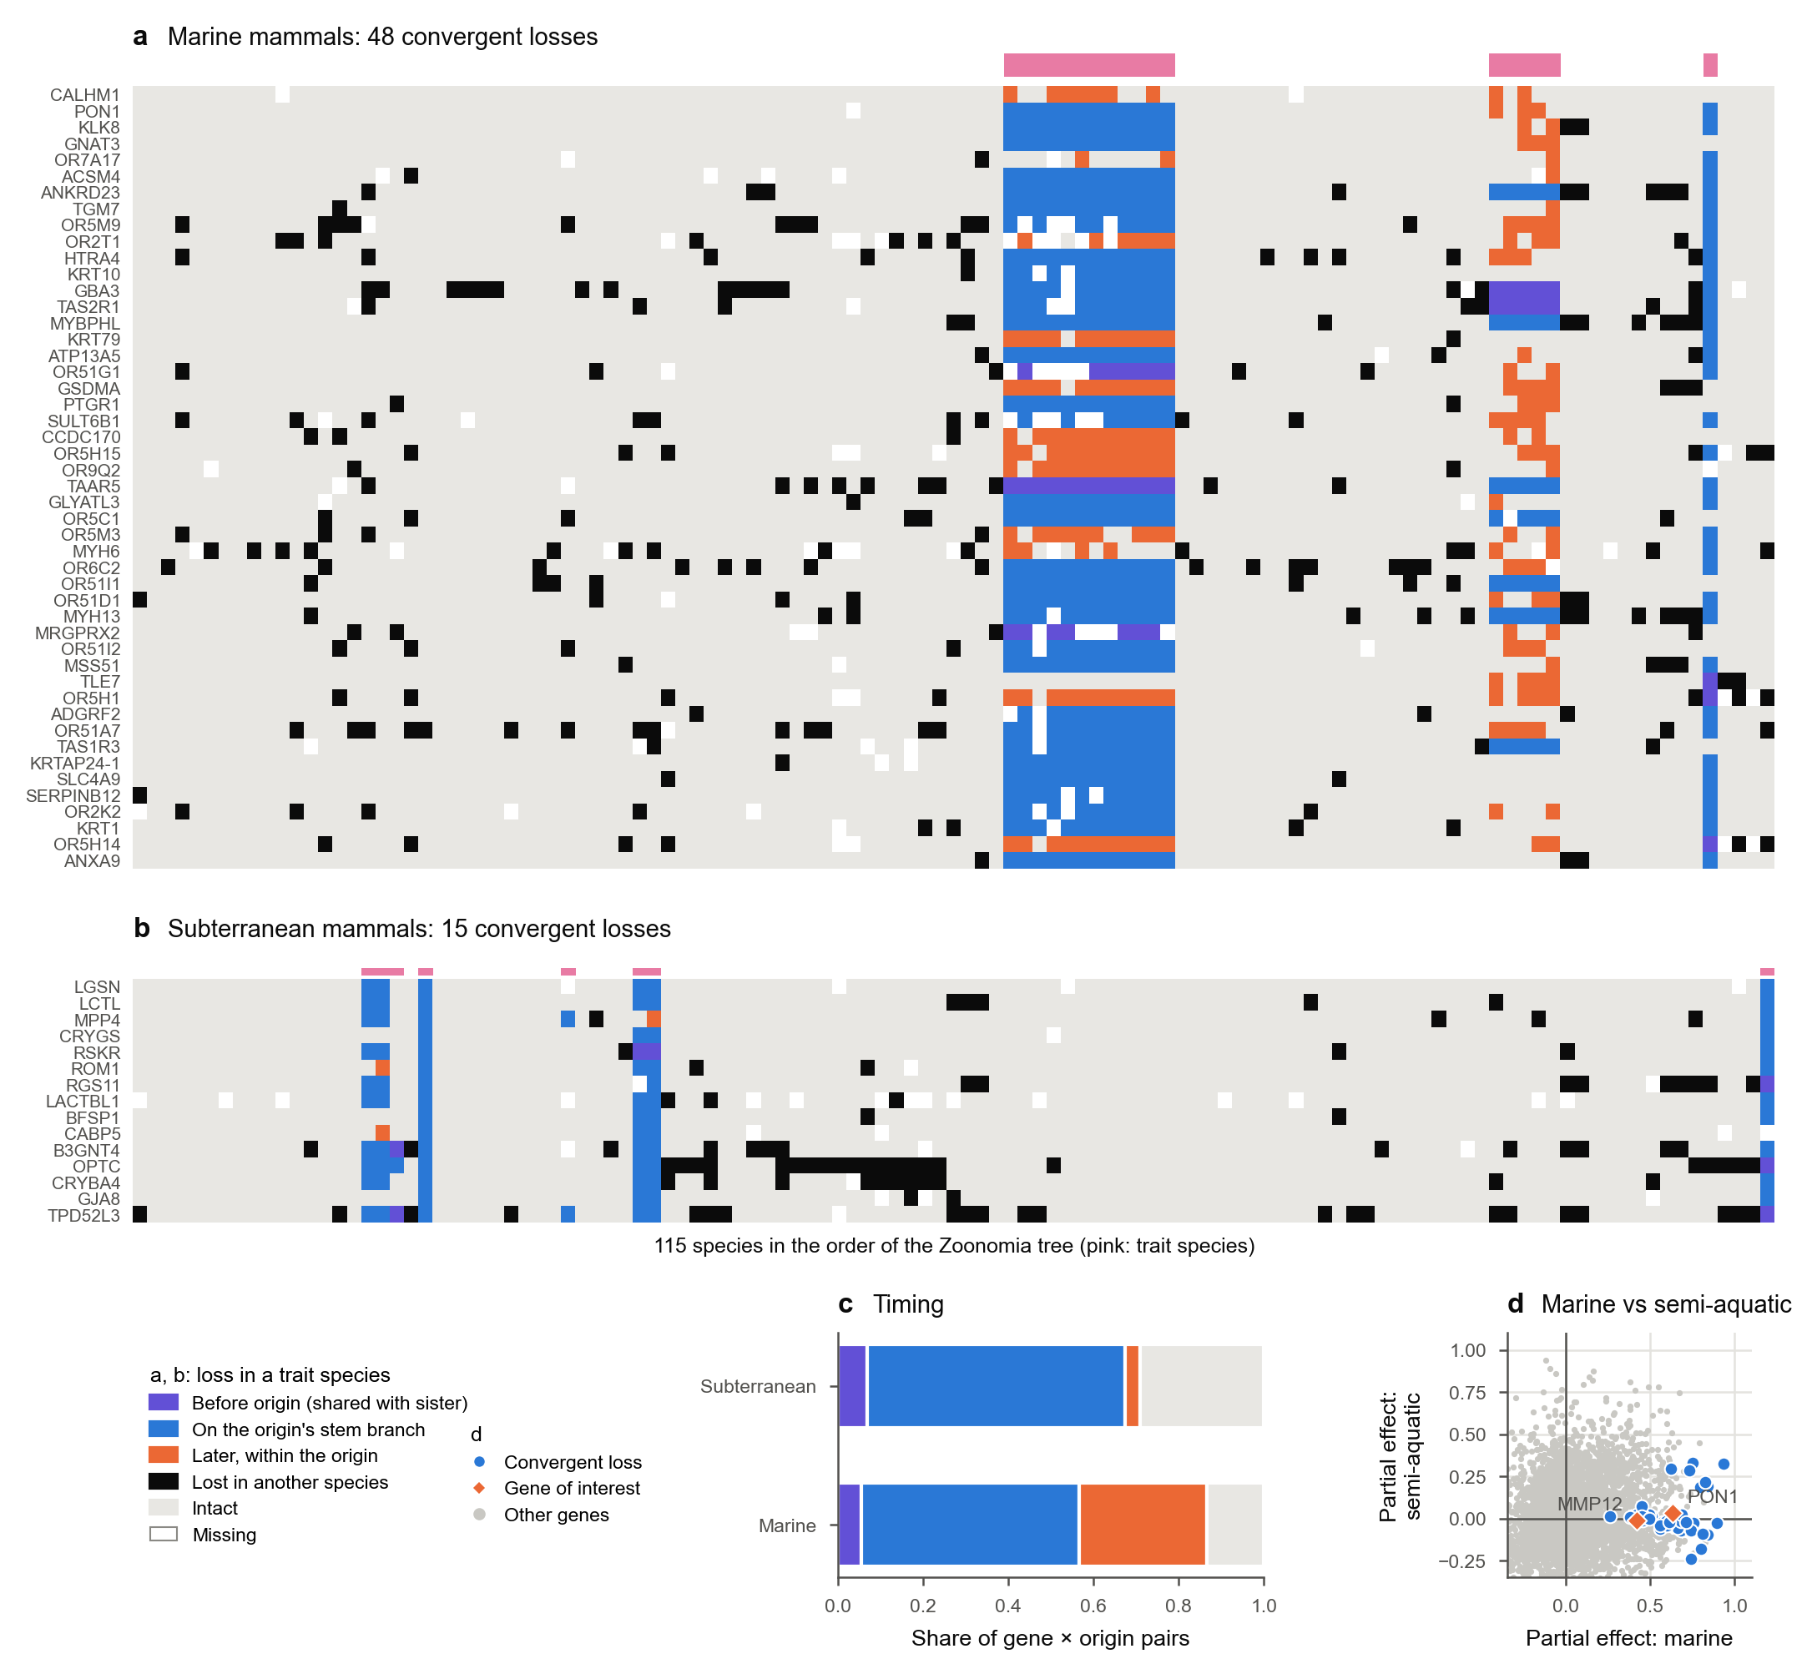
Extended Data Fig. 5 | Which species lost each convergent gene, and when the loss arose in each origin. a, The 48 marine losses; b, the 15 subterranean losses. Columns are the 115 species in the order of the pruned Zoonomia tree; pink bars mark trait species. A loss (TOGA lost or uncertain loss) in a trait species is coloured by its mapped timing in that origin under the irreversible-loss model (a state-based mapping, not a date): violet, lost before the origin (shared with its sister lineage); blue, lost on the origin’s stem branch (all observed species of the origin lost); orange, lost later within the origin (some species). Black, lost in another species; grey, intact (intact or partially intact); white, missing. For origins of one species (manatee, tuco-tuco, blind mole-rat, mole vole, golden mole), the stem branch is the terminal branch. c, Share of gene × origin pairs in each timing class. d, Partial effects of the marine trait and of semi-aquatic life on gene loss (as in Fig. 4c). Grey, all testable genes; blue, the marine losses; orange, genes of interest.
[image: Extended Data Fig. 6]
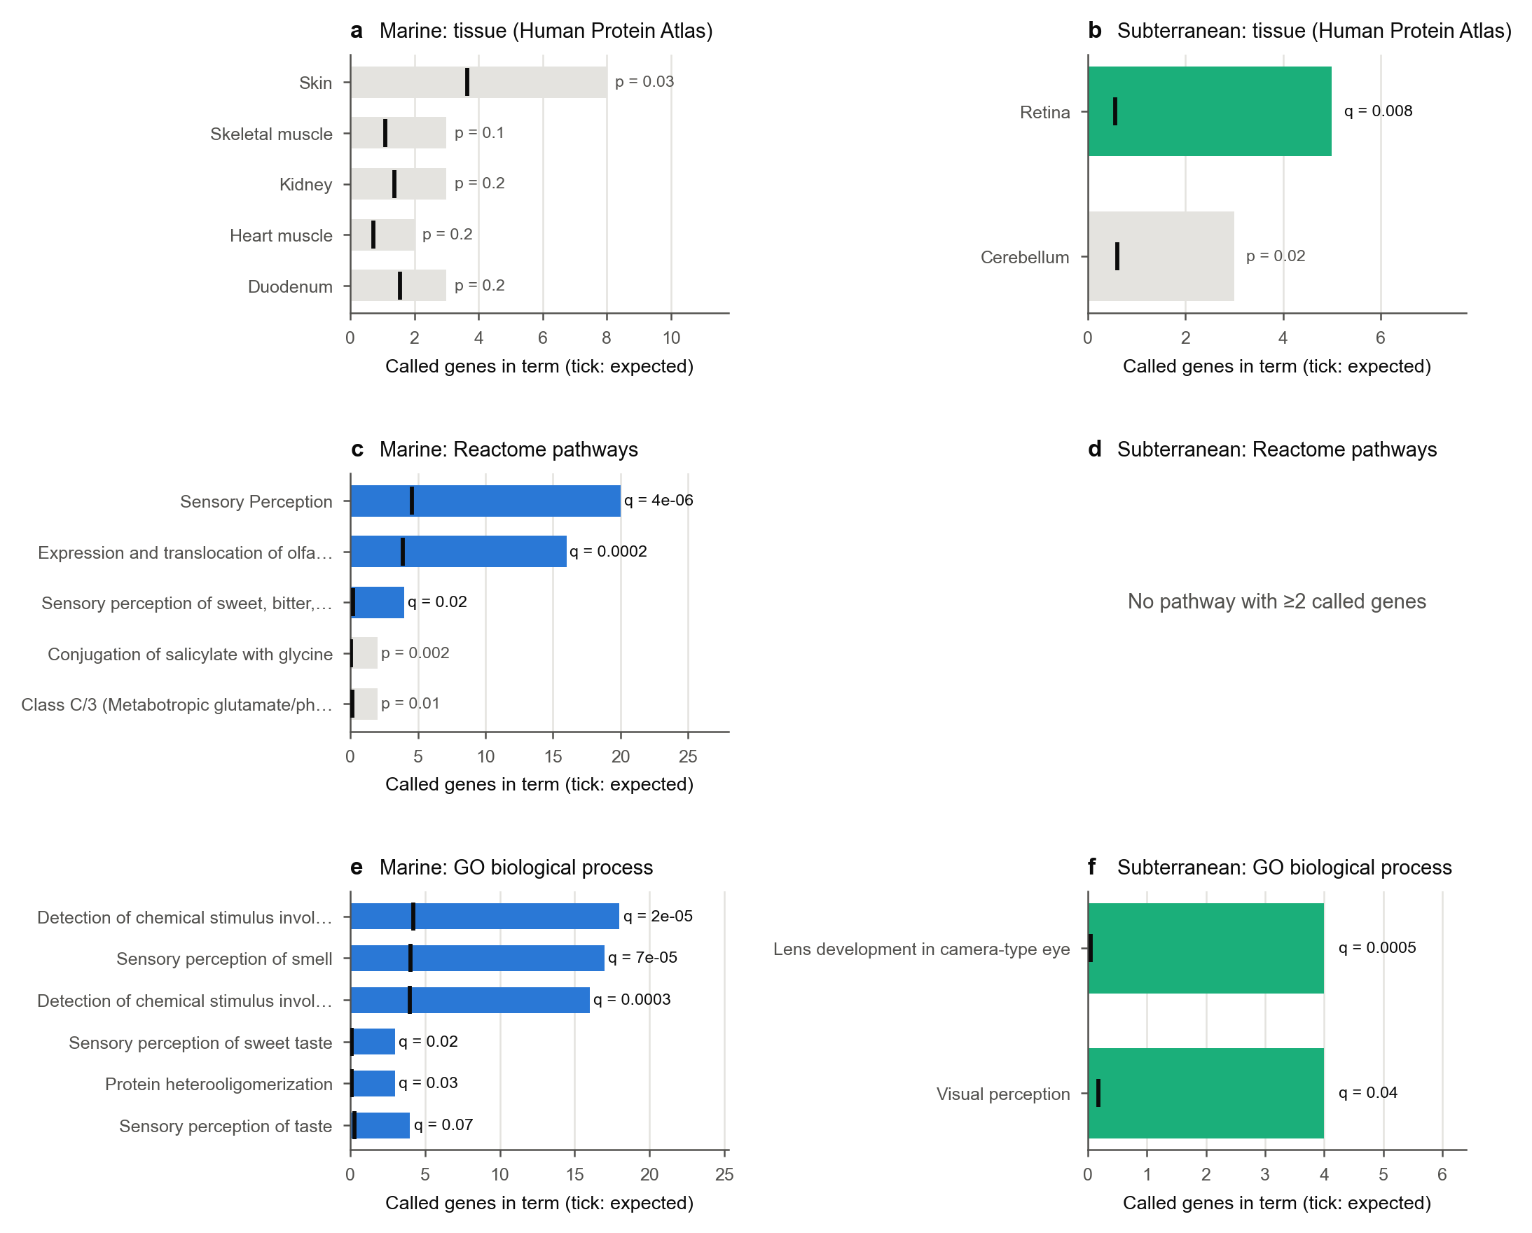
Extended Data Fig. 6 | Tissue, pathway and GO enrichment of the convergent losses. Bars, number of called genes in each annotation term; black ticks, number expected when each called gene is replaced by a random tested gene lost equally often across the 115 mammals. Coloured bars are terms significant after Benjamini–Hochberg correction over all eligible terms (q < 0.1); grey bars are shown with their uncorrected P. a, b, Tissues in which genes are elevated (Human Protein Atlas consensus expression, 50 human tissues) [47] for marine (a) and subterranean (b) losses; only tissues with at least two called genes are shown. c, d, Reactome pathways [48]; no pathway contains two or more subterranean losses. e, f, Gene Ontology biological processes [49] (terms with at most 450 genes; for terms with the same called genes, the most specific is shown).
[image: Extended Data Fig. 7]
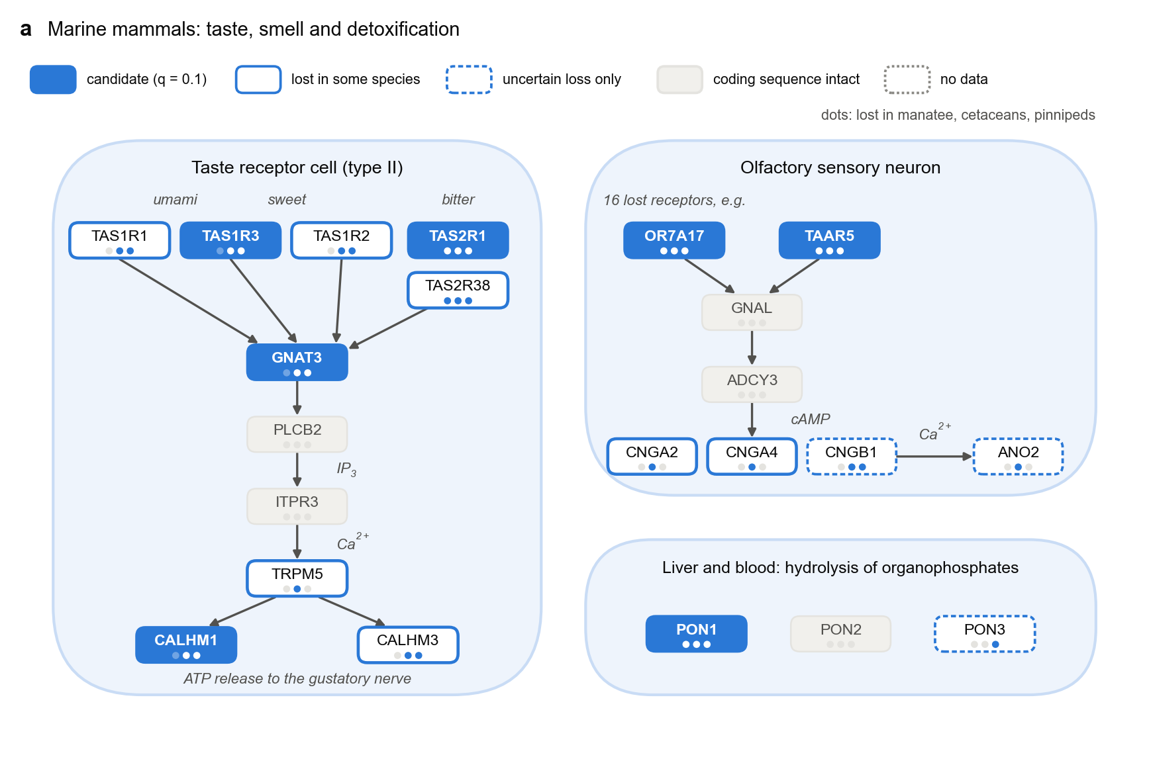
Extended Data Fig. 7 | Which parts of taste, smell and detoxification were lost in marine mammals. Canonical pathways (schematic; interactions from the literature) coloured as in Fig. 6a; dots mark the manatee, cetacean and pinniped origins. Type II taste receptor cell: sweet, umami and bitter receptors signal through gustducin (GNAT3), phospholipase Cβ2 (PLCB2), the IP₃ receptor (ITPR3) and TRPM5 to ATP release through CALHM1 and CALHM3. Olfactory sensory neuron: odorant and trace-amine receptors (16 lost olfactory receptors are represented by OR7A17) signal through Gαolf (GNAL), adenylyl cyclase 3 (ADCY3), the cyclic-nucleotide-gated channel (CNGA2, CNGA4, CNGB1) and the chloride channel ANO2. Paraoxonases PON1–3.
[image: Extended Data Fig. 8]
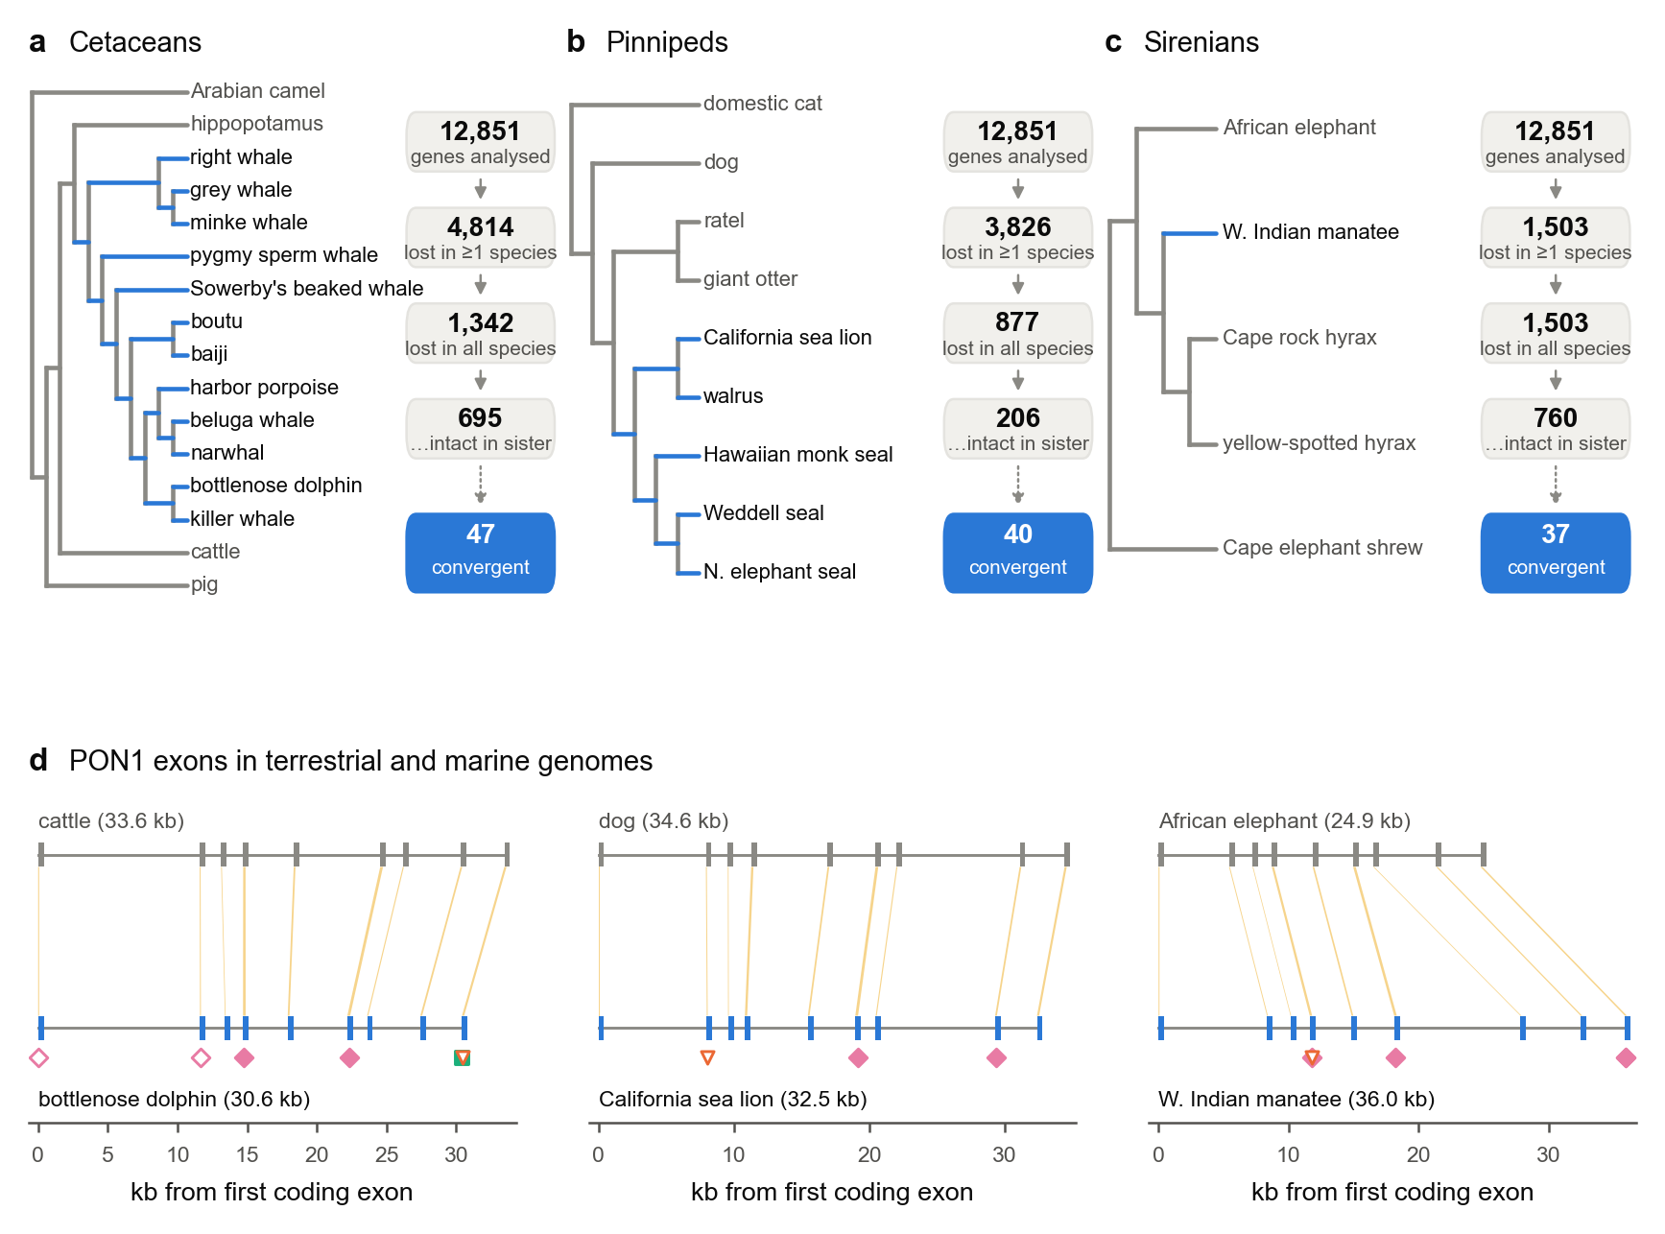
Extended Data Fig. 8 | Marine gene losses per lineage and the PON1 locus. a–c, Each marine origin with its closest terrestrial relatives in the study (cladograms; marine branches in blue). Boxes count genes, out of 12,851 analysed, that are lost in at least one species of the origin, lost in every species with data, and of those intact in the sister lineage; the blue box gives the number of the 48 convergent genes lost in at least one species of the origin. d, PON1 exons in the genome of a terrestrial relative (top, grey) and a marine species (bottom, blue) for each origin, with orthologous exons joined (yellow). Coordinates in kb from the first coding exon, in the direction of transcription; locus lengths in brackets. Mutations in the marine genome are shown below it with the symbols of Fig. 5a. Exon coordinates and mutations are TOGA projections of the human hg38 annotation [30].
[image: Extended Data Fig. 9]
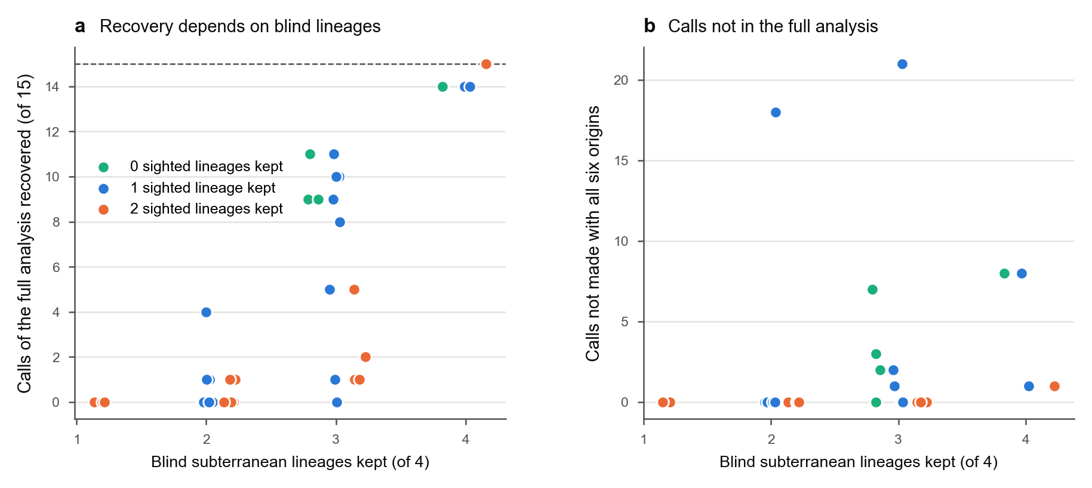
Extended Data Fig. 9 | Recovery of subterranean candidates depends on the origins retained. The subterranean analysis was repeated on every subset of three, four and five of its six origins (41 subsets); species of dropped origins were set to missing, and the fitted loss model and 50 simulated genomes per subset were used as in the full analysis. Subsets share data and the target set was selected using all origins, so this is candidate recovery, not an independent estimate of power. a, Number of the 15 losses called with all six origins that are called again, against the number of blind lineages kept (blind mole-rat, golden mole, African mole-rats, moles). Colour, number of sighted subterranean lineages kept (tuco-tuco, mole vole): green none, blue one, orange two. Dashed line, all 15. b, Calls made in a subset but not with all six origins. Points are jittered horizontally.
[image: Extended Data Fig. 10]
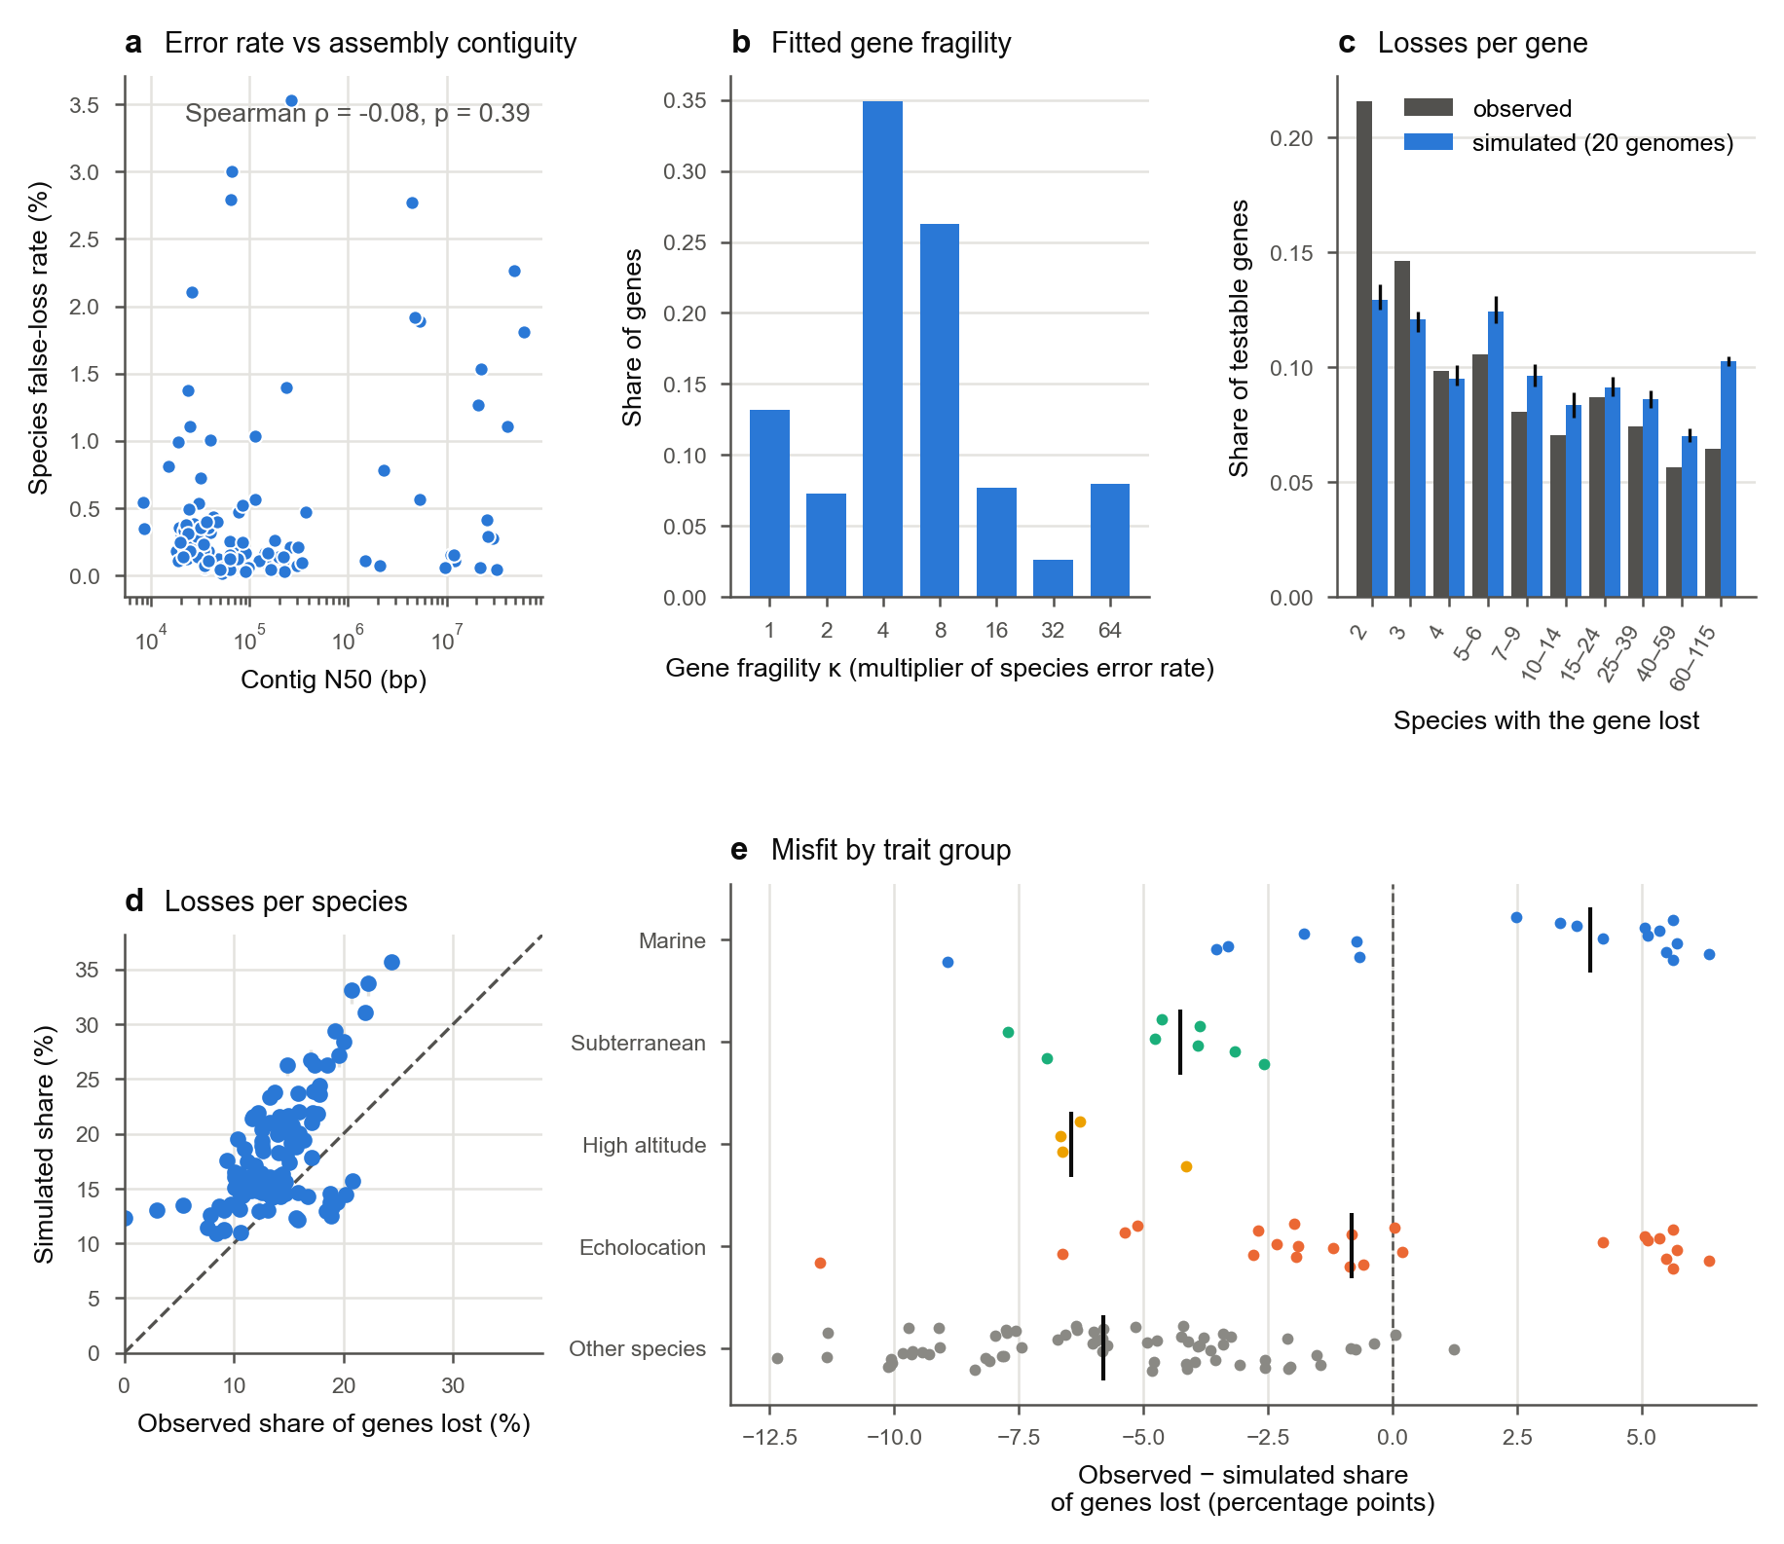
Extended Data Fig. 10 | The gene-loss model: data quality and goodness of fit. a, Fitted species false-loss rate against assembly contig N50 (114 species; human reference excluded). b, Distribution of fitted gene fragility κ, the factor by which a gene’s false-loss probability exceeds its species’ rate. c, Number of species in which each testable gene is lost, observed (grey) and in 20 genomes simulated from the fitted model (blue; bars, range). d, Share of genes lost per species, observed against simulated (bars, range over 20 genomes); dashed line, equality. e, Observed minus simulated share of genes lost per species (percentage points), by trait group; vertical lines, group medians (marine +4.0, subterranean −4.3, high altitude −6.4, echolocation −0.8, other species −5.8).

Supplementary Information

Supplementary Note 1. Standard models are miscalibrated on sequence-derived rates
A Brownian phylogenetic mixed model is calibrated when branch values are simulated from it, but not when they are estimated from simulated sequences. On AliSim genomes with no convergent genes (80 species, 600 genes), its per-layer false-positive rate at α = 0.05 was 0.10–0.14 for the two rate layers.
Three features of estimated rates break the model:
- Unequal noise. Estimation noise is much larger on short branches; the spread of a branch’s value across genes was strongly anticorrelated with its true length (Spearman ρ = −0.83).
- Correlated errors. Estimates of neighbouring branches trade off against each other.
- Rate jumps. Clade-wide rate changes are discontinuous rather than Brownian.
Per-branch weighting and a gene-by-branch measurement-error model did not remove the excess: null z-scores kept a standard deviation of 1.15–1.32 instead of 1.
Learning the null covariance from the genome restored calibration. With the same data, GLS gave false-positive rates of 0.038–0.053 across the three layers, and null z-scores had a standard deviation of 0.99–1.03 for each of 60 control trait sets as well as for the observed trait. In the main benchmark (10 trees of 200 species, 3,000 genes) the learned-covariance test held its false-positive rate at 0.049, 0.051 and 0.055 at confounding 0, 1 and 2, while the Brownian model reached 0.046, 0.070 and 0.080.

Supplementary Note 2. Rate jumps in single lineages cause false discoveries that only a repetition test removes
Correct calibration at α = 0.05 did not guarantee FDR control. With 2% convergent genes (80 species, 3 origins, 1,500 genes), GLS on the nucleotide rate layer had a realised FDR of 0.41 at q = 0.10, and 0.43 even when Σ was learned from a separate genome with no convergence. The excess came from the extreme tail: a rate jump that happens to fall on one trait clade produces a large z-score without any repeated shift. The rate contrast, which cancels overall rate changes, was largely immune (FDR 0.00–0.15).
Requiring the signal to survive the removal of each origin removed these false discoveries. In the realistic design (200 species, 5 origins, 3,000 genes, 2% convergent, 2 trees), per-layer GLS had FDR 0.21 (nucleotide rate), 0.05 (protein rate) and 0.00 (rate contrast); with leave-one-origin-out all three were 0.00. A Benjamini–Heller partial-conjunction test [50] over per-origin effects gave the same protection with lower power when origins were small, and was not pursued.

Supplementary Note 3. Only the final test controls false discoveries across confounding levels
In the main benchmark (Extended Data Fig. 1a–d; 10 trees of 200 species, 5 origins, 3,000 genes; results/final_benchmark.csv and results/robustness/main_tree*.csv), the final test made false calls in only 2 of the 30 genomes without convergence (at most 2 calls). Its realised FDR was 0.000, 0.003 and 0.007 at confounding 0, 1 and 2, and at most 0.06 in any single genome. Every other method exceeded the 0.10 target once lineage-specific rate jumps were present.
Method | False calls per null genome (conf 0 / 1 / 2) | Realised FDR (conf 0 / 1 / 2) | Power (weak / moderate / strong)
Naive | 0.9 / 210 / 395 | 0.15 / 0.84 / 0.91 | 0.43 / 0.60 / 0.64
Control-lineage permutation | 124 / 189 / 199 | 0.73 / 0.84 / 0.86 | 0.42 / 0.54 / 0.60
Naive Fisher over layers | 63 / 327 / 504 | 0.42 / 0.83 / 0.89 | 0.86 / 0.98 / 0.99
Brownian phylogenetic LMM | 6.2 / 20 / 39 | 0.08 / 0.36 / 0.45 | 0.67 / 0.93 / 0.98
Learned-covariance GLS | 0 / 16 / 16 | 0.00 / 0.19 / 0.24 | 0.70 / 0.91 / 0.96
Final (GLS + leave-one-origin-out) | 0 / 0.1 / 0.2 | 0.000 / 0.003 / 0.007 | 0.49 / 0.81 / 0.91
Power is reported for every method, but it is only meaningful where FDR is controlled. The final test’s power depended on the kind of convergence: selection shifts were found at 0.51, 0.89 and 0.98 (weak, moderate, strong), combined selection and rate shifts at 0.71, 0.95 and 1.00, and rate-only shifts at 0.23, 0.55 and 0.71. Power fell with confounding (0.88, 0.70 and 0.63 at levels 0, 1 and 2), the cost of refusing to call shifts confined to one lineage.
The control-lineage permutation baseline was inflated even without confounding (false-positive rate 0.13). Its per-gene null moments come from a limited pool of matched clades, so they underestimate the variance; this is a property of our implementation and not evidence about RERconverge’s permulations, which are assessed below.

Supplementary Note 4. Selection shifts are detectable with two origins; rate-only shifts need more
With the trait placed on 2 to 6 nested origins of each of 10 trees (Extended Data Fig. 1e,f; strong effect, confounding 1; results/origins_power.csv), the final test controlled false discoveries at every number of origins: FDR ≤ 0.01 and at most 0.3 false calls per null genome on average. Without leave-one-origin-out, learned-covariance GLS had FDR 0.27 with 2 origins, falling to 0.09 with 6; the naive test had FDR 0.82–0.88 throughout.
Origins | Power (all) | Selection shift | Rate shift only | Selection + rate
2 | 0.56 | 0.72 | 0.09 | 0.81
3 | 0.76 | 0.90 | 0.35 | 0.96
4 | 0.88 | 0.97 | 0.63 | 1.00
5 | 0.90 | 0.98 | 0.72 | 0.99
6 | 0.94 | 0.99 | 0.81 | 0.99
Changes in selection pressure were detected at 72–81% power even with two origins and at 90% or more with three, whereas rate-only convergence required four or more origins to exceed 60% power. For traits with few independent origins, such as laryngeal echolocation in mammals (two to four, depending on the bat phylogeny), the method is therefore expected to detect selection-type convergence but to miss much rate-only convergence.

Supplementary Note 5. Convergence signatures
The signature model was developed on one tree and tested on a second tree simulated after the rule for the number of learned directions had been fixed (results/signatures/evaluation.txt). Exact accuracy is the share of correctly detected convergent genes whose predicted set of active layers matched the simulation (selection shift: protein rate and rate contrast; rate shift: nucleotide and protein rate; both: all three).
Method | Tree A (development) | Tree B (held out)
Learned directions (k = 2^L − 1) | 0.90 | 0.98
Per-layer rule (p < 0.05) | 0.78 | 0.86
On/off configuration model (EBCM) | 0.80 | 0.42
Detection on both trees gave 92 true calls and no false calls. Without information about the simulation, both trees learned the same three directions (loadings on nucleotide rate, protein rate, rate contrast): rate shift ≈ (0.84, 0.55, 0.0), selection shift ≈ (0.1, 0.55, 0.82) and both ≈ (0.5, 0.65, 0.6). Tree B also learned a negative rate direction (−0.83, −0.55, −0.05), which absorbs lineages that slowed down; such genes are not called convergent. In the main benchmark, signature accuracy for detected genes was 0.74, 0.88 and 0.95 at weak, moderate and strong effects.

Supplementary Note 6. Comparison with RERconverge
RERconverge was run on the same simulated genomes (1 tree of 200 species, 5 origins, 3,000 genes, moderate effect; results/rerconverge_compare.csv).
Method | False calls, null genome (conf 0 / 1 / 2) | Realised FDR (conf 0 / 1 / 2) | Power (conf 0 / 1 / 2)
RERconverge, nucleotide trees | 0 / 37 / 119 | 0.07 / 0.54 / 0.75 | 0.65 / 0.67 / 0.60
RERconverge, protein trees | 0 / 28 / 78 | 0.00 / 0.43 / 0.61 | 0.93 / 0.87 / 0.82
RERconverge, protein trees + 1,000 permulations on 150 candidates | 0 / 0 / 0 | 0.39 / 0.39 / 0.33 | 0.93 / 0.72 / 0.60
RERconverge, protein trees + 10,000 permulations on all genes (separate genomes) | 15 / 0 / 0 | 0.24 / 0.04 / 0.15 | 1.00 / 0.83 / 0.77
Final pipeline | 0 / 0 / 0 | 0.00 / 0.00 / 0.00 | 0.87 / 0.72 / 0.65
Without lineage-specific rate jumps, RERconverge on protein trees was calibrated and slightly more powerful than the final pipeline (0.93 against 0.87). With rate jumps, its parametric test lost FDR control (0.43–0.75). The final pipeline made no false calls in any of the six genomes. Permulations [33] run only on the 150 genes with the smallest parametric P removed all false calls on genomes without convergence, yet with 2% convergent genes 18–35 non-convergent genes were called (FDR 0.33–0.39). Run on all genes with 10,000 permulations (one genome per rate-jump intensity), RERconverge had FDR 0.24, 0.04 and 0.15 at intensities 0, 1 and 2, with power 1.00, 0.83 and 0.77, and made 15 false calls on the intensity-0 genome without convergence. On the same genomes the final pipeline made no false call (power 0.97, 0.83 and 0.72). These all-gene comparisons used one simulated genome per intensity, separate from the genome of the table above, on which the final pipeline had power 0.87, 0.72 and 0.65 (results/rerconverge_compare.csv against results/robustness/rerconverge_allperm10k*.csv); each comparison is paired within its own genomes, and neither establishes general superiority. Permulations on all genes thus reduce the excess of the candidate-only design but do not remove it. The number of permulations matters: with 100, the smallest attainable P value (about 0.02) lies above the Benjamini–Hochberg threshold for 3,000 genes, and no gene was called. Permulations on all genes took about 11 CPU-hours per genome, against seconds for the final test, which in addition provides the gene-loss layer, convergence signatures and control-trait calibration on real genomes.

Supplementary Note 7. Calibration on real gene trees (pilot)
The protein gene trees distributed with RERconverge (mamTreesSub: 1,000 genes, 62 mammals) were used; the 761 genes present in all 62 species were analysed (118 branches after excluding root edges). The single layer was the log protein branch length with a pseudo-count of 0.001, mean-centred per branch. Echolocation was coded in two origins: vespertilionid bats (Eptesicus fuscus, Myotis davidii, M. lucifugus) and toothed whales (Tursiops truncatus, Orcinus orca). One hundred distinct control trait sets were drawn as pairs of non-echolocating clades matched in size and age; calls for control configurations were treated as putative false calls under the assumed control null.
Method | Mean false calls per control set | Control sets with any call | Most calls in one set | Echolocation calls
Naive | 73.8 | 100% | 170 | 12
RERconverge (parametric) | 0.85 | 22% | 17 | 0
Learned-covariance GLS | 0.75 | 43% | 9 | 0
Final pipeline | 0 | 0% | 0 | 0
The naive test called 12 genes for echolocation, well inside the 74 false calls it made on average for control traits, which illustrates on real data the problem raised by Thomas and Hahn [31].

Supplementary Note 8. Calibrating a gene-loss test needs a model of annotation error
Each step below was assessed on matched control-trait configurations from empirical genomes. We treated calls in these configurations as putative false calls, conditional on the assumption that the controls lack genuine convergent associations.
Null for the loss layer | Data | Trait calls | Control sets: mean false calls | with any call
GLS t-test, no correction | marine, 101 species | 42 | 5.1 | 60%
200 other control trait sets, pooled by number of losses | marine, 101 species | 14 | 0.25 | 20%
same, only 142 distinct control sets available | marine, 105 species | 1 | 0.15 | 10%
Simulated losses, species error rate only | marine, 105 species | 53 | 0.05 | 5%
Simulated losses, species error rate × gene fragility | all five traits, 115 species | 0–48 | 0.26 (pooled; 0.08–0.66 by trait) | 13% (pooled; 7–19% by trait)
The GLS t-test assumes roughly continuous data; clade-inherited 0/1 losses violate it badly. A null from other control trait sets is valid but depends on how many distinct sets the tree offers; with few, the same clade-specific losses recur across sets and the null becomes conservative (PON1: p = 2 × 10⁻⁴ instead of 6 × 10⁻¹⁰). The simulated null first assumed one false-loss rate per species, which held for three origins but failed for ten single-species origins (28 false calls in one hypoxia control set). Letting false-loss rates also vary by gene removed them and left the trait results unchanged in substance (marine 48 calls instead of 53; the same leading genes).

Supplementary Note 9. Fit of the loss model; assembly statistics do not predict annotation error
Fitted species false-loss rates ranged from 0.02% to 3.5% (median 0.21%). They were not explained by contig N50 (Spearman ρ = −0.08, p = 0.39), scaffold N50 (ρ = 0.17, p = 0.07), distance to the human reference (ρ = 0.15, p = 0.11) or terminal branch length (ρ = 0.12, p = 0.21) (Extended Data Fig. 10a). Most genes (87%) had a fragility above 1 (Extended Data Fig. 10b). Genomes simulated from the fitted model had too few genes lost in exactly two species (12.9% against 21.6% observed) and too many lost in 60 or more (10.3% against 6.5%), and they overestimated each species’ share of lost genes by 4.1 percentage points (Extended Data Fig. 10c,d). These misfits pull in opposite directions: too many simulated losses widen the null, but too few genes lost in exactly two species could make shared losses look rarer than they are. The direction of the net bias therefore cannot be read from the fit, and calibration was judged directly on control traits (Fig. 4b). The misfit also differs between trait groups (Extended Data Fig. 10e): the model underpredicts losses in marine species (median +4.0 percentage points) and overpredicts them in subterranean (−4.3), high-altitude (−6.4) and echolocating species (−0.8) and in species without a focal trait (−5.8). Marine species therefore carry more losses than the fitted error model accounts for, through genuine lineage-specific loss, annotation error or both, which is a further reason to treat the marine candidates with caution.

Supplementary Note 10. Calibration on 500 matched control traits
Each analysis was repeated on 100 control-trait configurations matched to the focal trait in origin number, clade size and clade age. Calls in these controls were treated as putative false calls under the assumed control null. The focal-trait calls were unchanged from the initial runs with 20 control configurations.
Analysis | Any rate call | Any loss call | Any combined call | Mean false loss calls per control trait | Loss calls, real trait
Marine | 1% (0–5%) | 16% (9–25%) | 11% (6–19%) | 0.20 | 48
Subterranean | 8% (4–15%) | 7% (3–14%) | 11% (6–19%) | 0.08 | 15
Combined hypoxia | 4% (1–10%) | 10% (5–18%) | 5% (2–11%) | 0.12 | 11
High altitude | 0% (0–4%) | 19% (12–28%) | 10% (5–18%) | 0.66 | 1
Echolocation | 2% (0–7%) | 12% (6–20%) | 9% (4–16%) | 0.22 | 0
All 500 | 3% (2–5%) | 13% (10–16%) | 9% (7–12%)
Exact binomial 95% intervals in brackets. The share of control traits with any loss call is a family-wise error rate and is somewhat above the nominal 10%. The expected number of false calls per trait, however, is small compared with the calls for marine and subterranean mammals. One high-altitude control trait made 33 calls; its origins were the African elephant (2,945 annotated losses), the two camels (2,379 and 2,498), a bat and the human reference, against a median of 1,688 losses per species. Lineages with unusually many annotated losses are therefore where the loss null is least reliable. Marine species carry many annotated losses (median 2,321, the 84th percentile of species), so a further set of 100 marine control traits was drawn among lineages whose species carry as many annotated losses as the marine species (within 30%): 20% had any loss call (13–29%) and the mean was 0.23 false loss calls per control trait, against 16% (9–25%) and 0.20 for the unmatched marine controls. Matching on annotated losses therefore raised the false-call rate only slightly, and the same 48 marine genes were called.
Under the assumption that the matched configurations are biologically null, their pooled gene P values provide an empirical diagnostic of the test’s null distribution (Extended Data Fig. 4). Gene-loss P values were close to uniform: pooled over the 100 control traits of each analysis, 4.1–4.8% were below 0.05, 0.9–1.3% below 0.01 and 0.09–0.16% below 0.001, against 5%, 1% and 0.1% expected. Rate P values were strongly conservative (0.2–0.9% below 0.05), consistent with the conservatism of the leave-one-origin-out requirement; the rate test therefore has little power to find modest convergent shifts. For marine, subterranean and combined hypoxia, the gene-loss P values of the real trait depart above the band spanned by the control traits, whereas for high altitude and echolocation they stay within it (results/extra/control_null_pvalues.csv).

Supplementary Note 11. Counting only confident losses
TOGA classifies a gene as lost (L) or as an uncertain loss (UL) when the evidence is weaker. The main analysis counts both as lost. Here every trait was rerun counting only L, with UL treated as missing data, and checked on 100 matched control traits. The calls were the same as in an earlier run with 20 control traits. Across the 500 control traits, 10% gave any loss call (exact 95% interval 8–13%): 6% for marine, 11% subterranean, 16% high altitude, 14% combined hypoxia and 4% echolocation, with 0.04–0.23 false loss calls per control trait.
Analysis | Calls, L and UL | Calls, L only | Called in both
Marine | 48 | 28 | 17
Subterranean | 15 | 26 | 11
Combined hypoxia | 11 | 6 | 6
High altitude | 1 | 0 | 0
Echolocation | 0 | 41 | 0
The 17 marine and 11 subterranean genes called under both codings are the basis of the high-confidence core (Supplementary Table 1). The 31 marine genes not called with L only include losses documented before in these lineages (KLK8, KRT1, KRT10, GSDMA, SLC4A9, TGM7, TAS2R1), so uncertain losses often mark real losses, here mainly in pinnipeds. The 15 subterranean genes added with L only are almost all eye genes (ABCA4, CRYBA1, CRYBB1, GJA10, GJE1, IMPG1, RBP7, RTBDN, SLC16A8 and others), which strengthens the eye result. DEAF1, the single high-altitude call, was not called with L only, which supports its interpretation as an annotation error. Echolocation gained 41 calls with L only, although only 4% of its control traits gave any call. Under the main coding these genes are often uncertain losses in non-echolocating species (median five), which makes their losses look less specific. Twenty-one are lost in all three origins and 20 in two (17 of these in the two bat lineages but no toothed whale); 28 pass the per-gene check, 15 of them lost in all three origins (APCS, ATP1A4, FABP12, IGKV2D-28, IGKV2D-30, IL36A, KRTAP21-2, LDLRAD2, LMAN1L, OR13F1, OR5K3, OR6P1, SLURP1, TIGD6, ZNF793). None is a hearing gene; they include olfactory and taste receptors (TAS1R1, already reported lost in bats and toothed whales), immune genes and skin genes. Because the result depends on how uncertain losses are coded and none of the genes is a hearing gene, we report them as coding-sensitive candidates (results/audit/Lonly100_echolocation), with the same standing as the 11 marine and 15 subterranean candidates that appear only under this coding. Their association with echolocating lineages is statistical; it does not identify a mechanism, and diet, immunity or sensory ecology shared by bats and toothed whales are alternative explanations to be tested.

Supplementary Note 12. Timing of the convergent losses per origin
Origin | Species | At origin | Later, within origin | Before origin | Intact
Cetaceans | 12 | 32 | 12 | 3 | 1
Pinnipeds | 5 | 7 | 31 | 2 | 8
Manatee | 1 | 34* | – | 3 | 10
African mole-rats | 2 | 10 | 2 | 0 | 3
Moles | 2 | 13 | 1 | 1 | 0
Blind mole-rat | 1 | 15* | – | 0 | 0
Golden mole | 1 | 11* | – | 3 | 0
Tuco-tuco | 1 | 1* | – | 2 | 12
Mole vole | 1 | 2* | – | 0 | 10
Counts of genes; * one species, so “at origin” means anywhere on its terminal branch. Genes without data in an origin are omitted. Among the hypoxia genes of interest, only EGLN1 had a large high-altitude partial effect (+0.61); it is lost in one species (the wild yak) and unobserved in two others, which is why the leave-one-origin-out test did not call it.

Supplementary Note 13. Genes of interest for echolocation and high altitude
Gene | Trait | Rate P | Loss P
SLC26A5 (prestin) | Echolocation | 0.45 | 0.15
TMC1 | Echolocation | 0.031 | 0.55
LOXHD1 | Echolocation | 0.021 | 0.98
OTOF | Echolocation | 0.61 | 0.055
EPAS1 | High altitude | 0.63 | 0.78
EGLN1 | High altitude | not tested | 1.0
HIF1A | High altitude | 0.67 | not tested
HBA2 | High altitude | not tested | 0.06
NGB | High altitude | 0.89 | 0.12
“Not tested” means the gene failed the filters for that layer. The smallest P values genome-wide were 0.001 (rate) and 5 × 10⁻⁵ (loss) for echolocation, and 2 × 10⁻⁴ (rate) for high altitude, all above the FDR threshold.

Supplementary Note 14. Robustness to held-out controls, model settings and loss coding
All analyses in this note were run locally with scripts/run_review_checks.sh; commands, environment, logs and outputs are in results/review/.
Held-out control traits. The first 20 control traits of each analysis were used while the loss null was developed; traits 21–100 were not. Pooled over the five analyses, at least one loss call occurred in about 13% of development control traits and 13% of held-out control traits with the main coding (L and UL), and in about 11% and 10% with confident losses only. The high-altitude analysis had the highest held-out rate (21%, mean 0.80 false calls per control trait), driven by control traits of species with many annotated losses (heldout_controls.csv).
Composite null with finer resolution. Genes not called by the primary screen were assigned P = 1, and Benjamini–Hochberg was applied across all loss-tested genes to Monte Carlo intersection–union P values computed from replicate counts alone, (k + 1)/(n + 1) with k the largest number of replicates reaching the observed statistic over origins, together with one-sided 95% Clopper–Pearson upper bounds (results/audit2). With 1,000,000 replicates per gene and origin for the primary coding, LGSN (k = 0 in every origin; P = 1.0 × 10⁻⁶; adjusted 0.013) and CRYGS (k = 12; P = 1.3 × 10⁻⁵; adjusted 0.084) remained at q = 0.1; at the upper Monte Carlo bound only LGSN did. MPP4 (P = 3.7 × 10⁻⁵; adjusted 0.16) and CABP5 (P = 1.1 × 10⁻⁴) did not. An earlier version of this check, which used a fitted tail for the smallest P values and global-null P values for unchecked genes, had retained CRYGS, LGSN and MPP4; the construction used here replaces both choices with conservative ones. With 200,000 replicates, the confident-loss coding retained 9 genes (LGSN, LCTL, RSKR, CRYGS, BFSP1, CRYBA1, ABCA4, DDIT4L and ROM1) and the uncertain-as-intact coding 8 (the same without ROM1), among 5,425 and 5,438 loss-tested genes. For marine mammals (100,000 replicates), no gene passed at any rank: the smallest P values were 4 × 10⁻⁵ (PON1) and 8 × 10⁻⁵ (GNAT3), against thresholds of 7.8 × 10⁻⁶ and 1.6 × 10⁻⁵. In simulations of 300 genes per scenario under the fitted loss model (2,000 replicates per gene), the intersection–union P value fell below 0.05 for 1.7% of genes without a true loss and for 4.0% (subterranean) and 4.3% (marine) of genes with a true loss in one origin, and below 0.01 for 1.0% and 2.0% of the latter; with true losses in two origins, 33% and 71% fell below 0.05, and with three, 64% and 91%.
Model settings. Agreement with the primary call set is given as the Jaccard index (shared / union of calls; callset_stability.csv):
Setting | Marine calls (shared, Jaccard) | Subterranean calls (shared, Jaccard)
Primary | 48 | 15
False-intact probability 0.01 (0.001) | 49 (47, 0.94) | 15 (15, 1.00)
False-loss cap 0.9 (0.5) | 48 (46, 0.92) | 15 (14, 0.88)
False-loss cap 0.2 | 65 (47, 0.71) | 17 (14, 0.78)
Covariance shrinkage 0.1 | 62 (47, 0.75) | 16 (15, 0.94)
Covariance shrinkage 0.3 | 55 (37, 0.56) | 13 (12, 0.75)
Uncertain losses counted as intact | 7 (3, 0.06) | 17 (9, 0.39)
A lower cap and covariance shrinkage made the test more liberal for marine mammals, adding olfactory, keratin and metabolic genes; no added gene changed the functional picture. Counting uncertain losses as intact removed most marine candidates, because many pinniped losses are classified as uncertain, whereas the subterranean set kept its eye-gene character (ABCA4, CRYBA1, CRYBB1 and IMPG1 added). Under this coding the high-altitude call DEAF1 was replaced by AUTS2, and echolocation had seven calls; none of these calls is robust across codings.
Enrichment with gene families collapsed. Keeping one called gene per family (olfactory receptor subfamilies, keratins, keratin-associated proteins, trace-amine and taste receptors, crystallins) left the enriched terms essentially unchanged. Families were defined by gene symbol (OR subfamily, KRTAP number, KRT, TAAR, TAS2R, TAS1R, CRYA/B/G, BFSP and SERPINA/B), and the called gene with the smallest loss P value represented each family. Only the called set was collapsed; the tested background and the loss-frequency-matched null were not, so the check is conservative for terms driven by one family but does not model shared deletions between neighbouring genes of different families. The terms that remained were retina for subterranean tissue enrichment; sensory perception of taste and smell for marine Reactome pathways; lens and eye development for subterranean and chemical-stimulus perception for marine GO processes (12 rather than 13 marine terms at q < 0.1; enrichment_collapse.csv). Annotation versions are recorded in data/annot/VERSIONS.txt.

Supplementary Table 1. The 63 primary gene-loss candidates
One row per gene: trait, functional group (assigned by hand), loss P value, number of trait and other species that lost the gene, number of origins with a loss, and prior literature: whether the loss was named before in these lineages, in some of them, or only as part of a gene-family reduction, with references. The literature search covered published abstracts and main texts gene by gene; it was not an exhaustive systematic assessment of novelty, and supplementary gene lists of earlier surveys (for example refs 14 and 18) and the Gene Loss database may name further genes. File: results/extra/supplementary_table1_convergent_losses.xlsx.

Supplementary Table 2. Sequence evidence for each convergent loss
For each of the 63 losses: the number of origins, the number of origins in which at least one trait species lost the gene, and the number in which at least one lost species carries an unmasked inactivating mutation (stop codon, frameshift, splice-site mutation) or a deleted exon on TOGA’s orthologous projection. Missing exons caused by assembly gaps are not counted as evidence. The table also gives the number of trait species classified lost (L), uncertain loss (UL), intact and missing, and counts of each kind of lesion. Evidence tiers were defined before the table was computed:
- A: lesion-supported loss in every origin with a loss, and in at least two origins (48 genes: 35 marine, 13 subterranean).
- B: lesion-supported loss in at least two origins, but not in every origin with a loss (9 genes: 7 marine olfactory and trace-amine receptors; CRYBA4 and B3GNT4).
- C: lesion-supported loss in fewer than two origins (6 genes: OR2T1, OR51G1, OR9Q2, OR51I2, KRT1, KRTAP24-1).
Across trait species that lost a called gene, 69% were classified L and 31% UL. Files: results/extra/loss_evidence_by_gene.csv and loss_evidence_by_species.csv.

Supplementary Table 3. Species, genome assemblies and trait coding
One row per species (115): scientific and common name, the assembly identifier used by TOGA and Zoonomia, its NCBI accession (100 assemblies; the exact versions used, some since superseded) or other source (13 DNA Zoo assemblies; the elephant loxAfr4 assembly from the Broad Institute; the human reference GRCh38), contig and scaffold N50, and membership of each focal trait (marine 18, subterranean 8, high altitude 4, echolocation 25 species). Files: results/extra/supplementary_table3_species.xlsx and .csv, made by scripts/make_species_table.py.

