- “No LEDs! No buttons! Now what?”

Blinky Envy
By now you're probably saying to yourself: “Trying to tell what my design is doing by looking at a flashing LED really sucks! All the other FPGA boards have loads of flashing LEDs. And they have bunches of buttons and switches! My XuLA board has nothing!”
Now when you learned how to ride a bike, you might have started out using training wheels. These were helpful – they let you get experience with the bike without getting hurt (unless your parents push you out in a busy street – but that's another story). But after a while, you couldn't wait to get rid of those training wheels. Wherever you went, they just screamed out: “I'm a bike-riding noob! Come give me a wedgie!” But the worst part is they got in the way; you couldn't get any speed up because those training wheels were dragging on the ground. Luckily, they weren't welded to the bike and you could take them off. Then you could use the bike for what it was for: getting you from here to there faster and easier than being on foot.
LEDs and buttons are similar to training wheels: good when getting started, but a hindrance after that. LEDs and buttons are meant to operate at human interaction speeds, like 10 Hz or less. But FPGAs are meant for applications that run at hundreds of MHz; it's a waste to have them waiting around while you look at an LED and then push a button to tell them what to do! Plus, they're hard to use for anything but the simplest designs: do you really want to flip switches to input a three-digit hexadecimal number and then translate the pattern on a bunch of LEDs back into hex? (If you do, then I've got a PDP-8 in the basement with your name on it!)
But LEDs and buttons are different from training wheels in one important aspect: they aren't easy to take off when you're done with them. They're usually soldered to the board where they take up space (and make the board larger than it needs to be). They interfere electrically when you use the FPGA pins for other purposes (unless there are jumpers to disconnect them, taking up even more space). And they're never connected to the pin you want them on (although this is less of a problem with FPGAs since you can move your I/O signals from pin to pin as you please).
Still, there is no denying that you need some way to observe what your design is doing. Logic probes are one solution (sort of a portable LED), but limited in the amount of information they can present (just like an LED). Oscilloscopes are good for capturing signal behavior, especially at high frequencies, but most scopes have four inputs or less and they cost a fair bit of money (around $300 for a minimal scope). Logic analyzers provide a lot of inputs that can be sampled at hundreds of MHz, but they are truly a pain to hook up to your circuit (but they are much cheaper now: as little as $50). A companion to the logic analyzer is the digital pattern generator which can drive signals into your design and which suffers from the same connection difficulties as the analyzer.
The ideal solution for observing what your application circuit is doing would have these characteristics:
- Free.
- Flexible.
- Easy to use.
- Takes up no space.
- Uses no FPGA pins.
- Lets you drive inputs into your circuit and also observe its response.
- Drives inputs into your circuit and observes its response automatically.
- Goes away when you no longer need it.
This sounds like a fantasy product, but you actually already have it! The FPGA itself can provide the circuitry you need to monitor and control your own application circuit. Here's the basic idea: shift a test vector into the FPGA, apply it in parallel to the inputs of your circuit, load the output response of your circuit into the shift register and shift it out of the FPGA (see the figure below).
You need three things to make this work:
- Hardware modules are needed for the interface through the FPGA's JTAG port, the shift register, and other housekeeping details.
- Firmware is needed for the microcontroller on the XuLA board so it can transfer the test vectors and responses between the FPGA's JTAG port and the USB port of a host PC.
- Software is needed on the host PC to make it easy to generate, transmit, receive and display the test vectors and responses.
Now that's a lot of stuff to build and test, but luckily I've already done that for you. All you have to do is apply it to your own circuits. And I'll show you an example of how to do that using our old friend – you guessed it – the LED blinker!
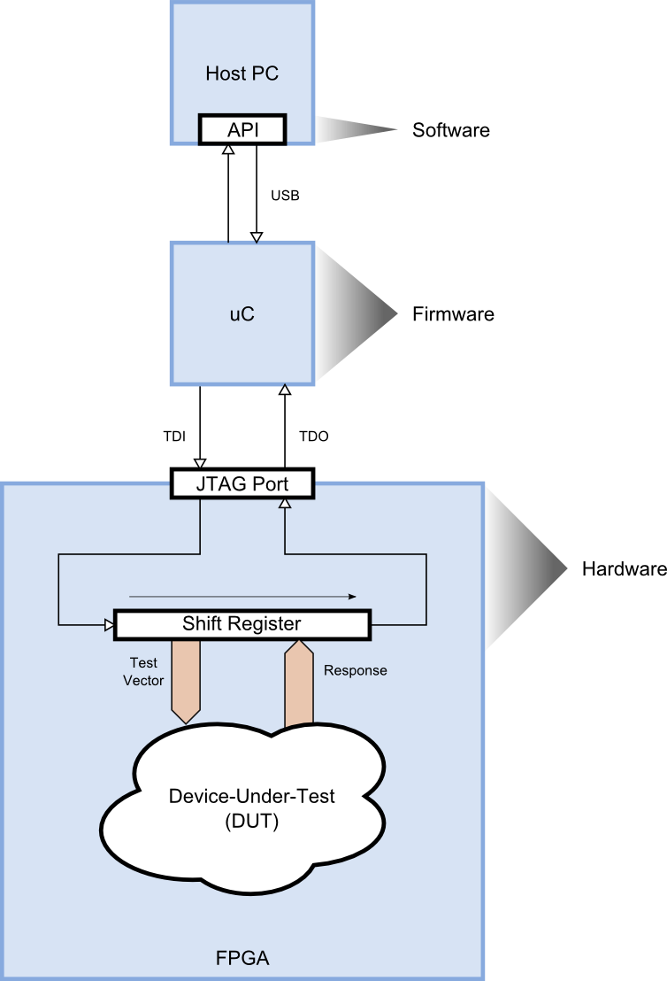

Monitoring the LED Blinker from the Host PC

Modifying the LED Blinker Project
Before diving into the VHDL code, it might be helpful to get a picture of what we're trying to do. The original LED blinker circuit from Chapter 3 is shown at the bottom of the figure below: it takes a 12 MHz clock, divides the frequency down using a counter, and attaches one bit of the counter to an LED so it flashes about once per second. The counter bit is also loaded into a shift-register (although it's not just a shift-register) where its value can be shifted out of the FPGA through the JTAG port and on to a PC. The PC could also shift in bits to drive inputs to the counter, but the counter has no inputs so these signals are left dangling. There are a few other signals running around in the background that aren't shown so I don't complicate the very simple technique that is being used here. Don't worry, you'll be seeing them soon.
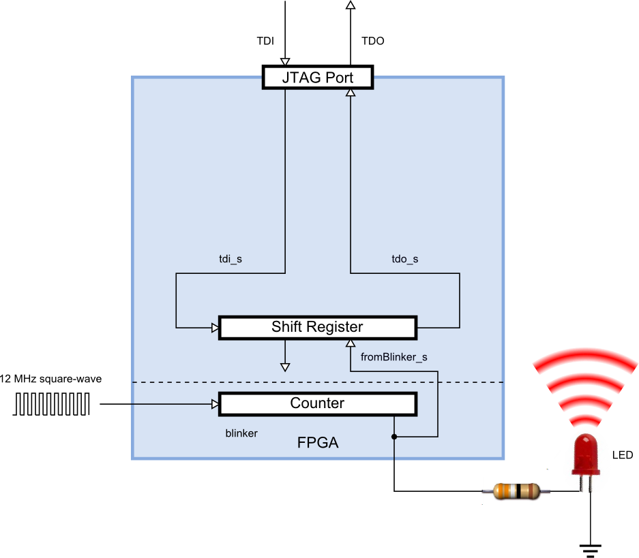
Now on to the VHDL. The list of files needed to add the JTAG interface and shift-register modules to the LED blinker project are shown below. Here's what each one does:
HostIo.vhd: This file contains the VHDL for the JTAG entry point and shift-register modules that will let the host PC talk to the blinker circuit in the FPGA.
Common.vhd: Some helpful VHDL functions that are used in the HostIo.vhd code are defined in this file.
SyncToClk.vhd: This file describes some synchronization circuitry that is used in the HostIo.vhd file, but which has no role to play in this example. You need it to keep the VHDL synthesizer from complaining about undefined modules.
pc_blinker.vhd: This is where the original LED blinker VHDL code is augmented with the modules found in HostIo.vhd.
pc_blinker.ucf: The same pin assignments for the original LED blinker are repeated in this file.
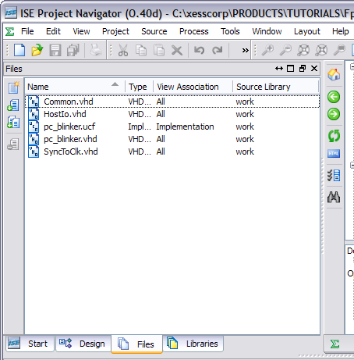
The pc_blinker module is where we want to concentrate our attention. Let's take a look inside:
The first three lines are the same as for the original LED blinker. They just import some standard packages from the IEEE library. But the fourth line is new: it imports the JTAG entry point and shift-register modules from the HostIo.vhd file. The work library just refers to the directory where the whole project is stored; HostIoPckg refers to the package of modules defined in the HostIo.vhd file; all just says to import every module found in the HostIoPckg (although I could have been more discriminating and just imported the modules that were needed by this design).
- library IEEE;
- use IEEE.STD_LOGIC_1164.all;
- use IEEE.STD_LOGIC_UNSIGNED.all;
- use work.HostIoPckg.all; -- Package for PC <=> FPGA communications.

The next few lines declare the interface for the LED blinker. It is identical to the entity declaration used in the original LED blinker. Even though we are going to monitor the LED blinker with the PC, the signals that pass in and out of the JTAG port do not need to be declared here.
- entity pc_blinker is
- port (clk_i : in std_logic;
- blinker_o : out std_logic);
- end entity;

The architecture section comes next. The 23-bit counter for the LED blinker is declared on line 12. Lines 14 and 15 declare two, 1-bit vectors: one for carrying bits from the PC to the blinker's inputs, and one to carry the outputs of the blinker back to the PC. (There are no inputs to the blinker, but a dummy signal is needed just to have something to connect to the shift-register module.) Even though these are both single-bit signals, they need to be declared as std_logic_vectors in order to match the declared I/O types of the modules in the HostIoPckg.
Lines 17-20 declare the signals that connect from the JTAG entry point to the shift-register. A selection signal and a clock are declared which are used to shift bits in and out of the register on the tdi_s and tdo_s signals.
- architecture Behavioral of pc_blinker is
- signal cnt_r : std_logic_vector(22 downto 0) := (others => '0');
- -- Connections between the shift-register module and the blinker.
- signal toBlinker_s : std_logic_vector(0 downto 0); -- From PC to blnkr.
- signal fromBlinker_s : std_logic_vector(0 downto 0); -- From blnkr to PC.
- -- Connections between JTAG entry point and the shift-register module.
- signal inShiftDr_s : std_logic; -- True when bits shift btwn PC & FPGA.
- signal drck_s : std_logic; -- Bit shift clock.
- signal tdi_s : std_logic; -- Bits from host PC to the blinker.
- signal tdo_s : std_logic; -- Bits from blinker to the host PC.
- Begin

Next up is circuitry for the LED blinker. It's identical to what you've already seen in Chapter 3.
- -------------------------------------------------------------------------
- -- Application circuitry: the LED blinker.
- -------------------------------------------------------------------------

- -- This counter divides the input clock.
- process(clk_i) is
- begin
- if rising_edge(clk_i) then
- cnt_r <= cnt_r + 1;
- end if;
- end process;

- blinker_o <= cnt_r(22); -- This counter bit blinks the LED.

The JTAG entry point module follows. The I/O for this module connects to the internal signals declared on lines 17-20.
- -------------------------------------------------------------------------
- -- JTAG entry point.
- -------------------------------------------------------------------------

- -- Main entry point for the JTAG signals between the PC and the FPGA.
- UBscanToHostIo : BscanToHostIo
- port map (
- inShiftDr_o => inShiftDr_s,
- drck_o => drck_s,
- tdi_o => tdi_s,
- tdo_i => tdo_s
- );

Finally, there's the shift-register module that grabs the output from the blinker counter and sends it back to the PC. Line 55 assigns an identifier of '1' to this module so the PC can select it for access (I know this seems unnecessary, but it will make sense later). Lines 58-61 tie this module to the JTAG entry point module. And line 67 - arguably the most important of all - connects the bit of the counter that drives the LED to the shift-register so it can be loaded and shifted back to the PC.
- -------------------------------------------------------------------------
- -- Shift-register.
- -------------------------------------------------------------------------

- -- This is the shift-register module between blinker and JTAG entry point.
- UHostIoToBlinker : HostIoToDut
- generic map (ID_G => "00000001") -- The identifier used by the PC.
- port map (
- -- Connections to the BscanToHostIo JTAG entry-point module.
- inShiftDr_i => inShiftDr_s,
- drck_i => drck_s,
- tdi_i => tdi_s,
- tdo_o => tdo_s,
- -- Connections to the blinker.
- vectorToDut_o => toBlinker_s, -- From PC to blinker (dummy sig).
- vectorFromDut_i => fromBlinker_s -- From blinker to PC.
- );

- fromBlinker_s <= cnt_r(22 downto 22); -- Blinker output to shift reg.

- end architecture;

Once the pc_blinker.vhd and the other files are included in the pc_blinker project, the Hierarchy pane looks like this:
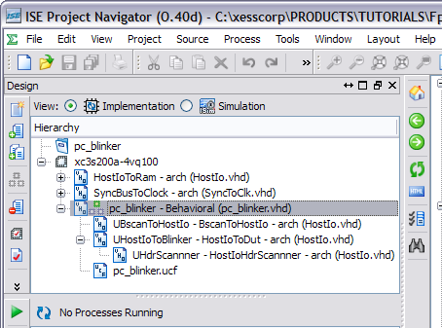
The HostIoToRam and SyncBusToClock modules aren't used in this project; they're just showing up because their code is included in the VHDL files. In order to make sure the pc_blinker design is compiled and not one of these, right-click on the pc_blinker identifier and select Set as top module from the pop-up menu.
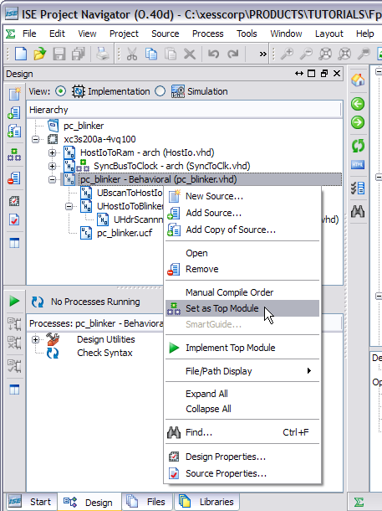
Before generating the bitstream, remember to change the configuration settings to make the it compatible with the XuLA board. Right-click on Generate Programming File and select Process Properties... from the pop-up menu.
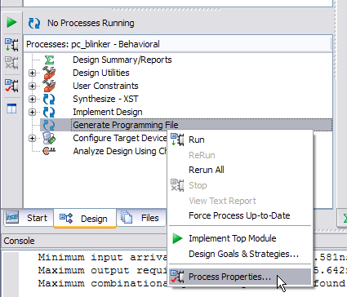
In the Configuration Options tab of the Process Properties window that appears, click on the Unused IOB Pins drop-down menu and select Float from the list of options. This will cause all FPGA I/O pins that are not specifically used in this design to float in a high-impedance state.
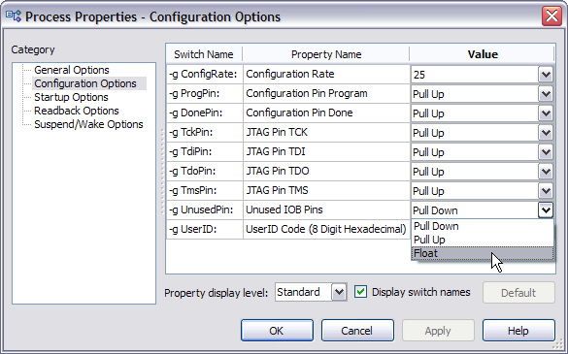
Now click on the Startup Options category and change the FPGA Start-Up Clock to JTAG clock.
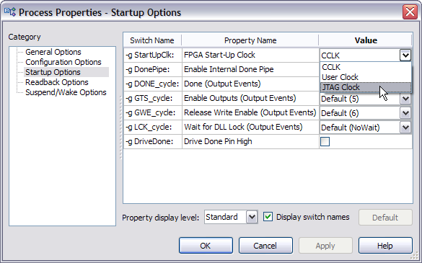
After setting these two options, click on the OK button and return to Navigator. Now you can double-click Generate Programming File to build the bitstream for the pc_blinker project.

Changing the XuLA Firmware
The XuLA board's factory-installed firmware does not support the commands needed to use the HostIoPckg modules. Therefore, you must upgrade the firmware using the XuLA Firmware Update command placed in the Windows Start menu when you installed the XSTOOLs software. If your XSTOOLs software does not have this command, you can install the latest software from the XESS website or use the firmware upgrade command in the FMW subdirectory for this project.
Once you've upgraded the XuLA firmware, you won't need to change it again. The upgrade provides all the features of the previous firmware while adding support for the HostIoPckg modules.

PC Software for Talking with the LED Blinker
The host-side software that communicates with the LED blinker is contained in a single file: pc_blinker_test.py. This is a Python script file, so you'll need a Python interpreter on your PC to run it. You can get a complete Python environment for free from Enthought or ActiveState. (Please use the 32-bit version of Python to avoid run-time problems encountered with the 64-bit version.)
After installing Python, you'll also need to install the XsTools package that supports communications between the XuLA board and the PC. That's easy to do using the command:
C:\> easy_install xstools
or:
C:\> pip install xstools
Here's what's in the pc_blinker_test.py file. It starts by importing all the functions and classes needed to drive the inputs and read the outputs of a device-under-test (DUT) in the FPGA.
- from xstools.xsdutio import * # Import funcs/classes for PC <=> FPGA link.

Then the program prints out a description of what it's trying to do.
- print '''\n
- ##################################################################
- # This program tests the interface between the host PC and the FPGA
- # on the XuLA board that has been programmed to act as a blinker.
- # You should see the state of the LED displayed on the screen
- # flip back-and-forth between one and zero about once per second.
- ##################################################################
- '''
Next, the program defines two identifiers: one for the USB port index of the XuLA board (which is usually 0 because your XuLA port is usually USB0), and another for the interface identifier of the blinker in the FPGA (as defined on line 56 of the pc_blinker.vhd file).
- USB_ID = 0 # USB port index for the XuLA board connected to the host PC.
- BLINKER_ID = 1 # This is the identifier for the blinker in the FPGA.

Now create an object that lets the host talk to the blinker in the FPGA. The USB and blinker identifiers are needed to initialize the object. You also pass in two arrays: one which defines the sizes of the input fields to the blinker, and another that defines the sizes of the output fields. (As I said before, while there are no inputs to the blinker, we still needed to define a single dummy input so we also need to recognize that dummy input when we create the blinker object here.)
- # Create a blinker intfc obj with one 1-bit input and one 1-bit output.
- blinker = XsDut(USB_ID, BLINKER_ID, [1], [1])

Finally, go into an infinite loop where the state of the counter output that drives the LED is monitored using the Read() method of the blinker object. Then print the value of the counter bit along with a RETURN character to go back to the start of the line. When this program is run, this will give the effect of the LED value flipping back-and-forth between one and zero.
- while True: # Do this forever...
- led = blinker.Read() # Read the current state of the LED.
- print 'LED: %1d\r' % led.unsigned, # Print the LED state and return.

Putting It All Together
At this point, I assume you have the pc_blinker ISE project compiled and the bitstream is ready to go, the firmware in your XuLA board has been upgraded to support the HostIoPckg modules, and you have Python installed and the pc_blinker_test.py file available. Now all you have to do is this:
- Download the pc_blinker.bit file to the FPGA on the XuLA board using GXSLOAD.
- Run the Python program in a command window as follows:
C:\SFW> python pc_blinker_test.py
Then you should see the following text appear in the command window:
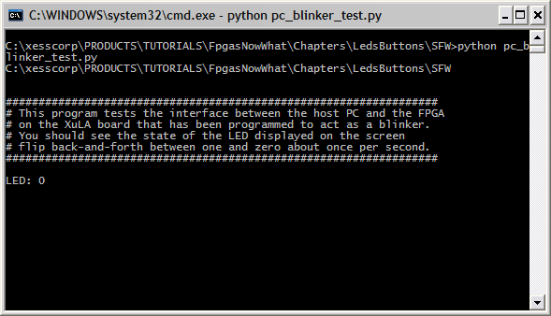
What I can't show here is the digit flipping back-and-forth between one and zero. But you can see it in this exciting video. Notice how the LED and the digit are synchronized with each other, showing that the PC is able to accurately display what the FPGA is doing.

Testing a Subtractor
I know you've really grown to love the LED blinker over the past few chapters, but it's time to move on to something new: a subtractor. The subtractor circuit in this section takes two eight-bit inputs (a minuend and a subtrahend) and calculates their difference.
Here's a picture of how the subtractor is hooked up to the JTAG entry point and the shift-register. It's not too different from what we did with the LED blinker except here there are two, byte-wide inputs and a byte-wide output instead of just a single output bit. That means we have more data to shift in and out of the circuit for each test, but that's not a big complication. The HostIoPckg modules will handle all that transparently.
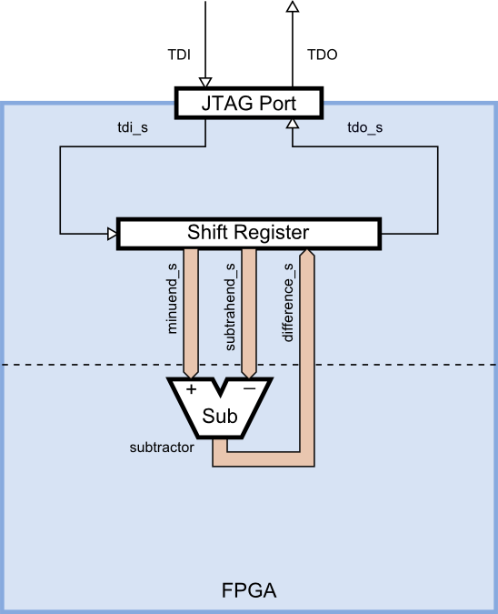
We use the same VHDL files as in the previous section, except we replace the pc_blinker.vhd file with the pc_subtractor.vhd file that contains the following code:
- library IEEE;
- use IEEE.STD_LOGIC_1164.all;
- use IEEE.STD_LOGIC_UNSIGNED.all;
- use work.HostIoPckg.all; -- Package for PC <=> FPGA communications.

We're not connecting the subtractor to the outside world, so there are no inputs or outputs declared in the entity section.
- entity pc_subtractor is
- end entity;

On line 11, the signal from the shift-register module to the subtractor is declared to be sixteen bits wide in order to hold both byte-wide operands. On line 12, another byte-wide signal is declared to carry the result from the subtractor to the shift register. Aliases to these signals are declared on lines 13 – 15 so we can use more understandable names in the rest of the code.
- architecture Behavioral of pc_subtractor is
- -- Connections between the shift-register module and the subtractor.
- signal toSub_s : std_logic_vector(15 downto 0); -- From PC to subtrctr.
- signal fromSub_s : std_logic_vector(7 downto 0); -- From subtrctr to PC.
- alias minuend_s is toSub_s(7 downto 0); -- Subtrctr's 1st operand.
- alias subtrahend_s is toSub_s(15 downto 8); -- Subtrctr's 2nd oprnd.
- alias difference_s is fromSub_s; -- Subtractor's output.
- -- Connections between JTAG entry point and the shift-register module.
- signal inShiftDr_s : std_logic; -- True when bits shift btwn PC & FPGA.
- signal drck_s : std_logic; -- Bit shift clock.
- signal tdi_s : std_logic; -- Bits from host PC to the subtractor.
- signal tdo_s : std_logic; -- Bits from subtractor to the host PC.
- begin

The actual subtraction operation is defined on line 27.
- ---------------------------------------------------------------------------
- -- Application circuitry: the subtractor.
- ---------------------------------------------------------------------------

- difference_s <= minuend_s - subtrahend_s;

The JTAG entry point is the same as in the previous example.
- ---------------------------------------------------------------------------
- -- JTAG entry point.
- ---------------------------------------------------------------------------

- -- Main entry point for the JTAG signals between the PC and the FPGA.
- UBscanToHostIo : BscanToHostIo
- port map (
- inShiftDr_o => inShiftDr_s,
- drck_o => drck_s,
- tdi_o => tdi_s,
- tdo_i => tdo_s
- );

On line 48, the shift-register module is assigned an identifier of '4' so the PC can select it for access. The signals from the shift-register to the minuend and subtrahend operands of the subtractor are connected on line 56. The difference output by the subtractor is connected to the shift-register on line 57.
- ---------------------------------------------------------------------------
- -- Shift-register.
- ---------------------------------------------------------------------------

- -- Shift-register module between subtractor and JTAG entry point.
- UHostIoToSubtractor : HostIoToDut
- generic map (ID_G => "00000100") -- The identifier used by the PC.
- port map (
- -- Connections to the BscanToHostIo JTAG entry-point module.
- inShiftDr_i => inShiftDr_s,
- drck_i => drck_s,
- tdi_i => tdi_s,
- tdo_o => tdo_s,
- -- Connections to the subtractor.
- vectorToDut_o => toSub_s, -- From PC to sbtrctr subtrahend & minuend.
- vectorFromDut_i => fromSub_s -- From subtractor difference to PC.
- );

- end architecture;

Here's the design hierarchy for the pc_subtractor project:
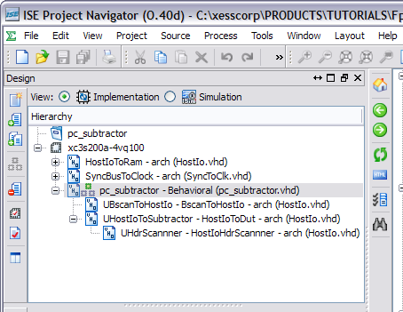
At this point, you can compile the design to create the bitstream. (As in the previous example, remember to set the pc_subtractor as the top module and to assign the JTAG clock as the start-up clock and place the unused FPGA pins in a high-impedance state.)
With the VHDL completed and compiled, it's time to move on to the microcontroller firmware. You should have already updated that to handle the HostIoPckg modules in the previous example, so there's no need to do it again.
Finally, a new host-side program is needed to drive the subtractor's inputs and monitor its output. Here's the Python source code from the pc_subtractor_test.py file. As in the previous example, it starts by importing all the functions and classes in the XsTools Python package. It also imports a random number library that is used to generate random inputs to the subtractor.
- from xstools.xsdutio import * # Import funcs/classes for PC <=> FPGA link.
- from random import * # Import some random number generator routines.

- print '''
- ##################################################################
- # This program tests the interface between the host PC and the FPGA
- # on the XuLA board that has been programmed to act as a subtractor.
- ##################################################################
- '''

On line 12, the program defines an identifier to match that of the subtractor in the FPGA (as defined on line 48 of the pc_subtractor.vhd file).
- USB_ID = 0 # USB port index for the XuLA board connected to the host PC.
- SUBTRACTOR_ID = 4 # This is the identifier for the subtractor in the FPGA.

Now create an object that lets the host talk to the subtractor in the FPGA (line 15). The USB and subtractor identifiers are needed to initialize the object. You also pass in two arrays: one which declares the inputs to the subtractor to be two byte-wide fields, and another that declares the output as a single byte-wide field.
- # Create a subtractor intfc obj with two 8-bit inputs and one 8-bit output.
- subtractor = XsDut(USB_ID, SUBTRACTOR_ID, [8, 8], [8])

Finally, iterate through 100 test cases (line 18) where a random minuend and subtrahend are generated (lines 19 and 20) and sent to the subtractor using its Exec() method (line 21) which also returns their difference. Print the operands and the resulting difference (line 22). Then, do the same subtraction operation in Python and compare it to the previous result returned by the subtractor in the FPGA (line 23). Report whether the results agree or not (lines 24 – 26).
- # Test the subtractor by iterating through some random inputs.
- for i in range(0, 100):
- minuend = randint(0, 127) # Get a random, positive byte...
- subtrahend = randint(0, 127) # And subtract this random byte from it.
- diff = subtractor.Exec(minuend, subtrahend) # Use the subtractor in FPGA.
- print '%3d - %3d = %4d' % (minuend, subtrahend, diff.int),
- if diff.int == minuend - subtrahend: # Compare Python result to FPGA's.
- print '==> CORRECT!' # Print this if the differences match.
- else:
- print '==> ERROR!!!' # Oops! Something's wrong with the subtractor.

Now that everything is ready, you can test the subtractor like this:
- Download the pc_subtractor.bit file to the FPGA on the XuLA board using GXSLOAD.
- Run the Python program in a command window as follows:
C:\SFW> python pc_subtractor_test.py
Then you should see something similar to the following text appear in the command window:
##################################################################
# This program tests the interface between the host PC and the FPGA
# on the XuLA board that has been programmed to act as a subtractor.
##################################################################

68 - 60 = 8 ==> CORRECT!
107 - 114 = -7 ==> CORRECT!
90 - 47 = 43 ==> CORRECT!
105 - 91 = 14 ==> CORRECT!
71 - 114 = -43 ==> CORRECT!
60 - 115 = -55 ==> CORRECT!
19 - 80 = -61 ==> CORRECT!
...

Two at Once!
You've seen how to use the HostIoPckg modules to test individual designs, but how would you control and monitor a design built from several submodules? You could just build a larger shift-register and hook everything to that of course, but then you would have to worry about screwing-up the inputs to one submodule while you were twiddling the bits of another.
A better way is to give each submodule its own shift-register and connect them all through the JTAG port. But how do you select which shift-register is connected to the JTAG port? Well, that's where the shift-register identifiers come in. Before the host-side PC accesses any shift-register, it sends an eight-bit identifier. The shift-register that has that identifier will enable itself and accept bits shifted in from the JTAG port, and it will unlock its TDO output so its contents can be shifted out of the JTAG port. All the other shift-registers will ignore the bits coming from the JTAG port and will force their TDO outputs to zero. (I told you these weren't just shift-registers.) Then, the TDO outputs of all the shift-registers are logically OR'ed together and sent to the JTAG port. Since all the inactive shift-registers hold their TDO outputs at zero, only the TDO output of the selected shift-register actually gets to the JTAG port and out to the host PC. An example of how the JTAG port and shift-registers are connected is shown below, using the LED blinker and the subtractor as the submodules.
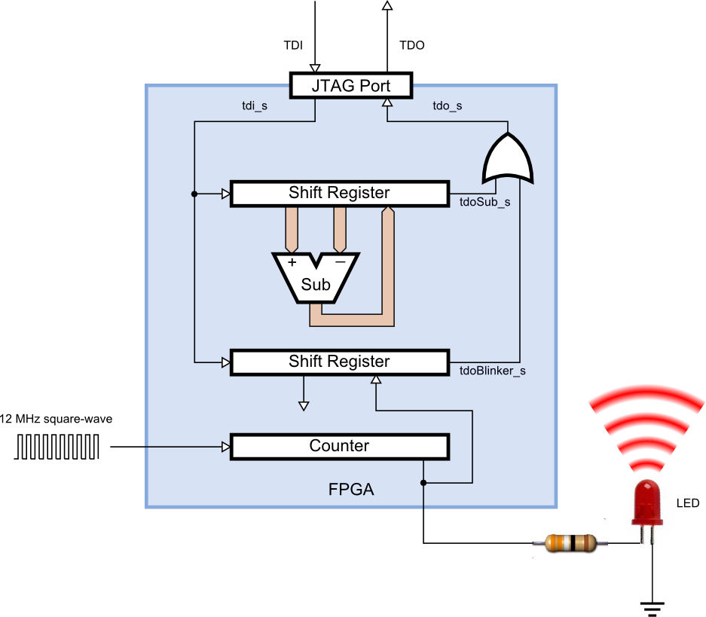
The VHDL code for the circuit shown above is stored in the pc_blink_sub.vhd file. It basically looks like the VHDL files for the two previous examples were just smashed into the same file.
- library IEEE;
- use IEEE.STD_LOGIC_1164.all;
- use IEEE.STD_LOGIC_UNSIGNED.all;
- use work.HostIoPckg.all; -- Package for PC <=> FPGA communications.

- entity pc_blink_sub is
- port (clk_i : in std_logic;
- blinker_o : out std_logic);
- end entity;

The only change in the signal declarations for the merged design is that two individual TDO signals are created, one for the LED blinker (line 27) and another for the subtractor (line 28).
- architecture Behavioral of pc_blink_sub is
- signal cnt_r : std_logic_vector(22 downto 0) := (others => '0');
- -- Connections between first shift-register module and the blinker.
- signal toBlinker_s : std_logic_vector(0 downto 0); -- From PC to blnkr.
- signal fromBlinker_s : std_logic_vector(0 downto 0); -- From blnkr to PC.
- -- Connections between second shift-register module and the subtractor.
- signal toSub_s : std_logic_vector(15 downto 0); -- From PC to subtrctr.
- signal fromSub_s : std_logic_vector(7 downto 0); -- From subtrctr to PC.
- alias minuend_s is toSub_s(7 downto 0); -- Subtrctr's 1st operand.
- alias subtrahend_s is toSub_s(15 downto 8); -- Subtrctr's 2nd oprnd.
- alias difference_s is fromSub_s; -- Subtractor's output.
- -- Connections between JTAG entry point and the shift-register modules.
- signal inShiftDr_s : std_logic; -- True when bits shift btwn PC & FPGA.
- signal drck_s : std_logic; -- Bit shift clock.
- signal tdi_s : std_logic; -- Bits from host PC to blnkr/subtrctr.
- signal tdo_s : std_logic; -- Bits from blnkr/subtrctr to host PC.
- signal tdoBlinker_s : std_logic; -- Bits from the blinker to the host PC.
- signal tdoSub_s : std_logic; -- Bits from the sbtrctr to the host PC.
- begin

The VHDL for the LED blinker and subtractor stay the same; they're just merged into the same section.
- ---------------------------------------------------------------------------
- -- Application circuitry
- ---------------------------------------------------------------------------

- -- This counter divides the input clock.
- process(clk_i) is
- begin
- if rising_edge(clk_i) then
- cnt_r <= cnt_r + 1;
- end if;
- end process;

- blinker_o <= cnt_r(22); -- This counter bit blinks the LED.

- -- This is the subtractor.
- difference_s <= minuend_s - subtrahend_s;

The JTAG entry-point doesn't change at all. Only one entry-point is needed no matter how many shift-register modules you use.
- ---------------------------------------------------------------------------
- -- JTAG entry point.
- ---------------------------------------------------------------------------

- -- Main entry point for the JTAG signals between the PC and the FPGA.
- UBscanToHostIo : BscanToHostIo
- port map (
- inShiftDr_o => inShiftDr_s,
- drck_o => drck_s,
- tdi_o => tdi_s,
- tdo_i => tdo_s
- );

This is where the TDO outputs of the LED blinker and subtractor are OR'ed together. The result is passed into the JTAG entry-point above.
- -- OR the bits from both shift-registers and send them back to the PC.
- -- (Non-selected modules pull their TDO outputs low, so only bits from
- -- the active module are transferred.)
- tdo_s <= tdoBlinker_s or tdoSub_s;

Next, two shift-registers are created. The only change from the previous examples is that the TDO outputs of the shift-registers are connected to the individual TDO signals (lines 78 and 94) that are OR'ed together on line 64.
- ---------------------------------------------------------------------------
- -- Shift-registers.
- ---------------------------------------------------------------------------

- -- Shift-register module between blinker and JTAG entry point.
- UHostIoToBlinker : HostIoToDut
- generic map (ID_G => "00000001") -- The identifier used by the PC.
- port map (
- -- Connections to the BscanToHostIo JTAG entry-point module.
- inShiftDr_i => inShiftDr_s,
- drck_i => drck_s,
- tdi_i => tdi_s,
- tdo_o => tdoBlinker_s, -- Serial bits from blinker output.
- -- Connections to the blinker.
- vectorToDut_o => toBlinker_s, -- From PC to blinker (dummy sig).
- vectorFromDut_i => fromBlinker_s -- From blinker to PC.
- );

- fromBlinker_s <= cnt_r(22 downto 22); -- Blinker output to shift reg.

- -- Shift-register module between subtractor and JTAG entry point.
- UHostIoToSubtractor : HostIoToDut
- generic map (ID_G => "00000100") -- The identifier used by the PC.
- port map (
- -- Connections to the BscanToHostIo JTAG entry-point module.
- inShiftDr_i => inShiftDr_s,
- drck_i => drck_s,
- tdi_i => tdi_s,
- tdo_o => tdoSub_s,-- Serial bits from subtractor result.
- -- Connections to the subtractor.
- vectorToDut_o => toSub_s, -- From PC to sbtrctr subtrahend & minuend.
- vectorFromDut_i => fromSub_s -- From subtractor difference to PC.
- );

- end architecture;

That's all there is to it! You can compile it and download the bitstream into the XuLA board.
You don't need a new Python test program – the ones from the previous examples will work just fine. The shift-register module identifier coded into each program will select the appropriate portion of the circuit for testing. You can run them in any order and they will produce the correct result. (Just don't try to run them simultaneously since they will collide when trying to use the same USB link.)

So What?
At this point you might be saying: “I'm adding tons of VHDL code and writing Python programs that access DLLs that access firmware that talks to the FPGA just so I can see a blinking LED. My head hurts! All I wanted was some LEDs and some buttons! Is that too much to ask?”
I can understand those feelings, but I'll restate the advantages you get from the techniques shown in this chapter:
It's free. LEDs and buttons cost money and board space, and those things would add cost to the XuLA board. While cheaper isn't always better, it is always cheaper.
It's flexible. You can use it with multiple sub-circuits each having hundreds of inputs and outputs and perform tests that are limited only by your ability to write programs for them.
It' easy to use. OK, stop laughing! Admittedly, it's not as easy as using a single LED with the blinker project, but most of your circuits aren't going to be that simple. Even the byte-wide subtractor would require sixteen switches for the inputs and eight LEDs for the output. Would you want to build that for just a single test, or try flipping the switches to test all 65,536 different input combinations?
It takes no space. You need space to attach a bunch of switches and LEDs and even more headroom to manipulate and observe them. With these techniques, you can fit the XuLA board into some pretty tight spaces and still have controllability and observability. (It does take up space inside the FPGA, using about 3% of the LUTs and flip-flops in an XC3S200A.)
It uses no FPGA pins. All it needs is the JTAG port and those pins can't even by used by the application circuitry in the FPGA. Without these techniques, testing a simple 16-bit wide subtractor would require 48 I/O pins, and that's impractical with the XuLA board.
It's automated. Once you write your test program, all you have to do is run it whenever you want to perform that test. So it's faster to run the test, making it more likely you'll do so because it takes so little effort. (This is the same advantage you get from writing simulation testbenches for your designs.)
It's removable. Once you're done testing your circuit, you can remove the HostIoPckg modules and reclaim any space they consumed in the FPGA.
You'll be seeing a lot more of this technique in the coming chapters, so if I haven't convinced you, then you might as well stop reading now. For example, in a future chapter I'll use a variation on this technique to read and write RAMs and registers in the FPGA. Try that with LEDs and buttons!

