- “RAMs! Now What!?”
There are two metrics that almost everybody uses to evaluate an FPGA: how much logic can it hold, and how much memory does it contain. Up to now, I've concentrated pretty much on logic design and ignored memory. That will change in this chapter: I am going to talk about memory. A lot.
There are three types of memory you can use with your FPGA:
Distributed RAM: This is internal memory built from the FPGA's LUTs as I discussed briefly back in Chapter 1.
Block RAM: This is also internal memory, but built using one or more larger, special-purpose block RAM (BRAM) components interspersed throughout the FPGA fabric.
External RAM: Just like the name says, this is memory housed in a RAM chip outside the FPGA that's connected to the FPGA's pins.
Along with the three types of memory, there are three ways to include RAM in your VHDL design:
Inference: You can write your VHDL code in such a way that the logic synthesizer can infer your desire to use memory and will instantiate and connect the correct FPGA components for you.
Core Generator: You can use the ISE CORE Generator tool to build the memory you want from the FPGA components and then instantiate this higher-level module in your VHDL.
Instantiation: You can plunk down RAM modules and/or external memory interfaces in your VHDL and then wire them together to build the memory you want.
In the sections that follow, I'll use each of these techniques to implement various types of memory.

Inferring RAM

Inferring Distributed RAM
To show how to build RAM by inference, I'm going to build a simple application (located in the DRamSPInf project directory) that will store some numbers into a single-port distributed RAM and then read each RAM address, multiply the address with whatever number is stored there, and then sum all these products together. (I know this is a stupid example, but it shows the basics: how to write to RAM and how to read the data back. Plus, you get to use a hardware multiplier! Does it get any better than that!?)
The beginning section of the DRamSPInf.vhd file will look pretty familiar by now. In this example, I'm using the NUMERIC_STD library to support the arithmetic operations I'll need.
- --*********************************************************************
- -- Distributed RAM, single-port, inferred.
- --*********************************************************************

- library IEEE;
- use IEEE.STD_LOGIC_1164.all;
- use IEEE.NUMERIC_STD.all;

The entity declaration for my application follows. The I/O is pretty simple: just an input clock to drive the logic and a 32-bit output for the final sum-of-products.
- entity DRamSPInf is
- port (
- clk_i : in std_logic;
- sum_o : out std_logic_vector(31 downto 0) := (others => '0')
- );
- end entity;

The architecture section starts with some constants to specify the number of RAM locations (line 19) and the number of bits in each word (line 20). Lines 21 and 22 specify the beginning and ending addresses for the summation process.
- architecture Behavioral of DRamSPInf is
- constant NO : std_logic := '0';
- constant YES : std_logic := '1';
- constant RAM_SIZE_C : natural := 16; -- Number of words in RAM.
- constant RAM_WIDTH_C : natural := 8; -- Width of RAM words.
- constant MIN_ADDR_C : natural := 1; -- Process RAM from this address
- constant MAX_ADDR_C : natural := 5; -- ... to this address.

Line 23 defines a subtype of the NUMERIC_STD unsigned bit vector which has the same length as the RAM word. This subtype is used to define a type of array with the same number of elements as the RAM (line 23). Then the actual RAM is declared on line 25.
- subtype RamWord_t is unsigned(RAM_WIDTH_C-1 downto 0); -- RAM word type.
- type Ram_t is array (0 to RAM_SIZE_C-1) of RamWord_t; -- RAM word array.
- signal ram_r : Ram_t; -- RAM declaration.

Lines 26-29 declare the RAM's write-enable control line, the address bus, and the input and output data buses. The address bus is sized such that it can hold any possible RAM address, and the input and output data bus types are the same as that of the RAM words for a similar reason. Finally, the register that holds the summation is sized to hold the product of the largest possible address and data word (line 30). That completes the declaration section of the architecture.
- signal wr_s : std_logic; -- Write-enable control.
- signal addr_r : natural range 0 to RAM_SIZE_C-1; -- RAM address.
- signal dataToRam_r : RamWord_t; -- Data to write to RAM.
- signal dataFromRam_s : RamWord_t; -- Data read from RAM.
- signal sum_r : natural range 0 to RAM_SIZE_C*(2**RAM_WIDTH_C)-1;
- begin

The first thing I do in the body of the architecture is create the VHDL code that will infer the distributed RAM. But, can I write the VHDL any way I want and still have the synthesizer figure out that I'm trying to build a RAM? Probably not! That's why the ISE software provides a set of templates to guide me. Simply click the Edit ⇨ Language Templates... menu item and a Language Templates tab will appear. Then expand the tree structure until you reach the Single Port, Async Read template for the distributed RAM:
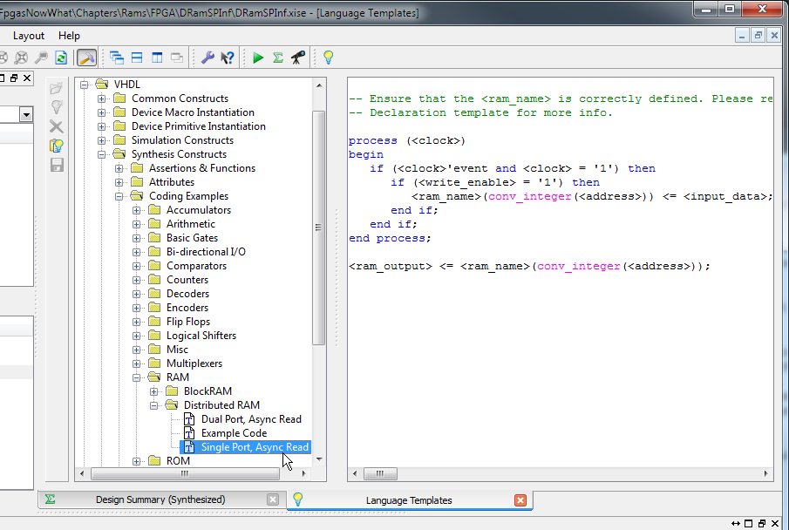
I cut-and-pasted the template code into lines 36-46 and replaced the template names with the actual signal names for my example. If a rising clock edge occurs (line 39) when the write-enable line is high (line 40), then whatever is on the input data bus is written into the RAM at the current address (line 41). So this is a synchronous-write RAM.
Meanwhile, the RAM output bus shows whatever data is stored at the current address (line 46). This is an asynchronous-read RAM since the output value will change whenever the address changes, regardless of the clock.
- --*********************************************************************
- -- RAM is inferred from this process.
- --*********************************************************************
- Ram_p : process (clk_i)
- begin
- -- Write to the RAM at the given address if the write-enable is high.
- if rising_edge(clk_i) then
- if wr_s = YES then
- ram_r(addr_r) <= dataToRam_r;
- end if;
- end if;
- end process;
- -- Continually read data from whatever RAM address is present.
- dataFromRam_s <= ram_r(addr_r);

The finite-state machine (FSM) that performs the summation of the RAM contents is shown on lines 48-88. The FSM starts off in the INIT state (line 54) and performs an operation and changes state on each rising edge of the input clock (line 56). In the INIT state (lines 58-62), the FSM sets the address and input data buses to the RAM at their initial values (0 and 1, respectively) and sets the write-control signal high to enable writing. Then it moves to the next state.
- --*********************************************************************
- -- State machine that initializes RAM and then reads RAM to compute
- -- the sum of products of the RAM address and data.
- --*********************************************************************
- Fsm_p : process (clk_i)
- type state_t is (INIT, WRITE_DATA, READ_AND_SUM_DATA, DONE);
- variable state_v : state_t := INIT; -- Start off in init state.
- begin
- if rising_edge(clk_i) then
- case state_v is
- when INIT =>
- wr_s <= YES; -- Enable writing of RAM.
- addr_r <= MIN_ADDR_C; -- Start writing data at this address.
- dataToRam_r <= TO_UNSIGNED(1, RAM_WIDTH_C); -- Initial write value.
- state_v := WRITE_DATA; -- Go to next state.

In the WRITE_DATA state, the FSM increments the address (line 65) and adds three to the data value to write to RAM (line 66) as long as the address has not reached its maximum (line 64). When the maximum address is reached, the write-enable is lowered (line 68), the address is reset to its beginning value (line 69), and the summation register is initialized to zero (line 70). Then the FSM moves to the next state (line 71). At this point, the RAM locations 1 through 5 should be loaded with the values 1, 4, 7, 10 and 13.
- when WRITE_DATA =>
- if addr_r < MAX_ADDR_C then -- If haven't reach final address ...
- addr_r <= addr_r + 1; -- go to next address ...
- dataToRam_r <= dataToRam_r + 3; -- and write this value.
- else -- Else, the final address has been written...
- wr_s <= NO; -- so turn off writing, ...
- addr_r <= MIN_ADDR_C; -- go back to the start, ...
- sum_r <= 0; -- clear the sum-of-products, ...
- state_v := READ_AND_SUM_DATA; -- and go to next state.
- end if;

In the READ_AND_SUM_DATA state, the FSM gets the number read from the RAM location, multiplies it by the location's address and then adds it to the summation register (line 77). It also increments the address to point to the next location (line 78). This is repeated until the maximum address is reached (line 79). At that point, the summation register has the complete sum-of-products, so the FSM moves into the DONE state (line 80) where it remains forever.
- when READ_AND_SUM_DATA =>
- if addr_r <= MAX_ADDR_C then -- If haven't reached final address
- -- add product of RAM address and data read
- -- from RAM to the summation ...
- sum_r <= sum_r + TO_INTEGER(dataFromRam_s * addr_r);
- addr_r <= addr_r + 1; -- and go to the next address.
- else -- Else, the final address has been read ...
- state_v := DONE; -- so go to the next state.
- end if;
- when DONE => -- Summation complete ...
- null; -- so wait here and do nothing.
- when others => -- Erroneous state ...
- state_v := INIT; -- so re-run the entire process.
- end case;
- end if;
- end process;

The next few lines just dump the value in the summation register onto the output bus of this module.
- -- Output the sum of the RAM address-data products.
- sum_o <= std_logic_vector(TO_UNSIGNED(sum_r, sum_o'length));

- end architecture;

At this point, I can run the synthesizer on this design and see how the RAM is implemented by checking the synthesis report.
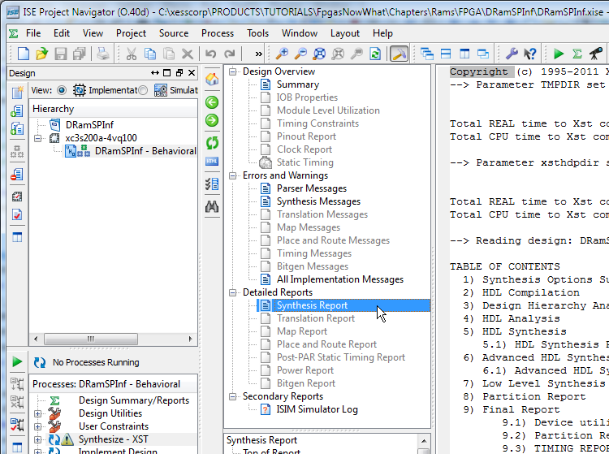
Scrolling through the report, I see the following:
- INFO:Xst:3231 - The small RAM <Mram_ram_r> will be implemented on LUTs in order to maximize performance and save block RAM resources. If you want to force its implementation on block, use option/constraint ram_style.
- -----------------------------------------------------------------------
- | ram_type | Distributed | |
- -----------------------------------------------------------------------
- | Port A |
- | aspect ratio | 16-word x 8-bit | |
- | clkA | connected to signal <clk_i> | rise |
- | weA | connected to signal <wr_s> | high |
- | addrA | connected to signal <addr_r> | |
- | diA | connected to signal <dataToRam_r> | |
- | doA | connected to signal <dataFromRam_s> | |
- -----------------------------------------------------------------------
Line 1 indicates the RAM was implemented using LUTs, and this is further confirmed on line 3 where it shows a distributed RAM was used. The size of the RAM (line 6) matches the number of locations and word-size that I specified in the VHDL. The connections to the clock, write-enable, address bus, and input/output data buses also match with the VHDL.
Now it's time to see if the RAM works. I added a simple VHDL test-bench file (DramSPInf_tb.vhd) to the project that just applies a clock to the FSM and RAM. Then I ran the simulator.
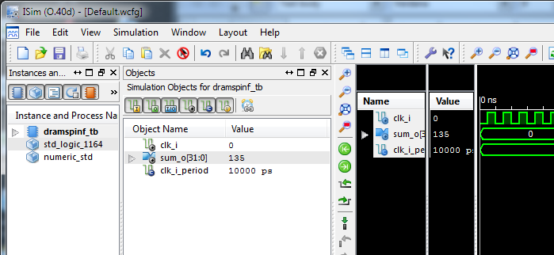
I want to see more than just the clock and the output summation, so I expand the design instances a bit and select the FSM portion.
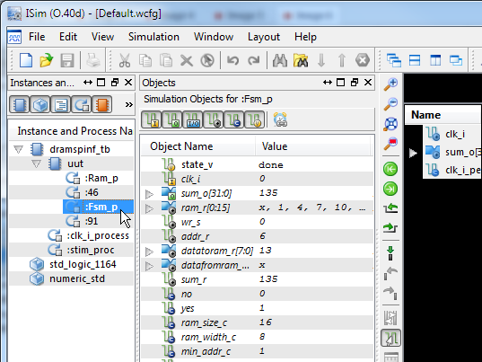

Within the list of simulation objects for the FSM, I select the RAM's write-enable, address and input/output data buses and drag them into the pane of observable signals.
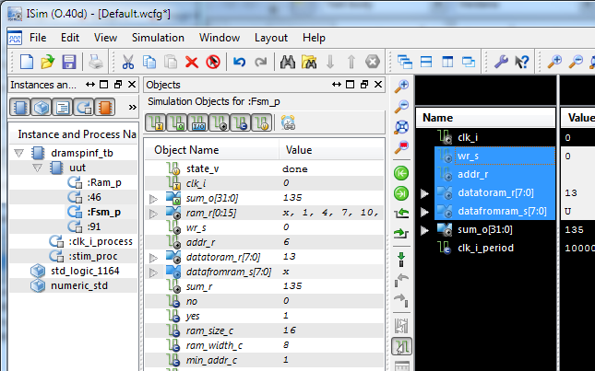
Now I can re-run the simulation and see what happens. On the first rising clock edge, the address (addr_r) and data (datatoram_r) are initialized to 1, and the write-enable is raised. Over the next five rising clock edges, the values 1, 4, 7, 10, and 13 are written to addresses 1 through 5. The write-enable goes low after the last write and then the values are read back from RAM (datafromram_s). Multiplying each value by its address gives 1x1 + 2x4 + 3x7 +4x10 + 5x13 = 135 which matches the final value on the sum output.
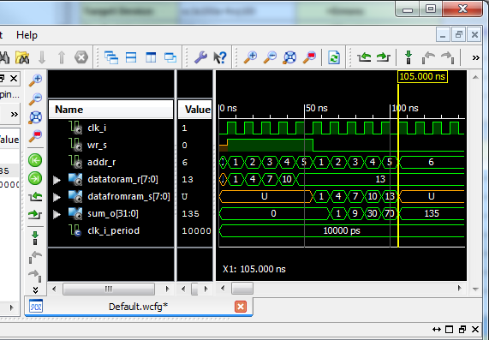

I can also view the contents of the RAM by selecting the Memory tab and double-clicking the ram_r memory. This shows the right data is stored at the right addresses.
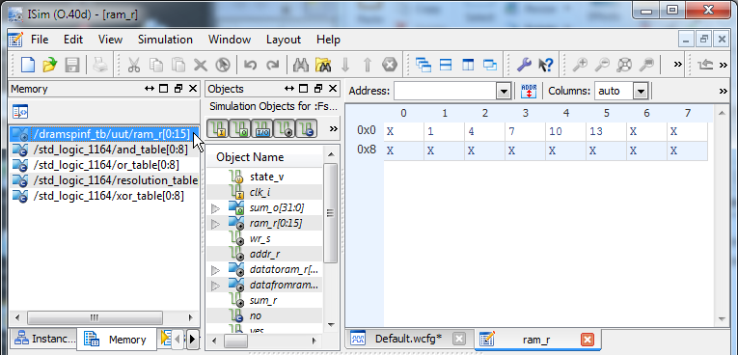

At this point, I've managed to infer a small 16x8 distributed RAM and managed to make it operate correctly (at least, in simulation). But what if I need more memory? That's when block RAMs come into play.

Inferring Block RAM
The FPGA's internal BRAMs provide a total of 18 Kb of memory in a variety of word widths (anywhere from 1 to 36 bits). I can infer BRAM the same way that I did distributed RAM: look-up the associated language template and then customize it for my application. In this case, I use the 1 Clock, 1 Write Port, 1 Read Port BRAM.
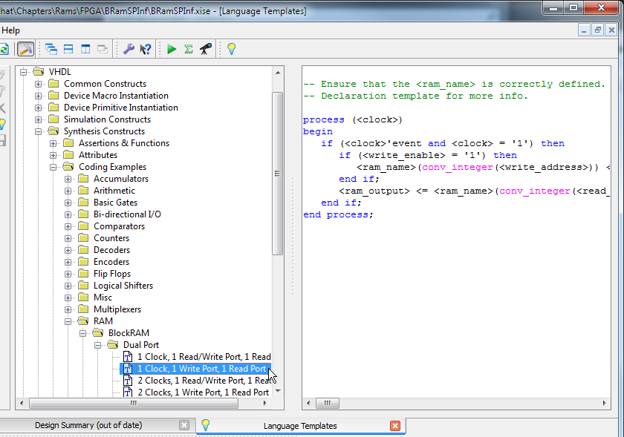
The customized BRAM code is shown on lines 36-46 of BRamSPInf.vhd and it looks very similar to the previous code for the distributed RAM with one important exception: block RAM reads are synchronous. The read operation has been pulled into the process block and only gets updated on the rising clock edge. So if an address is applied to a BRAM, the value stored at that address only appears after the next rising clock edge. This has implications on the FSM portion of the application.
- Ram_p : process (clk_i)
- begin
- -- Write to the RAM at the given address if the write-enable is high.
- if rising_edge(clk_i) then
- if wr_s = YES then
- ram_r(addr_r) <= dataToRam_r;
- end if;
- -- Synchronously read from whatever RAM address is present.
- dataFromRam_s <= ram_r(addr_r);
- end if;
- end process;

The one-cycle delay caused by the synchronous read nature of BRAMs has implications on the FSM process. On line 78 below, the calculation has been changed to the product of the current data from the BRAM and the address sent to the BRAM in the previous cycle (stored in the newly-added signal prevAddr_r). Also, the exit from the READ_AND_SUM_DATA state occurs when the RAM address goes one location past the maximum address in order for read of the last address to be completed (line 75).
Another issue that needs to be handled is the initial entry into the READ_AND_SUM_DATA state. At that time, there is no valid data coming from the BRAM because the read operation from the first address has not completed yet. To keep from corrupting the summation, the prevAddr_r register is cleared upon exiting from the WRITE_DATA state (line 72) so that the first multiplication (line 78) returns a zero. This is a hack that works for this particular application. A more general solution would be to place a one-cycle wait state between the WRITE_DATA and READ_AND_SUM_DATA states to allow the first BRAM read operation time to complete.
- Fsm_p : process (clk_i)
- type state_t is (INIT, WRITE_DATA, READ_AND_SUM_DATA, DONE);
- variable state_v : state_t := INIT; -- Start off in init state.
- begin
- if rising_edge(clk_i) then
- case state_v is
- when INIT =>
- wr_s <= YES; -- Enable writing of RAM.
- addr_r <= MIN_ADDR_C; -- Start writing data at this address
- dataToRam_r <= TO_UNSIGNED(1, RAM_WIDTH_C); -- Initial value.
- state_v := WRITE_DATA; -- Go to next state.
- when WRITE_DATA =>
- if addr_r < MAX_ADDR_C then -- If haven't reach final address ...
- addr_r <= addr_r + 1; -- go to next address ...
- dataToRam_r <= dataToRam_r + 3; -- and write this value.
- else -- Else, the final address has been written...
- wr_s <= NO; -- so turn off writing, ...
- addr_r <= MIN_ADDR_C; -- go back to the start, ...
- sum_r <= 0; -- clear the sum-of-products, ...
- state_v := READ_AND_SUM_DATA; -- and go to next state.
- prevAddr_r <= 0; -- THIS IS A HACK!
- end if;
- when READ_AND_SUM_DATA =>
- if addr_r <= MAX_ADDR_C + 1 then -- If not the final address+1 ...
- -- add product of previous RAM address and data read
- -- from that address to the summation ...
- sum_r <= sum_r + TO_INTEGER(dataFromRam_s * prevAddr_r);
- addr_r <= addr_r + 1; -- and go to next address.
- else -- Else, the final address has been read ...
- state_v := DONE; -- so go to the next state.
- end if;
- prevAddr_r <= addr_r; -- Store current address ...
- when DONE => -- Summation complete ...
- null; -- so wait here and do nothing.
- when others => -- Erroneous state ...
- state_v := INIT; -- so re-run the entire process.
- end case;
- end if;
- end process;

Now if I increase RAM_SIZE_C to 256 and synthesize the design, the synthesis report shows that a block RAM is used to build the memory:
- INFO:Xst:3225 - The RAM <Mram_ram_r> will be implemented as BLOCK RAM
- -----------------------------------------------------------------------
- | ram_type | Block | |
- -----------------------------------------------------------------------
- | Port A |
- | aspect ratio | 256-word x 8-bit | |
- | mode | write-first | |
- | clkA | connected to signal <clk_i> | rise |
- | weA | connected to signal <wr_s> | high |
- | addrA | connected to signal <addr_r> | |
- | diA | connected to signal <dataToRam_r> | |
- -----------------------------------------------------------------------
- | optimization | speed | |
- -----------------------------------------------------------------------
- | Port B |
- | aspect ratio | 256-word x 8-bit | |
- | mode | write-first | |
- | clkB | connected to signal <clk_i> | rise |
- | addrB | connected to internal node | |
- | doB | connected to signal <dataFromRam_s> | |
- -----------------------------------------------------------------------
- | optimization | speed | |
- -----------------------------------------------------------------------

But if I return RAM_SIZE_C to 16 and re-synthesize, the memory is built with distributed RAM again even though the VHDL specifies a synchronous read operation. This happens because the synthesizer judges that a distributed RAM is more efficient for smaller memories, so it places a register on the outputs of the distributed RAM to implement the synchronous read behavior and uses the combination in place of a BRAM.
So the synthesizer is able to switch the method for building RAMs in the FPGA based on how much storage is needed. However, you can force the synthesizer to use a particular type of RAM by right-clicking on the Synthesize-XST process and selecting Process Properties...
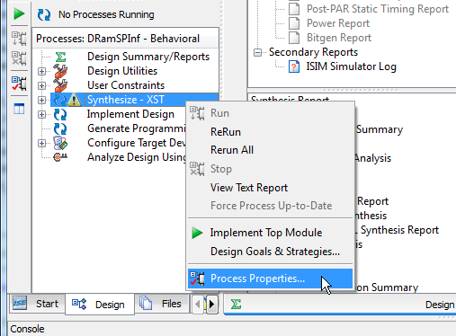
Then set the style of RAM to Distributed or Block, depending upon what you want. Note that this setting will be applied to all the RAMs in your design, so it's probably best to leave it set at Auto and let the synthesizer select the best RAM implementation on a case-by-case basis.
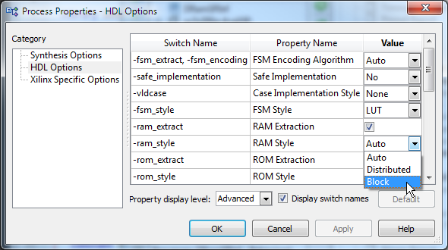

Simulating the 256 x 8 BRAM version of the application gives the following results.
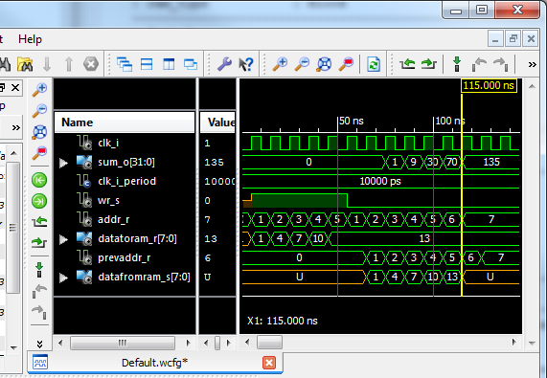
Note that the final sum is the same as for the previous design, but the result appears at 115 ns instead of 105 ns – one full clock-cycle later than for the distributed RAM version. That's a direct result of the synchronous read nature of the BRAM.

Integrating RAM into the FSM
While I can successfully infer distributed or block RAMs using the VHDL I've already shown, requiring a separate process to describe the RAM is a bit clunky. It would be nice if this could be integrated right into the FSM process so the intent of the code would be clearer. Below is a re-write of the architecture section from the distributed RAM example that does just that (DramSPInfClear.vhd). The separate process for the RAM has been removed and lines 46 and 59 of the FSM process have been changed so that the write and read operations are now expressed as accesses directly to the RAM array.
- Fsm_p : process (clk_i)
- type state_t is (INIT, WRITE_DATA, READ_AND_SUM_DATA, DONE);
- variable state_v : state_t := INIT;
- begin
- if rising_edge(clk_i) then
- case state_v is
- when INIT =>
- addr_r <= MIN_ADDR_C;
- dataToRam_r <= TO_UNSIGNED(1, RAM_WIDTH_C);
- state_v := WRITE_DATA;
- when WRITE_DATA =>
- ram_r(addr_r) <= dataToRam_r; –- Write to RAM
- if addr_r < MAX_ADDR_C then
- addr_r <= addr_r + 1;
- dataToRam_r <= dataToRam_r + 3;
- else
- addr_r <= MIN_ADDR_C;
- sum_r <= 0;
- state_v := READ_AND_SUM_DATA;
- end if;
- when READ_AND_SUM_DATA =>
- if addr_r <= MAX_ADDR_C then
- -- add product of RAM address and data read
- -- from RAM to the summation …
- sum_r <= sum_r + TO_INTEGER(ram_r(addr_r) * addr_r); –- Read RAM
- addr_r <= addr_r + 1;
- else
- state_v := DONE;
- end if;
- when DONE =>
- null;
- when others =>
- state_v := INIT;
- end case;
- end if;
- end process;

- -- Output the sum of the RAM address-data products.
- sum_o <= std_logic_vector(TO_UNSIGNED(sum_r, sum_o'length));

The synthesis report indicates that the synthesizer is still able to infer the correct type of RAM from this VHDL, and the simulator shows that the calculated result is the same as that of the original dual-process VHDL.
In addition, I can even increase RAM_SIZE_C to 256 and the synthesizer will shift to using a BRAM while still maintaining the same timing behavior. This is not always guaranteed. You may write obfuscated code that hides its intent, or request read/write behavior that the synthesizer just can't translate. In those cases, you may have to revert to a more explicit style of VHDL like in the first two examples I discussed.

Inferring Multi-Port RAM
So far I've used a simple, single-port RAM with a single address bus and both input and output data buses. The FPGA also supports dual-port RAMs which have an additional address and output data bus, thus making it possible to read data from two locations at once. Dual-port RAMs can also be inferred from VHDL as in the inner-product application shown below.
- --*********************************************************************
- -- Distributed RAM, dual-port, inferred more clearly.
- --*********************************************************************

- library IEEE;
- use IEEE.STD_LOGIC_1164.all;
- use IEEE.NUMERIC_STD.all;

- entity DRamDPInfClear is
- port (
- clk_i : in std_logic;
- innerProd_o : out std_logic_vector(31 downto 0) := (others => '0')
- );
- end entity;

- architecture Behavioral of DRamDPInfClear is
- constant NO : std_logic := '0';
- constant YES : std_logic := '1';
- constant RAM_SIZE_C : natural := 16;
- constant RAM_WIDTH_C : natural := 8;
- constant VEC_LEN_C : natural := 5; -- Length of vectors.
- subtype RamWord_t is unsigned(RAM_WIDTH_C-1 downto 0);
- type Ram_t is array (0 to RAM_SIZE_C-1) of RamWord_t;
- signal ram_r : Ram_t; -- RAM declaration.
- signal dataToRam_r : RamWord_t; -- Data to write to RAM.
- signal vec1Ptr_r : natural range 0 to RAM_SIZE_C-1; -- Ptr to 1st vec.
- signal vec2Ptr_r : natural range 0 to RAM_SIZE_C-1; -- Ptr to 2nd vec.
- signal innerProd_r : natural range 0 to (2**RAM_WIDTH_C - 1)**2;
- begin

- --*********************************************************************
- -- State machine that initializes RAM with two vectors and then reads
- -- the vectors simultaneously from RAM to compute the inner-product.
- --*********************************************************************
- Fsm_p : process (clk_i)
- type state_t is (INIT, WRITE_VECS, INNER_PRODUCT, DONE);
- variable state_v : state_t := INIT;
- begin
- if rising_edge(clk_i) then
- case state_v is
- when INIT =>
- vec1Ptr_r <= 0; -- Init ptr for writing data to RAM.
- dataToRam_r <= TO_UNSIGNED(1, dataToRam_r'length); -- Init data val
- state_v := WRITE_VECS;
- when WRITE_VECS => -- Init the 1st and 2nd vectors.
- ram_r(vec1Ptr_r) <= dataToRam_r; -- Write data to RAM at curr ptr.
- if vec1Ptr_r < 2 * VEC_LEN_C - 1 then -- Still init'ing both vecs.
- vec1Ptr_r <= vec1Ptr_r + 1; -- point at next RAM location ...
- dataToRam_r <= dataToRam_r + 1; -- and load with the next value.
- else -- Else, finished initializing the vectors.
- vec1Ptr_r <= 0; -- Init ptr to 1st vector at start of RAM.
- vec2Ptr_r <= VEC_LEN_C; -- Init ptr to 2nd vec follow 1st vec.
- innerProd_r <= 0; -- Init inner-product summation register.
- state_v := INNER_PRODUCT; -- Go to next state.
- end if;
- when INNER_PRODUCT => -- Compute inner-prod of 1st and 2nd vectors.
- if vec1Ptr_r <= VEC_LEN_C - 1 then -- Still proc'ing vec elems...
- -- Add the product of the current elements from the 1st
- -- and 2nd vectors using two simultaneous reads of the RAM.
- innerProd_r <= innerProd_r +
- TO_INTEGER(ram_r(vec1Ptr_r) * ram_r(vec2Ptr_r));
- vec1Ptr_r <= vec1Ptr_r + 1; -- Inc to next element of 1st vec.
- vec2Ptr_r <= vec2Ptr_r + 1; -- Inc to next element of 2nd vec.
- else -- Else, all the vector elements have been processed ...
- state_v := DONE; -- so go to the next state.
- end if;
- when DONE => -- Inner-product complete ...
- null; -- so wait here and do nothing.
- when others => -- Erroneous state ...
- state_v := INIT; -- so re-run the entire process.
- end case;
- end if;
- end process;

- -- Output the inner-product.
- innerProd_o <= std_logic_vector(
- TO_UNSIGNED(innerProd_r, innerProd_o'length));

- end architecture;

The basic idea of the inner-product FSM is to write a sequence of values to the RAM in the WRITE_VECS state. Then, two pointers are initialized: one pointing at the first vector at the beginning of the RAM (line 51), and another pointing at the second vector immediately following the first vector (line 52). In the INNER_PRODUCT state, the contents of the RAM addressed by each pointer are read out simultaneously, multiplied and added to the inner-product register (lines 60-61), after which the pointers are incremented (lines 62-63). The basic operations are depicted below.
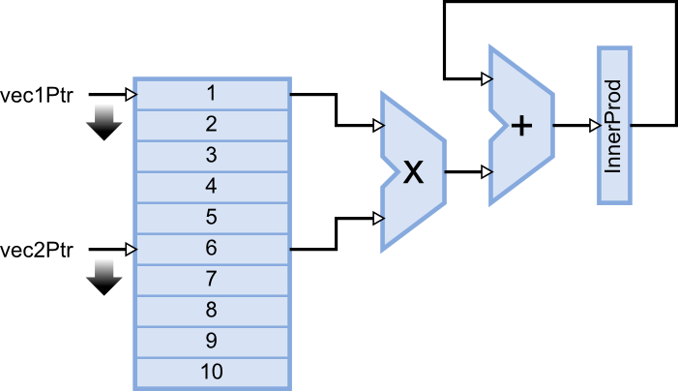

After the VHDL shown above is synthesized, the synthesis report shows a single dual-port distributed RAM has been used (line 6).
- Advanced HDL Synthesis Report

- Macro Statistics
- # FSMs : 1
- # RAMs : 1
- 16x8-bit dual-port distributed RAM : 1
- # Multipliers : 1
- 8x8-bit multiplier : 1
- # Adders/Subtractors : 4
- 16-bit adder : 1
- 4-bit adder : 2
- 8-bit adder : 1
- # Registers : 32
- Flip-Flops : 32
- # Comparators : 2
- 4-bit comparator less : 1
- 4-bit comparator lessequal : 1

Given the data the RAM is initialized with, the inner product should be 1x6 + 2x7 + 3x8 + 4x9 + 5x10 = 130. Running a simulation on the VHDL shows that it produces the correct result.
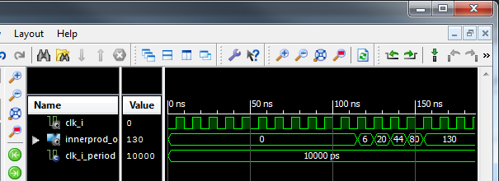
If a dual-port RAM can be synthesized, are triple- and quad-port RAMs possible? The answer is yes! Although the FPGA hardware itself is limited to building single and dual-port RAMs, the synthesizer can replicate data into multiple RAMs to provide the number of simultaneous read operations that are required. For example, here is how a triple-port RAM is realized:
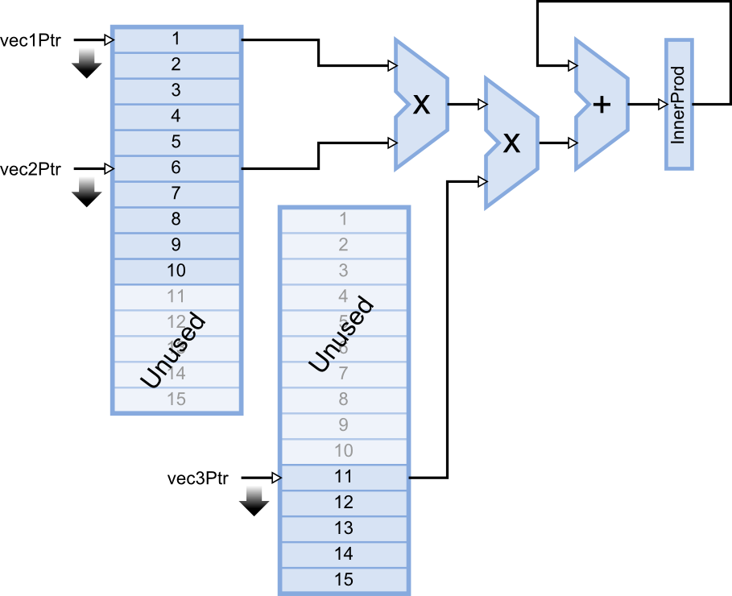
Notice that the number of RAM blocks has doubled, but half of it goes unused. That's usually what happens with digital systems: you can make them go faster by using more circuitry, or slower using less, but you seldom achieve speed and efficiency at the same time.

Generating RAM
To demonstrate the use of ISE's CORE Generator, I'm going to use it to re-build the BRAM-version of the single-port RAM example (BramSPInf). I'll begin with an empty project (BramSPCoreGen) and add a new source file for the soon-to-be-generated RAM to it.
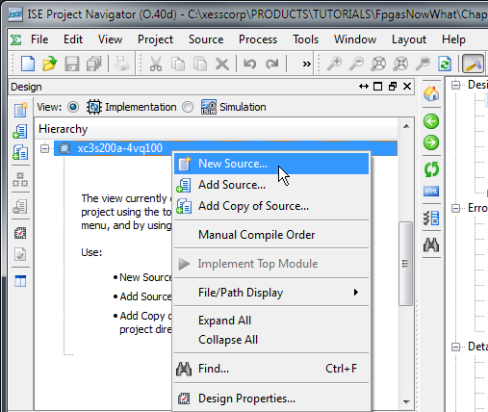
For this example, I've given the CORE Generator source file the descriptive name of BRAM.
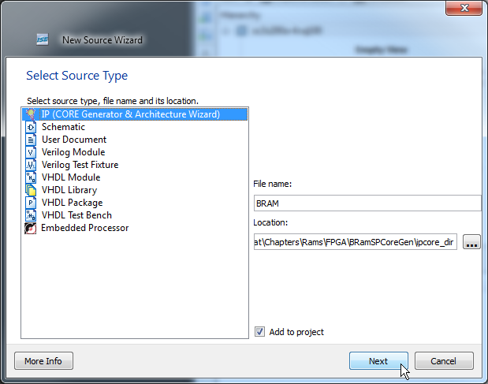
The CORE Generator gives me a choice of either block or distributed RAMs. For this example, I chose block RAM.
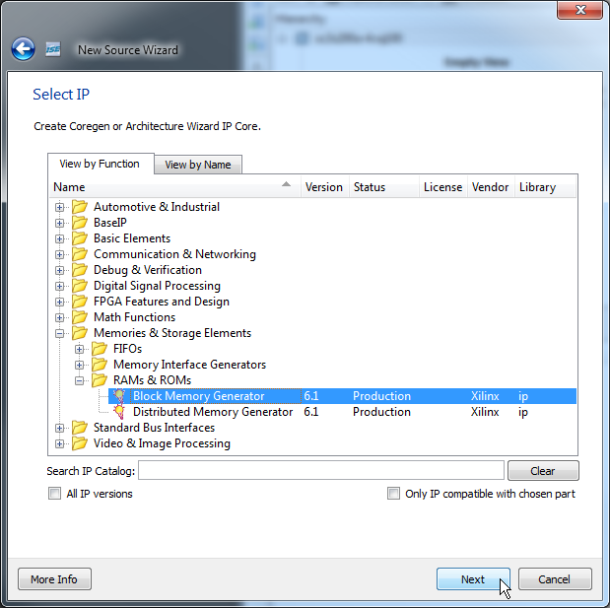
Then I just click on the Finish button to add the BRAM core to the project.
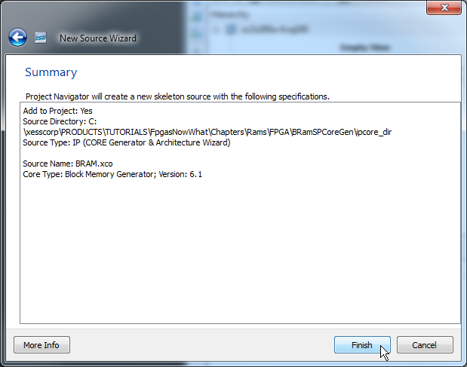
Now the real fun begins! I have to set all the configuration parameters that define how the block RAM works. There isn't much to do in the first configuration screen.
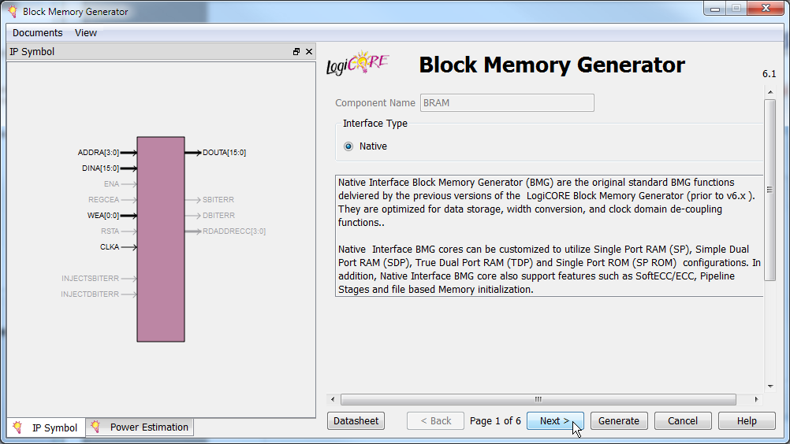
On the next screen, all I need to do is select a single-port RAM and move on.
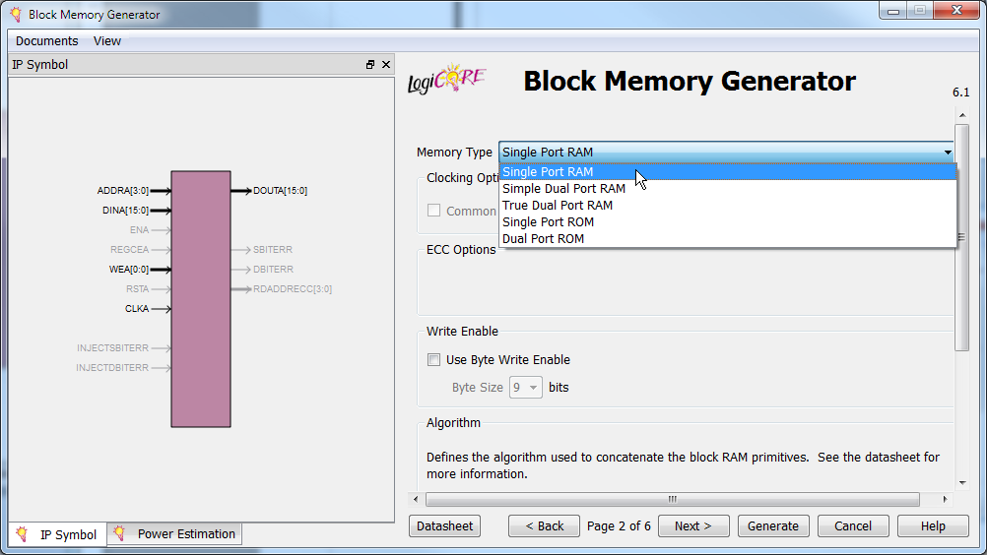
Then I set the RAM's word width (eight bits) and the number of memory words it contains (256).
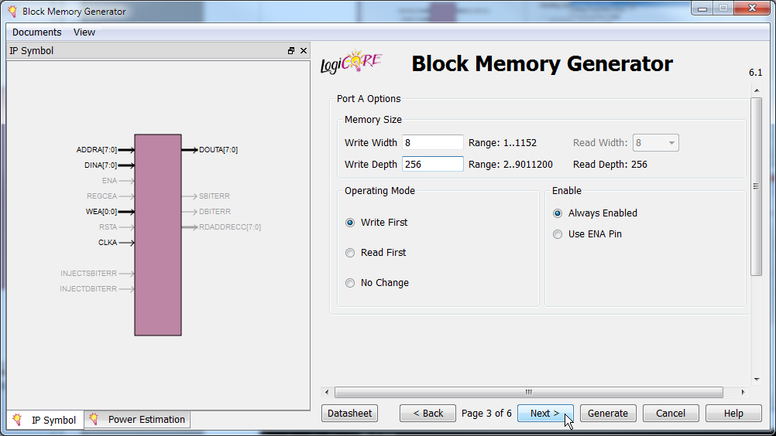
I don't want any registers on the output of the generated RAM (although it will still be a synchronous-read RAM even without them because it will be made from BRAMs) and I don't want to initialize the RAM, so I can just click Next on this screen.
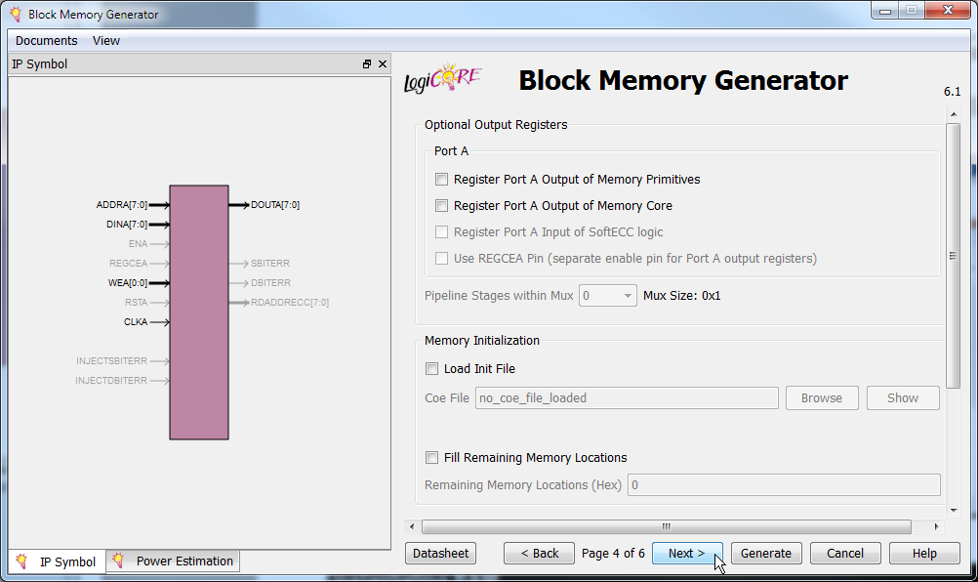
I also don't need a reset for the output of the RAM.
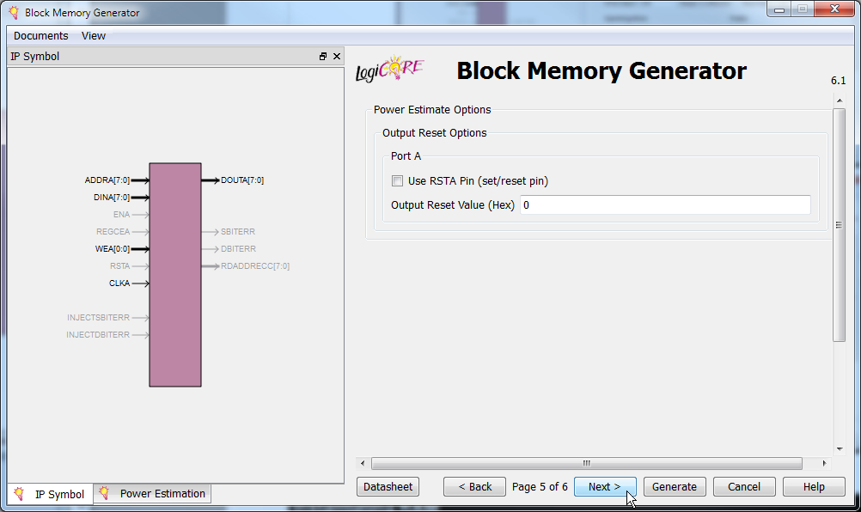
Finally, I've set all the configuration parameters and CORE Generator can build the RAM as specified.
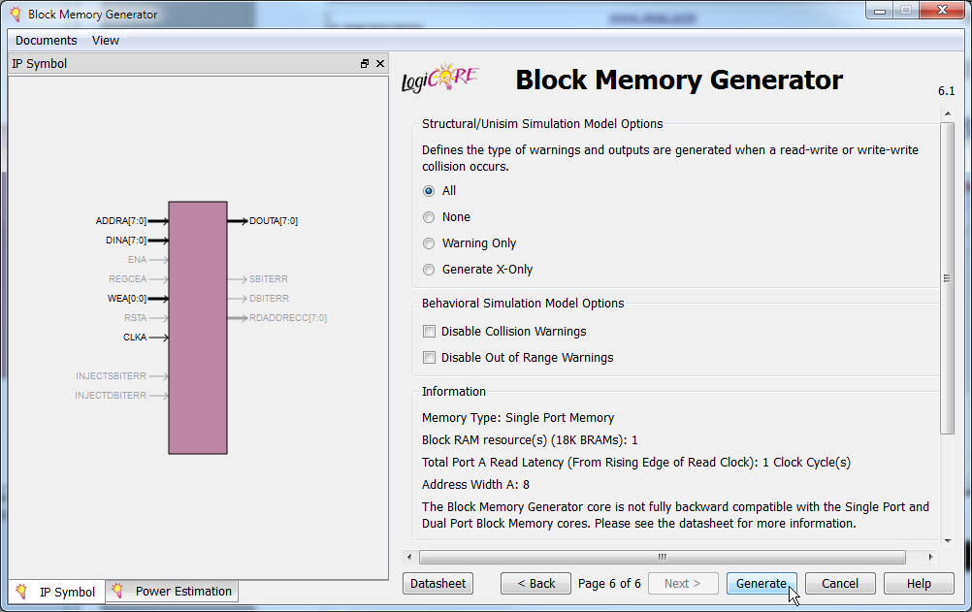
After grinding away for about ten seconds, the BRAM.xco source file gets added to the project. If I decide I need to change any of the RAM parameters, I can just double-click the BRAM.xco file and proceed through the configuration screens again while making modifications.
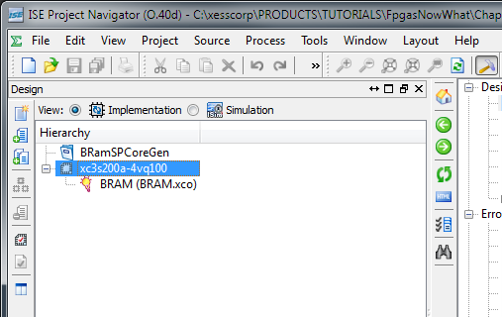
Now that I have the RAM built by the CORE Generator, how do I use it in my VHDL file? To figure that out, highlight the BRAM module and then double-click the View VHDL Instantiation Template in the Process pane.
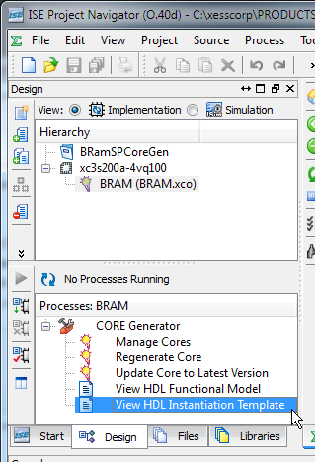

The template file that opens has two sections of interest. The first is the component declaration for the generated RAM that I'll have to include verbatim in the architecture header.
- ------------- Begin Cut here for COMPONENT Declaration ------ COMP_TAG
- COMPONENT BRAM
- PORT (
- clka : IN STD_LOGIC;
- wea : IN STD_LOGIC_VECTOR(0 DOWNTO 0);
- addra : IN STD_LOGIC_VECTOR(7 DOWNTO 0);
- dina : IN STD_LOGIC_VECTOR(7 DOWNTO 0);
- douta : OUT STD_LOGIC_VECTOR(7 DOWNTO 0)
- );
- END COMPONENT;
- -- COMP_TAG_END ------ End COMPONENT Declaration ------------

The second section has a template for the generated RAM that I have to paste into the body of my architecture and then edit the signal names.
- ------------- Begin Cut here for INSTANTIATION Template ----- INST_TAG
- your_instance_name : BRAM
- PORT MAP (
- clka => clka,
- wea => wea,
- addra => addra,
- dina => dina,
- douta => douta
- );
- -- INST_TAG_END ------ End INSTANTIATION Template ------------

Now I can take the existing code from the BramSPInf.vhd file, put it in a file called BramSPCoreGen.vhd and add it to this project. Then all I need to do is edit the file a bit as follows.
The component declaration is entered as-is into the architecture header on lines 17-25.
- architecture Behavioral of BRamSPCoreGen is
- component BRAM
- port (
- clka : in std_logic;
- wea : in std_logic_vector(0 downto 0);
- addra : in std_logic_vector(7 downto 0);
- dina : in std_logic_vector(7 downto 0);
- douta : out std_logic_vector(7 downto 0)
- );
- end component;

Next, the signal declaration for the inferred RAM isn't needed anymore, so it's been removed. I've kept the RamWord_t subtype definition (line 32), however, because I still need it for declaring the input and output buses of the RAM.
- constant NO : std_logic := '0';
- constant YES : std_logic := '1';
- constant RAM_SIZE_C : natural := 256; -- Number of words in RAM.
- constant RAM_WIDTH_C : natural := 8; -- Width of RAM words.
- constant MIN_ADDR_C : natural := 1; -- Process RAM from this address ...
- constant MAX_ADDR_C : natural := 5; -- ... to this address.
- subtype RamWord_t is unsigned(RAM_WIDTH_C-1 downto 0); -- RAM word type.
- signal wr_s : std_logic; -- Write-enable control.
- signal addr_r, prevAddr_r : natural range 0 to RAM_SIZE_C-1;-- RAM address.
- signal dataToRam_r : RamWord_t; -- Data to write to RAM.
- signal dataFromRam_s : RamWord_t; -- Data read from RAM.
- signal sum_r : natural range 0 to RAM_SIZE_C * (2**RAM_WIDTH_C)-1;

At the end of the architecture header, I declare three new eight-bit, std_logic_vector signals for attaching to the RAM module's address and input/output data buses. This makes it a bit easier to attach the RAM (which uses std_logic_vector signals for its I/O) to the FSM (which uses natural and RamWord_t types of signals).
- signal addrCoreGen_s : std_logic_vector(7 downto 0);
- signal dataToRamCoreGen_s : std_logic_vector(7 downto 0);
- signal dataFromRamCoreGen_s : std_logic_vector(7 downto 0);
- begin

The first change in the architecture body is to remove the VHDL process that inferred the BRAM and replace it with an instantiation of the RAM created using the CORE Generator (lines 46-53). The clock for the RAM is connected to the master clock of the application (line 48), and the RAM write-enable from the FSM attaches directly to the single bit of the RAM's write-enable bus (line 49). But on lines 50-52, the RAM's address and data buses are routed to the intermediate signals I defined previously. Then these intermediate signals are attached to the analogous signals from the FSM (lines 56-58) after a bit of type-casting to keep the synthesizer from complaining about mismatched signal types.
- --*********************************************************************
- -- Instantiate the block RAM created by CORE Generator.
- --*********************************************************************
- ram_u0 : BRAM
- port map (
- clka => clk_i,
- wea(0) => wr_s,
- addra => addrCoreGen_s,
- dina => dataToRamCoreGen_s,
- douta => dataFromRamCoreGen_s
- );

- -- Connect the RAM signals to the signals from the FSM.
- dataToRamCoreGen_s <= std_logic_vector(dataToRam_r);
- dataFromRam_s <= RamWord_t(dataFromRamCoreGen_s);
- addrCoreGen_s <= std_logic_vector(TO_UNSIGNED(addr_r,8));

That's all there is to it; the FSM code doesn't have to change at all since the generated-RAM behaves the same as the VHDL-inferred RAM.
The synthesis report shows that a single BRAM is used for this design (line 11):
- Device utilization summary:
- ---------------------------

- Selected Device : 3s200avq100-4

- Number of Slices: 47 out of 1792 2%
- Number of Slice Flip Flops: 44 out of 3584 1%
- Number of 4 input LUTs: 88 out of 3584 2%
- Number of IOs: 33
- Number of bonded IOBs: 33 out of 68 48%
- Number of BRAMs: 1 out of 16 6%
- Number of MULT18X18SIOs: 1 out of 16 6%
- Number of GCLKs: 1 out of 24 4%

Finally, the simulation results for this design are identical to those for the inferred BRAM in both the calculated result and the timing of the signal waveforms.
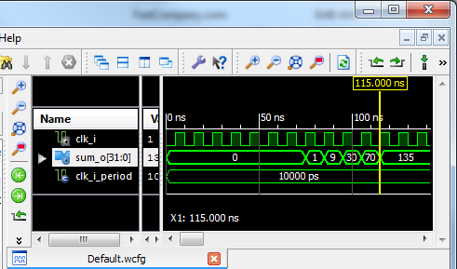

So after all that, was using CORE Generator worth it? Here are some of the disadvantages:
- CORE Generator creates modules which use std_logic_vectors for their I/O buses. This always requires some fiddling with the types to make the connections with other parts of the VHDL that are using more application-appropriate types. (Using std_logic_vector for module I/O is actually standard industry practice, so I can't really fault CORE Generator for this.)
- Changing anything about the RAM – even width or size – requires another trip through CORE Generator. And, after that, you may have to edit the component declaration and instantiation and change the widths of the connecting buses.
- CORE Generator .xco files aren't portable to the design software for non-Xilinx FPGAs.
Even with these problems, there are times I would use CORE Generator:
- If I needed to build a large and/or wide RAM that takes advantage of some of the special features of the FPGA hardware, then CORE Generator can be easier to use than trying to craft the behavior in VHDL.
- If I needed to build something really complicated (e.g., an FFT module), then CORE Generator would save me a lot of time writing and verifying the module.

Instantiating RAM
I already used instantiation in the previous example to drop the RAM built with CORE Generator into the top-level VHDL code. Now I'm going to use it again for building an interface to the SDRAM on the XuLA board.
The Winbond W9812 SDRAM chip stores 8-million sixteen-bit words – much more than the internal RAMs in the FPGA can hold. This large memory works by storing bits as charges on millions of tiny capacitors. Since the charge on a capacitor tends to leak away over time (thus losing the bit that was stored there), the SDRAM memory cells need to be refreshed every so often to restore their charge. (In essence, the SDRAM has to be continually reminded of what it remembers so it doesn't forget. Kind of like me.)
SDRAMs are internally organized into banks, rows and columns. For example, the W9812 is divided into four banks, each containing 4096 rows, with each row made up of 512 columns, and with each column holding a sixteen-bit number. To access an individual memory location requires a 23-bit address (4 x 4096 x 512 = 2²³). In order to cut down on the number of address pins needed on the physical chip package, a multiplexed address bus is used consisting of a two-bit bank-address bus and a twelve-bit row and column address bus (for a total of fourteen address pins). To access a memory location, the bank address is set and the row address is strobed-in which activates an internal row of that bank in the SDRAM. After the activation completes, column elements can be accessed by strobing in the column addresses without the need to re-enter the row address.
The need for periodic refreshing, address multiplexing, and row-activation makes it more complicated to use an SDRAM than the distributed or block RAMs I've already discussed. For this reason, I created a controller module that simplifies the interface so SDRAM looks more like a regular RAM with just an address and data bus. Here's a block diagram for the application that sums the products of addresses and data, but using the SDRAM on the XuLA board instead of internal RAMs. The SDRAM controller module (SdramCntl) handles breaking the address into pieces, activating the appropriate bank, row and column, and inserts the periodic refreshes needed by the SDRAM.
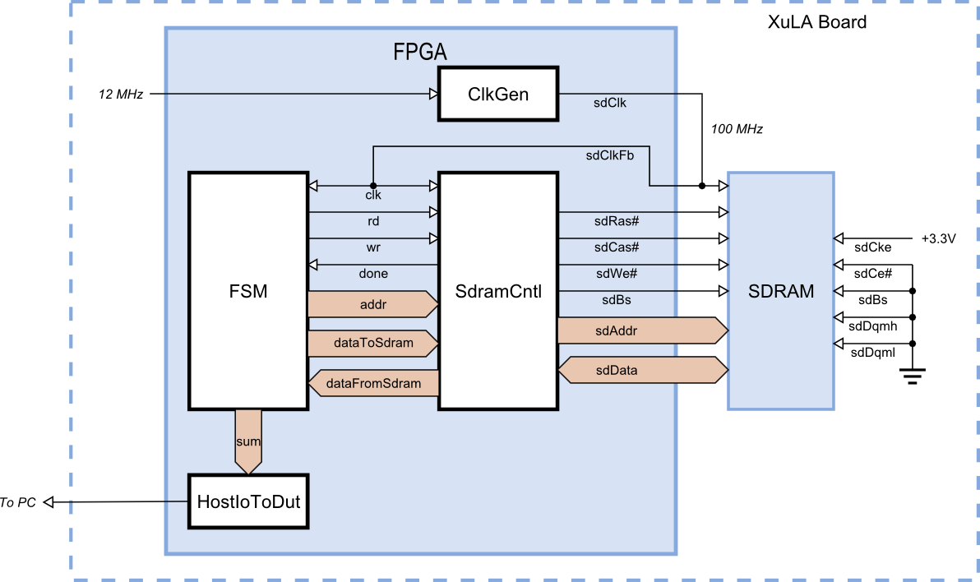
On one side of the SDRAM controller module is a host interface that connects to the FSM with the following signals:
clk: This is the master clock input. Anything the SDRAM controller connects to has to be synchronous with this clock.
rd: This active-high input initiates a read of a single word from the SDRAM. It is sampled on the rising clock edge and must be held high until the read process completes as indicated by the done signal going high. The read control must be lowered before the next rising clock edge after the done signal goes high or else another read operation will start.
wr: This active-high input initiates a write of a single word from the SDRAM. It is sampled on the rising clock edge and must be held high until the done signal indicates the write process completes. The write control must be lowered before the next rising clock edge after the done signal goes high or else another write operation will start.
done: This synchronous output signal goes high to indicate the completion of the currently active read or write operation. It remains high for a single clock cycle.
addr: The address of the SDRAM word that is to be read or written is passed through this input bus. The address value must be held stable until the done signal goes high. The two most-significant bits of addr correspond to the bank address bits of the SDRAM, the next log2(N_{ROWS})-bits of addr correspond to the row address within that bank, and the least-significant log2(N_{COLS})-bits correspond to the column address within that row.
dataToSdram: The data to be written to the SDRAM enters through this input bus. The data value must be held stable until the done signal goes high.
dataFromSdram: The data read from the SDRAM comes out on this bus. This data must be latched by the host-side logic on the rising clock edge after the done signal goes high.

The signals on the other side of the SdramCntl module attach directly to the SDRAM chip:
sdRas#: This active-low output drives the row-address strobe input of the SDRAM.
sdCas#: This active-low output drives the column-address strobe input of the SDRAM.
sdWe#: This active-low output drives the write-enable input of the SDRAM.
sdBs: This output selects one of the two banks of SDRAM. (Due to a shortage of pins on the XuLA FPGA chip, the other bank-select pin of the SDRAM had to be permanently tied to ground, thus preventing access to the other two banks.)
sdAddr: The row and column addresses for the SDRAM memory location are output on this bus.
sdData: The data word to be written to SDRAM exits the FPGA on this bus during write operations, and data from the SDRAM enters the FPGA on this bus during read operations.
sdCke: This active-high output drives the clock-enable input of the SDRAM. (Due to a shortage of pins on the XuLA FPGA chip, the clock-enable pin on the SDRAM was tied high, thus keeping the SDRAM from ever entering a quiescent state.)
sdCs#: This active-low output drives the chip-select of the SDRAM. (Due to a shortage of pins on the XuLA FPGA chip, the chip-select pin on the SDRAM was tied to ground, thus keeping the SDRAM permanently enabled.)
sdDqmh: This active-high output drives the SDRAM input that disables the drivers for the upper-half of the data bus during read operations. (Due to a shortage of pins on the XuLA FPGA chip, this pin on the SDRAM was tied low so the upper-half of the databus is always enabled.)
sdDqml: This active-high output drives the SDRAM input that disables the drivers for the lower-half of the data bus during read operations. (Due to a shortage of pins on the XuLA FPGA chip, this pin on the SDRAM was tied low so the lower-half of the databus is always enabled.)

The SDRAM controller module supports several modes of operation, but I'll use it here in its simplest and lowest-performance form to do non-pipelined reads and writes of SDRAM.
The timing waveforms for a non-pipelined read operation are shown below. These assume the read operation accesses a memory location in the currently active bank and row of the SDRAM. The sequence of actions is:
Cycle 1: The SDRAM address is applied and the read control signal is driven high. The address and read control must be held stable until the done signal goes high.
Cycle 2: The column address is output on the pins that go to the SDRAM chip and the SDRAM control signals are set to initiate a read operation.
Cycle 3: The SDRAM initiates a read of the given column address on the rising clock edge.
Cycle 4: The SDRAM waits for the data to arrive from the given address.
Cycle 5: The data from the SDRAM arrives sometime during this cycle and is guaranteed to be stable by the end of the cycle.
Cycle 6: The data from the SDRAM is clocked into a register on the rising clock edge. The done signal goes high to signal the host-side logic that the data is available on the dataFromRam bus. The read control must be lowered before the next rising clock edge or else another read operation will be initiated.
Cycle 7: The done signal goes low again but the output data remains stable until another read operation is completed.
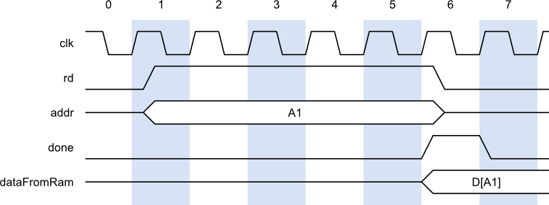
Next up are the timing waveforms for a non-pipelined write operation. This example assumes the write operation accesses a memory location in the currently active bank and row of the SDRAM. The sequence of actions is:
Cycle 1: The SDRAM address and the data to be stored there are applied and the write control signal is driven high. The address, data and write control must be held stable until the done signal goes high.
Cycle 2: The data and the column address are output on the pins that go to the SDRAM chip and the SDRAM control signals are set to initiate the write operation. The done signal goes high because the SDRAM controller is effectively done at this point since the SDRAM can complete the write operation on its own.
Cycle 3: On the rising clock edge the SDRAM latches the address and data and initiates a write operation. The output drivers on the data bus are disabled to free the SDRAM data bus.
Cycles 4 and 5: The SDRAM continues its internal operations to write the data into the given address.
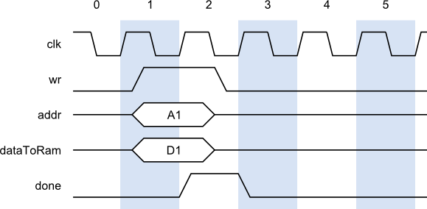
In the previous sequence of actions for a read or write operation, it was assumed the operation was initiated as soon as the appropriate control signal was asserted. There are several cases when the SDRAM controller delays the initiation of an operation:
When a row is being refreshed. In this case, SDRAM controller completes the row refresh operation. Then the SDRAM banks are precharged and the bank and row containing the given address are activated. Then the read or write operation can progress as described above.
When the given address is not in the currently active bank or row of the SDRAM. In this case, the controller precharges the SDRAM banks and the bank and row containing the given address is activated. Then the read or write operation can progress as described above.
When a previous write operation is still in progress. For write operations, the SDRAM controller indicates the operation is complete before the SDRAM chip has actually finished storing the data. If another read or write operation is initiated before the SDRAM chip is actually done, then the SDRAM controller will delay the current operation until the SDRAM is completely finished writing the previous data. Then the current operation proceeds, including any preceding activation steps that are needed.

You don't actually have to be concerned with these delays because the SDRAM controller handles them automatically. All you have to do is initiate a read or write operation and hold your signals steady until the done signal goes high.
In adition to the FSM and SDRAM controller modules, there is a clock generator module (ClkGen) that takes the 12 MHz input clock to the FPGA and ramps it up to 100 MHz. This high-speed clock exits the FPGA and goes to the clock input of the SDRAM. It also gets fed back into the FPGA and drives the clock inputs of the FSM and SDRAM controller. This effectively synchronizes the internal operations of the FPGA with those of the SDRAM since each receives a clock signal with approximately the same amount of accumulated chip-I/O and PCB trace delays.
Finally, I include a single HostIoToDut module to transfer the value in the summation register back to the PC. Looking at this value will tell me if the FPGA and SDRAM performed correctly or not.
The top-level module of the SdramSPInst ISE project that connects all these modules together is shown below. The first order of business is to pull in the necessary VHDL packages for the clock generator, SDRAM controller and the PC-to-XuLA transfer modules (lines 8-10).
- --*********************************************************************
- -- SDRAM, single-port, instantiated.
- --*********************************************************************

- library IEEE;
- use IEEE.STD_LOGIC_1164.all;
- use IEEE.NUMERIC_STD.all;
- use work.ClkgenPckg.all; -- For the clock generator module.
- use work.SdramCntlPckg.all; -- For the SDRAM controller module.
- use work.HostIoPckg.HostIoToDut; -- For the FPGA<=>PC transfer link module.

In the entity declaration, the output for the summation has been removed since the HostIo package will be used to send it to the PC. The I/O signals for connecting the FPGA to the SDRAM have also been added.
- entity SdramSPInst is
- port (
- fpgaClk_i : in std_logic; -- 12 MHz clock from external clock source.
- sdClk_o : out std_logic; -- 100 MHz clock to SDRAM.
- sdClkFb_i : in std_logic; -- 100 MHz clock fed back into FPGA.
- sdRas_bo : out std_logic; -- SDRAM row address strobe.
- sdCas_bo : out std_logic; -- SDRAM column address strobe.
- sdWe_bo : out std_logic; -- SDRAM write-enable.
- sdBs_o : out std_logic; -- SDRAM bank-address.
- sdAddr_o : out std_logic_vector(11 downto 0); -- SDRAM address bus.
- sdData_io : inout std_logic_vector(7 downto 0) -- SDRAM data bus.
- );
- end entity;

In the architecture header, there's no need to add the component declarations for any of the modules because their respective VHDL packages already include this information.
Note also that several of the declared registers have been divided into two, distinct signals: one with a _r suffix that holds the current value, and another with a _x suffix that holds the signal value that will become current on the next rising clock edge. The reason for this will become clear when I discuss the FSM portion of the code.
- architecture Behavioral of SdramSPInst is
- constant NO : std_logic := '0';
- constant YES : std_logic := '1';
- constant RAM_SIZE_C : natural := 256; -- # of words in RAM.
- constant RAM_WIDTH_C : natural := 8; -- Width of RAM words.
- constant MIN_ADDR_C : natural := 1; -- Process RAM from here
- constant MAX_ADDR_C : natural := 5; -- ... to here.
- subtype RamWord_t is unsigned(RAM_WIDTH_C-1 downto 0); -- RAM word type.
- signal clk_s : std_logic; -- Internal clock.
- signal wr_s : std_logic; -- Write-enable control.
- signal rd_s : std_logic; -- Read-enable control.
- signal done_s : std_logic; -- R/W operation done signal.
- signal addr_r, addr_x : natural range 0 to RAM_SIZE_C-1; -- addr.
- signal dataToRam_r, dataToRam_x : RamWord_t; -- Data to write to RAM.
- signal dataFromRam_s : RamWord_t; -- Data read from RAM.
- -- Convert the busses for connection to the SDRAM controller.
- signal addrSdram_s : std_logic_vector(22 downto 0); –- Address.
- signal dataToSdram_s : std_logic_vector(sdData_io'range); -- Data.
- signal dataFromSdram_s : std_logic_vector(sdData_io'range); -- Data.
- -- FSM state.
- type state_t is (INIT, WRITE_DATA, READ_AND_SUM_DATA, DONE); -- FSM states.
- signal state_r, state_x : state_t := INIT; -- FSM state reg.
- signal sum_r, sum_x : natural range 0 to RAM_SIZE_C * (2**RAM_WIDTH_C)-1;
- signal sumDut_s : std_logic_vector(15 downto 0); -- Send sum bck to PC.
- signal nullDutOut_s : std_logic_vector(0 downto 0); -- HostIo dummy output.
- begin

The clock generator module multiplies the 12 MHz input clock by 25/3 to create the 100 MHz clock that is output to the SDRAM. The 100 MHz clock also re-enters the FPGA and becomes the master clock for all the rest of the FPGA circuitry (line 60).
- --*********************************************************************
- -- Generate a 100 MHz clock from the 12 MHz input clock and send it out
- -- to the SDRAM. Then feed it back in to clock the internal logic.
- --*********************************************************************
- Clkgen_u1 : Clkgen
- generic map (BASE_FREQ_G => 12.0, CLK_MUL_G => 25, CLK_DIV_G => 3)
- port map(I => fpgaClk_i, O => sdClk_o);
- clk_s <= sdClkFb_i; -- SDRAM clock feeds back into the FPGA.

The SDRAM controller module is instantiated on lines 66-87. The FREQ_G generic parameter (line 68) is used to inform the module of the input clock frequency so it can accurately calculate the timing delays that the SDRAM requires. The rest of the instantiation is just the connection of I/O signals to the FSM and the external SDRAM.
- --*********************************************************************
- -- Instantiate the SDRAM controller that connects to the FSM
- -- and interfaces to the external SDRAM chip.
- --*********************************************************************
- SdramCntl_u0 : SdramCntl
- generic map(
- FREQ_G => 100.0, -- Use clock freq. to calc. timing parameters.
- DATA_WIDTH_G => RAM_WIDTH_C -- Width of data words.
- )
- port map(
- clk_i => clk_s,
- -- FSM side.
- rd_i => rd_s,
- wr_i => wr_s,
- done_o => done_s,
- addr_i => addrSdram_s,
- data_i => dataToSdram_s,
- data_o => dataFromSdram_s,
- -- SDRAM side.
- sdRas_bo => sdRas_bo,
- sdCas_bo => sdCas_bo,
- sdWe_bo => sdWe_bo,
- sdBs_o(0) => sdBs_o,
- sdAddr_o => sdAddr_o,
- sdData_io => sdData_io
- );

Next, the host-side address and data buses are routed to the intermediate signals the same way I did in the previous CORE Generator example.
- -- Connect the SDRAM controller signals to the FSM signals.
- dataToSdram_s <= std_logic_vector(dataToRam_r);
- dataFromRam_s <= RamWord_t(dataFromSdram_s);
- addrSdram_s <= std_logic_vector(TO_UNSIGNED(addr_r, addrSdram_s'length));

The biggest change in this example is to the FSM VHDL code. I have divided it into two, separate processes: a combinatorial process that computes the current outputs and the next state given the current inputs and state (lines 100-151), and a sequential process that updates the registers with their new values upon a rising clock edge (lines 157-165).
The combinatorial process starts with a sensitivity list. Basically, this includes every signal in the process that appears on the right-hand side of an assignment statement or in a conditional statement. If any of these signals changes value, then the entire process is re-evaluated.
- --*********************************************************************
- -- State machine that initializes RAM and then reads RAM to compute
- -- the sum of products of the RAM address and data. This section
- -- is combinatorial logic that sets the control bits for each state
- -- and determines the next state.
- --*********************************************************************
- FsmComb_p : process(state_r, addr_r, dataToRam_r,
- sum_r, dataFromRam_s, done_s)
- begin

The first thing the combinatorial process does is set the default values for various outputs and registers. These assignments will be overridden further-on in the process when a given signal needs to be changed. Note that signals with a _x suffix are always on the left-hand side of an assignment while signals with a _r suffix are on the right.
- -- Disable RAM reads and writes by default.
- rd_s <= NO; -- Don't write to RAM.
- wr_s <= NO; -- Don't read from RAM.
- -- Load the registers with their current values by default.
- addr_x <= addr_r;
- sum_x <= sum_r;
- dataToRam_x <= dataToRam_r;
- state_x <= state_r;

- case state_r is

The initialization state operates pretty much the same as always, but note how the default values of some of the signals have been overridden.
- when INIT => -- Initialize the FSM.
- addr_x <= MIN_ADDR_C; -- Start writing data at this addr.
- dataToRam_x <= TO_UNSIGNED(1, RAM_WIDTH_C); -- Initial write value.
- state_x <= WRITE_DATA; -- Go to next state.

When values are being written to the SDRAM, the write-enable is asserted until the done signal from the SDRAM controller goes high (line 120). Once that occurs, and before the next rising clock edge, the write-enable signal has to be disabled. This is the reason the FSM was divided into combinatorial and sequential portions. If a one-process sequential FSM like those in the previous examples was used, then the write-enable signal would not change until the next rising clock edge after the done signal went high, and that would be too late. With a combinatorial process, the write-enable goes low as soon as the done signal is asserted.
- when WRITE_DATA => -- Load RAM with values.
- if done_s = NO then -- While current RAM write is not complete ...
- wr_s <= YES; -- keep write-enable active.
- elsif addr_r < MAX_ADDR_C then -- If haven't reach final address ...
- addr_x <= addr_r + 1; -- go to next address ...
- dataToRam_x <= dataToRam_r + 3; -- and write this value.
- else -- Else, the final address has been written ...
- addr_x <= MIN_ADDR_C; -- go back to the start, ...
- sum_x <= 0; -- clear the sum-of-products, ...
- state_x <= READ_AND_SUM_DATA; -- and go to next state.
- end if;

Reading values back from the SDRAM also uses the done signal to gate the read-enable signal and to accumulate to the sum-of-products only when the data becomes available (lines 134-142).
- when READ_AND_SUM_DATA => -- Read RAM and sum address*data products
- if done_s = NO then -- While current RAM read is not complete ...
- rd_s <= YES; -- keep read-enable active.
- elsif addr_r <= MAX_ADDR_C then -- If not the final address ...
- -- add product of previous RAM address and data read
- -- from that address to the summation ...
- sum_x <= sum_r + TO_INTEGER(dataFromRam_s * addr_r);
- addr_x <= addr_r + 1; -- and go to next address.
- if addr_r = MAX_ADDR_C then -- If last addr has been read ...
- state_x <= DONE; -- go to the next state.
- end if;
- end if;

- when DONE => -- Summation complete ...
- null; -- so wait here and do nothing.
- when others => -- Erroneous state ...
- state_x <= INIT; -- so re-run the entire process.

- end case;

- end process;

Here's the sequential process of the FSM. On the rising clock edge, the registers get updated with the values calculated in the combinatorial process.
- --*********************************************************************
- -- Update the FSM's registers with their next values as computed by
- -- the FSM's combinatorial section.
- --*********************************************************************
- FsmUpdate_p : process(clk_s)
- begin
- if rising_edge(clk_s) then
- addr_r <= addr_x;
- dataToRam_r <= dataToRam_x;
- state_r <= state_x;
- sum_r <= sum_x;
- end if;
- end process;

The final thing to do is send the summation value back to the PC. Since I'm only using a single HostIoToDut module in this application, I can employ an easy-to-use version that already incorporates the BscanToHostIo module internally.
- --*********************************************************************
- -- Send the summation to the HostIoToDut module and then on to the PC.
- --*********************************************************************
- sumDut_s <= std_logic_vector(TO_UNSIGNED(sum_r, 16));
- HostIoToDut_u2 : HostIoToDut
- generic map (SIMPLE_G => true) -– Use simple form of module.
- port map (
- vectorFromDut_i => sumDut_s, -– Send sum back to PC.
- vectorToDut_o => nullDutOut_s –- Dummy output. Not used.
- );

- end architecture;

That completes the top-level module in the SdramSPInst.vhd file. Here's the SdramSPInst ISE project hierarchy:
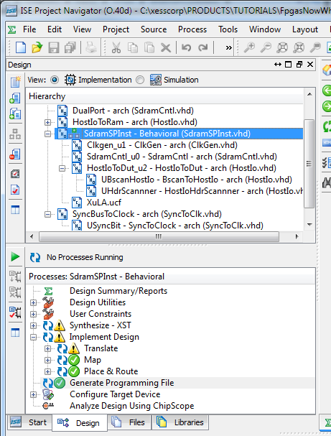
Compiling the project in the same way as all the previous examples (you should know the drill by now) generates the SdramSPInst.bit file.
Of course, to go with the FPGA bitstream, I need a Python program on the PC to grab the summation value from the XuLA board. Here's what's in the sdram_test.py file. It starts by importing all the functions and classes in the XsTools package.
- from xstools.xsdutio import * # Import funcs/classes for PC <=> FPGA link.

Then the program prints out a description of what it's trying to do.
- print '''\n
- ##################################################################
- # Read the summation of the address * data products from the
- # FSM + SDRAM application on the XuLA board.
- ##################################################################
- '''
Next, the program defines two identifiers: one for the USB port index of the XuLA board (which is usually 0 because your XuLA port is usually USB0), and another for the interface identifier of the HostIoToDut module attached to the summation register in the FPGA (the identifier is 255 by default for the simple version of the module).
- USB_ID = 0 # USB port index for the XuLA board connected to the host PC.
- DUT_ID = 255 # This is the default identifier for the DUT in the FPGA.

Now create an object that lets the PC talk to the HostIoToDut module in the FPGA. The USB and DUT identifiers are needed to initialize the object. Then two arrays are needed: one which defines the size of the summation register that will be read back to the PC, and another that defines the size of the single dummy output of the HostIoToDut module. (Obviously the dummy output of the HostIoToDut module doesn't do anything; I just need at least one output to keep the VHDL synthesizer from complaining. And because the dummy output is there, I need to account for it in the Python code even though nothing is done with that, either.)
- # Create an intfc obj with one 16-bit input and one 1-bit output.
- dut = XsDut(USB_ID, DUT_ID, [16], [1])

Finally, use the Read() method of the dut object to get the value in the summation register. Then print the value of the sum and exit.
- sum = dut.Read(); # Read the 16-bit summation from the FPGA.
- print 'Sum = %d\r' % sum.unsigned

At this point, I assume you have the SdramSPInst ISE project compiled and the bitstream is ready to go, the firmware in your XuLA board has been upgraded to support the HostIoPckg modules (you should have already done that in the previous chapter), and you have Python installed and the sdram_test.py file is available. Now all you have to do is this:
- Download the SdramSPInst.bit file to the FPGA on the XuLA board using GXSLOAD.
- Run the Python program in a command window as follows:
C:\SFW> python sdram_test.py
Then you should see the following text appear in the command window:
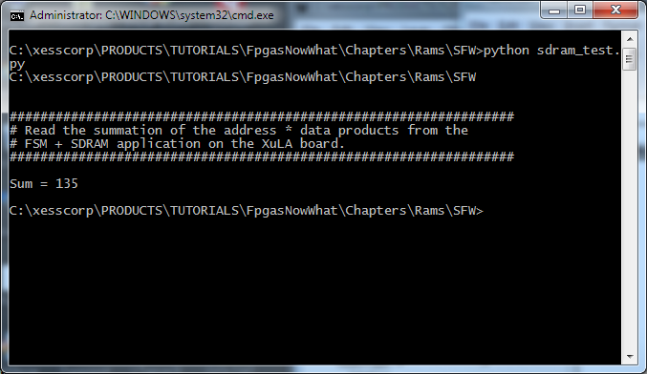
The value in the sum register matches the results found in the previous examples, so the SDRAM circuitry appears to be working.
Now you might ask (if you're still there): “Why did you go to all the trouble of running this on the actual hardware instead of doing a simulation like in the other examples?” The answer to that is simple: the ISE simulator knows how to model the behavior of the distributed and block RAMs built into the FPGA itself, but it has no built-in model for the external SDRAM chip. So I just went straight to the hardware and prayed that it worked.
The problem with doing it in hardware is that if the result is incorrect, then how do you find where the problem is? Is it in the FSM? Is the SDRAM controller being operated in the correct manner? Is the problem inside the SDRAM controller itself? (If so, take a look in the SdramCntl.vhd file and tell me you would want to debug that! I did back in 2001 after I wrote it and believe me, it was not pretty.)
So, while throwing a “Hail Mary” with the hardware sometimes works, we really need a backup plan to debug systems that extend beyond the boundaries of the FPGA. That's what I'll show you in the next chapter.

