- “Only 12 MHz! Now what?”

Speed Envy
In the last chapter, some of you were probably saying: “A 12 MHz clock? That's all!? My Arduino runs faster than that. My grandmother runs faster than that!” (Maybe your grandmother, but not mine, both of whom died long ago. If you see them up and running around, then something's really gone wrong.)
One of the unfortunate consequences of the popularization of computers has been people's fixation on clock speed, with more being better. But fear not that your Arduino-toting compatriots will laugh at you, because the FPGA on the XuLA board has a feature that will let it run at over 300 MHz.

The Digital Clock Manager
Modern Xilinx FPGAs contain Digital Clock Managers (or DCMs) that serve many functions, one of which is multiplying the frequency of a clock. A Digital Frequency Synthesizer (DFS) within the DCM can multiply an incoming clock signal by any integer in the range 2..32 and then divide it by any factor in the range 1..32. Here's an example of generating an 18 MHz clock:
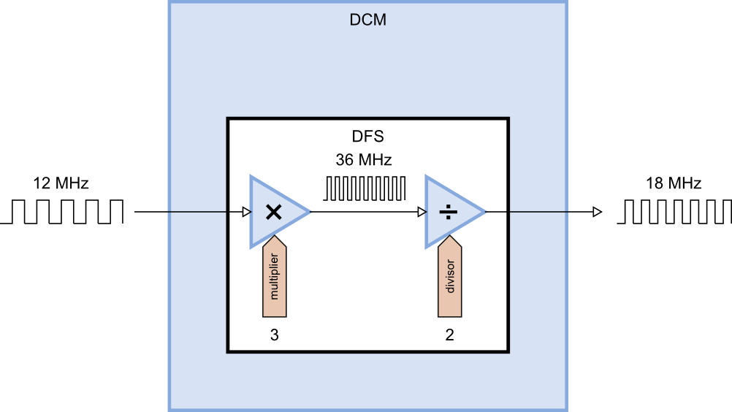
With a 12 MHz input clock and a multiplier of 32, you can theoretically generate a clock up to 384 MHz, but the practical electrical limit for a Spartan-3A device is between 320 to 350 MHz (depending upon the speed grade of the FPGA).

Adding a DFS to the Blinker
Now, how am I going to demonstrate the operation of a DFS to you if you don't have an oscilloscope to view the incoming and outgoing clock signals? Simple! We can take the blinker design from the previous chapter, add a DFS to multiply the input clock, and then see if the blinker pulses faster.
So the first thing to do is to add the DFS to the blinker VHDL file. But how do you describe a DFS in VHDL? After all, it's not something simple like a NAND gate or a counter.
Well, Xilinx has made it easy for you by creating a device primitive for the DFS. (It's called a primitive because it can't be decomposed into a collection of simpler components. Perhaps atom would have been a better name.) You can instantiate the DFS device primitive into your VHDL source and not have to worry about how it is actually built.
But you need to know what the inputs and outputs of the DFS primitive are in order to use it. To get this information, click on the Edit ⇨ Language Templates... menu item. This will make the Language Templates tab appear in the workspace pane like so:
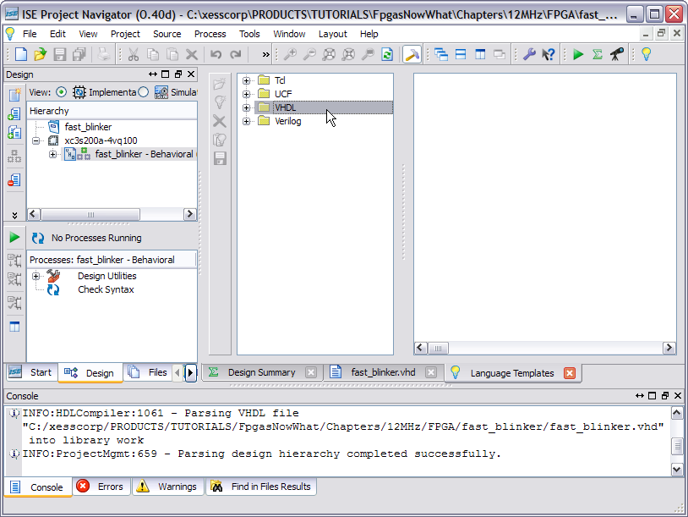
To find the DFS primitive, click on the VHDL folder and expand it until you see the DCM item appear. Then select the DCM item and a VHDL template for instantiating this primitive will appear in the rightmost pane.
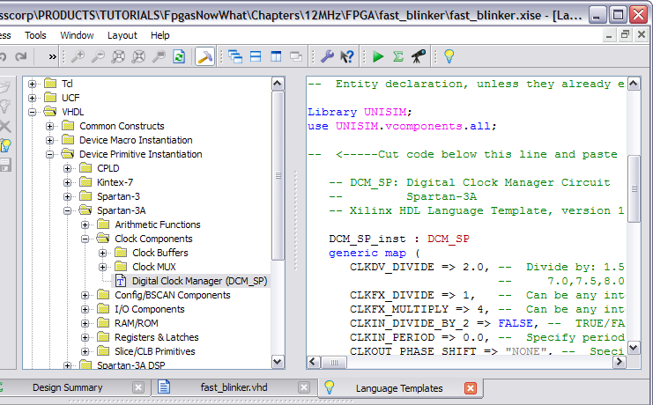
The VHDL template is intimidating! There are eighteen inputs and outputs and twelve generic parameters for tuning the operation of the DCM primitive. But we can ignore most of them and accept their default settings. The only things we care about for this application are the reset (RST), input clock (CLK_IN), the DFS output clock (CLK_FX), and the DFS multiplier (CLKFX_MULTIPLY) and divider (CLKFX_DIVIDE).
After instantiating the DCM and doing some trimming and editing, the blinker VHDL looks like what's shown on the following page. Here's what changed:
Lines 26-27: Since the DCM primitive is being used, these lines need to be uncommented to bring in the Xilinx primitive libraries.
Line 35: A new signal, clk_fast, was added to carry the clock generated by the DFS.
Lines 39-48: The DCM is instantiated here. The DFS divider and multiplier are set to one and four, respectively, on lines 41 and 42. The DFS output is connected to the clk_fast signal on line 45, and the input clock is connected to the DFS clock input on line 46. The reset input is tied to an inactive level on line 47.
Lines 50-55: The clock for the counter was changed from clk_in to clk_fast.

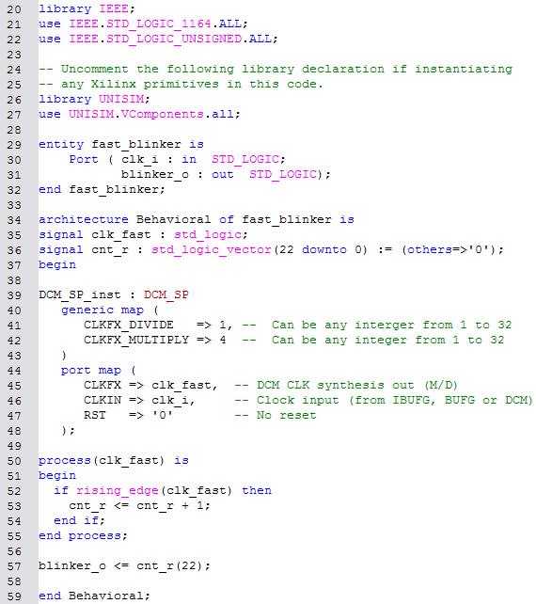
After the VHDL file is finished, you can run the synthesizer to see if there are any problems. (There aren't, at least when I did it).

Does It Work?
That's always the question, especially when you are applying a chip feature that you haven't used before. So let's run a simulation to find out. First, add a new test bench to your project:
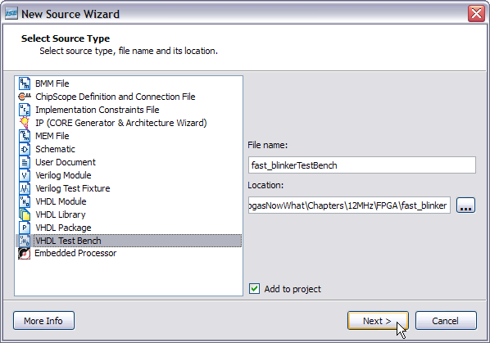
Then go into the test bench VHDL file and change the clock period to match the 12 MHz clock period:
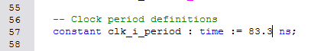
Then switch to the Simulation view of your project and click on the Simulate Behavioral Model item in the Processes pane. When the ISim window appears, enter 2.8s in the simulation duration field and then click on the run button.
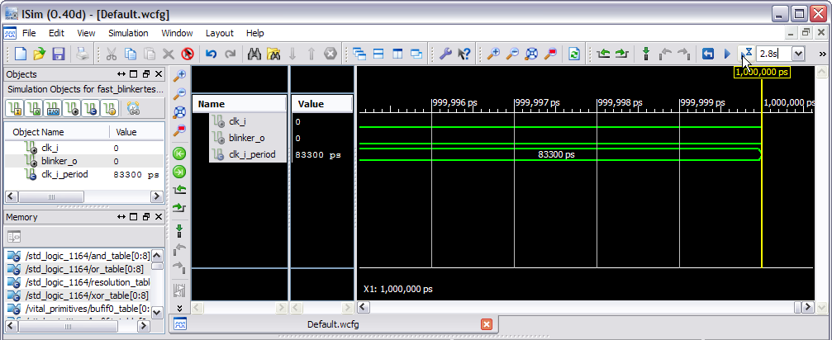
Then be prepared to wait … for … a … very … long … time. On my PC the simulation took about 30 minutes, probably because simulating the DFS is computationally demanding. After the simulation finishes, compress the view so the entire 2.8 s time interval is visible and count the number of blinker pulses. You should see sixteen pulses. Remember in the previous blinker design, there were only four pulses in the 2.8 s window. So it appears – at least in the simulation – that the DFS has multiplied the 12 MHz clock by a factor of four.
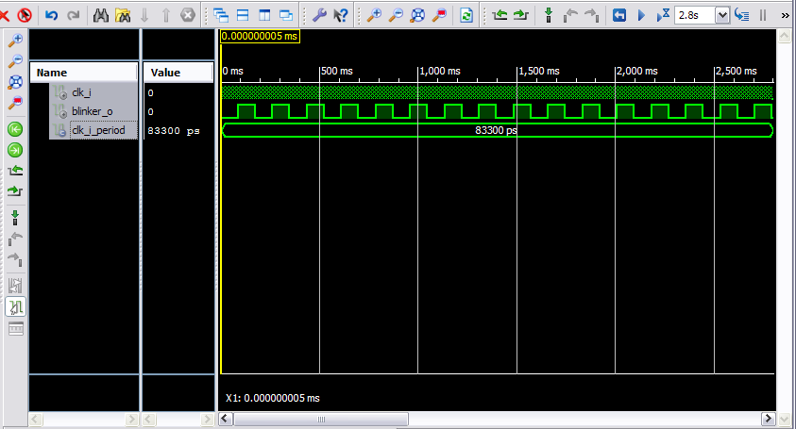

But Does It Really Work?
That's always the real question: Will it work in the FPGA? Well, it's easy enough to find out. Here are the high points for how to do that:
- Connect an LED and resistor to the XuLA board just as you did for the previous blinker project. Then connect the XuLA board to a USB port on your PC.
- Add a constraints file to your project that's identical to the one you used for the previous blinker project since the LED and clock pin assignments haven't changed.
- Right-click the Generate Programming File process item and select Process Properties... from the pop-up menu. Then select the options to float any unused I/O pins after configuration and to use the JTAG clock as the start-up clock.
- Double-click the Generate Programming File process. This will run the synthesis and implementation tools in sequence and then create a downloadable bitstream.
- Start the GXSLOAD tool and drag-and-drop the fast_blinker.bit file into the FPGA pane. Then click the Load button to download the bitstream into the FPGA on the XuLA board.
After doing these steps, you should be rewarded by seeing the LED attached to the XuLA board blinking away at about six times per second.

