- “I have no compiler. Now what?”

The Compilation Process: From Schematic to Bitstream
As you can imagine, figuring out which bits to set in the LUTs and the switching matrix in order to create a logic circuit is quite a chore. Not many people would want to delve into the details of this (probably the same ones who like to program in assembly). That's why the FPGA manufacturers provide development software that compiles a high-level description of a logic design and outputs a bitstream which sets the FPGA configuration bits appropriately.
The process the development software goes through to compile a design into a bitstream is depicted in the figure on the next page. Here's what happens:
- You enter a description of your logic circuit using a hardware description language (HDL) such as VHDL or Verilog. Or you can also draw your design using a schematic editor. Or you can use a combination of the two.
- A logic synthesizer transforms the HDL into a netlist. The netlist is just a description of the various logic gates in your design and how they are interconnected. (A schematic is already pretty close to a netlist, so it doesn't need as much work done on it as the HDL code.)
- The implementation phase employs three different tools. A translator merges together one or more netlists along with any design constraints (don't worry about those now). This is fed to a mapper that combines gates in the netlist into groups that will fit efficiently into the LUTs of the FPGA. The gate groupings are sent to the place & route tool that assigns them to LUTs at various locations in the FPGA and then determines how to connect them together using the routing resources (wires) in the switching matrix. This part takes the most time as finding a placement that can be routed efficiently requires a lot of computation.
- A bitstream generator takes the output of the implementation phase, combines it with a few other configuration settings, and outputs a binary bitstream. This bitstream (which, depending upon the size of the FPGA, can be many megabits in length) contains the truth-tables that will be loaded into the RAM of every LUT and the connection settings for the wiring matrix that will connect them.
- At this point, a bitstream is just a bunch of 1s and 0s in a file on the computer. The downloader will transfer this file into a physical FPGA chip. In most cases, this chip is already mounted on a circuit board where it waits for the bitstream that will make it perform its intended function.
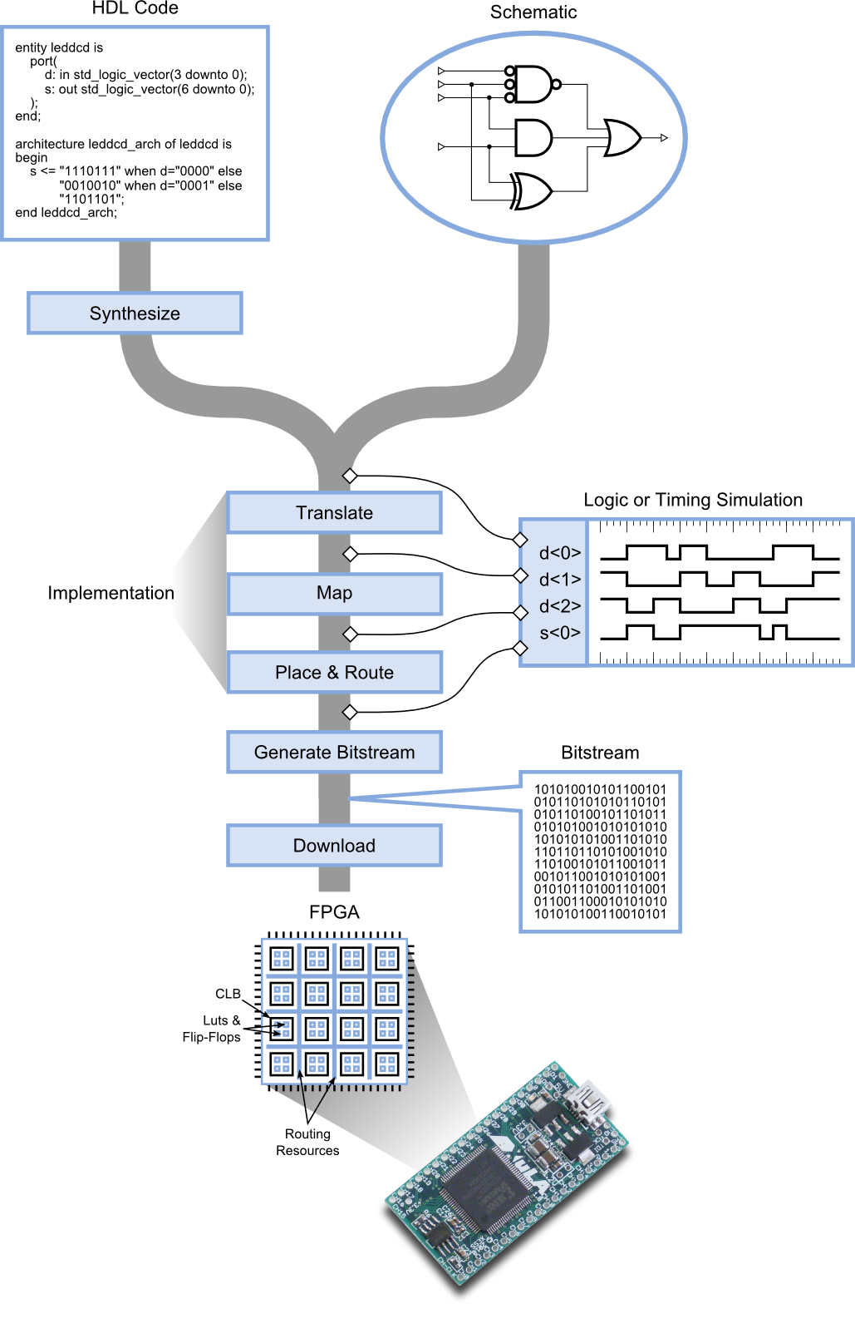
After downloading, you can apply patterns of input signals (or test vectors) to the I/O pins of the FPGA to check the operation of your design. This is often an effective way to do testing, but sometimes it's difficult to set up a particular combination of signals and look deeply into the internals of your design to see why it may not be performing as you intended.
If that's the case, you can use a simulator to try out test examples and see how your circuit reacts before you actually load it into an FPGA. There are several places in the design flow where you can perform a simulation. If you capture the netlist before it enters the implementation tools, you can run a logic simulation that only tests the logical operations of the gates in your circuit. Such simulations are good for debugging the basic functions of your design.
As you tap the design flow at points further downstream, the netlist is augmented with more and more information about how your design will be placed into the FPGA. This allows you to perform a more realistic timing simulation that incorporates the effects of gate and wiring delays on the operation of your circuit. This is useful for detecting errors caused when signals arrive too quickly or slowly at their destinations. Because of this extra level of detail, timing simulations take longer to run than a pure logic simulation.
At this point you know the steps in the compilation process, but what you really want to know is how to get a compiler. That comes next.

Getting and Installing Xilinx ISE WebPACK
Xilinx develops and sells their ISE FPGA tools, and they also distribute a free version called WebPACK. WebPACK won't generate bitstreams for the really large FPGAs and it lacks some special-function design tools, but it will perform all the functions I discussed in the previous section for FPGAs containing up to 75,000 LUTs with hundreds of I/O pins. That will be more than sufficient for this tutorial.
To get WebPACK, just do a search for “xilinx webpack download” (use Google, Bing, whatever). If you click on the first link you get, it will probably take you to the page shown below. The latest version of the software should be highlighted along the left side (it's currently 13.1). Click on the Full Installer link for whatever operating system you're using (either Windows or Linux, currently).
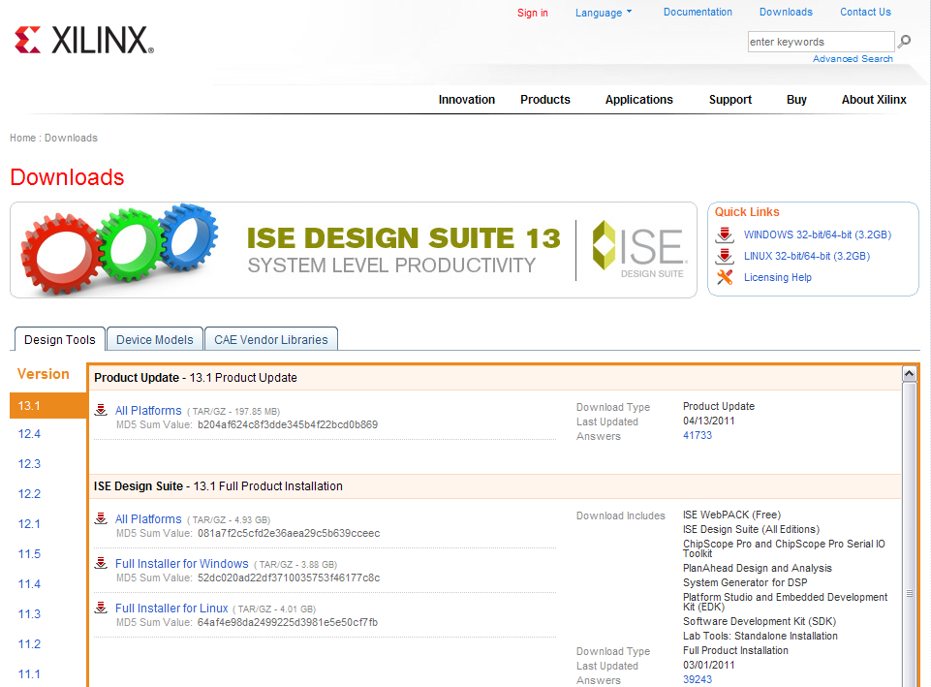
Before the download begins, you'll be presented with a sign-in screen. If you don't already have a Xilinx account, you'll have to create one. Then sign in using your ID and password.

Then you'll have to go through a screen that verifies all your contact information. Click on the Next button at the bottom and your download will begin. Now be prepared to wait an hour or two as the file is about 4 GB.
After the archive is downloaded, you can unpack it (that'll take a ten minutes) and run the installer. You'll go through a set of installation screens. Make sure you choose the WebPACK edition unless you want to pay money for one of the others or are willing to accept a time-limited license (usually 30 days).
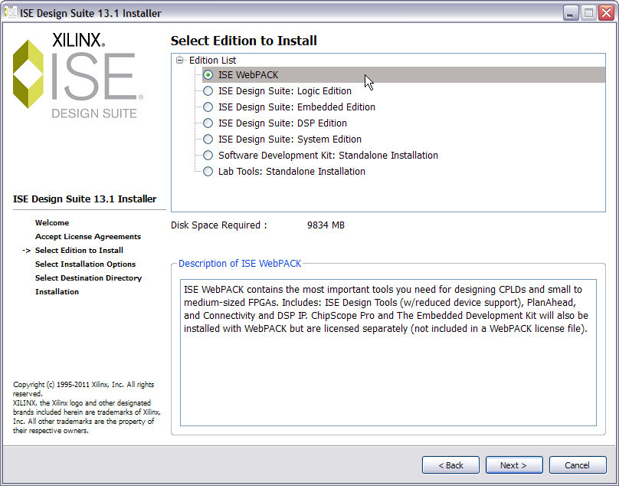
Also make sure to select the option to get a license key. (Yes, you will need a key even though WebPACK is free. The WebPACK license is not time-limited, so it will never expire.)
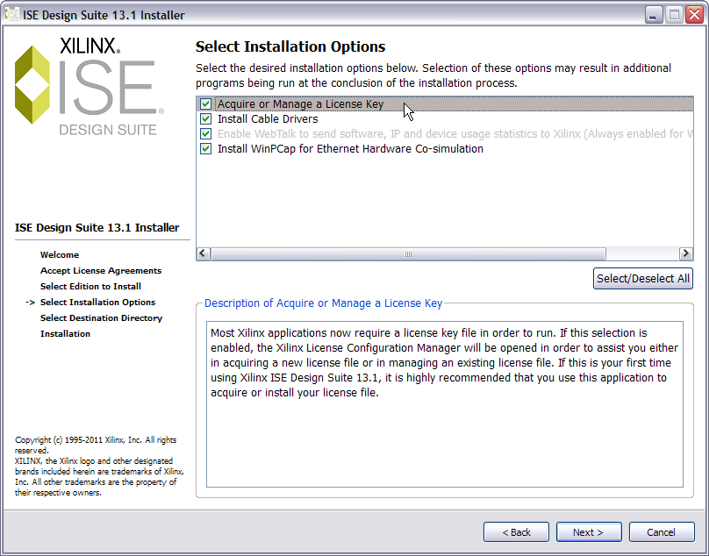
When the installation is almost done (that takes about 45 minutes), you'll see this screen appear. Select the WebPACK license as the one you want to get and click Next.
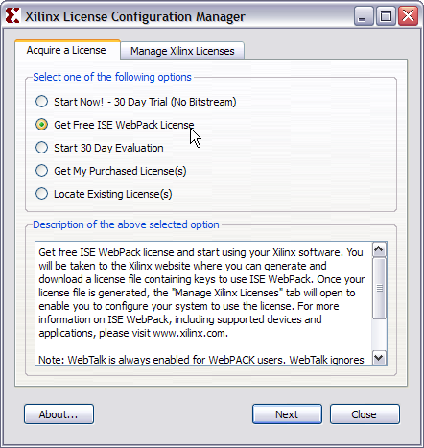
Then you'll get a screen showing the information that will be associated with your license.
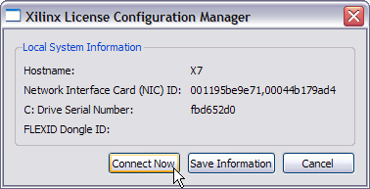
Click the Connect Now button to start the license generation process. Once you do, your browser will open a window to Xilinx and you'll have to login using your account information (again). Then you'll have to verify your contact information (again). Finally, you'll get to this screen. Select the WebPACK checkbox and click on the Generate Node Locked License button.
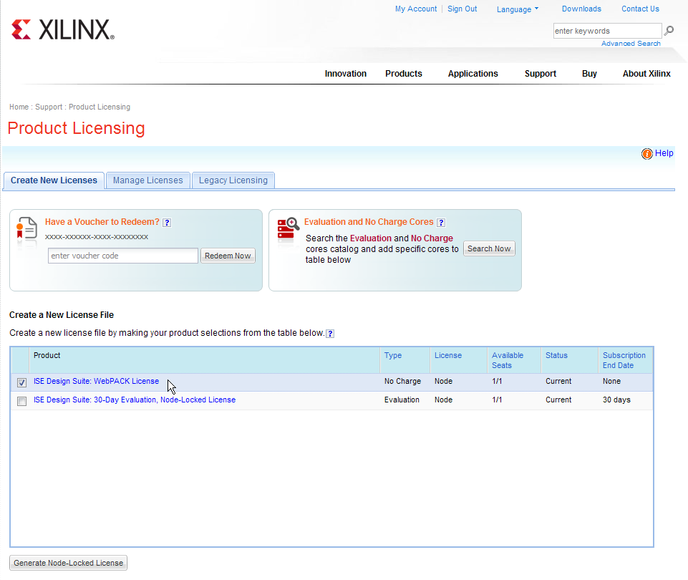
Next you'll see a couple of confirmation screens like the following:
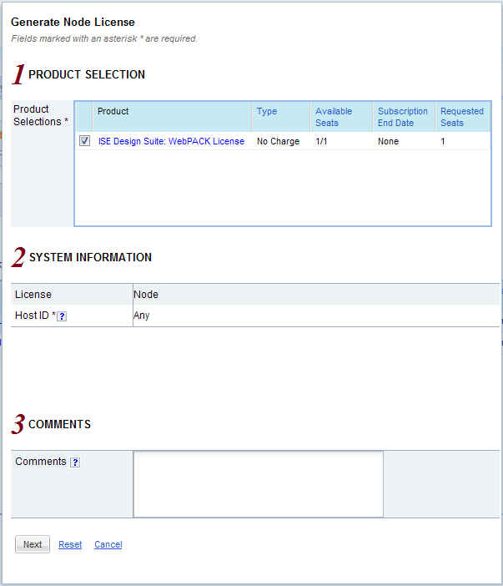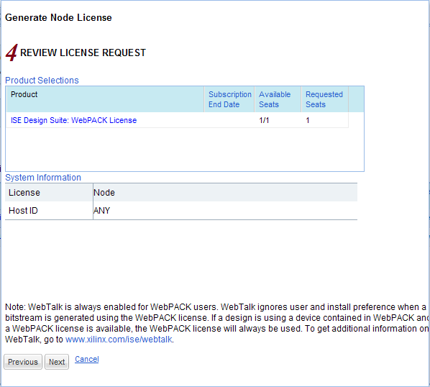
After clicking the Next button in the final confirmation screen, you'll get an acknowledgment that your license has been emailed to you.
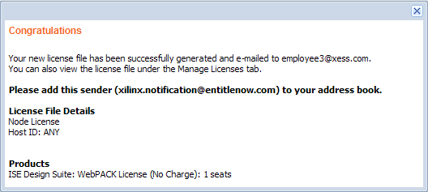
Once you've received the email, save the attached license file somewhere (but remember where you put it!). Then go back to the Xilinx License Configuration Manager screen and click on the Manage Xilinx Licenses tab. Enter the location of your license file into the XILINXD_LICENSE_FILE field and click on the Set button.
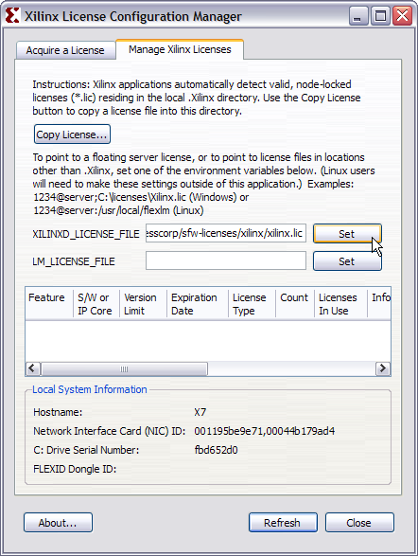
Once you click on the Set button, a list of the enabled features in the WebPACK software should appear. You're done setting up your license, so click on the Close button.
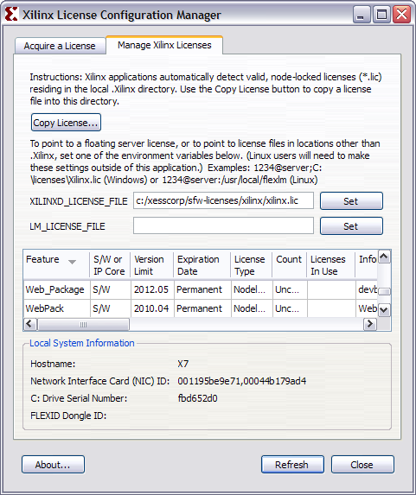
You can also click on the Finish button in the final window of the WebPACK installer. (You probably forgot all about that by now.)
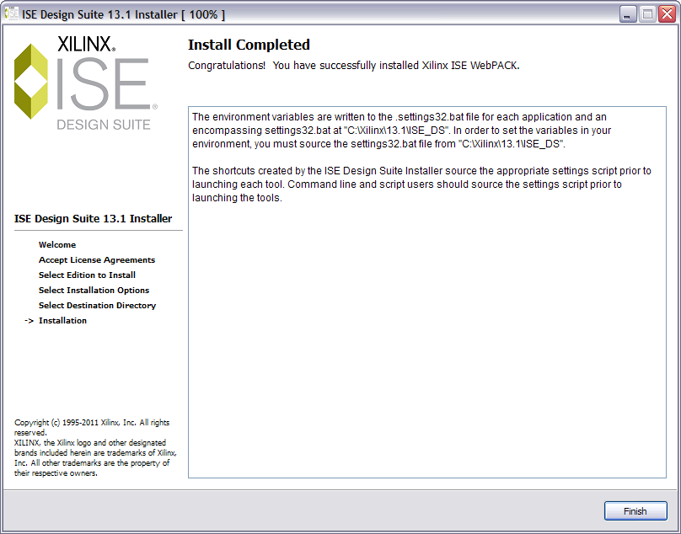
The WebPACK installation is done! You've got your party dress on, now it's time to dance!

