- “I know nothing about FPGAs. Now what?”

What Is Programmable Logic?
In the beginning (OK, actually in the 60's) there were discrete logic chips. Systems were built from lots of individual ANDs, ORs, flip-flops, etc. with a spaghetti-like maze of wiring between them. It was difficult to modify such a system after you built it. Jeez, after a week or two it was difficult to remember what each of the chips was for!

Manufacturing a system like this took a lot of time because each design change required that the wiring be redone which usually meant building a new printed circuit board. The chip makers addressed this problem by placing an unconnected array of AND-OR gates in a single chip called a programmable logic device (PLD). The PLD contained an array of fuses that could be blown open or left closed to connect various inputs to each AND gate. You could program a PLD with a set of Boolean sum-of-product equations to perform the logic functions needed in your system. You could change the function of a design by removing the PLDs, blowing a new fuse pattern into them, and then placing them back into the circuit board. This reduced the need to change the actual wiring of the printed circuit boards which held them.
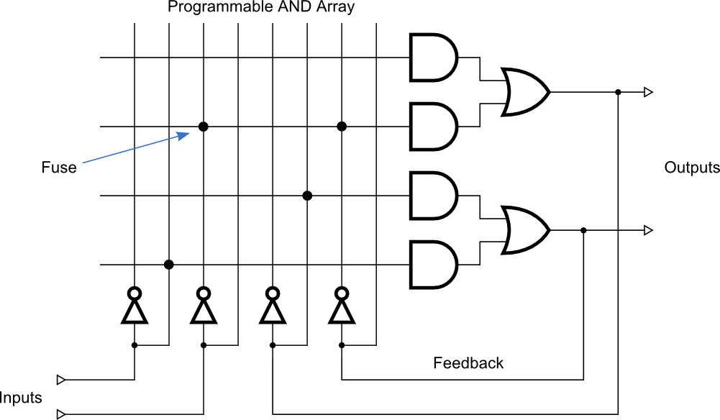
Simple PLDs could only handle up to 10–20 logic equations, so you couldn't fit a very large logic design into just one of them. You had to figure out how to break your larger designs apart and fit them into a set of PLDs. This was time-consuming and meant you had to interconnect the PLDs with wires. The wires were a big no-no because eventually you would make some design change that couldn't be handled just by reprogramming the PLDs and then you would have to build a new circuit board. The chip makers came to the rescue again by building much larger programmable chips called complex programmable logic devices (CPLDs) and field-programmable gate arrays (FPGAs). With these, you could essentially get a complete system onto a single chip.
A CPLD contains a bunch of PLD blocks like the one shown above, but their inputs and outputs are connected together by a global interconnection matrix. So a CPLD has two levels of programmability: each PLD block can be programmed, and then the interconnections between the PLDs can be programmed.
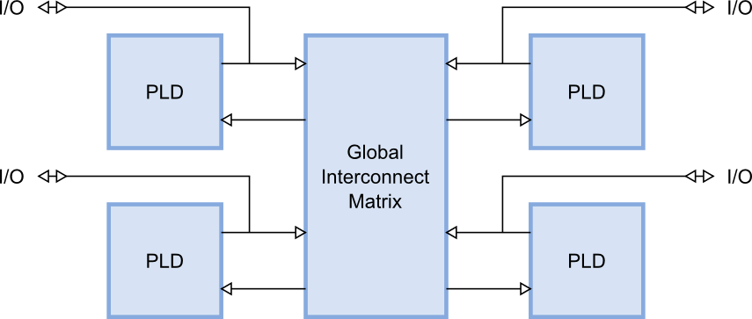
An FPGA takes a different approach. It has a bunch of simple, configurable logic blocks (CLBs) interspersed within a switching matrix that can rearrange the interconnections between the them. Each logic block is individually programmed to perform a logic function (such as AND, OR, XOR, etc.) and then the switches are programmed to connect the blocks so that the complete logic functions are implemented.
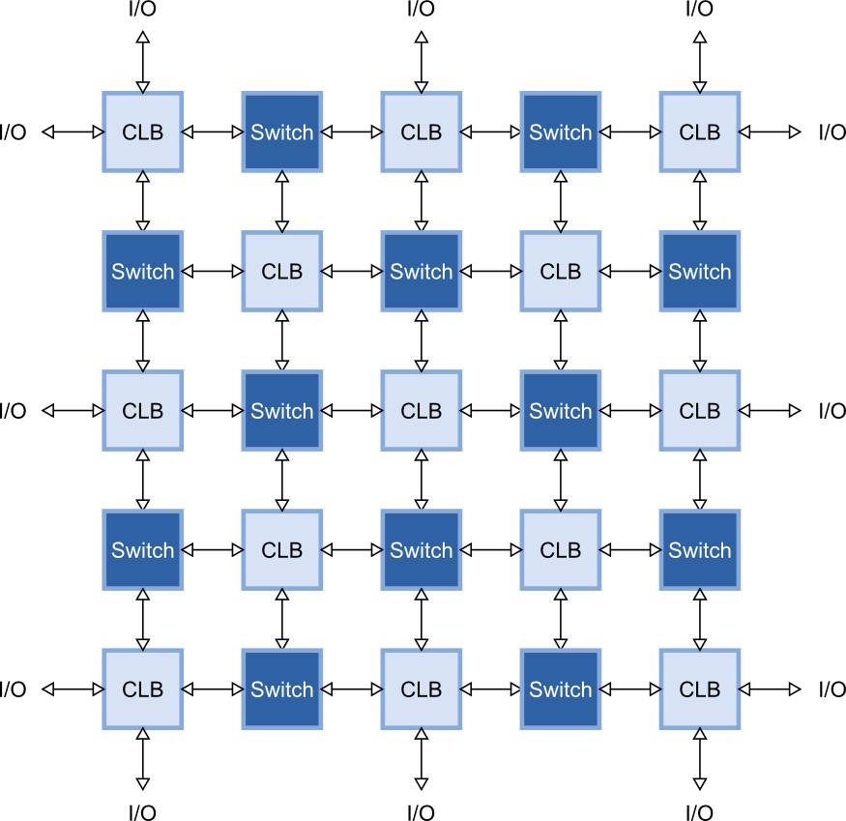
CPLD and FPGA manufacturers use a variety of methods to make the connections between logic blocks. Some make chips with fuses or anti-fuses that are programmed by passing a large current through them. These types of CPLDs and FPGAs are one-time programmable (OTP) because you can't rewire them internally once the fuses are blown.
Other manufacturers make the connections using pass transistors that are opened or closed by storing a charge on their gate electrodes using a high-voltage pulse. This type of programmable device resembles an EPROM or EEPROM: you can erase it and then place it in a special programmer socket and reprogram it. That's fine unless you have the CPLD or FPGA soldered into a circuit board.
Finally, some manufacturers use static RAM or Flash bits to control the pass transistors for each interconnection. By loading each bit with a 1 or a 0, you can control whether the switch is closed or opened and, therefore, whether two logic elements are connected or not. CPLDs and FPGAs built using RAM/Flash switches can be reprogrammed without removing them from the circuit board. They are often said to be in-circuit reconfigurable or in-circuit programmable. They are different, however: a Flash-based FPGA always has its programming intact whether it is powered or not, but a RAM-based FPGA will be erased and stop functioning if it ever loses power. Even with this drawback, most FPGAs are RAM-based because the RAMs can be built on the chip using the same manufacturing process as for the CLBs and switches (that makes the chips cheaper to produce). The manufacturers also provide a separate, Flash-based chip that stores the programming switch settings externally and loads it into the FPGA whenever power is applied.
For the rest of this book, we'll concentrate on using RAM-based FPGAs from Xilinx. I'll introduce a little terminology because it will be important later on.
Within the CLBs of an FPGA are look-up tables (LUTs) that perform the actual logic operations. These are usually built as small RAMs that are loaded with a truth table. For example, an eight-bit RAM can perform a three-input AND operation if it is loaded as follows:
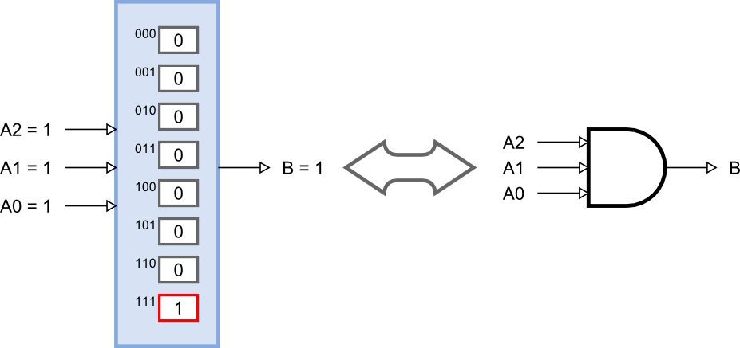
If the inputs for the AND gate are applied to the address pins of the RAM, then the output of the RAM will only be 1 when location 7 = 111 is selected. This is exactly how a three-input AND gate would operate. By setting the contents of the RAM in the right way, you can perform any logic function of three binary inputs. (Modern FPGAs use LUTs with four to six inputs.)
The output of a LUT can be used directly as an input to another LUT to make more complicated logic functions. Or it can be stored in a flip-flop for later use (there's usually at least one register for each LUT).
The switching matrix routes all the signals between the LUTs and registers and also to the I/O blocks (IOBs) around the perimeter of the FPGA chip. The IOBs connect selected internal signals of the FPGA to the outside world and contain special analog circuitry to adjust the input and output voltage levels, insert small delays, and handle single-ended or differential signaling.
Over time, other types of more specialized circuit blocks have found their way into FPGAs: blocks of RAM, multipliers and DSP blocks, delay-locked and phase-locked loops, gigabit serial transceivers, and even complete microprocessors. But, at least when you're starting off, your main concern will be the LUTs and registers. These are the equivalent of the program and data memories in a processor: the values in the LUTs and flip-flops determine how your logic circuit functions, and your design must fit into the available number of LUTs and flip-flops within your target FPGA.
Also, like a microprocessor, you need a way to write programs for your FPGA. That's the subject of the next chapter.

