“Verilog! Now What!?”
Back in the 80's, there was a TV commercial for Reeses Peanut Butter Cups that went something like this. Some dude is bebopping down the sidewalk on his skateboard eating from a jar of peanut butter. Another dork is riding down the sidewalk on a bike eating a chocolate bar. They don't see each other as they arrive at an intersection (probably because THEY ARE TOO BUSY EATING!) and a horrendous crash occurs. The first guy is lying on the ground and says “Hey, you got chocolate in my peanut butter!” The second guy retorts “Oh, yeah? You got peanut butter on my chocolate!”. (Nowadays the conversation would go something like this: “I'm going to sue you 'til your eyeballs explode!”; “Yeah? Say hello to my 9mm.”) Well, they each try the mixed concoction and arrive at the shared realization that chocolate and peanut butter taste pretty good together. Then they gaze into each other's eyes, join hands, and go off to start a B&B in the Napa Valley wine country.
So what does this have to do with using FPGAs? Not much, really; I just thought it was funny. But it is kind of similar to how VHDL and Verilog users view their favorite language as superior and it shouldn't be mixed with the other when, in reality, sometimes a combination of them is unavoidable and desirable. I'll demonstrate this with a simulation of the FPGA sum-of-products circuit and the external SDRAM from the last chapter.

Simulating SDRAM
As I said at the end of the last chapter, ISE knows how to simulate the internal RAMs of the FPGA, but it doesn't know jack about the behavior the external SDRAM on the XuLA board – it doesn't have those models. So to run a simulation, we need a VHDL model of the XuLA's Winbond W9812 8M x 16 SDRAM to combine with the VHDL for the FPGA circuit. Unfortunately, I've never been able to find a VHDL model of the W9812. Winbond does supply a Verilog model of the W9812, but it's encrypted so it will only work with the NC-Verilog simulator. That's not much help.
So there's no VHDL model for the W9812, and there's no vanilla-Verilog version, either. Luckily, the free market works in my favor here. All memory vendors are competing for the same slots in PCs, tablets and phones, so they all make their chips interoperable to try to steal business from each other. That means we can use an SDRAM model from another manufacturer in place of the one from Winbond. In this case, Micron supplies a Verilog model for their equivalent 8M x 16 SDRAM, the MT48LC8M16A2: http://www.micron.com/parts/dram/sdram/mt48lc8m16a2p-7e?pc={428A5CC9-2A78-447E-939B-6F3A40D538C6}#sim.
After downloading the archive from Micron, I just unpack it and store the mt48lcm16a2.v Verilog file in the folder for the SdramSPInst ISE project I built in the last chapter. Then I reopen the project in ISE and select the Add Source... item from the pop-up menu.
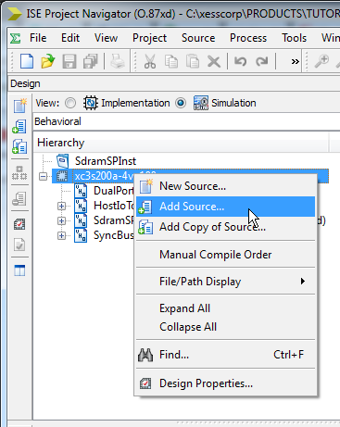
Once the dialog for selecting the source file appears, I highlight the mt48lcm16a2.v file and click Open which should add the Verilog file to my previously pristine VHDL project.
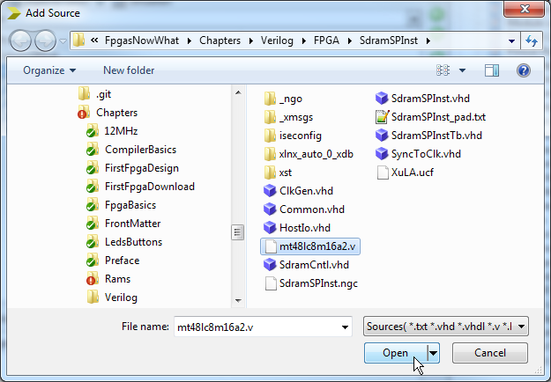
When adding the SDRAM model, I make sure to only associate the SDRAM Verilog file with simulation processes! That's because the SDRAM model contains stuff that's un-synthesizable or, at least, very inefficient to synthesize. I don't want ISE trying to build the SDRAM inside the FPGA if I run the implementation tools. That would only lead to tears.
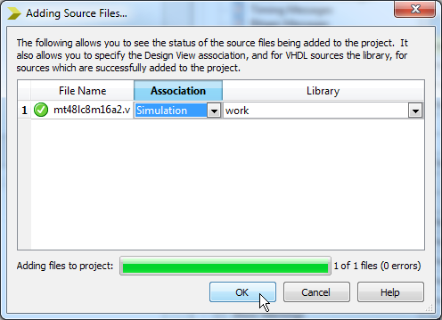
Now it's time to create a simulation test bench, so I do the whole New Source... thing.
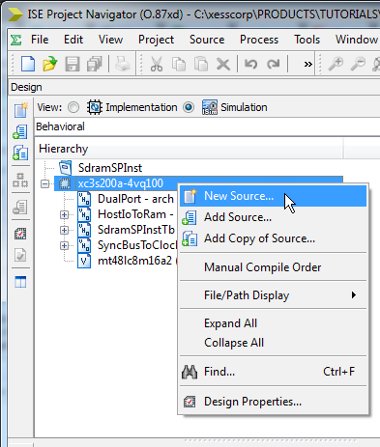
Then I add a VHDL test bench source file called SdramSPInstTb.
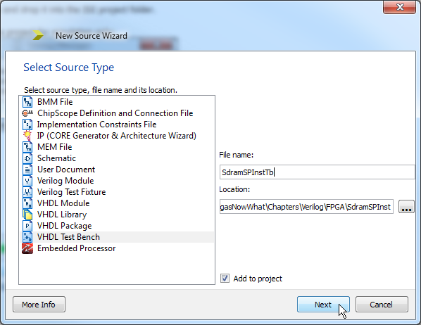
Next I associate the test bench with the SdramSPInst.vhd file containing the sum-of-products module.
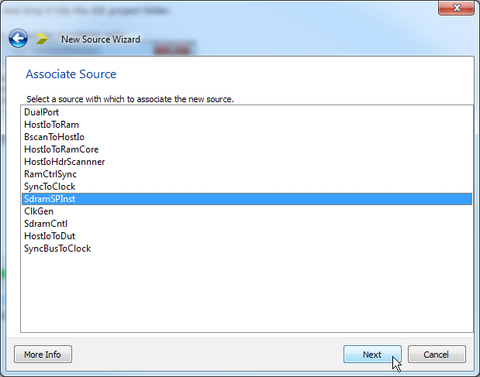
Now the test bench appears at the top of the design hierarchy with the original SdramSPInst as a submodule.
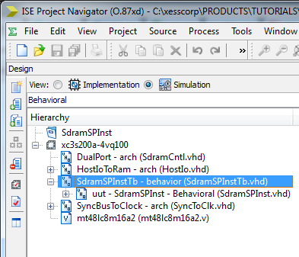
Note that the SDRAM Verilog model is outside the test bench hierarchy, so my next task is to integrate that into the mix by attaching it to the sum-of-products module within the SdramSPInstTb.vhd file. In effect, the test bench file emulates the XuLA board because it describes how an FPGA programmed with a sum-of-products function is connected to an external SDRAM. But to make this connection, I have to figure out the I/O definitions for the SDRAM from the Verilog source. Here is the pertinent portion of the mt48lc8m16a2.v file:
- module mt48lc8m16a2 (Dq, Addr, Ba, Clk, Cke, Cs_n, Ras_n, Cas_n, We_n, Dqm);

- parameter addr_bits = 12;
- parameter data_bits = 16;
- parameter col_bits = 9;
- parameter mem_sizes = 2097151;

- inout [data_bits - 1 : 0] Dq;
- input [addr_bits - 1 : 0] Addr;
- input [1 : 0] Ba;
- input Clk;
- input Cke;
- input Cs_n;
- input Ras_n;
- input Cas_n;
- input We_n;
- input [1 : 0] Dqm;

Using this information, I can go into the SdramSPInstTb.vhd file and add an equivalent VHDL component declaration that uses the same module name with the same I/O names, in the same order, and with the same vector widths as follows:
- component mt48lc8m16a2
- port(
- Dq : inout std_logic_vector(15 downto 0);
- Addr : in std_logic_vector(11 downto 0);
- Ba : in std_logic_vector(1 downto 0);
- Clk : in std_logic;
- Cke : in std_logic;
- Cs_n : in std_logic;
- Ras_n : in std_logic;
- Cas_n : in std_logic;
- We_n : in std_logic;
- Dqm : in std_logic_vector(1 downto 0)
- );
- end component;

Then I instantiate and connect the mt48lc8m16a2 module to the SdramSPInst module like so:
- -- Instantiate the Unit Under Test (UUT)
- uut: SdramSPInst PORT MAP (
- fpgaClk_i => fpgaClk_i, -- 12 MHz XuLA clock.
- sdClk_o => sdClk_o, -- 100 MHz clock from DCM.
- sdClkFb_i => sdClkFb_i, -- 100 MHz clock fed back into FPGA.
- sdRas_bo => sdRas_bo, -- Row-address strobe.
- sdCas_bo => sdCas_bo, -- Column-address strobe.
- sdWe_bo => sdWe_bo, -- Write-enable.
- sdBs_o => sdBs_o, -- Bank-select.
- sdAddr_o => sdAddr_o, -- 12-bit address bus.
- sdData_io => sdData_io -- 16-bit data bus.
- );
- sdClkFb_i <= sdClk_o; -- Feedback 100 MHz clock to FPGA.

- -- Use the mt48lc8m16a2 declaration from above to instantiate
- -- the SDRAM here and connect it to the UUT.
- sdram: mt48lc8m16a2 port map(
- Dq => sdData_io, -- 16-bit data bus.
- Addr => sdAddr_o, -- 12-bit address bus.
- Ba(0) => sdBs_o, -- One bank-select pin.
- Ba(1) => '0', -- The other is tied to GND on XuLA PCB.
- Clk => sdClk_o, -- 100 MHz clock.
- Cke => '1', -- Clock-enable tied high on XuLA PCB.
- Cs_n => '0', -- Chip-enable tied low on XuLA PCB.
- Ras_n => sdRas_bo, -- Row-address strobe.
- Cas_n => sdCas_bo, -- Column-address strobe.
- We_n => sdWe_bo, -- Write-enable.
- Dqm(0) => '0', -- Data qualifier masks tied low ...
- Dqm(1) => '0' -- on the XuLA PCB.
- );

Finally, I define the clock period to match the 12 MHz clock of the XuLA board:
- constant fpgaClk_period : time := 83.3333 ns; -- 12 MHz XuLA clock.

Then I place the clock signal name into the process that generates the clock:
- fpgaClk_process :process
- begin
- fpgaClk_i <= '0';
- wait for fpgaClk_period/2;
- fpgaClk_i <= '1';
- wait for fpgaClk_period/2;
- end process;

After making these changes, I'm rewarded by seeing the inclusion of the Micron SDRAM as a submodule of the test bench:
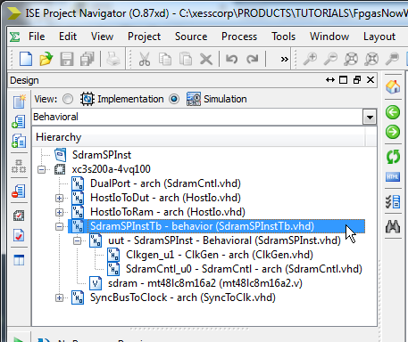
Now it's time to run the simulation. I highlight the SdramSPInstTb test bench module in the Hierarchy pane and double-click the Simulate Behavioral Model process in the Processes pane. The ISim window will appear. I type 202 uS into the simulation run-time field and click on the button to run the simulation. (The reason for the long simulation run-time is that the SDRAM has a 200uS initialization delay before it can perform any read/write operations.)
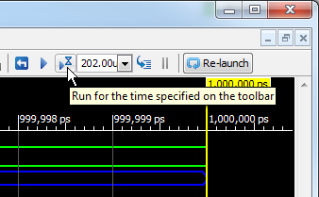
Looking at the simulation waveforms after the initialization period, you can see the five write operations as the sum-of-products circuit loads the SDRAM with data: 1 is written to address 1, 4 to address 2, 7 to address 3, and so on as in the example from the previous chapter.
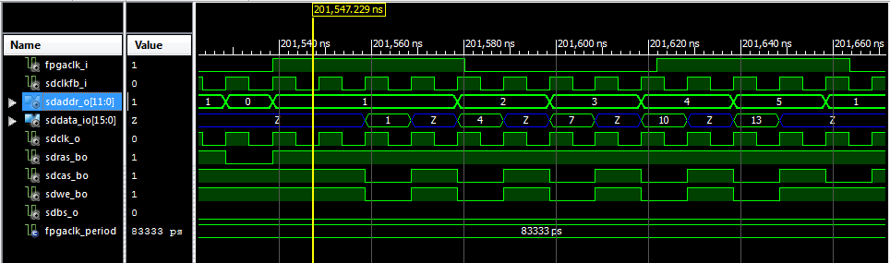
After the writes, the data is read back from the SDRAM. Notice that 1 is read from address 1, 4 from address 2, and so on. It appears the SDRAM Verilog model is working correctly for the basic read and write functions.
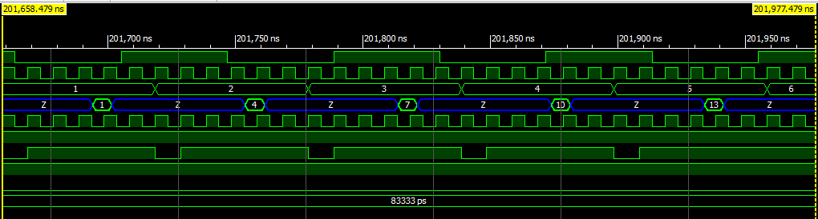
The final test of the SDRAM model is whether the computed sum-of-products value is correct. To check this, I highlight the uut instance in the Instance and Process Name pane and then look for the sum_r register in the Objects pane. There I see that the sum register contains the value of 135 at the end of the simulation. This matches the result I saw in the SDRAM example of the last chapter.
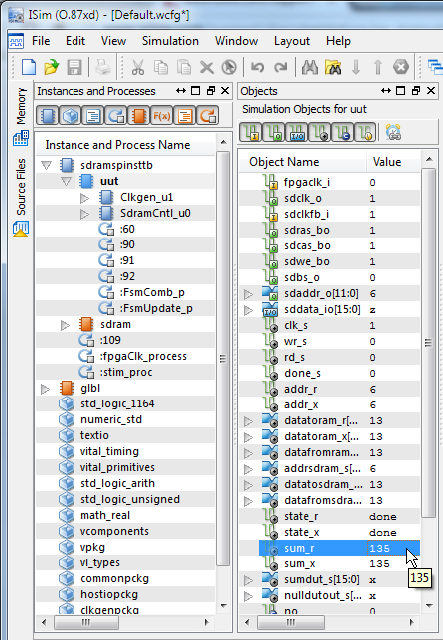
So to recap, here's what I did:
- Found a file containing a Verilog model for some circuit.
- Added the file to my project and associated it with simulation processes only.
- Opened the Verilog file and found the I/O declarations for the model.
- Created a component declaration in my VHDL code that has the same module name with the same I/O names, in the same order, and with the same vector widths.
- Instantiated and connected the module wherever it was needed just as if it was another VHDL component.
The example I've just described was done for simulation purposes. Is there any difference if I had wanted to include a Verilog module for actual implementation in my FPGA? Not really, except in that case I would want to associate that module with both simulation and implementation processes, rather than just simulation alone. Everything else would stay the same.

