- “I have a synthesizer. Now what?”

The “Hello, World” of FPGAs: the LED Blinker
Now that your WebPACK tools are installed, it's time to do your first FPGA design: an LED blinker. This blinker will take a 12 MHz square-wave clock signal (you'll see why in the next chapter) and slow it down so an LED will turn on-and-off about once per second (i.e., 1 Hz).
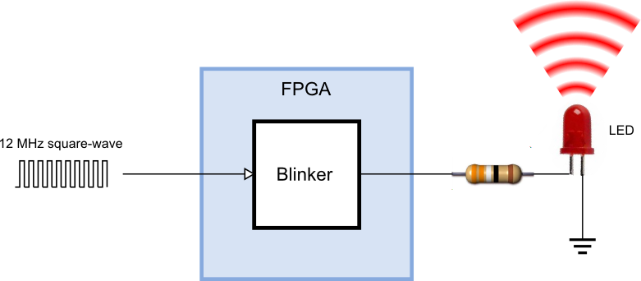

Starting a Design in WebPACK
You start WebPACK by double-clicking the  icon on the desktop. This will bring up an ISE Project Navigator window like the following one.
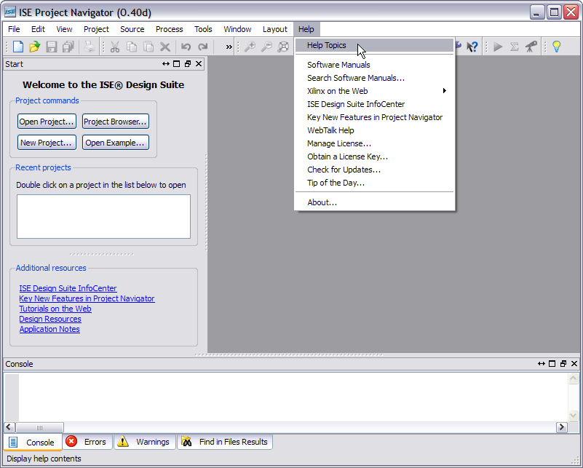
If this is your first time using Navigator, it's a good idea to click on the Help button and bring up the Project Navigator Overview. Read this to get an idea of what all the panes in the Navigator window are used for.
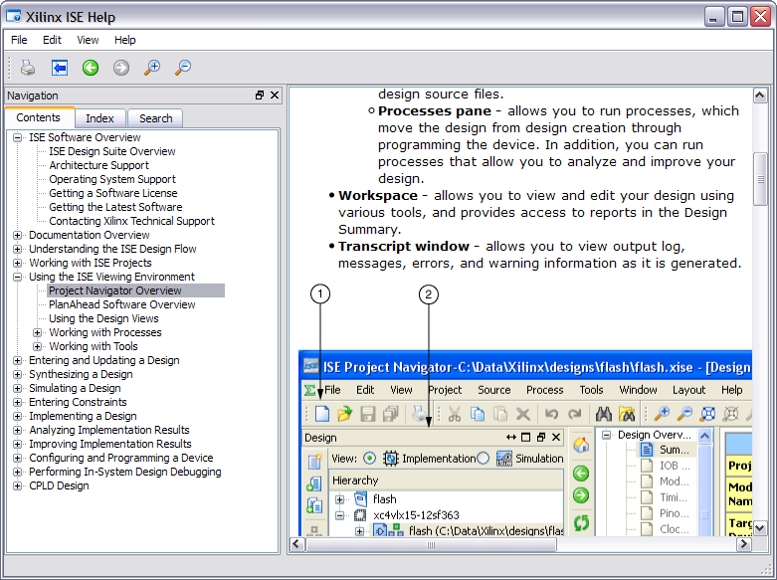
To start your LED blinker design, click on the New Project... button in the Navigator window.
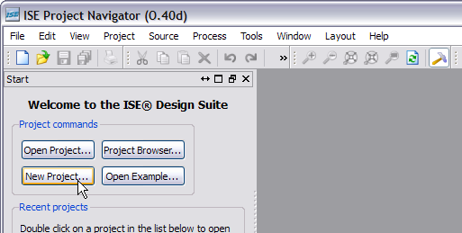
This will bring up the New Project Wizard. The first thing to do is select a location for your project. (The screenshot below shows my choice; yours, of course, will be different.)
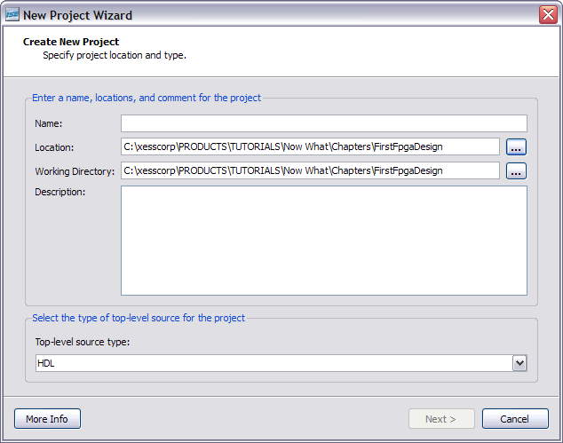
Then type in a name for the project. I've chosen “blinker”. (Notice how the project name is added to the end of the location you set previously. A folder with this name will be created there.) Then click on the Next button.
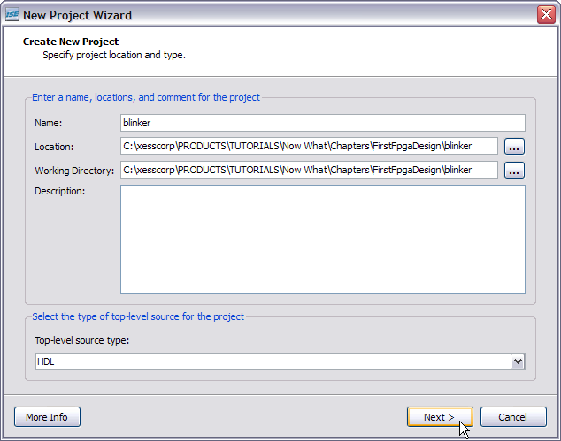
The next screen that appears is used to select the type of FPGA you want to use for your design (i.e., the target). Set the Family, Device, Package and Speed fields as shown below. (This sets up your design for the particular FPGA used on the XuLA board.) Also, change any other fields that don't match the screenshot. Then click the Next button
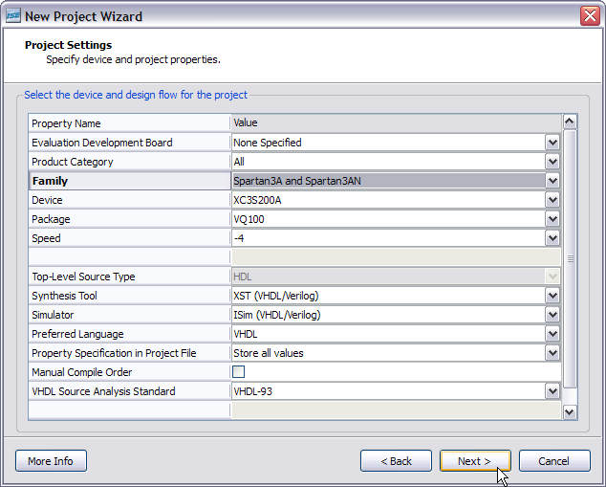
Now you'll get a summary of the information you've entered about your blinker design. Click on the Finish button and your new project will appear in the Navigator window.
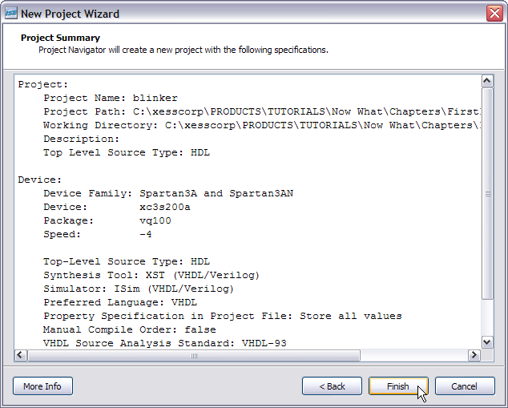

The Actual Blinker Design (in VHDL!)
At this point, your project exists, but it doesn't do anything. It's time to enter the source information that describes how the blinker operates. In the Navigator window, right-click on the FPGA identifier (xc3s200a-4vq100 in this design) in the Hierarchy pane and select New Source... from the drop-down menu.
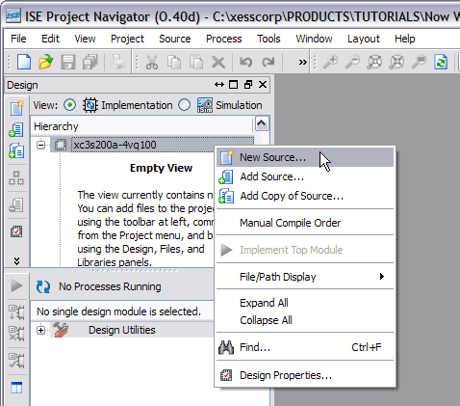
The New Source Wizard window appears. Here, you can select how you want to describe your design. For example, you could create the blinker from logic gates using schematics. Or maybe there is already a pre-built blinker circuit provided as an intellectual property (IP) core (don't bet on it!). But for this design, I will chose to use VHDL. VHDL (or Verilog, they're really quite similar) lets you describe the operations of logic designs using a high-level language. So, select VHDL Module from the list of source types. Then type a name for the VHDL source file. There will only be one for this simple design, so you can just name it “blinker”. Then click on the Next button
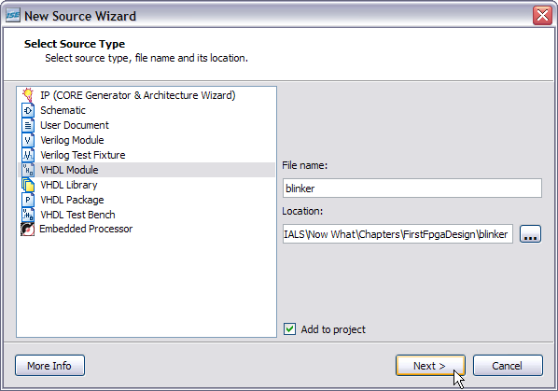
The next window that appears lets you define the input and output ports for the blinker design. Type “clk_i” into the first Port Name field. This will be the input for the 12 MHz clock signal. (The “_i” suffix on the port name is not necessary. I just use this notation to indicate which ports are inputs. That can help if I'm trying to figure out how an old design works if I haven't seen it for a few years.)
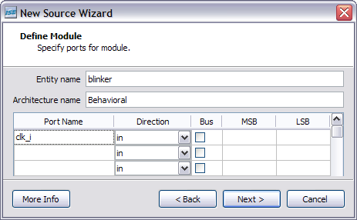
Then you can add the output that drives the LED. Name this “blinker_o” and set it to be an output using the Direction drop-down list as shown below.
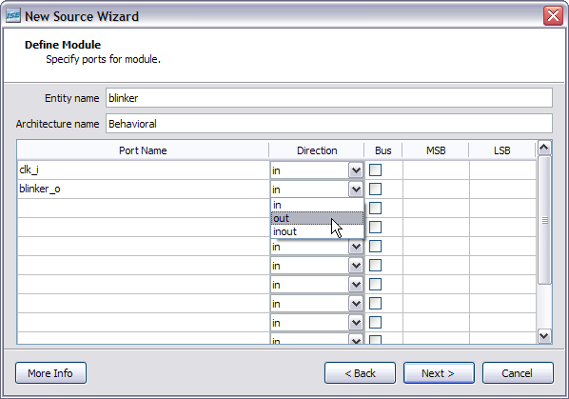
That's all the inputs and outputs you need. Click on the Next button and you'll get a summary of your VHDL module. No surprises there! Click on the Finish button to complete the module.
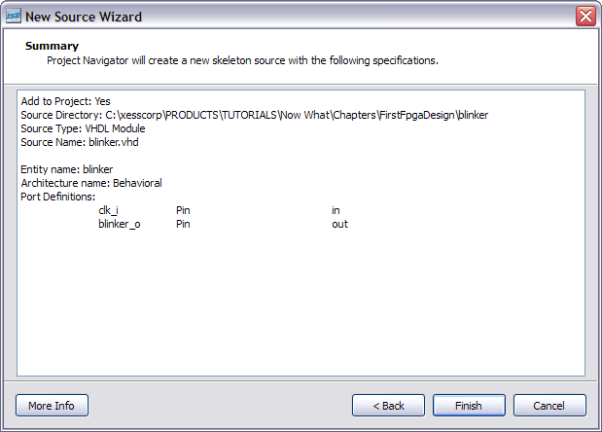
Now you should see the contents of your blinker VHDL module in the Navigator workspace pane to the right. (If you don't see it, click on the blinker.vhd tab along the bottom of the workspace.)
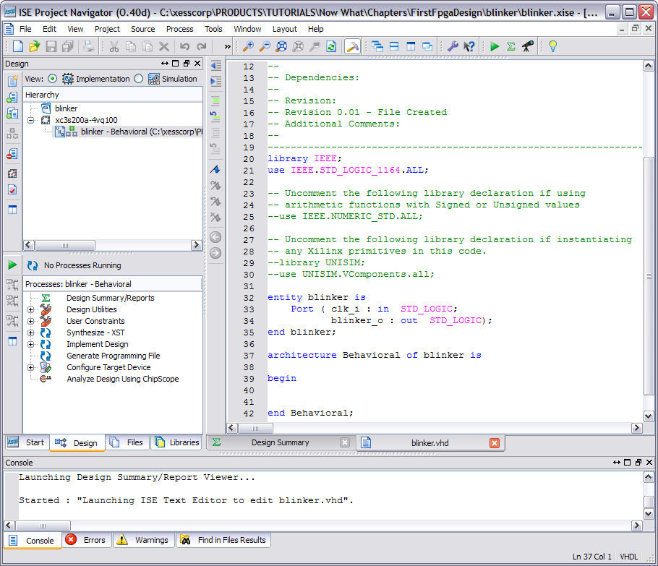
Most of the blinker.vhd file is comments, but there are a few spots you should look at:
Lines 20-21: These two lines open the STD_LOGIC_1164 package of the IEEE library. This library includes a bunch of useful functions and definitions and you'll see it included in most VHDL designs.
Lines 32-35: This is the entity section of the blinker where all the inputs and outputs are declared. This is like the skin of the module which defines how everyone on the outside will see the blinker.
Lines 37-42: This is the architecture section of the blinker where all the functions are defined. This portion is the guts of the design where the inputs are taken in, worked on, and then the result is passed out through the outputs. Notice, however, that the architecture section is conspicuously empty – the blinker will do nothing at this point!
So it's pretty clear that you need to put something into the architecture section to make the blinker work. A counter is a common component for reducing a 12 MHz clock down to a 1 Hz waveform. Why? Because a binary counter increments whenever the clock pulses and it goes through a binary sequence such as 000, 001, 010, 011, 100, 101, 110, 111, … If you look, you'll see that each bit of the counter pulses at half the frequency of the previous bit. (Look here for a better illustration of how binary counters work.) So if you build a counter with a enough bits, you can divide the 12 MHz clock downto 1 Hz.
But how many counter bits do you need? Well, a one-bit counter would divide the clock by two down to 6MHz. A two-bit counter would divide it by four downto 3 MHz. An N-bit counter would divide by 2^{N}. So what value of N would divide by 12,000,000? It turns out you can't get exactly 12,000,000, but you can get 8,388,608 if you use N=23, or you can get 16,777,216 with N=24. For no particularly good reason, let's use N=23.
Here's a more detailed view of the blinker design given what we just covered:
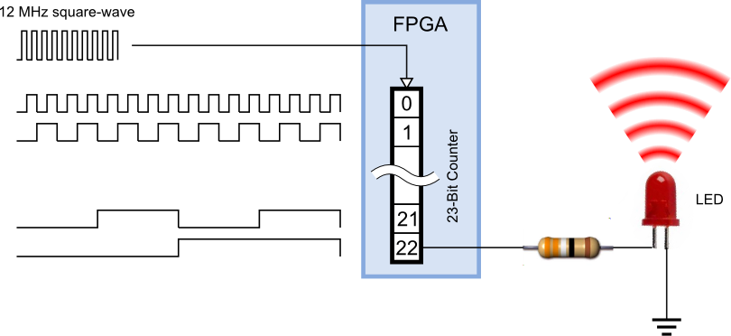
The 23-bit counter is incremented on the rising edge of the 12 MHz input clock. Bit 0 of the counter outputs a 6 MHz signal. (Why do we count the counter's bits starting from zero? BECAUSE THAT'S HOW ENGINEERS DO THINGS!!) Bit 1 outputs a 3 MHz signal. By the time we reach the final bit of the counter (bit 22), the signal is pulsing at a rate of 12,000,000 / 8,388,608 = 1.43 Hz. This bit is output from the FPGA and is connected to the LED. So the LED flashes once every 0.7 seconds.
Now all you have to do is describe this 23-bit counter in VHDL. That's not too hard. Here it is:
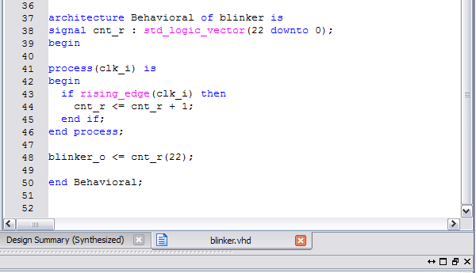
Here's what's going on in the architecture section:
Line 38: This is the declaration for the register (cnt_r) that holds the 23-bit count value. The value is represented as a vector of 23 binary digits with indexes from 22 down to 0. (I used the “_r” suffix to remind myself that this is a register.)
Lines 41-46: This is a process that is triggered every time the clock input changes its value, either on the rising edge (i.e., from 0 ⇨1) or the falling edge (1 ⇨0). Within the process is an if statement that increments the value in the count register only on the rising edges of the clock.
Line 48: The most-significant bit of the count register is attached to the blinker output.
That's all there is to it. Now let's see if it passes through the synthesizer.

Synthesizing the Blinker (or Not)
To run the synthesizer, left-click on the blinker icon in the Hierarchy pane. Once you do that, you should see a list possible operations appear in the Process pane. Double-click the Synthesize – XST process icon to start the VHDL synthesizer.
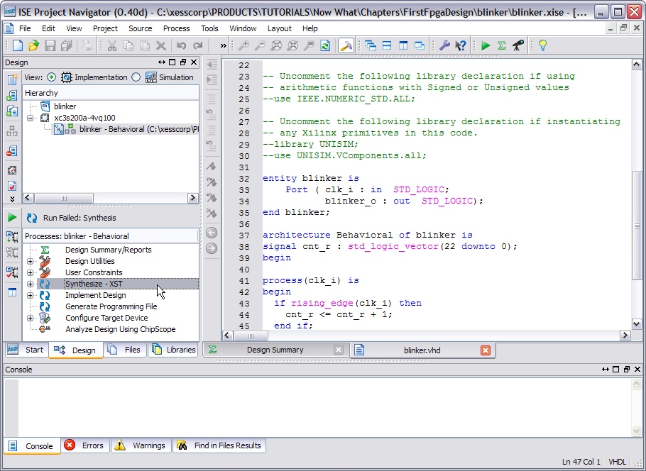

Within a few seconds you should see the results of the synthesis, and it isn't good. In the bottom portion of Navigator, you'll see this:
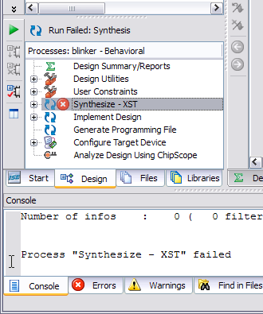
That red “X” is never a good sign. In this particular instance, it means the synthesizer has run into an error. As to what the error is, click on the Errors tab of the Transcript window to get the details.
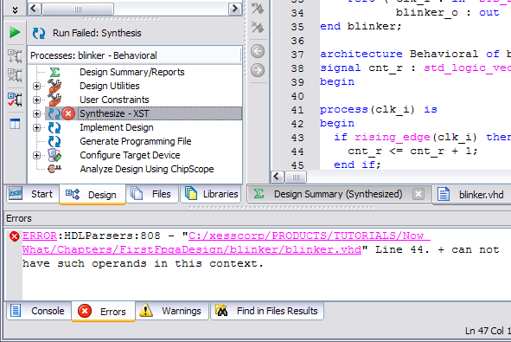
The synthesizer is telling you that the “+” operator cannot process its operands. In other words, there is no operation defined for adding an integer to a std_logic_vector. That's not a big problem; you just have to include the package that defines this particular addition operator. It turns out it's defined in the STD_LOGIC_UNSIGNED package, so just add what's shown on line 22 to the VHDL like so:
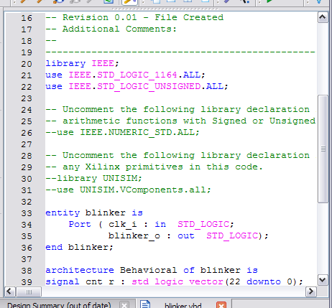
Save the file and double-click the Synthesize – XST process icon again. Now you should see the synthesis completed successfully.
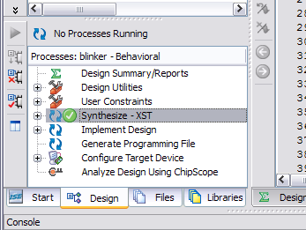
Now you have a netlist synthesized from your VHDL file. But does it work?

Testing the Logic
Before you charge off and run the implementation tools so you can blast your design into an FPGA to see if it works, it might be wise to take a little time to do a logic simulation. (Now I admit I always run the implementation tools and blast my designs into an FPGA to see if it works before even considering running a simulation, but you shouldn't emulate my bad habits.)
In order to simulate your design, you need something to exercise its inputs and watch its outputs. For your blinker design, you need an external wrapper that will apply a signal to the clock input and watch the output to see what it does. This wrapper is called a test bench.
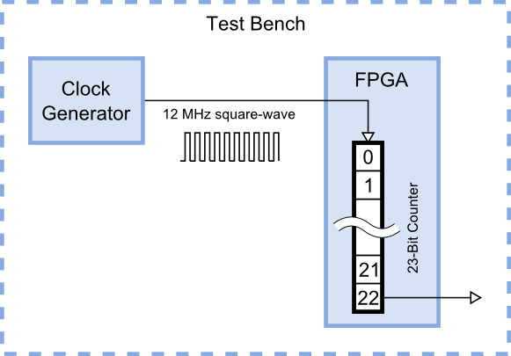
So you need to add a test bench to your project. To do this, right-click on the FPGA identifier in the Hierarchy pane and select New Source... in the pop-up menu. In the New Source Wizard window, select the VHDL Test Bench as the source type and name it “blinkerTestBench”. Then click on the Next button.
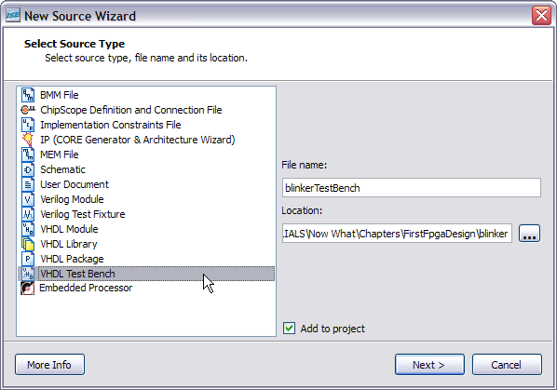
The next window that appears asks you to select a source file to associate with your test bench. Essentially, this is asking for the module to wrap the test bench around. There's only one module in your design (blinker), so that's your only choice. Click Next and move on.
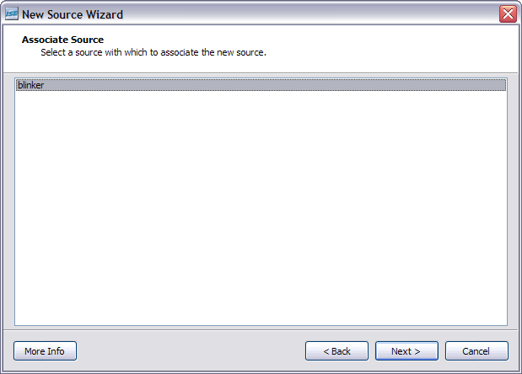
You'll get a summary screen about the choices you've made. Again, no surprises! Click on the Finish button to complete the addition of the test bench module.
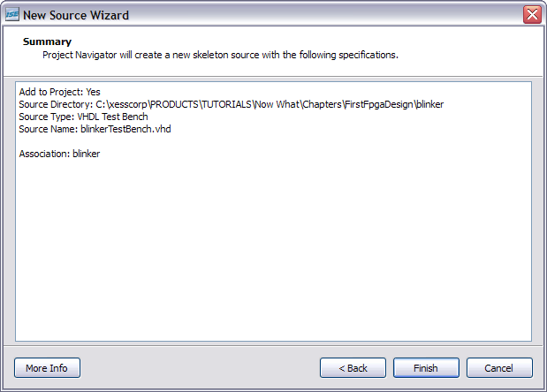
When you return to the Navigator screen, take a look at your Hierarchy pane. Where's the test bench you just added? It's not actually missing, it just doesn't show up in the Implementation view of your project. In order to see the test bench, you have to select Simulation in the View pane like so:
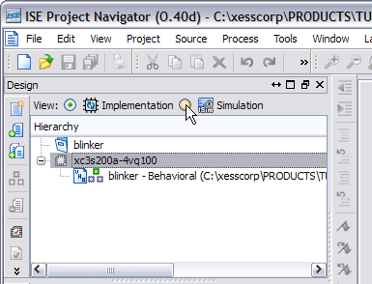
Once you select the Simulation view, the blinkerTestBench file shows up in the Hierarchy pane. The important point to note here is that the test bench module is not something that will ever be implemented and downloaded to the FPGA. In fact, it might be difficult or impossible to do so because the test bench might contain language constructs that are difficult or impossible to build in the FPGA (like accessing a file on the host computer to store test results). The test bench serves only to help in exercising the actual modules that will end up in the FPGA. Speaking of which, where is the blinker module?
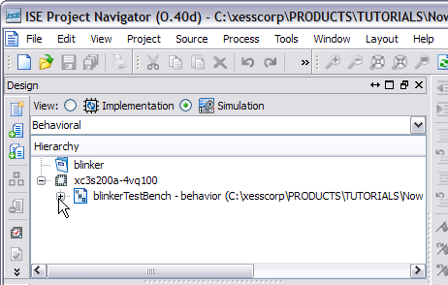
By clicking on the “+” sign next to the blinkerTestBench icon, you can see the blinker module is displayed as a submodule contained in the blinkerTestBench module. The blinker module is labeled “uut” in the test bench. This stands for “unit under test” to indicate the blinker module is what is being tested.
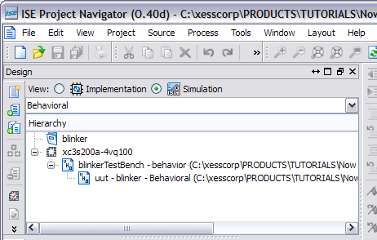
Now you'll want to double-click the blinkerTestBench file so you can add the VHDL code for exercising the blinker module. (It turns out you won't have to do much.) In the initial portion of the test bench file, you'll see the inclusion of the IEEE library (lines 28-29) and the entity declaration for the blinkerTestBench module. Notice that the entity section lists no inputs or outputs. That's because the test bench completely wraps the UUT and no inputs or outputs pierce the wrapper – everything happens inside the test bench.
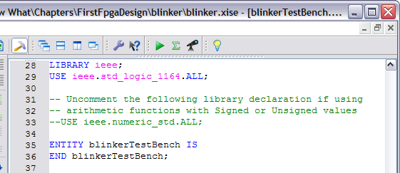
The architecture section (see the following figure) instantiates the blinker module as the UUT, connects to its inputs and outputs, and then drives the inputs. Here are the details:
Lines 42-47: This is a component declaration so the rest of the code knows what the interface to the blinker module looks like. Hence, it looks very similar to the blinker module entity section.
Lines 50-54: Signals internal to the test bench are declared that will be connected to the input and output ports of the blinker module.
Line 57: The period of the clock input is defined with the default value of 10 ns. Since you want to simulate the blinker with an input clock of 12 MHz, this constant should be changed to 83.3 ns.
Lines 62-65: The blinker module is instantiated here. Its input and output ports are connected to the similarly-named signals declared previously.
Lines 68-74: The clock signal is generated in by this process. The clock signal is forced to 0 and the process waits for half of the clock period. Then the clock is raised to 1 and the process waits for the remaining half of the clock period. Then the entire sequence repeats forever.
Lines 78-88: Test vectors for other inputs to the UUT can be generated in this process. Since the blinker module only has a clock input, there's nothing for this process to do. So leave it unchanged.
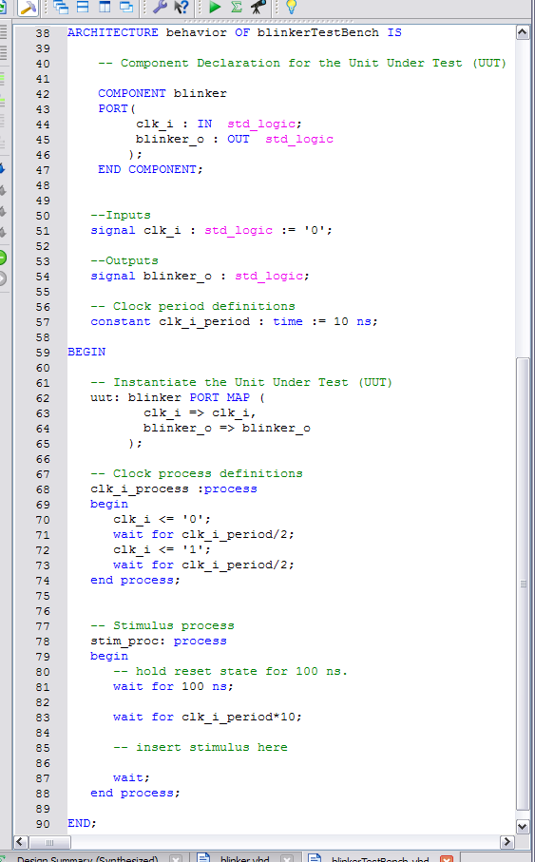
The test bench looks like it's ready, so it's time to run a simulation. Click on the blinkerTestBench entry in the Hierarchy pane, and then double-click the Simulate Behavioral Model in the Processes pane. (There's no need to run the Behavioral Check Syntax since only the clock period was changed.)
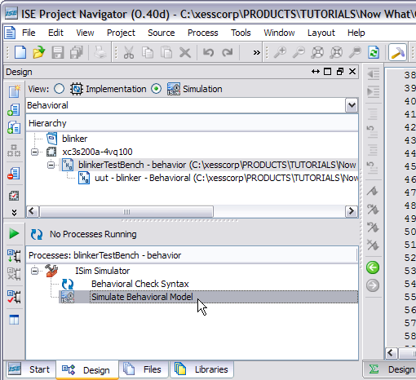
The ISim window will appear and display the results of a 1 μs simulation run. (Click on the View ⇨ Zoom ⇨ To Full View menu item to make the entire waveform visible.)
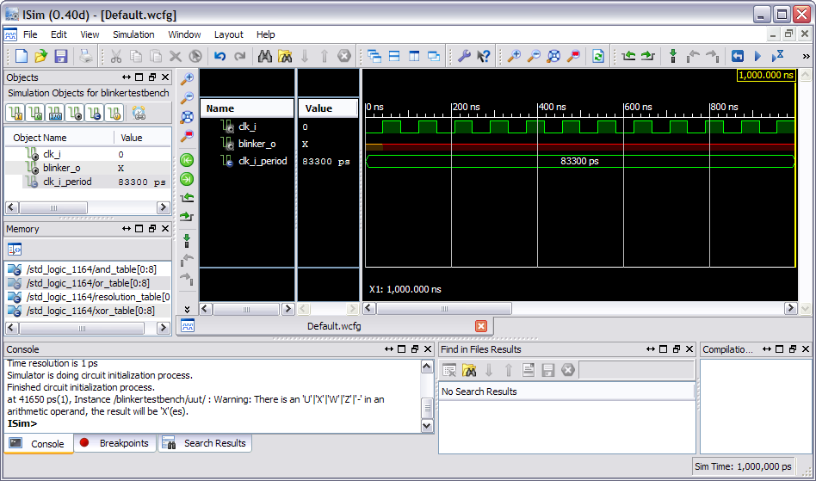
Although the simulation only ran for a microsecond, there's already something wrong about it. The blinker_o output remains in an unknown state (signified by an “X”) even after the clock signal has pulsed twelve times. It should have gone to one or zero after the first clock pulse.
This is a symptom of an initialization problem. In this case, the counter register is not initialized to a known value at the start of the simulation. Since the counter value is unknown, the simulator can't determine the next value it should contain when a rising clock edge occurs. So all the counter bits stay in an unknown state, including the counter bit attached to the blinker_o output.
How do you fix this? Well, the right way would be to build some reset circuitry in the blinker module that sets the counter register to zero when a reset input is triggered. Then the test bench could be modified to trigger the blinker module reset at the start of the simulation. But that's a lot of work. A simpler solution, but not recommended in general, is to initialize the counter register value when it is declared. To do this, double-click the blinker module in the Hierarchy pane of the Navigator window. This will open the blinker module. Then change the cnt_r declaration on line 39 to:
signal cnt_r : std_logic_vector(22 downto 0) := (others=>'0');
This will initialize all the counter register bits to zero. Save the blinker.vhd file. Then re-run the simulation by clicking on the Simulation ⇨ Relaunch menu item. Now the blinker_o output takes on a value of zero at the start of the simulation.
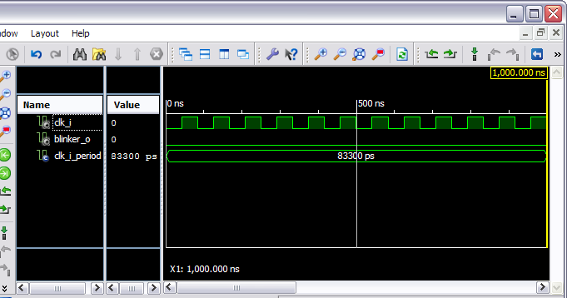
But you still don't know if the blinker output is going to do anything (except sit at zero) because the simulation duration is too small. The blinker output should pulse every 0.7 s, so a simulation time of 2.8 s will be enough to see four pulses. Enter “2.8s” into the simulation run-time field on the ISim toolbar and then click on the Run button.
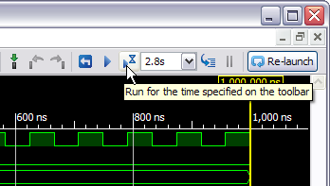
After a minute or two (because computing 2.8 s of simulation time takes a lot of work), the results of the simulation will appear. Use the View ⇨ Zoom ⇨ To Full View menu item to display the entire simulation. You can see that the blinker_o output pulses four times during the 2.8 s simulation, giving a period of 0.7 s. So the blinker seems to be working as expected.
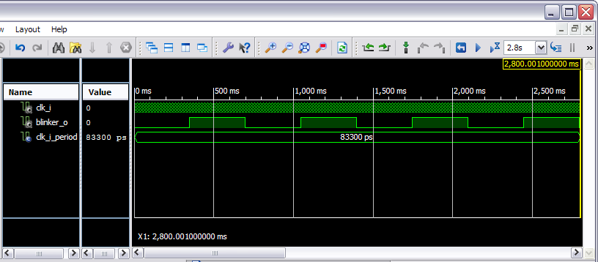
This chapter has been all software. Even the blinker, when it runs, is executing in software. That's not the reason you're interested in FPGAs, is it? No! - you want to build circuits that run in the real world. And that's what you'll do in the next chapter.

