- “I have a netlist. Now what?”

Physical Hardware – the XuLA Board
OK, you've designed the blinker in VHDL. You've synthesized it. You've simulated it and it seems to work. But, up to now, it's all been virtual. Now it's time to get physical.
To get the blinker design into the real world, you'll need an FPGA chip. But the FPGA chip isn't much good by itself because its usually in a surface-mount package that can't be plugged directly into a breadboard. And it needs some type of interface to download the bitstream from the host (where WebPACK is running). And it would be nice to have some ancillary circuitry around the FPGA for providing clock signals, etc. For these reasons, you'll probably need an FPGA development board. For this book, I've chosen the XuLA board, but you can use other boards for the same purpose.
Here's a picture of the front and back of the XuLA board. The FPGA is the big chip on the front below the “XuLA” logo. (No, it is not the quarter.)
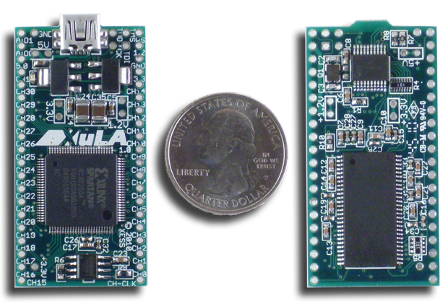
Here's a block diagram of what's on the XuLA board. You can safely ignore the most of the board's circuitry for now. I've highlighted the following parts that will be important for the blinker design:
FPGA: Of course the FPGA is important! I shouldn't need to explain why that is at this point. The FPGA is the Xilinx XC3S200A in a 100-pin QFP package (xc3s200a-4vq100), just like the one you selected when you started the blinker project in the last chapter.
Clock input: The XuLA board provides a 12 MHz square-wave clock to the FPGA. That will be the clock you'll use as the input to the blinker design.
Prototyping header: Some pins on the FPGA chip are connected to header pins around the outside of the XuLA board. These header pins are a convenient way to access signals from the FPGA when the XuLA board is inserted into a standard breadboard. You'll output the blinker_o signal on one of the FPGA pins that goes to this header and connect an external LED to it.
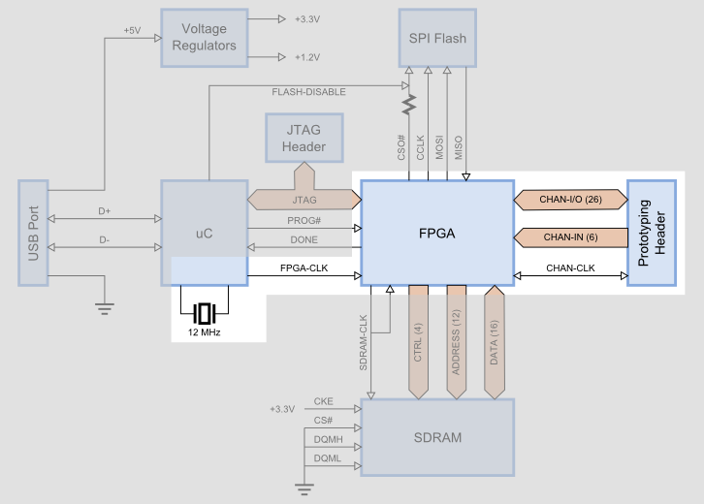
Finally, here's how the pins of the FPGA are assigned to the XuLA prototyping header. The FPGA pin numbers begin with a “p” so, for example, pin p50 of the FPGA is connected to the CHAN3 pin of the prototyping header.
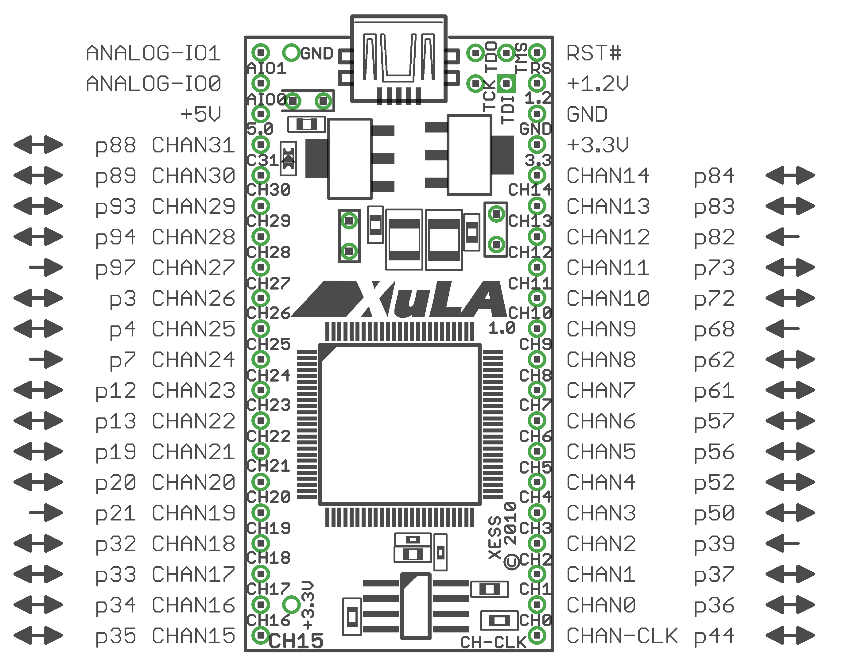

Assigning I/O Signals to FPGA Pins
Now that you know a little bit about the hardware that will be running your blinker design, you can proceed to the implementation phase. Open the ISE Project Navigator and return to the blinker project. Then move your project from simulation mode to implementation mode by clicking on the Implementation button in the Views pane.
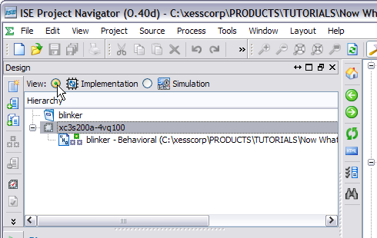
Before you can pass the synthesized netlist through the implementation tools, you'll need to tell them what pins of the FPGA will be used for the input and output ports of your blinker. Otherwise, the tools will just assign them to any pins it deems fit for the purpose. An Implementation Constraints File (sometimes called a User Constraints File or UCF) is used to assign I/O signals to the FPGA pins.
To add a constraints file to your project, right-click in the Hierarchy pane and select New Source... from the pop-up menu. In the New Source Wizard window, select Implementation Constraints File as the source type and give it the name “blinker”. (You don't have to give it the same name as the project, but I usually do.) Then click on the Next button.
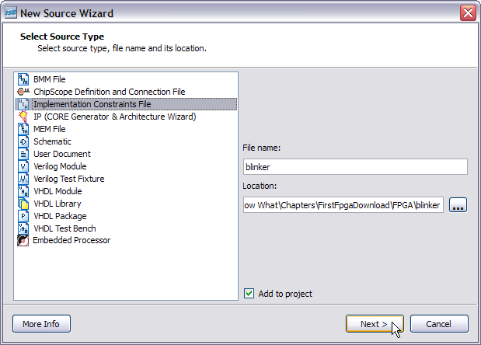
Another summary window will appear. Ho hum. Click on the Finish button and your constraints file will appear in the Hierarchy pane. Double-click on the constraints file and it will open in the workspace area to the right.
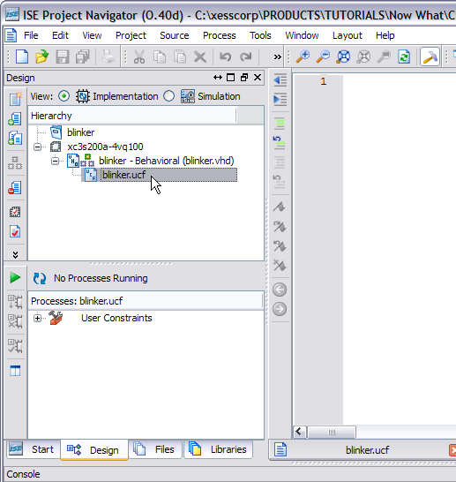
Type the following two lines into the blinker.ucf file and then save the file.
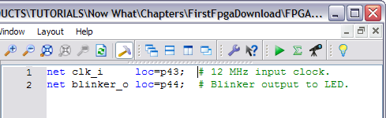
The first line assigns the clk_i net to pin location p43 of the FPGA. This is the pin that is driven by the 12 MHz clock on the XuLA board. (I know because I read the XuLA manual.) The implementation tools will look through the blinker netlist and see that clk_i is an input net, and then they will configure the IOB for p43 as an input buffer.
Similarly, the second line assigns output net blinker_o to pin location p44 whose IOB is then configured as an output driver. Why p44? Because that is one of the FPGA pins connected to the XuLA prototyping header. Pin p44 exits the XuLA board on the lower-right corner pin labeled “CHAN-CLK”.
That's all you need to do before running the implementation tools.

Doing the Implementation
After all this work, the actual implementation is going to be rather anticlimactic. To begin, highlight the blinker module in the Hierarchy pane. Then, double-click Implement Design in the Processes pane.
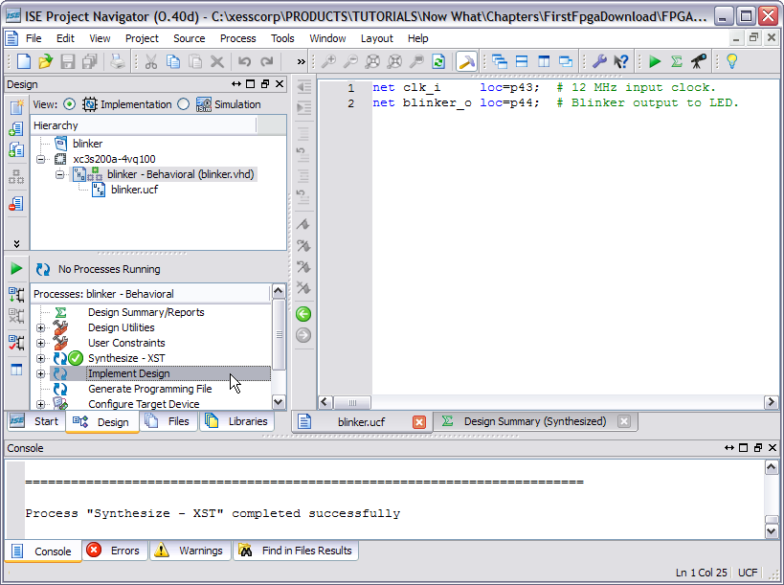
You'll see messages scrolling through the Console tab in the Transcript window. In less than a minute (depending upon the speed of your PC), the translation, mapping and place & route phases will be done and a green check-mark will appear. You have successfully implemented your blinker! Now you have to get it into a form that you can download into the FPGA.
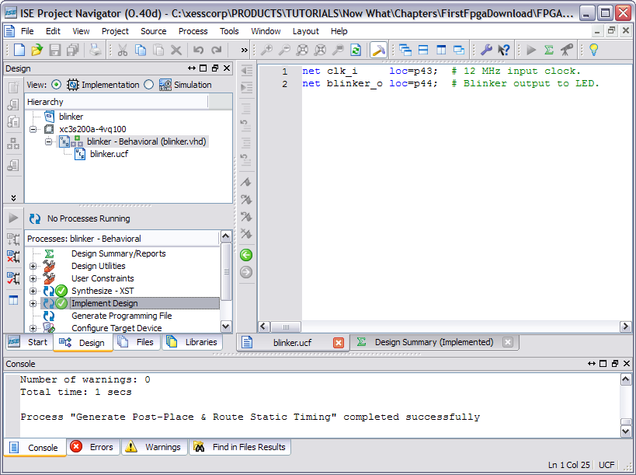

Preparing the Bitstream
To generate the bitstream, all you have to do is double-click Generate Programming File in the Processes pane. But don't do that yet!
First, you have to change some configuration settings to make the bitstream compatible with the XuLA board. To do this, right-click on Generate Programming File and select Process Properties... from the pop-up menu.
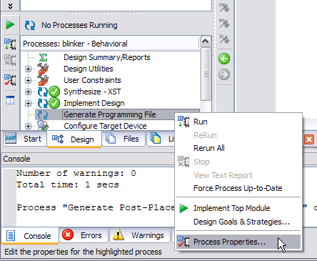
In the Process Properties window that appears, click on the Configuration Options category.
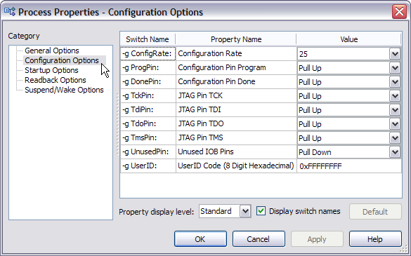
Then, click on the Unused IOB Pins drop-down menu and select Float from the list of options. This will cause all FPGA I/O pins that are not specifically used in your design to float in a high-impedance state.
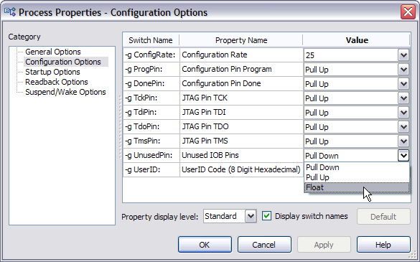
Now click on the Startup Options category and change the FPGA Start-Up Clock to JTAG clock. The FPGA on the XuLA board is programmed through the JTAG port and the clock that kickstarts your design right after downloading also comes through there. If you select any other option, your design will just sit in the FPGA and not do anything because it hasn't gotten a startup clock. This is always a good thing to check if you have a design that acts like that.
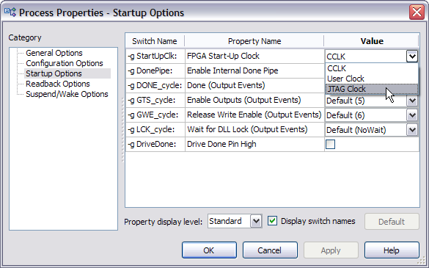
After setting these two options, click on the OK button and return to Navigator. Now you can double-click Generate Programming File to build the bitstream for the blinker project.
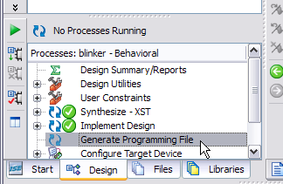
If the bitstream is generated successfully, you should be rewarded with the sight of three green check-marks!
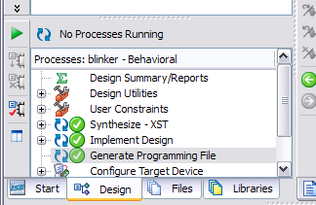
Now that you have the blinker project bitstream, we will leave Navigator and use a XuLA-specific tool to download the bitstream.

Installing the XSTOOLs Utilities
To download bitstreams to the XuLA board, you'll need to install the XSTOOLs utilities. You can download them here. After you download the installer, just double-click it and accept the default installation settings. You'll download the blinker bitstream to the XuLA board using the GXSLOAD utility that gets installed.

Connecting the XuLA Board
Before you download the bitstream, you'll need to hook a resistor and LED to the XuLA Board. This is relatively easy. First, insert a XuLA board into a breadboard.
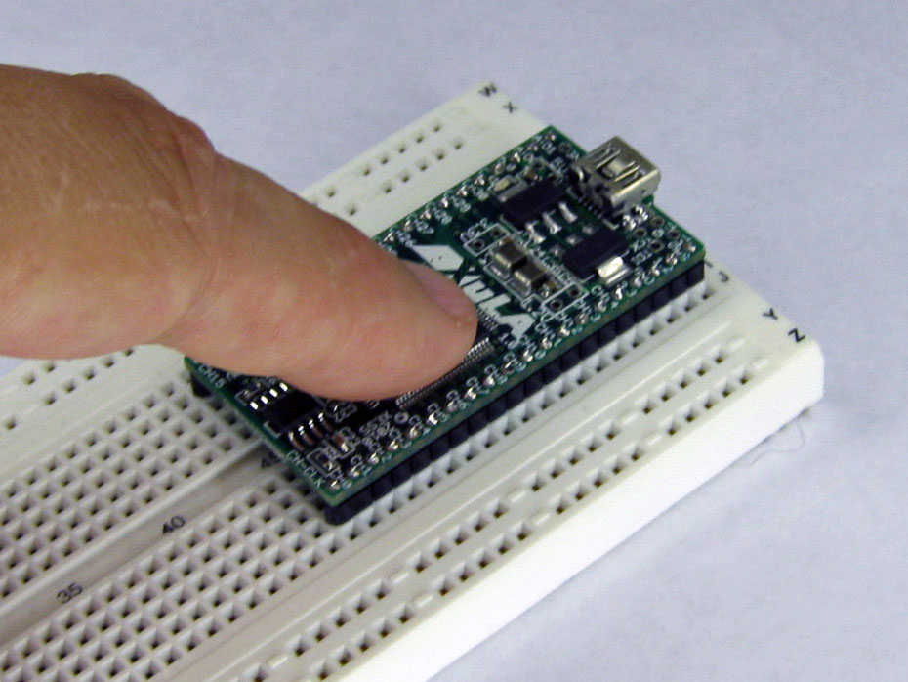
Then connect the ground connection of the XuLA board to the ground bus of the breadboard.
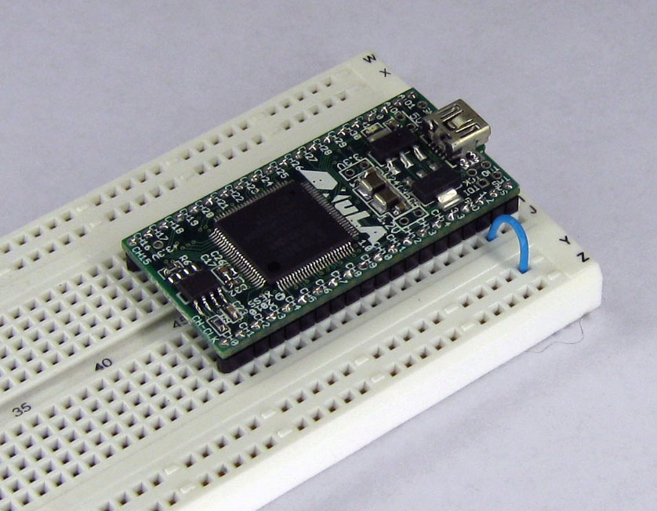
Add a resistor from the prototyping header pin that carries the blinker_o signal. (The resistor value can be anywhere in the range of 100Ω to 500Ω.)
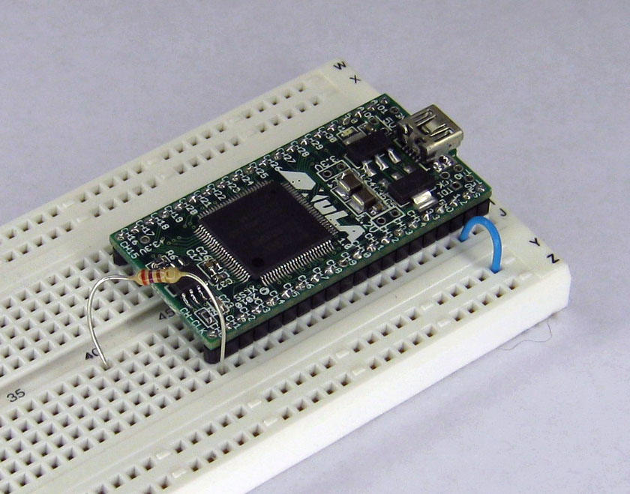
Insert an LED with the anode (the rounded side of the case) connected to the resistor and the cathode (the flat side of the case) plugged into an empty breadboard row. (I apologize – the leads on my diode were too short and you can't actually see where they plug into the breadboard.)
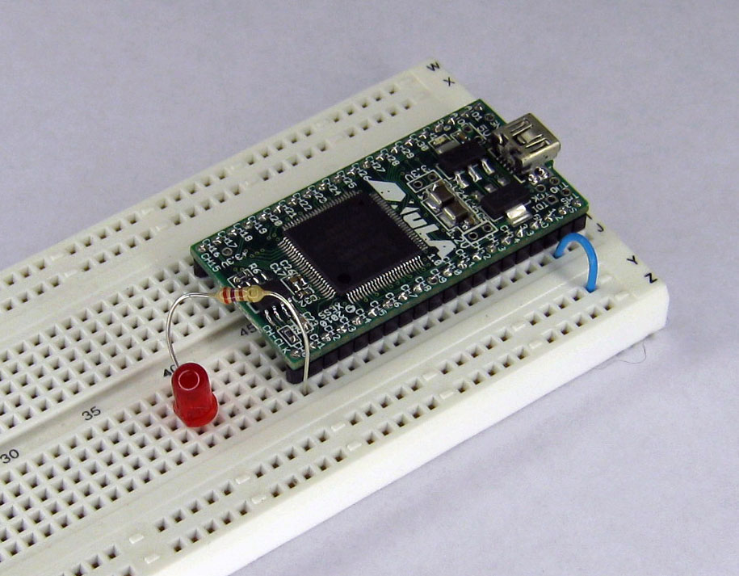
Then use a jumper wire to connect the LED's cathode to the ground bus.
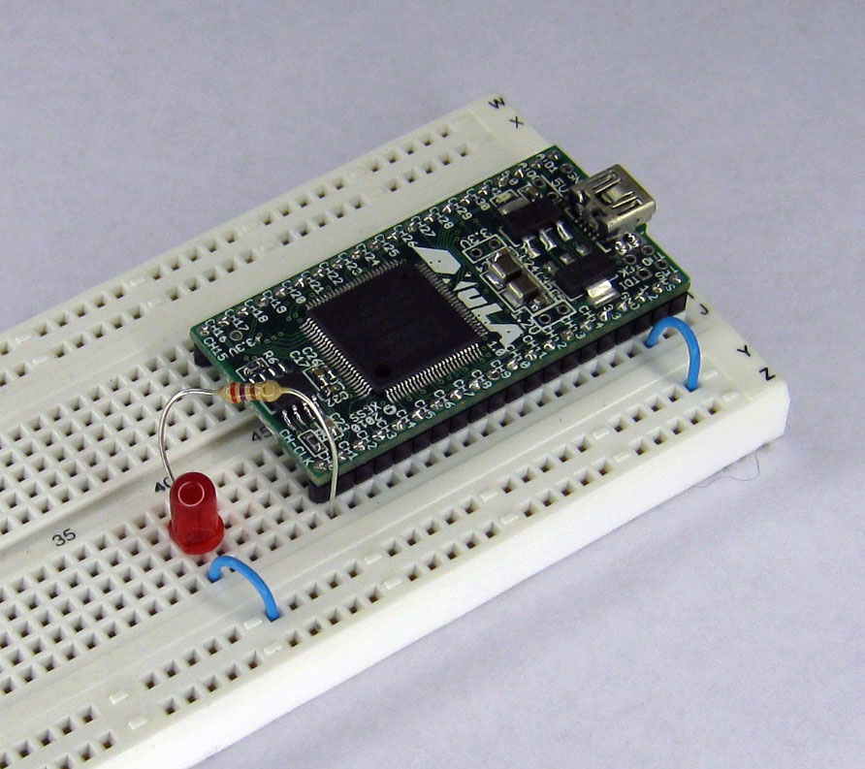
Finally, connect a mini-USB cable from the XuLA board to the PC that you installed the XSTOOLs utilities on.
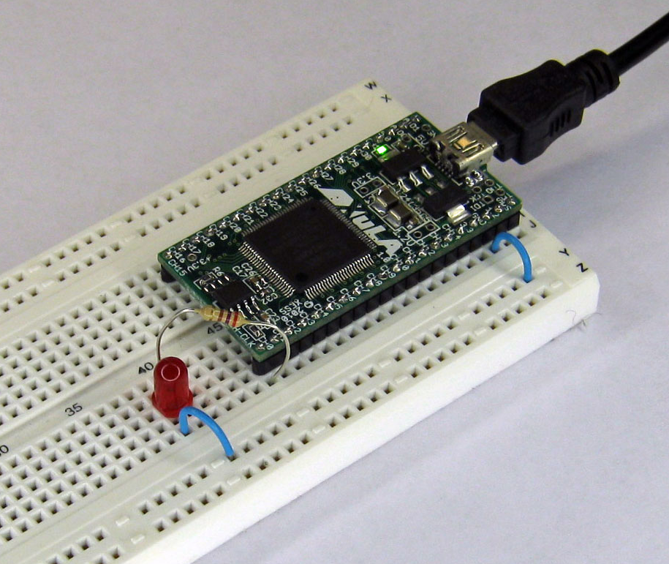
That's it! Time to dance.

Downloading the Blinker Bitstream
To begin the downloading process, double-click the  icon. This will bring up the following window:
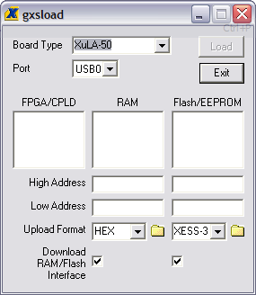
Select the Board Type using the drop-down list. Since the blinker project was targeted at the XC3S200A, then you must be using a XuLA-200 board. (If you were using a XuLA-50 board, then your target FPGA would have been the XC3S50A.)
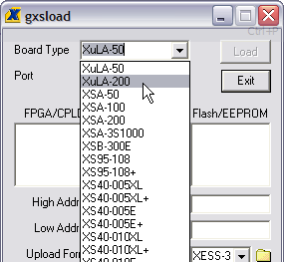
As for the Port, it should be set to USB0 (if you only have one XuLA board connected to the PC).
Next, open the folder where you stored your blinker project. Locate the blinker.bit bitstream file and drag-and-drop it into the FPGA/CPLD pane of the gxsload window.
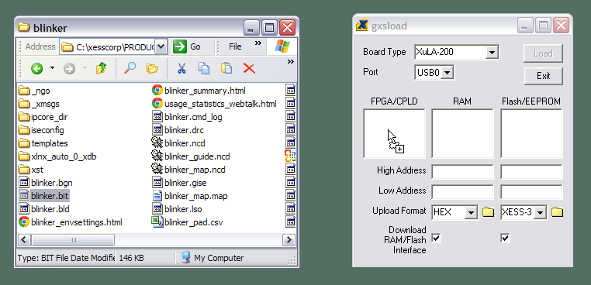
Once the bitstream file is dropped into the FPGA/CPLD pane, the Load button becomes active (i.e., it's no longer grayed-out). Just click on the Load button and the blinker bitstream will download from the PC into the FPGA on the XuLA board.
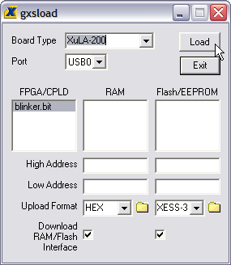
When the download begins, the green LED on the XuLA board will flash as the bitstream enters the FPGA. This LED will stop flashing once the complete bitstream has entered the FPGA. Then the blinker circuit will take control of the FPGA and it will start to blink the other LED you inserted into the breadboard. This video shows the downloading and operation of the blinker. If you time the flashing of the LED, you'll see it is pulsing once every 0.7 s as we hoped.
This completes your first design. You coded it, synthesized it, simulated it, implemented it, generated it, built it, downloaded it and ran it. You are officially an FPGA designer. A beginner, true, but an FPGA designer none the less.

