FPGAs!? Now What?
Learning FPGA Design with the XuLA Board
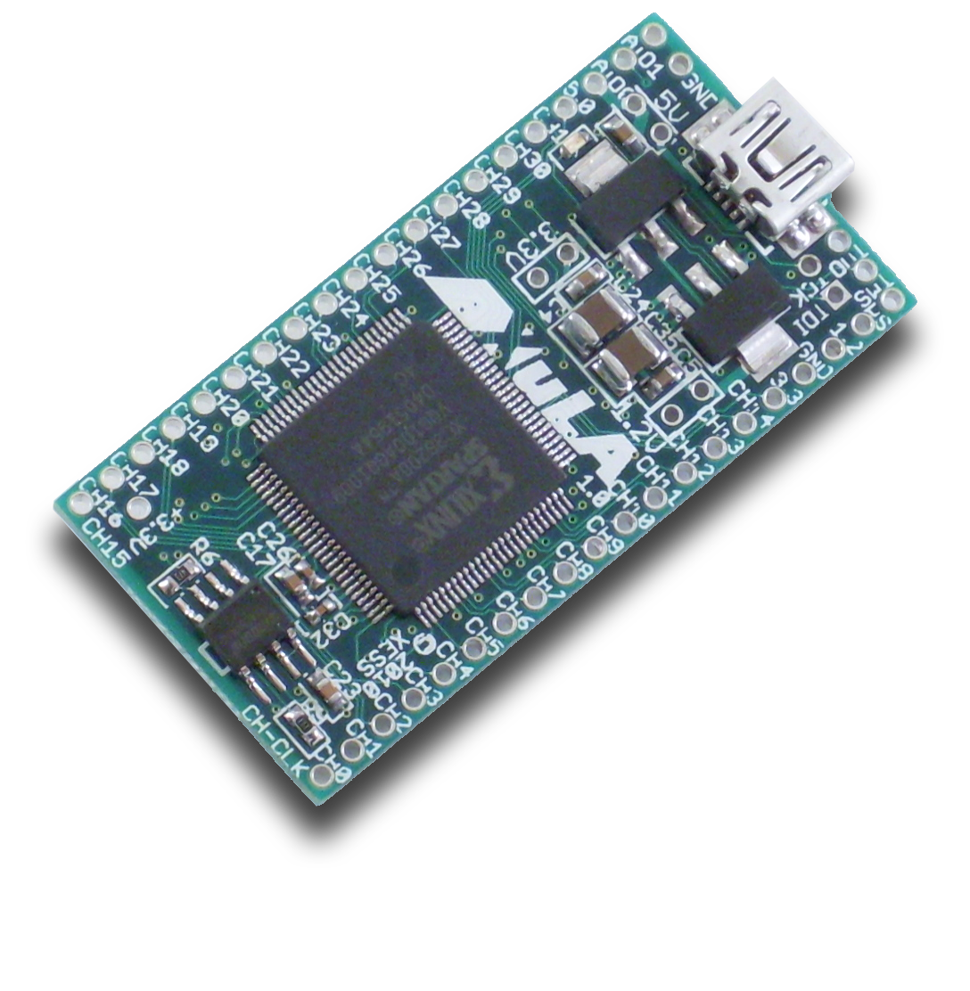

Dave Vandenbout, Ph.D.
XESS Corporation
© 2001–2011 XESS, Inc. XESS, the XESS logo, and other designated brands included herein are trademarks of XESS Corporation. All other trademarks are the property of their respective owners.
This document is licensed under the Attribution-ShareAlike 3.0 Unported license, available at http://creativecommons.org/licenses/by-sa/3.0/.
FPGAs!? Now What?
TUT001 (V1.0) June 24, 2011
The following table shows the revision history for this document.
Date | Version | Revision
06/24/11 | 1.0 | Initial release of Chapters 1-4.

Table of Contents

