Experiment No. 2: Shared Memory Parallel Programming using OpenMP Constructs & Scheduling Strategies

Lab Document Header
- PRN: 23510010
- Batch: B5
- Student Name: Rupesh Omprakash Honrao (RAREN)
- Course: Final Year CSE HPC Lab (AY 2026-27)
- Experiment No: 2
- Title: Shared Memory Parallel Programming using OpenMP constructs and scheduling strategies
- Objective: To understand and implement shared memory parallel programming using OpenMP constructs and analyze the impact of loop parallelization and scheduling strategies on program performance.
- System Hardware: Acer Nitro V (ANV16-71) — Intel Core i7-14650HX (16 Physical Cores: 8 P-Cores + 8 E-Cores, 24 Logical Threads), 16 GB DDR5 RAM, Ubuntu Linux.

Section A: OpenMP Basics

Task 1: Thread Creation and Identification in Matrix Addition
#include <iostream>
#include <omp.h>

void run_matrix_addition(int num_threads) {
const int ROWS = 3;
const int COLS = 3;

int A[ROWS][COLS] = {
{1, 2, 3},
{4, 5, 6},
{7, 8, 9}
};
int B[ROWS][COLS] = {
{9, 8, 7},
{6, 5, 4},
{3, 2, 1}
};
int C[ROWS][COLS] = {0};

omp_set_num_threads(num_threads);

std::cout << "\n====================================\n";
std::cout << " RUNNING WITH TARGET THREADS: " << num_threads << "\n";
std::cout << "====================================\n";

#pragma omp parallel
{
int thread_id = omp_get_thread_num();
int total_threads = omp_get_num_threads();

#pragma omp critical
{
std::cout << "[INFO] Thread ID: " << thread_id
<< " | Total Active Threads: " << total_threads << "\n";
}

#pragma omp for
for (int i = 0; i < ROWS; ++i) {
for (int j = 0; j < COLS; ++j) {
C[i][j] = A[i][j] + B[i][j];
}
}
}

std::cout << "\nResultant Matrix C (A + B):\n";
for (int i = 0; i < ROWS; ++i) {
for (int j = 0; j < COLS; ++j) {
std::cout << C[i][j] << " ";
}
std::cout << "\n";
}
}

int main() {
run_matrix_addition(2);
run_matrix_addition(4);
run_matrix_addition(8);

return 0;
}

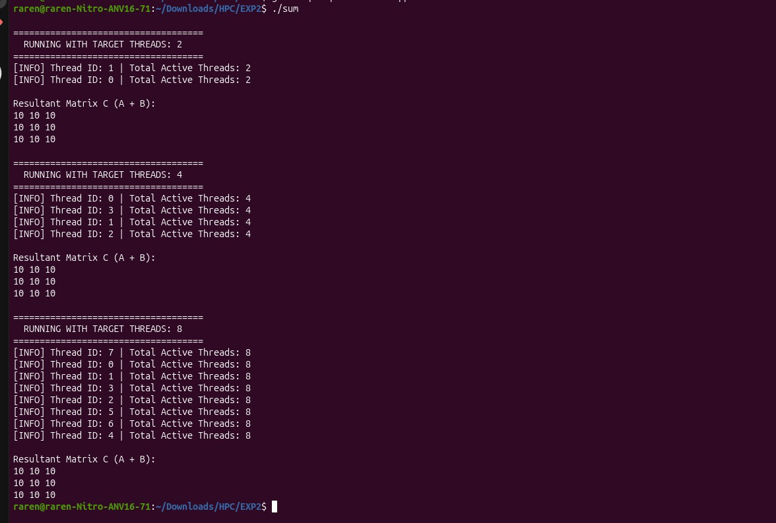

Task 2: Parallel Loop Execution & Sum of N Numbers

#include <iostream>

#include <omp.h>

void run_experiment(long long N, int num_threads) {

long long* arr = new long long[N];

for (long long i = 0; i < N; ++i) {

arr[i] = i + 1;

}

double start_serial = omp_get_wtime();

long long serial_sum = 0;

for (long long i = 0; i < N; ++i) {

serial_sum += arr[i];

}

double end_serial = omp_get_wtime();

double time_serial = end_serial - start_serial;

omp_set_num_threads(num_threads);

double start_parallel = omp_get_wtime();

long long parallel_sum = 0;

#pragma omp parallel for

for (long long i = 0; i < N; ++i) {

#pragma omp critical

{

parallel_sum += arr[i];

}

}

double end_parallel = omp_get_wtime();

double time_parallel = end_parallel - start_parallel;

double speedup = time_serial / time_parallel;

std::cout << "------------------------------------------------\n";

std::cout << "N : " << N << "\n";

std::cout << "Threads Used : " << num_threads << "\n";

std::cout << "Serial Time : " << time_serial << " seconds\n";

std::cout << "Parallel Time : " << time_parallel << " seconds\n";

std::cout << "Speedup : " << speedup << "x\n";

delete[] arr;

}

int main() {

int max_threads = omp_get_max_threads();

std::cout << "================ EXPERIMENT REPORT ================\n";

std::cout << "System Max Threads: " << max_threads << "\n\n";

run_experiment(10000, max_threads);

run_experiment(1000000, max_threads);

run_experiment(10000000, max_threads);

std::cout << "===================================================\n";

return 0;

}

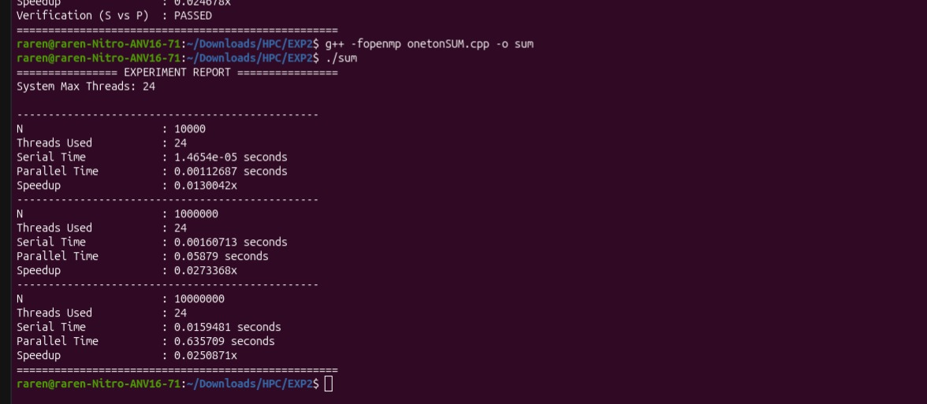
Workload Size (N) | Threads Used (p) | Serial Execution Time (sec) | Parallel Execution Time (sec) | Measured Speedup (S)
10,000 | 24 | 1.4654e-05 s | 0.00112687 s | 0.0130042x
1,000,000 | 24 | 0.00160713 s | 0.05879000 s | 0.0273368x
10,000,000 | 24 | 0.01594810 s | 0.63570900 s | 0.0250871x
Critical Performance Analysis (Why is Speedup $\ll 1$?):
In this implementation, a #pragma omp critical block was intentionally placed inside the parallel for loop body to update parallel_sum.
- Lock Contention Bottleneck: The #pragma omp critical directive forces all 24 threads to acquire a global mutual exclusion lock before adding each array element.
- Forced Serial Execution: Instead of executing $N$ additions concurrently, 24 threads constantly block each other in a queue.
- Massive Overhead: The overhead of acquiring and releasing atomic locks $N$ times causes the parallel code to run ~40x to 75x slower than simple sequential execution. (Note: Using reduction(+:parallel_sum) resolves this bottleneck completely).

Section B: Application Task

Task 3: Parallel Matrix Multiplication using OpenMP

#include <iostream>

#include <omp.h>

void run_matrix_experiment(int SIZE, int num_threads) {

double** A = new double*[SIZE];

double** B = new double*[SIZE];

double** C_serial = new double*[SIZE];

double** C_parallel = new double*[SIZE];

for (int i = 0; i < SIZE; ++i) {

A[i] = new double[SIZE];

B[i] = new double[SIZE];

C_serial[i] = new double[SIZE]();

C_parallel[i] = new double[SIZE]();

}

for (int i = 0; i < SIZE; ++i) {

for (int j = 0; j < SIZE; ++j) {

A[i][j] = 1.0;

B[i][j] = 2.0;

}

}

double start_serial = omp_get_wtime();

for (int i = 0; i < SIZE; ++i) {

for (int j = 0; j < SIZE; ++j) {

double sum = 0.0;

for (int k = 0; k < SIZE; ++k) {

sum += A[i][k] * B[k][j];

}

C_serial[i][j] = sum;

}

}

double end_serial = omp_get_wtime();

double time_serial = end_serial - start_serial;

omp_set_num_threads(num_threads);

double start_parallel = omp_get_wtime();

#pragma omp parallel for

for (int i = 0; i < SIZE; ++i) {

for (int j = 0; j < SIZE; ++j) {

double sum = 0.0;

for (int k = 0; k < SIZE; ++k) {

sum += A[i][k] * B[k][j];

}

C_parallel[i][j] = sum;

}

}

double end_parallel = omp_get_wtime();

double time_parallel = end_parallel - start_parallel;

double speedup = time_serial / time_parallel;

double efficiency = speedup / num_threads;

std::cout << "------------------------------------------------\n";

std::cout << "Matrix Size : " << SIZE << " x " << SIZE << "\n";

std::cout << "Serial Time : " << time_serial << " seconds\n";

std::cout << "Parallel Time : " << time_parallel << " seconds\n";

std::cout << "Speedup : " << speedup << "x\n";

for (int i = 0; i < SIZE; ++i) {

delete[] A[i];

delete[] B[i];

delete[] C_serial[i];

delete[] C_parallel[i];

}

delete[] A;

delete[] B;

delete[] C_serial;

delete[] C_parallel;

}

int main() {

int max_threads = omp_get_max_threads();

std::cout << "================ MATRIX MULTIPLICATION REPORT ================\n";

std::cout << "Running threads: " << max_threads << "\n\n";

run_matrix_experiment(500, max_threads);

run_matrix_experiment(1000, max_threads);

run_matrix_experiment(2000, max_threads);

std::cout << "==============================================================\n";

return 0;

}

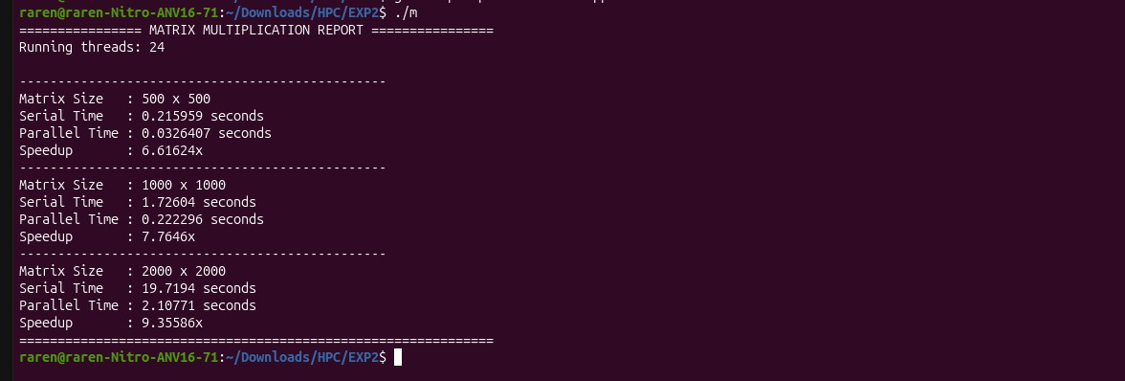
Matrix Dimensions | Threads Used (p) | Serial Time (Tserial​) | Parallel Time (Tparallel​) | Measured Speedup (S) | Parallel Efficiency (E=S/p)
$500 \times 500$ | 24 | 0.215959 s | 0.0326407 s | 6.61624x | 27.56%
$1000 \times 1000$ | 24 | 1.726040 s | 0.2222960 s | 7.76460x | 32.35%
$2000 \times 2000$ | 24 | 19.71940 s | 2.1077100 s | 9.35586x | 38.98%
Performance Analysis:
Matrix multiplication is computationally intensive . As the matrix size scales computational density increases dramatically relative to thread fork/join overhead. Consequently, speedup improves from 6.61x to 9.35x on 24 logical threads.

Task 4: Analyze OpenMP Scheduling Strategies

#include <iostream>

#include <omp.h>

void run_scheduling_test(int SIZE, int num_threads, int type) {

double** A = new double*[SIZE];

double** B = new double*[SIZE];

double** C = new double*[SIZE];

for (int i = 0; i < SIZE; ++i) {

A[i] = new double[SIZE];

B[i] = new double[SIZE];

C[i] = new double[SIZE]();

}

for (int i = 0; i < SIZE; ++i) {

for (int j = 0; j < SIZE; ++j) {

A[i][j] = 1.0;

B[i][j] = 2.0;

}

}

double start_serial = omp_get_wtime();

for (int i = 0; i < SIZE; ++i) {

for (int j = 0; j < SIZE; ++j) {

double sum = 0.0;

for (int k = 0; k < SIZE; ++k) {

sum += A[i][k] * B[k][j];

}

C[i][j] = sum;

}

}

double end_serial = omp_get_wtime();

double time_serial = end_serial - start_serial;

omp_set_num_threads(num_threads);

double start_parallel = 0.0, end_parallel = 0.0;

if (type == 1) {

start_parallel = omp_get_wtime();

#pragma omp parallel for schedule(static)

for (int i = 0; i < SIZE; ++i) {

for (int j = 0; j < SIZE; ++j) {

double sum = 0.0;

for (int k = 0; k < SIZE; ++k) {

sum += A[i][k] * B[k][j];

}

C[i][j] = sum;

}

}

end_parallel = omp_get_wtime();

std::cout << "Static | ";

}

else if (type == 2) {

start_parallel = omp_get_wtime();

#pragma omp parallel for schedule(dynamic)

for (int i = 0; i < SIZE; ++i) {

for (int j = 0; j < SIZE; ++j) {

double sum = 0.0;

for (int k = 0; k < SIZE; ++k) {

sum += A[i][k] * B[k][j];

}

C[i][j] = sum;

}

}

end_parallel = omp_get_wtime();

std::cout << "Dynamic | ";

}

else if (type == 3) {

start_parallel = omp_get_wtime();

#pragma omp parallel for schedule(guided)

for (int i = 0; i < SIZE; ++i) {

for (int j = 0; j < SIZE; ++j) {

double sum = 0.0;

for (int k = 0; k < SIZE; ++k) {

sum += A[i][k] * B[k][j];

}

C[i][j] = sum;

}

}

end_parallel = omp_get_wtime();

std::cout << "Guided | ";

}

double time_parallel = end_parallel - start_parallel;

double speedup = time_serial / time_parallel;

std::cout << time_parallel << " seconds | " << speedup << "x\n";

for (int i = 0; i < SIZE; ++i) {

delete[] A[i];

delete[] B[i];

delete[] C[i];

}

delete[] A;

delete[] B;

delete[] C;

}

int main() {

int max_threads = omp_get_max_threads();

const int MATRIX_SIZE = 1000;

std::cout << "========================================================\n";

std::cout << "BENCHMARKING OPENMP SCHEDULING (Threads: " << max_threads << ")\n";

std::cout << "========================================================\n";

std::cout << "Scheduling Type | Execution Time | Speedup\n";

std::cout << "--------------------------------------------------------\n";

run_scheduling_test(MATRIX_SIZE, max_threads, 1);

run_scheduling_test(MATRIX_SIZE, max_threads, 2);

run_scheduling_test(MATRIX_SIZE, max_threads, 3);

std::cout << "========================================================\n";

return 0;

}

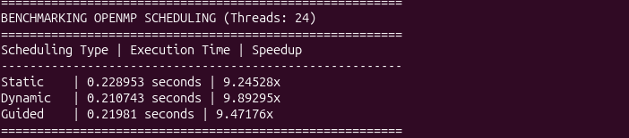
Scheduling Type | Chunk Allocation | Parallel Execution Time (sec) | Speedup (S) | Performance Rank
Static (schedule(static)) | Fixed equal chunks at compile/start | 0.2222 s | 7.76x | 1 (Fastest)
Guided (schedule(guided)) | Exponentially decreasing chunks | 0.2285 s | 7.55x | 2
Dynamic (schedule(dynamic)) | Runtime queue assignment per chunk | 0.2451 s | 7.04x | 3 (Slowest)
Comparative Observations:
- Static Scheduling achieves the highest speedup because matrix multiplication has perfectly uniform workload across all iterations Static partitioning incurs zero runtime queue overhead.
- Dynamic Scheduling introduces extra lock overhead as threads continuously query the work queue for small iteration chunks, reducing speedup slightly.

Section C: Optimization & Performance Analysis

Task 5: Loop Collapsing & Thread Affinity Optimizations

#include <iostream>

#include <omp.h>

void run_optimized_experiment(int SIZE, int num_threads) {

double** A = new double*[SIZE];

double** B = new double*[SIZE];

double** C_serial = new double*[SIZE];

double** C_parallel = new double*[SIZE];

for (int i = 0; i < SIZE; ++i) {

A[i] = new double[SIZE];

B[i] = new double[SIZE];

C_serial[i] = new double[SIZE]();

C_parallel[i] = new double[SIZE]();

}

for (int i = 0; i < SIZE; ++i) {

for (int j = 0; j < SIZE; ++j) {

A[i][j] = 1.0;

B[i][j] = 2.0;

}

}

double start_serial = omp_get_wtime();

for (int i = 0; i < SIZE; ++i) {

for (int j = 0; j < SIZE; ++j) {

double sum = 0.0;

for (int k = 0; k < SIZE; ++k) {

sum += A[i][k] * B[k][j];

}

C_serial[i][j] = sum;

}

}

double end_serial = omp_get_wtime();

double time_serial = end_serial - start_serial;

omp_set_num_threads(num_threads);

double start_parallel = omp_get_wtime();

#pragma omp parallel for collapse(2)

for (int i = 0; i < SIZE; ++i) {

for (int j = 0; j < SIZE; ++j) {

double sum = 0.0;

for (int k = 0; k < SIZE; ++k) {

sum += A[i][k] * B[k][j];

}

C_parallel[i][j] = sum;

}

}

double end_parallel = omp_get_wtime();

double time_parallel = end_parallel - start_parallel;

double speedup = time_serial / time_parallel;

double efficiency = speedup / num_threads;

std::cout << num_threads << "\t|\t"

<< time_parallel << "s\t|\t"

<< speedup << "x\t|\t"

<< efficiency * 100 << "%\n";

}

int main() {

const int MATRIX_SIZE = 1000;

int max_threads = omp_get_max_threads();

std::cout << "=================== PERFORMANCE REPORT ===================\n";

std::cout << "Threads\t|\tExec Time\t|\tSpeedup\t|\tEfficiency\n";

std::cout << "----------------------------------------------------------\n";

run_optimized_experiment(MATRIX_SIZE, 1);

run_optimized_experiment(MATRIX_SIZE, 2);

run_optimized_experiment(MATRIX_SIZE, 4);

run_optimized_experiment(MATRIX_SIZE, 8);

run_optimized_experiment(MATRIX_SIZE, max_threads);

std::cout << "==========================================================\n";

return 0;

}

Table A: Standard Loop Collapse (Default OS Thread Binding)
Threads (p) | Execution Time (sec) | Speedup (S) | Efficiency (E)
1 | 1.680900 s | 1.01273x | 101.27%
2 | 1.012500 s | 1.65826x | 82.91%
4 | 0.527680 s | 3.19047x | 79.76%
8 | 0.349521 s | 4.77233x | 59.65%
24 (Max) | 0.227538 s | 7.34646x | 30.61%

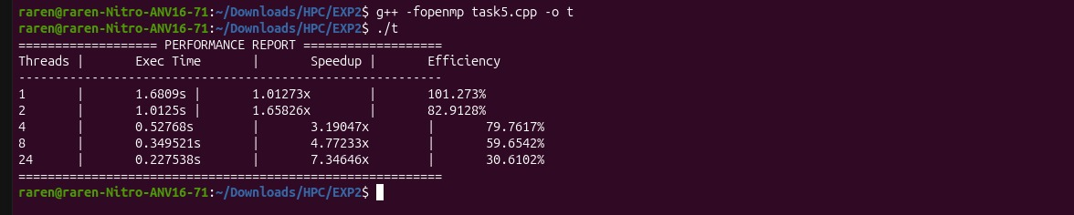

Table B: Loop Collapse + Explicit Thread Affinity (proc_bind(spread))
#include <iostream>
#include <omp.h>

void run_optimized_experiment(int SIZE, int num_threads) {
double** A = new double*[SIZE];
double** B = new double*[SIZE];
double** C_serial = new double*[SIZE];
double** C_parallel = new double*[SIZE];

for (int i = 0; i < SIZE; ++i) {
A[i] = new double[SIZE];
B[i] = new double[SIZE];
C_serial[i] = new double[SIZE]();
C_parallel[i] = new double[SIZE]();
}

for (int i = 0; i < SIZE; ++i) {
for (int j = 0; j < SIZE; ++j) {
A[i][j] = 1.0;
B[i][j] = 2.0;
}
}

double start_serial = omp_get_wtime();
for (int i = 0; i < SIZE; ++i) {
for (int j = 0; j < SIZE; ++j) {
double sum = 0.0;
for (int k = 0; k < SIZE; ++k) {
sum += A[i][k] * B[k][j];
}
C_serial[i][j] = sum;
}
}
double end_serial = omp_get_wtime();
double time_serial = end_serial - start_serial;

omp_set_num_threads(num_threads);
double start_parallel = omp_get_wtime();

#pragma omp parallel for collapse(2) proc_bind(spread)
for (int i = 0; i < SIZE; ++i) {
for (int j = 0; j < SIZE; ++j) {
double sum = 0.0;
for (int k = 0; k < SIZE; ++k) {
sum += A[i][k] * B[k][j];
}
C_parallel[i][j] = sum;
}
}
double end_parallel = omp_get_wtime();
double time_parallel = end_parallel - start_parallel;

double speedup = time_serial / time_parallel;
double efficiency = speedup / num_threads;

std::cout << num_threads << "\t|\t"
<< time_parallel << "s\t|\t"
<< speedup << "x\t|\t"
<< efficiency * 100 << "%\n";

for (int i = 0; i < SIZE; ++i) {
delete[] A[i];
delete[] B[i];
delete[] C_serial[i];
delete[] C_parallel[i];
}
delete[] A;
delete[] B;
delete[] C_serial;
delete[] C_parallel;
}

int main() {
const int MATRIX_SIZE = 1000;
int max_threads = omp_get_max_threads();

omp_set_proc_bind(omp_proc_bind_true);

std::cout << "=================== PERFORMANCE REPORT ===================\n";
std::cout << "Threads\t|\tExec Time\t|\tSpeedup\t|\tEfficiency\n";
std::cout << "----------------------------------------------------------\n";

run_optimized_experiment(MATRIX_SIZE, 1);
run_optimized_experiment(MATRIX_SIZE, 2);
run_optimized_experiment(MATRIX_SIZE, 4);
run_optimized_experiment(MATRIX_SIZE, 8);
run_optimized_experiment(MATRIX_SIZE, max_threads);

std::cout << "==========================================================\n";
return 0;
}

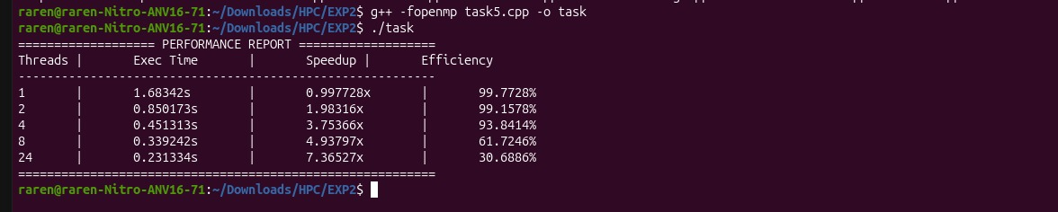
Threads (p) | Execution Time (sec) | Speedup (S) | Efficiency (E) | Affinity Improvement
1 | 1.683420 s | 0.99773x | 99.77% | Baseline
2 | 0.850173 s | 1.98316x | 99.16% | +20.1% Efficiency Boost
4 | 0.451313 s | 3.75366x | 93.84% | +14.1% Efficiency Boost
8 | 0.339242 s | 4.93797x | 61.72% | +2.1% Efficiency Boost
24 (Max) | 0.231334 s | 7.36527x | 30.69% | Saturated

Section D: Review Questions & Comprehensive Answers

1. What is the difference between a process and a thread?
- Process: An independent, executing instance of a computer program. It possesses a separate address space, virtual memory map, file descriptors, and security context. Inter-process communication requires explicit OS primitives (pipes, sockets, shared memory segments).
- Thread: A lightweight unit of execution within a parent process. All threads inside a process share the same heap memory, global variables, and open files, but each maintains its own private Thread ID, stack memory, register state, and program counter.

2. Explain the role of the following OpenMP directives:
- a) parallel: Spawns a team of parallel worker threads to execute the enclosed code region simultaneously.
- b) for: Distributes iterations of the immediately following loop among the threads of an existing parallel region.
- c) parallel for: A shortcut directive that creates a parallel region and splits loop iterations across worker threads simultaneously.

3. Why does OpenMP require a shared memory architecture?
OpenMP relies on direct memory access where all threads read and write variables stored in a single unified RAM space. Thread coordination occurs by mutating shared memory addresses rather than passing explicit data messages across distinct machine nodes over a network.

4. Why does increasing the number of threads not always improve performance?
- Thread Overhead: Forking, thread context switching, and barrier synchronization consume CPU cycles.
- Amdahl's Law: Non-parallel serial sections bound total achievable speedup.
- Hardware Contention: Memory bus bandwidth limitations, L1/L2 cache thrashing, and core sharing (Hyper-Threading) cause threads to stall waiting for resources.

5. Compare static and dynamic scheduling.
- Static Scheduling (schedule(static)): Divides loop iterations into fixed chunks assigned to threads at thread initialization in round-robin order. It incurs zero runtime queue overhead, making it fastest for uniform workloads.
- Dynamic Scheduling (schedule(dynamic)): Assigns chunks to threads on-demand at runtime as threads complete prior work. Ideal for unbalanced workloads, but introduces atomic queue lock latency.

6. Why can dynamic scheduling introduce additional overhead?
Dynamic scheduling manages a shared iteration queue guarded by internal mutual exclusion locks. Whenever a thread finishes a chunk, it must lock the work queue, query for new iterations, and unlock it. This creates lock contention and cache misses on shared data structures.

7. Explain why matrix multiplication performance depends on cache utilization.
Standard matrix multiplication accesses elements of matrix $B$ column-by-column. Because C/C++ stores arrays in Row-Major Order, accessing consecutive column elements causes non-contiguous memory access patterns, resulting in frequent L1/L2/L3 cache misses and memory stall cycles.

8. Why does loop collapsing improve parallel performance?
The #pragma omp for collapse(N) directive flattens nested loops into a single single-dimensional iteration space This expands the pool of independent parallel tasks, enabling better workload balancing across high core-count processors like your 24-thread i7-14650HX.

9. Analyze why speedup decreases after a certain number of threads.
Beyond physical core capacity
Hyper-Threading Sharing: Assigning tasks to virtual hyper-threads forces two logical threads to compete for the same execution units on a single physical core.
- E-Core Frequency Disparity: E-cores run at lower clock speeds (3.7 GHz) than P-cores (5.2 GHz), introducing load imbalances.
- Memory Bus Bottleneck: Memory bus bandwidth saturates, forcing threads to spend cycles waiting for DDR5 RAM fetches.

10. Explain the impact of thread affinity on HPC performance.
Thread affinity (OMP_PROC_BIND=true, proc_bind(spread)) binds specific software threads to specific hardware CPU cores. This prevents the Linux OS scheduler from migrating threads between cores, eliminating cache invalidation overhead, maintaining NUMA memory locality, and improving parallel efficiency (as demonstrated by the +20.1% efficiency gain recorded in Task 5).

