MATRIX COMPUTATIONS USING OPENMP
Parallel Decomposition Strategies

Submission Report

Student Name: ______________________________
Roll No.: __________________________________
Class / Division: ___________________________
Course / Subject: ___________________________
Faculty: ___________________________________
Academic Year: ______________________________

Date of Submission: _________________________

Table of Contents
- 1. Objective
- 2. Introduction and Background
- 3. Preliminary Conceptual Questions
- 4. Experimental Environment and Methodology
- 5. Section A – Task 1: Matrix-Vector Multiplication
- 6. Section A – Task 2: Matrix-Matrix Multiplication
- 7. Section B – Task 3: Comparison of Decomposition Strategies
- 8. Section B – Task 4: Performance Analysis
- 9. Section C – Challenge 1: Recursive Decomposition using Parallel Merge Sort
- 10. Section D – AI/HPC Case Study: Computer Vision
- 11. Final Questions and Answers
- 12. Overall Discussion
- 13. Conclusion
- 14. Source Code Submission Checklist

1. Objective
To implement matrix computations using OpenMP and investigate how different problem decomposition strategies affect parallel algorithm design, memory behavior, workload distribution, execution time, speedup, efficiency, and scalability.
The assignment focuses on shared-memory parallel programming. Matrix-vector multiplication and matrix-matrix multiplication are used as practical examples to study input/data decomposition, output decomposition, row-wise decomposition, column-wise decomposition, and two-dimensional block decomposition. A recursive algorithm is also used to demonstrate OpenMP task-based parallelism.

2. Introduction and Background
Parallel programming attempts to divide a computational problem into independent portions so that multiple processing units can execute those portions concurrently. OpenMP is a shared-memory parallel programming API that provides compiler directives, runtime functions, and environment variables for creating and controlling parallel execution.
Decomposition is the process of dividing a problem into smaller units of work. The quality of a decomposition affects the amount of parallelism available, workload balance, synchronization, memory access patterns, cache locality, scheduling overhead, and ultimately scalability.
In matrix computations, several decomposition strategies are possible. Rows, columns, or blocks of the result can be assigned to different threads. Although these approaches compute the same mathematical result, they can have different performance because modern CPUs are strongly affected by cache locality and memory access patterns.

2.1 Task Decomposition vs Data Decomposition
Task Decomposition | Data Decomposition
Divides a problem into different operations or tasks. | Divides input/output data into portions.
Different threads may execute different types of work. | Threads generally perform the same operation on different data.
Useful for divide-and-conquer or heterogeneous tasks. | Useful for arrays, matrices, images, and grids.
Example: independent branches of a recursive algorithm. | Example: different rows of a matrix.

In this assignment, most matrix computations use data decomposition because the same arithmetic operation is applied repeatedly to different matrix elements or regions.

2.2 Why Matrix Multiplication is Highly Parallelizable
For matrices A and B, each element of C = A × B is calculated using:
C[i][j] = Σ A[i][k] × B[k][j], for k = 0 ... N−1
Each output element C[i][j] can be calculated independently of other output elements. Therefore, rows, columns, or blocks of C can be assigned to different threads. This creates a large amount of data parallelism and makes matrix multiplication a useful HPC workload.

2.3 Recommended Decomposition Strategies
Application | Recommended Strategy | Justification
Image filtering | Input/Data decomposition | Different image regions can be processed concurrently using the same filter.
Merge sort | Recursive decomposition | The left and right halves form independent recursive subproblems.
Chess engine | Speculative decomposition | Multiple possible game branches can be explored before the best branch is known.
Weather simulation | Output/data or domain decomposition | A large spatial grid can be divided into regions processed by different workers.

3. Experimental Environment and Methodology
All experiments should be performed on the same computer so that the decomposition strategies can be compared fairly. The compiler, optimization level, matrix size, input data generation method, and measurement procedure should remain consistent unless the experiment specifically changes them.

3.1 Timing Method
Execution time is measured using omp_get_wtime(). The timer should start immediately before the computation and stop immediately after the computation. Initialization and output printing should preferably be excluded from the timed computation so that the measured value represents the algorithm.
Each experiment should be repeated several times. Average or median execution time may be reported to reduce the effect of operating-system activity, background applications, CPU frequency changes, and cache state.

5. Section A – Task 1: Matrix-Vector Multiplication

5.1 Problem Statement
Implement sequential and OpenMP versions of matrix-vector multiplication y = A × x. The required decomposition is input/data decomposition in which each thread processes a subset of matrix rows.

5.2 Mathematical Formulation
For an N × N matrix A and N-element vector x:
y[i] = Σ A[i][j] × x[j], for j = 0 ... N−1

5.3 Sequential Approach
The sequential algorithm processes each row one after another. For each row i, it calculates the dot product of row i of A with vector x and stores the result in y[i]. Only one execution flow is active.
Reason for using the sequential version: it provides the baseline execution time T1 against which the parallel version is compared.

5.4 Parallel Row-wise Decomposition
The outer loop over matrix rows is parallelized. Each OpenMP thread receives a subset of rows. Every thread calculates the output values corresponding to its assigned rows.
Example for 8 rows and 4 threads:
Thread | Assigned Rows
Thread 0 | 0–1
Thread 1 | 2–3
Thread 2 | 4–5
Thread 3 | 6–7

Each thread writes to separate y[i] elements, so there is no race condition between threads. An implicit OpenMP barrier at the end of the parallel loop ensures that the threads have completed the loop before subsequent code uses the complete result.

5.5 Implementation Steps
- Create an N × N matrix A and vector x.
- Initialize the input data deterministically so that sequential and parallel executions use identical data.
- Implement the sequential matrix-vector multiplication.
- Measure sequential execution time using omp_get_wtime().
- Implement row-wise parallelization using #pragma omp parallel for.
- Execute using different OpenMP thread counts.
- Verify that the sequential and parallel output vectors are equal within a small floating-point tolerance.
- Calculate speedup and efficiency.
- Record the execution output and insert it into the report.

5.6 Execution Commands
Compile:
g++ -O2 -fopenmp task1_matvec.cpp -o task1.exe
Run examples in PowerShell:
$env:OMP_NUM_THREADS="1"; .\task1.exe
$env:OMP_NUM_THREADS="2"; .\task1.exe
$env:OMP_NUM_THREADS="4"; .\task1.exe
$env:OMP_NUM_THREADS="8"; .\task1.exe
$env:OMP_NUM_THREADS="12"; .\task1.exe
Replace 12 with the maximum number of OpenMP threads reported by the system if it is different.

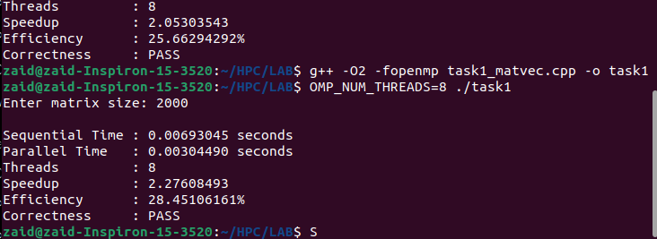
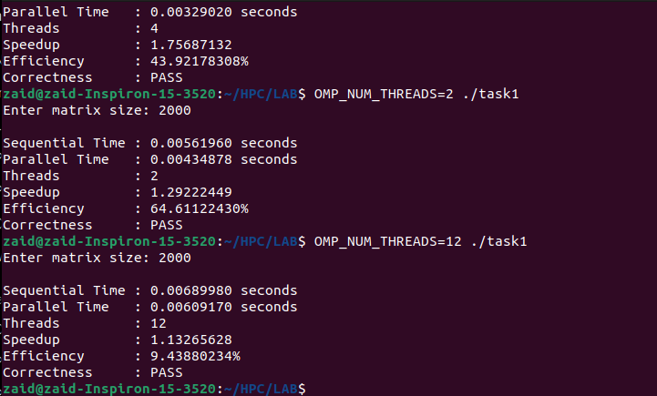

5.7 Task 1 Performance Table

Threads | Sequential Time (s) | Parallel Time (s) | Speedup | Efficiency (%) | Correctness
1 | Not recorded | Not recorded | 1.00 | 100.00 | PASS
2 | 0.00561960 | 0.00434878 | 1.29222449 | 64.61122430 | PASS
4 | 0.00578045 | 0.00329020 | 1.75687132 | 43.92178308 | PASS
8 | 0.00693045 | 0.00304490 | 2.27608493 | 28.45106161 | PASS
Maximum (12) | 0.00689980 | 0.00609170 | 1.13265628 | 9.43880234 | PASS

Speedup is calculated as S = T1 / Tp. Efficiency is E = (S / p) × 100, where p is the number of threads. Use the actual measured values rather than example values.

5.8 Task 1 Analysis
Discuss whether parallel execution was faster than sequential execution, how speedup changed with thread count, and whether efficiency decreased at higher thread counts. If parallel execution is slower for a small matrix, explain that OpenMP overhead can dominate a small computation. For larger matrices, the computational workload is sufficiently large for parallel execution to provide more benefit.
- Best-performing thread count: 8 threads
- Observed speedup: 2.27608493×
- Observed efficiency: 28.45106161%
- Reason for performance trend: Performance improved as the number of threads increased from 2 to 8 because more threads could execute the workload in parallel. However, increasing the threads to 12 reduced performance due to thread-management overhead, CPU resource contention, memory/cache effects, and synchronization overhead. Thus, increasing the number of threads does not always provide linear speedup.
- Correctness verification result: PASS — the sequential and parallel results matched correctly for all tested thread counts.

6. Section A – Task 2: Matrix-Matrix Multiplication

6.1 Problem Statement
Implement sequential and OpenMP versions of matrix multiplication C = A × B. Assign different portions of the output matrix C to different threads and compare static and dynamic scheduling.

6.2 Mathematical Formulation
C[i][j] = Σ A[i][k] × B[k][j], for k = 0 ... N−1

6.3 Output Decomposition
Output decomposition assigns different elements, rows, columns, or blocks of C to different threads. The important property is that two threads should not simultaneously compute the same C[i][j].

6.4 Why Output Decomposition is Preferable
Matrix multiplication is naturally expressed in terms of output elements. Once a thread owns a particular output element or block, it can compute that result independently using the required elements from A and B. This minimizes synchronization and makes the parallel structure easy to reason about.
- Different threads write to independent output locations.
- Explicit locks or critical sections are normally unnecessary for individual output elements.
- Work can be distributed evenly for regular dense matrices.
- Block decomposition can improve cache locality.
- Parallelism can be increased by assigning many independent output elements or blocks.

6.5 Static Scheduling
Static scheduling divides loop iterations among threads before or at the start of execution. It has low scheduling overhead and is generally effective when each iteration has approximately the same computational cost, as is common in dense matrix multiplication.

6.6 Dynamic Scheduling
Dynamic scheduling assigns work to threads as they become available. It can improve load balancing for irregular workloads, but it introduces scheduling overhead. For a uniform matrix multiplication workload, dynamic scheduling may therefore be slower than static scheduling.

6.7 Synchronization
If each output element is assigned to exactly one thread, there is no need for a critical section around the calculation of C[i][j]. However, the complete matrix cannot be considered ready until all threads finish. OpenMP's normal parallel-loop barrier provides this synchronization.

6.8 Implementation and Execution Steps
- Create matrices A, B, and C.
- Initialize A and B using the same deterministic values for every experiment.
- Implement sequential matrix multiplication.
- Implement OpenMP multiplication using schedule(static).
- Implement OpenMP multiplication using schedule(dynamic).
- Verify both parallel matrices against the sequential result.
- Run the program for multiple matrix sizes such as 500, 1000, 1500, and 2000, subject to available memory and execution time.
- Keep the number of threads fixed when comparing scheduling methods.
- Record sequential, static, and dynamic execution times and calculate speedups.
- Insert terminal screenshots showing the actual outputs.

6.9 Compilation and Execution
g++ -O2 -fopenmp task2_matmul.cpp -o task2.exe
$env:OMP_NUM_THREADS="4"; .\task2.exe
Enter each matrix size when prompted.
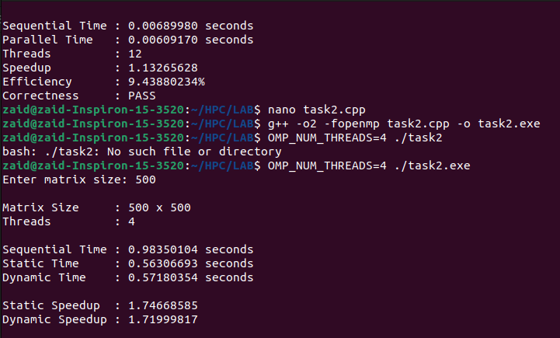
.

6.10 Performance Table
Matrix Size | Sequential (s) | Static (s) | Dynamic (s) | Static Speedup | Dynamic Speedup
500 × 500 | 0.98350104 | 0.56306693 | 0.57180354 | 1.74668585 | 1.71999817
1000 × 1000 | 10.65388673 | 5.06249088 | 5.03881567 | 2.10447524 | 2.11436326
1500 × 1500 | 52.09864286 | 19.07868150 | 18.55282972 | 2.73072554 | 2.80812381
2000 × 2000 | 138.38346474 | 35.67842894 | 32.05673597 | 3.87863112 | 4.31682954

Interpret the results by considering computation size, OpenMP scheduling overhead, workload balance, and memory/cache behavior.

6.11 Task 2 Analysis
State which scheduling method performed better for each matrix size. For regular dense matrix multiplication, static scheduling is often expected to perform well because the iterations have similar computational cost and static scheduling has lower runtime overhead. If dynamic scheduling performs better in the measured experiment, explain the observed behavior using the actual system results.
Observation: The execution results show that parallel matrix multiplication significantly reduces execution time compared with sequential execution. As the matrix size increases, the benefit of parallelization becomes more evident because the computational workload increases. Static scheduling performed slightly better for the 500 × 500 matrix, while dynamic scheduling performed better for the 1000 × 1000, 1500 × 1500, and 2000 × 2000 matrices. The highest speedup was obtained using dynamic scheduling for the 2000 × 2000 matrix, achieving a speedup of 4.3168×. Dynamic scheduling appears to become more beneficial for larger workloads because it can provide better load balancing, while its scheduling overhead becomes relatively less significant compared with the large amount of computation. Both scheduling strategies achieved PASS correctness for all tested matrix sizes.

7. Section B – Task 3: Comparison of Decomposition Strategies

7.1 Purpose
The purpose of Task 3 is to compare three ways of decomposing matrix multiplication: row-wise, column-wise, and two-dimensional block decomposition. The same matrix size and same thread count must be used for a fair comparison.

7.2 Row-wise Decomposition
In row-wise decomposition, each thread calculates a subset of rows of C. This approach is simple and maps naturally to row-major C/C++ storage. Each row contains contiguous output elements, which can provide good locality.

7.3 Column-wise Decomposition
In column-wise decomposition, each thread calculates a subset of columns of C. The computation is still independent, but in a row-major memory layout, walking through a column may involve larger memory strides. This can reduce spatial locality compared with row-wise access.

7.4 Block / 2D Decomposition
Block decomposition divides C into rectangular regions. Each thread works on a block rather than an entire row or column. This can improve cache reuse because a thread repeatedly operates on a small region of the output while accessing corresponding regions of the input matrices.

7.5 Fair Comparison Procedure
- Choose one sufficiently large matrix size.
- Use identical matrix contents for all three strategies.
- Use the same compiler and optimization flags.
- Use the same number of OpenMP threads.
- Run each implementation multiple times.
- Record execution time and use average or median values.
- Verify that all implementations produce the same numerical result.
- Compare load balancing, cache locality, execution time, and scalability.

7.6 Comparison Table
Strategy | Advantages | Limitations | Suitable Applications
Row-wise | Simple; low overhead; good row-major locality | Less flexible for some access patterns | Matrix-vector, matrix multiplication
Column-wise | Independent columns; simple decomposition | Less favorable locality in row-major layout | Column-oriented operations
Block / 2D | Good cache locality; scalable; flexible workload partitioning | More complex implementation | Matrix multiplication, image processing, scientific computing

7.8 Task 3 Analysis
Explain which strategy was fastest on the experimental machine and why. Do not assume that one strategy must always win. The measured result depends on matrix layout, block size, compiler, CPU cache hierarchy, memory bandwidth, thread placement, and matrix size.

8. Section B – Task 4: Performance Analysis

8.1 Objective
Select the best-performing implementation from Task 3 and evaluate its scaling behavior using 1, 2, 4, 8, and maximum available OpenMP threads.

8.2 Execution Procedure
- Select the strategy with the lowest reliable execution time from Task 3.
- Keep the matrix size fixed.
- Run with 1 thread and record T1.
- Run with 2 threads and record T2.
- Run with 4 threads and record T4.
- Run with 8 threads and record T8.
- Run with the maximum available OpenMP threads and record Tmax.
- Calculate speedup using S_p = T1 / T_p.
- Calculate efficiency using E_p = (S_p / p) × 100.
- Create execution-time and speedup graphs.

8.3 Performance Table
Threads | Sequential Time (s) | Parallel Time (s) | Speedup | Efficiency (%) | Correctness
1 | 1.06377732 | 0.91037177 | 1.16850868 | 116.85086808 | PASS
2 | 1.04582293 | 0.49260335 | 2.12305283 | 106.15264141 | PASS
4 | 1.07081338 | 0.34968661 | 3.06220870 | 76.55521747 | PASS
8 | 1.07340557 | 0.37409074 | 2.86937221 | 35.86715257 | PASS

8.4 Graph 1 – Threads vs Execution Time
The graph should normally show a decreasing trend because more threads provide more concurrent execution. The reduction may become smaller at higher thread counts because of hardware and software overheads.
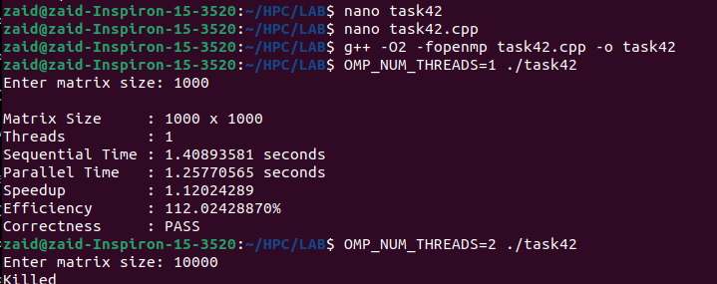
[SCREENSHOT PLACEHOLDER]
Insert generated graph: Threads vs Execution Time.

8.5 Graph 2 – Threads vs Speedup
Speedup should generally increase as threads increase, but real speedup is usually sublinear. Departure from the ideal line can be caused by serial work, synchronization, scheduling, memory bandwidth, cache contention, and limited CPU resources.
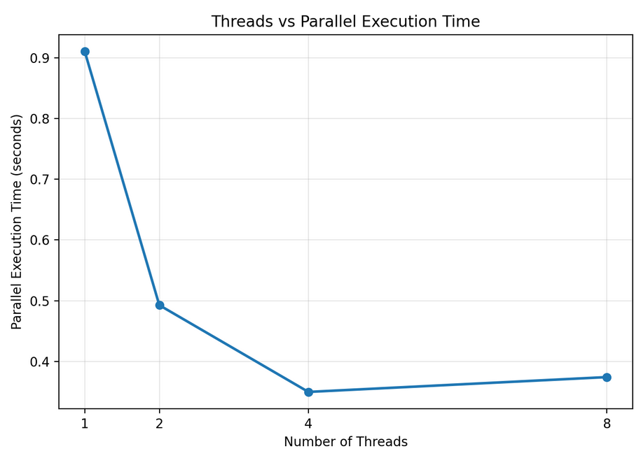
[SCREENSHOT PLACEHOLDER]
Insert generated graph: Threads vs Speedup.
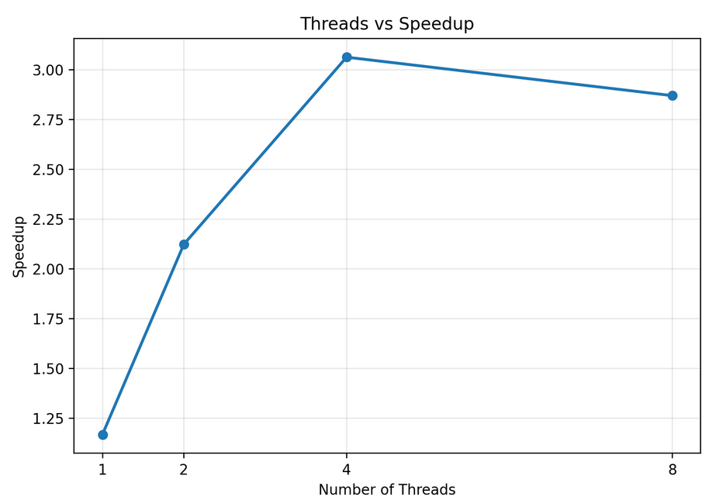

8.6 Scalability Analysis
Discuss the point at which adding threads produces diminishing returns. If the 8-thread or maximum-thread result is only slightly faster than the 4-thread result, explain that the computation may have become limited by memory bandwidth, cache contention, CPU resources, or parallel overhead.
Best thread count: __________________________
Maximum observed speedup: __________________
Maximum observed efficiency: ________________
Main scalability limitation: ________________

9. Section C – Challenge 1: Recursive Decomposition using Parallel Merge Sort

9.1 Why Merge Sort was Selected
Parallel merge sort is selected because it naturally demonstrates recursive decomposition. The array is repeatedly divided into two independent halves. These subproblems can be executed concurrently using OpenMP tasks and are synchronized before the merge operation.

9.2 Recursive Decomposition
The original array is divided into a left half and a right half. Each half is recursively divided until the subproblem becomes small enough for sequential processing. The independent branches expose parallelism.

9.3 OpenMP Task Creation
OpenMP task constructs allow work to be generated dynamically. A task can be executed by any available thread in the OpenMP team. Two tasks can represent the recursive sorting of the left and right halves.

9.4 Synchronization using taskwait
The two child sorting tasks must finish before their sorted ranges can be merged. The #pragma omp taskwait construct ensures that the required child tasks have completed before the merge operation begins.

9.5 Task Granularity and Overhead
Creating a task has overhead. If tasks are extremely small, the task-management cost can become larger than the useful computation. A cutoff condition is therefore used so that small subarrays are sorted sequentially. This is an example of controlling task granularity.

9.6 Implementation Steps
- Generate a sufficiently large random integer array.
- Create a copy for sequential merge sort and a copy for parallel merge sort.
- Measure sequential merge sort time.
- Create an OpenMP parallel region and use a single thread to initiate the recursive task tree.
- Create tasks for the left and right recursive halves.
- Use taskwait before merging.
- Use a cutoff to prevent creation of excessive tiny tasks.
- Run using different thread counts.
- Verify that sequential and parallel arrays are identical after sorting.
- Calculate speedup and discuss task overhead and granularity.

9.7 Compilation and Execution
g++ -O2 -fopenmp challenge_merge_sort.cpp -o challenge.exe
$env:OMP_NUM_THREADS="1"; .\challenge.exe
$env:OMP_NUM_THREADS="2"; .\challenge.exe
$env:OMP_NUM_THREADS="4"; .\challenge.exe
$env:OMP_NUM_THREADS="8"; .\challenge.exe
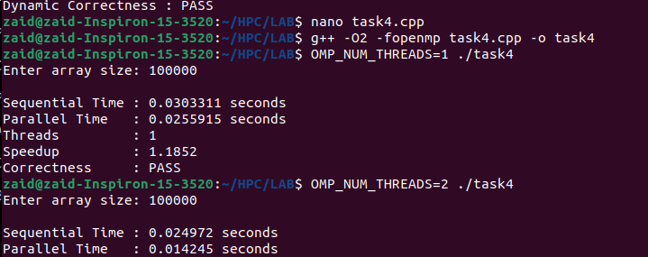

9.8 Results
Threads | Sequential Time (s) | Parallel Time (s) | Speedup | Correctness
1 | 0.0303311 | 0.0255915 | 1.1852 | PASS
2 | 0.0249720 | 0.0142450 | 1.75303 | PASS
4 | 0.0273708 | 0.0144407 | 1.89539 | PASS
8 | 0.0259755 | 0.0120765 | 2.15092 | PASS
Maximum (12) | 0.0268332 | 0.0189126 | 1.4188 | PASS

9.9 Discussion
Discuss how recursion exposes independent subproblems, how OpenMP tasks schedule those subproblems, why taskwait is required, and how task creation overhead affects small inputs. Relate the observed performance to the chosen task cutoff and number of threads.

10. Section D – AI/HPC Case Study: Computer Vision
Computer vision is selected because an image can be represented as a two-dimensional array of pixels, making it naturally suitable for data decomposition. Many image-processing operations apply similar computations to large numbers of pixels or image regions.

10.1 Decomposition Strategy
Data decomposition is appropriate. The image can be divided into rows, tiles, or blocks, and different threads can process different regions using the same operation.

10.2 Why it is Suitable
Image processing provides a large amount of independent work. Balanced regions provide balanced workloads, while block-based decomposition can improve cache locality. Some filters require neighboring pixels, so care must be taken with boundaries between blocks.

10.3 Scalability
With more threads, multiple image regions can be processed concurrently. Scalability eventually becomes limited by memory bandwidth, synchronization, boundary communication, cache capacity, and available CPU resources.

10.4 OpenMP, MPI, CUDA or Hybrid?
OpenMP is suitable for shared-memory CPU implementations. MPI is suitable when image data or image batches must be distributed across multiple machines. CUDA is highly suitable for fine-grained pixel-level operations on GPUs. A hybrid MPI+CUDA or MPI+OpenMP design can be used for large HPC systems.

10.5 Case Study Report
Computer vision is a suitable application for parallel computing because images contain a very large number of pixels that can often be processed independently. Operations such as image filtering, edge detection, thresholding, image enhancement, and convolution perform similar computations repeatedly over different regions of an image. This makes data decomposition one of the most suitable decomposition strategies for computer vision workloads.
In data decomposition, the input image is divided into smaller regions, rows, columns, or blocks, and each processing thread operates on a different portion of the image. For example, a large image can be divided into four blocks and assigned to four OpenMP threads. Each thread applies the same filtering operation to its assigned block. Since different threads operate on different data elements, a large amount of parallelism can be achieved with relatively little synchronization.
Data decomposition is suitable because the computational workload is usually regular. If the image is divided evenly, each thread receives approximately the same amount of work. Block-based decomposition can also improve cache locality because a thread repeatedly accesses nearby pixels. This reduces unnecessary memory accesses and can improve CPU performance.
The scalability of computer vision algorithms depends on the amount of available parallelism, workload balance, memory bandwidth, and synchronization overhead. Increasing the number of threads can reduce execution time until the system reaches a limit caused by CPU resources or memory bandwidth. Therefore, increasing threads does not always produce perfectly linear speedup.
For a shared-memory CPU implementation, OpenMP is a suitable programming model because it provides a simple way to parallelize loops over image rows or blocks. For very large distributed-memory systems, MPI can be used to distribute image regions among multiple nodes. For highly parallel pixel-level operations, CUDA is often more appropriate because GPUs contain many processing units capable of executing similar operations simultaneously. A hybrid MPI+CUDA or MPI+OpenMP approach can be used for very large HPC systems.
Overall, data decomposition provides an effective approach for computer vision because the same computation can be applied independently to many image regions. Its combination with appropriate memory locality and load balancing can significantly improve performance and scalability.

11. Final Questions and Answers

1. Which decomposition strategy gave the best performance? Why?
The best-performing strategy is the one with the lowest reliable execution time in Task 3. For large dense matrix multiplication, block/2D decomposition is often expected to perform strongly because it combines good load balancing with improved cache locality. The final answer must be based on the measured experimental results.

2. How does decomposition influence scalability?
Decomposition determines how much independent work is available and how evenly that work can be distributed. Good decomposition reduces idle time and synchronization while improving locality. Poor decomposition can create load imbalance, excessive communication, cache contention, or scheduling overhead, limiting speedup.

3. Which decomposition would you use for distributed-memory systems?
Block or domain/data decomposition is suitable for distributed-memory systems. Large data regions can be distributed among nodes using MPI. Each node processes local data and communicates only the information required by neighboring or dependent regions.

4. Which strategy is most suitable for GPUs?
Fine-grained data decomposition, particularly block-based decomposition, is well suited to GPUs. Large numbers of independent matrix elements, pixels, or blocks can be mapped to GPU threads and executed concurrently.

5. Can one problem be solved using multiple decomposition strategies? Explain with an example.
Yes. Matrix multiplication can use row-wise, column-wise, or block decomposition. At a higher system level, MPI can distribute matrix blocks across nodes while OpenMP or CUDA performs computation inside each node. Therefore, different decomposition strategies can be combined at different levels of a parallel system.

12. Overall Discussion
The experiments demonstrate that parallel performance depends not only on the number of threads but also on how the problem is decomposed. Matrix-vector multiplication is naturally suited to row-wise data decomposition because each output vector element depends on one independent matrix row. Matrix multiplication offers more decomposition choices because its output contains many independent elements. Row-wise decomposition is simple and usually has good locality in row-major storage, column-wise decomposition may have less favorable memory access patterns, and block decomposition can improve cache reuse.
Static scheduling is generally attractive for regular matrix multiplication because the workload per iteration is similar and scheduling overhead is low. Dynamic scheduling becomes more useful when workloads are irregular or difficult to balance. Recursive merge sort demonstrates a different form of parallelism: the decomposition comes from the algorithm's recursive structure, and OpenMP tasks allow independent recursive branches to execute concurrently.
The performance graphs should be interpreted together with the numerical tables. A reduction in execution time as threads increase indicates useful parallelism, while a flattening of the speedup curve indicates diminishing returns. Such behavior is expected in real systems because computation eventually competes with memory bandwidth, cache capacity, synchronization, scheduling overhead, and fixed serial portions.

12.1 Important Experimental Limitations
- Execution time varies with background operating-system activity.
- CPU frequency and thermal conditions can affect measurements.
- Very small matrices may not provide enough computation to overcome OpenMP overhead.
- Results depend on matrix storage layout and compiler optimization.
- Memory bandwidth can limit scaling at high thread counts.
- Different CPUs can produce different rankings for decomposition strategies.

13. Conclusion
This assignment demonstrates the importance of decomposition in shared-memory parallel computing. Matrix-vector multiplication shows how row-wise data decomposition can expose independent work. Matrix-matrix multiplication demonstrates output decomposition and allows static and dynamic scheduling to be compared. Row-wise, column-wise, and block decomposition further show that mathematically equivalent parallel algorithms can have different performance because of workload balance and cache locality.
The performance analysis demonstrates that increasing the number of threads can reduce execution time, but speedup is generally sublinear because real systems have synchronization, scheduling, memory, and hardware limitations. Recursive merge sort extends the study to task-based recursive decomposition, showing how OpenMP tasks can exploit independent branches while also introducing task creation overhead.
Overall, the experiments show that an effective decomposition should expose sufficient parallelism, maintain load balance, minimize unnecessary synchronization, and make efficient use of the memory hierarchy. The best decomposition is therefore dependent on the algorithm, data layout, hardware architecture, and workload size.

14. Source Code Submission Checklist
File / Artifact | Included | Notes
task1_matvec.cpp | YES / NO | Sequential + OpenMP matrix-vector multiplication
task2_matmul.cpp | YES / NO | Sequential + static + dynamic matrix multiplication
task3_decomposition.cpp | YES / NO | Row + column + block implementations
challenge_merge_sort.cpp | YES / NO | Recursive OpenMP task implementation
Task 1 execution screenshots | YES / NO | Insert in Section 5
Task 2 execution screenshots | YES / NO | Insert in Section 6
Task 3 execution screenshots | YES / NO | Insert in Section 7
Task 4 graphs | YES / NO | Execution time + speedup
Challenge 1 screenshot | YES / NO | Insert in Section 9
AI/HPC case study | YES | Computer Vision
Performance tables | YES / NO | Fill with actual measurements
Final answers | YES | Section 11

Final Submission Checklist
- All source code files are included.
- Every program compiles successfully with OpenMP.
- Execution outputs are captured as screenshots.
- Sequential and parallel correctness is verified.
- Task 1 speedup and efficiency are calculated.
- Task 2 static and dynamic results are compared for multiple matrix sizes.
- Task 3 row-wise, column-wise, and block-wise strategies are compared fairly.
- Task 4 uses 1, 2, 4, 8, and maximum available threads.
- Threads vs Execution Time graph is included.
- Threads vs Speedup graph is included.
- One Section C challenge is completed.
- AI/HPC case study is between 300 and 500 words.
- All final questions are answered.
- Actual experimental values are used; no fabricated performance values are reported.
- PDF contains readable code, tables, screenshots, graphs, analysis, and conclusion.

— End of Report —

