HPC LAB – EXPERIMENT NO. 6
Introduction to MPI: Installation, Processes, Ranks, Groups and Point-to-Point Communication
Name | ____________________________
PRN | ____________________________
Class / Division | TY BTech CSE _____________
Academic Year | 2026–27

1. Aim
To configure the MPI environment and understand distributed-memory parallel programming by creating MPI processes, identifying process ranks, working with MPI groups and communicators, and implementing one-to-one communication using MPI_Send() and MPI_Recv().

2. What This Experiment Teaches
OpenMP uses multiple threads that normally share memory. MPI is designed for distributed-memory systems, where separate processes have separate address spaces and communicate by sending messages. This experiment therefore builds the basic concepts needed before larger MPI applications such as matrix computations.
- MPI environment, initialization and termination
- MPI processes, rank, size and MPI_COMM_WORLD
- MPI groups and communicators
- Point-to-point communication using MPI_Send() and MPI_Recv()
- Message tags, source and destination
- Communication time, ping-pong communication and RTT
- Blocking communication and deadlock
- MPI vs OpenMP and distributed-memory application design

3. Pre-Lab Theory
Distributed-memory parallel computing: A parallel model in which each process has its own private memory/address space. Processes exchange data explicitly through communication mechanisms such as MPI.
MPI: Message Passing Interface is a standard programming interface used to write parallel programs for distributed-memory systems. MPI itself is a standard; OpenMPI and MPICH are implementations.
Process vs thread: A process has its own address space. Threads within the same process normally share the process memory. MPI mainly works with processes; OpenMP mainly works with threads.
MPI rank: A unique integer identifier assigned to a process inside a communicator. Rank 0 is often used as a coordinator, but every rank is a peer unless the program assigns special work.
MPI communicator: An MPI object that defines a communication context and the processes allowed to communicate in that context. MPI_COMM_WORLD contains all processes started for the job.
MPI_Send vs MPI_Recv: MPI_Send sends a message from the calling process to a destination. MPI_Recv receives a matching message from a source. Matching depends on communicator, source/destination, tag and datatype/count constraints.
Why message passing is needed: Separate processes cannot directly read each other's private memory. Data therefore has to cross the process boundary through communication.

4. Software and Environment Setup
Recommended environment for this lab: Ubuntu/Linux with an MPI implementation such as OpenMPI. The PDF asks you to record MPI implementation/version, compiler version, operating system and CPU configuration.
Step 1 – Update package information:
sudo apt update
Reason: refreshes Ubuntu's package index before installing packages.
Step 2 – Install OpenMPI compiler/runtime:
sudo apt install openmpi-bin libopenmpi-dev
Reason: openmpi-bin provides mpirun/mpiexec and libopenmpi-dev provides MPI headers and the mpicc wrapper compiler.
Step 3 – Verify:
mpicc --version
mpirun --version
mpiexec --version
which mpicc
which mpirun
Step 4 – Record machine details:
uname -a
lsb_release -a
lscpu
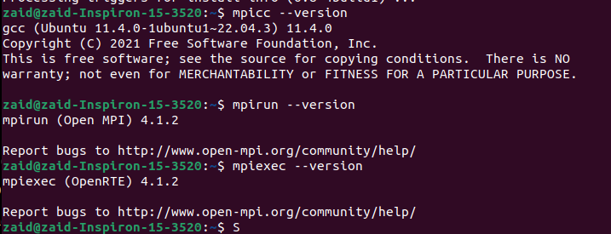

5. Recommended Folder Structure
mkdir -p ~/MPI_Experiment6
cd ~/MPI_Experiment6
mkdir -p screenshots results
Reason: keeping each experiment in one folder makes compilation, execution and submission evidence easy to organize.

6. Task 2 – First MPI Program
What we have to do: create the smallest MPI program that initializes MPI, prints a message from each process, and then terminates MPI.
// hello.c
#include <mpi.h>
#include <stdio.h>
int main(int argc, char *argv[])
{
MPI_Init(&argc, &argv);
printf("Hello from MPI\n");
MPI_Finalize();
return 0;
}
Compile:
mpicc hello.c -o hello
Run with 4 MPI processes:
mpirun -np 4 ./hello
Why these functions are required:
- MPI_Init(): starts the MPI environment for the calling process. MPI routines generally should not be used before initialization.
- MPI_Finalize(): shuts down the MPI environment for the calling process after MPI work is complete.
- mpicc: MPI compiler wrapper that supplies the required include paths and libraries.
- mpirun -np 4: launches four MPI processes.
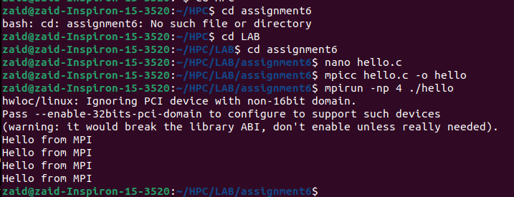

7. Task 3 – Understanding MPI Rank and Size
The important idea is that each process needs to know both its identity and how many processes are participating.
// rank_size.c
#include <mpi.h>
#include <stdio.h>
int main(int argc, char *argv[])
{
int rank, size;
MPI_Init(&argc, &argv);
MPI_Comm_rank(MPI_COMM_WORLD, &rank);
MPI_Comm_size(MPI_COMM_WORLD, &size);
printf("Process %d of %d\n", rank, size);
MPI_Finalize();
return 0;
}
mpicc rank_size.c -o rank_size
mpirun -np 2 ./rank_size
mpirun -np 4 ./rank_size
mpirun -np 8 ./rank_size
Why:
- MPI_Comm_rank(MPI_COMM_WORLD, &rank) returns the calling process's rank inside MPI_COMM_WORLD.
- MPI_Comm_size(MPI_COMM_WORLD, &size) returns the total number of processes in that communicator.
- Output order is not guaranteed because processes execute concurrently.
Processes | Ranks observed | Total processes
2 | 0 to 1 | 2
4 | 0 to 3 | 4
8 | 0 to 7 | 8
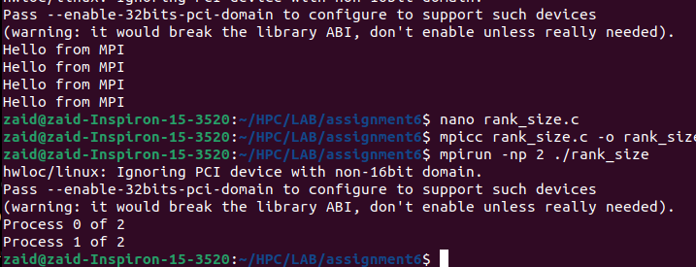

8. Task 4 – MPI Groups and Communicators
The PDF asks for an 8-process example selecting ranks 0, 2, 4 and 6. MPI_COMM_WORLD is the original communicator. MPI_Comm_group() obtains its group; MPI_Group_incl() creates a subgroup from selected ranks; MPI_Comm_create_group() creates a communicator for that subgroup.
// group_comm.c
#include <mpi.h>
#include <stdio.h>
int main(int argc, char *argv[])
{
int world_rank, world_size;
MPI_Group world_group, even_group;
MPI_Comm even_comm = MPI_COMM_NULL;
int selected[] = {0, 2, 4, 6};
MPI_Init(&argc, &argv);
MPI_Comm_rank(MPI_COMM_WORLD, &world_rank);
MPI_Comm_size(MPI_COMM_WORLD, &world_size);
if (world_size < 8) {
if (world_rank == 0)
printf("Run this program with at least 8 processes.\n");
MPI_Finalize();
return 0;
}
MPI_Comm_group(MPI_COMM_WORLD, &world_group);
MPI_Group_incl(world_group, 4, selected, &even_group);
MPI_Comm_create_group(MPI_COMM_WORLD, even_group, 0, &even_comm);
if (even_comm != MPI_COMM_NULL) {
int local_rank, local_size;
MPI_Comm_rank(even_comm, &local_rank);
MPI_Comm_size(even_comm, &local_size);
printf("Global rank = %d, subgroup rank = %d, subgroup size = %d\n",
world_rank, local_rank, local_size);
MPI_Comm_free(&even_comm);
}
MPI_Group_free(&even_group);
MPI_Group_free(&world_group);
MPI_Finalize();
return 0;
}
mpicc group_comm.c -o group_comm
mpirun -np 8 ./group_comm
Expected selected global ranks: 0, 2, 4, 6. Their ranks inside the new communicator will normally be 0, 1, 2, 3 respectively because MPI_Group_incl preserves the order of the selected rank list.
Important distinction: a global rank belongs to one particular communicator. The same process can have a different local rank in another communicator.
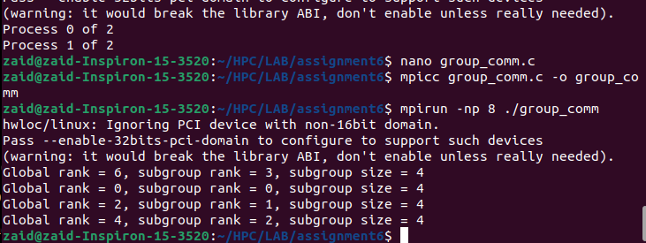

9. HPC Programmer Questions – Groups and Communicators
Why create separate communicators? To isolate communication contexts and organize different teams of processes for different computational tasks.
Can the same process belong to different groups? Yes. A process can participate in multiple MPI groups/communicators and therefore can have different ranks in different communicators.
Why is the communicator important? It defines the communication context and participating process set, preventing unrelated communication from being mixed.
How do groups help large applications? They let a program divide processes into logical teams, such as one team for one computation and another team for a different computation.

10. Task 5 – One-to-One Message Communication
Requirement: Process 0 sends a text message to Process 1; Process 1 receives and displays it.
// send_receive.c
#include <mpi.h>
#include <stdio.h>
#include <string.h>
int main(int argc, char *argv[])
{
int rank, size;
char message[] = "Hello from Process 0";
char received[100];
MPI_Init(&argc, &argv);
MPI_Comm_rank(MPI_COMM_WORLD, &rank);
MPI_Comm_size(MPI_COMM_WORLD, &size);
if (size < 2) {
if (rank == 0)
printf("Run with at least 2 processes.\n");
MPI_Finalize();
return 0;
}
if (rank == 0) {
MPI_Send(message, (int)strlen(message) + 1, MPI_CHAR,
1, 100, MPI_COMM_WORLD);
printf("Process 0 sent: %s\n", message);
}
else if (rank == 1) {
MPI_Recv(received, 100, MPI_CHAR,
0, 100, MPI_COMM_WORLD, MPI_STATUS_IGNORE);
printf("Process 1 received: %s\n", received);
}
MPI_Finalize();
return 0;
}
mpicc send_receive.c -o send_receive
mpirun -np 2 ./send_receive
MPI_Send arguments used here: buffer, count, datatype, destination rank, tag, communicator. MPI_Recv uses buffer, maximum count, datatype, source rank, tag, communicator and status.
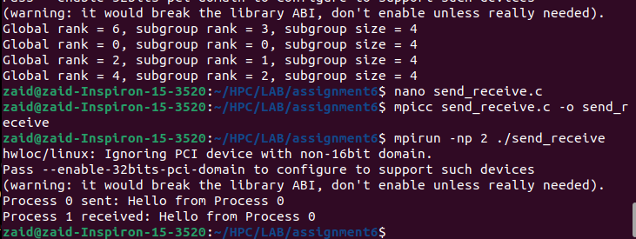

11. Task 6 – Integer Data Communication
// send_integer.c
#include <mpi.h>
#include <stdio.h>
int main(int argc, char *argv[])
{
int rank, size;
int value = 100;
int received = 0;
MPI_Init(&argc, &argv);
MPI_Comm_rank(MPI_COMM_WORLD, &rank);
MPI_Comm_size(MPI_COMM_WORLD, &size);
if (size < 2) {
if (rank == 0)
printf("Run with at least 2 processes.\n");
MPI_Finalize();
return 0;
}
if (rank == 0) {
MPI_Send(&value, 1, MPI_INT, 1, 200, MPI_COMM_WORLD);
printf("Process 0 sent value = %d\n", value);
}
else if (rank == 1) {
MPI_Recv(&received, 1, MPI_INT, 0, 200,
MPI_COMM_WORLD, MPI_STATUS_IGNORE);
printf("Process 1 received value = %d\n", received);
}
MPI_Finalize();
return 0;
}
mpicc send_integer.c -o send_integer
mpirun -np 2 ./send_integer
What we verify: the value after MPI_Recv() must match the value sent by Process 0. This demonstrates typed message passing using MPI_INT.
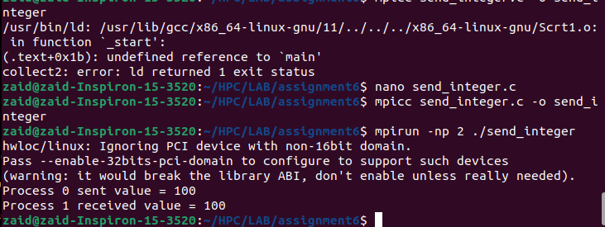

12. Task 7 – Array Communication and Statistics
Process 0 sends an integer array. Process 1 receives it and calculates sum, average and maximum.
// array_communication.c
#include <mpi.h>
#include <stdio.h>
#include <limits.h>
int main(int argc, char *argv[])
{
int rank, size;
int data[5] = {10, 20, 30, 40, 50};
int received[5];
int sum = 0, max = INT_MIN;
MPI_Init(&argc, &argv);
MPI_Comm_rank(MPI_COMM_WORLD, &rank);
MPI_Comm_size(MPI_COMM_WORLD, &size);
if (size < 2) {
if (rank == 0)
printf("Run with at least 2 processes.\n");
MPI_Finalize();
return 0;
}
if (rank == 0) {
MPI_Send(data, 5, MPI_INT, 1, 300, MPI_COMM_WORLD);
printf("Process 0 sent: 10 20 30 40 50\n");
}
else if (rank == 1) {
MPI_Recv(received, 5, MPI_INT, 0, 300,
MPI_COMM_WORLD, MPI_STATUS_IGNORE);
for (int i = 0; i < 5; i++) {
sum += received[i];
if (received[i] > max)
max = received[i];
}
printf("Process 1 received: ");
for (int i = 0; i < 5; i++)
printf("%d ", received[i]);
printf("\nSum = %d\n", sum);
printf("Average = %.2f\n", sum / 5.0);
printf("Maximum = %d\n", max);
}
MPI_Finalize();
return 0;
}
mpicc array_communication.c -o array_communication
mpirun -np 2 ./array_communication
Expected calculations for the sample array: Sum = 150, Average = 30.00, Maximum = 50.
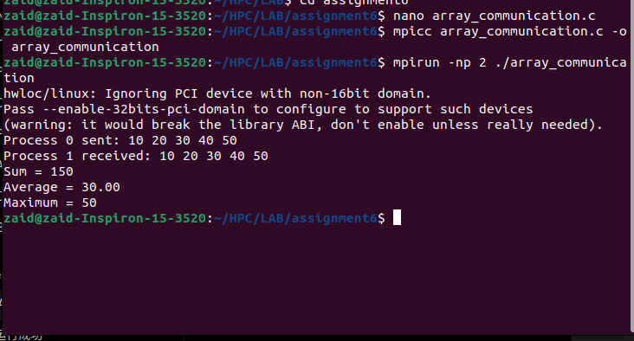

13. Performance Activity – Message Size vs Communication Time
The assignment requires tests for 1 KB, 10 KB, 100 KB, 1 MB and 10 MB. The cleanest method is to benchmark a send/receive operation using MPI_Wtime(). The following program automatically measures each required size.
// communication_time.c
#include <mpi.h>
#include <stdio.h>
#include <stdlib.h>
int main(int argc, char *argv[])
{
int rank, size;
int sizes[] = {1024, 10*1024, 100*1024, 1024*1024, 10*1024*1024};
int num_sizes = 5;
MPI_Init(&argc, &argv);
MPI_Comm_rank(MPI_COMM_WORLD, &rank);
MPI_Comm_size(MPI_COMM_WORLD, &size);
if (size < 2) {
if (rank == 0)
printf("Run with at least 2 processes.\n");
MPI_Finalize();
return 0;
}
for (int s = 0; s < num_sizes; s++) {
int bytes = sizes[s];
char *buffer = (char *)malloc(bytes);
if (rank == 0) {
for (int i = 0; i < bytes; i++)
buffer[i] = 'A';
MPI_Barrier(MPI_COMM_WORLD);
double start = MPI_Wtime();
MPI_Send(buffer, bytes, MPI_CHAR, 1, 400 + s, MPI_COMM_WORLD);
double end = MPI_Wtime();
printf("%d bytes, send time = %.9f seconds\n",
bytes, end - start);
}
else if (rank == 1) {
MPI_Barrier(MPI_COMM_WORLD);
MPI_Recv(buffer, bytes, MPI_CHAR, 0, 400 + s,
MPI_COMM_WORLD, MPI_STATUS_IGNORE);
}
free(buffer);
MPI_Barrier(MPI_COMM_WORLD);
}
MPI_Finalize();
return 0;
}
mpicc communication_time.c -o communication_time
mpirun -np 2 ./communication_time
Record the measured times from your own machine. Do not replace them with example values from another computer because communication time depends on hardware, MPI implementation, process placement and system load.
Message Size | Communication Time (s)
1 KB | 0.000015374
10 KB | 0.000032521
100 KB | 0.000080344
1 MB | 0.000737203
10 MB | 0.009459892
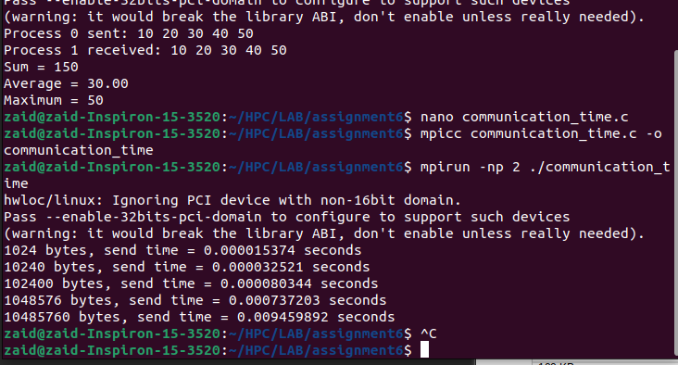
Analysis to write after measurement: communication time generally tends to increase as the message becomes larger because more bytes must be transferred. The exact curve may not be perfectly linear because MPI protocols, buffering, latency, bandwidth, process placement and system load affect measurements. Communication can become a bottleneck when processes spend a significant fraction of total runtime waiting for data.

14. Challenge – Ping-Pong Communication and RTT
Process 0 sends a message to Process 1; Process 1 sends it back. One complete send-return cycle is a round trip.
// ping_pong.c
#include <mpi.h>
#include <stdio.h>
#include <stdlib.h>
int main(int argc, char *argv[])
{
int rank, size;
int sizes[] = {1024, 10*1024, 100*1024, 1024*1024, 10*1024*1024};
int iterations = 1000;
MPI_Init(&argc, &argv);
MPI_Comm_rank(MPI_COMM_WORLD, &rank);
MPI_Comm_size(MPI_COMM_WORLD, &size);
if (size < 2) {
if (rank == 0)
printf("Run with at least 2 processes.\n");
MPI_Finalize();
return 0;
}
for (int s = 0; s < 5; s++) {
int bytes = sizes[s];
char *buffer = malloc(bytes);
MPI_Barrier(MPI_COMM_WORLD);
double start = MPI_Wtime();
if (rank == 0) {
for (int i = 0; i < iterations; i++) {
MPI_Send(buffer, bytes, MPI_CHAR, 1, 500, MPI_COMM_WORLD);
MPI_Recv(buffer, bytes, MPI_CHAR, 1, 501,
MPI_COMM_WORLD, MPI_STATUS_IGNORE);
}
}
else if (rank == 1) {
for (int i = 0; i < iterations; i++) {
MPI_Recv(buffer, bytes, MPI_CHAR, 0, 500,
MPI_COMM_WORLD, MPI_STATUS_IGNORE);
MPI_Send(buffer, bytes, MPI_CHAR, 0, 501, MPI_COMM_WORLD);
}
}
double end = MPI_Wtime();
if (rank == 0) {
double total = end - start;
double rtt = total / iterations;
printf("%d bytes: iterations=%d total=%.9f s average RTT=%.9f s\n",
bytes, iterations, total, rtt);
}
free(buffer);
}
MPI_Finalize();
return 0;
}
mpicc ping_pong.c -o ping_pong
mpirun -np 2 ./ping_pong
Formula required by the assignment:
RTT = Total Time / Number of Iterations
Use the measured average RTT for the final performance table.
Message Size | Iterations | Total Time (s) | Average RTT (s)
1 KB | 1000 | total=0.002091020 | RTT=0.000002091
10 KB | 1000 | total=0.011158761 | RTT=0.000011159
100 KB | 1000 | total=0.065088910 | RTT=0.000065089
1 MB | 1000 | total=0.341166079 | RTT=0.000341166
10 MB | 1000 | total=7.429212987 | RTT=0.007429213
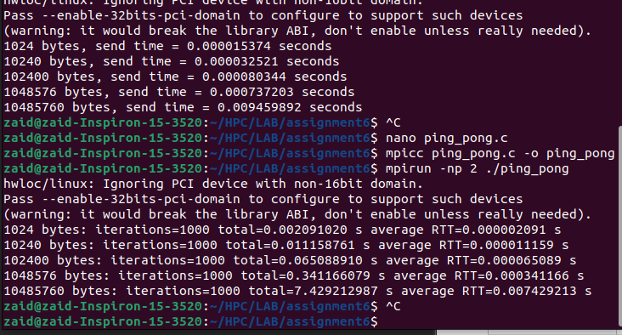
Graph 1: Message Size vs Communication Time. Graph 2: Message Size vs Round-Trip Time. Use a line/scatter chart with message size on the x-axis and measured time on the y-axis.

15. Advanced Challenge – Blocking Communication and Deadlock
The assignment asks why deadlock can occur if both processes attempt to send before receiving. With blocking MPI_Send/MPI_Recv, each process can reach an operation that waits for progress while the matching receive is not yet posted. Depending on message size and MPI buffering, behavior can vary, so do not use an unbounded deadlock on a shared HPC system.
// deadlock_demo.c
#include <mpi.h>
#include <stdio.h>
int main(int argc, char *argv[])
{
int rank;
int value = 123;
MPI_Init(&argc, &argv);
MPI_Comm_rank(MPI_COMM_WORLD, &rank);
if (rank == 0) {
MPI_Send(&value, 1, MPI_INT, 1, 600, MPI_COMM_WORLD);
MPI_Recv(&value, 1, MPI_INT, 1, 601,
MPI_COMM_WORLD, MPI_STATUS_IGNORE);
}
else if (rank == 1) {
MPI_Send(&value, 1, MPI_INT, 0, 601, MPI_COMM_WORLD);
MPI_Recv(&value, 1, MPI_INT, 0, 600,
MPI_COMM_WORLD, MPI_STATUS_IGNORE);
}
MPI_Finalize();
return 0;
}
Do not leave this program running indefinitely. If testing, use a small controlled run and terminate it safely. A common redesign is to post receives before sends or use MPI_Sendrecv(), which is specifically designed for exchange patterns.
// Safe exchange idea
MPI_Sendrecv(&value, 1, MPI_INT, peer, 700,
&received, 1, MPI_INT, peer, 700,
MPI_COMM_WORLD, MPI_STATUS_IGNORE);
- Message ordering matters because tags, source and communicator are used to match messages.
- A receive must match the message that is actually sent.
- Blocking operations can make a process wait; cyclic waiting can form a deadlock.
- MPI_Sendrecv or a carefully ordered send/receive sequence can avoid the cyclic wait.

16. HPC / AI Case Study – Weather Forecasting
Weather forecasting is a natural distributed-memory application because a numerical weather model works with a large spatial grid representing atmospheric variables such as temperature, pressure, wind and humidity. A single process may not have enough memory or computation capacity to process the entire grid efficiently, so the domain can be divided into regions and assigned to multiple MPI processes.
Each process computes the cells belonging to its region. However, neighbouring regions depend on boundary values from one another. For example, a process handling one geographical block may need temperature or wind values from the adjacent block before it can update its boundary cells. MPI point-to-point communication can exchange these boundary data between neighbouring processes. A communicator can also be used to organize a particular team of processes working on a computational part of the model.
The data exchanged depends on the numerical method, but commonly includes boundary or halo cells and other intermediate model values. Processes that own neighbouring regions need to communicate directly or through the communication pattern defined by the algorithm. The overall computation can proceed in repeated time steps: compute local values, exchange required boundary data, synchronize where necessary, and compute the next step.
Communication time is important because faster computation does not automatically produce faster overall execution. If processes spend too much time waiting for data from other processes, communication overhead can dominate the computation. As the number of processes increases, the amount and coordination of communication may also increase, and load imbalance can cause some processes to wait for others. Therefore, an effective MPI application tries to balance computation and communication while distributing data appropriately.
This case study addresses the assignment's five requested points: why distribution is required, what data is exchanged, which processes communicate, how MPI can be used, and what happens when communication becomes larger than computation.

17. Final Questions – Answers
1. What is MPI? MPI is a standard message-passing interface for writing parallel programs for distributed-memory systems.
2. What is an MPI process? An independently executing process participating in an MPI program, with its own address space.
3. What is an MPI rank? The integer identifier of a process within a particular communicator.
4. What is MPI_COMM_WORLD? The default communicator containing all MPI processes launched for the MPI job.
5. Difference between MPI_Send() and MPI_Recv()? MPI_Send transmits a message to a destination; MPI_Recv obtains a matching message from a source.
6. Group vs communicator? A group is an ordered collection of process identities. A communicator combines a process group with a communication context used for MPI communication.
7. Why can ranks differ between communicators? Rank numbers are local to a communicator. The same process can have different positions in different process groups.
8. What information is specified in MPI_Send()? Buffer, count, datatype, destination rank, tag and communicator.
9. What information is specified in MPI_Recv()? Buffer, maximum count, datatype, source rank, tag, communicator and a status object or MPI_STATUS_IGNORE.
10. Why does operation order matter? Because blocking operations may wait for matching communication. Incorrect ordering can cause waiting or deadlock.
11. What is communication overhead? The time and system resources spent moving/synchronizing data between processes rather than doing the application's useful computation.
12. How does message size affect performance? Larger messages generally require more data transfer and therefore tend to increase communication time; latency, bandwidth, buffering and MPI protocols also influence the result.
13. What is deadlock in MPI? A condition in which processes wait indefinitely for communication or resources that cannot become available because of the program's communication ordering.
14. Why can blocking communication lead to deadlock? A blocking call may wait until communication can progress. If processes form a cycle in which each waits for another, no process can proceed.
15. Why is communication important in distributed algorithms? Because data required by one process may be produced or stored by another process. Poor communication can dominate execution time.

18. OpenMP vs MPI
Aspect | OpenMP | MPI
Primary model | Threads | Processes
Memory model | Shared memory | Distributed/private process memory
Communication | Shared variables/synchronization | Explicit message passing
Typical use | Multicore shared-memory node | Multiple nodes or distributed-memory systems
Identity | Thread ID | MPI rank
Scaling consideration | Shared-memory limits | Communication + data distribution + process count

19. Answers to the Final Concept Questions
- Fundamental difference: OpenMP is primarily a shared-memory threading model, while MPI is a process/message-passing model for distributed-memory systems.
- MPI is appropriate when the application must use multiple processes, potentially across multiple nodes, and data must be exchanged explicitly.
- Data distribution matters because each process owns only its local data; poor distribution can cause load imbalance or excessive communication.
- Communication connects the separate memory spaces so processes can exchange required intermediate and boundary data.
- Increasing process count can introduce more communication, synchronization, scheduling, load imbalance and coordination overhead.
- For a future MPI matrix-computation assignment, the concepts here provide the foundation for distributing matrix blocks, identifying ranks, exchanging required data and measuring communication cost.

20. What We Actually Did – Stepwise Learning Summary
- Installed/configured an MPI implementation and verified mpicc/mpirun.
- Created an MPI program with MPI_Init() and MPI_Finalize().
- Launched multiple processes using mpirun -np.
- Used MPI_Comm_rank() to identify each process.
- Used MPI_Comm_size() to find the number of participating processes.
- Created a subgroup from MPI_COMM_WORLD using MPI_Comm_group(), MPI_Group_incl() and MPI_Comm_create_group().
- Observed the difference between global rank and subgroup/local rank.
- Sent a character message from rank 0 to rank 1 using MPI_Send() and MPI_Recv().
- Sent an integer and verified that the received value matched the sent value.
- Sent an integer array and calculated sum, average and maximum at the receiver.
- Measured communication time for increasing message sizes.
- Implemented ping-pong communication and calculated average RTT.
- Studied why blocking communication can lead to deadlock and how ordering/MPI_Sendrecv can avoid it.
- Connected MPI concepts to an HPC case study and compared MPI with OpenMP.

21. What We Understood – Viva-Friendly Explanation
The main idea of this experiment is simple: MPI lets multiple independent processes work together even when they do not share the same memory. MPI_Init() starts the MPI environment and MPI_Finalize() ends it. MPI_COMM_WORLD represents the default set of all processes. Every process has a rank inside a communicator, and MPI_Comm_size() tells how many processes are in it. Groups let us select processes, while communicators create a communication context for those processes.
For communication, Process 0 can send data using MPI_Send(), and Process 1 can obtain it using MPI_Recv(). A message is identified/matched using information such as source/destination, tag, datatype and communicator. When messages become larger, transfer time generally increases, so communication can become a performance bottleneck. In ping-pong communication, the data goes from one process to another and back, allowing us to measure round-trip time. Finally, blocking operations must be ordered carefully because cyclic waiting can produce deadlock.

22. Submission Evidence Checklist
☐ Task 1: MPI installation/version and system details screenshot
☐ Task 2: hello.c code + compilation + execution screenshot
☐ Task 3: outputs for 2, 4 and 8 processes + observation table
☐ Task 4: group/communicator code + output screenshot
☐ Task 5: send/receive text message screenshot
☐ Task 6: integer communication screenshot
☐ Task 7: array + sum/average/max screenshot
☐ Communication-time measurements for 1 KB, 10 KB, 100 KB, 1 MB, 10 MB
☐ Ping-pong total time and average RTT table
☐ Message Size vs Communication Time graph
☐ Message Size vs Round-Trip Time graph
☐ Deadlock explanation / controlled test evidence if performed
☐ 300–500 word HPC/AI case study
☐ Answers to final questions
☐ Conclusion

23. Conclusion
This experiment introduced the fundamental concepts of MPI-based distributed-memory programming. The programs demonstrated MPI initialization, process creation, ranks, communicator size, groups, point-to-point communication, integer and array data transfer, and communication performance measurement. The ping-pong experiment showed how message size affects communication cost, while the deadlock activity showed why communication order is important in blocking MPI programs. These concepts form the foundation for larger MPI applications, including distributed matrix computations.

END OF EXPERIMENT 6 REPORT

