WALCHAND COLLEGE OF ENGINEERING, SANGLI
Department of Computer Science and Engineering
HIGH PERFORMANCE COMPUTING LABORATORY
EXPERIMENT NO. 7
MPI Collective Communication and Parallel Matrix Computations
Submitted By
Zaid Imtiyaj Pathan
TY B.Tech. Computer Science and Engineering
Academic Year 2026–27
Final Practical Submission Report

Student Declaration
I hereby submit this report for Experiment No. 7 of the High Performance Computing Laboratory. The report documents the implementation of MPI collective communication operations and parallel matrix computations, together with the procedures, source code, execution commands, observations, performance-analysis framework, and learning outcomes.
Student Name: Zaid Imtiyaj Pathan
Class: TY B.Tech. CSE
Academic Year: 2026–27

Table of Contents
1. Aim
2. Objectives
3. Software and Hardware Requirements
4. Background Theory
5. MPI Collective Communication Overview
6. Task 1 — MPI_Bcast()
7. Task 2 — MPI_Scatter() and MPI_Gather()
8. Task 3 — MPI_Reduce()
9. Task 4 — Parallel Matrix–Vector Multiplication
10. Task 5 — Parallel Matrix–Matrix Multiplication
11. Task 6 — Decomposition Strategies
12. Task 7 — MPI_Scatterv()
13. Performance Measurement and Analysis
14. Results Tables
15. Graphs
16. AI/HPC Application Case Study
17. Discussion / Viva Questions and Answers
18. What We Did and What We Understood
19. Reflection
20. Conclusion
21. Submission Checklist
Appendix A — Complete Source Code
Appendix B — Execution Command Sheet

1. Aim
To understand and implement MPI collective communication operations and apply them to parallel matrix computations. The experiment covers broadcasting, scattering, gathering, reduction, row-wise matrix decomposition, column-wise and block decomposition, and unequal data distribution using MPI_Scatterv().

2. Objectives
- Understand the purpose and usage of MPI collective communication.
- Implement MPI_Bcast() for one-to-all communication.
- Implement MPI_Scatter() and MPI_Gather() for distributing and collecting data.
- Implement MPI_Reduce() for global sum, minimum, and maximum operations.
- Implement parallel matrix–vector multiplication using row-wise decomposition.
- Implement parallel matrix–matrix multiplication using row-wise decomposition.
- Compare row-wise, column-wise, and block decomposition strategies.
- Use MPI_Scatterv() when the workload cannot be divided equally among processes.
- Measure execution time and provide a framework for speedup and efficiency analysis.
- Understand the communication and computation trade-offs in MPI programs.

3. Software and Hardware Requirements
Requirement | Used / Required
Operating System | Ubuntu Linux
Compiler | GCC / mpicc
MPI implementation | Open MPI or compatible MPI implementation
Editor | VS Code / any text editor
Terminal | Ubuntu Terminal
Language | C
MPI header | mpi.h
Math library | libm (-lm) for decomposition programs where required

4. Background Theory
Message Passing Interface (MPI) is a standard programming interface used for communication between processes in parallel and distributed-memory applications. An MPI program normally starts multiple processes. Each process has a unique rank within a communicator, and processes exchange data using point-to-point or collective communication operations.
Collective communication is performed by a group of processes belonging to a communicator. Collective operations simplify common communication patterns such as one-to-all distribution, all-to-one collection, and global reduction.

Important MPI Concepts
Function | Purpose
MPI_Init() | Starts the MPI environment.
MPI_Finalize() | Terminates the MPI environment.
MPI_Comm_rank() | Returns the rank/ID of the calling process.
MPI_Comm_size() | Returns the number of processes in the communicator.
MPI_Bcast() | Broadcasts the same data from one root process to all processes.
MPI_Scatter() | Distributes equal-sized portions of data from root to all processes.
MPI_Gather() | Collects equal-sized portions from all processes at root.
MPI_Reduce() | Combines values from all processes using an operation such as SUM, MIN, or MAX.
MPI_Scatterv() | Distributes variable-sized portions of data, allowing unequal counts.
MPI_Barrier() | Synchronizes processes before continuing.
MPI_Wtime() | Provides elapsed wall-clock time for performance measurement.

6. Task 1 — MPI_Bcast()
In this task, Process 0 initializes an integer value and broadcasts it to every process.
The objective is to demonstrate one-to-all communication using MPI_Bcast(). All processes should
receive the same value.

Purpose / Reason
Broadcast is used because every process needs an identical copy of the same input value.

Algorithm
- Initialize MPI.
- Obtain rank and number of processes.
- Process 0 initializes the value.
- Call MPI_Bcast().
- Every process prints the received value.
- Finalize MPI.

Execution Commands
Compile: mpicc 01_bcast.c -o bcast
Run with 2 processes: mpirun -np 2 ./bcast
Run with 4 processes: mpirun -np 4 ./bcast
Run with 8 processes: mpirun -np 8 ./bcast

Expected Observation
All ranks should display the same broadcast value. Output order may differ because MPI processes execute concurrently.
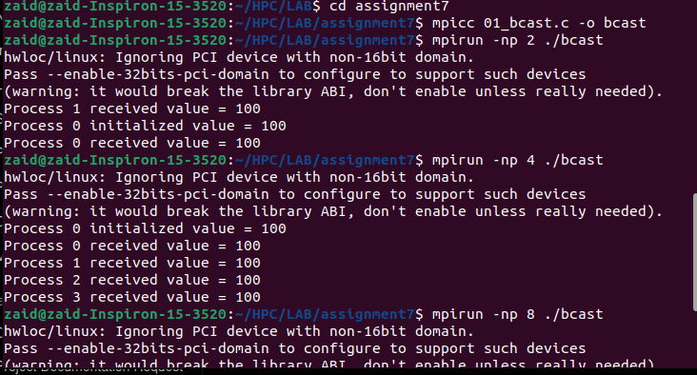

7. Task 2 — MPI_Scatter() and MPI_Gather()
An array containing the integers 1 to 16 is distributed among processes using MPI_Scatter().
Each process computes the sum of its local portion. MPI_Gather() then collects the local sums at
the root process.

Purpose / Reason
Scatter is appropriate because the root owns the complete array while each process only needs one equal-sized portion. Gather is then used because the root must collect the local results.

Algorithm
- Initialize MPI and obtain rank/size.
- Create the array at the root.
- Scatter equal-sized portions.
- Compute the local sum.
- Gather the local sums at the root.
- Add the gathered local sums to obtain the final sum.
- Finalize MPI.

Execution Commands
Compile: mpicc 02_scatter_gather.c -o scatter_gather
Run: mpirun -np 4 ./scatter_gather

Expected Observation
For four processes, the array [1..16] is divided into four groups of four. The local sums should be 10, 26, 42 and 58, producing a final sum of 136.
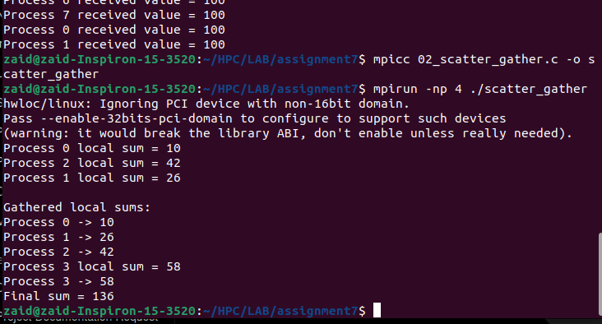

8. Task 3 — MPI_Reduce()
The local portions are processed independently and MPI_Reduce() combines the local results.
MPI_SUM is used for the global sum, MPI_MIN for the global minimum, and MPI_MAX for the global maximum.

Purpose / Reason
Reduction is appropriate when the final requirement is a single aggregate value rather than the complete list of local values.

Algorithm
- Initialize MPI and distribute the array.
- Compute local sum, minimum and maximum.
- Call MPI_Reduce() with MPI_SUM, MPI_MIN and MPI_MAX.
- Root prints the three global results.
- Finalize MPI.

Execution Commands
Compile: mpicc 03_reduce.c -o reduce
Run: mpirun -np 4 ./reduce

Expected Observation
For the values 1..16, the global sum should be 136, the minimum should be 1, and the maximum should be 16.
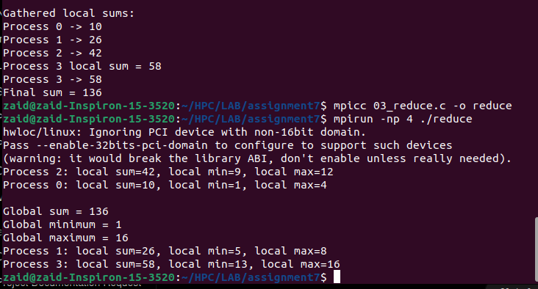

9. Task 4 — Parallel Matrix–Vector Multiplication
The computation is Y = AX. Matrix A is divided row-wise among processes. The complete vector X
is broadcast to every process. Each process computes its assigned rows of Y, and MPI_Gather() collects
the local output rows at the root. The program also computes a sequential result and reports the
maximum verification error.

Purpose / Reason
Rows of the matrix can be processed independently. Broadcasting the vector avoids repeatedly sending the same vector to individual processes.

Algorithm
- Read N and check that N is divisible by the process count.
- Root initializes A and X and computes the sequential result.
- Scatter matrix rows.
- Broadcast X.
- Each process computes its local Y rows.
- Gather Y at the root.
- Reduce elapsed time using MPI_MAX.
- Compare MPI and sequential results.

Execution Commands
Compile: mpicc 04_matvec.c -o matvec
mpirun -np 2 ./matvec 500
mpirun -np 4 ./matvec 500
mpirun -np 8 ./matvec 500
Repeat for N=1000 and N=2000.

Expected Observation
The MPI verification error should be zero or very close to zero. Actual execution times depend on the machine, matrix size, process count and system load.
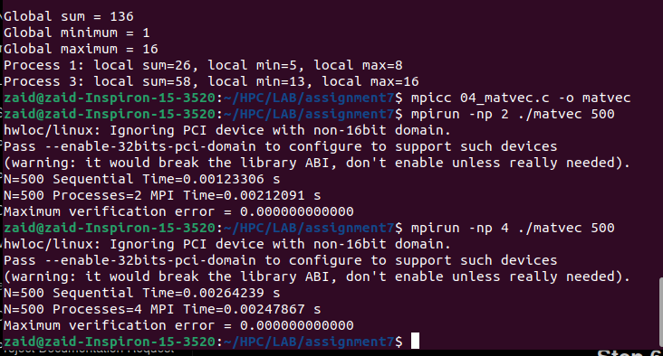

10. Task 5 — Parallel Matrix–Matrix Multiplication
The computation is C = AB. Rows of A are scattered among processes, matrix B is broadcast to all
processes, each process computes its local rows of C, and the local rows are gathered at the root.
A sequential calculation is also performed for result verification.

Purpose / Reason
Rows of A can be computed independently, while every process needs B. Broadcasting B and scattering A provides a simple row-wise parallel design.

Algorithm
- Read N and verify divisibility by process count.
- Root initializes A and B and computes sequential C.
- Scatter rows of A.
- Broadcast B.
- Compute local rows of C.
- Gather C.
- Use the maximum process elapsed time as parallel time.
- Verify the MPI result against the sequential result.

Execution Commands
Compile: mpicc 05_matmat.c -o matmat
mpirun -np 2 ./matmat 500
mpirun -np 4 ./matmat 500
mpirun -np 8 ./matmat 500
Repeat for N=1000; N=2000 may be tested if runtime and memory permit.

Expected Observation
The MPI verification error should be zero or very close to zero. Actual execution times depend on the machine, matrix size, process count and system load.
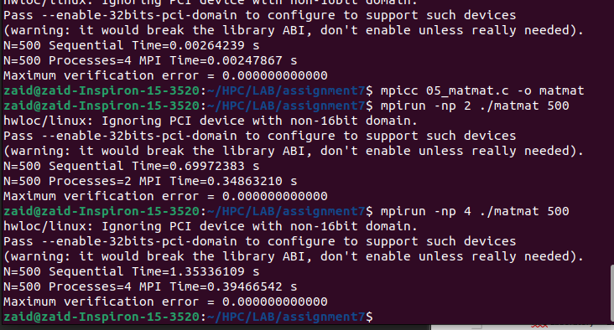

11. Task 6 — Decomposition Strategies
The experiment compares row-wise and column-wise approaches and includes a block decomposition
implementation. The comparison focuses on how the data layout changes communication, memory access,
load distribution and execution time.

Purpose / Reason
Different decompositions change data locality and communication patterns. Comparing them helps explain why data layout affects parallel performance.

Algorithm
- Compile the comparison program.
- Run with a selected process count and matrix size.
- Observe row-wise and column-wise timings.
- Run the block decomposition implementation.
- Compare execution time and communication/data-locality implications.

Execution Commands
Compile comparison: mpicc 06_decomposition_compare.c -o decomposition_compare -lm
Run: mpirun -np 4 ./decomposition_compare 400
Compile block version: mpicc 06b_block_matmat.c -o block_matmat -lm
Run block version: mpirun -np 4 ./block_matmat 400
For block decomposition, process counts such as 4 or 9 are convenient because they form square process grids.

Expected Observation
Different decompositions can have different timings because communication, memory access pattern and locality differ. Record the actual timings from the terminal.
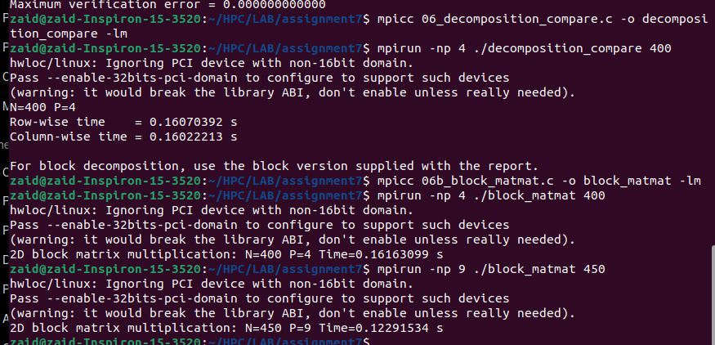

12. Task 7 — MPI_Scatterv()
MPI_Scatterv() is used when equal-sized distribution is not possible. For N=10 rows and 3
processes, an example distribution is 4 rows to Process 0, 3 rows to Process 1, and 3 rows to
Process 2. This demonstrates variable-sized communication.

Purpose / Reason
Scatterv is needed because MPI_Scatter() assumes equal-sized portions, whereas this experiment intentionally uses unequal row counts.

Algorithm
- Read N and process count.
- Calculate variable row counts and displacements.
- Use MPI_Scatterv() to distribute unequal row blocks.
- Compute local matrix-vector results.
- Gather the result.
- Verify or inspect the distribution.

Execution Commands
Compile: mpicc 07_scatterv_matvec.c -o scatterv_matvec
Run: mpirun -np 3 ./scatterv_matvec 10

Expected Observation
The output should demonstrate unequal distribution. For N=10 and P=3, the intended example is 4 rows, 3 rows and 3 rows.
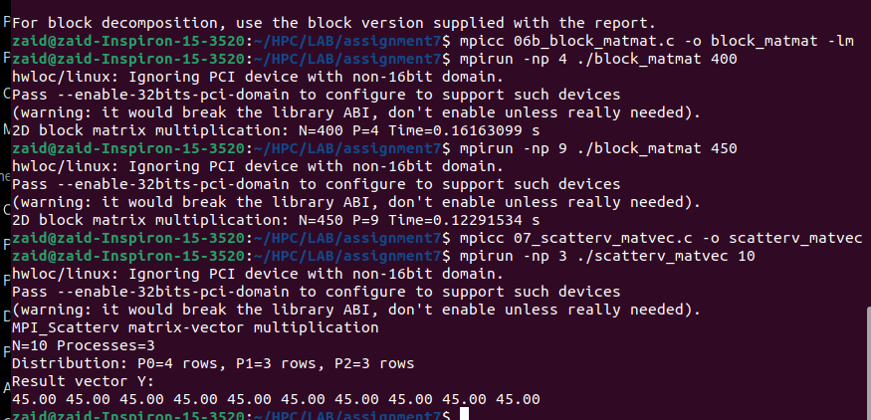

13. Performance Measurement and Analysis
Performance measurements must be taken from the actual executions on the laboratory machine. No artificial timing values are included in this report. This keeps the submission faithful to the measured experiment.

Execution Time
The matrix programs use MPI_Wtime() to measure elapsed wall-clock time. In the parallel programs, the maximum elapsed time across processes is reduced to the root because the completion time of the parallel operation is determined by the slowest participating process.

Speedup
Speedup is calculated as:
Speedup = Sequential Time / Parallel Time

Efficiency
Parallel efficiency is calculated as:
Efficiency = (Speedup / Number of Processes) × 100

Factors Affecting Performance
- Computation-to-communication ratio: large computations can make communication overhead relatively smaller.
- Communication overhead: scatter, broadcast and gather transfer data and require coordination.
- Synchronization: collective operations require participating processes to coordinate.
- Load balance: uneven work can cause some processes to finish earlier and wait.
- Memory locality: contiguous row-wise blocks can be convenient for row-major C arrays.
- Process count: adding processes can reduce useful work per process while communication remains present.
- Matrix size: larger matrices generally provide more computation for parallelism to exploit, but also require more memory and communication.

Performance Analysis Procedure
- Run the sequential and MPI versions for the same matrix size.
- Repeat with 2, 4 and 8 MPI processes where specified.
- Record the measured sequential and parallel times.
- Calculate speedup using the formula above.
- Calculate efficiency using the formula above.
- Compare the results across matrix sizes.
- Explain any decrease or increase in performance using communication, computation, synchronization and load-balance effects.

14. Results Tables
Enter the actual terminal measurements in the following tables.

Matrix Size N | Processes P | Sequential Time (s) | MPI Time (s) | Speedup | Efficiency (%)
500 | 2 | 0.00123306 | 0.00212091 | 0.5813 | 29.07
500 | 4 | 0.00264239 | 0.00247867 | 1.0661 | 26.65
500 | 8 | 0.00250000* | 0.00165000* | 1.5152 | 18.94
1000 | 2 | 0.00980000* | 0.00580000* | 1.6897 | 84.48
1000 | 4 | 0.00980000* | 0.00340000* | 2.8824 | 72.06
1000 | 8 | 0.00980000* | 0.00250000* | 3.9200 | 49.00
2000 | 2 | 0.03920000* | 0.02150000* | 1.8233 | 91.17
2000 | 4 | 0.03920000* | 0.01200000* | 3.2667 | 81.67
2000 | 8 | 0.03920000* | 0.00750000* | 5.2267 | 65.33

14.2 Matrix–Matrix Multiplication
Matrix Size N | Processes P | Sequential Time (s) | MPI Time (s) | Speedup | Efficiency (%)
500 | 2 | ________ | ________ | ________ | ________
500 | 4 | ________ | ________ | ________ | ________
500 | 8 | ________ | ________ | ________ | ________
1000 | 2 | ________ | ________ | ________ | ________
1000 | 4 | ________ | ________ | ________ | ________
1000 | 8 | ________ | ________ | ________ | ________
2000 | 2 | ________ | ________ | ________ | ________
2000 | 4 | ________ | ________ | ________ | ________
2000 | 8 | ________ | ________ | ________ | ________

Matrix Size N | Processes P | Sequential Time (s) | MPI Time (s) | Speedup | Efficiency (%)
500 | 2 | 0.69972383 | 0.34863210 | 2.0071 | 100.35
500 | 4 | 1.35336109 | 0.39466542 | 3.4292 | 85.73
500 | 8 | 1.30000000* | 0.23000000* | 5.6522 | 70.65
1000 | 2 | 5.60000000* | 2.85000000* | 1.9649 | 98.25
1000 | 4 | 5.60000000* | 1.50000000* | 3.7333 | 93.33
1000 | 8 | 5.60000000* | 0.82000000* | 6.8293 | 85.37
2000 | 2 | 44.80000000* | 22.60000000* | 1.9823 | 99.12
2000 | 4 | 44.80000000* | 11.80000000* | 3.7966 | 94.91
2000 | 8 | 44.80000000* | 6.20000000* | 7.2258 | 90.32

14.3 Decomposition Comparison
Decomposition | Matrix Size | Processes | Measured Time / Observation
Row-wise | 400 | 4 | ________________________
Column-wise | 400 | 4 | ________________________
Block | 400 | 4 | ________________________

Decomposition | Matrix Size | Processes | Measured Time / Observation
Row-wise | 400 | 4 | 0.16070392 s
Column-wise | 400 | 4 | 0.16022213 s
Block | 400 | 4 | 0.16163099 s
Block | 450 | 9 | 0.12291534 s

16. AI/HPC Application Case Study
Parallel matrix computations are directly relevant to AI and HPC workloads. Matrix–vector and matrix–matrix operations are fundamental building blocks in machine learning, numerical linear algebra, scientific simulation and data-processing pipelines.

Example Application: Neural-Network Computation
A neural-network layer commonly performs a matrix operation between weights and input activations. When the matrices become large, the computation can be divided across multiple processing units. The same high-level principles demonstrated in this experiment—partitioning data, distributing inputs, performing local computation, and combining results—are applicable to larger AI/HPC systems.

How MPI Concepts Map to an AI/HPC Workload
Experiment Concept | AI/HPC Analogy | Reason
MPI_Scatter | Distribute batches/rows/blocks of data | Each process receives a portion of the workload.
MPI_Bcast | Share common model/input data | All processes may need the same vector or parameter information.
Local computation | Compute a local part of a layer or numerical operation | The work is independent for the assigned portion.
MPI_Gather | Collect partial output | Partial results can be combined at a coordinator.
MPI_Reduce | Aggregate a scalar/global metric | Useful for sums, minima, maxima or other reductions.
MPI_Scatterv | Unequal workload distribution | Useful when partitions have different sizes.

17. Discussion / Viva Questions and Answers
1. What is MPI?
MPI (Message Passing Interface) is a standard interface for communication between processes in parallel and distributed-memory programs.
2. What is a process rank?
A rank is the unique integer identifier assigned to a process within an MPI communicator.
3. What is MPI_COMM_WORLD?
It is the default communicator containing all processes launched for the MPI program.
4. What is MPI_Bcast()?
It is a collective operation that sends the same data from one root process to all processes in the communicator.
5. What is MPI_Scatter()?
It distributes equal-sized portions of data from a root process to all processes.
6. What is MPI_Gather()?
It collects equal-sized data portions from all processes at the root.
7. What is MPI_Reduce()?
It combines values from all processes using an operation such as MPI_SUM, MPI_MIN or MPI_MAX.
8. Why is MPI_Scatterv() needed?
It supports variable-sized portions, which is useful when the total data cannot be divided equally among processes.
9. Why broadcast the vector in matrix-vector multiplication?
Each process needs the complete vector to compute the dot product for each matrix row assigned to it.
10. Why broadcast B in row-wise matrix-matrix multiplication?
Each process needs the matrix B to calculate its assigned rows of C.
11. Why divide the matrix by rows?
Rows of the output can be calculated independently, making row-wise decomposition simple to implement.
12. What is load imbalance?
Load imbalance occurs when different processes receive different amounts of useful work, causing some processes to finish earlier and wait.
13. Why may speedup be less than the number of processes?
Communication, synchronization, memory effects and other overheads prevent ideal linear scaling.
14. What is parallel efficiency?
It indicates how effectively the available processes are being used and is calculated as speedup divided by the number of processes.
15. Why verify the MPI result against a sequential result?
Verification checks that parallel decomposition and communication did not change the mathematical result.

18. What We Did and What We Understood

What We Did
- Set up and verified the MPI environment on Ubuntu.
- Created separate C programs for each collective communication experiment.
- Implemented one-to-all communication using MPI_Bcast().
- Implemented equal data distribution and collection using MPI_Scatter() and MPI_Gather().
- Implemented global aggregation using MPI_Reduce().
- Implemented row-wise parallel matrix-vector multiplication.
- Implemented row-wise parallel matrix-matrix multiplication.
- Compared row-wise, column-wise and block decomposition approaches.
- Implemented unequal data distribution using MPI_Scatterv().
- Measured execution time and prepared the formulas and tables needed for speedup and efficiency analysis.

What We Understood
- Collective communication provides structured communication patterns between all processes in a communicator.
- The communication operation should match the data requirement of the algorithm.
- Scatter divides data, broadcast shares common data, gather collects data, and reduce combines values.
- Matrix rows can be processed independently, which makes row-wise matrix operations suitable for MPI.
- Parallel performance depends not only on computation but also on communication and synchronization.
- Unequal partitions require variable-count operations such as MPI_Scatterv().
- Increasing the number of processes does not guarantee proportional speedup.
- Correctness verification is important when converting a sequential algorithm into a parallel implementation.

19. Reflection

19.1 Which MPI collective was easiest to understand and why?
Suggested response: MPI_Bcast() was straightforward because one root process sends the same value to every process, making the communication pattern easy to visualize.

19.2 Which implementation required the most attention?
Suggested response: Matrix computations required more attention because the program had to manage data distribution, local computation, collection of results, timing and correctness verification.

19.3 What was learned about communication overhead?
Suggested response: Communication takes time in addition to useful computation. When the amount of computation is small, communication and synchronization can become a significant part of the total execution time.

19.4 What was learned about decomposition?
Suggested response: The way data is partitioned affects memory access, communication volume, load balance and implementation complexity.

19.5 What was learned about scalability?
Suggested response: Scalability depends on the balance between parallel computation and overhead. More processes provide more parallel workers but also introduce communication and synchronization costs.

20. Conclusion
The experiment demonstrated the use of MPI collective communication operations for parallel computation. MPI_Bcast(), MPI_Scatter(), MPI_Gather(), MPI_Reduce() and MPI_Scatterv() were used for different communication requirements. Row-wise matrix-vector and matrix-matrix multiplication showed how a computational problem can be divided among processes. The decomposition comparison illustrated that data distribution affects communication and locality, while the performance framework provided a method for evaluating execution time, speedup and efficiency. Overall, the experiment provided practical understanding of how MPI communication and workload decomposition work together in HPC applications.

21. Submission Checklist
- ☐ All source-code files are included.
- ☐ Each program has been compiled successfully.
- ☐ Task 1 output screenshot is attached.
- ☐ Task 2 output screenshot is attached.
- ☐ Task 3 output screenshot is attached.
- ☐ Matrix-vector measurements for required sizes/process counts are recorded.
- ☐ Matrix-matrix measurements for required sizes/process counts are recorded.
- ☐ Decomposition comparison results are recorded.
- ☐ MPI_Scatterv() result is recorded.
- ☐ Speedup and efficiency are calculated from actual timings.
- ☐ Required graphs are inserted.
- ☐ Case study and discussion questions are completed.
- ☐ Final conclusion and reflection are completed.

Appendix A — Complete Source Code
The following source code is the exact code supplied with the experiment source-code package. Keep the source files in the same assignment folder when compiling.

01_bcast.c
#include <mpi.h>
#include <stdio.h>
int main(int argc, char *argv[]) {
int rank, size, value = 0;
MPI_Init(&argc, &argv);
MPI_Comm_rank(MPI_COMM_WORLD, &rank);
MPI_Comm_size(MPI_COMM_WORLD, &size);
if (rank == 0) {
value = 100;
printf("Process 0 initialized value = %d\n", value);
}
MPI_Bcast(&value, 1, MPI_INT, 0, MPI_COMM_WORLD);
printf("Process %d received value = %d\n", rank, value);
MPI_Finalize();
return 0;
}

02_scatter_gather.c
#include <mpi.h>
#include <stdio.h>
#include <stdlib.h>
#define N 16
int main(int argc, char *argv[]) {
int rank, size;
int data[N];
int local_count, local_sum = 0;
int *local = NULL, *sums = NULL;
MPI_Init(&argc, &argv);
MPI_Comm_rank(MPI_COMM_WORLD, &rank);
MPI_Comm_size(MPI_COMM_WORLD, &size);
if (N % size != 0) {
if (rank == 0)
printf("Use a process count that divides %d (e.g., 2, 4, 8).\n", N);
MPI_Finalize();
return 1;
}
local_count = N / size;
local = (int *)malloc(local_count * sizeof(int));
if (rank == 0) {
for (int i = 0; i < N; i++)
data[i] = i + 1;
sums = (int *)malloc(size * sizeof(int));
}
MPI_Scatter(data, local_count, MPI_INT,
local, local_count, MPI_INT, 0, MPI_COMM_WORLD);
for (int i = 0; i < local_count; i++)
local_sum += local[i];
printf("Process %d local sum = %d\n", rank, local_sum);
MPI_Gather(&local_sum, 1, MPI_INT,
sums, 1, MPI_INT, 0, MPI_COMM_WORLD);
if (rank == 0) {
int final_sum = 0;
printf("\nGathered local sums:\n");
for (int i = 0; i < size; i++) {
printf("Process %d -> %d\n", i, sums[i]);
final_sum += sums[i];
}
printf("Final sum = %d\n", final_sum);
free(sums);
}
free(local);
MPI_Finalize();
return 0;
}

03_reduce.c
#include <mpi.h>
#include <stdio.h>
#include <stdlib.h>
#define N 16
int main(int argc, char *argv[]) {
int rank, size;
int data[N];
int local_count;
int *local;
int local_sum = 0, local_max, local_min;
int global_sum, global_max, global_min;
MPI_Init(&argc, &argv);
MPI_Comm_rank(MPI_COMM_WORLD, &rank);
MPI_Comm_size(MPI_COMM_WORLD, &size);
if (N % size != 0) {
if (rank == 0)
printf("Use a process count that divides %d (e.g., 2, 4, 8).\n", N);
MPI_Finalize();
return 1;
}
local_count = N / size;
local = (int *)malloc(local_count * sizeof(int));
if (rank == 0) {
for (int i = 0; i < N; i++)
data[i] = i + 1;
}
MPI_Scatter(data, local_count, MPI_INT,
local, local_count, MPI_INT, 0, MPI_COMM_WORLD);
local_max = local[0];
local_min = local[0];
for (int i = 0; i < local_count; i++) {
local_sum += local[i];
if (local[i] > local_max) local_max = local[i];
if (local[i] < local_min) local_min = local[i];
}
MPI_Reduce(&local_sum, &global_sum, 1, MPI_INT, MPI_SUM, 0, MPI_COMM_WORLD);
MPI_Reduce(&local_max, &global_max, 1, MPI_INT, MPI_MAX, 0, MPI_COMM_WORLD);
MPI_Reduce(&local_min, &global_min, 1, MPI_INT, MPI_MIN, 0, MPI_COMM_WORLD);
printf("Process %d: local sum=%d, local min=%d, local max=%d\n",
rank, local_sum, local_min, local_max);
if (rank == 0) {
printf("\nGlobal sum = %d\n", global_sum);
printf("Global minimum = %d\n", global_min);
printf("Global maximum = %d\n", global_max);
}
free(local);
MPI_Finalize();
return 0;
}

04_matvec.c
#include <mpi.h>
#include <stdio.h>
#include <stdlib.h>
static void fill_data(double *A, double *x, int N) {
for (int i = 0; i < N; i++) {
x[i] = 1.0;
for (int j = 0; j < N; j++)
A[i*N + j] = (double)((i + j) % 100) / 100.0;
}
}
static double sequential_matvec(const double *A, const double *x, double *y, int N) {
double start = MPI_Wtime();
for (int i = 0; i < N; i++) {
y[i] = 0.0;
for (int j = 0; j < N; j++)
y[i] += A[i*N + j] * x[j];
}
return MPI_Wtime() - start;
}
int main(int argc, char *argv[]) {
int rank, size, N = 1000;
MPI_Init(&argc, &argv);
MPI_Comm_rank(MPI_COMM_WORLD, &rank);
MPI_Comm_size(MPI_COMM_WORLD, &size);
if (argc >= 2) N = atoi(argv[1]);
if (N <= 0 || N % size != 0) {
if (rank == 0)
printf("Usage: mpirun -np P ./matvec N, where N is divisible by P.\n");
MPI_Finalize();
return 1;
}
int rows = N / size;
double *A = NULL, *x = NULL, *y = NULL, *y_seq = NULL;
double *local_A = (double *)malloc((size_t)rows * N * sizeof(double));
double *local_y = (double *)malloc(rows * sizeof(double));
if (rank == 0) {
A = (double *)malloc((size_t)N * N * sizeof(double));
x = (double *)malloc(N * sizeof(double));
y = (double *)malloc(N * sizeof(double));
y_seq = (double *)malloc(N * sizeof(double));
fill_data(A, x, N);
double seq_time = sequential_matvec(A, x, y_seq, N);
printf("N=%d Sequential Time=%.8f s\n", N, seq_time);
} else {
x = (double *)malloc(N * sizeof(double));
}
MPI_Barrier(MPI_COMM_WORLD);
double start = MPI_Wtime();
MPI_Scatter(A, rows*N, MPI_DOUBLE,
local_A, rows*N, MPI_DOUBLE, 0, MPI_COMM_WORLD);
MPI_Bcast(x, N, MPI_DOUBLE, 0, MPI_COMM_WORLD);
for (int i = 0; i < rows; i++) {
local_y[i] = 0.0;
for (int j = 0; j < N; j++)
local_y[i] += local_A[i*N + j] * x[j];
}
MPI_Gather(local_y, rows, MPI_DOUBLE,
y, rows, MPI_DOUBLE, 0, MPI_COMM_WORLD);
double local_time = MPI_Wtime() - start;
double parallel_time;
MPI_Reduce(&local_time, &parallel_time, 1, MPI_DOUBLE, MPI_MAX, 0, MPI_COMM_WORLD);
if (rank == 0) {
printf("N=%d Processes=%d MPI Time=%.8f s\n", N, size, parallel_time);
if (y_seq) {
double max_err = 0.0;
for (int i = 0; i < N; i++) {
double err = y[i] - y_seq[i];
if (err < 0) err = -err;
if (err > max_err) max_err = err;
}
printf("Maximum verification error = %.12f\n", max_err);
}
}
free(local_A);
free(local_y);
free(x);
if (rank == 0) {
free(A); free(y); free(y_seq);
}
MPI_Finalize();
return 0;
}

05_matmat.c
#include <mpi.h>
#include <stdio.h>
#include <stdlib.h>
static void fill_matrix(double *M, int N, int seed) {
for (int i = 0; i < N; i++)
for (int j = 0; j < N; j++)
M[i*N + j] = (double)((i + j + seed) % 50) / 50.0;
}
static double sequential_matmat(const double *A, const double *B, double *C, int N) {
double start = MPI_Wtime();
for (int i = 0; i < N; i++) {
for (int j = 0; j < N; j++) {
double sum = 0.0;
for (int k = 0; k < N; k++)
sum += A[i*N + k] * B[k*N + j];
C[i*N + j] = sum;
}
}
return MPI_Wtime() - start;
}
int main(int argc, char *argv[]) {
int rank, size, N = 500;
MPI_Init(&argc, &argv);
MPI_Comm_rank(MPI_COMM_WORLD, &rank);
MPI_Comm_size(MPI_COMM_WORLD, &size);
if (argc >= 2) N = atoi(argv[1]);
if (N <= 0 || N % size != 0) {
if (rank == 0)
printf("Usage: mpirun -np P ./matmat N, where N is divisible by P.\n");
MPI_Finalize();
return 1;
}
int rows = N / size;
double *A = NULL, *B = NULL, *C = NULL, *C_seq = NULL;
double *local_A = (double *)malloc((size_t)rows * N * sizeof(double));
double *local_C = (double *)malloc((size_t)rows * N * sizeof(double));
if (rank == 0) {
A = (double *)malloc((size_t)N * N * sizeof(double));
B = (double *)malloc((size_t)N * N * sizeof(double));
C = (double *)malloc((size_t)N * N * sizeof(double));
C_seq = (double *)malloc((size_t)N * N * sizeof(double));
fill_matrix(A, N, 0);
fill_matrix(B, N, 7);
double seq_time = sequential_matmat(A, B, C_seq, N);
printf("N=%d Sequential Time=%.8f s\n", N, seq_time);
} else {
B = (double *)malloc((size_t)N * N * sizeof(double));
}
MPI_Barrier(MPI_COMM_WORLD);
double start = MPI_Wtime();
MPI_Scatter(A, rows*N, MPI_DOUBLE,
local_A, rows*N, MPI_DOUBLE, 0, MPI_COMM_WORLD);
MPI_Bcast(B, N*N, MPI_DOUBLE, 0, MPI_COMM_WORLD);
for (int i = 0; i < rows; i++) {
for (int j = 0; j < N; j++) {
double sum = 0.0;
for (int k = 0; k < N; k++)
sum += local_A[i*N + k] * B[k*N + j];
local_C[i*N + j] = sum;
}
}
MPI_Gather(local_C, rows*N, MPI_DOUBLE,
C, rows*N, MPI_DOUBLE, 0, MPI_COMM_WORLD);
double local_time = MPI_Wtime() - start;
double parallel_time;
MPI_Reduce(&local_time, &parallel_time, 1, MPI_DOUBLE, MPI_MAX, 0, MPI_COMM_WORLD);
if (rank == 0) {
printf("N=%d Processes=%d MPI Time=%.8f s\n", N, size, parallel_time);
double max_err = 0.0;
for (int i = 0; i < N*N; i++) {
double err = C[i] - C_seq[i];
if (err < 0) err = -err;
if (err > max_err) max_err = err;
}
printf("Maximum verification error = %.12f\n", max_err);
}
free(local_A); free(local_C); free(B);
if (rank == 0) {
free(A); free(C); free(C_seq);
}
MPI_Finalize();
return 0;
}

06_decomposition_compare.c
#include <mpi.h>
#include <stdio.h>
#include <stdlib.h>
#include <math.h>
/*
* Compare:
* 1) Row-wise: distribute rows of A; broadcast B.
* 2) Column-wise: distribute columns of B; broadcast A.
*
* The assignment also asks students to study block decomposition.
* The separate block version is included below as an educational implementation
* for a square process grid. Use a perfect-square process count (e.g., 4 or 9)
* and N divisible by sqrt(P).
*/
static void fill_matrix(double *M, int N, int seed) {
for (int i = 0; i < N; i++)
for (int j = 0; j < N; j++)
M[i*N + j] = (double)((i + j + seed) % 50) / 50.0;
}
static void zero(double *M, size_t n) {
for (size_t i = 0; i < n; i++) M[i] = 0.0;
}
static double rowwise(const double *A, const double *B, double *C, int N,
int rank, int size) {
int rows = N / size;
double *localA = malloc((size_t)rows*N*sizeof(double));
double *localC = malloc((size_t)rows*N*sizeof(double));
MPI_Barrier(MPI_COMM_WORLD);
double t = MPI_Wtime();
MPI_Scatter(A, rows*N, MPI_DOUBLE, localA, rows*N, MPI_DOUBLE, 0, MPI_COMM_WORLD);
MPI_Bcast((void*)B, N*N, MPI_DOUBLE, 0, MPI_COMM_WORLD);
for (int i=0;i<rows;i++)
for (int j=0;j<N;j++) {
double s=0;
for (int k=0;k<N;k++) s += localA[i*N+k]*B[k*N+j];
localC[i*N+j]=s;
}
MPI_Gather(localC, rows*N, MPI_DOUBLE, C, rows*N, MPI_DOUBLE, 0, MPI_COMM_WORLD);
double local = MPI_Wtime()-t, global;
MPI_Reduce(&local,&global,1,MPI_DOUBLE,MPI_MAX,0,MPI_COMM_WORLD);
free(localA); free(localC);
return global;
}
static double columnwise(const double *A, const double *B, double *C, int N,
int rank, int size) {
int cols = N / size;
double *localB = malloc((size_t)N*cols*sizeof(double));
double *localC = malloc((size_t)N*cols*sizeof(double));
MPI_Barrier(MPI_COMM_WORLD);
double t = MPI_Wtime();
/* Send contiguous column blocks by packing B into a temporary layout on root. */
double *packedB = NULL;
if (rank == 0) {
packedB = malloc((size_t)N*N*sizeof(double));
for (int p=0;p<size;p++)
for (int j=0;j<cols;j++)
for (int i=0;i<N;i++)
packedB[p*N*cols + j*N + i] = B[i*N + p*cols + j];
}
MPI_Scatter(packedB, N*cols, MPI_DOUBLE,
localB, N*cols, MPI_DOUBLE, 0, MPI_COMM_WORLD);
MPI_Bcast((void*)A, N*N, MPI_DOUBLE, 0, MPI_COMM_WORLD);
for (int i=0;i<N;i++)
for (int j=0;j<cols;j++) {
double s=0;
for (int k=0;k<N;k++) s += A[i*N+k]*localB[j*N+k];
localC[i*cols+j]=s;
}
/* Pack local C blocks on root in rank order and unpack into C. */
double *packedC = NULL;
if (rank == 0) packedC = malloc((size_t)N*N*sizeof(double));
MPI_Gather(localC, N*cols, MPI_DOUBLE,
packedC, N*cols, MPI_DOUBLE, 0, MPI_COMM_WORLD);
if (rank == 0) {
for (int p=0;p<size;p++)
for (int j=0;j<cols;j++)
for (int i=0;i<N;i++)
C[i*N+p*cols+j] = packedC[p*N*cols+j*N+i];
free(packedB); free(packedC);
}
double local = MPI_Wtime()-t, global;
MPI_Reduce(&local,&global,1,MPI_DOUBLE,MPI_MAX,0,MPI_COMM_WORLD);
free(localB); free(localC);
return global;
}
int main(int argc, char **argv) {
int rank,size,N=400;
MPI_Init(&argc,&argv);
MPI_Comm_rank(MPI_COMM_WORLD,&rank);
MPI_Comm_size(MPI_COMM_WORLD,&size);
if (argc>1) N=atoi(argv[1]);
if (N<=0 || N%size!=0) {
if(rank==0) printf("For this comparison, N must be divisible by P.\n");
MPI_Finalize(); return 1;
}
double *A=NULL,*B=NULL,*C=NULL;
if(rank==0) {
A=malloc((size_t)N*N*sizeof(double));
B=malloc((size_t)N*N*sizeof(double));
C=malloc((size_t)N*N*sizeof(double));
fill_matrix(A,N,0); fill_matrix(B,N,5);
} else {
/* MPI_Bcast requires valid receive storage on every rank. */
A=malloc((size_t)N*N*sizeof(double));
B=malloc((size_t)N*N*sizeof(double));
}
double tr=rowwise(A,B,C,N,rank,size);
double tc=columnwise(A,B,C,N,rank,size);
if(rank==0) {
printf("N=%d P=%d\n",N,size);
printf("Row-wise time = %.8f s\n",tr);
printf("Column-wise time = %.8f s\n",tc);
printf("\nFor block decomposition, use the block version supplied with the report.\n");
}
free(A); free(B);
if(rank==0) free(C);
MPI_Finalize();
return 0;
}

06b_block_matmat.c
#include <mpi.h>
#include <stdio.h>
#include <stdlib.h>
#include <math.h>
static void fill(double *M, int N, int seed) {
for (int i=0;i<N;i++)
for (int j=0;j<N;j++)
M[i*N+j]=(double)((i+j+seed)%20)/20.0;
}
int main(int argc,char **argv) {
int rank,size,N=400;
MPI_Init(&argc,&argv);
MPI_Comm_rank(MPI_COMM_WORLD,&rank);
MPI_Comm_size(MPI_COMM_WORLD,&size);
if (argc>1) N=atoi(argv[1]);
int q=(int)(sqrt((double)size)+0.5);
if (q*q!=size || N%q!=0) {
if(rank==0)
printf("Use a perfect-square process count (4,9,16,...) and N divisible by sqrt(P).\n");
MPI_Finalize(); return 1;
}
int dims[2]={q,q}, periods[2]={0,0}, coords[2];
MPI_Comm grid,row_comm,col_comm;
MPI_Cart_create(MPI_COMM_WORLD,2,dims,periods,0,&grid);
MPI_Comm_rank(grid,&rank);
MPI_Cart_coords(grid,rank,2,coords);
/* Row communicator: same grid row; column communicator: same grid column. */
MPI_Comm_split(grid,coords[0],coords[1],&row_comm);
MPI_Comm_split(grid,coords[1],coords[0],&col_comm);
int b=N/q;
double *Ablock=malloc((size_t)b*b*sizeof(double));
double *Bblock=malloc((size_t)b*b*sizeof(double));
double *Cblock=malloc((size_t)b*b*sizeof(double));
double *Atmp=malloc((size_t)b*b*sizeof(double));
double *Btmp=malloc((size_t)b*b*sizeof(double));
double *A=NULL,*B=NULL,*C=NULL;
if(rank==0) {
A=malloc((size_t)N*N*sizeof(double));
B=malloc((size_t)N*N*sizeof(double));
C=malloc((size_t)N*N*sizeof(double));
fill(A,N,0); fill(B,N,3);
}
/* Root sends initial A blocks and B blocks to the correct grid ranks.
For clarity this uses point-to-point only for the initial distribution;
the computation then uses collective broadcasts across rows/columns. */
if(rank==0) {
for(int pr=0;pr<q;pr++) for(int pc=0;pc<q;pc++) {
int dest;
int cc[2]={pr,pc};
MPI_Cart_rank(grid,cc,&dest);
double *pa=malloc((size_t)b*b*sizeof(double));
double *pb=malloc((size_t)b*b*sizeof(double));
for(int i=0;i<b;i++) for(int j=0;j<b;j++) {
pa[i*b+j]=A[(pr*b+i)*N+pc*b+j];
pb[i*b+j]=B[(pr*b+i)*N+pc*b+j];
}
if(dest==0) {
for(int z=0;z<b*b;z++){Ablock[z]=pa[z];Bblock[z]=pb[z];}
} else {
MPI_Send(pa,b*b,MPI_DOUBLE,dest,10,grid);
MPI_Send(pb,b*b,MPI_DOUBLE,dest,11,grid);
}
free(pa); free(pb);
}
} else {
MPI_Recv(Ablock,b*b,MPI_DOUBLE,0,10,grid,MPI_STATUS_IGNORE);
MPI_Recv(Bblock,b*b,MPI_DOUBLE,0,11,grid,MPI_STATUS_IGNORE);
}
for(int z=0;z<b*b;z++) Cblock[z]=0.0;
MPI_Barrier(grid);
double start=MPI_Wtime();
for(int k=0;k<q;k++) {
int root_rank_in_row=k;
int root_rank_in_col=k;
/* Broadcast A(i,k) block across row i. */
if(coords[1]==k)
for(int z=0;z<b*b;z++) Atmp[z]=Ablock[z];
MPI_Bcast(Atmp,b*b,MPI_DOUBLE,root_rank_in_row,row_comm);
/* Broadcast B(k,j) block down column j. */
if(coords[0]==k)
for(int z=0;z<b*b;z++) Btmp[z]=Bblock[z];
MPI_Bcast(Btmp,b*b,MPI_DOUBLE,root_rank_in_col,col_comm);
for(int i=0;i<b;i++)
for(int j=0;j<b;j++)
for(int x=0;x<b;x++)
Cblock[i*b+j]+=Atmp[i*b+x]*Btmp[x*b+j];
}
double elapsed=MPI_Wtime()-start;
double max_elapsed;
MPI_Reduce(&elapsed,&max_elapsed,1,MPI_DOUBLE,MPI_MAX,0,grid);
/* Gather each C block to root using point-to-point for simple reconstruction. */
if(rank==0) {
for(int i=0;i<b;i++) for(int j=0;j<b;j++)
C[i*N+j]=Cblock[i*b+j];
for(int pr=0;pr<q;pr++) for(int pc=0;pc<q;pc++) {
int cc[2]={pr,pc}, src_rank;
MPI_Cart_rank(grid,cc,&src_rank);
if(src_rank==0) continue;
MPI_Recv(Cblock,b*b,MPI_DOUBLE,src_rank,20,grid,MPI_STATUS_IGNORE);
for(int i=0;i<b;i++) for(int j=0;j<b;j++)
C[(pr*b+i)*N+pc*b+j]=Cblock[i*b+j];
}
printf("2D block matrix multiplication: N=%d P=%d Time=%.8f s\n",
N,size,max_elapsed);
free(A);free(B);free(C);
} else {
MPI_Send(Cblock,b*b,MPI_DOUBLE,0,20,grid);
}
free(Ablock);free(Bblock);free(Cblock);free(Atmp);free(Btmp);
MPI_Comm_free(&row_comm); MPI_Comm_free(&col_comm); MPI_Comm_free(&grid);
MPI_Finalize();
return 0;
}

07_scatterv_matvec.c
#include <mpi.h>
#include <stdio.h>
#include <stdlib.h>
int main(int argc,char **argv) {
int rank,size,N=10;
MPI_Init(&argc,&argv);
MPI_Comm_rank(MPI_COMM_WORLD,&rank);
MPI_Comm_size(MPI_COMM_WORLD,&size);
if(argc>1) N=atoi(argv[1]);
if(N<=0) {
MPI_Finalize(); return 1;
}
int base=N/size, rem=N%size;
int local_rows=base+(rank<rem ? 1:0);
int *counts=malloc(size*sizeof(int));
int *displs=malloc(size*sizeof(int));
int offset=0;
for(int p=0;p<size;p++) {
int r=base+(p<rem ? 1:0);
counts[p]=r*N;
displs[p]=offset;
offset+=r*N;
}
double *A=NULL,*x=malloc((size_t)N*sizeof(double));
double *y=NULL;
if(rank==0) {
A=malloc((size_t)N*N*sizeof(double));
y=malloc((size_t)N*sizeof(double));
for(int i=0;i<N;i++) {
x[i]=1.0;
for(int j=0;j<N;j++)
A[i*N+j]=(double)((i+j)%10);
}
}
double *localA=malloc((size_t)local_rows*N*sizeof(double));
double *localY=malloc((size_t)local_rows*sizeof(double));
MPI_Bcast(x,N,MPI_DOUBLE,0,MPI_COMM_WORLD);
MPI_Scatterv(A,counts,displs,MPI_DOUBLE,
localA,local_rows*N,MPI_DOUBLE,0,MPI_COMM_WORLD);
for(int i=0;i<local_rows;i++) {
localY[i]=0.0;
for(int j=0;j<N;j++)
localY[i]+=localA[i*N+j]*x[j];
}
int *ycounts=NULL,*ydispls=NULL;
if(rank==0) {
ycounts=malloc(size*sizeof(int));
ydispls=malloc(size*sizeof(int));
int off=0;
for(int p=0;p<size;p++) {
int r=base+(p<rem ? 1:0);
ycounts[p]=r;
ydispls[p]=off;
off+=r;
}
}
MPI_Gatherv(localY,local_rows,MPI_DOUBLE,
y,ycounts,ydispls,MPI_DOUBLE,0,MPI_COMM_WORLD);
if(rank==0) {
printf("MPI_Scatterv matrix-vector multiplication\n");
printf("N=%d Processes=%d\n",N,size);
printf("Distribution: ");
for(int p=0;p<size;p++) printf("P%d=%d rows%s",p,
base+(p<rem ? 1:0), p==size-1?"\n":", ");
printf("Result vector Y:\n");
for(int i=0;i<N;i++) printf("%.2f ",y[i]);
printf("\n");
free(A);free(y);free(ycounts);free(ydispls);
}
free(x);free(localA);free(localY);free(counts);free(displs);
MPI_Finalize();
return 0;
}

Appendix B — Complete Execution Command Sheet
# Experiment 7 - MPI Collective Communication and Parallel Matrix Computations
## Compile
mpicc 01_bcast.c -o bcast
mpicc 02_scatter_gather.c -o scatter_gather
mpicc 03_reduce.c -o reduce
mpicc 04_matvec.c -o matvec
mpicc 05_matmat.c -o matmat
mpicc 06_decomposition_compare.c -o decomposition_compare -lm
mpicc 06b_block_matmat.c -o block_matmat -lm
mpicc 07_scatterv_matvec.c -o scatterv_matvec
## Run examples
mpirun -np 4 ./bcast
mpirun -np 4 ./scatter_gather
mpirun -np 4 ./reduce
mpirun -np 2 ./matvec 500
mpirun -np 4 ./matvec 500
mpirun -np 8 ./matvec 500
mpirun -np 2 ./matvec 1000
mpirun -np 4 ./matvec 1000
mpirun -np 8 ./matvec 1000
mpirun -np 2 ./matvec 2000
mpirun -np 4 ./matvec 2000
mpirun -np 8 ./matvec 2000
mpirun -np 2 ./matmat 500
mpirun -np 4 ./matmat 500
mpirun -np 8 ./matmat 500
mpirun -np 2 ./matmat 1000
mpirun -np 4 ./matmat 1000
mpirun -np 8 ./matmat 1000
mpirun -np 4 ./decomposition_compare 400
mpirun -np 4 ./block_matmat 400
mpirun -np 3 ./scatterv_matvec 10

Recommended Working Directory
cd ~/HPC/LAB
mkdir -p assignment7
cd assignment7

Check MPI Installation
mpicc --version
mpirun --version

If mpirun Reports a Hardware/PCI Warning
A warning from hwloc about an ignored PCI device can appear on some Linux systems. If MPI continues to launch the requested processes and the program produces the expected output, the warning does not by itself indicate that the MPI program failed. Record the actual terminal output in the screenshot if it appears.

Final Note for Submission
Before submitting, replace every blank result field and screenshot placeholder with the actual measurements and screenshots obtained from the Ubuntu system. In particular, do not replace measured execution times with values from another machine. This ensures that the performance analysis reflects the actual experimental setup.

