REPORT ON STUDENT INDUSTRIAL WORK EXPERIENCE SCHEME (SIWES)

BY

YUNUS ABDULFATAH ABUBAKAR

SCI/2016/2449

A REPORT SUBMITTED TO THE DEPARTMENT OF COMPUTER SCIENCE AND INFORMATION TECHNOLOGY

IN PARTIAL FULFILMENT OF THE REQUIREMENTS FOR STUDENT INDUSTRIAL WORK EXPERIENCE SCHEME (SIWES)

FEDERAL UNIVERSITY DUTSINMA, KATSINA STATE.

OCTOBER 2018

# DECLARATION

I YUNUS Abdulfatah Abubakar with the matriculation number SCI/2016/2449 hereby declare that this technical report was written by me as a requisite for completion of the Student Industrial Work Experience Scheme (SIWES) at ICT DIRECTORATE FEDERAL UNIVERSITY DUTSIN-MA, KATSINA STATE.

___________________________ _____________________________

YUNUS Abdulfatah Abubakar DATE

(SCI/2016/2449)

# ACKNOWLEDGEMENT

First and foremost, I must express my profound gratitude to Almighty Allah for his provision and wisdom that guided me throughout the period of this work. A work of this nature cannot be done successfully without the help, goodwill, co-operation and moral assistance of others.

I therefore say a big thanks to my supervisor, who was able to take time out of his busy schedule to supervise me during the training and gave me quality input that has further enhanced the quality of this work. I cannot forget the effort of the Departmental SIWES Coordinator in the person of Mal. Muhammad Muntasir.

This will not be complete without specially acknowledging my beloved parents, Mr. and Mrs. YUNUS for their support (financial and otherwise).

I am also grateful to my siblings, friends and every individual who contributed in one way or the other towards the success of this work. May Allah bless you all.

# DEDICATION

I dedicate this work to my parent for all the support (financial and otherwise) they gave me during the training period.

# 

# CERTIFICATION

This is to certify that the Student Industrial Work Experience Scheme (SIWES) was written by YUNUS Abdulfatah Abubakar with matriculation number SCI/2016/2449, and that the training took place at ICT DIRECTORATE FEDERAL UNIVERSITY DUTSIN-MA, KATSINA STATE for the period of six (6) months.

___________________________ ___________________________

Mal. Abdulhafeez Date

(SIWES SUPERVISOR)

___________________________ ___________________________

Mal. Muhammad Muntasir Date

(SIWES COODINATOR)

___________________________ ___________________________

Dr. Mrs. Olarewaju Date

(HOD)

# TABLE OF CONTENT

TITLE PAGE **Error! Bookmark not defined.**

DECLARATION ii

ACKNOWLEDGEMENT iii

DEDICATION iv

CERTIFICATION v

TABLE OF CONTENT vi

LIST OF FIGURES USED ix

LIST OF ACRONYMS xi

CHAPTER ONE 1

1.0 INTRODUCTION 1

1.1 GENERAL INTRODUCTION OF SIWES 1

1.2 BRIEF HISTORY OF SIWES 2

1.3 AIM OF SIWES 2

1.4 OBJECTIVES OF SIWES 3

CHAPTER TWO 4

2.0 DESCRIPTION OF THE ESTABLISHMENT 4

2.1 BRIEF HISTORY OF FEDERAL UNIVERSITY DUTSIN-MA 4

2.2 VISION OF FEDERAL UNIVERSITY DUTSIN-MA 4

2.3 MISSION OF FEDERAL UNIVERSITY DUTSIN-MA 5

2.4 MOTTO OF FEDERAL UNIVERSITY DUTSIN-MA 5

2.5 OBJECTIVES OF FEDERAL UNIVERSITY DUTSIN-MA 5

2.6 ORGANOGRAM OF FEDERAL UNIVERSITY DUTSIN-MA ICT UNIT 6

CHAPTER THREE 7

3.0 DESCRIPTION OF ACTIVIES CARRIED OUT 7

3.1 THE DEPARTMENTS WHERE THE SIWES TRAINING WAS DONE 8

3.1.1 WEEK ONE: NETWORKING DEPARTMENT 9

3.1.1.1 Understanding Networking and its Components 9

3.1.1.2 Classification of Computer Network 11

3.1.1.3 Network topology 14

3.1.1.4 Application of Computer Network 15

3.1.1.5 Networking component and there uses. 15

3.1.1.6 Practical class on how to configure manageable switch using Cisco Packet Tracer 17

3.1.1.7 Open System Interconnection (OSI) Model 18

3.1.1.8 Introduction to Server Architecture 20

3.1.1.8.1 Components of a server 20

3.1.1.8.2 Types of server architecture 20

3.1.1.8.3 Features of a server 20

3.1.1.8.4 Practical class on how to configure a server using VMware and Ubuntu operating system (O.S) 21

3.1.1.9 Network protocols 21

3.1.1.9 .1 Types of network protocols 21

3.1.2 WEEK TWO: SOFTWARE DEPARTMENT) 22

3.1.2.1 Understanding Software Development 22

3.1.2.2 Introduction to web design 23

3.1.2.3 What is ASP.NET? 23

3.1.2.4 Relational Database Concepts (MYSQL) 25

3.1.2.5 Database 25

3.1.2.5 Database schema 25

3.1.4 WEEK THREE: HARDWARE MAINTENANCE 27

3.1.4.1 Understanding hardware maintenance 27

3.1.4.2 What Is Hardware? 27

3.1.5 WEEK FOUR: HARDWARE PROGRAMING 30

3.1.5.1 Understanding Hardware Programming (Embedded systems) 30

3.1.5.2` Common characteristics of these systems are 30

3.1.5..3 Application of Embedded systems 31

3.1.5.4 The Components of Embedded Systems 31

3.1.5.5 Embedded Systems design processes 32

3.1.6 KNOWLEDGE GAINED IN SOFTWARE DEPARTMENT 33

3.1.6.1 Hypertext Markup Language (HTML5) 33

3.1.6.1.1 Types of HTML elements 34

3.1.6.2 Cascading Style Sheet (CSS) 37

3.1.6.3 Hypertext Preprocessor (PHP) 39

3.1.6.4 My Structured Query Language (MYSQL) 41

3.1.6.4.1 What is a database table? 42

3.1.6.4.2 What is a Record or a Row? 43

3.1.6.4.3 What is a column? 44

3.1.6.5 Structured Query Language (SQL) 45

3.1.7 THE WEB APPLICATION I DEVELOPED WITH THE KNOWLEDGE I GAINED 47

3.1.7.1 SCOPE OF THE APPLICATION 47

3.1.7.2 FUNCTIONALITIES OF THE APPLICATION 47

3.1.8 ROLES AND RESPONSIBILITIES I CARRIED OUT 52

CHAPTER FOUR 53

4.0 CHALLENGES, RECOMMENDATION AND CONCLUSION 53

4.1 CHALLENGES ENCOUNTERED AT WORK PLACE 53

4.2 RECOMMENDATION 53

4.3 CONCLUSION 54

REFERENCES 55

# LIST OF FIGURES USED

Figure 2.6 organogram of federal university dutsinma **Error! Bookmark not defined.**

Figure 3.1.1.1.0 a simp;le computer netwok with two computers connected.. **Error! Bookmark not defined.**

Figure 3.1.1.2.0 a LAN Network. **Error! Bookmark not defined.**

Figure3.1.1.2.1 a MAN Network. **Error! Bookmark not defined.**

Figure3.1.1.2.2 a WAN Network. **Error! Bookmark not defined.**

Figure 3.1.1.3.0various types of physical topology. **Error! Bookmark not defined.**

Figure 3.1.1.4.0 common networking peripherals. **Error! Bookmark not defined.**

Figure 3.1.1.5.0 a router. **Error! Bookmark not defined.**

Figure 3.1.1.5.1 a switch. **Error! Bookmark not defined.**

Figure 3.1.1.5.2 a router. **Error! Bookmark not defined.**

Figure 3.1.1.5.3 a cable. **Error! Bookmark not defined.**

Figure 3.1.1.6.0 a network I created using CISCO Packet Tracer. **Error! Bookmark not defined.**

Figure 3.1.1.7.0 the OSI Model arranged in descending order with functions and examples. **Error! Bookmark not defined.**

Figure 3.1.1.8.2.0 Client-Server architecture. **Error! Bookmark not defined.**

Figure 3.1.2.3.0 a simple web page I designed. **Error! Bookmark not defined.**

Figure 3.1.2.3.0 how to connect PHP to MYSQL. **Error! Bookmark not defined.**

Figure 3.1.2.4.0 a database table. **Error! Bookmark not defined.**

Figure 3.1.2.5.0 a database schema **Error! Bookmark not defined.**

Figure 3.1.4.2.0 a mother board. **Error! Bookmark not defined.**

Figure 3.1.4.2.1a hard drive. 28

Figure3.1.4.2.2 a RAM. **Error! Bookmark not defined.**

Figure 3.1.4.2.3 a ROM. **Error! Bookmark not defined.**

Figure 3.1.5.5.0 a circuit design using ISIS emulator. **Error! Bookmark not defined.**

Figure 3.1.6.1.0 HTML element. **Error! Bookmark not defined.**

Figure 3.1.6.1.1 HTML link underlined. **Error! Bookmark not defined.**

Figure 3.1.6.1.2 an image added to a web site. **Error! Bookmark not defined.**

Figure 3.1.6.1.3 a video added to a web site. **Error! Bookmark not defined.**

Figure 3.1.6.1.4 an audio added to a web site. **Error! Bookmark not defined.**

Figure 3.1.6.1.5 a simple HTML table. **Error! Bookmark not defined.**

Figure 3.1.6.1.6 a simple HTML form. **Error! Bookmark not defined.**

Figure 3.1.6.2.0 CSS declaration. **Error! Bookmark not defined.**

Figure 3.1.6.2.1 a table styled with CSS. **Error! Bookmark not defined.**

Figure3.1.6.3.0 How to connect PHP to database. **Error! Bookmark not defined.**

Figure 3.1.6.3.1 a page linked to database using PHP. **Error! Bookmark not defined.**

Figure 3.1.6.4.0 structure of database with its table. **Error! Bookmark not defined.**

Figure 3.1.6.4.1.0 a database table. **Error! Bookmark not defined.**

Figure 3.1.6.4.2.0a single record. **Error! Bookmark not defined.**

Figure 33.1.6.4.3.0a database column. **Error! Bookmark not defined.**

Figure 3.1.6..5.0 data definition language. **Error! Bookmark not defined.**

Figure 3.1.6..5.1 data manipulation language. **Error! Bookmark not defined.**

Figure 3.1.6..5.2 data control language. **Error! Bookmark not defined.**

Figure3.1.7.2.0 admins’ home page. **Error! Bookmark not defined.**

Figure 3.1.7.2.1 admins’ post page. **Error! Bookmark not defined.**

Figure 3.1.7.2.2 user’s home page. **Error! Bookmark not defined.**

Figure 3.1.7.2.3users’ sign up page. **Error! Bookmark not defined.**

Figure 3.1.7.2.4users’ login page. **Error! Bookmark not defined.**

Figure3.1.7.2.5 users’ comment page. **Error! Bookmark not defined.**

# LIST OF ACRONYMS

ASP.NET Active Server Pages Network

CISCO Computer Information System Company

CSS Cascading Style Sheet

CD Compact Disk

DVD Digital Video Disk

DCL Data Control Language

DBMS Database Management System

DCL Data Control Language

DDL Data Definition Language

DML Data Manipulation Language

FUDMA Federal University Dutsinma

HTML Hyper Text Markup Language

ISO International Organization for Standardization

ICT Information and Communication Technology

ID Identification

ISIS Intel System Implementation Supervisor

ITF Industrial Training Fund

LAN Local Area Network

MD Managing Director

MAN Metropolitan Area Network

MYSQL My Structured Query Language

MS Microsoft

NUC National University Commission

OSI Open System Interconnection

PHP Hypertext Preprocessor

SIWES Student Industrial Work Experience Scheme

SQL Structured Query Language

RDBMS Relational Database Management System

VLAN Virtual Local Area Network

WAN Wide Area Network

# CHAPTER ONE

## 1.0 INTRODUCTION

## 1.1 GENERAL INTRODUCTION OF SIWES

The Students Industrial Work Experience Scheme (SIWES) is the accepted technical training program, which forms part of the approved minimum Academic standards in various degree programs for all Nigerian Universities. It is aimed at exposing students to instruments and equipment, professional work methods and ways of safe guarding the work areas and workers in industries.

The effort is aimed at helping the students in the Nigerian tertiary institutions to practice the theoretical aspect of their field of study. It is one of the requirements for the award in Bachelor of Science Degree (B.Sc.) in Computer Science and Information Technology.

One of the primary goals of the SIWES is to help students integrate leadership development into the experiential learning process. Students are expected to learn and develop basic non-profit leadership skills through a mentoring relationship with innovative non-profit leaders.

By integrating leadership development activities into the Industrial Training experience, it is hoped that it will encourage students to actively engage in non-profit management as a professional career objective. However, the effectiveness of the SIWES experience will have varying outcomes based on the individual student, the work assignment, and the supervisor/mentor requirements. It is vital that each internship position description includes specific, written learning objectives to ensure leadership skill development is incorporated.

Participation in **SIWES** has become a necessary pre-condition for the award of Diploma and Degree certificates in specific disciplines in most institutions of higher learning in the country, in accordance with the education policy of government.

## 1.2 BRIEF HISTORY OF SIWES

The students industrial work experience scheme (SIWES) was initiated in 1973 by the Industrial Training Fund (ITF). It is tripartite program involving the students, the Universities and Industries. It is funded by the Federal Government of Nigeria and jointly coordinated by the ITF and the National Universities Commission (NUC). It is a skill training program designed to expose and prepare students of tertiary institutions for industrial work situation they are likely to meet after graduation. The scheme also affords the students the opportunity of familiarizing and exposing themselves to the needed experience in handling equipment and machinery.

The Students Industrial Work Experience Scheme (SIWES) is a planned and supervised training intervention based on stated and specific learning and career objectives and geared towards developing the occupational competencies of the participants.

## 1.3 AIM OF SIWES

SIWES is aimed at providing avenues for students to acquire industrial skill and experience in the approved course of study and also prepare students for their industrial work situation which they are likely to meet after graduation.

## 1.4 OBJECTIVES OF SIWES

1. SIWES Students will be able to outline at least five specific goals with several staff members by comparing performance with job duties and develop a draft plan with staff to accomplish performance needs, supervision plan and rewards.
2. SIWES Students will be able to develop a draft agency or project budget and will be able to identify methods of obtaining revenue to support the budget.
3. SIWES Students will be able to provide tools to use in prioritizing tasks of  
   an assigned project and create with staff a tentative schedule for completion based on these tasks.
4. SIWES Students will be able to develop a model policy that gives current  
   front-line leaders the permission and expectation to work with other staff on  
   conflict resolution and explain how this works to current front line leaders.
5. SIWES Students will be able to describe different skills leaders can use to  
   Foster commitment and collaboration with both internal and external  
   constituents.

# CHAPTER TWO

## 2.0 DESCRIPTION OF THE ESTABLISHMENT

## 2.1 BRIEF HISTORY OFFEDERAL UNIVERSITY DUTSIN-MA

Federal University Dutsin-Ma (FUDMA) was established by the Federal Government of Nigeria through the approval given by the Federal Executive Council in the fourth quarter of 2010, together with eight other universities, for the purpose of increasing access to university education and ensuring equitable distribution of federally owned universities across the nation.

The University is located in Dutsin-Ma, the headquarters of Dutsin-Ma Local Government Area, about 60 kilometers south of Katsina, along Katsina-Kankara Road.

The institution is ICT-driven and envisioned to be a top ranking, world-class university, committed to excellence in research and the production of leaders with a passion for service with integrity.

The institution’s ICT directorate operates in a fully functional and efficient way that has made information and communication technology a powerful instrument of learning and communicating to the university community. It has also facilitated quick and easy access to the Internet and automated most of the university’s activities and programs.

## 2.2 VISION OF FEDERAL UNIVERSITY DUTSIN-MA

The Vision of Federal University, Dutsin-Ma is ‘to be a top ranking, world-class University, committed to excellence in research and the production of a generation of leaders with passion for service’.

## 2.3 MISSION OF FEDERAL UNIVERSITY DUTSIN-MA

The Vision of Federal University, Dutsin-Ma is ‘to create knowledge, impart it to transform human being, deploy it to grow the economy and solve local and global challenges, and do so in partnership and with integrity’.

## 2.4 MOTTO OF FEDERAL UNIVERSITY DUTSIN-MA

Integrity and service

## 2.5 OBJECTIVES OF FEDERAL UNIVERSITY DUTSIN-MA

The Federal University, Dutsin-Ma has the following objectives governing its establishment by the law. The objectives of the university are:

1. To encourage the advancement of learning and hold out all persons without distinction of race, creed, sex, or political conviction in the opportunity of acquiring higher and liberal education.
2. To provide courses of instruction and other facilities for the pursuit of learning in all its branches, and to make those facilities available on proper terms to such persons as are equipped to benefit from them.
3. To encourage and promote scholarship and conduct researches in restricted fields of learning and human endeavors.
4. To relates its activities to social, cultural and economic needs of the people of Nigeria.
5. To undertake in any other activity appropriate for a university of the highest standard.

## 2.6 ORGANOGRAM OF FEDERAL UNIVERSITY DUTSIN-MA ICT UNIT



Figure 2.6.0 organogram of Federal University Dutsina-MA.

# CHAPTER THREE

## 3.0 DESCRIPTION OF ACTIVIES CARRIED OUT

The six (6) months Students Industrial Work Experience Scheme (SIWES) which is a requirement for the completion of my course of study, B.Sc. in Computer Science and Information Technology, was undertaken at Information and Communication Technology (ICT) Unit of Federal University Dutsin-Ma. The SIWES training was done in Software Department.

Most of the departments in Federal university Dutsin-Ma rely on information and this information can be passed on more reliably and faster through the use of computer systems and other computer accessories like the internet, intranet etc. Thus there is the need to have a department or a section within the organization that will see to the procurement, distribution, installation, and overall maintenance of these computer systems and their related accessories. This is where the ICT Unit of Federal University Dutsin-Ma comes into play.

The ICT Unit is located directly under the Managing Director (MD) and is headed by the ICT Manager. The ICT Unit is further divided into four (4) arms which are

1. **Client Support Services**: This part of the ICT Unit acts as a call center, users in the organization call the Helpdesk when they have any challenge with their computers. Students also go to the Helpdesk to change password and obtain other information. This Department also has other sub departments for handling procurement and installation of new computer systems, repair of existing computer systems and preventive maintenance of the computer systems.E.g. Facility Management and ICT centers Management Department.
2. **Network and Internet Services:**This arm of the Unit is involved in resolving challenges that are related to computer networking within the Agency. This concerns the local intranet and internet connections.
3. **Management Information System:** This arm of the Unit is involved in managing the whole information of the entire departments in the institution both academic and non-academic information e.g. students, staff, library and bursary information. The department also helps in issuing ID card to both students and staff.
4. **Training and Development:** This arm of the Unit is responsible for training the institution’s staff and IT student on utility programs that are relevant for business operations in the institution. Staff and IT students are trained to use the computer. They also train staff on how to use some dedicated systems/workstations and new programs for the day to day running of the agency. The training center is the venue for software development and engineering, the dissemination of knowledge and ideas based on the world of the ever growing and improving software and hardware architecture.

## 3.1 THE DEPARTMENTS WHERE THE SIWES TRAINING WAS DONE

I reported to work at the ICT Unit of Federal University Dutsin-Ma on 7th May, 2018 as the first day of my SIWES training. For the first week, the IT coordinator of the institution carried out orientation to SIWES students in the week in which I did documentation and I was told the working principles of the institution.

For the first one month, there was no specific department given to me because the IT coordinator of the institution said all the IT students must go through each department for one week in order for them to know what each department is meant for so that a student will know which department will best fit him/her. Out of all the sub departments in the ICT departments,there were three departments in which I was exposed to. These departments were

1. Hardware Maintenance
2. Networking department
3. Software Department

The functions of each of the above departments were told to me in details and some basic knowledge about them was given to me each for one week. The followings are the knowledge I gained in each department for the one week.

### 3.1.1 NETWORKING DEPARTMENT

After the introduction, orientation and documentation in the first week, the next activity was on networking and it took place in the Networking Lab. The activities done in Networking Lab held for two weeks on which the basic of networking and its components were explained to me and also there were practical classes in which I was able to see many networking components physically and used them. The knowledge I gained is as follow

#### Understanding Networking and its Components

A **computer network** consists of two or more computing devices that are connected together in order to share resources. As shown in Figure 3.1.1.1.0. The most basic computer network (which consists of just two connected computers) can expand and become more usable when additional computers join and add their resources to those being shared.

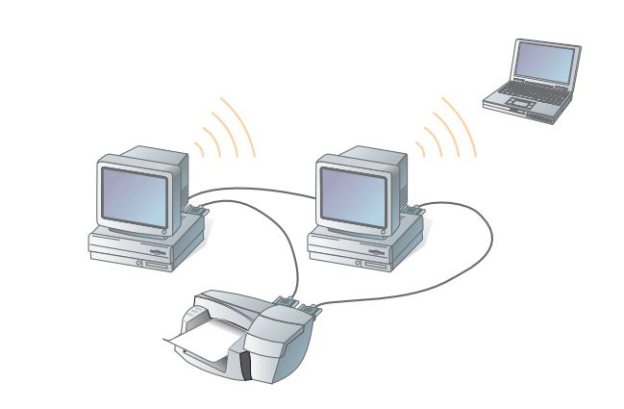

Figure 3.1.1.1.0 a simple computer network with two computers connected

The first computer, yours, is commonly referred to as your **local computer**. As more and more computers are connected to a network and share their resources, the network becomes a more powerful tool, because employees using a network with more information and more capability are able to accomplish more through those added computers or additional resources. The real power of networking computers becomes apparent if you envision your own network growing and then connecting it with other distinct networks, enabling communication and resource sharing across both networks. That is, one network can be connected to another network and become a more powerful tool because of the greater resources. For example, you could connect the network you and your classmates develop for this course to similarly constructed networks from other introductory networking classes if you wanted them to share your information and networked resources. Those classes could be within your own school, or they could be anywhere in the world. Wherever that newly joined network is, the communication and resource sharing activities in that new network could then be shared with anyone connected to your network. All you have to do is join that new network’s community or allow its members to join yours.

#### 3.1.1.2 Classification of Computer Network

Networks are frequently classified according to the geographical boundaries the network spans. Two basic geographical designations for networks are the local area network (LAN) and wide area network (WAN). A third designation, metropolitan area network (MAN), is also used, although its use has become clouded (because it might not be a clear-cut classification anymore) as networks continue connecting to the Internet. These three classifications, unlike the other methods used to describe networks, are based upon the specific levels of technology they use when going from one level to the other. The three geographical classifications are discussed next because the geographical concepts and the increased emphasis they place on technology as you go from one level to the next still apply.

1. **Local Area Network (LAN)**

If the network is contained within a relatively small area, such as a classroom, school, or single building, it is commonly referred to as a **local area network (LAN)**. This type of network has the lowest cost and least overall capability of the three geographic classifications. Because the pieces of equipment in a LAN are in relatively close proximity, LANs are inexpensive to install. Despite their decreased capability, however, their closeness and resultant low costs typically result in the use of the fastest technology on a LAN. Thus, this network classification usually has the highest speed components and fastest communications equipment before the other network classifications see such equipment using the same speeds. This is because it takes less overall investment to get the smaller network running the faster equipment. LANs, therefore, are commonly considered the building blocks for creating larger networks.

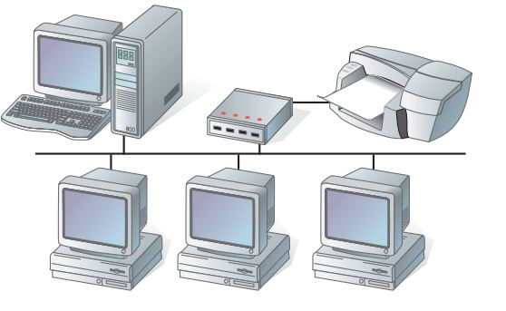

Figure 3.1.1.2.0 a LAN Network.

1. **Metropolitan Area Network (MAN)**

As the computers get further apart, a LAN becomes more difficult to install, and additional measures such as additional communications equipment may need to be employed. When the network spans the distance of a typical metropolitan city, as shown in Figure 3.1.1.2.1, it can be referred to as a **metropolitanarea network (MAN)**. Although this term is beginning to lose its popular use, the concept of the network outgrowing its local confines and requiring additional resources still applies. Much of the same technology, such as the fast networking components and communications equipment used in LANs, can be used in MANs, but more are required, so this classification is not quite as technologically advanced as LANs. Although the speeds  
achieved in a MAN are typically as high as in a LAN, it requires high-speed connections, such as fiber optics. Increasing the distance and the technology levels increases the relative installation and operation costs of MANs.

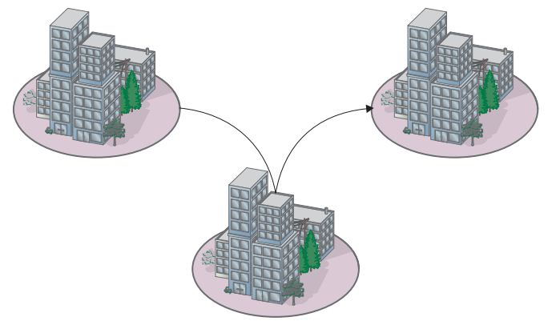

Figure 3.1.1.2.1a MAN Network.

1. **Wide Area Network (WAN)**

The MAN outgrows its usefulness when the network must expand beyond the confines of the typical metropolitan area. When the network spans a larger area, as shown in Figure 3.1.1.2.2, it is classified as a **wide area network (WAN)** because of the extensive distances over which WANs communicate;they use long-distance telecommunications networks for their connections, which increase the costs of the network. The Internet is just a giant WAN.

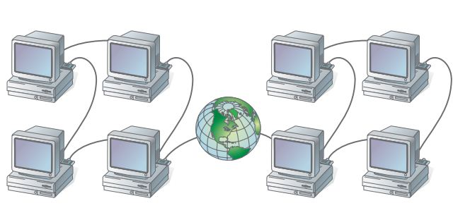

Figure 3.1.1.2.2 a WAN network.

#### 3.1.1.3 Network topology

Topology can be defined as the arrangement of network including its node and connectivity lines. There are two types of topology

1. **Physical topology:** The term physical topology refers to the way in which a network is laid out physically. The actual layout of the wire or media. Two or more devices connect to a link; two or more links form a topology. Some of the types of physical topology are
2. Bus topology
3. Ring topology
4. Star topology
5. Mesh topology

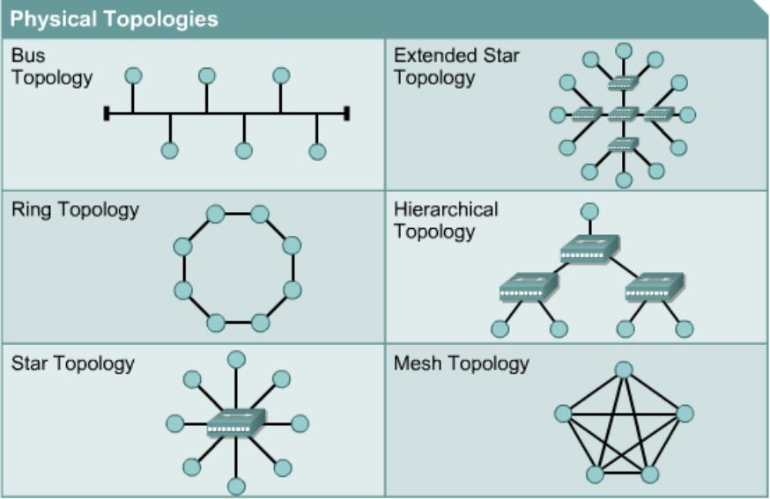

Figure 3.1.1.3.0 various types of physical topology.

1. Logical topology: The logical topology of a network determines how the hosts communicate across the medium. The two most common types of logical topologies are **broadcast** and **token passing.**

#### 3.1.1.4 Application of Computer Network

In era we are now, network is used almost in every sector to enhance productivity. Some of the key applications of network are:

1. Sharing of Information
2. Sharing of Resources
3. Connecting Peripherals

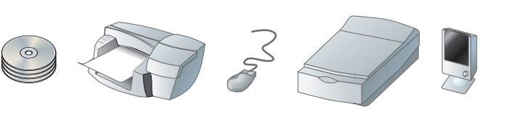

Figure 3.1.1.4.0 common networking peripherals.

#### 3.1.1.5 Open System Interconnection (OSI) Model

The international organization for standardization (ISO) created the OSI model as a framework for defining standard for connecting devices on a network. The OSI model includes seven layers which are orderly arrange in ascending order as follows

1. Physical layer
2. Data link layer
3. Network layer
4. Transport layer
5. Session layer
6. Presentation layer
7. Application layer

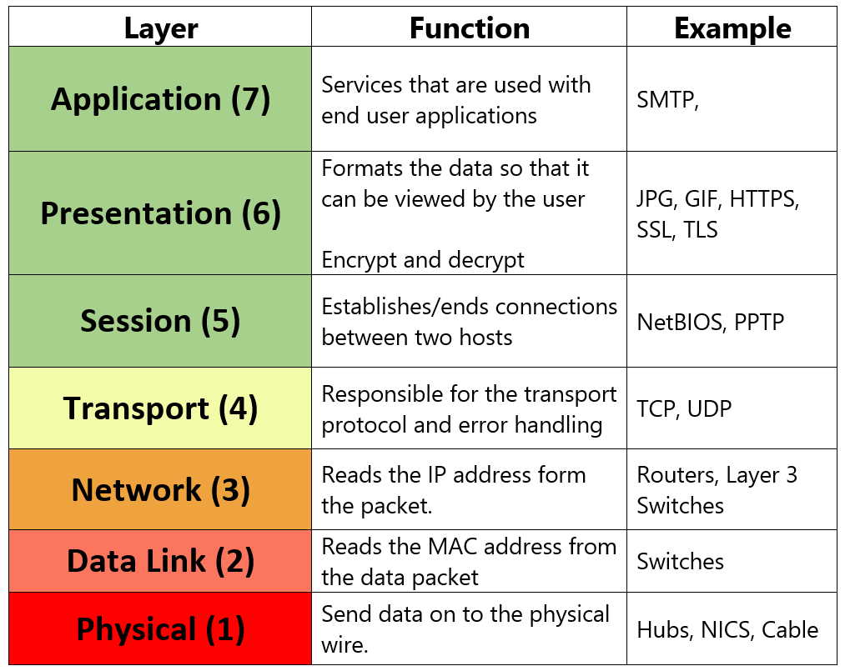

Figure 3.1.1.5.0 the OSI Model arranged in descending order with functions and examples.

#### 3.1.1.6 Network protocols

In information technology, protocols are the special set of rules that end points in a telecommunication connection use when they communicate. A Protocol specifies interactions between the communicating entities.

##### 3.1.1.6.1 Types of network protocols

Some of the types of network protocols are

1. IP: internet protocol
2. SMTP: Simple Mail Transfer Protocol
3. HTTP: Hyper Text Transfer protocol
4. TCP: Transmission Control Protocol
5. FTP: File Transfer protocol

### 3.1.2 SOFTWARE DEPARTMENT

After spending three weeks in Networking Department, I moved to Software Department whereI was given introduction and basic knowledge on software development. I spent one week in Software Department and I was able to gain the following knowledge

#### 3.1.2.1 Understanding Software Development

Software development is the process of computer programming, documenting, testing, and bug fixing involved in creating and maintaining applications and frameworks resulting in a software product. Software development is a process of writing and maintaining the source code, but in a broader sense, it includes all that is involved between the conception of the desired software through to the final manifestation of the software, sometimes in a planned and structured process. Therefore, software development may include research, new development, prototyping, modification, reuse, re-engineering, maintenance, or any other activities that result in software products. Software can be developed for a variety of purposes, the three most common being to meet specific needs of a specific client/business (the case with custom software), to meet a perceived need of some set of potential users (the case with commercial and open source software), or for personal use (e.g. a mathematicians may write software to automate a business task).

Software development is a vast field which incorporates many professions but the ICT Unit is only involved in the following software design

1. Applications Development
2. Systems Development
3. Web Development
4. Embedded Systems Development

#### 3.1.2.2 Introduction to web design

Web design is a process of conceptualizing, planning, and building a collection of electronic files that determine the layout, colors, text styles, structure, graphics, images, and use of interactive features that deliver pages to your site visitors.

#### 3.1.2.3 What is ASP.NET?

ASP.NET is a web development platform, which provides a programming model, a comprehensive software infrastructure and various services required to build up robust web applications for PC as well as mobile devices.

ASP.NET works on top of the HTTP protocol, and uses the HTTP commands and policies to set a browser-to-server bilateral communication and cooperation. ASP.NET is a part of Microsoft .Net platform. ASP.NET applications are compiled codes, written using the extensible and reusable components or objects present in .Net framework. These codes can use the entire hierarchy of classes in .Net framework.

ASP.NET application codes can be written in any of the following languages:

1. C#
2. Visual Basic.Net
3. Jscript
4. Jscript
5. J#

I learnt how to practically develop a web page using Hypertext Markup Language (HTML) and Active Server Page (ASP.NET). Also I learnt how to connect front end (web page) to back end (database and scripting language) to save information to the back end.

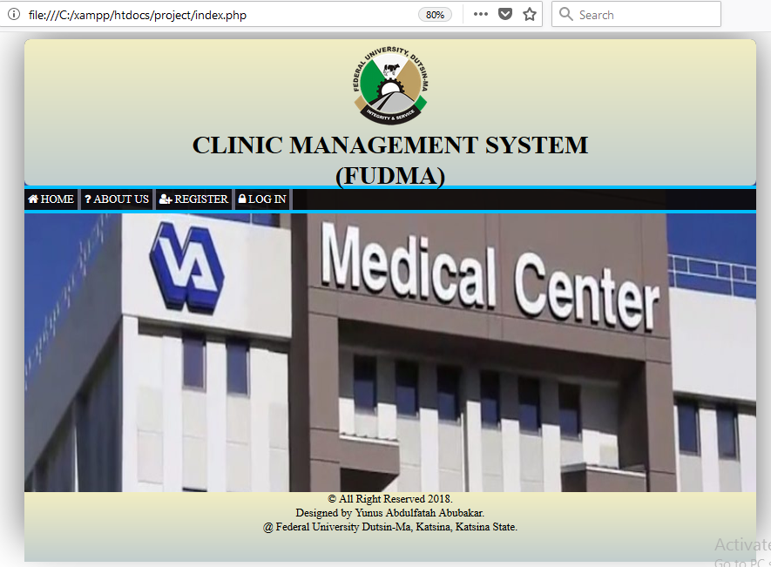

Figure 3.1.2.3.0 a simple web page I designed.

**3.1.2.4 Relational Database Concepts (MYSQL)**

Relational databases are, by far, the most common used type of databases. Relation is made up of relations, commonly called table. A table is made up rows and columns also called records and entities respectively.

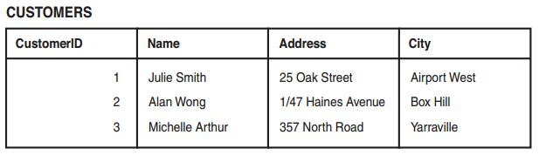

Figure 3.1.2.4.0 a database table.

#### 3.1.2.5 Database

A database is a collection of data. The term database usually indicates that the collection of data is stored on a computer.

Databases implemented through a computer are created within software. That software, commonly known as a database application, it controls how the actual data is stored and retrieved.

#### 3.1.2.6 Database schema

The term "schema" refers to the organization of data as a blueprint of how the database is constructed (divided into database tables in the case of relational databases). The formal definition of a database schema is a set of formulas (sentences) called integrity constraints imposed on a database.

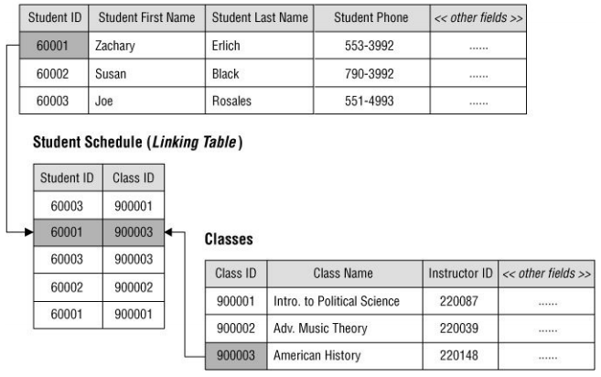

Figure 3.1.2.6.0 a database Schema.

Among the other things I learnt were

1. How to use integrated development Environment (IDE) such as Notepad++ for XHTML and PHP application.
2. I learnt how to use MYSQL as Relational Database Management System (RDMS) to create database for various applications.

**3.1.3 KNOWLEDGE GAINED IN SOFTWARE DEPARTMENT**

I learnt more on web design using eXtensible Hypertext Markup Language (XHTML), Cascading Style Sheet (CSS), Hypertext Preprocessor (PHP), and My Structured Query Language (MYSQL). Some of the things i learnt were

#### 3.1.3.1 HypertextMarkup Language (HTML5)

HTML is a markup language, a markup is a language used in creating a web site. With HTML, I learnt the key concept of creating web site and how to give it structure. Structures are added to website so that web browsers can present the site page to people who visit the site. .The followings have to be learnt first:

1. **Structuring Documents for the Web**

A news story in print or on the Web is made up of a headline, some paragraphs of text,  
maybe some sub headings, and one or more pictures. On the Web you need to explain the structure of these documents, and you do that using HTML. To structure a web page, you have to use tag and elements.

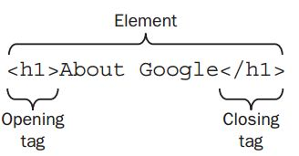

Figure 3.1.3.1.0 a HTML element.

##### 3.1.3.1.1 Types of HTML elements

1. Presentation elements e.g. <be>, <i>, <u>, <s>, and <tt> elements.
2. Phrase element e.g. <em>,<cite>, <q> elements.
3. Core elements e.g. <h1>, <p>, <pre> element.
4. **Links and Navigation**

What really distinguishes the Web from other mediums is the way in which a web page can contain links (or hyperlinks) that you can click on to be taken from one page to another page. The link can be a word, phrase, or image. When you link to another page in your own web site, the link is known as an internal link. When you link to a different site, it is known as an external link.

A link is specified using the <a> element. Anything between the opening <a>tag and the closing </a> tag becomes part of the link that users can click in a browser.

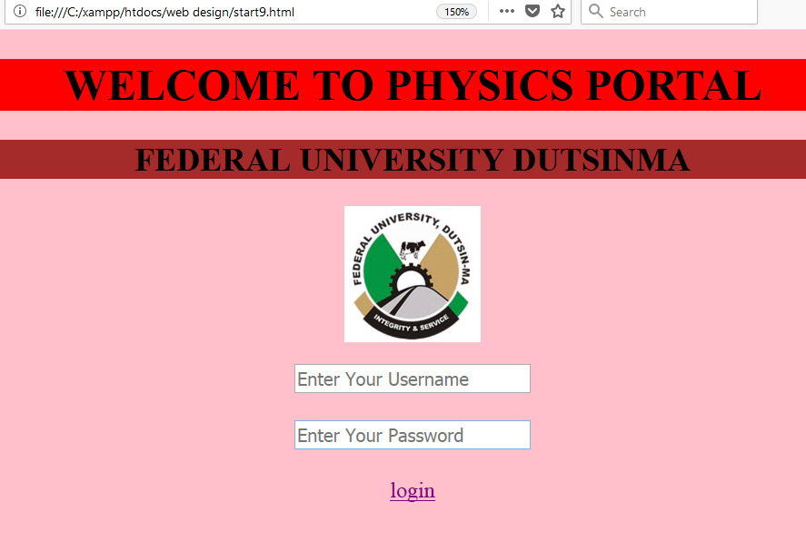

Figure 3.1.3.1.1 a HTML link underlined.

1. **Images, Audio, and Video**

Images are added to a site using the <img> element, which has to carry at least two attributes: the **src** attribute, indicating the source of the image, and an **alt** attribute, which provides a description of the image. For example, the following line of code would add the image called logo.gif into the page (in this case, the image lives in a directory called images).

<img src=”logo.gif” alt=”logo” / >

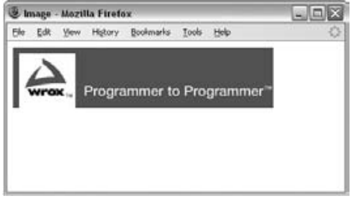

Figure 3.1.3.1.2 an image added to a website.

Videos and audios are added to a site using the<object> and <embed>element.

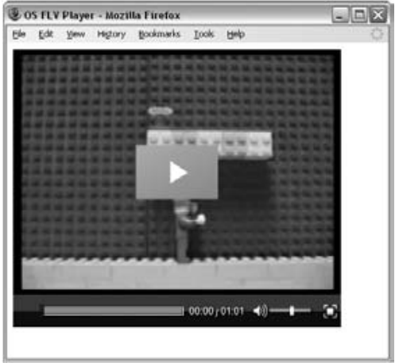

Figure 3.1.3.1.3 a video added to a website.

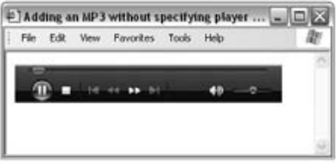

Figure 3.1.3.1.4 an audio added to a website.

1. **Tables**

Tables display information in rows and columns; they are commonly used to display all manner of data that fits in a grid such as train schedules, television listings, financial reports, and sports results. In order to work with tables, you need to start thinking in grids. The elements used in creating table are <table>,<tr>,<th> and <td> elements.

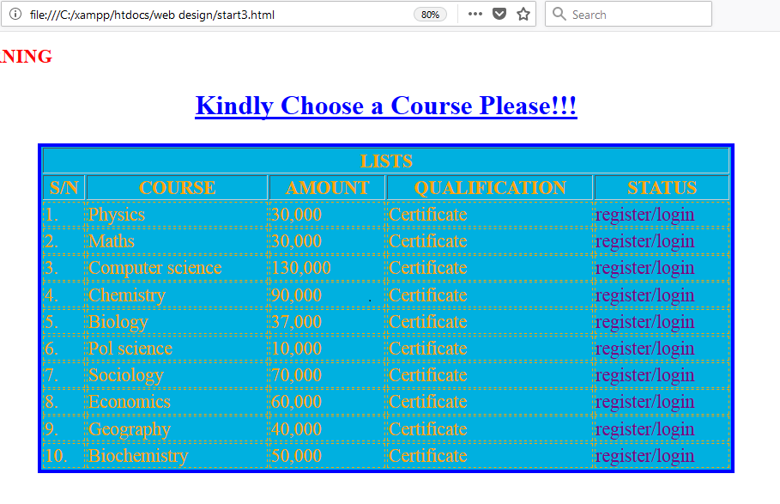

Figure 3.1.3.1.5 HTML table.

1. **Forms**

Almost every time you want to collect information from a visitor to your site, you need to use a form. Some forms are quite complex, such as those that allow you to book plane tickets or purchase insurance online. Others are quite simple, such as the search box on the homepage of Google. To create a form, a <form> element is used.

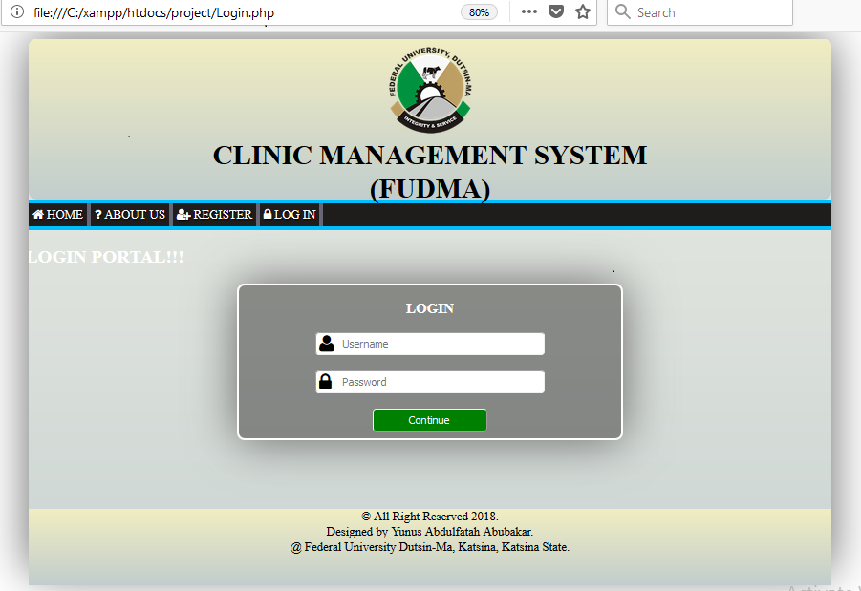

Figure 3.1.3.1.6 HTML form.

#### 3.1.3.2 Cascading Style Sheet (CSS)

CSS is used to set layout to a web page. CSS works by allowing you to associateruleswith the elements that appear in a web page. These rules govern how the content of those elements should be rendered.

Theselector indicates which element or elements the declaration applies to whilethe declaration sets out how the elements referred to in the selector should be styled

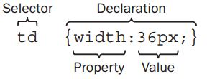

Figure 3.1.3.2.0 CSS declaration.

The declaration is also divided into two parts, separated by a colon. These parts are

1. A **property**, which is the property of the selected element(s) that you want to affect.
2. A **value**, which is a specification for the property.

Here is an example of a CSS rule that applies to several different elements (in this example, the <h1>, <h2>, and <h3> elements). A comma separates the name of each element that this rule will apply to. The rule also specifies several properties for these elements with each property -value pair separated by a semicolon. Note how all the properties are kept inside the curly braces.

h1, h2, h3 {

Font-weight: bold;

Font-family:arial;

Color:#000000;

Background-color: #FFFFFF ;}

Even if you have never seen a CSS rule before, you should now have a good idea of what this rule is doing. There are three heading elements named in the selector (<h1>, <h2>, and <h3>), and this rule says that where these headings are used they will be written in a bold Arial font in black with a white background.

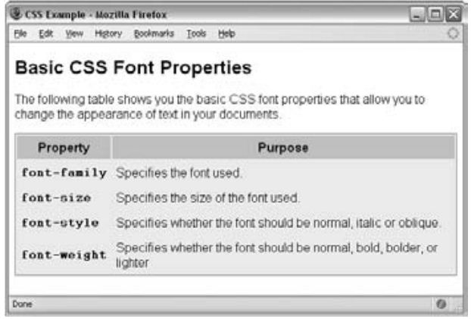

Figure 3.1.3.2.1 a table styled using CSS

#### 3.1.3.3 Hypertext Preprocessor (PHP)

PHP is the web development language written for web developers. PHP stands for Hypertext Preprocessor*.* The product was originally named Personal Home Page Tools.PHP is a server-side scripting language, usually used to create web applications in combination with a web server, such as Apache. PHP can also be used to create command-line scripts akin to Perl or shell scripts, but such use is much less common than PHP’s use as a web language.

PHP allows you to manipulate web page content on the serverjust before a page is delivered to the client browser. It works like this: A PHP script runs on the server and can alter or generate HTML code at will. An HTML web page is still delivered to the browser, which doesn’t know or care that PHP is involved in tweaking the HTML on the server.

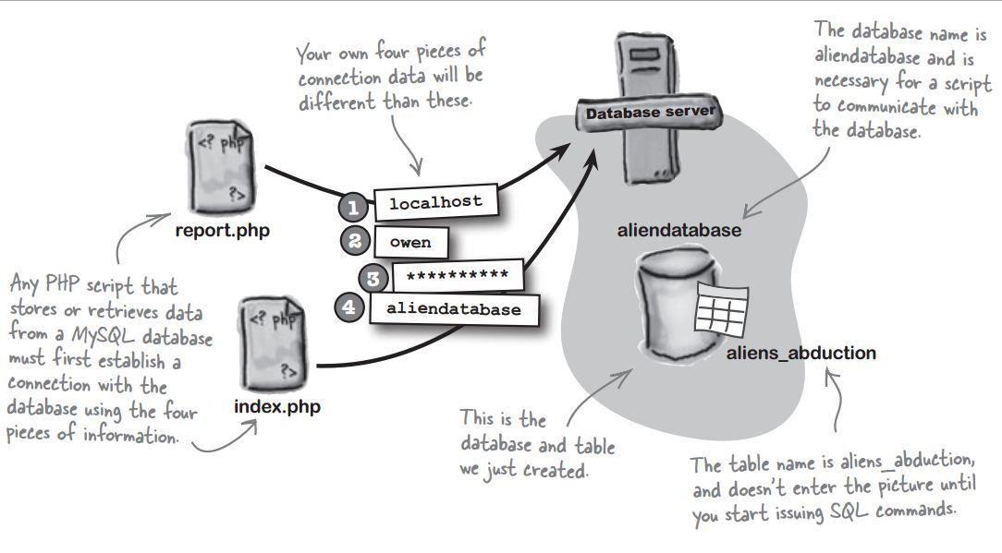

Figure 3.1.3.3.0 How to connect PHP to database.

Some of the things I learnt in PHP were

1. PHP Syntax and Variables.
2. PHP Control Structures and Functions.
3. PHP String Handling.
4. Arrays.
5. PHP Number Handling etc.
6. How to connect web page to database using PHP.
7. How to develop a sophisticated website using PHP.

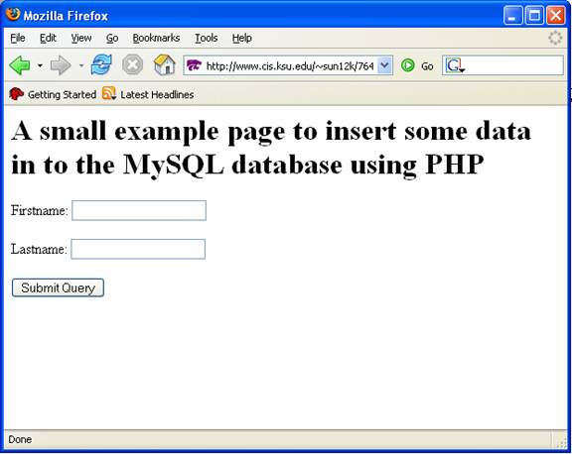

Figure 3.1.3.3.1 a page linked to database using PHP.

#### 3.1.3.4 My Structured Query Language (MYSQL)

A **database**is a collection of data. The term database usually indicates that the collection of data is stored on a computer.Databases are managed by a special program called a database server. You communicate with a database server in a language it can understand, which is **SQL**. A database server typically runs alongside a web server on the same server computer, working together in concert reading and writing data, and delivering web pages.

MySQL databases are organized into tables, which store information as rows and columns of related data. Most web applications use one or more tables inside a single database.

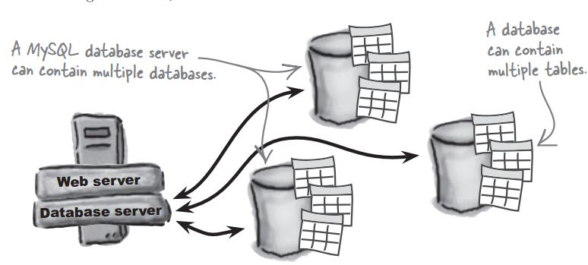

Figure 3.1.3.4.0 structure of database with its tables.

##### 3.1.3.4.1 What is a database table?

The data in a Relational Database Management System (RDBMS) is stored in database objects which are called as tables. This table is basically a collection of related data entries and it consists of numerous columns and rows.

A table is the most common and simplest form of data storage in a relational database. The following is an example of a CUSTOMERS table

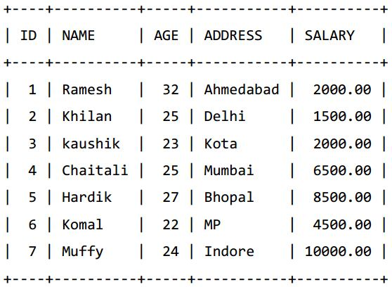

Figure 3.1.3.4.1.0 a database table.

##### 3.1.3.4.2 What is a Record or a Row?

A record is also called as a row of data; it is each individual entry that exists in a table. For  
example, there are 7 records in the above CUSTOMERS table in Figure 3.1.3.4.1.0.

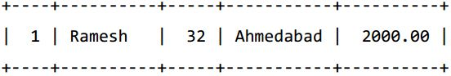

Figure 3.1.3.4.2.0 a single record.

3.1.3.4.3 What is a column?  
A column is a vertical entity in a table that contains all information associated with a specific field in a table.  
For example, a column in the CUSTOMERS table in Figure 3.1.3.4.1.0 is ADDRESS, which represents location description and would be as shown below:

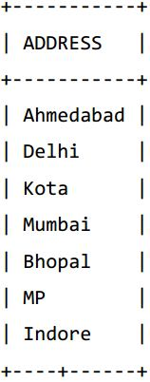

Figure 3.1.3.4.3.0 a database column

#### 3.1.3.5 Structured Query Language (SQL)

SQL is Structured Query Language use for storing, manipulating and retrieving data stored in a relational database.

SQL is the standard language for Relational Database System. All the Relational Database Management Systems (RDMS) like MySQL, MS Access, Oracle, Sybase and SQL Server use SQL as their standard database language.

The standard SQL commands to interact with relational databases are CREATE, SELECT, INSERT, UPDATE, DELETE and DROP. These commands can be classified into the following  
groups based on their nature

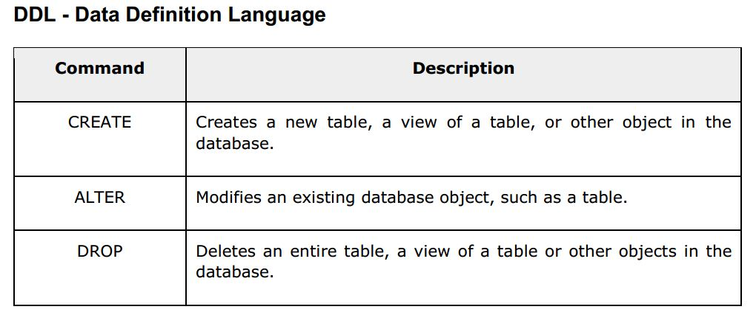

Figure 3.1.3.5.0 data definition language.

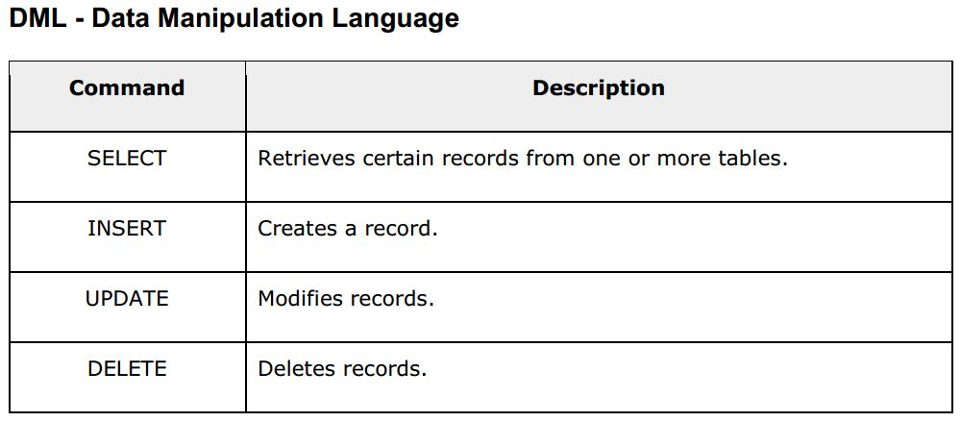

Figure 3.1.3.5.1 data manipulation language

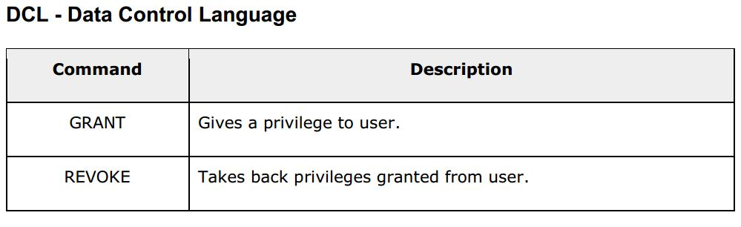

Figure 3.1.3.5.2 data control language.

I also learnt the followings in MYSQL

1. SQL constraint.
2. Data integrity.
3. SQL operators.

### 3.1.4 THE WEB APPLICATION I DEVELOPED WITH THE KNOWLEDGE I GAINED

With the practical knowledge I gained, I developed a web application for my school. The web application has the following details

#### 3.1.7.1 SCOPE OF THE APPLICATION

The web application is limited to Federal University Dustin-Ma, it is to be use by the students and the admins (the ICT staff).

#### 3.1.7.2 FUNCTIONALITIES OF THE APPLICATION

The function of the application is to provide a medium of sharing information in the institution. The admin will post news and the students can view and comment on the news. The admin can be able to

1. Post news
2. Send email
3. Edit/Delete post
4. View the number of users
5. Remove user

Some of the admins’ webpages are

1. **Homepage**

The home page is to be use by the admin in order toselect the action he/she wants to perform.

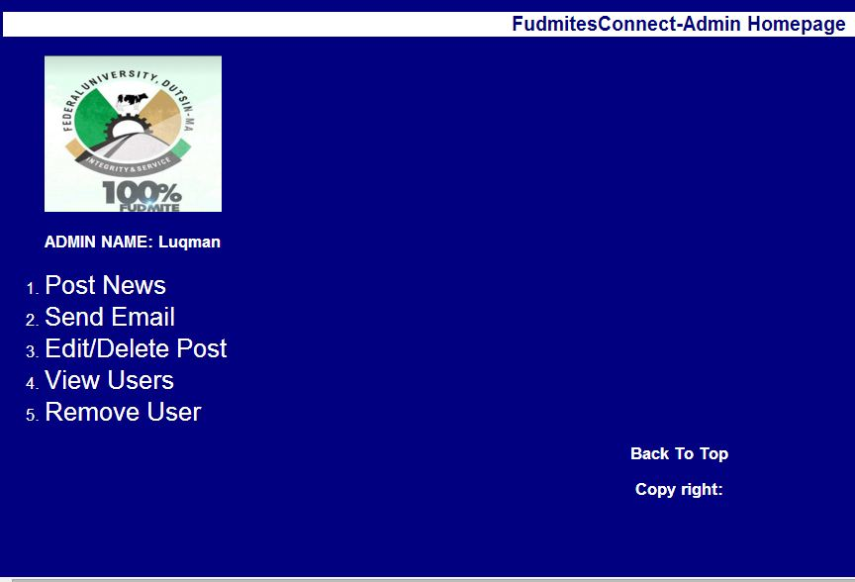

Figure 3.1.7.2.0 admins’ home page

1. **Post News**

The post news link as shown in Figure 3.1.7.2.0 takes the admin to the page where the news is to be posted to students.

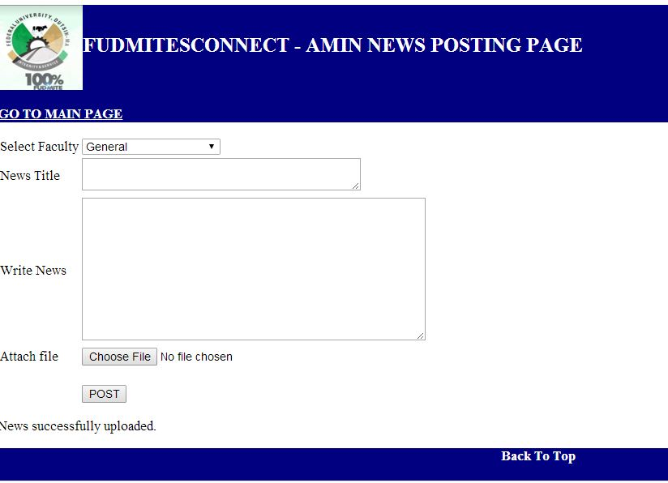

Figure 3.1.7.2.1 admins’ post news page.

The other links on admin home page in Figure 3.1.7.2.0 will also take the admin to where he/she will send email, edit/delete post, view users and remove users respectively.

The users or students can use the application to do the followings

1. Views news
2. View their profiles
3. Edit their profiles
4. Link to their emails
5. Log out of the application
6. Log into the application
7. Register as new users.

Some of the users’ web pages are

1. **Home page**

The home page allows the user to view the news posted by the admin and also it has links to various web pages e.g. the users’ view profile, edit profile, security pages.

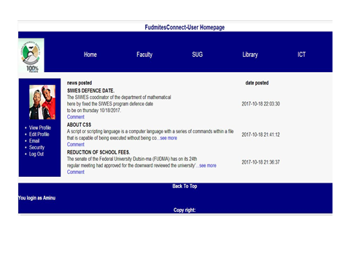

Figure 3.1.7.2.2 users’ home page.

1. **Sign up**

The sign up page allows a new user to register in to the application

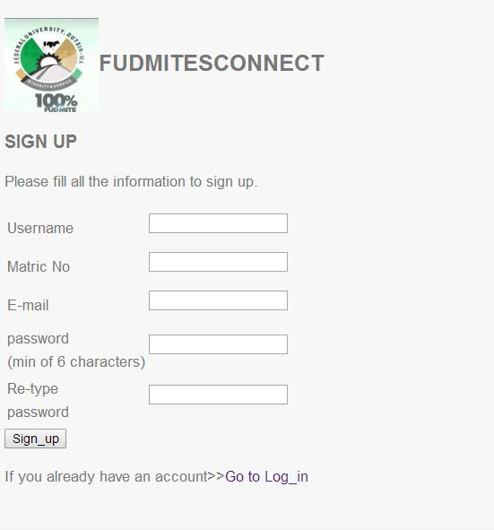

Figure 3.1.7.2.3 users’ sign up page.

1. **Login page**

This web page allows a valid user to log into the application and view the news.

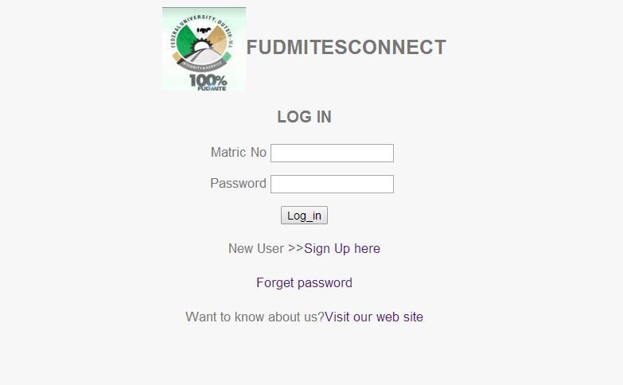

Figure 3.1.7.2.4 users’log in page.

1. **Comment page**
2. This page allows a user to respond to news or to send a feedback by providing a comment.

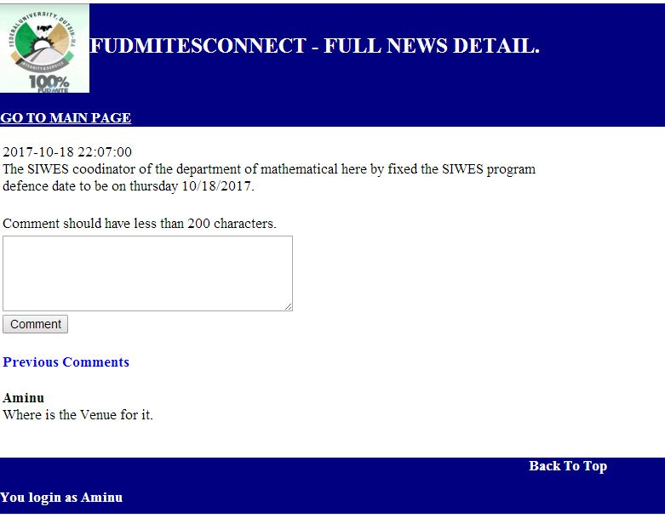

Figure 3.1.7.2.5 users’ comment in page.

### 3.1.8 ROLES AND RESPONSIBILITIES I CARRIED OUT

Some of the roles and responsibilities I carried out in the institution during my SIWES training were

1. I was assigned to work in the helpdesk to attain to users complains and solve them or direct them to the one that will solve them if beyond my control.
2. I was given the job of formatting and setting the computers that were used for the institution’s Computer Base Test (CBT).
3. I was among those assigned to coordinate the institution’s Post UTME.

# CHAPTER FOUR

## 4.0 CHALLENGES, RECOMMENDATION AND CONCLUSION

## 4.1 CHALLENGES ENCOUNTERED AT WORK PLACE

Challenges that I was confronted with at the helpdesk were mainly centered on poor inter-personal relationship between the IT students. This was put in check via the intervention of our superiors through discussion and meeting. Also, when users come in, some of them are either rude and talk impolitely, or most do not even know how to table their complaint. So I was told to try and be patient and understanding with some of these users.

At the workshop, the major problems were due to the fact that the software we use was outdated. And there was a problem getting genuine software and applications for users. As such we resulted in purchasing substandard software or downloading them from the internet, which takes a lot of time. There was also a time when the number of IT students at the workshop was small and this resulted to some students being overworked. More students were however brought on during the course of my stay.

## 4.2 RECOMMENDATION

For subsequent trainees being taken up by the company, I strongly recommend a more stringent supervision of their training program, especially by the Software Department. This will go a long way in ensuring that trainees do not lose focus and will constantly remind them that their services to the company remain valuable.  
Also I suggest ITF should liaise with some companies where they will take up students for industrial training. This will help students who find it difficult to find attachments or who end up in companies where they do nothing.

## 4.3 CONCLUSION

This industrial training has afforded me the basic practical and theoretical knowledge that I may not have gotten from the lecture room. It also gave me the opportunity to have a feel of what it would be like after graduation when I start working.

After my internship with FUDMA

1. I can effectively handle the demands a help desk of any Organization I find myself in future.
2. I can effectively assist in the administration of a company’s computer software system.
3. I can carry out repair works on computer systems and accessories, which includes printers and scanners.

Other benefits include:

**Good working ethics:** As a result of the close working relationship I had with the ICT manager, I have been able to imbibe good working ethics. These ethics includes been able to handle situation with little or no help, being able to provide solutions to lingering problems, etc.

**Career Path:** I have been able to use this training to explore various avenues available at my disposal career-wise. It has given me the opportunity to have a look into the future and access my readiness for employment or entrepreneurship.

Finally the internship has bridged the gap between academic theory and practical and has built a good degree of confidence especially in my abilities to perform. It has also given me a first-hand experience of the entire information and communications technology industry

I can confidently say that the experience gotten from this training was a worthwhile experience.

# REFERENCES

Agboko, A. (2015) Server administration: *A Lecture delivered at Federal University*

*Dustin-ma, Directorate of ICT*

Chris, B. (2005) *Mastering Binary Math and Sub netting*

Green, J.H. (2005) *The Irwin handbook of telecommunications*: Inc 3 Apple Hill Drive, M.A 017602098.

Harry, R. and Doug M. (2009) *JUNOS Enterprise Switching:* O’ Reilly Media Inc 1005

Graven stem Highway North, Sebastol, CA 95472.

Roger, L.F. (2004),*Telecommunication system engineering*. John wiley and sons: S.Chand & Company LTD

Todd, L. (2007) *Cisco Certified Network Associate Study Guide Sixth Edition*: Wiley

Publishing, Inc., Indianapolis, Indiana