Learner Name
Learner Registration No.
Study Centre Name | Lincoln University of Business and Management
Qualification Title | L7 Diploma in Strategic Management & Leadership
Unit Reference No. | A/616/2724
Unit Title | Strategic Management
Word Count
Submission Date | 3rd March 2022
Declaration of authenticity:
- I declare that the attached submission is my own original work. No significant part of it has been submitted for any other assignment and I have acknowledged in my notes and bibliography all written and electronic sources used.
- I acknowledge that my assignment will be subject to electronic scrutiny for academic honesty.
- I understand that failure to meet these guidelines may instigate the centre’s malpractice procedures and risk failure of the unit and / or qualification.

_________________  Learner signature  Date: |  | Priyanka Bhatia  Tutor signature  Date: 4th February 2022

Table of Contents
Table of Figures 4
1 TASK 2: 5
2 Basic strategic planning model 5
2.1 Basic strategic planning model 5
2.2 Issues - based strategic planning 6
2.3 Implementing SWOT 6
2.4 Major issues being identified the stakeholder 6
2.5 Vision and mission 7
2.5.1 Mission of KFC 7
2.6 Action plan 7
2.6.1 Product Development 7
2.6.2 Anti-racism training 7
2.6.3 Innovation 8
2.7 Budgeting and monitoring 8
2.8 Critical evaluation of the strategic options 8
2.8.1 Product development 8
2.8.2 Anti-racism training 8
2.8.3 Innovation 8
2.9 Justification of the issues based strategic planning model 8
2.9.1 Proactive approach model 8
2.9.2 Provides direction 9
2.10 Force Field Analysis 9
2.11 Strategy implementation 9
2.11.1 Set and communicate clear, strategic goals 9
2.11.2 Engage your team 10
2.11.3 Execute the strategic plan 10
2.11.4 Get closure 10
2.11.5 Reflect 10
2.12 Strategic implementation monitoring tool 10
2.13 Performance indicators 10
2.14 Potential risk 10
2.14.1 Failure of the strategy 11
2.14.2 Waste of resources and time 11
2.14.3 Impact on Performance 11
2.15 Effectiveness of the plan 11
3 TASK 3: 14
3.1 The usefulness of Change management models 14
3.2 Lewin’s Change Management Model 15
3.2.1 Unfreeze 16
3.2.2 Change 16
3.2.3 Freeze 16
3.3 Leadership during change 17
3.4 Transformational leadership 18
3.4.1 Team building 18
3.4.2 Effective Listening 18
3.4.3 Interpersonal skills 18

Table of Figures
Figure 1 The basic model 6
Figure 2 Poor customer service of the company 7
Figure 3 Transformational Leadership 14
Figure 4 Lewin's model of Change 16

TASK 2:
The organization is one of the entities that are comprised of several other companies. For every business there are several aspects according to its structure which is important to get followed including the legal structure, the difference between them lies in the structure of them. The organization as mentioned includes several companies or stakeholders having the same purpose. On the other hand, the business of several things and several businesses can be less than one organization. The business could also be profitable or non-profitable (Seifzadeh, and Rowe, 2019). There are several types of business including sole prosperity and more. Corporate is the collection of several companies and the stakeholder are bonded through the same or similar vision on something. The operational strategies are linked with every aspect.
Either in the corporate, business, or the company the operational stories are equally significant and inevitable to focus upon. Every kind of business needs to focus on the operational strategies as they could either make the image of the business or damage it (Szczepańska-Woszczyna, 2018). The fast-food chain business KFC also includes several operational strategies through which they not only satisfy their customer but are expanding around the globe. The role of the operational strategy is very important regardless of the stage at which they are being implemented.
Strategic models are an important sect for the company. Also, organizational strategic planning plays a significant role in increasing the sales and ultimately the revenue being generated by the company. There are several models of strategic planning through which the organization can grow and expand its operations. Some of the models of strategic management include the,

Basic strategic planning model
Although it is important that the organizations opt for the strategic planning or management model that most suited it but some of the methods are more effective than others. Among the effective one simplest method is the,

Basic strategic planning model
The stages included in the model are; finding the purpose of the organization includes the vision clarification and getting resources ready according to the vision of the company. After vision identification, the next stage is to identify the approaches and strategies through which the organization can implement those strategies (Yapandi, 2018). The next stage is the action planning and then the implementation of the strategic option could be made.
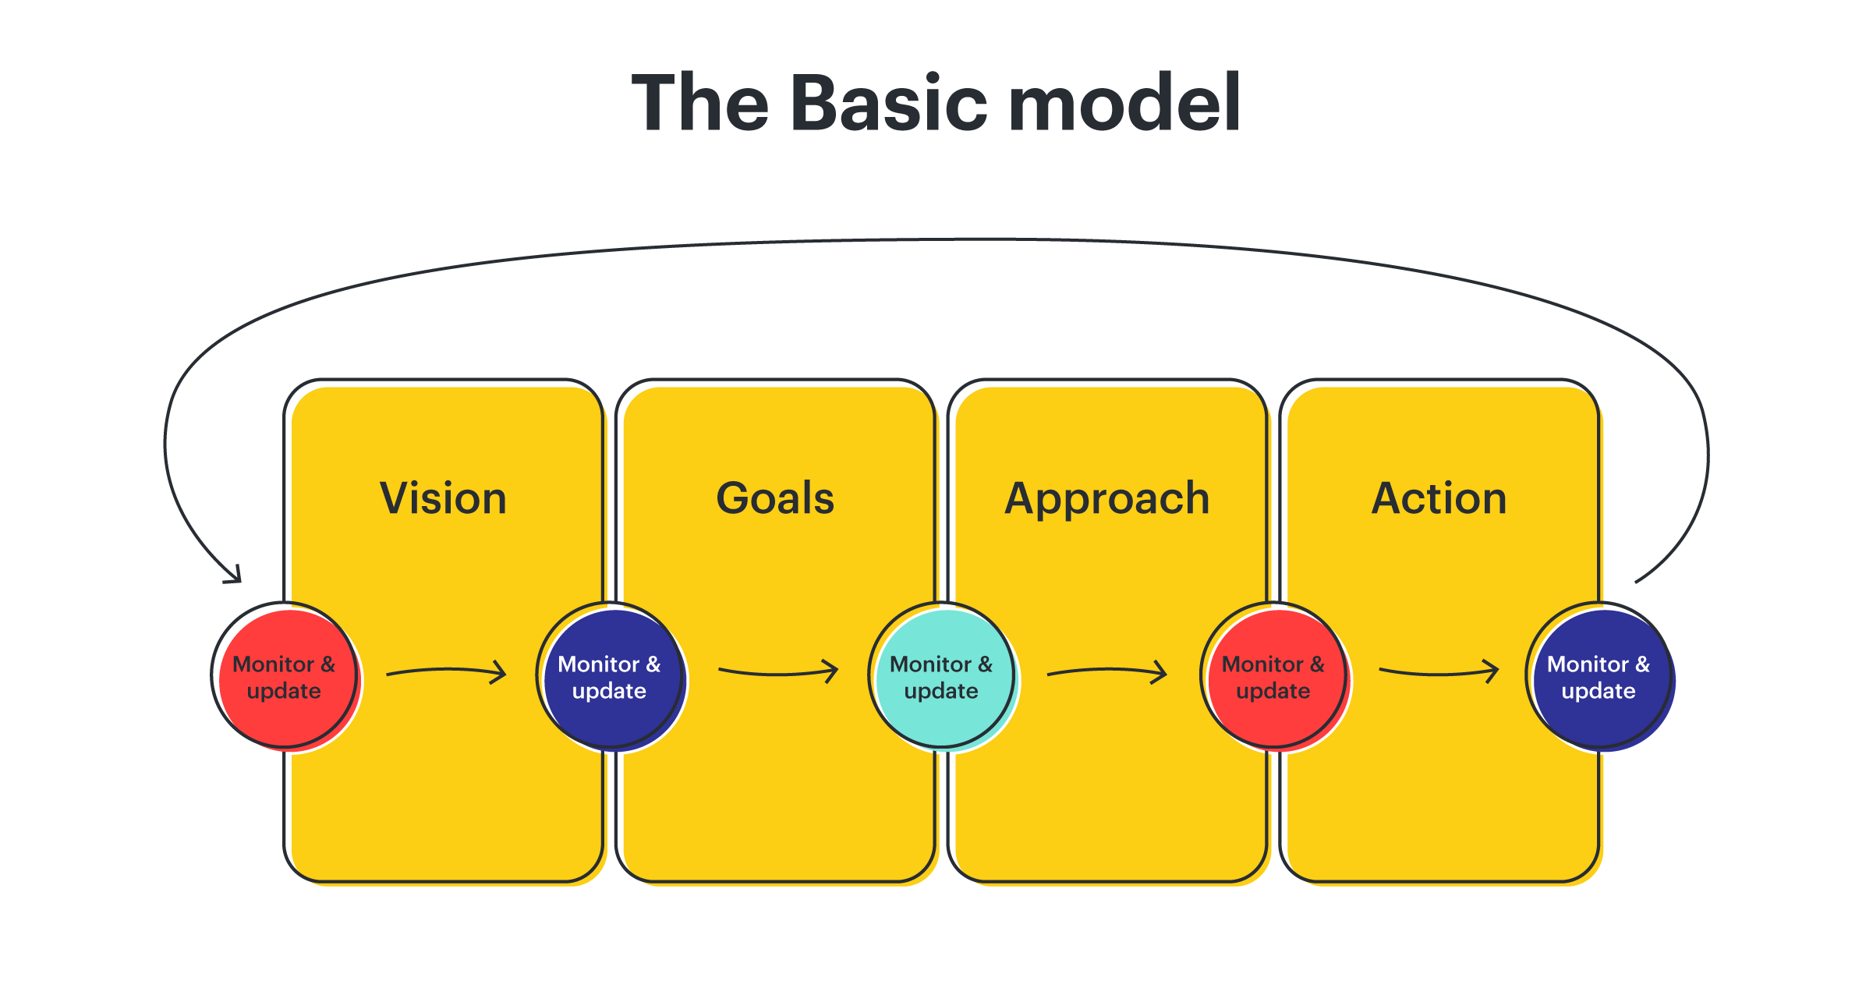
Figure 1 the basic model
Source: Top Strategic Planning Models and Frameworks (2020). Available at: https://www.lucidchart.com/blog/strategic-planning-frameworks (Accessed: 21 February 2022).

Issues - based strategic planning
One of the models that could be effectively implemented in the organization of the KFC is the issue-based strategic planning (Hu, 2021); stages included in the

Implementing SWOT
The strength of the KFC includes its effective position of it in the merging market such as China and other regions.
Another strength that could be identified through studies of KFC is its leading position in the market in the industry of fried chicken.
Weakness includes unhealthy food and the negative aspects of it are advertised in the marketing process.
Opportunities of the company include the diversion and including more healthy options in the menu as compared that will attract the consumer more as they are demanding healthy food.
The threat for the company is the highly competitive market.

Major issues being identified the stakeholder
Some of the issues which are out by the stakeholder of the KFC include:
- The chicken health is being used in the meals for serving customers.
- Racism in the business is also found to exist at a higher level also.
- Poor customer service is also identified.
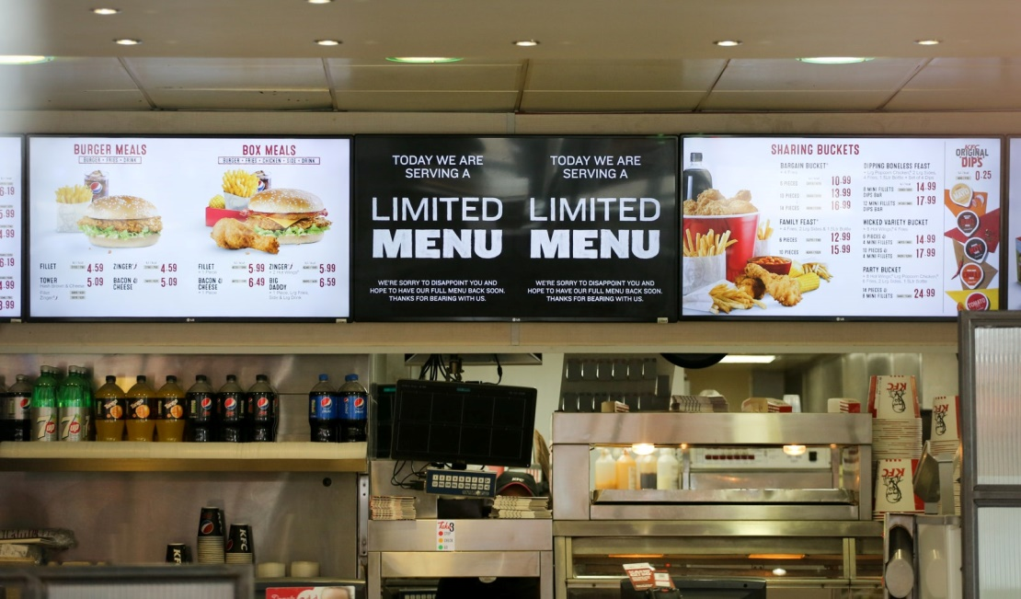
Figure 2 Poor customer service of the company
Source: Nast, C. (2018) The inside story of the great KFC chicken shortage of 2018, WIRED UK. Available at: https://www.wired.co.uk/article/kfc-chicken-crisis-shortage-supply-chain-logistics-experts (Accessed: 21 February 2022).

Vision and mission
“The company implies innovation to satisfy current market needs” (Pandey, et al 2021).

Mission of KFC
Through the following of ethical rules and regulations, the mission of the company is to effectively focus on the increase of business for its stakeholder, improve customer experience, and more (Omer, 2018).

Action plan
To implement the plan through which the issues of the KFC will be catered includes the measures of,

Product Development
Through the strategic option of the product development, KFC should use this opportunity to provide the best fried chicken through different meal option. Although they have several option in their menu, still things are not working as they should have, due to which the product development strategic option can help the KFC to rollout the new food options.

Anti-racism training
Racism is one of the few factors that can tarnish the image of the company, due to which it is suggested that every week anti-racism training will be provided to every member of the company, even the CEO, to overcome such critical issues.

Innovation
Implementation of the innovation through effective feedback technology system is a very important aspect through which the customer satisfaction got increased.

Budgeting and monitoring
The final two stages are budgeting for each of the plans and monitoring. Both the stages are significant in making the company successful.

Critical evaluation of the strategic options

Product development
For the business of the KFC it is not effective to conclude that they are completely in loss, but they have to change their current models, and an effective way is to provide the new product to the customers. For the customer it is very important that the company on which they trust, and from where they buy items for their food must have the change, through which they will get new food options.

Anti-racism training
The second strategic option for the KFC is the anti-racism training that will be provided on the weekly basis. Such strategic measures will not only increase the detrimental factor of the company over racism but improve its brand images as one of the leading fried chicken businesses that are intolerant towards racism (Hecht, 2020). Also, it will promote healthy practices in the company.

Innovation
The third strategic option for the improvement of the company includes innovative feedback system. Whether it is KFC or any of the product or service-based firms, it is highly required that the feedback system should get integrated in the system; Further, the implementation of it with the current and existing system is inevitable.

Justification of the issues based strategic planning model
Although there are many benefits of using and integrating the issues-based planning model is one of the models through which the effective management of the scenarios and the different issues will be gained effectively. Some benefits of the issue based strategic planning model include,

Proactive approach model
One of the benefits of issues based approach is that it promotes the proactive approach. Through the effective understanding of the company policy vision and integrating them in the implementation planning, the results would be positive (Brege, and Kindström, 2020). The company must effectively implement the proactive approach through which the precautionary measures would help the company stay on the right path, and the impact of the negative factors also gets reduced.

Provides direction
Through the implementation of the issues-based planning model, the focus of the company will remain on the issues. Without the issue-based model, the focus gets spread and the KFC would be unable to focus and solve the major issues.

Force Field Analysis
One of the tools that are used for the analysis of finding the root cause of the issues includes the Force field analysis which is provided by the Lewin’s. The model provides insight into the two categories of forces through which the change is either supported, or the change gets restricted in the company (Mak, and Chang, 2019). The force field analysis for the company of KFC would be,

Strategy implementation
To implement the strategy for the company of KFC, there are some stages, through which the plan could be implemented without any negative outcome,

Set and communicate clear, strategic goals
The first stage is of setting the clear goals which in the current scenario are the brand image setting of the KFC through eliminating three major issues which are,
- The chicken health is being used in the meals for serving customers.
- Racism in the business is also found to exist at a higher level also.
- Poor customer service is also identified.

Engage your team
The next stage is of including the team, through training them and sharing them the knowledge about the strategy that will help the company to grow and eliminate the obsolete methods the team of the KFC will be included in the strategic implementation.

Execute the strategic plan
The next phase is the execution of the strategic plan which includes the training of the employees (Cândido, and Santos, 2018); contacting the local suppliers for the chicken, and developing an effective system to check the implementation of the feedback system gained through the employees.

Get closure
The next stage includes the closure of the strategic plan implementation that includes the gathering of all the issues faced, all the feedback collected, and more.

Reflect
Finally, the reflecting stage will be the changes in the strategic plan through which the better solution and alternatives will be provided next time during the strategic implementation.

Strategic implementation monitoring tool
The strategic implementation and monitoring tool for the current scenario will be the Lewin's Change Management Model of all the activities through which the KFC can manage its activities without any delay (Turisová, et al 2018). Also through the supervision of all the activities, the effective implementation of the strategy will be implemented through which the positive will be gained.

Performance indicators
Performance indicators are one of the highly effective ways through which the controlling and effectively managing of the strategic implementation could be gained. It is an effective approach to cater strategic changes in a prompt manner (Singh, et al 2019). Some of the performance indicators for the KFC issues-based strategic planning model implementation would be,
Feedback will be collected from the employee and the customers also. Through effective feedback, the results would be collected which will provide an effective insight into how beneficial the strategies were.
Monitoring the change in sales would be achieved. Through gaining effective insight about the sales KFC will be making, it would work as a performance indicator.
Customer satisfaction would be the next performance indicator that will help the company of KFC to understand whether the strategic implementation was either successful or not.

Potential risk
Some of the potential risks that could be faced by the company of KFC include,

Failure of the strategy
One of the biggest issues or the risk that makes the strategic implementation process highly uncertain is the chances of its failure. Due to the failure in the strategic implementation, the outcome performance projected on the company would be negative.

Waste of resources and time
The second potential risk that is identified through the studies is the waste of resources that will happen if the strategy is unable to provide the expected outcome to the KFC and the issues persist. The budget allocation on the strategic implementation cannot be cut with this risk, as without investment it is impossible that the change will get implemented effectively as every activity requires the investment.

Impact on Performance
Another potential threat while implementing the change is the impact on the performance of the employees. It is highly possible that during the implementation of the strategic implementation, workers of the company get demotivated (Jabbarzadeh, et al 2018). They will be unable to contribute their part in the implementation of the strategy.

Effectiveness of the plan
It is highly required that the effectiveness of the plan should be measured through the right performance indicators. Moreover, through the results, it is also found that the effectiveness of the strategic implementation is important from the stakeholder, customer, and employee perspective. It is because; the strategic implementation in the KFC will immensely impact every sector of it. The effectiveness of the current plan would be gained through the change of sales and the brand image that will be developed after the implementation of this strategy, further, the increase in the rank, fewer scandals, and elimination of the poor practices are some of the many indicators that can help the KFC to increase its market competitiveness more.

References
Brege, H. and Kindström, D., 2020. Exploring proactive market strategies. Industrial Marketing Management, 84, pp.75-88.
Cândido, C.J. and Santos, S.P., 2018. Implementation obstacles and strategy implementation failure. Baltic Journal of Management.
Hecht, B., 2020. Moving beyond diversity toward racial equity. Harvard Business Review.
Hu, D., 2021. Case study of individual pension issue-based on lifelong finance model: annotation to master's thesis.
Jabbarzadeh, A., Fahimnia, B. and Sabouhi, F., 2018. Resilient and sustainable supply chain design: sustainability analysis under disruption risks. International Journal of Production Research, 56(17), pp.5945-5968.
Mak, A.H. and Chang, R.C., 2019. The driving and restraining forces for environmental strategy adoption in the hotel industry: A force field analysis approach. Tourism Management, 73, pp.48-60.
Nast, C. (2018) The inside story of the great KFC chicken shortage of 2018, WIRED UK. Available at: https://www.wired.co.uk/article/kfc-chicken-crisis-shortage-supply-chain-logistics-experts (Accessed: 21 February 2022).
Omer, S.K., 2018. SWOT ANALYSIS; THE TOOL OF ORGANIZATIONS STABILITY (KFC) AS A CASE STUDY. Journal of process management and new technologies, 6(4).
Pandey, R., Rao, K.S., Er, C.C., Kee, D.M.H., Chua, W.J., Hon, H.S., Tan, C.Y., Tayal, S., Sariya, S. and Narendath, P., 2021. A Case Study of Consumer Satisfaction of Kentucky Fried Chicken. International journal of Tourism and hospitality in Asia Pasific (IJTHAP), 4(2), pp.98-111.
Seifzadeh, P. and Rowe, W.G., 2019. The role of corporate controls and business-level strategy in business unit performance. Journal of Strategy and Management.
Singh, C.S., Soni, G. and Badhotiya, G.K., 2019. Performance indicators for supply chain resilience: review and conceptual framework. Journal of Industrial Engineering International, 15(1), pp.105-117.
Szczepańska-Woszczyna, K., 2018. Strategy, corporate culture, structure and operational processes as the context for the innovativeness of an organization. Foundations of Management, 10(1), pp.33-44.
Top Strategic Planning Models and Frameworks (2020). Available at: https://www.lucidchart.com/blog/strategic-planning-frameworks (Accessed: 21 February 2022).
Turisová, R., Tkac, M. and Pachta, M., 2018. Monitoring of process performance by means of financial indicators. Problems and perspectives in management, (16, Iss. 3), pp.477-487.
Yapandi, Y., 2018. Strategic Planning Model to Increase Quality Basic School Education by 2020. JP2D (Jurnal Penelitian Pendidikan Dasar) UNTAN, 1(1), pp.35-47.

TASK 3:

The usefulness of Change management models
For every company, the change management model is very important and plays a significant role. Through the effective integration of the change model, it is found out that the company or the corporate that is providing the services to the customer can effectively increase its services. For the effective inclusion of better services to the customers, and improving the current strategies the change model implementation is important (Alqatawenh, 2018). Through the change model, the identification of potential obsolete technologies and practices get identified. For the corporate the obsolete practices must get identified so that the results would be highly positive for the company, if there would be no change model implementation then there would be no identification of the improvement areas and the company will keep on using the negative strategies that will so impact the sales and success of the company.
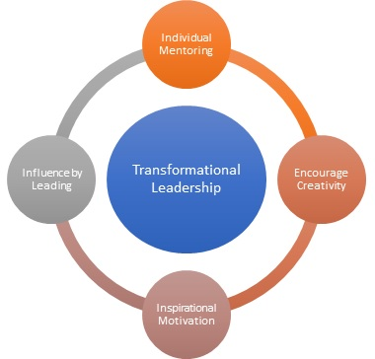
Figure 3 Transformational Leadership
Source: Team, M. (2022) Transformational Leadership Meaning, Importance, Steps & Example | MBA Skool, MBA Skool. Available at: https://www.mbaskool.com/business-concepts/human-resources-hr-terms/8837-transformational-leadership.html (Accessed: 22 February 2022).
The change model is also important for businesses it helps the business to find out the forces that are resisting the change in the company. The change should be positive and the forces that are retraining it must get eliminated from the organization through which the results would be highly positive in every aspect. I think that the change management models are very effective for the company to get the outcome-based and certain results from the processes of the company.
Through the change management model another benefit that could be counted as the positive of it, I think that is the communication strategy that is focused in almost every change model. There are many instances of the companies in which the communication of them is not strong, which became the cause of the low productivity of the employees working in the organization. Through the effective implementation of the change management model the aspects of the customer services, product development, and the employee that are involved in the change would be highly effective. It is significant to manage the change and to find out the issues that are resisting the change so that the company will adopt the new strategies.
According to me, the change management model is one of the methods through which not only the change could get implemented but also the strategy of the firm gets identified, that requires to be changed. For the success of the company, the implementation of the change model is important because every model provides several stages that are proven to be effective in the change model. Without the implementation of the change model, the company does not have the management rules or the path through which the effective implementation of the change model could get done. Also, the impact that might be negative and the potential risk of the change implementation can be effectively catered only through the change model implementation, as they provide effective steps to cater to them.

Lewin’s Change Management Model
Although there are several models of change; one of the models that are also beneficial for KFC to implement the strategic option of product development and innovation in its organization is Lewin’s Change management model. Through Lewin’s model of change, the supervision and the monitoring of the strategic option could be implemented effectively. Lewin’s model of change is very significant and effective providing only three stages but managing the change most appropriately.
Lewin’s model of change is one of the highly effective change models through which the new strategies could be effectively implemented in the organization. There are three stages provided by the Lewin’s model of change including unfreeze, change and freeze.
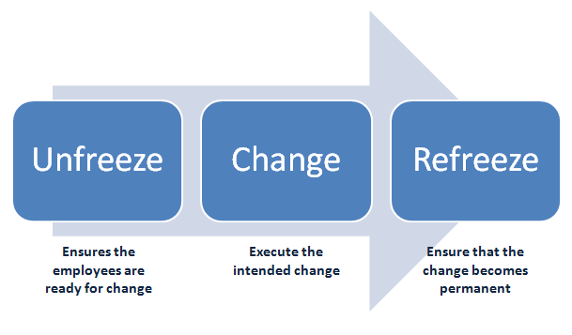
Figure 4 Lewin's model of Change
Source: Joy, M. (2022) Figure 1.9 Lewin's three step model of organizational change , ResearchGate. Available at: https://www.researchgate.net/figure/Lewins-three-step-model-of-organizational-change_fig5_323695129 (Accessed: 22 February 2022).`

Unfreeze
This is the first and the initial stage provided by the model. It includes the measures through which the employee gets mentally prepared for the change. It is significant that the employees know about the change and should get ready conceptually regarding the change. As employees are the core for the change, through them the new methods and the plan will get implemented. Due to this, the employees must remain the effective part of the change.

Change
The second stage is the change implementation as the employees are ready to embrace it. When the employee gets ready it is high time to make the change. Delay in the change will cause a lack of productivity, delay in the results, and not gaining the outcome expected. Due to this, significantly, the change will get executed as soon as the workers in the company are mentally prepared for it.

Freeze
Finally the third and the last stage of Lewin’s change model is the freeze. This stage includes the making of change a permanent part of the organization. If KFC is implementing product development and innovation in its process; then they should also include them in their policy that every certain interval of time they will make sure that the change is happening in the organization. The stage of freezing provided the chance to the company through which the company can effectively understand and monitor the change in the policy permanently.

Leadership during change
For every company, the role of the leadership is very significant through which effective outcome is gained. It is found out that the leadership style I the company should be effectively positive and should help the company so that the employees will remain on the right path and the strategies will be implemented in the right way (Mansaray, 2019). For the change to be effective and positive the leadership must be highly result-oriented and the practices by the leadership style should remain on the high end. Leadership style and the practices that are exhibited by the leaders are very important and play a significant role in the success of the strategies.
The role of the leadership is very important for the organization to understand and its role especially in change management is important due to the reason that if there is no one to guide then the change implementation in the company will not be implemented effectively. It is highly recommended for every company including KFC that the integration of the policies through which the leadership style that will help the objectives of the company to get aligned with the strategies gets done (Aitken, and von Treuer, 2020). For the effective understanding of leadership, the researchers have provided several leadership styles which are important to understand the needs of the organization and to use according to them. The leadership style that is being practiced or adopted by the leader of the company must effectively help the change management process model to get done positively.
The major tasks of the leader also involve its role in the change management, as during the change employees and all the other staff is looking for support and guidance, empathy from the managers, or the designations including leaders. Although there are leadership styles that are important to embrace during a change, I would say that the most important and effective would be the one through which the change could get implemented effectively and positively. Leadership is also very important for the organization during the change as leaders are the one who provides support and guidance to the people that are working in the organization (Yue, et al 2019). Without the support, the change will not get implemented in the organizations. Through the effective implementation of the change, the leader and the employees both will gain outcome-based results.
Communication which is found out to be one of the most important aspects of the company that is required during a change is only achieved through effective leadership. Without communication, the new strategies will not be implemented in the way they should have. Also through productive leadership, the collaboration among the employees and the different designation managers will be outcome-based. The leaders in the organization are the one that promotes collaboration through their practices (Lerman, and Jameson, 2018). If the leaders of the company are not supportive and failed to establish positive practices then the results would be highly negative. Also, stakeholder management is a very important aspect of the change, as the stakeholders are those pillars that are important to remain satisfied; through the change, several uncertainties could encircle the stakeholders.

Transformational leadership
One leadership style that is highly effective under the condition of the change and implementing that change is the transformational leadership style. Through the implementation and the execution of the transformational leadership style, several benefits could be gained during the implementation of change. One of the highly beneficial aspects of the change is that it includes the engagement of the person or the employees. The employees or the core of the organization that is the worker must remain in the loop during the change so that the people will highly contribute according to their role (Alqatawenh, 2018). Through the negating of the employees, transformational leadership promotes the ideas and the aspects through which the strategies being implemented will get effectively aligned with the goals and the objectives of the company
Another benefit that is gained through transformational leadership during the change is the clarity in the vision and the objectives of the corporate. For the employees that are the primary factor through which the change is being implemented the understanding of them the aim or the vision of the company is very important. It is significant for them to know why a certain change is important, how the business market of the company and the other aspects of it are effectively productive through the effective implementation of the transformational leadership style. Not only the leadership style but the other agents of change are required that helps and assisted the leadership to practice the change the organization the best way possible some of the cage agents which are identified through the studies includes,

Team building
One of the change agents that are highly required while any organization is adopting the change is team building. I think it is because, individual performance in the business matter a lot, and every team in the business could be considered as a single entity. Team building practices and the ways are very important through which the outcomes of the company become significant (Margherio, et al 2020, June). If there is no team bonding ability of the leader and the employees of the business the change will not be able to get implemented in the processes or the activities of the enterprise. For an effective and certain change, it is highly required that the team building capability of the team should get effectively done.

Effective Listening
With the communication factor comes effective listening that is only possible through the adoption of team building. Effective listening is highly required as I think during the change several issues can only be catered, to through the effective listening ability of the team.

Interpersonal skills
Another change through which I think, the organization of not only the KFC but all the other organizations implementing to implement the change, interpersonal communication can be and barrier and at the same time can become a powerful tool for the organization. If the team members of the company or the leaders of the company are unable to communicate with each other or other stakeholders the negative results would be projected to the company's success (Soni, 2020). For success, I think that for the execution, it is highly required that the duties and the responsibilities to the employees and the other stakeholder should get conveyed effectively.
I think that according to the case scenario of KFC observed and the other results of the change implementation. It is highly required that the change in the company should get implemented, to gain the benefits of innovation. Also through implementing the suitable change model, and focusing on the leadership style, I think the new strategies will be beneficial.

References
Aitken, K. and von Treuer, K., 2020. Leadership behaviours that foster organisational identification during change. Journal of Organizational Change Management.
Alqatawenh, A.S., 2018. Transformational leadership style and its relationship with change management. Verslas: teorija ir praktika, 19(1), pp.17-24.
Alqatawenh, A.S., 2018. Transformational leadership style and its relationship with change management. Verslas: teorija ir praktika, 19(1), pp.17-24.
Lerman, C. and Jameson, J.L., 2018. Leadership development in medicine. The New England journal of medicine, 378(20), p.1862.
Mansaray, H.E., 2019. The role of leadership style in organisational change management: a literature review. Journal of Human Resource Management, 7(1), pp.18-31.
Margherio, C., Doten-Snitker, K., Litzler, E., Williams, J., Andrijcic, E. and Mohan, S., 2020, June. Building Your Dream Team for Change. In 2019 ASEE Virtual Annual Conference Content Access.
Soni, V.D., 2020. Importance and Strategic Planning of Team Management. International Journal of Innovative Research in Technology, 7(2), pp.47-50.

Team, M. (2022) Transformational Leadership Meaning, Importance, Steps & Example | MBA Skool, MBA Skool. Available at: https://www.mbaskool.com/business-concepts/human-resources-hr terms/8837-transformational-leadership.html (Accessed: 22 February 2022).
Yue, C.A., Men, L.R. and Ferguson, M.A., 2019. Bridging transformational leadership, transparent communication, and employee openness to change: The mediating role of trust. Public relations review, 45(3), p.101779.

