COMPREHENSIVE ACADEMIC AND TECHNICAL AUDIT
HospitalOrg Blockchain EHR System
Technical Analysis & Audit Report
Module Reference: 25CSMR10
Subsystems Analyzed
ehr-chaincode-v3 • ehr-backend-v3 • ehr-frontend-v2 • ehr-network
In-depth analysis of the ehr-chaincode-v3, ehr-backend-v3, and ehr-frontend-v2 architectures.

Executive Summary — In Simple Terms

What is the problem?
The hospital's record-keeping system runs on a blockchain, which is great for making patient records tamper-proof and trustworthy. But the way it is currently built causes several everyday problems:
- When many updates happen quickly for the same patient, the system can reject some of them instead of saving all of them, because it keeps piling every update into one single record instead of giving each one its own slot.
- Old, unused files uploaded to off-chain storage (IPFS) are never cleaned up, so storage space keeps growing without limit.
- Looking up patients (for example, by status) is slow because the database has no shortcuts (indexes) built in, so it has to check everything.
- The reason and details behind a record change are written in plain, readable text on the shared ledger, which can indirectly reveal a patient's diagnosis to people on the network who should not see it.
- Lab results are stored on the shared ledger before they are even finalized, so every connected organization can technically see internal, unapproved data.
- Login sessions cannot be properly cancelled — even after logging out, a stolen or leaked session token could still work until it naturally expires.
- The system does not notify the app when something changes; it depends on the user manually refreshing the page instead of receiving updates instantly.
- Server addresses are hardcoded to “localhost,” so the system cannot easily be spread across multiple computers or servers.

What is our idea to solve it?
Our idea introduces a Privacy-Preserving, Event-Driven architecture that fixes each of these problems with a small, targeted change rather than rebuilding the whole system:
- Instead of stacking every update into one record, we give each update its own unique, timestamped entry, so many updates can happen at once without being rejected.
- We add an automatic cleanup worker that periodically finds and removes old, unused files from off-chain storage.
- We add proper database shortcuts (indexes) so common searches return instantly instead of scanning every record.
- We scramble (hash or encrypt) the sensitive description text before it is saved, so the ledger still keeps an audit trail, but the details cannot be read by people who should not see them.
- We move drafts and unapproved lab results into a private, hospital-only storage area, and only share the finished, approved version with the rest of the network.
- We add a fast “block list” for logged-out or revoked sessions, so access is cut off immediately instead of waiting for the token to expire naturally.
- We make the system push updates to the screen the instant something changes, using a live connection similar to how a chat app instantly shows new messages, so nobody needs to refresh the page.
- We make server addresses configurable instead of hardcoded, so the system can run across multiple machines without editing code.
In short: the current system works and is genuinely secure at its core, but it has rough edges around speed, privacy, and real-time updates. Our proposed architecture keeps everything that already works well and adds focused improvements — private storage for drafts, hidden metadata, faster lookups, and instant live updates — to make the whole system faster, safer, and more pleasant to use.

1. Existing Architecture

Folder & Module Mapping
The HospitalOrg module serves as the primary medical administration node in the federated EHR system.
- ehr-chaincode-v3/ — Contains the Hyperledger Fabric Node.js smart contracts (accessControl.js, ehrContract.js, visitContract.js, patientContract.js, claimsContract.js). This layer enforces business logic, role-based access, and anchors off-chain IPFS CIDs to the ledger.
- ehr-backend-v3/ — Houses the API Gateway microservices (peer0-api, peer1-api, peer2-api, patient-api, extorg-api). Built with Express.js, these nodes authenticate clients via JWT and proxy transactions to the Fabric network using the @hyperledger/fabric-gateway SDK.
- ehr-frontend-v2/ — A React 18 + Vite frontend providing role-specific UI dashboards (Admin, Doctor, Patient, Pharmacist) to interact with the backend APIs.
- ehr-network/ — Infrastructure automation scripts encompassing docker-compose.yaml, configtx.yaml, and crypto material configurations (crypto-config.yaml) to bootstrap the Fabric network.

System Component Flow
1. Client Request — A Doctor logs into the React frontend and requests to update a patient's EHR.
2. API Gateway Routing — The request hits peer0-api (Express.js) via HTTP REST. The API verifies the clinician's JWT.
3. Off-Chain Anchoring — The heavy clinical payload (JSON/PDF) is uploaded to an IPFS Kubo node (handled via an IPFS microservice), generating an immutable CID.
4. Smart Contract Invocation — The API Gateway uses the fabric-gateway gRPC client to submit a transaction (e.g., UpdateEHRCID) using the clinician's Fabric X.509 certificate.
5. Access Control & Consensus — The Fabric peer evaluates the ABAC rules in accessControl.js (verifying role=doctor and active consent). Upon endorsement, the orderer blocks the transaction and the CouchDB world state is updated.

Tech Stack Referenced
- Blockchain Infrastructure: Hyperledger Fabric, Orderers, Peers, Raft consensus.
- Smart Contract Layer: Node.js smart contracts using the Fabric chaincode API.
- API Middleware: Node.js, Express.js, @hyperledger/fabric-gateway (gRPC), JWT-based authentication, express-validator, helmet.
- Frontend Layer: React 18, Vite.
- Database & Off-Chain Storage: CouchDB (World State), IPFS Kubo (off-chain payload storage).

2. Observations

Current State of Implementation
- Fully Functional: Fabric network topology orchestration (Orderers, Peers, CouchDB), smart contract ABAC enforcement, JWT-to-Fabric identity binding, and off-chain CID anchoring.
- Partially Implemented: The frontend UI is mocked in certain state transitions. The integration between the React UI and the actual Fabric wallets relies on a coupled REST proxy.

Code Quality & Pattern Evaluation
- Modularity: Excellent separation of concerns in the chaincode (ehrContract.js vs accessControl.js).
- Error Handling: The API gateways utilize express-validator and helmet, showing good baseline security hygiene.
- Reentrancy & Concurrency: Hyperledger Fabric's MVCC (Multi-Version Concurrency Control) mitigates smart contract reentrancy, but concurrent writes to the same EHR:patientId key currently risk MVCC read-write conflict rejections under high load.

Security & Access Control Audit
- Identity & ABAC: Robust implementation. accessControl.js correctly parses ctx.clientIdentity to extract X.509 attributes.
- Consent Model: Dynamic, time-bound consent grants (GrantAccess / RevokeAccess) provide strong patient sovereignty.

3. Existing Limitations

Scalability Bottlenecks
- MVCC Conflicts on High-Frequency Writes: The cidHistory array in ehrContract.js appends every update to a single state key. High-frequency updates will cause severe Fabric MVCC conflicts.
- IPFS Garbage Collection: No mechanism exists to pin or unpin stale EHR CIDs, leading to infinite bloat on the off-chain storage layer.
- Database & Query Optimization: Missing explicit CouchDB index definitions (META-INF/statedb/couchdb/indexes/), which will cause slow rich queries and trigger performance warnings under heavy network load.

Privacy & Compliance Violations
- Ledger Metadata Leaks: The reason and section fields in the UpdateEHRCID ledger audit trail are stored in plaintext. This metadata can indirectly leak patient diagnosis data to unauthorized ledger nodes.
- Lack of Private Data Collections (PDC): Lab results are currently committed to the shared channel ledger, meaning all organizations (Hospital, Provider, Diagnostics) can theoretically see internal/unapproved lab data before it is finalized.

Architectural Flaws & Incomplete Features
- Authentication Vulnerabilities: JWT refresh tokens are entirely stateless with no blacklist or revocation mechanism implemented, leaving active sessions vulnerable if compromised.
- Event-Driven Architecture Missing: Zero implementation of Fabric Chaincode Events (stub.setEvent). The system relies on polling instead of real-time WebSocket notifications.
- Network Centralization & Hardcoding: Gateway .env configurations and peer addresses are strictly hardcoded for localhost.

4. Enhancements to Overcome the Drawbacks

1. Ledger Metadata Cipher (Resolves Metadata Leaks)
Apply SHA-256 hashing or symmetric encryption to audit trail strings (like reason) before committing to the public ledger.

2. Composite Key Architecture (Resolves MVCC Conflicts)
Refactor ehrContract.js to use Fabric Composite Keys instead of appending to an array. Store updates as EHR_UPDATE~patientId~timestamp to allow concurrent high-frequency writes without transaction rejections.

3. Fabric Private Data Collections (PDC) (Resolves Inter-Org Data Leaks)
Isolate sensitive data such as draft lab reports or internal hospital operational notes into a PDC (collectionHospitalPrivate). Only anchor the public cryptographic hash to the main ehrchannel until the visit is officially finalized.

4. Embedded JSON Indexing (Resolves Query Bottlenecks)
Define and package standard CouchDB JSON indexes inside the chaincode META-INF folder to optimize getStateByRange and eliminate full-state database scans.

5. Real-Time Chaincode Event Subscriptions (Resolves Polling Inefficiency)
Implement stub.setEvent in ForwardContract and LabContract. Establish a WebSocket or Server-Sent Events (SSE) server in the backend to push real-time notifications to the React frontend.

6. Stateful Token Revocation & Dynamic Environments
Implement a Redis cache for active JWT blacklisting to enforce secure session termination. Refactor configuration files to resolve hostnames dynamically for multi-host deployments.

5. Proposed Architecture — Privacy-Preserving Event-Driven State Channels
To solve the data visibility limitations while supercharging the UI experience, the proposed architecture introduces a dual-layer enhancement: Fabric Private Data Collections (PDC) integrated seamlessly with real-time WebSockets.
- Internal staff actions (like draft lab reports or internal doctor notes) are committed exclusively to a collectionHospitalPrivate PDC.
- The transaction triggers an immediate stub.setEvent, which the Node.js API Gateway intercepts and broadcasts over an encrypted WebSocket to the React frontend.
- The UI updates instantly for authorized staff, while external organizations (like Pharmacies or Insurance) see absolutely nothing until a final, public “Approve” transaction is made to the main ehrchannel.

Architecture Diagram
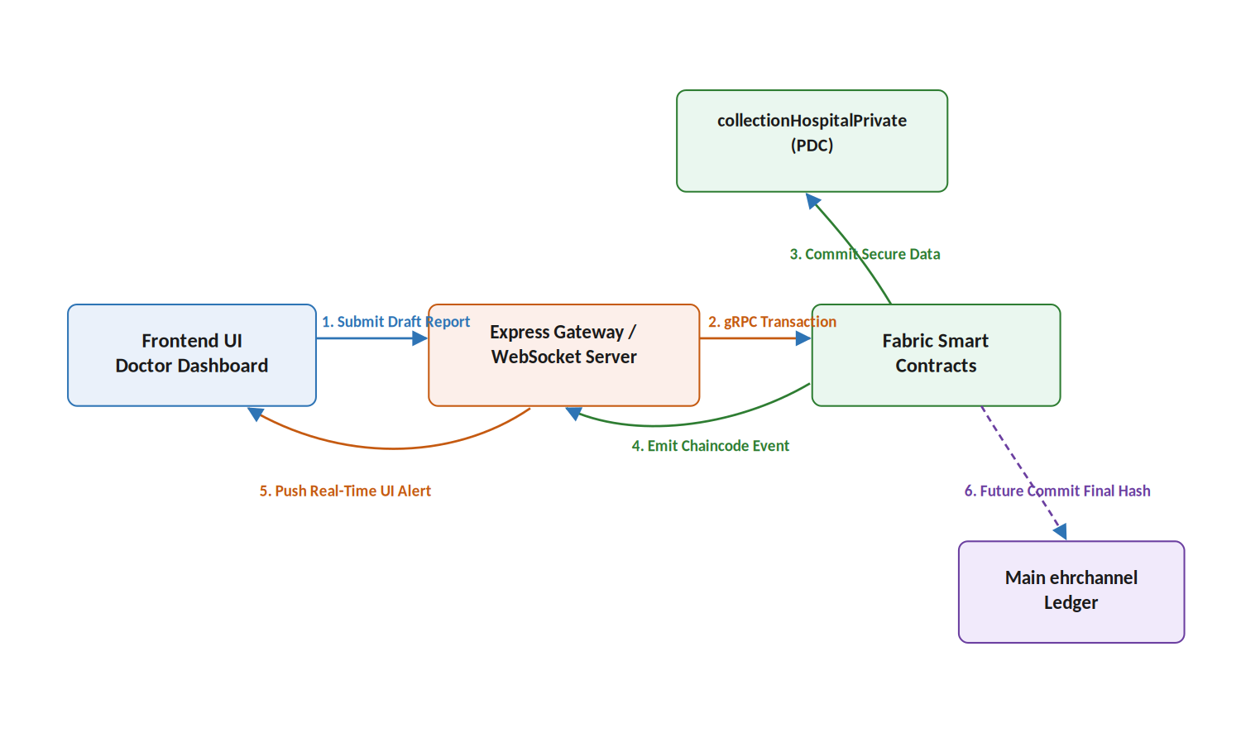
Figure 1. Novel system architecture — draft data flows privately through the PDC, with real-time events pushed to the UI, and only a final hash reaching the shared ledger.

