TECHNICAL ANALYSIS & ARCHITECTURE REPORT
Hospital Organization Module
Module Reference: 25CSMR10
System Component
25CSMR10-20260812T214155Z-1-001
Subsystems Analyzed
ehr-chaincode-v3 • ehr-backend-v3 • ehr-frontend-v2 • ehr-network

Executive Summary — In Simple Terms

What is the problem?
The hospital's record-keeping system runs on a blockchain, which is great for making patient records tamper-proof and trustworthy. But the way it is currently built causes several everyday problems:
- When two doctors or staff members try to update the same patient's record at almost the same time, the system can reject one of the updates instead of saving both. This is like two people trying to save the same document at once and one save getting lost.
- Looking up patients (for example, “show me all patients currently admitted”) is slow because the system has to check every single record instead of using a shortcut (an index).
- Sensitive details about why a record was changed, or which department made the change, are written in plain, readable text on the shared ledger — so anyone with access to the network can read them, even if they are not supposed to.
- Draft notes and unfinished lab results are stored on the same shared ledger as finished records, so they are not properly kept private to the hospital until a doctor confirms them.
- Staff have to keep refreshing or reloading the page to see new updates, because the app does not automatically notify them when something changes.
- Even after a user logs out, their login session can still technically be used until it naturally expires, which is a security risk.
- The system is currently wired to only work on one computer (localhost), so it cannot easily be spread across multiple servers.
- Old files that are no longer needed are never automatically cleaned up, so storage keeps filling up over time.

What is our idea to solve it?
Our idea, which we call the EDPS Architecture (Event-Driven Private State Architecture), fixes each of these problems with a small, targeted change rather than rebuilding the whole system:
- Instead of updating one shared record every time (which causes clashes), we give each update its own unique entry. This means multiple updates can happen at the same time without conflicts, and we can still rebuild the full history whenever we need it.
- We add proper shortcuts (search indexes) to the database so common lookups, like “show all admitted patients,” return instantly instead of scanning everything.
- We scramble (hash or encrypt) the sensitive description text before it is saved, so it stays on the ledger for audit purposes but cannot be read by people who should not see it.
- We move drafts and unfinished notes into a private, hospital-only storage area, and only publish the finished, approved version to the shared ledger.
- We make the system push updates to the screen automatically the moment something changes, using a live connection (similar to how a chat app instantly shows new messages), so nobody needs to refresh the page.
- We add a fast, temporary “do-not-allow” list for logged-out sessions, so a session is blocked immediately at logout instead of staying valid until it expires.
- We make the system read server addresses from settings instead of hardcoding “localhost,” so it can run across multiple machines or servers without editing code.
- We add an automatic cleanup helper that periodically checks for old, unused files and removes them, keeping storage usage under control.
In short: the current system works, but it has rough edges around speed, privacy, and real-time updates. Our proposed EDPS Architecture keeps everything that already works well and adds focused improvements — private storage for drafts, hidden metadata, faster lookups, and instant live updates — to make the whole system faster, safer, and more pleasant to use.

1. Existing Architecture

Folder & Module Mapping
The HospitalOrg directory (25CSMR10) acts as the primary administrative and clinical authority node within the federated network.
- ehr-chaincode-v3/ — Smart contracts written in Node.js utilizing fabric-contract-api.
  - lib/accessControl.js: Attribute-Based Access Control (ABAC) verifier for certificate attributes.
  - lib/ehrContract.js: Manages main patient EHR state, IPFS CID updates, and audit trail entries.
  - lib/accessContract.js: Controls time-bound patient consent grants (GrantAccess, RevokeAccess).
  - lib/visitContract.js, patientContract.js, claimsContract.js: Manages hospital admission visits, patient demographic profiles, and insurance claim workflows.
- ehr-backend-v3/ — API Gateway services built with Node.js and Express.js.
  - peer0-api/, peer1-api/, peer2-api/: Gateway nodes exposing REST endpoints (ports 4000–4002) to interface with corresponding Fabric peers.
  - patient-api/ (Port 4003): Patient-facing portal gateway.
  - extorg-api/ (Port 4004): External organization integration endpoint.
- ehr-frontend-v2/ — User interface developed using React 18, Vite, and Tailwind CSS. Provides dashboards for Admins, Doctors, Patients, and Pharmacists.
- ehr-network/ — Shell scripts and Docker Compose files (docker-compose.yaml, configtx.yaml, crypto-config.yaml) for bootstrapping the local Fabric network topology.

System Component Flow
1. User Authentication & Request — A clinician logs in via the React frontend. Requests are routed to peer0-api with a signed JSON Web Token (JWT).
2. Off-Chain Payload Pinning — Clinical files (JSON/PDF) are uploaded to an IPFS Kubo node via HTTP API, returning a Content Identifier (CID).
3. Transaction Execution — The Express backend converts the request into a gRPC proposal using the @hyperledger/fabric-gateway SDK and signs it with the user's mapped X.509 certificate.
4. ABAC Validation & Ledger Persistence — The target Fabric peer executes accessControl.js, verifying role=doctor and active consent. Upon endorsement, the Raft orderer commits the block and updates CouchDB.
Flow path: React Frontend → Express API Gateway → IPFS (CID pin/return) → Fabric Peer → ABAC / Smart Contract → CouchDB World State

Tech Stack Audit
- Blockchain Infrastructure: Hyperledger Fabric v2.5, Raft Consensus, Gossip Protocol.
- Smart Contract Layer: Node.js, fabric-contract-api.
- API Middleware: Node.js (v18/v20), Express.js, @hyperledger/fabric-gateway, jsonwebtoken, bcryptjs.
- Frontend Layer: React 18, Vite, Tailwind CSS.
- Database & Off-Chain Storage: CouchDB v3.3.2 (World State), IPFS Kubo (Off-chain storage).

2. Observations

Current Implementation State
- Fully Operational: Core Fabric network configuration, identity enrollment scripts, ABAC logic in smart contracts, Express REST proxies, and IPFS CID anchoring.
- Partially Implemented: Frontend state management relies heavily on REST proxies rather than browser-level Web3 signing. Certain UI state transitions use mock data fallback when gateway timeouts occur.
- Stubbed Out: Automated X.509 certificate renewal and real-time revocation checking workflows are scaffolded but not active in production runtime.

Code Quality & Patterns
- Modularity: Strong separation of concerns across contract classes (ehrContract vs accessContract).
- Security Middleware: Gateway endpoints utilize helmet and express-validator for input sanitization.
- Concurrency Vulnerabilities: Smart contract updates append history directly into a single key (EHR:<patientId>), introducing a risk of Multi-Version Concurrency Control (MVCC) write conflicts under parallel requests.

Security & Access Control
- Attribute Verification: accessControl.js correctly reads caller identity attributes directly from ctx.clientIdentity X.509 certs.
- Consent Control: Patient dynamic grants (GrantAccess / RevokeAccess) successfully restrict unauthorized clinician queries on-chain.

3. Existing Limitations
Category | Identified Drawback | Technical Impact
Performance | MVCC Write Conflicts | Appending update records to a single array inside EHR:<patientId> causes transaction rejections when multiple updates occur simultaneously.
Performance | Missing CouchDB Indexes | Absence of packaged index files in META-INF/statedb/couchdb/indexes/ leads to full-state scans during rich queries (GetPatientsByStatus), degrading query performance.
Privacy | Ledger Metadata Leakage | Plaintext reason and section strings in UpdateEHRCID audit logs remain visible to all channel peers, leaking diagnostic context.
Privacy | Unisolated Draft Records | Unfinalized lab results and internal notes are committed directly to the shared ledger without organization-level isolation.
User Experience | Lack of Real-Time UI Updates | Frontend does not listen to Fabric chaincode events, requiring manual browser reloads or polling to view new records.
Security | Stateless JWT Risks | Express gateways lack a token revocation/blacklisting mechanism, leaving active sessions valid even after user logout until expiration.
Infrastructure | Hardcoded Localhost Configs | Backend environment files strictly specify localhost, preventing multi-host / multi-VM deployment without manual file edits.
Storage | Unbounded IPFS Bloat | Absence of an automated unpinning/lifecycle policy allows stale or unreferenced CIDs to accumulate indefinitely on IPFS nodes.

4. Enhancements to Overcome the Drawbacks
To resolve the limitations identified above, the following low- and medium-difficulty technical enhancements are proposed for integration into the system:

1. Composite Key Architecture (Fixes MVCC Conflicts)
- Strategy: Refactor ehrContract.js to store updates under Fabric Composite Keys (EHR_UPDATE~<patientId>~<timestamp>) instead of mutating a shared array.
- Outcome: Eliminates MVCC read-write conflicts, enabling concurrent updates. CouchDB rich queries reconstruct full patient history dynamically.

2. Audit Trail Metadata Encryption (Fixes Metadata Leakage)
- Strategy: Apply lightweight SHA-256 hashing or symmetric encryption to the reason and section metadata strings before committing transactions in ehrContract.js.
- Outcome: Prevents unauthorized channel peers from reading clinical metadata from the public ledger audit log.

3. Fabric Private Data Collections (Fixes Unisolated Drafts)
- Strategy: Configure a Private Data Collection (collectionHospitalPrivate) in the chaincode definition for unapproved drafts and internal notes.
- Outcome: Restricts sensitive draft data to the hospital organization; only the public hash is committed to the main channel until finalized.

4. Packaged CouchDB Indexing (Fixes Query Latency)
- Strategy: Create JSON index definitions inside META-INF/statedb/couchdb/indexes/patientStatusIndex.json within the chaincode directory.
- Outcome: Cuts search latency for GetPatientsByStatus and suppresses full-scan database warnings.

5. WebSocket Chaincode Event Streaming (Fixes Polling Delay)
- Strategy: Add stub.setEvent() triggers inside visitContract.js and labContract.js, paired with a Socket.io WebSocket emitter in the Express gateway.
- Outcome: Pushes real-time updates directly to the React UI when records are created or consent is granted.

6. Redis JWT Blacklist (Fixes Stateless Auth Vulnerabilities)
- Strategy: Introduce a lightweight Redis cache instance to store revoked JWT IDs upon user logout.
- Outcome: Enforces instant session termination across all backend endpoints.

7. Dynamic Environment Resolution (Fixes Infrastructure Hardcoding)
- Strategy: Refactor gateway configuration files to read hostnames dynamically from environment variables or DNS aliases.
- Outcome: Enables smooth deployment across multi-host networks and Tailscale VPN environments.

8. IPFS Garbage Collection Service (Fixes Storage Bloat)
- Strategy: Implement an automated Node.js background worker to periodically scan active CIDs on-chain and unpin stale off-chain files.
- Outcome: Reclaims unused disk space on IPFS storage nodes.

5. Proposed Architecture — Event-Driven Private State Architecture (EDPS)
The EDPS-Architecture integrates Private Data Collections (PDC), real-time chaincode event streaming, metadata obfuscation, and composite key indexing into a single, cohesive enhancement model for the Hospital Organization module.

Architecture Diagram
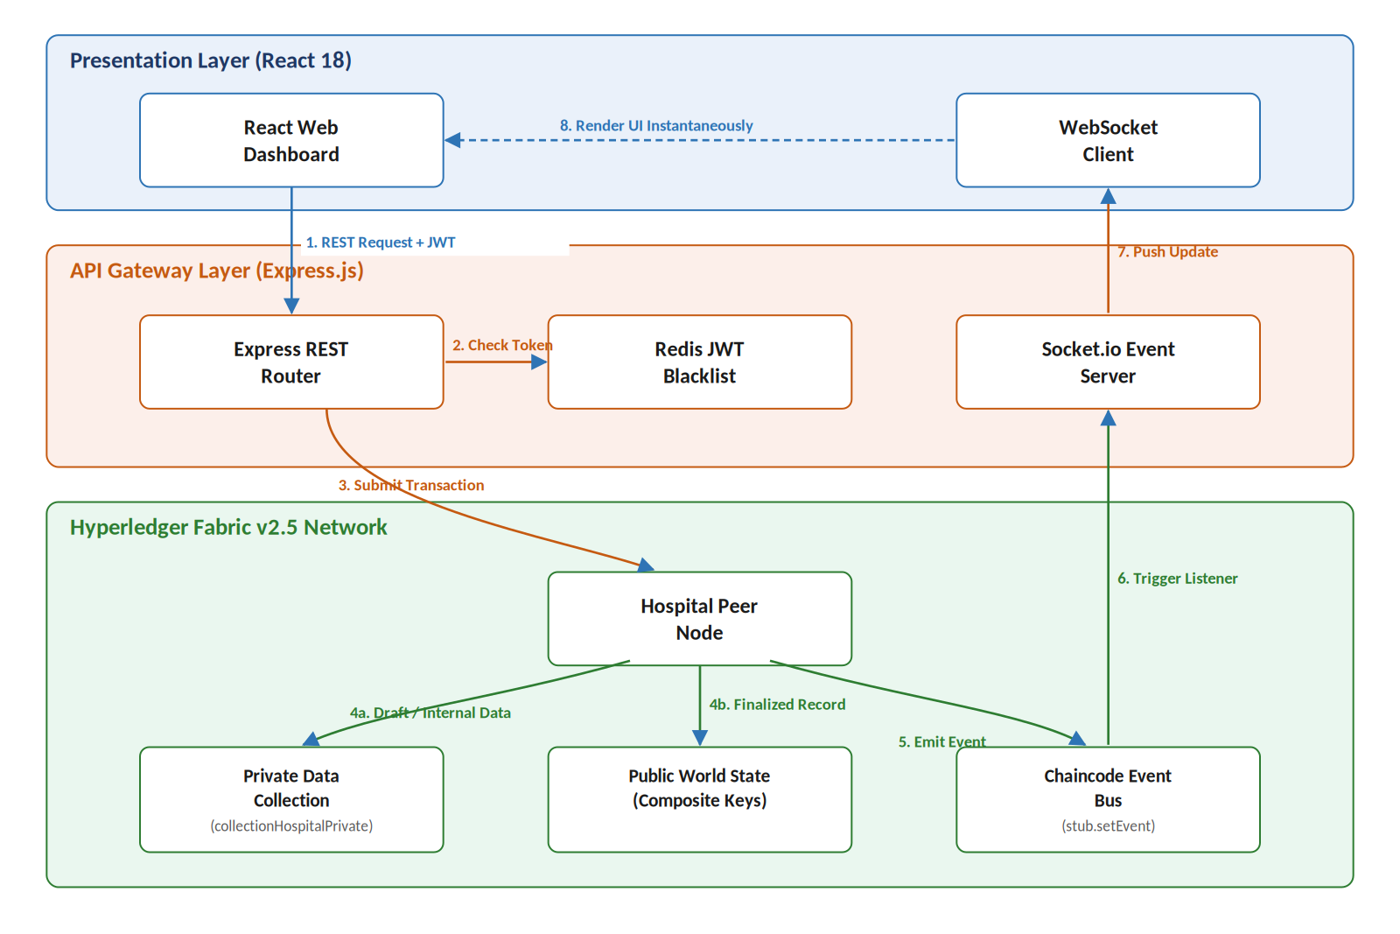
Figure 1. Proposed EDPS Architecture — data and event flow across the presentation, gateway, and Fabric layers.

Data & Event Flow
1. REST Request + JWT — React Web Dashboard sends an authenticated request to the Express REST Router.
2. Token Validity Check — Express REST Router checks the Redis JWT Blacklist before proceeding.
3. Submit Transaction — Express REST Router submits the transaction to the Hospital Peer Node.
4a. Draft / Internal Data — routed to the Private Data Collection (collectionHospitalPrivate).
4b. Finalized Record + Hashed Metadata — committed to the Public World State using Composite Keys.
5. Emit Event — the Hospital Peer Node emits a chaincode event via the Chaincode Event Bus (stub.setEvent).
6. Trigger Event Listener — the Socket.io Event Server picks up the emitted event.
7. Push Real-Time Update — the Socket.io Event Server pushes the update to the WebSocket Client.
8. Render UI Instantaneously — the WebSocket Client updates the React Web Dashboard without a manual refresh.

Architecture Layers
- Presentation Layer (React 18): React Web Dashboard, WebSocket Client.
- API Gateway Layer (Express.js): Express REST Router, Socket.io Event Server, Redis JWT Blacklist.
- Hyperledger Fabric v2.5 Network: Hospital Peer Node, Private Data Collection, Public World State (Composite Keys), Chaincode Event Bus.

