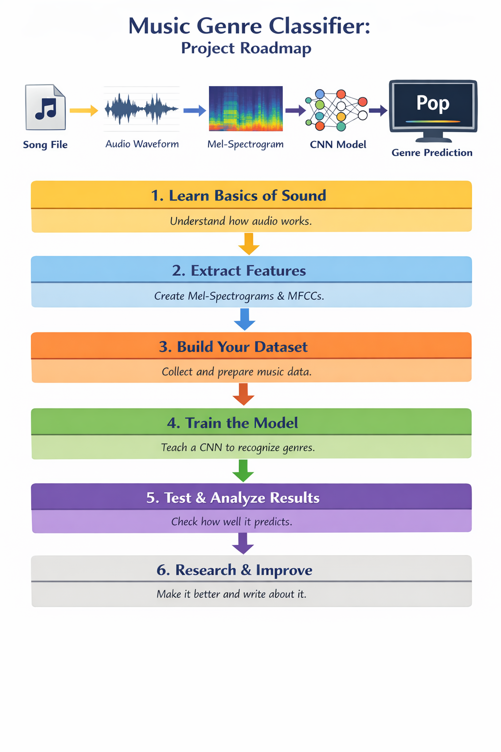
🎵 What is this project?
We want to make a computer program that can listen to a song and tell:
“This is Rock”
“This is Classical”
“This is Jazz”
But computers cannot hear.
So we will convert sound into pictures and then use AI to learn from those pictures.

🧰 What things do you need?
Software you need
We will use:
- Python (main programming language)
- Librosa (to read music files and extract sound features)
- NumPy (to work with numbers)
- Matplotlib (to draw graphs and images)
- TensorFlow or PyTorch (to train the AI model)
- Streamlit or Flask (to make a simple app)
Data you need
We need music files with genres:
- GTZAN dataset
or
- Free Music Archive (FMA) dataset
These contain folders like:
- rock
- jazz
- pop
- classical
Each folder has many songs.

🪜 Step by Step Roadmap
1️⃣ Learn what sound is
A song is just:
numbers changing over time
You will use Librosa to:
- Load a .wav or .mp3 song
- See its waveform (sound wave)
You will learn words like:
- Sampling rate – how fast sound is recorded
- Amplitude – how loud the sound is
- Frequency – how high or low the sound is
Now you understand:
Music = numbers + waves

2️⃣ Change music into pictures
AI cannot learn from raw waves easily.
So we convert sound into pictures.
Using Librosa, you will create:
- Spectrogram
- Mel-Spectrogram
- MFCC (Mel Frequency Cepstral Coefficients)
These are colorful images that show:
- Time on one side
- Frequency on the other
- Color shows sound strength
These images are what the AI will study.

3️⃣ Build your dataset
you take all songs and for each song:
- Convert it to a Mel-spectrogram image
- Save it in the correct folder
Example:
dataset/
rock/
jazz/
classical/
pop/
Now you have:
Music pictures + their correct genre names
This is training dataset.

4️⃣ Train the AI (CNN model)
we use Deep Learning.
use a CNN (Convolutional Neural Network) from:
- TensorFlow or PyTorch
The CNN will:
- Look at spectrogram images
- Learn patterns
- Learn which patterns belong to which genre
This process is called:
Model training
The model slowly becomes better at guessing genres.

5️⃣ Test the AI
you give new songs to the AI.
You calculate:
- Accuracy (how many it got right)
- Confusion Matrix (which genres it mixes up)

6️⃣ Make a simple app
you use Streamlit or Flask to build a small website.
The user can:
- Upload a song
- See the waveform
- See the Mel-spectrogram
- See the predicted genre
Now it looks like a real AI product.

7️⃣ Improve and write a research paper
- Compare MFCC vs Mel-spectrogram
- Try different CNN models
- Improve accuracy

