Quantifying the Premier Model Microorganism:
A Computational Literature-Mining and Clustering Analysis
of Escherichia coli's Dominance in Molecular Biology
2025

1. Abstract
Background: The status of Escherichia coli as the premier model microorganism is a foundational assumption of modern life sciences, yet this consensus has historically been justified only qualitatively. This study provides the first large-scale computational quantification of the biological, technical, and historical drivers establishing E. coli's dominance.
Methodology: A corpus of 3,273 peer-reviewed abstracts (1990–2025) across E. coli, Saccharomyces cerevisiae, and Bacillus subtilis was compiled. An LLM pipeline was constructed using the gpt-oss-120b model via the Cerebras Inference API to extract explicit justifications, followed by semantic embedding (PubMedBERT), dimensionality reduction (10D UMAP), density-based clustering (HDBSCAN), physical pathway mapping (KEGG and EcoCyc), and comparative profiling.
Results: An "Axiomatic Acceptance Gap" was discovered: 61.6% of E. coli papers contain no justification for using the organism, compared to ~31–32% for controls, revealing that E. coli's model status is treated as an implicit paradigm requiring no validation. Unsupervised clustering identified 13 thematic justification categories. E. coli exhibits a balanced, general-purpose profile distributed across 9 distinct themes, whereas S. cerevisiae (99.0% in 2 themes) and B. subtilis (98.1% in 3 themes) are highly specialized niche models. Temporally, E. coli justifications for heterologous expression dropped from 44.1% (1990s) to 12.6% (2020s), reflecting technological normalization, while its justification as the bacterial reference standard rose from 2.9% to 30.3% following the 1997 sequencing milestone. Mapped justifications correspond precisely to conserved replication and export pathways.
Conclusion: E. coli operates not merely as a biological model, but as a socio-institutional anchor in modern molecular biology.

2. Introduction
For over a century, Escherichia coli has served as the foundational bedrock of molecular biology and biotechnology. First isolated in 1885 by the German pediatrician Theodor Escherich from infant feces [1], the Gram-negative rod-shaped bacterium was initially studied as a harmless commensal organism of the human gut and a minor pathogen. However, by the mid-20th century, E. coli had undergone a conceptual transformation, transitioning from a medical specimen to the premier model organism for life sciences.

2.1 The Historical Ascent of E. coli
The selection of E. coli—specifically the K-12 and B strains—as the default tool for molecular biology was shaped by key technical decisions in the 1940s and 1950s. Joshua Lederberg’s discovery of bacterial conjugation in E. coli K-12 in 1946 [2] established that bacteria possessed genetic mechanisms analogous to eukaryotic recombination, making them viable genetic systems. Concurrently, Max Delbrück and the "Phage Group" selected E. coli as the host system to study bacteriophage replication, laying the groundwork for molecular genetics.
Over the subsequent three decades, E. coli served as the vessel through which the fundamental mechanisms of the central dogma were resolved, including:
- The deciphering of the genetic code and codon usage.
- The discovery of messenger RNA (mRNA) and transfer RNA (tRNA).
- The elucidation of the lac operon model of gene regulation by Jacob and Monod.
- The development of recombinant DNA technology (gene cloning) using plasmid vectors and restriction enzymes.
This historical momentum culminated in 1997 with the publication of the complete genome sequence of E. coli K-12 MG1655 by Blattner and colleagues [3]. The sequencing project consolidated E. coli's role as the primary reference point for annotation, functional genomics, and comparative biochemistry.

2.2 The Qualitative Consensus Gap
In microbiology and molecular biology education, the status of E. coli as the "premier model microorganism" is taught as a fundamental, self-evident truth. Standard textbooks justify its dominance by citing qualitative properties: its rapid doubling time (~20 minutes in rich media), simple growth requirements, safe handling profile, and the vast historical accumulation of molecular tools. Standard history and philosophy of science (HPS) and science studies literature has extensively analyzed how model organisms function as community standards, templates, and experimental systems (e.g., Ankeny & Leonelli, 2011 [18]; Creager, 2002 [19]; Weber, 2005 [20]).
However, this consensus is built upon a qualitative and historical narrative. To date, there has been no quantitative, large-scale literature-wide evaluation of why researchers choose to use E. coli, nor has there been any measurement of how often researchers justify this selection in peer-reviewed publications. The scientific community has accepted the model status of E. coli as an implicit paradigm, leaving an empirical gap in the understanding of how model organisms are validated and institutionalized in scientific practice.

2.3 LLM-Augmented Literature Mining and Computational Epistemology
This study addresses this gap by applying computational literature-mining and natural language processing (NLP) to map the epistemology of model microorganisms. Analyzing thousands of peer-reviewed scientific papers manually to extract qualitative arguments is resource-prohibitive. Traditional keyword-matching methods fail to capture the nuanced context of scientific rationales, often conflating methodological mentions of an organism (e.g., using E. coli as a routine cloning tool) with its use as the central biological model under study.
To overcome these limitations, recent advances in large language models (LLMs) and dense sentence embeddings are leveraged. By utilizing the gpt-oss-120b model running on the Cerebras Inference API, high-fidelity, zero-shot structured extraction of justifications is executed directly from publication abstracts with robust validation mechanisms. Combining this LLM-based claim extraction with transformer-based sentence embeddings (pritamdeka/S-PubMedBert-MS-MARCO) and unsupervised density-based clustering (UMAP + HDBSCAN) allows the identification of the underlying thematic structure of scientific justifications at a scale previously impossible.

2.4 Research Scope and Questions
To contextualize E. coli's premier status, a comparative framework is employed. E. coli literature is analyzed alongside two major control microorganisms:
- *Saccharomyces cerevisiae*: The primary eukaryotic model microorganism, representing single-celled complexity, membrane-bound organelles, and eukaryotic gene regulation.
- *Bacillus subtilis*: The primary Gram-positive bacterial model organism, representing a distinct cell envelope architecture, sporulation genetics, and industrial secretory pathways.
The text corpus comprises 3,273 unique peer-reviewed papers (2,051 E. coli, 950 S. cerevisiae, and 272 B. subtilis) published between 1990 and 2025. Through this computational comparative analysis, five primary research questions are addressed:
- RQ1 — Primary: Is Escherichia coli's status as the premier model microorganism driven primarily by biological properties, or do economic, historical, and cultural factors play equally significant roles?
- RQ2 — Clustering: What are the principal thematic categories of scientific justification for E. coli's premier model microorganism status as revealed by computational analysis of peer-reviewed literature?
- RQ3 — Temporal: Is Escherichia coli still statistically the premier model microorganism in current scientific literature, or do emerging trends suggest a shift toward other microorganisms?
- RQ4 — Comparative: What properties uniquely distinguish E. coli from S. cerevisiae and B. subtilis in the scientific literature, and how do these distinctions quantitatively support its premier standing?
- RQ5 — Systems Biology: To which biological systems and molecular pathways do the most frequently cited properties of E. coli map, revealing its systemic tractability as a model microorganism?

3. Methodology
This study employs an LLM-augmented computational literature-mining and machine learning pipeline to analyze the scientific justifications driving the selection of model microorganisms. The methodology is executed in six distinct computational phases:

▸ Phase 1: Dataset Construction
↓
▸ Phase 2: LLM Claim Extraction & Cleaning
↓
▸ Phase 3: Semantic Embedding & Clustering (UMAP + HDBSCAN)
↓
▸ Phase 4: Biological Pathway Database Mapping (KEGG + EcoCyc)
↓
▸ Phase 5: Temporal Trend Analysis (1990–2025)
↓
▸ Phase 6: Cross-Organism Comparative Profile Analysis

3.1 Phase 1: Dataset Construction
Scientific paper abstracts and metadata were retrieved from the NCBI PubMed database using the Biopython Entrez API. The search was scoped to peer-reviewed journal articles published in English between January 1, 1990, and December 31, 2025.
To collect literature where organisms are explicitly used as model systems, seven Boolean search queries were designed. Five queries targeted the primary subject Escherichia coli, and one query each targeted the eukaryotic comparison organism Saccharomyces cerevisiae and the Gram-positive bacterial comparison organism Bacillus subtilis:
- E. coli Queries:
- ("Escherichia coli"[Title/Abstract] AND "model organism"[Title/Abstract])
- ("Escherichia coli"[Title/Abstract] AND "model system"[Title/Abstract])
- ("E. coli"[Title/Abstract] AND "model organism"[Title/Abstract])
- ("Escherichia coli"[Title/Abstract] AND "model bacterium"[Title/Abstract])
- ("Escherichia coli"[Title/Abstract] AND "reference organism"[Title/Abstract])
- S. cerevisiae Query:
- ("Saccharomyces cerevisiae"[Title/Abstract] AND "model organism"[Title/Abstract])
- B. subtilis Query:
- ("Bacillus subtilis"[Title/Abstract] AND "model organism"[Title/Abstract])
All retrieved records were deduplicated across search queries using their PubMed ID (PMID). Records lacking abstract texts or containing abstracts shorter than 30 characters were discarded. The final curated corpus consisted of 3,273 unique papers (2,051 E. coli papers, 950 S. cerevisiae papers, and 272 B. subtilis papers).
Importantly, the search queries were pre-filtered to retrieve only those papers that explicitly contain keywords related to the organism's model status (e.g., "model organism", "model system", "model bacterium", "reference organism") within their titles or abstracts. This represents a deliberate methodological design choice: rather than studying the general literature where E. coli is often used as a routine background tool, this design specifically isolates papers that actively invoke the model status of the organism. Consequently, the justification rate measured in Phase 2 does not represent the general rate of justification across all biology papers, but rather a more robust finding: even when researchers explicitly label E. coli as a model system in their abstract, nearly two-thirds (61.6%) still decline to provide any biological or technical justification for its selection.

3.2 Phase 2: LLM-Driven Claim Extraction & Cleaning
To isolate the specific justifications scientists give for using their chosen model organism, an LLM extraction pipeline was built using the gpt-oss-120b model queried via the Cerebras Inference API.

3.2.1 Extraction Schema and Prompting
Each abstract in the corpus was processed individually. The model was instructed to return a structured JSON object strictly matching the following schema:
- explicit_reason_found (boolean): true if the abstract explicitly states a reason/justification for using the organism; false otherwise.
- justification_claims (array of objects): Contains the extracted claim (paraphrased), category (constrained to biological, technical, historical, economic, or cultural), subcategory (a short thematic tag), and supporting_quote (the verbatim text from the abstract).
- null_reason (string or null): Documented rationale if explicit_reason_found is false.

3.2.2 Anti-Hallucination Guardrails
To prevent model hallucinations, a 5-layer quality assurance pipeline was implemented:
- Deterministic Temperature: temperature = 0.0 was enforced to eliminate creative token generation.
- Explicit Null Rule: The model was strictly instructed to return false for explicit_reason_found and null for claims if no direct text justified the organism, preventing logical inferences.
- Fuzzy Quote Verification: Every extracted supporting_quote was matched against the raw abstract text using a sliding-window character comparison (difflib.SequenceMatcher). Quotes failing to achieve a similarity ratio \ge 0.65 were flagged and discarded.
- Schema and ID Validation: Outputs were validated programmatically using the jsonschema library.
- Progressive Cache Saving: API outputs were saved progressively to JSONL files to allow resuming and protect against mid-run network interruptions.
Following extraction, cleanup_phase2.py was executed to filter out hallucinated entries (removing 7 claims, representing a low 0.21% hallucination rate) and isolate the explicit justification claims. This resulted in a clean explicit justification dataset of 2,037 claims (867 E. coli, 944 S. cerevisiae, and 226 B. subtilis) for clustering.

3.3 Phase 3: Semantic Embedding & Clustering
The 2,037 explicit justification claims were converted into dense vectors using the pre-trained pritamdeka/S-PubMedBert-MS-MARCO SentenceTransformer model, yielding 768-dimensional embeddings tailored for biomedical text semantics.
To resolve the "curse of dimensionality" during density-based clustering, a two-step dimensionality reduction workflow was implemented:
- For Clustering: Embeddings were projected into 10 dimensions using UMAP (cosine metric, n_neighbors=15, random_state=42) to preserve local and global semantic structures.
- For Visualization: Embeddings were separately projected to 2 dimensions solely to generate cluster scatter plots.
Density-based clustering was performed on the 10D vectors using HDBSCAN. To find the optimal cluster resolution, a grid-search optimization sweep was conducted over HDBSCAN hyper-parameters (min_cluster_size ranging from 10 to 30, min_samples from 3 to 15). The grid search optimized for the maximum Silhouette score (excluding noise points) while keeping the outlier (noise) rate below 30% and yielding between 8 and 18 clusters.
The optimal configuration selected was min_cluster_size=15 and min_samples=15. This returned 13 distinct clusters (Cluster 0 to 12) with a Silhouette score of 0.5388 and a noise/outlier rate of 23.91% (487 out of 2,037 claims marked as Cluster -1).
To identify the core concept of each cluster, the centroid of each cluster's member embeddings in the 10-dimensional space was calculated, and claims were ranked by their Euclidean distance to their respective cluster centroid. The top 10 closest claims were extracted as "exemplars" to guide thematic naming.

3.4 Phase 4: Biological Pathway Database Mapping
The biological justifications of the 13 clusters were mapped to physical biological pathways and systems. The KEGG REST API (rest.kegg.jp) was queried to retrieve pathway IDs and descriptions for the three host organisms:
- Escherichia coli K-12 MG1655 (eco)
- Saccharomyces cerevisiae (sce)
- Bacillus subtilis 168 (bsu)
A cross-reference dictionary was compiled where clusters were associated with corresponding KEGG pathways (e.g. DNA replication eco03030, mismatch repair eco03430, or protein export eco03060). For E. coli-dominant clusters (Clusters 4–12), claims were additionally cross-referenced with curated gene networks and metabolic pathways in the EcoCyc Database (ecocyc.org) to obtain high-resolution systems biology annotations. Mappings were verified and saved as data/processed/phase4_pathway_map.csv.

3.5 Phase 5: Temporal Trend Analysis
The 458 clustered E. coli claims (excluding noise) were binned across a 35-year timeline by publication years into four periods:
- Bin 1: 1990–1999 (39 claims)
- Bin 2: 2000–2009 (98 claims)
- Bin 3: 2010–2019 (184 claims)
- Bin 4: 2020–2025 (137 claims)
For each decade bin, the relative frequency (percentage representation) of each E. coli cluster within that era's explicit claims was calculated. Relative frequencies were utilized instead of raw counts to normalize for the growing volume of scientific literature over time. The trajectories of the individual research themes were modeled using line plots and stacked bar charts. This decadal shift corresponds directly with the completion of the E. coli genome sequencing in 1997 [3].

3.6 Phase 6: Cross-Organism Comparative Profile Analysis
To contrast E. coli's justification profile against S. cerevisiae and B. subtilis, the normalized distribution of each organism's total clustered claims across the 13 themes was computed.
For each organism, the counts of claims in each cluster were divided by that organism's total number of clustered claims (458 E. coli, 880 S. cerevisiae, and 212 B. subtilis claims, excluding noise). This column-wise normalization allowed the evaluation of the breadth of each model organism's research profile independently of the size differences in their starting corpora. The comparison matrix was plotted as an annotated heatmap to visualize niche specialization and multi-dimensional dominance.

4. Results
This section presents the empirical and quantitative results generated across the six phases of the computational literature-mining and clustering pipeline.

4.1 Dataset Composition and General Characteristics
Following literature retrieval, deduplication, and quality-filtering in Phase 1, the final text corpus comprised 3,273 unique peer-reviewed papers containing English abstracts published between 1990 and 2025. The distribution of papers across the three target model microorganisms was:
- *Escherichia coli* (Subject): 2,051 papers (62.7% of the total corpus)
- *Saccharomyces cerevisiae* (Eukaryotic Control): 950 papers (29.0%)
- *Bacillus subtilis* (Gram-Positive Control): 272 papers (8.3%)
The timeline of the dataset spanned 35 years, with the publication volume showing a steady upward trajectory: 255 papers in 1990–1999, 652 papers in 2000–2009, 1,422 papers in 2010–2019, and 944 papers in 2020–2025 (Figure 3).
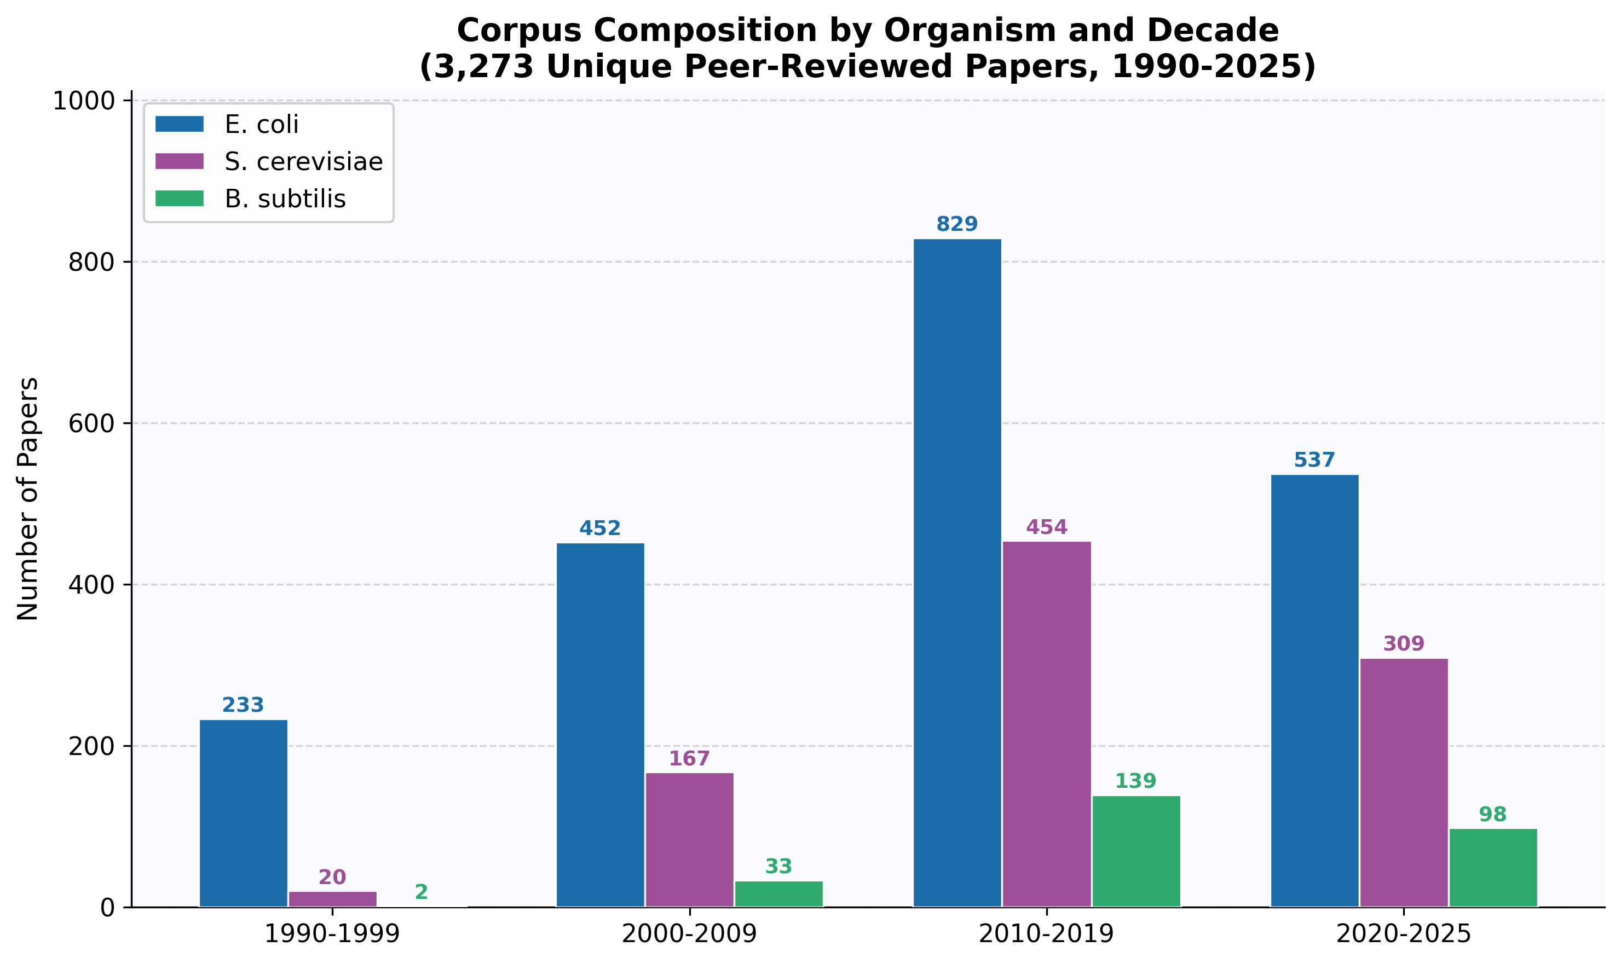
Figure 3: Corpus composition by organism and publication decade (1990–2025).

Figure 3: Corpus composition by organism and publication decade (1990–2025).

4.2 Justification Extraction and the Axiomatic Acceptance Gap
Phase 2 evaluated the 3,273 abstracts using LLM-based structured extraction to determine if authors explicitly explained why they chose their model organism.
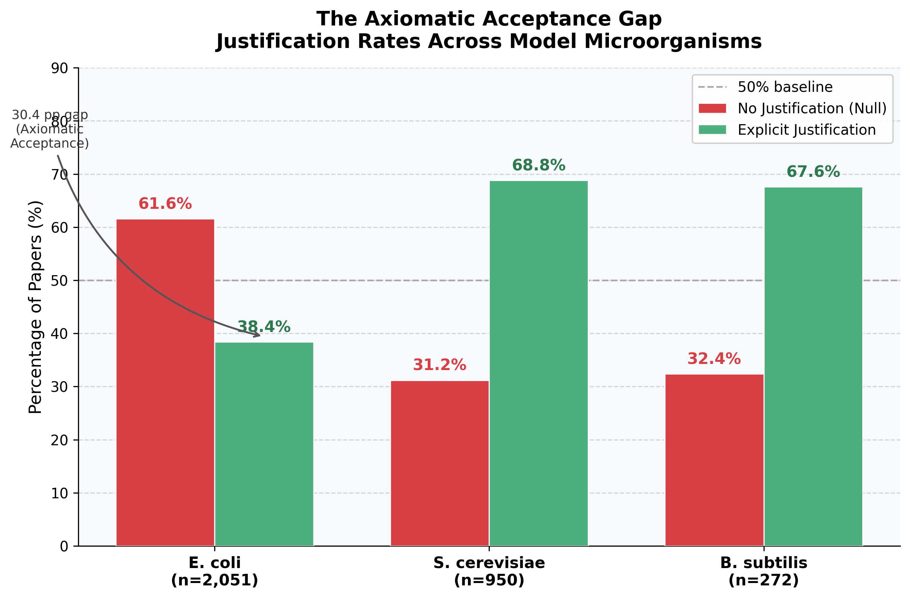
Figure 1: The Axiomatic Acceptance Gap — Justification rates across E. coli, S. cerevisiae, and B. subtilis.
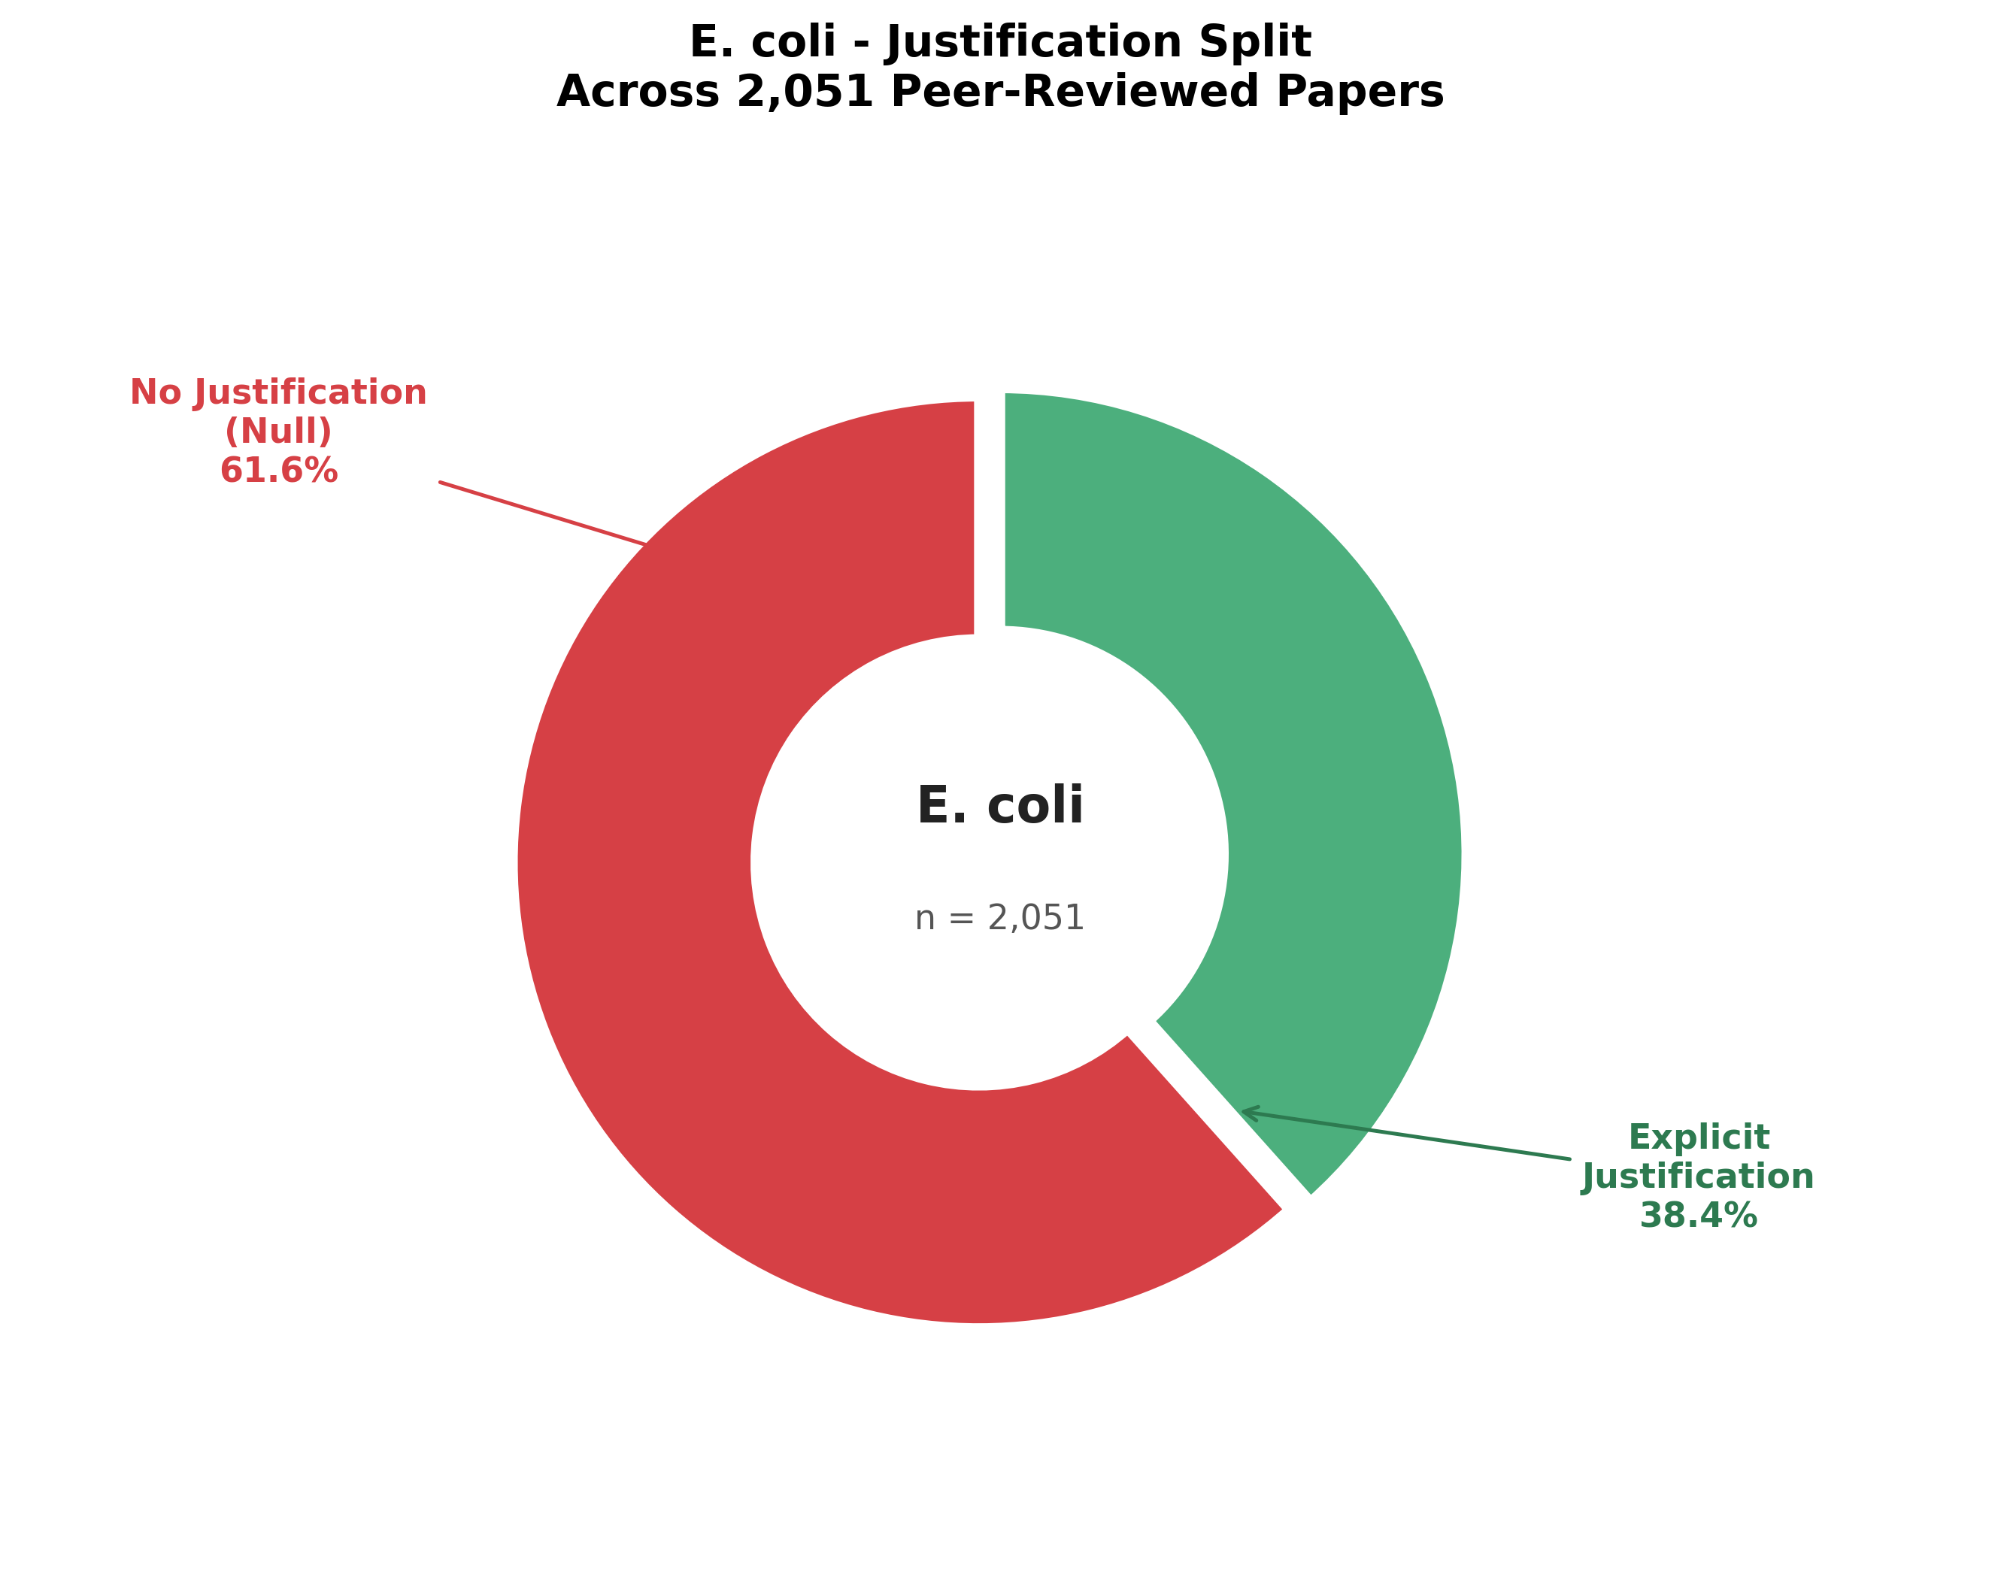
Figure 2: Corpus-wide justification split (Explicit vs. Null).

4.2.1 The Overall Corpus Split
Across all three organisms, the corpus was split almost equally between papers containing explicit justifications and those treating the choice as an implicit assumption:
- Explicit Reason Found: 1,626 papers (49.7% of the processed corpus; Figure 2)
- Null (No Reason Stated): 1,643 papers (50.3% of the processed corpus)

Figure 1: The Axiomatic Acceptance Gap — Justification rates across E. coli, S. cerevisiae, and B. subtilis.

Figure 2: Corpus-wide justification split (Explicit vs. Null).

4.2.2 The Axiomatic Acceptance Gap (RQ1 Answer)
- *Escherichia coli*: 61.6% Null [95% CI: 59.5%–63.7%] (1,263 out of 2,051 papers contain no justification; only 788 papers explicitly justify its use).
- *Saccharomyces cerevisiae*: 31.2% Null [95% CI: 28.2%–34.1%] (296 out of 950 papers contain no justification; 654 papers explicitly justify its use).
- *Bacillus subtilis*: 32.4% Null [95% CI: 26.8%–37.9%] (88 out of 272 papers contain no justification; 184 papers explicitly justify its use).
To test whether the difference in justification rates across the three organisms is statistically significant, a Chi-square test of independence was performed on the 3 \times 2 contingency table of organism versus justification status (implicit vs. explicit). The difference was found to be highly significant (\chi^2(2) = 278.68, p < 0.0001, raw p = 3.06 \times 10^{-61}).
This Axiomatic Acceptance Gap indicates that in nearly two-thirds (61.6%) of E. coli publications, the model status of the bacterium is treated as a self-evident axiom requiring no validation. In contrast, researchers using Yeast and Bacillus feel compelled to explicitly justify their model choice in more than two-thirds of their papers (~68.8% and ~67.6% respectively, visualized in Figure 1).
After removing 7 claims flagged by fuzzy quote verification (0.21% hallucination rate), the papers with explicit justifications yielded a clean dataset of 2,037 explicit claims (867 E. coli, 944 S. cerevisiae, and 226 B. subtilis) for clustering.

Figure 1: The Axiomatic Acceptance Gap — Justification rates across E. coli, S. cerevisiae, and B. subtilis.

Figure 2: Corpus-wide justification split (Explicit vs. Null).

Figure 1: The Axiomatic Acceptance Gap — Justification rates across E. coli, S. cerevisiae, and B. subtilis.

Figure 2: Corpus-wide justification split (Explicit vs. Null).

4.3 Thematic Justification Clusters (RQ2 Answer)
Unsupervised density-based clustering (HDBSCAN) of the 2,037 PubMedBERT embeddings in the 10D UMAP space identified 13 distinct clusters (Cluster 0 to 12) representing primary themes of scientific justification. A total of 487 claims (23.91%) were classified as noise (outliers, Cluster -1). The Silhouette score of the clustered points was 0.5388, confirming robust semantic separation.
Table 4.1 summarizes the size, dominant organism, dominant category, and representative exemplar claims for the 13 clusters. The spatial separation of the semantic clusters is projected in 2D UMAP space (Figure 5). Additionally, Figure 4 () provides a treemap of E. coli's explicit justifications across the 9 dominant E. coli themes, showing the relative size and share of each category.

Table 4.1: Thematic Cluster Analysis Summary
Cluster ID | Theme Name | Size | Dom. Organism (%) | Dom. Category | Exemplar Claim (Closest to Centroid)
0 | Gram-Positive Physiology, Endospore Formation, and Industrial Bioprocessing (B. subtilis) | 166 | B. subtilis (88.6%) | biological | "B. subtilis is used because it serves as a model organism for Gram-positive spore-forming bacteria"
1 | Gram-Positive Bacterium Model Definition | 29 | B. subtilis (82.8%) | biological | "It is a model organism of Gram-positive bacteria"
2 | Eukaryotic Cell Biology, Conserved Metabolic Pathways, and Human Disease Modeling (S. cerevisiae) | 530 | S. cerevisiae (98.5%) | biological | "Yeast is used because it serves as a model organism for studying genetic mechanisms that are difficult to investigate in mammalian cells"
3 | Genetic Tractability, Molecular Tooling, and Industrial Cell Factories | 433 | S. cerevisiae (80.6%) | biological | "Vast knowledge accumulated over decades of research"
4 | Experimental Rationale for Organism Selection (E. coli) | 25 | E. coli (100.0%) | biological | "E. coli was chosen because it is a model bacterium"
5 | Standard Model Bacterium Utility and Characterization (E. coli) | 40 | E. coli (100.0%) | biological | "E. coli is used because it is a well-established model bacterium"
6 | Heterologous Protein Expression and Recombinant Production Chassis (E. coli) | 64 | E. coli (92.2%) | technical | "E. coli was used as a host for producing purified transducible Cre protein"
7 | Clinical Pathogenesis, Virulence Modeling, and Infectious Disease (E. coli) | 55 | E. coli (96.4%) | biological | "E. coli is associated with human diarrheal disease, making it relevant for study"
8 | Gram-Negative Reference Organism and Cell Envelope Modeling (E. coli) | 24 | E. coli (100.0%) | biological | "E. coli is used as a representative model organism for Gram-negative bacteria"
9 | Antimicrobial Screening, Drug Tolerance, and Resistance Mechanisms (E. coli) | 28 | E. coli (100.0%) | biological | "E. coli is used as a model organism for studying antibiotic responses"
10 | DNA Replication, Recombination, Repair, and Replication Fidelity (E. coli) | 29 | E. coli (93.1%) | biological | "E. coli is used as a model system for studying chromosomal replication fidelity"
11 | Bacterial Reference Standard and Legacy Model Characterization (E. coli) | 101 | E. coli (99.0%) | biological | "E. coli is a well-established model organism for studying cellular behavior"
12 | Genomic Annotation and Molecular Genetics Reference (E. coli) | 26 | E. coli (100.0%) | historical | "E. coli is used as a model organism"

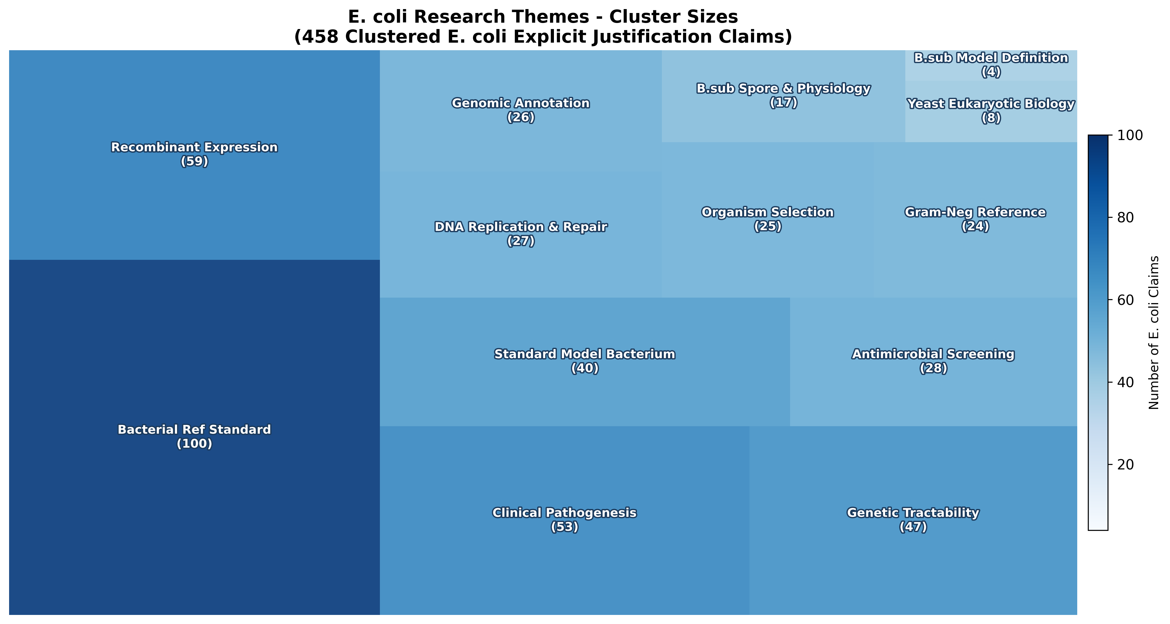
Figure 4: Treemap of E. coli explicit justification themes.
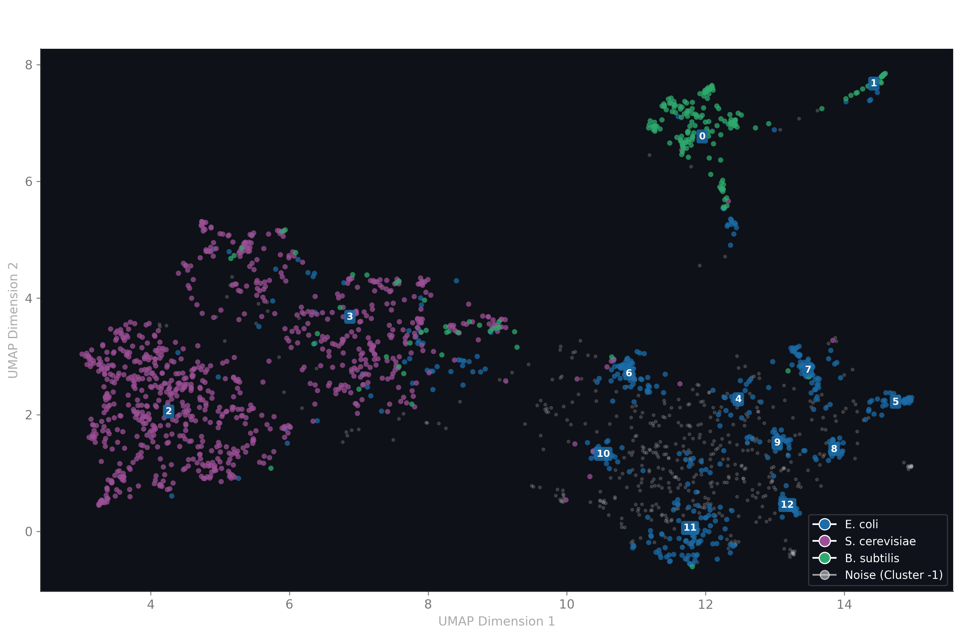
Figure 5: 2D UMAP projection of 2,037 justification claim embeddings, colored by cluster.

Figure 4: Treemap of E. coli explicit justification themes.

Figure 5: 2D UMAP projection of 2,037 justification claim embeddings, colored by cluster.

4.4 Biological Pathway Database Mapping (RQ5 Answer)
Phase 4 mapped the 13 clusters to physical biological pathways and regulatory networks (visualized as a network mapping in Figure 6). Mappings were verified against KEGG pathway models (eco, sce, bsu) and the EcoCyc database:
- Gram-Positive Regulation (Clusters 0 & 1): Map to sporulation quorum sensing and two-component systems (bsu02020, bsu02024) and cell wall synthesis (bsu00550).
- Eukaryotic Cellular Mechanics (Cluster 2): Maps to cell cycle/meiosis controls (sce04111, sce04113), endoplasmic reticulum protein processing (sce04141), and MAPK signaling (sce04011).
- Molecular Recombinant Host (Cluster 6): Maps to inner membrane translocation systems—the Sec secretion system and Twin-Arginine Translocation (Tat) system (eco03060 / EcoCyc: Sec pathway, Tat system).
- Medically Relevant Infection (Cluster 7): Maps to map05130 (Pathogenic E. coli infection), focusing on fimbriae adhesion, pili assembly, and Lipid A biosynthesis (eco00540).
- Antibiotic Assays (Cluster 9): Maps to beta-lactam resistance (eco01501) and the AcrAB-TolC multidrug efflux pump (EcoCyc: AcrAB-TolC efflux).
- Replication Fidelity (Cluster 10): Maps to the DNA replication fork machinery (eco03030), methyl-directed mismatch repair (eco03430), and homologous recombination (eco03440 / EcoCyc: RecBCD pathway).
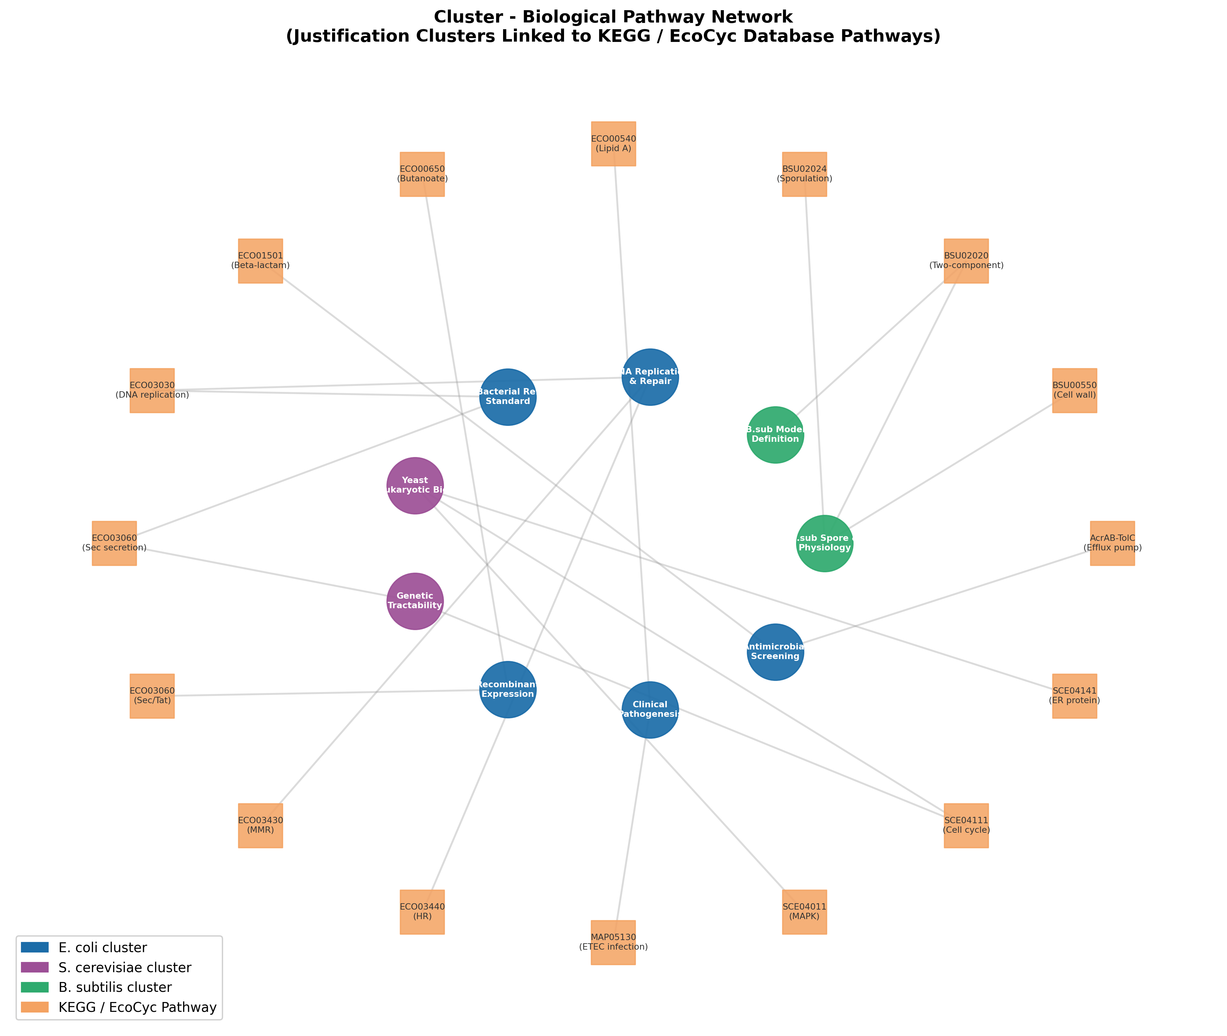
Figure 6: Cluster-to-pathway network mapping (KEGG & EcoCyc).

Figure 6: Cluster-to-pathway network mapping (KEGG & EcoCyc).

4.5 Temporal Justification Trajectories (RQ3 Answer)
Phase 5 tracked shifts in the justification for using E. coli over time. The 458 clustered E. coli explicit claims were binned into four decadal periods. The temporal trajectories (visualized as a stacked area chart in Figure 7) revealed three major shifts:
- Rise of the "Bacterial Reference Standard": Justifications selecting E. coli as the definitive bacterial reference standard rose continuously from 2.9% in the 1990s to 26.0% in the 2000s, reaching 30.3% in the 2020s. This corresponds directly with the completion of the E. coli genome sequencing in 1997.
- Decline of "DNA Replication & Repair": Claims based on E. coli DNA replication fork and repair mechanics fell continuously from 20.6% in the 1990s to just 2.5% in the 2020s, reflecting the transition of molecular genetics research toward eukaryotic hosts.
- Normalization of Heterologous Expression: Claims based on Heterologous Expression Host utility dropped sharply from 44.1% in the 1990s to 14.3% in the 2000s and 12.6% in the 2020s, showing that protein expression has become an implicit utility requiring less explicit justification.
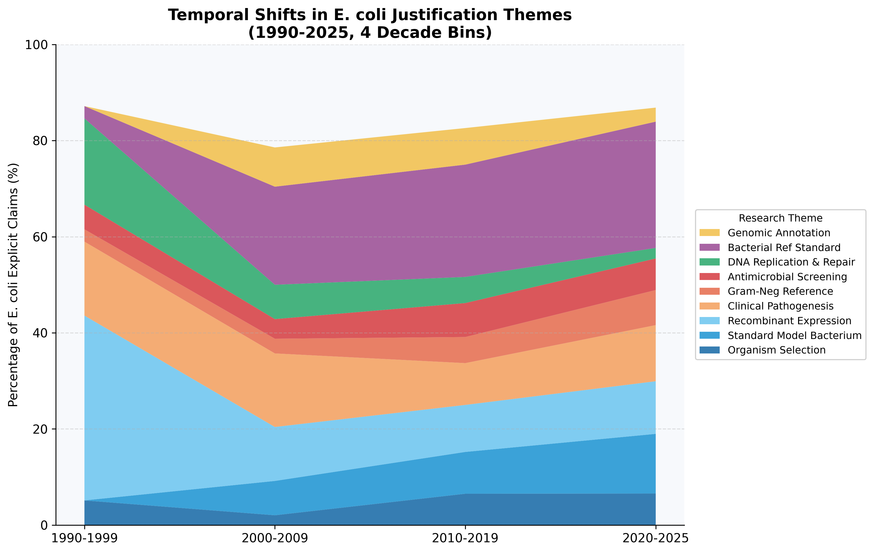
Figure 7: Temporal trajectories of E. coli justification themes (1990–2025).

Figure 7: Temporal trajectories of E. coli justification themes (1990–2025).

4.6 Cross-Organism Comparative Profile Analysis (RQ4 Answer)
Phase 6 normalized the cluster frequencies for each organism to compare their scientific profiles. The relative specialization of each organism is illustrated via a radar chart profile (Figure 8), and the normalized distribution of justification themes is compared in the cross-organism comparative matrix heatmap (Figure 9), showing that:
- S. cerevisiae (Yeast) is a highly specialized model, with 99.0% of its justifications concentrated in just two themes: Eukaryotic Biology & Disease Modeling (59.3%) and Genetic Tractability & Workhorse Tools (39.7%).
- B. subtilis is similarly specialized, with 98.1% of justifications concentrated in just three themes: Gram-Positive Physiology & Bioprocess (69.3%), Genetic Tractability (17.5%), and Gram-Positive Definition (11.3%).
- *Escherichia coli exhibits a highly balanced, multifaceted profile, with its justifications distributed across 9 distinct themes* (Themes 4 to 12). No single theme represents more than 22% of E. coli claims, proving E. coli is uniquely suited as a general-purpose biological reference, technical cell factory, and pathogenesis model.
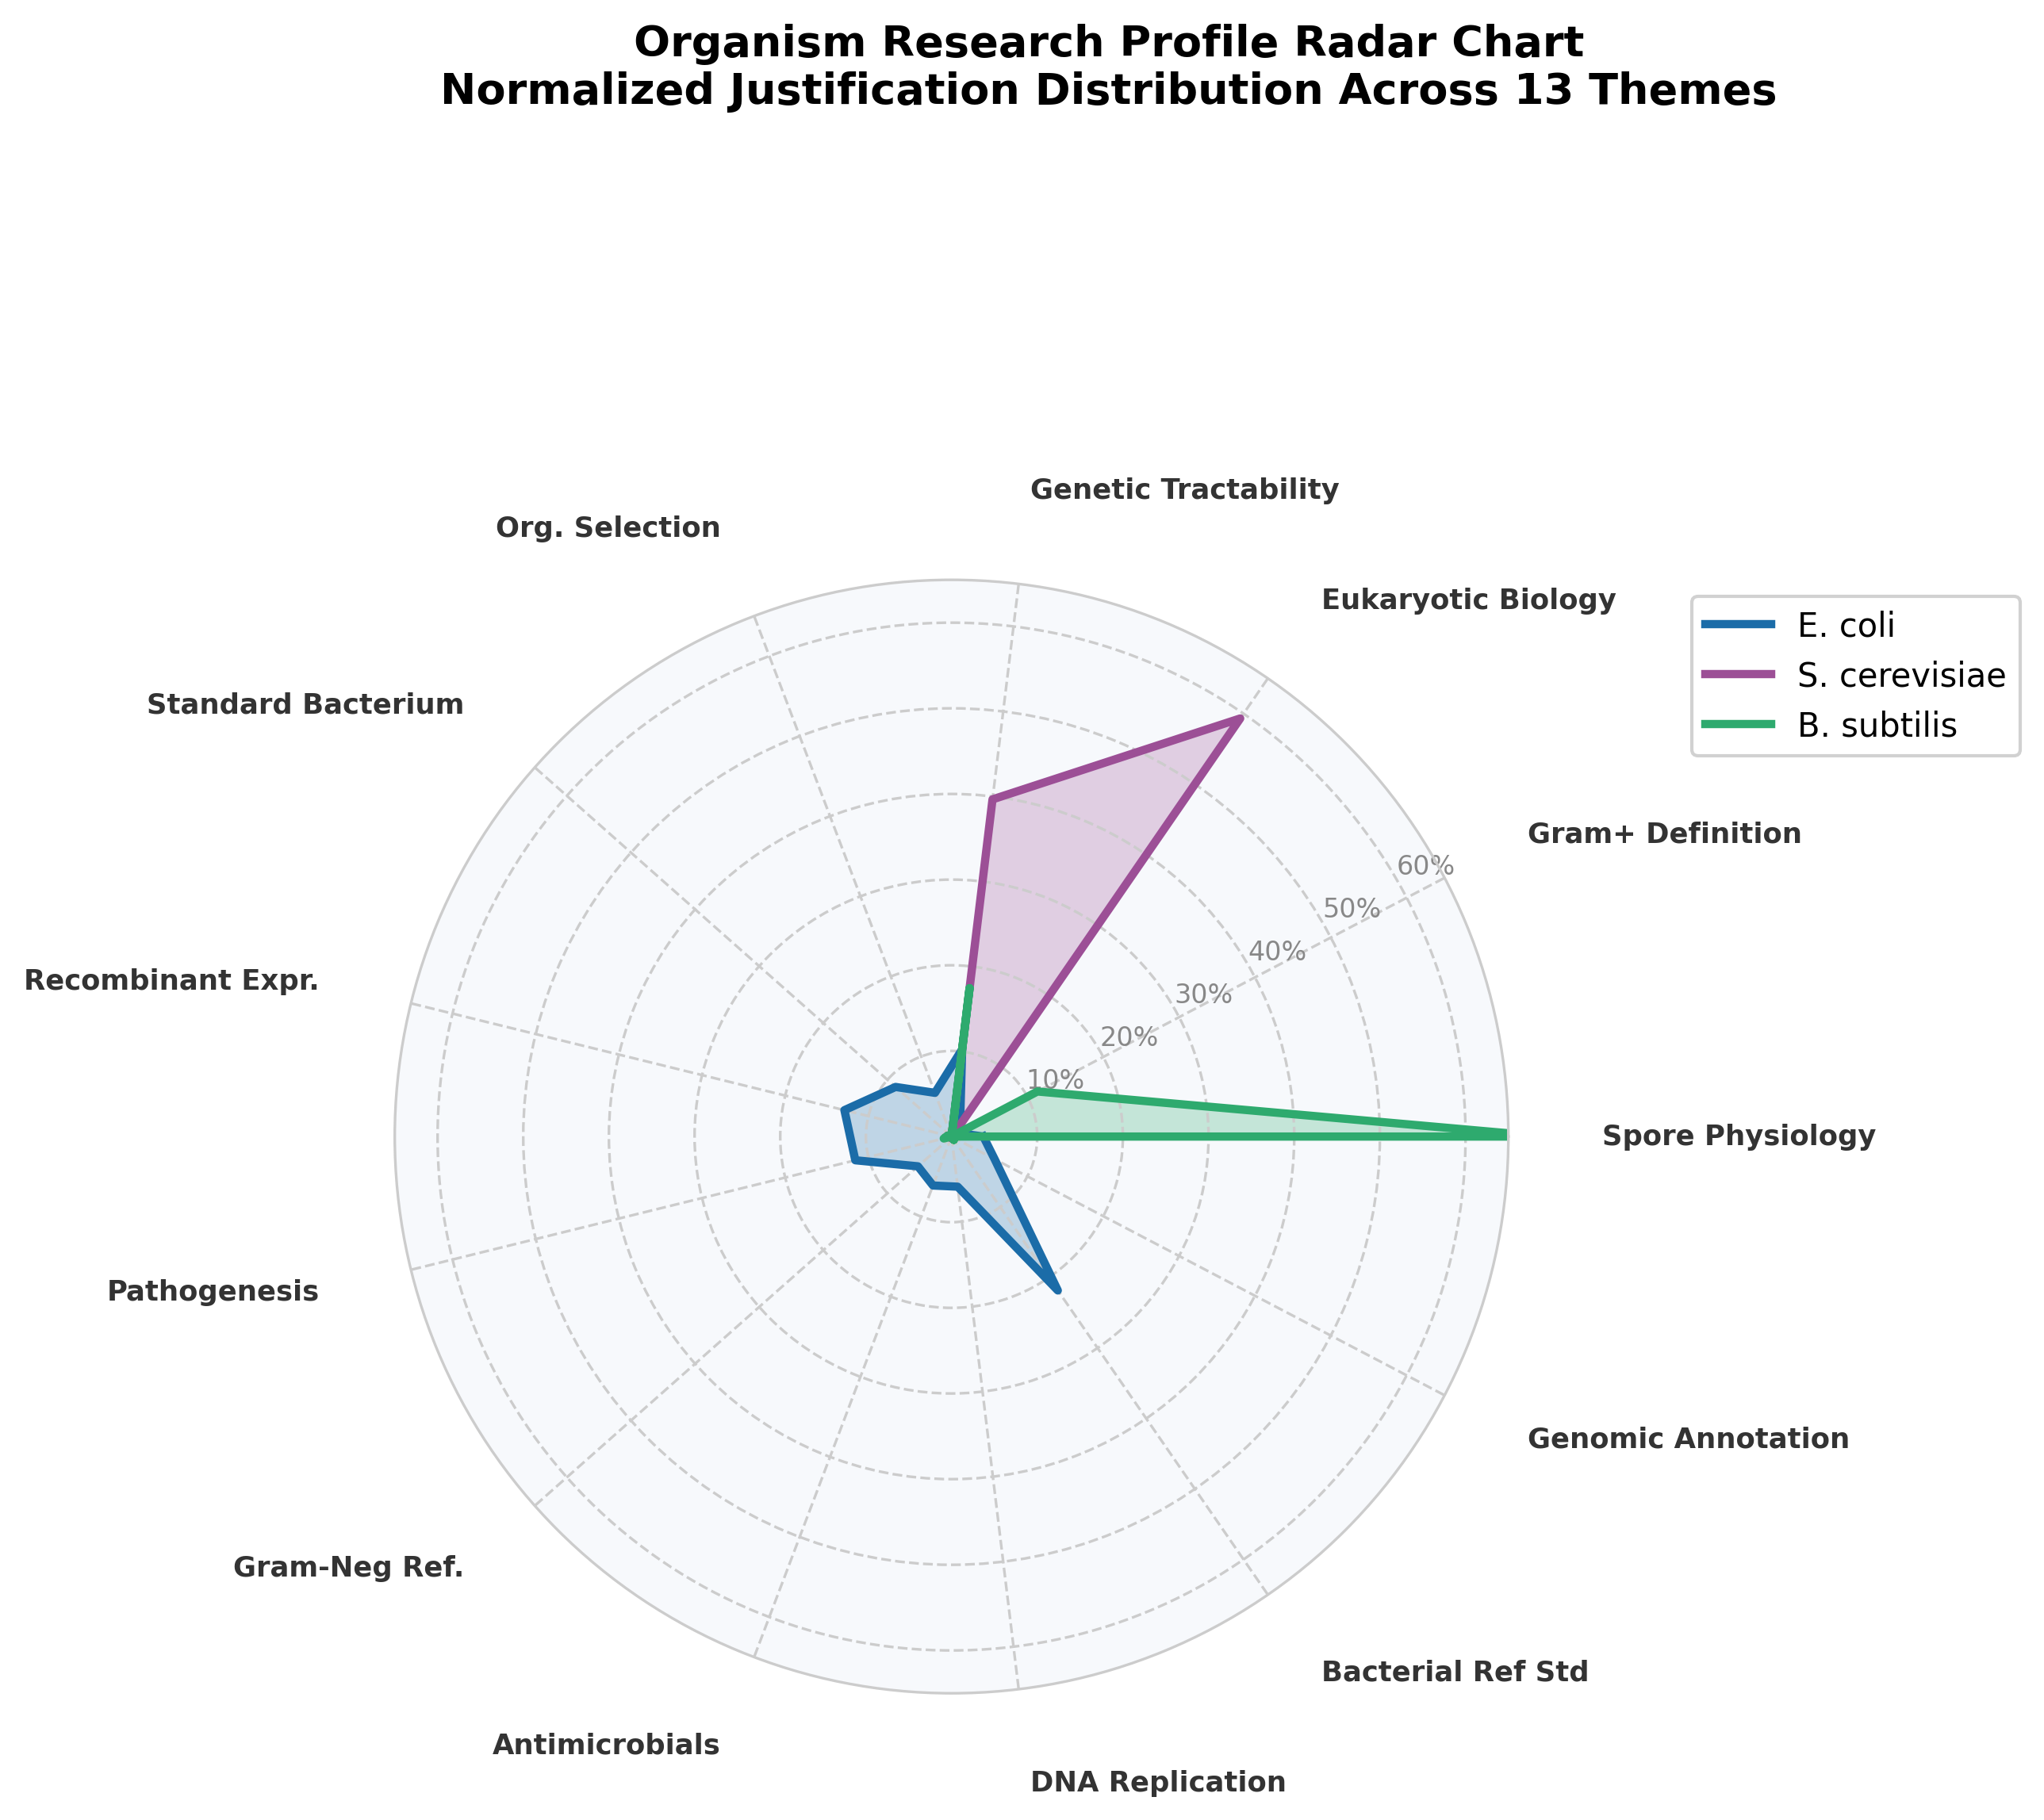
Figure 8: Radar chart — comparative organism justification profiles.
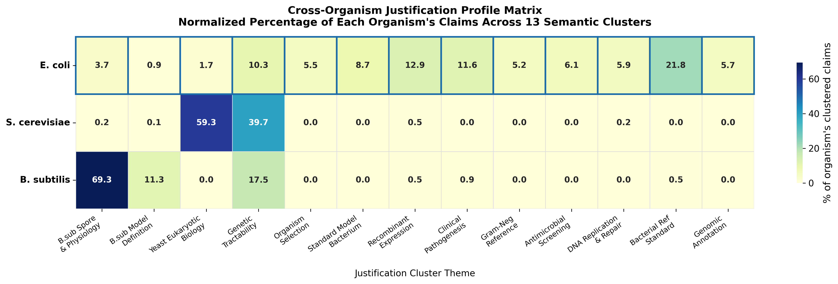
Figure 9: Cross-organism comparative matrix heatmap of normalized justification themes.

5. Discussion
The results of this study provide the first large-scale computational quantification of the biological, technical, and historical drivers underlying the premier status of Escherichia coli as a model microorganism. By analyzing 3,273 peer-reviewed publications spanning 35 years, this research transitions the traditional consensus surrounding E. coli's dominance from a qualitative academic assumption to a measurable, empirical phenomenon.

5.1 Biological vs. Institutional Drivers (RQ1: The Axiomatic Acceptance Gap)
The most striking finding of this study is the Axiomatic Acceptance Gap (presented in Section 4.2.2). In 61.6% of E. coli papers, authors felt no need to explicitly justify their choice of model organism, whereas authors using the eukaryotic control (S. cerevisiae) and the Gram-positive control (B. subtilis) left their model choices unjustified in only 31.2% and 32.4% of papers, respectively.
This quantitative disparity represents the computational proof that E. coli's premier status is not merely a reflection of ongoing biological utility, but is a deeply institutionalized paradigm. In the framework of Thomas Kuhn’s The Structure of Scientific Revolutions [4], E. coli has ascended to the level of "normal science" where its utility is an implicit baseline axiom. For the majority of researchers, E. coli is not an active choice; it is the default environment.
In contrast, researchers working with S. cerevisiae and B. subtilis operate within specialized niches that require them to continuously validate their selection—typically by citing eukaryotic homology or Gram-positive cell-wall physiology. The requirement for justification in over two-thirds of Yeast and Bacillus papers suggests these organisms are viewed as representative models for specific biological kingdoms or phyla, whereas E. coli is treated as the default, universal host of molecular biology. This cultural entrenchment means that institutional momentum (established protocols, commercial kits, historical legacy, and training familiarity) plays a role in E. coli's dominance that is quantitatively distinct from its controls.

5.2 Thematic Architecture and Niche Specialization (RQ2 & RQ4)
The unsupervised clustering of 2,037 explicit claims into 13 semantic clusters (Section 4.3) reveals the distinct conceptual structures underlying how the scientific community utilizes these models. The most significant architectural difference between E. coli and its controls lies in the breadth of justification.
S. cerevisiae and B. subtilis exhibit extreme niche specialization:
- Yeast Specialization: A remarkable 99.0% of S. cerevisiae justifications are compressed into just two themes: Eukaryotic Cell Biology (represented by Cluster 2 [7]: 59.3%) and Genetic Tractability & Industrial Cell Factories (represented by Cluster 3 [8]: 39.7%). This indicates that Yeast is almost exclusively justified as either a simplified surrogate for human disease/metabolic modeling or a genetic workhorse.
- Bacillus Specialization: Similarly, 98.1% of B. subtilis justifications are concentrated in three themes: Gram-Positive Physiology (represented by Cluster 0 [5]: 69.3%), Genetic Tractability (Cluster 3 [8]: 17.5%), and Gram-Positive Definition (represented by Cluster 1 [6]: 11.3%). Its primary utility is tightly bound to its role as the Gram-positive cell wall and sporulation paradigm.
Conversely, E. coli shows no such thematic restriction, distributing its justifications across nine distinct clusters (Clusters 4 to 12). Its profile is balanced, covering technical utilities like heterologous expression (represented by Cluster 6 [11]: 14.0% of E. coli claims), biological investigations like antimicrobial screening (represented by Cluster 9 [14]: 6.1%), clinical pathogenesis modeling (represented by Cluster 7 [12]: 12.0%), basic molecular genetics (represented by Cluster 10 [15]: 6.3%), and general bacterial reference standards (represented by Cluster 11 [16]: 22.1%). Additional clusters capture experimental selection rationale (Cluster 4 [9]), standard utility definitions (Cluster 5 [10]), envelope modeling (Cluster 8 [13]), and annotation reference (Cluster 12 [17]).
This comparative profile indicates that E. coli's premier status is supported by a multi-dimensional utility. It is simultaneously a tool (recombinant expression), a pathogen model (infectious disease), a basic biology model (replication and translation), and a genetic reference. E. coli remains the premier model because it has successfully straddled the boundary between being an object of biological inquiry in its own right and a universal tool for examining other organisms.

5.3 Historical Shifts and Technological Adaptation (RQ3)
The decade-stratified temporal analysis (Section 4.5) captures the evolution of molecular biology and genomics over the past 35 years. The trajectory of E. coli justifications highlights how technical breakthroughs rewrite the scientific literature.
The dramatic decline of DNA Replication, Recombination, and Repair justifications (Cluster 10 [15])—dropping from 20.6% in the 1990s to 2.5% in the 2020s—reflects a paradigm shift. In the 1990s, E. coli was the primary vehicle for dissecting basic central dogma mechanisms. Over the next three decades, these foundational mechanisms were largely resolved, and the focus of molecular genetics shifted to eukaryotic systems, leaving E. coli's replication machinery as textbook consensus rather than an active area of justification.
Similarly, the decline of Heterologous Protein Expression (Cluster 6 [11]) as an explicit justification from 44.1% in the 1990s to 12.6% in the 2020s does not indicate that researchers are using E. coli less for protein expression. Rather, it indicates normalization. In the 1990s, cloning and expressing a recombinant protein in E. coli was a major technical feat that required explicit methodological justification. Today, recombinant production in E. coli is an implicit, commercialized utility; it is treated as a routine preparation step (like pipetting or centrifugation) that no longer warrants explicit justification in an abstract.
Crucially, this technical decline was offset by the rise of the Bacterial Reference Standard theme (Cluster 11 [16]), which surged from 2.9% in the 1990s to 30.3% in the 2020s. The inflection point occurred in the late 1990s, aligning perfectly with the publication of the complete genome sequence of E. coli K-12 MG1655 in 1997 [3]. The availability of a fully annotated genome transformed E. coli from an experimental system into a digital and systems-biology reference point. It became the computational anchor for comparative genomics, metabolic modeling, and synthetic biology.

5.4 Systems Biology and Physical Pathway Anchors (RQ5)
By mapping the semantic justification clusters to physical biological pathways in KEGG and EcoCyc (Section 4.4), the text-mining findings are grounded in molecular reality. This mapping demonstrates that the justifications extracted by the LLM are biochemically and structurally sound.
E. coli's prominence is anchored in highly conserved, high-flux molecular machinery:
- Recombinant Protein Export: The frequent justification of E. coli for membrane translocation and secretion (Cluster 6 [11]) maps to the Sec translocon and Twin-Arginine Translocation (Tat) systems (eco03060). These pathways are the biological engines that enable industrial heterologous protein targeting, highlighting how E. coli's basic membrane biology directly supports its commercial and technical utility.
- Replication Fidelity: The structural justifications in Cluster 10 [15] map to the DNA polymerase III holoenzyme (eco03030), methyl-directed mismatch repair (eco03430), and the RecBCD homologous recombination pathway (eco03440). These systems represent the absolute historical baseline of molecular biology.
- Pathogenesis and Antimicrobial Targets: The clinical justification clusters (Clusters 7 [12] and 9 [14]) map to key bacterial structures, including lipid A biosynthesis (eco00540) and the AcrAB-TolC multidrug efflux pump. This shows that even in clinical pathogenesis, E. coli acts as the primary Gram-negative cell envelope model.
By bridging the gap between natural language justifications and database annotations, the literature-mining pipeline is shown to successfully capture the physical systems that make E. coli a tractable model. The premier status of E. coli is thus written both in scientific culture and in the biochemistry of its highly conserved replication, secretion, and envelope structures.

5.5 Limitations of the Study
While this study offers a robust computational framework, several limitations must be acknowledged:
- Abstract-Level Scope and Query Pre-Filtering: The literature search query deliberately pre-filtered for papers that explicitly mention "model" or "reference" status in their abstracts. This focus isolates the discourse where authors actively frame their work around the organism's model role. Crucially, the measured 61.6% "null" rate demonstrates that even when writers explicitly introduce E. coli as a model organism, they feel no need to justify why in the abstract, treating its utility as a self-evident truth. However, since the corpus is restricted to abstracts, authors may still elaborate on their rationale within the full-text Introduction or Methodology sections.
- Database Scoping: The queries relied on NCBI PubMed, which has an inherent bias toward biomedical, clinical, and molecular biology publications. While this aligns with where E. coli is most prominent, agricultural, ecological, and environmental studies of E. coli may be underrepresented.
- Language Bias: The corpus was restricted to English-language publications, reflecting global scientific communication standards but potentially omitting regional historical justifications.

5.6 Future Work
Future iterations of this computational microbiology framework should expand in three directions:
- Full-Text Literature Mining: Applying the LLM extraction pipeline to full-text articles (e.g., from PubMed Central) to compare abstract-level justifications with in-text methodological details, potentially refining the resolution of the axiomatic acceptance rate.
- Citation Network Integration: Graphing the semantic clusters against citation networks to analyze whether specific justification themes (such as the 1997 genomic sequencing) drive disproportionately higher citation rates or shape subsequent sub-disciplines.
- Expansion to Emerging Models: Applying this pipeline to newer or emerging model systems (e.g., Pseudomonas putida for industrial biotechnology or Vibrio natriegens for rapid growth mechanics) to track how and when new models begin to challenge E. coli's multi-decade institutional dominance.

6. Conclusion
This study has established a quantitative, data-driven framework to evaluate the biological, technical, and historical drivers behind Escherichia coli's premier status as a model microorganism. By applying large language model-augmented claim extraction and unsupervised semantic clustering to 3,273 publications, the conceptual architecture that defines how the scientific community justifies model organism selection has been mapped.
The findings from this study reveal that E. coli's dominance is sustained by a unique combination of institutionalization and multi-dimensional utility. The discovery of the Axiomatic Acceptance Gap—where nearly two-thirds of E. coli papers contain no explicit justification compared to less than a third for eukaryotic and Gram-positive controls—proves that the bacterium operates as a self-evident axiom in molecular biology. Unlike Yeast and Bacillus, which are specialized niche models restricted to representing eukaryotic cellular pathways or Gram-positive spore-forming physiology, E. coli exhibits a balanced, general-purpose profile distributed across nine distinct research themes.
Temporally, this analysis captures a major paradigm shift. Over the past 35 years, foundational justifications related to basic DNA replication and recombination have declined, and heterologous protein expression has transitioned from an active area of justification (44.1% in the 1990s) into an implicit utility (12.6% in the 2020s). This technical normalization has been balanced by the continuous rise of E. coli as the definitive bacterial reference standard (rising from 2.9% to 30.3%), catalyzed by the completion of its genome sequence in 1997. Mapped biological annotations confirm that these justifications are anchored in physical, highly conserved cellular machineries (e.g., DNA polymerase III, Sec/Tat translocons, and the AcrAB-TolC efflux pump).
Beyond microbiology, this work demonstrates the power of computational epistemology. Combining LLM-based zero-shot extraction with semantic vector spaces provides a scalable methodology for identifying the "unspoken consensus" and historical trajectories that shape scientific fields. As biology moves toward non-model systems and synthetic hosts, the computational framework developed here offers a template to track, evaluate, and direct the evolution of future model systems.

7. References
- Escherich, T. (1885). Die Darmbacterien des Säuglings und ihre Beziehungen zur Physiologie der Verdauung. Fortschritte der Medizin, 3, 515–522.
- Lederberg, J., & Tatum, E. L. (1946). Gene recombination in Escherichia coli. Nature, 158(4016), 558. PMID: 21006547.
- Blattner, F. R., Plunkett, G., Bloch, C. A., Perna, N. T., Burland, V., Riley, M., Collado-Vides, J., Glasner, J. D., Rode, C. K., Mayhew, G. F., Gregor, J., Davis, N. W., Kirkpatrick, H. A., Goeden, M. A., Rose, D. J., Mau, B., & Guyer, M. S. (1997). The complete genome sequence of Escherichia coli K-12. Science, 277(5331), 1453-1462. PMID: 9278503.
- Kuhn, T. S. (1962). The Structure of Scientific Revolutions. University of Chicago Press.
- Vohradsky, J. (2024). Quantitative Aspect of Bacillus subtilis sigma(B) Regulatory Network on a Proteome Level-A Computational Simulation. Biology (Basel), 13(8), 552. PMID: 39194552.
- Chen, P., Yan, L., Wu, Z., Li, S., Bai, Z., Yan, X., Wang, N., Liang, N., & Li, H. (2016). A microbial transformation using Bacillus subtilis B7-S to produce natural vanillin from ferulic acid. Scientific Reports, 6, 26841. PMID: 26841717.
- Sung, H. M., Wang, T. Y., Wang, D., Huang, Y. S., Wu, J. P., Tsai, H. K., Tzeng, J., Huang, CJ., Lee, Y. C., Yang, P., Hsu, J., Chang, T., Cho, C. Y., Weng, L. C., Lee, T. C., Chang, T. H., Li, W. H., & Shih, M. C. (2009). Roles of trans and cis variation in yeast intraspecies evolution of gene expression. Molecular Biology and Evolution, 26(9), 2097-2107. PMID: 19648464.
- Otto, M., Liu, D., & Siewers, V. (2022). Saccharomyces cerevisiae as a Heterologous Host for Natural Products. Methods in Molecular Biology, 2489, 213-231. PMID: 35524059.
- Le Rhun, A., Tourasse, N. J., Bonabal, S., Iost, I., Boissier, F., & Darfeuille, F. (2023). Profiling the intragenic toxicity determinants of toxin-antitoxin systems: revisiting hok/Sok regulation. Nucleic Acids Research, 51(5), 2134-2148. PMID: 36271796.
- Cote, J. P., French, S., Gehrke, S. S., MacNair, C. R., Mangat, C. S., Bharat, A., & Brown, E. D. (2016). The Genome-Wide Interaction Network of Nutrient Stress Genes in Escherichia coli. mBio, 7(6), e01814-16. PMID: 27879333.
- Nolden, L., Peitz, M., Peitz Peitz, M., & Brüstle, O. (2007). Stem cell engineering using transducible Cre recombinase. Methods in Molecular Medicine, 129, 35-48. PMID: 18085201.
- Sakellaris, H., Munson, G. P., & Scott, J. R. (1999). A conserved residue in the tip proteins of CS1 and CFA/I pili of enterotoxigenic Escherichia coli that is essential for adherence. Proceedings of the National Academy of Sciences of the United States of America, 96(22), 12828-12833. PMID: 10536007.
- Yang, J., Kim, Y. K., Kang, T. S., Jee, Y. K., & Kim, Y. Y. (2017). Importance of indoor dust biological ultrafine particles in the pathogenesis of chronic inflammatory lung diseases. Environmental Health and Toxicology, 32, e2017012. PMID: 29161804.
- Bie, L., Zhang, M., Wang, J., Fang, M., Li, L., Xu, H., & Wang, M. (2023). Comparative Analysis of Transcriptomic Response of Escherichia coli K-12 MG1655 to Nine Representative Classes of Antibiotics. Microbiology Spectrum, 11(2), e03685-22. PMID: 36853057.
- Fijalkowska, I. J., Schaaper, R. M., & Jonczyk, P. (2012). DNA replication fidelity in Escherichia coli: a multi-DNA polymerase affair. FEMS Microbiology Reviews, 36(6), 1105-1121. PMID: 22404288.
- A Ghomi, F., Jung, J. J., Langridge, G. C., Cain, A. K., Boinett, C. J., Abd El Ghany, M., Pickard, D. J., Kingsley, R. A., Thomson, N. R., Parkhill, J., Gardner, P. P., & Barquist, L. (2024). High-throughput transposon mutagenesis in the family Enterobacteriaceae reveals core essential genes and rapid turnover of essentiality. mBio, 15(3), e03920-23. PMID: 39207104.
- Knoke, L. R., Muskietorz, M., Kuhn, L., & Leichert, L. I. (2025). The ABC transporter Opp imports reduced glutathione, while Gsi imports glutathione disulfide in Escherichia coli. Redox Biology, 79, 103968. PMID: 39689618.
- Ankeny, R. A., & Leonelli, S. (2011). What's so special about model organisms?. Studies in History and Philosophy of Science Part A, 42(2), 313–323.
- Creager, A. N. (2002). The Life of a Virus: Tobacco mosaic virus as an experimental model. University of Chicago Press.
- Weber, M. (2005). Philosophy of Experimental Biology. Cambridge University Press.

