# **WooCommerce Filters**

(Documentation)

**Changing plugin details:**

To change the plugin details go to ***woo-filter-tax.php*** and edit following block of comment as per need.

|  |
| --- |
| /**  * Plugin Name: WooCommerce Filters  * Description: WooCommerce tax filter plugin  * Plugin URI: http://racase.com  * Author: caffenix  * Author URI: http://racase.com  * Version: 1.0  * License: GPL2  * Text Domain: woo-filter-tax  * Domain Path: /languages/  */ |

**Adding filters:**

After activating plugin, go to ***WooCommerce > Filters***. There will be list of previously added filter.

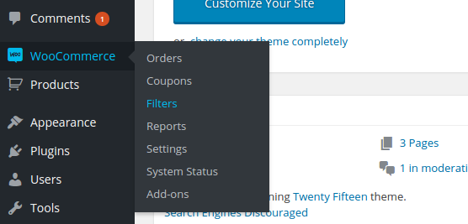

This page will list all the filter.

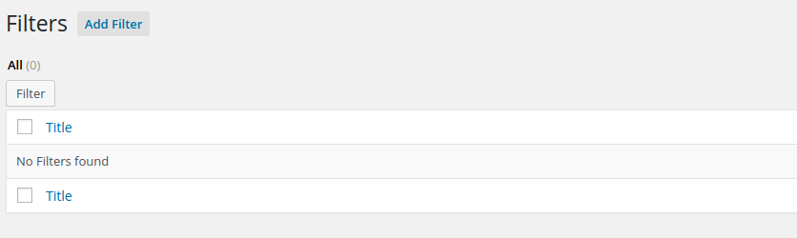

Click ***Add Filter*** button to add filter.

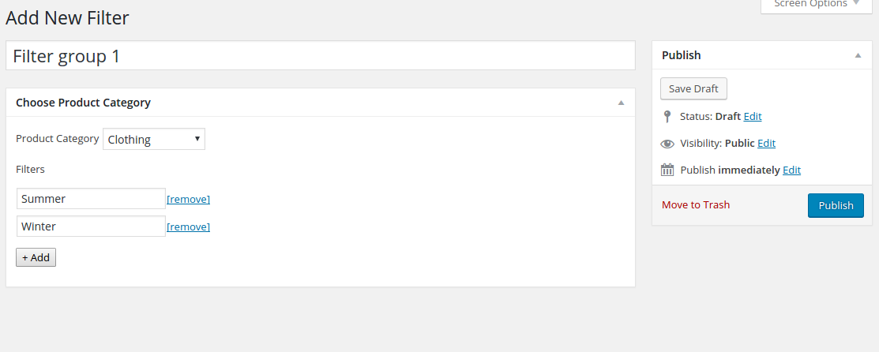

* Give title to filter so that it would be helpful to recognize later.
* Choose WooCommerce category to add filter types on it.
* Click ***+ Add*** button to add filter types.
* Filter can be removed from ***[remove]*** link.
* Click ***Publish*** button to save.

Once it gets published it will be redirected to edit page.

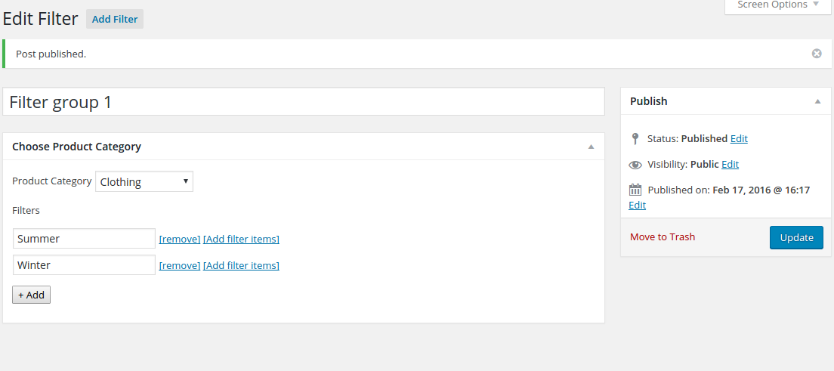

On the edit page click ***[Add filter items]*** link to add the filter items for the filter type. It will take to filter item listing page.

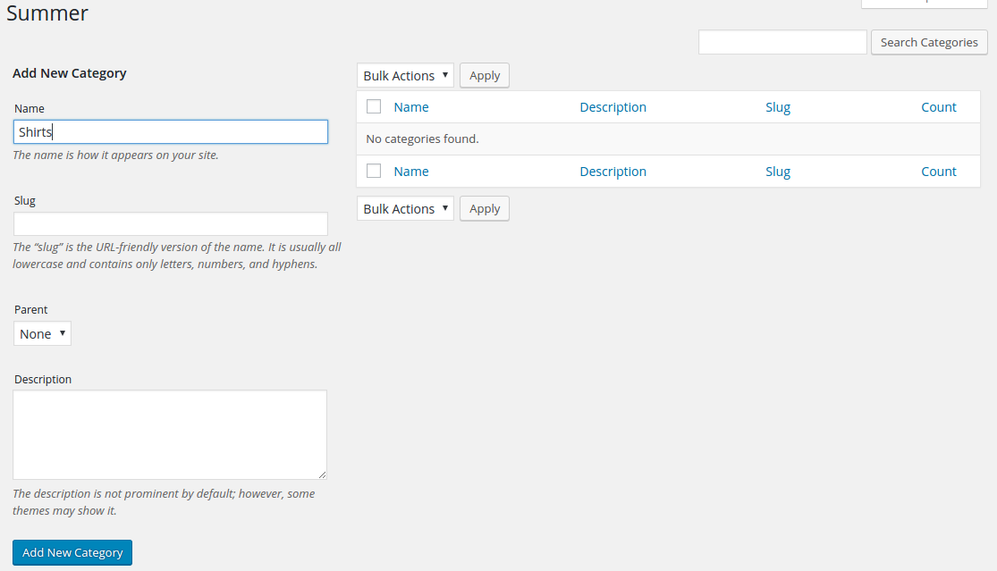

* Add name for the filter item and save it.

Now you filter items are saved we will add/ edit product.

**Note:**

Each time you add a new filter item. Settings > Permalink needs to be updated to get the archive link to the item. It’s a defect of WordPress which needs manual update of permalink.

**Adding filters to product:**

Go to ***Products > Add product*** to add new product.

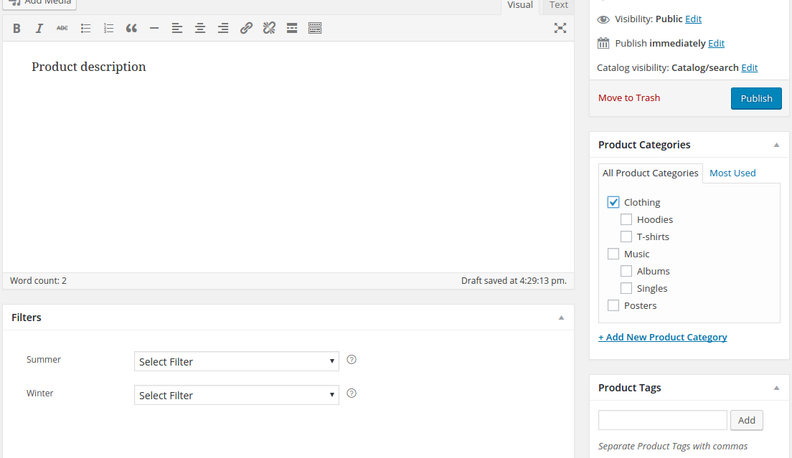

After checking category from right section, filter will be listed on the left section ***Filters*** box. Select filters to the products and click publish.

**Note:**

If products are already added (Before adding this plugin) and category are selected you might need to uncheck and check the category to make filters appear.

Now that you have added product and its filter. To add filter option in front end. Go to **Appearance > Widgets**.There is a widget name “WFT Widget”, drag it to any widget area.

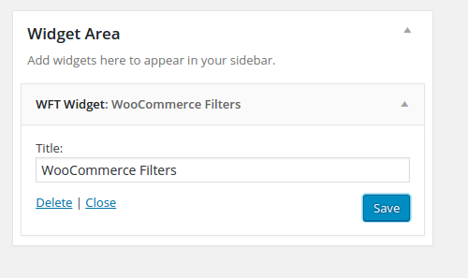

On front end will be shown on respective sidebar.

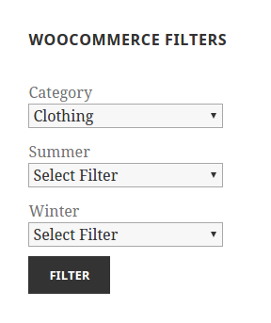

Additionally, filters will be shown on product detail page.

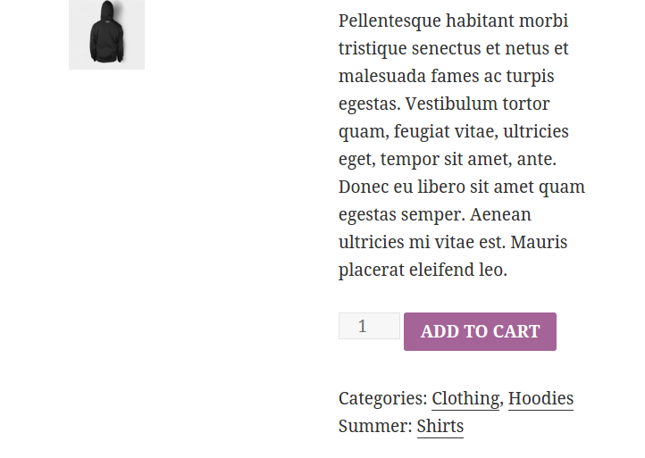

Just in case you want to remove it use following code on theme or plugin.

|  |
| --- |
| remove_action( 'woocommerce_single_product_summary', 'wft_show_filter', 45 ); |