Laboratory Exercise No. 4
Single-Layer Perceptron
Learning the AND and OR Truth Tables from Scratch

Ken Cedrick Jimeno
CSci 141 — Intelligent Systems
November 10, 2026

Table of Contents
Introduction 2
Program Execution Flow 3
Training Trace 4
Console Output 6
Link to Program Files 7

Introduction
This laboratory exercise implements a single-layer perceptron that learns the AND and OR logical functions. The program builds the neuron, the training loop, and the training trace from first principles, using only the Python standard library, so that every weight adjustment can be inspected by hand instead of taken on trust.
A perceptron is the simplest trainable classifier. It forms a weighted sum of its inputs, adds a bias, and passes the result through a step activation function. Learning is error-driven: after each training sample the weights move in the direction that reduces the difference between the target and the prediction. Because the correction uses only the current sample, the method is an example of online, or stochastic, gradient descent on a perceptron loss.
The model and its learning rule are as follows:
net = w1 * A + w2 * B + bias
prediction = 1 if net >= 0, otherwise 0
error = target - prediction
w1 = w1 + learning_rate * error * A
w2 = w2 + learning_rate * error * B
bias = bias + learning_rate * error

A net input of exactly zero predicts class 1, so the decision boundary belongs to the positive class. Both target functions are linearly separable: a single straight line in the input plane separates the positive from the negative examples. AND has one positive case, (1,1), while OR has three. Because both are separable, one neuron with two inputs is sufficient and training is guaranteed to terminate.
Table 1. Truth tables for the two target functions.
A | B | AND | OR
0 | 0 | 0 | 0
0 | 1 | 0 | 1
1 | 0 | 0 | 1
1 | 1 | 1 | 1

Each gate is trained from scratch. Weights and bias start at zero, the four samples are visited in the fixed order (0,0), (0,1), (1,0), (1,1), and the learning rate is 1 unless it is overridden on the command line. An epoch that produces no mistakes is treated as confirmation of convergence, and the confirmation epoch is included in the reported count.

Program Execution Flow
The implementation is one module with a pure training core and a thin command-line wrapper. A run proceeds through the following steps.
1. Parse the gate (and, or, both), the learning rate, and the epoch limit.
2. Validate the inputs: the gate must be known, the rate must be finite and positive, and at least one epoch must be allowed.
3. Initialise the weights and bias to zero and create a fresh trace for each requested gate.
4. For each sample, compute the net input and the prediction before any update.
5. Compute the error as target minus prediction, then update w1, w2, and the bias.
6. Record the step: the sample, the pre-update prediction, and the post-update parameters.
7. Repeat until a complete epoch contains no mistakes, or until the epoch limit is reached.
8. Print the trace, then re-evaluate all four input pairs with the final parameters.
9. Exit with status 0 if every requested gate converged, or 1 otherwise.
Two design choices keep the code testable. The train() function is pure: it takes a gate and the hyperparameters, returns an immutable TrainingResult, and prints nothing. The format_result() function owns all presentation, so the trace can be verified independently of how it is displayed.
The program is run from the repository root:
python perceptron_lab4.py --gate both
Table 2. Command-line options.
Option | Default | Description
--gate | both | Function to learn: and, or, or both.
--learning-rate | 1.0 | Positive step size for every update.
--max-epochs | 100 | Maximum passes over the training set.

A mistake-free epoch is required because one clean sample says nothing about the other three; rows with zero error appear inside epochs that still contain mistakes. The epoch limit exists so that a non-separable target, or an unfortunate learning rate, cannot loop forever. Reaching the limit is reported in the output and produces a non-zero exit status.

Training Trace
Each row below is one sample. The net input, prediction (Pred), and error are computed before the update; w1, w2, and bias are shown after it. Ep is the epoch number and T is the target. A non-zero error is what triggers learning, so rows with E = 0 leave the parameters unchanged.
Table 3. Complete training trace for the AND gate (24 updates over 6 epochs).
Ep | A | B | T | Net | Pred | Error | w1 | w2 | Bias
1 | 0 | 0 | 0 | 0 | 1 | -1 | 0 | 0 | -1
1 | 0 | 1 | 0 | -1 | 0 | 0 | 0 | 0 | -1
1 | 1 | 0 | 0 | -1 | 0 | 0 | 0 | 0 | -1
1 | 1 | 1 | 1 | -1 | 0 | 1 | 1 | 1 | 0
2 | 0 | 0 | 0 | 0 | 1 | -1 | 1 | 1 | -1
2 | 0 | 1 | 0 | 0 | 1 | -1 | 1 | 0 | -2
2 | 1 | 0 | 0 | -1 | 0 | 0 | 1 | 0 | -2
2 | 1 | 1 | 1 | -1 | 0 | 1 | 2 | 1 | -1
3 | 0 | 0 | 0 | -1 | 0 | 0 | 2 | 1 | -1
3 | 0 | 1 | 0 | 0 | 1 | -1 | 2 | 0 | -2
3 | 1 | 0 | 0 | 0 | 1 | -1 | 1 | 0 | -3
3 | 1 | 1 | 1 | -2 | 0 | 1 | 2 | 1 | -2
4 | 0 | 0 | 0 | -2 | 0 | 0 | 2 | 1 | -2
4 | 0 | 1 | 0 | -1 | 0 | 0 | 2 | 1 | -2
4 | 1 | 0 | 0 | 0 | 1 | -1 | 1 | 1 | -3
4 | 1 | 1 | 1 | -1 | 0 | 1 | 2 | 2 | -2
5 | 0 | 0 | 0 | -2 | 0 | 0 | 2 | 2 | -2
5 | 0 | 1 | 0 | 0 | 1 | -1 | 2 | 1 | -3
5 | 1 | 0 | 0 | -1 | 0 | 0 | 2 | 1 | -3
5 | 1 | 1 | 1 | 0 | 1 | 0 | 2 | 1 | -3
6 | 0 | 0 | 0 | -3 | 0 | 0 | 2 | 1 | -3
6 | 0 | 1 | 0 | -2 | 0 | 0 | 2 | 1 | -3
6 | 1 | 0 | 0 | -1 | 0 | 0 | 2 | 1 | -3
6 | 1 | 1 | 1 | 0 | 1 | 0 | 2 | 1 | -3

The AND gate converges in 6 epochs. Its final model is net = 2A + 1B + (-3), which predicts 0 for every input except (1,1). The complete trace is reproduced in Table 3 so that each update can be checked against the learning rule.
Table 4. Final truth table for the AND gate.
A | B | Target | Net | Prediction | Result
0 | 0 | 0 | -3 | 0 | PASS
0 | 1 | 0 | -2 | 0 | PASS
1 | 0 | 0 | -1 | 0 | PASS
1 | 1 | 1 | 0 | 1 | PASS

Table 5. Complete training trace for the OR gate (16 updates over 4 epochs).
Ep | A | B | T | Net | Pred | Error | w1 | w2 | Bias
1 | 0 | 0 | 0 | 0 | 1 | -1 | 0 | 0 | -1
1 | 0 | 1 | 1 | -1 | 0 | 1 | 0 | 1 | 0
1 | 1 | 0 | 1 | 0 | 1 | 0 | 0 | 1 | 0
1 | 1 | 1 | 1 | 1 | 1 | 0 | 0 | 1 | 0
2 | 0 | 0 | 0 | 0 | 1 | -1 | 0 | 1 | -1
2 | 0 | 1 | 1 | 0 | 1 | 0 | 0 | 1 | -1
2 | 1 | 0 | 1 | -1 | 0 | 1 | 1 | 1 | 0
2 | 1 | 1 | 1 | 2 | 1 | 0 | 1 | 1 | 0
3 | 0 | 0 | 0 | 0 | 1 | -1 | 1 | 1 | -1
3 | 0 | 1 | 1 | 0 | 1 | 0 | 1 | 1 | -1
3 | 1 | 0 | 1 | 0 | 1 | 0 | 1 | 1 | -1
3 | 1 | 1 | 1 | 1 | 1 | 0 | 1 | 1 | -1
4 | 0 | 0 | 0 | -1 | 0 | 0 | 1 | 1 | -1
4 | 0 | 1 | 1 | 0 | 1 | 0 | 1 | 1 | -1
4 | 1 | 0 | 1 | 0 | 1 | 0 | 1 | 1 | -1
4 | 1 | 1 | 1 | 1 | 1 | 0 | 1 | 1 | -1

The OR gate converges in 4 epochs. Its final model is net = 1A + 1B + (-1), which predicts 1 whenever at least one input is 1.
Table 6. Final truth table for the OR gate.
A | B | Target | Net | Prediction | Result
0 | 0 | 0 | -1 | 0 | PASS
0 | 1 | 1 | 0 | 1 | PASS
1 | 0 | 1 | 0 | 1 | PASS
1 | 1 | 1 | 1 | 1 | PASS

Table 7. Summary of training results.
Gate | Epochs | w1 | w2 | Bias | Accuracy
AND | 6 | 2 | 1 | -3 | 4 / 4
OR | 4 | 1 | 1 | -1 | 4 / 4

Both gates converge far below the 100-epoch default and all eight final predictions pass. Convergence is checked per epoch rather than per sample: the first AND epoch, for example, contains three error-free rows but still ends with a mistake, so a single clean sample is not sufficient evidence that learning is complete.

Console Output
The screenshots below capture the program's console output for the AND gate: the complete training trace, then the convergence summary and final truth-table verification.
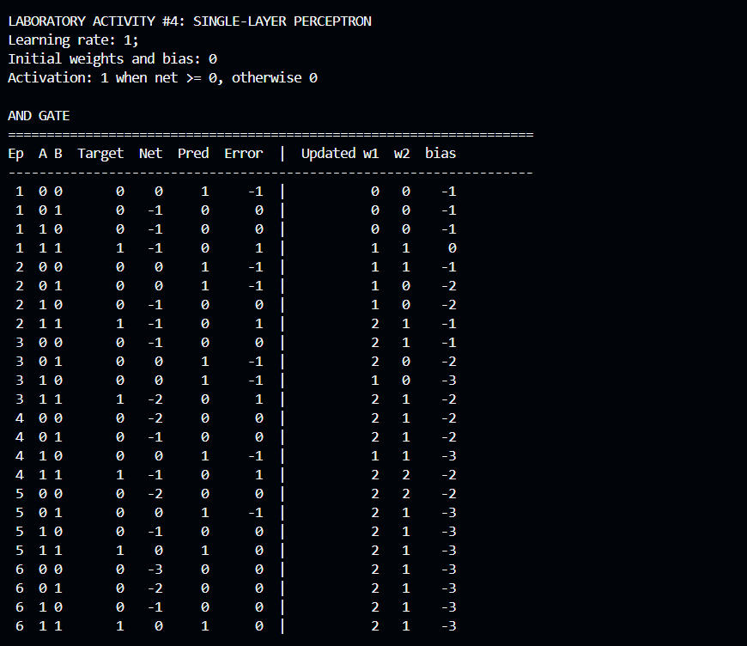
Figure 1. Complete AND training trace as printed by the program.
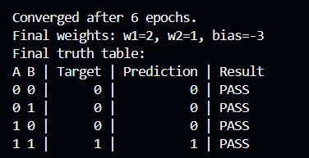
Figure 2. Convergence summary and final AND truth table.

Link to Program Files
The complete source code, this report, the captured console output, and a README are published in a public GitHub repository. The links below point to the repository and to the individual files.
• Repository: https://github.com/devcedrick/single-layer-perceptron-lab4
• Source code: https://github.com/devcedrick/single-layer-perceptron-lab4/blob/main/perceptron_lab4.py
• Training console output: https://github.com/devcedrick/single-layer-perceptron-lab4/blob/main/perceptron_console_output.txt
• README: https://github.com/devcedrick/single-layer-perceptron-lab4/blob/main/README.md
• This report: https://github.com/devcedrick/single-layer-perceptron-lab4/blob/main/Perceptron_Lab4_Documentation.docx
The program requires Python 3.10 or newer and no third-party packages. To reproduce the traces in this report, clone the repository and run the following command from its root.
python perceptron_lab4.py --gate both
Prepared by Ken Cedrick Jimeno for CSci 141 — Intelligent Systems.

