MISMANAGED PLASTIC WASTE ANANLYSIS

( WORLD-WIDE )

**1. INTRODUCTION :**

Plastic is one of the most useful materials around, but its proliferating use has created a ballooning heap of plastic waste , with more than 350 million tonnes generated each year . Not all the plastic waste that has been generated get recycled and reused properly, a major part of the waste get mismanaged , meaning it is dumped and littered without any proper management.

Asian countries account for the majority of global mismanaged plastic waste, in which india and china are topmost countries. Plastic waste has many negative implications for the environment, as it takes hundreds of years to decompose. On land, it threatens the quality of the soil and the ecosystem

and burning of plastic releases many toxins into the air , aquatic life is also severely affected by dumping of plastic waste into the oceans.

If current trend of generating mismanaged plastic waste continues, over 12 billion tonnes of plastic waste is expected to end up in landfills by 2050.

**2.**  **METHOD AND MATERIAL :**

In this project, we are going to analyse the mismanaged plastic waste produced all over the world in total and per capita in the year 2010 and 2019 and will compare the data of both years on various aspects and observe the trend , after that full conclusion will be given.

Different steps that we are going to follow in order to accomplish are goal are : -

* Data acquisition
* Data pre-processing
* Data analysis
* Data Visualisation
* Conclusion

Each phase will have some tasks and deliverables.

In order to achieve all this we are going to use various tools and libraries, and these are -

• Language :

PYTHON - Python is a High-level-purpose programming language. It’s design philosophy emphasises code readability with the use of significant indentation. We are going to use python extensively for our project.

• Tools :

JUPYTER NOTEBOOK - Jupyer notebook is an open source IDE and web based interactive computing platform. The notebook combines live code, narrative text and visualisations. It support various languages that are popular in data science like python, Julia, Scala, R etc.

MICROSOFT EXCEL - Microsoft Excel is spreadsheet tool that features calculations or computation capabilities, graphing tools, pivot tables etc.

• Libraries :

NUMPY - It is a python library used for scientific computation in python and work with arrays. It also has functions for working with linear algebra and matrices.

PANDAS - It is written for python fro data manipulation and analysis, it offers data structures and operations for manipulating numerical tables and time series.

MATPLOTLIB - It is plotting library for the python and its numerical extension Numpy. It provides an object oriented API for embedding plots and visualise data.

**3.**  **ALGORITHM :**

1. Importing the essential packages.
2. Reading the data into their designated variables.
3. Getting insights of data using pandas.
4. Comparing and plotting total waste by countries in 2019 and 2010 using stem chart.
5. Comparing and plotting total waste per capita by countries in 2019 and 2010 using stem chart.
6. Plotting bar graphs of 2019 and 2010 trend data values.
7. Plotting bubble chart of data containing ocean dump values by all countries.
8. Comparing GDP of year 2019 and 2010 using bubble chart.
9. Concluding result and observations.

**4.** **PROPOSED SYSTEM :**

We proposed that we will build a data visualisation project with Python and it’s libraries. Analyse various parameters like -

1. Maximum waste produce by a country in million tonnes in year 2019 and 2010.
2. Maximum mismanaged plastic waste produced per capita by a country in kg per year in year 2019 and 2010.
3. Maximum increase in generation of mismanaged plastic waste by top 5 countries from 2010 to 2019.
4. Compre GDP per capita of all countries in year 2019 and 2010 .
5. Average waste produced by countries per capita and in total in year 2019 and 2010.
6. Top 5 countries dumping plastic waste into ocean .

**5.** **RESULT :**

At the end of all procedure we get to see different graphs using unbelievable insights .

We have plotted different graphs as mentioned below:

a) Maximum waste produce by a country in million tonnes in year 2019 and 2010.

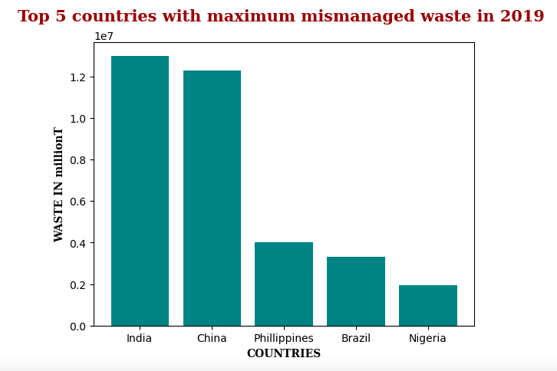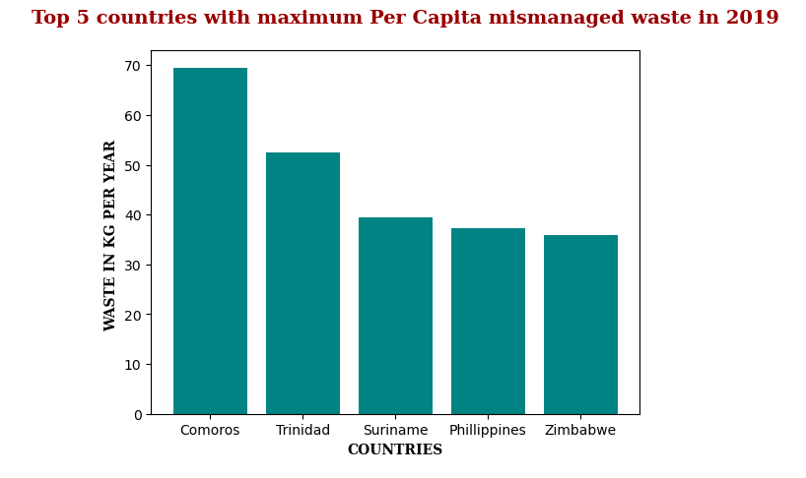

b) Maximum mismanaged plastic waste produced per capita by a country in kg per year in year 2019 and 2010.

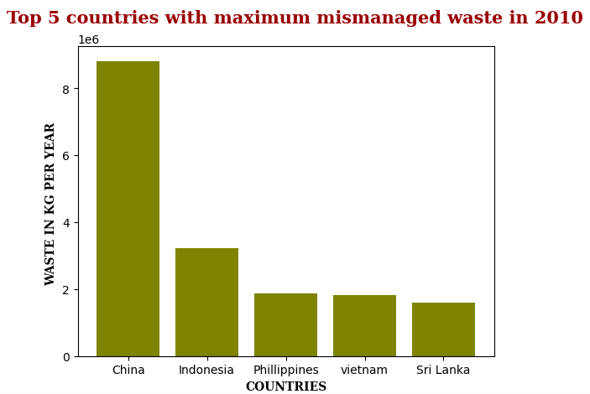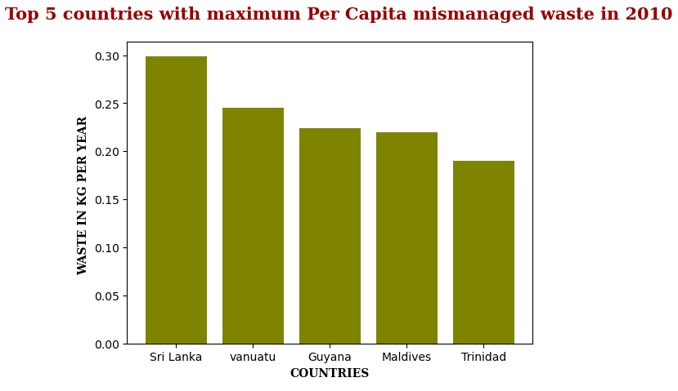

c) Maximum increase in generation of mismanaged plastic waste by top 5 countries from 2010 to 2019.

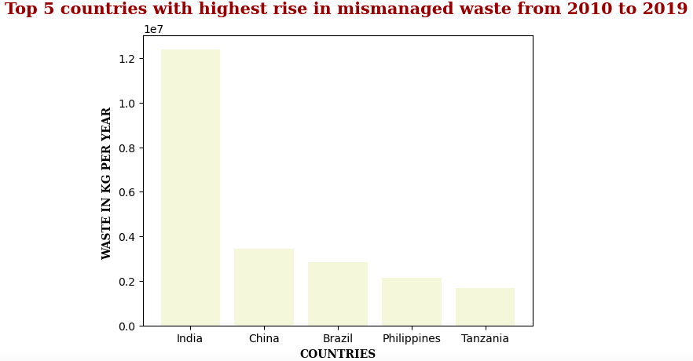

d) Compare GDP per capita of all countries in year 2019 and 2010 .

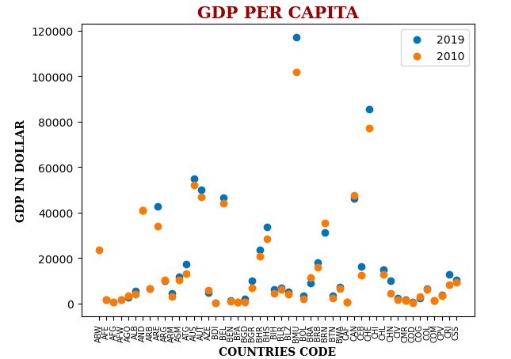

e) Top 5 countries dumping plastic waste into ocean

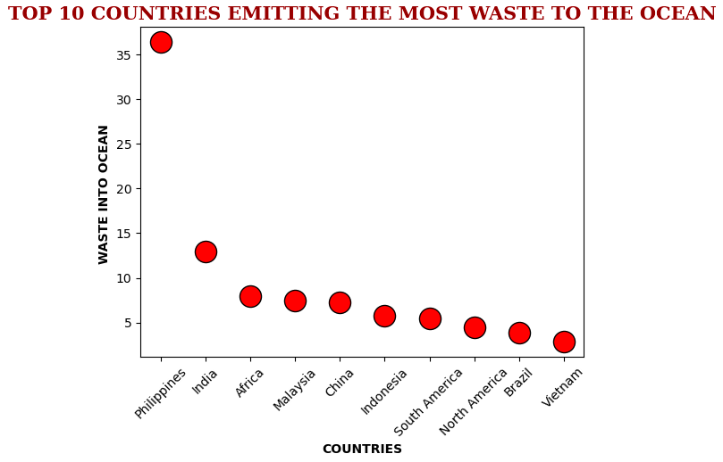

**6.** **CONCLUSION:**

At the end of this Mismanaged Plastic waste analysis with python project, we studied how to create data visualisations. We used different libraries of python like pandas, numpy, matplotlib that helped us in data manipulation and filtering of dataset of different years.

With this we conclude how Mismanaged plastic waste affect our environment and human health and what are the different measures that one can take in order to minimise plastic waste.