**What is Azure Synapse Analytics?**

**Azure Synapse** is an enterprise analytics service that accelerates time to insight across data warehouses and big data systems. Azure Synapse brings together the best of **SQL** technologies used in enterprise data warehousing, **Spark** technologies used for big data, **Data Explorer** for log and time series analytics, **Pipelines** for data integration and ETL/ELT, and deep integration with other Azure services such as **Power BI**, **CosmosDB**, and **AzureML**.

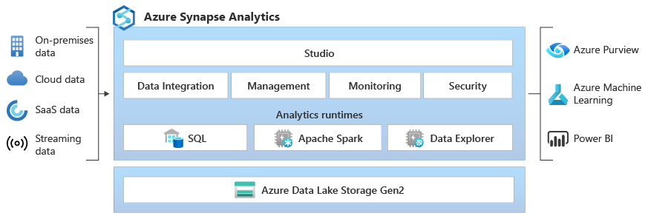

## Industry-leading SQL

**Synapse SQL** is a distributed query system for T-SQL that enables data warehousing and data virtualization scenarios and extends T-SQL to address streaming and machine learning scenarios.

* Synapse SQL offers both **serverless** and **dedicated** resource models. For predictable performance and cost, create dedicated SQL pools to reserve processing power for data stored in SQL tables. For unplanned or bursty workloads, use the always-available, serverless SQL endpoint.
* Use built-in **streaming** capabilities to land data from cloud data sources into SQL tables
* Integrate AI with SQL by using **machine learning** models to score data using the T-SQL PREDICT function

## Working with your Data Lake

Azure Synapse removes the traditional technology barriers between using SQL and Spark together. You can seamlessly mix and match based on your needs and expertise.

* Tables defined on files in the data lake are seamlessly consumed by either Spark or Hive.
* SQL and Spark can directly explore and analyze Parquet, CSV, TSV, and JSON files stored in the data lake.
* Fast, scalable data loading between SQL and Spark databases

## Built-in data integration

Azure Synapse contains the same Data Integration engine and experiences as Azure Data Factory, allowing you to create rich at-scale ETL pipelines without leaving Azure Synapse Analytics.

* Ingest data from 90+ data sources
* Code-Free ETL with Data flow activities
* Orchestrate notebooks, Spark jobs, stored procedures, SQL scripts, and more

## Data Explorer (Preview)

Azure Synapse Data Explorer provides customers with an interactive query experience to unlock insights from log and telemetry data. To complement existing SQL and Apache Spark analytics runtime engines, Data Explorer analytics runtime is optimized for efficient log analytics using powerful indexing technology to automatically index free-text and semi-structured data commonly found in the telemetry data.

Use Data Explorer as a data platform for building near real-time log analytics and IoT analytics solutions to:

* Consolidate and correlate your logs and events data across on-premises, cloud, third-party data sources.
* Accelerate your AI Ops journey (pattern recognition, anomaly detection, forecasting, and more)
* Replace infrastructure-based log search solutions to save cost and increase productivity.
* Build IoT Analytics solution for your IoT data.
* Build Analytical SaaS solutions to offer services to your internal and external customers.

## Unified experience

**Synapse Studio** provides a single way for enterprises to build solutions, maintain, and secure all in a single user experience

* Perform key tasks: ingest, explore, prepare, orchestrate, visualize
* Monitor resources, usage, and users across SQL, Spark, and Data Explorer
* Use Role-based access control to simplify access to analytics resources
* Write SQL, Spark or KQL code and integrate with enterprise CI/CD processes

LAB:

## Create a Synapse workspace

## Open Synapse Studio

## Create a dedicated SQL pool using Synapse Studio

## Create a dedicated SQL pool in Synapse Studio [ Not to do Hands On ]

1. On the Synapse Studio home page, navigate to the **Management Hub** in the left navigation by selecting the **Manage** icon.

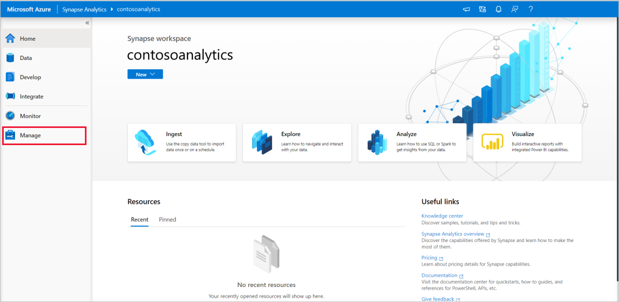

1. Once in the Management Hub, navigate to the **SQL pools** section to see the current list of SQL pools that are available in the workspace.

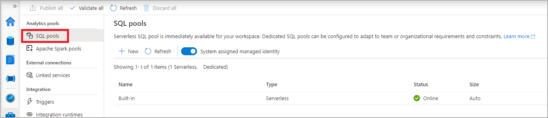

1. Select **+ New** command and the new SQL pool create wizard will appear.

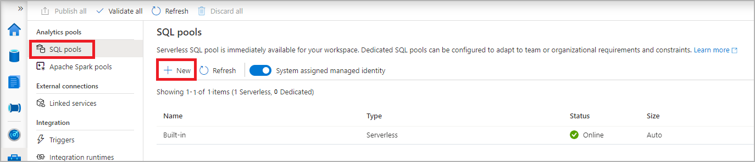

1. Enter the following details in the **Basics** tab:

| **TABLE 1** | | |
| --- | --- | --- |
| **Setting** | **Suggested value** | **Description** |
| **SQL pool name** | contosoedw | This is the name that the dedicated SQL pool will have. |
| **Performance level** | DW100c | Set this to the smallest size to reduce costs for this lab |

1. 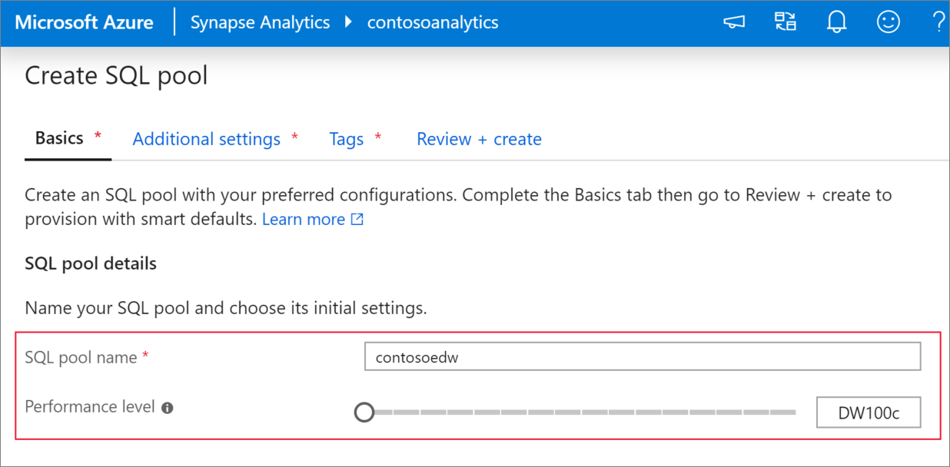
2. **Important**
3. Note that there are specific limitations for the names that dedicated SQL pools can use. Names can't contain special characters, must be 15 or less characters, not contain reserved words, and be unique in the workspace.
4. In the next tab, **Additional settings**, select **none** to provision the SQL pool without data. Leave the default collation as selected.

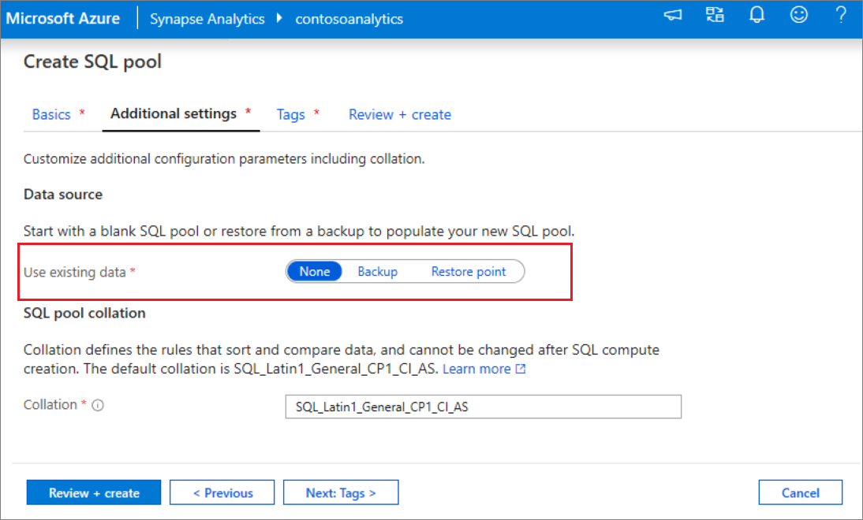

1. We won't add any tags for now, so next select **Review + create**.
2. In the **Review + create** tab, make sure that the details look correct based on what was previously entered, and press **create**.

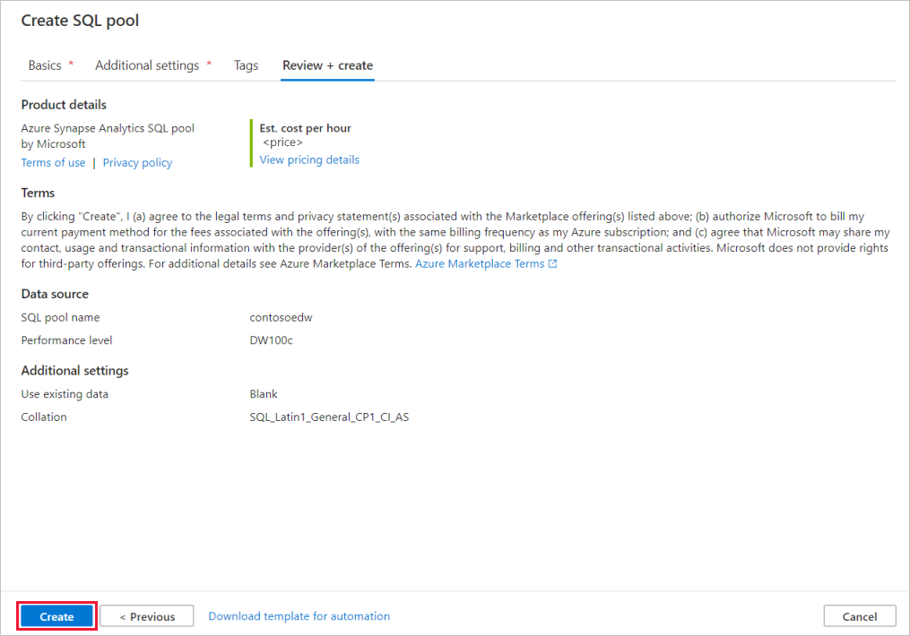

1. At this point, the resource provisioning flow will start.
2. After the provisioning completes, navigating back to the workspace will show a new entry for the newly created SQL pool.

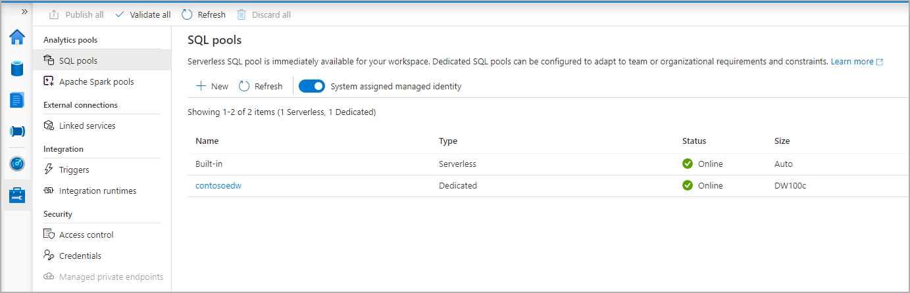

1. Once the dedicated SQL pool is created, it will be available in the workspace for loading data, processing streams, reading from the lake, etc.

## Clean up dedicated SQL pool using Synapse Studio

Follow the steps below to delete the dedicated SQL pool from the workspace using Synapse Studio.

**Warning**

Deleting a dedicated SQL pool will remove the analytics engine from the workspace. It will no longer be possible to connect to the pool, and all queries, pipelines, scripts that use this dedicated SQL pool will no longer work.

If you want to delete the dedicated SQL pool, do the following:

1. Navigate to the SQL pools in the Management Hub in Synapse Studio.
2. Select the ellipsis in the dedicated SQL pool to be deleted (in this case, **contosoedw**) to show the commands for the dedicated SQL pool:

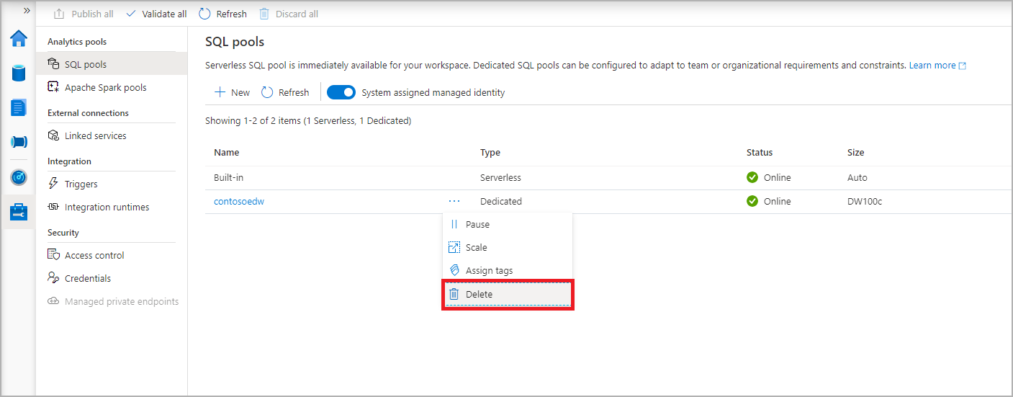

1. Press **delete**.
2. Confirm the deletion, and press **Delete** button.
3. When the process completes successfully, the dedicated SQL pool will no longer be listed in the workspace resources.

## Place sample data into the primary storage account

We are going to use a small 100K row sample dataset of NYX Taxi Cab data for many examples in this getting started guide. We begin by placing it in the primary storage account you created for the workspace.

* Download this file to your computer: <https://azuresynapsestorage.blob.core.windows.net/sampledata/NYCTaxiSmall/NYCTripSmall.parquet>
* In Synapse Studio, navigate to the Data Hub.

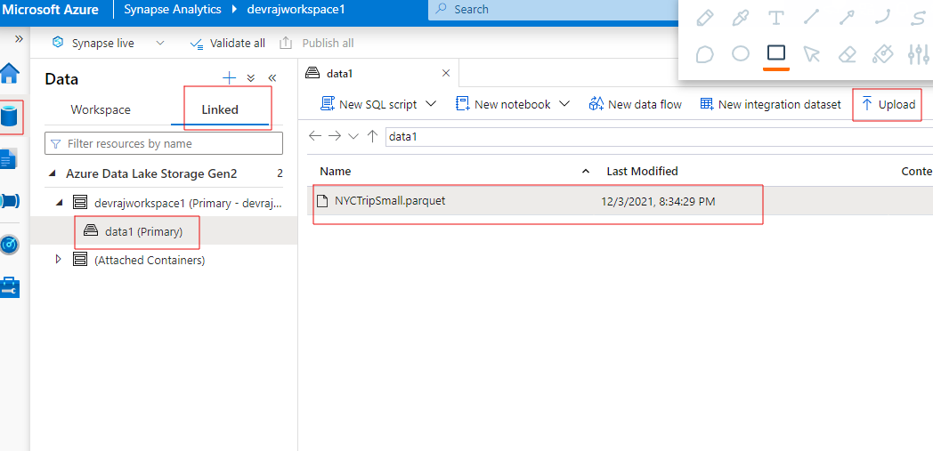

# Analyze data with a serverless SQL pool

## The Built-in serverless SQL pool

Serverless SQL pools let you use SQL without having to reserve capacity. Billing for a serverless SQL pool is based on the amount of data processed to run the query and not the number of nodes used to run the query.

Every workspace comes with a pre-configured serverless SQL pool called **Built-in**.

# 

# 