**Create and configure a self-hosted integration runtime**

The integration runtime (IR) is the compute infrastructure that Azure Data Factory and Synapse pipelines use to provide data-integration capabilities across different network environments.

A self-hosted integration runtime can run copy activities between a cloud data store and a data store in a private network. It also can dispatch transform activities against compute resources in an on-premises network or an Azure virtual network. The installation of a self-hosted integration runtime needs an on-premises machine or a virtual machine inside a private network.

**LAB:**

**Copy Data from Remote Application server to Azure DataLake Storage Gen2**

**Step1: Create Azure Windows VM and install nginx application server from this link**

<http://nginx.org/en/download.html>

Run nginx and check access logs

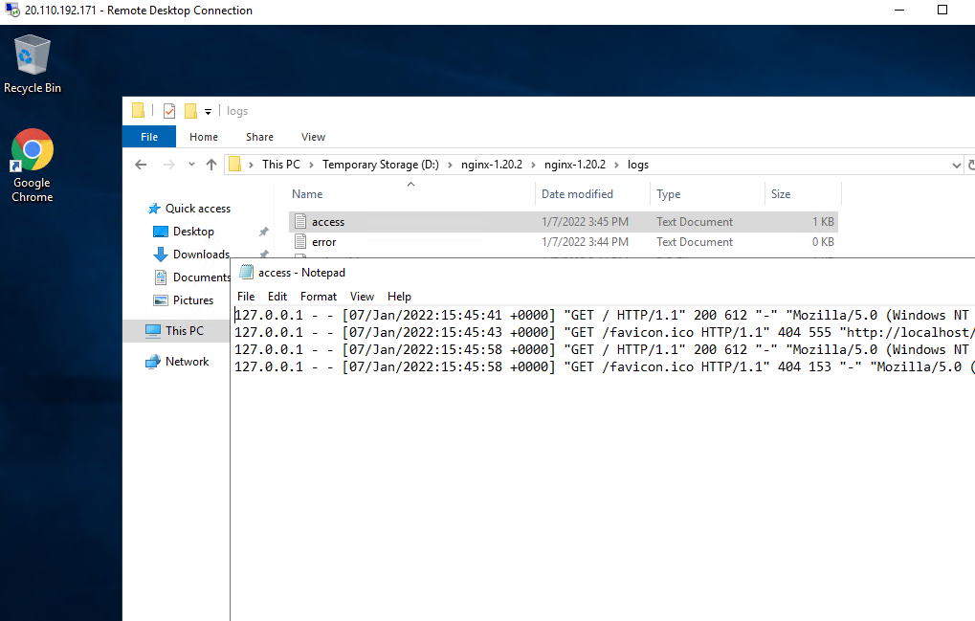

Step2: Create a storage account and create a container folder to copy file from remote server

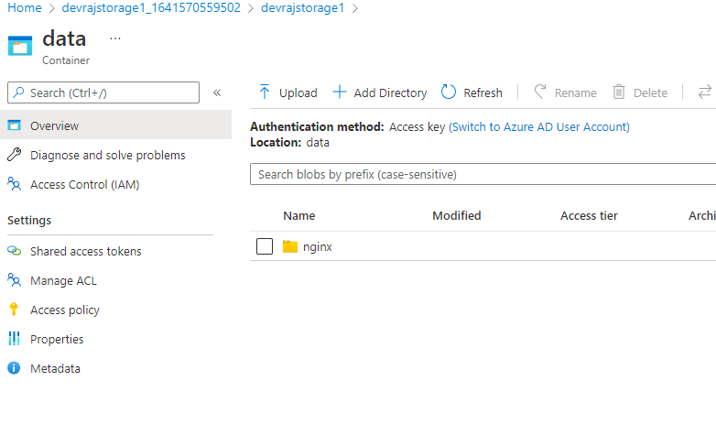

Step3: Create Azure DataFactory for creating self hosted integration runtime

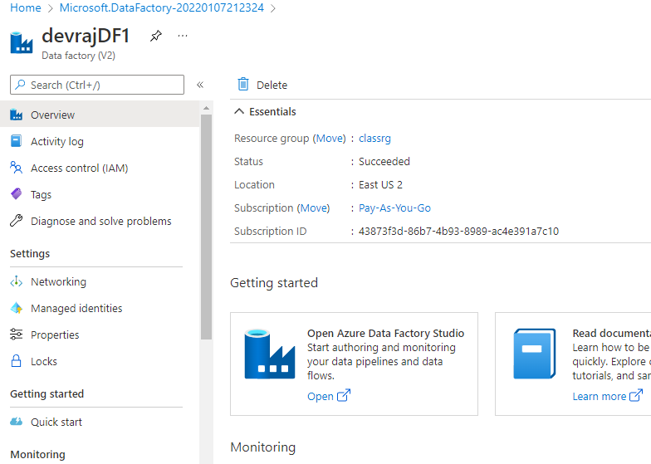

Step4: Open Studio

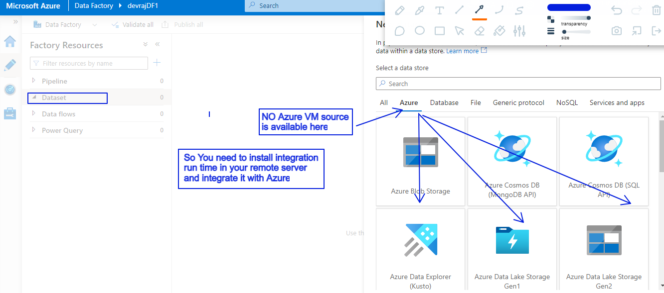

Step5: So go to manage section and choose Integration runtime and create a new one

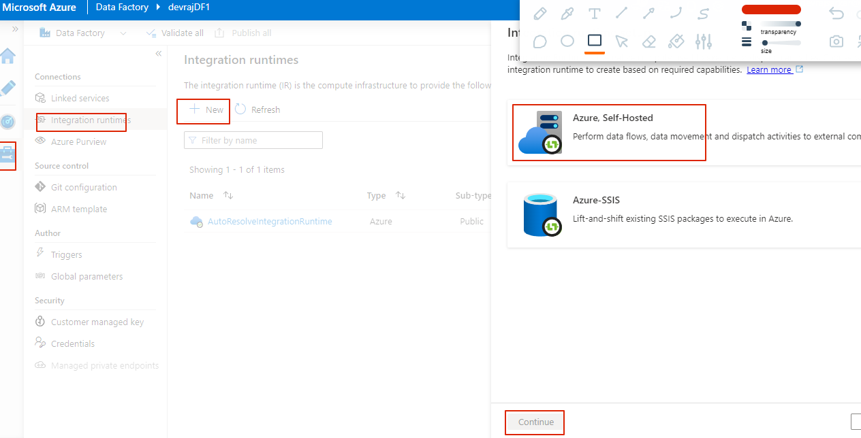

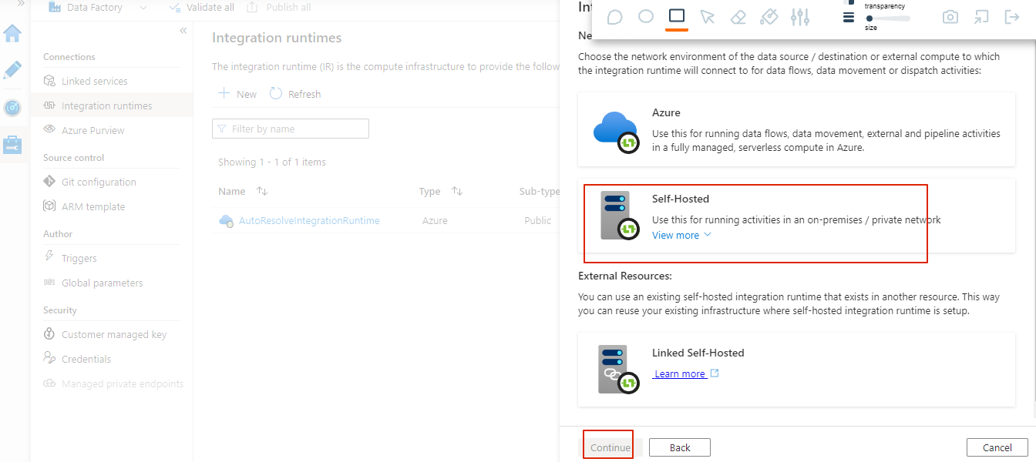

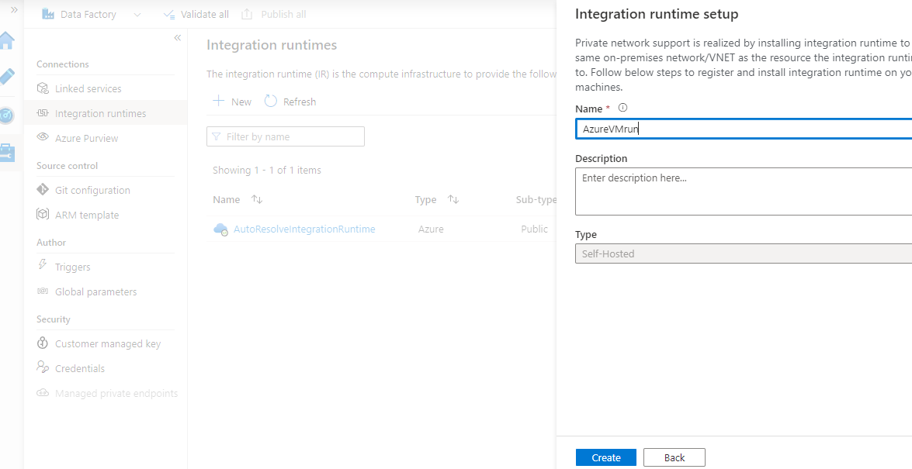

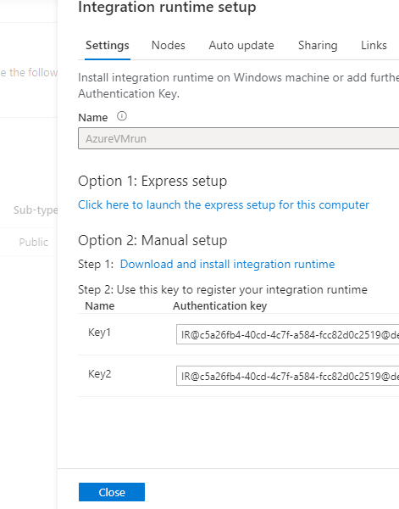

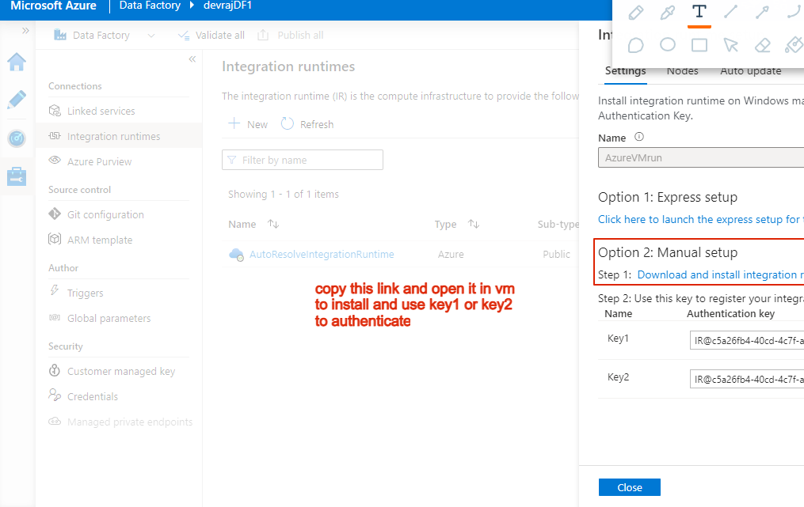

Step6: Install in VM and provide key

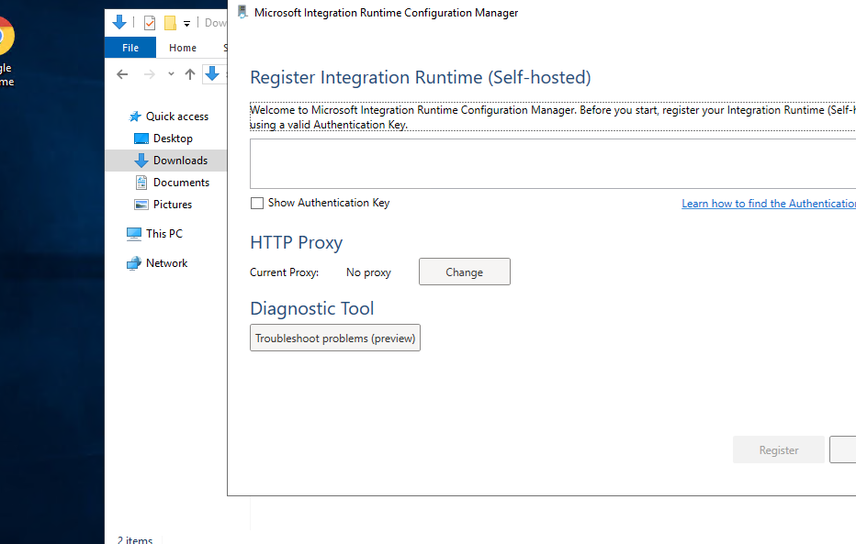

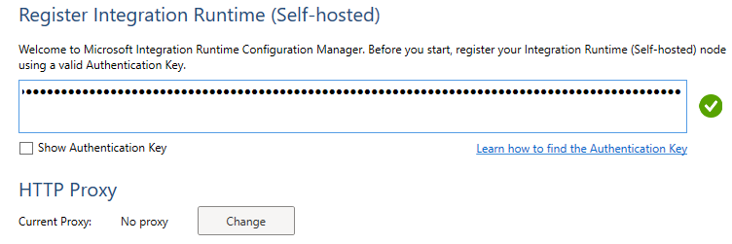

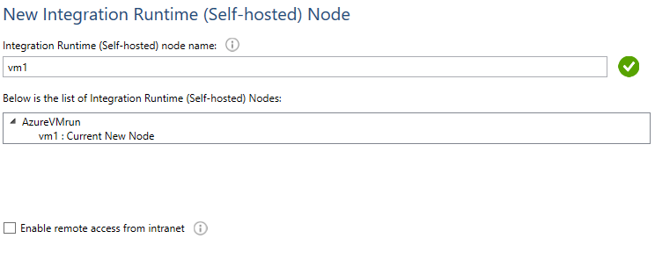

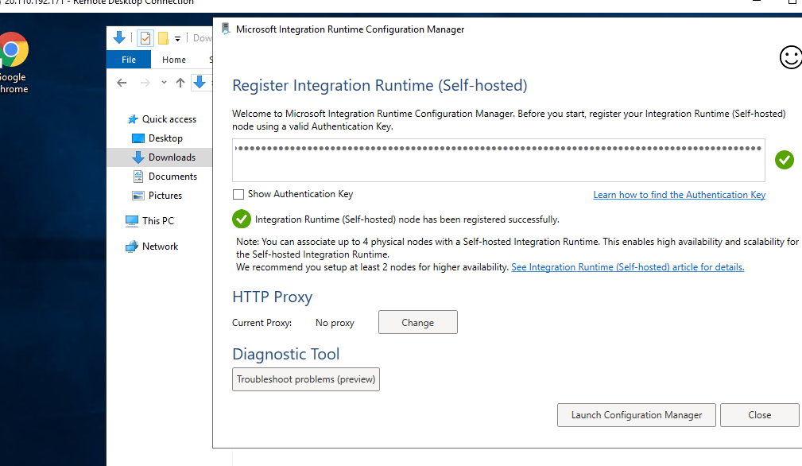

Tep7: Go to Studio and check

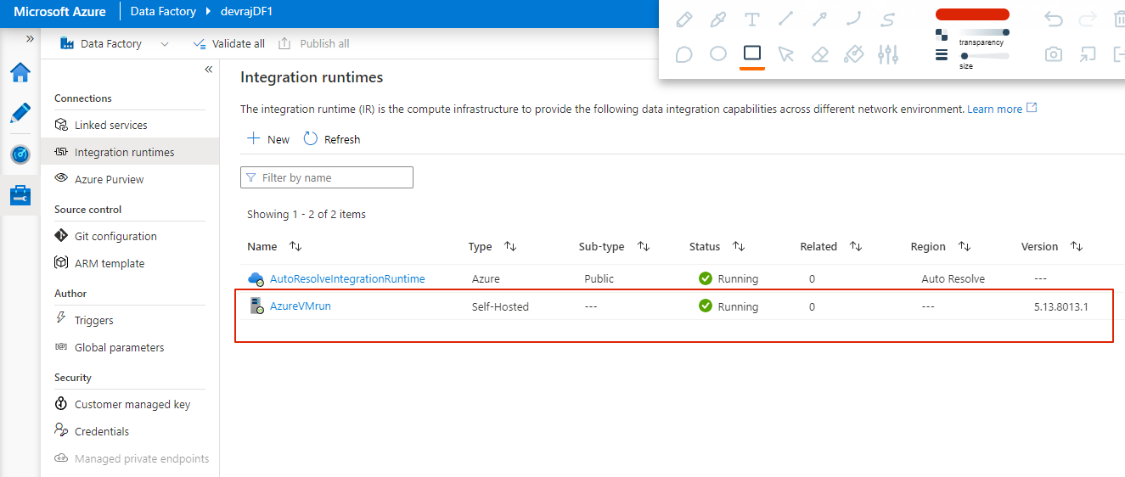

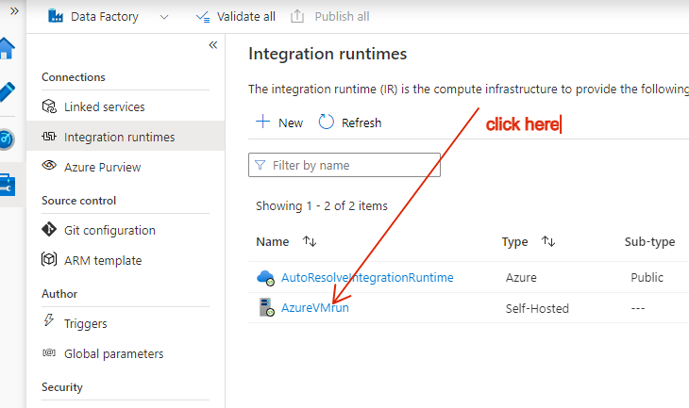

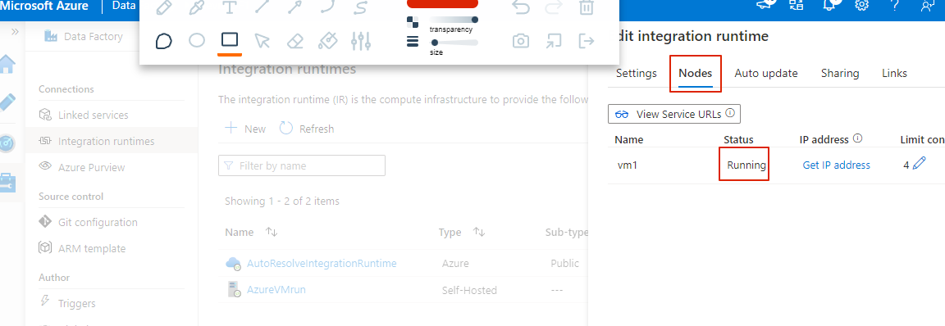

Step8: Build Final pipeline

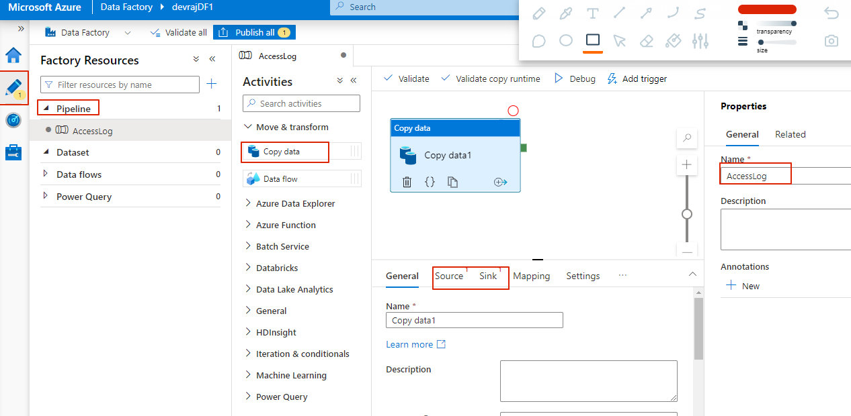

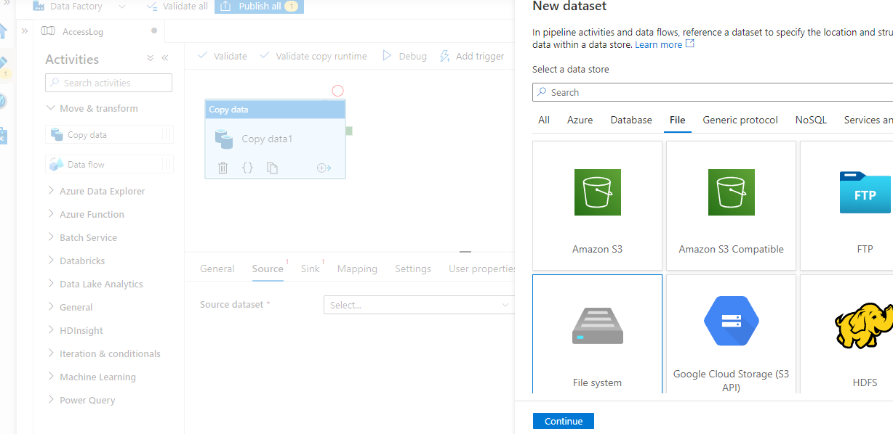

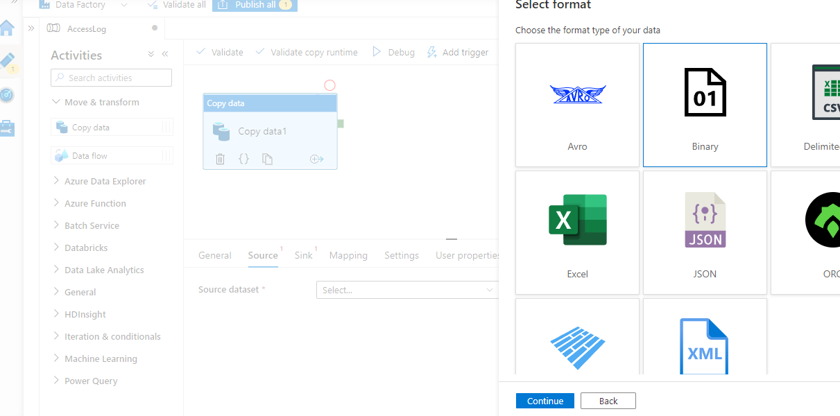

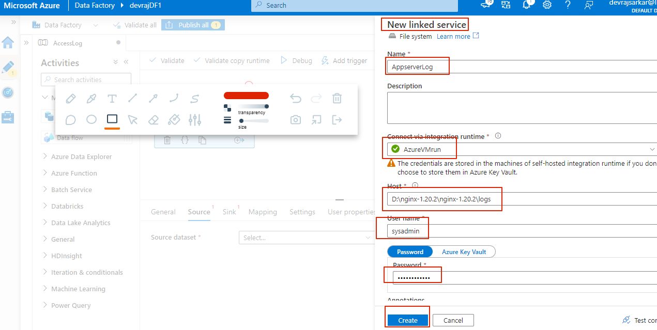

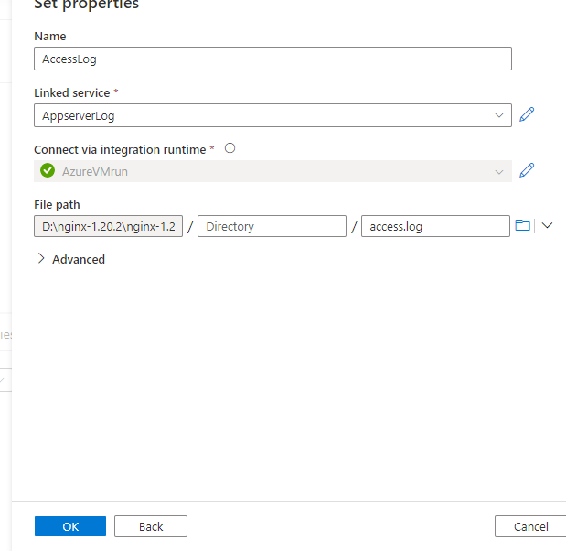

Now create the sink

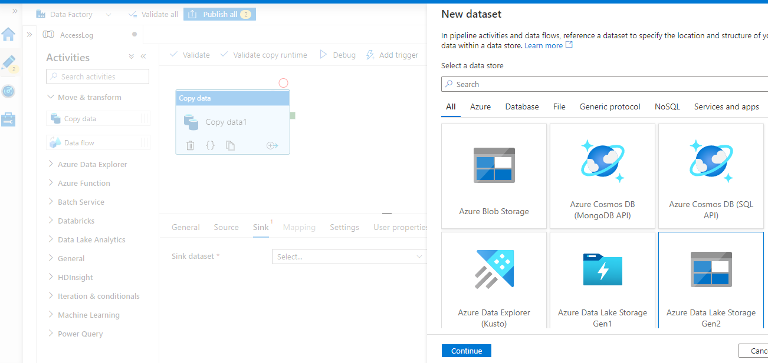

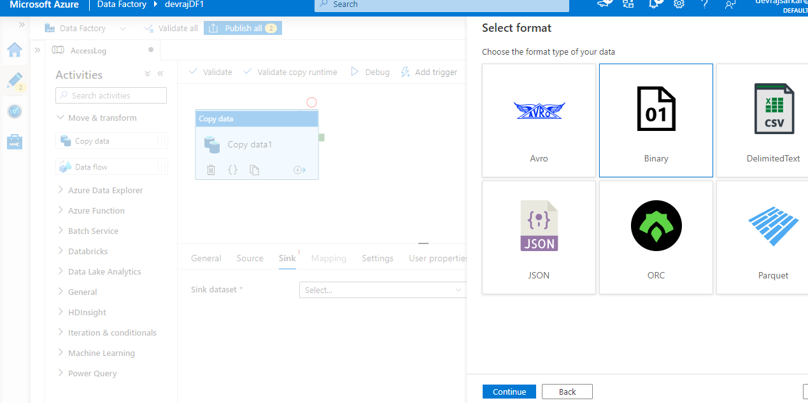

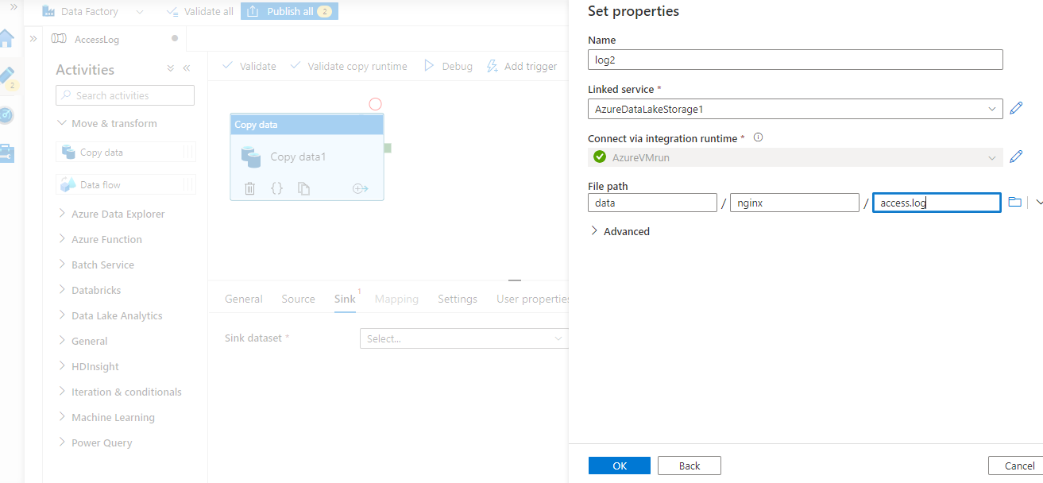

Publish and run pipeline and verify file is at azure storage now

