Azure Stream Analytics is an event-processing engine in the cloud that uncovers insights from data generated by devices, sensors, cloud infrastructure services and applications in real time. With out-of-the-box integration for Azure IoT Hub and Azure Event Hubs, Azure Stream Analytics can simultaneously ingest and process millions of events per second and can deliver actionable insights or alerts with ultra-low latencies, rich visual dashboards and kick off actions to other services.

The following scenarios are examples of when you can use Azure Stream Analytics:

* Analyze real-time telemetry streams from IoT devices
* Web logs/clickstream analytics
* Geospatial analytics for fleet management and driverless vehicles
* Remote monitoring and predictive maintenance of high value assets
* Real-time analytics on Point of Sale data for inventory control and anomaly detection

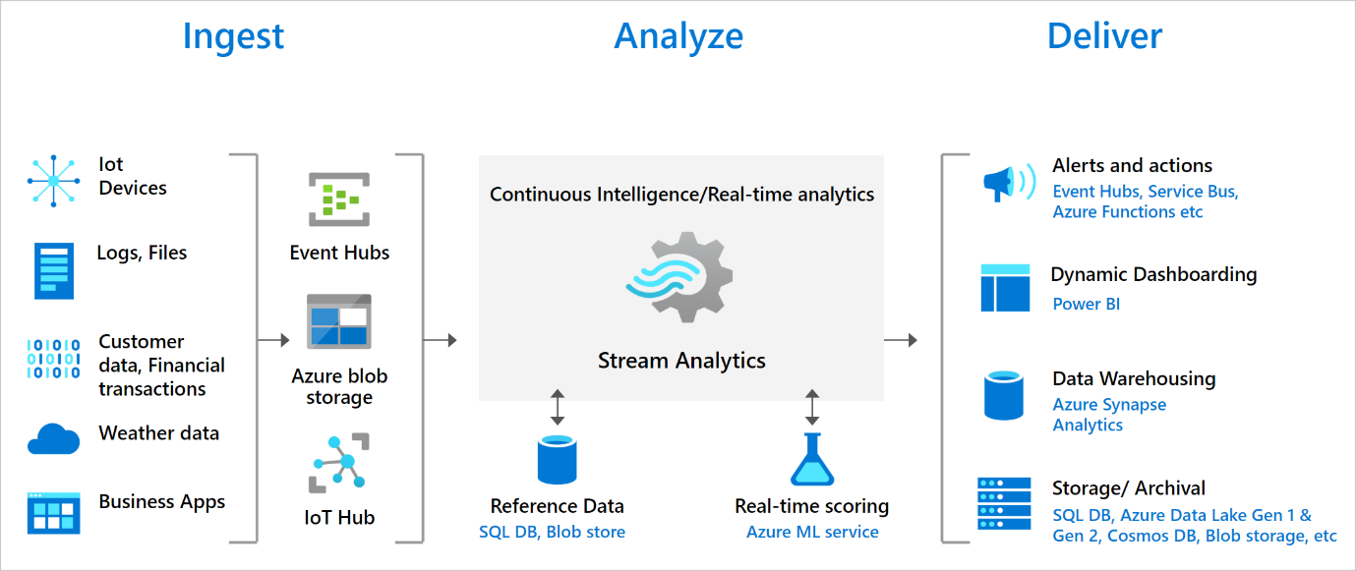

Benefits of Stream Analytics

* Ease of getting started
* Programmer productivity
* Fully managed
* Run in the cloud or on the intelligent edge
* Low total cost of ownership
* Mission-critical ready
* Reliability
* Security
* Compliance
* Performance

StreamAnalyticsJobs - HandsOn

The final output:

**Input preview:**

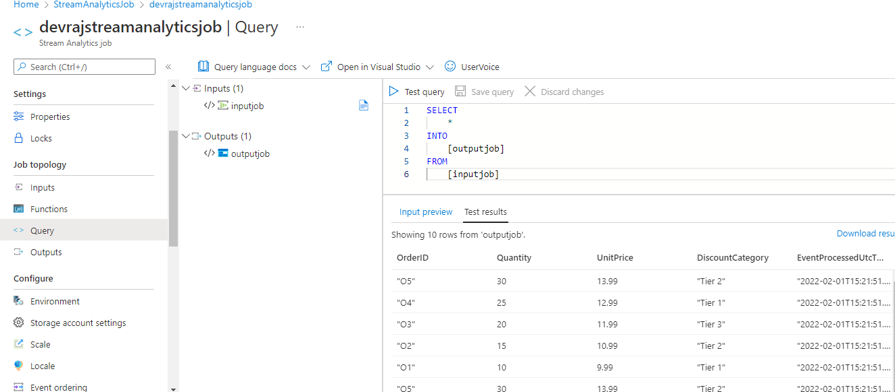

Storage account setting:

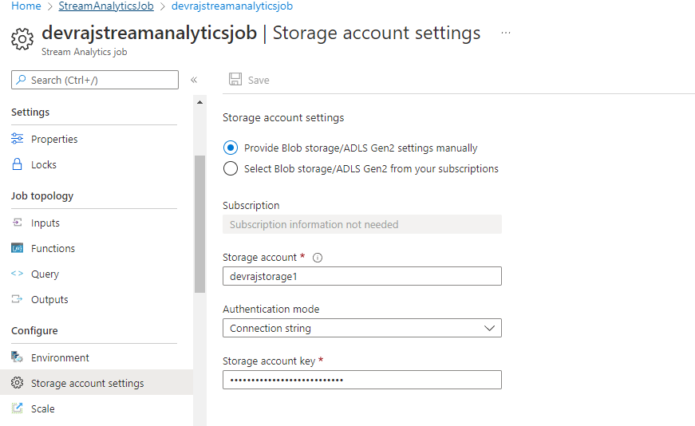

Creating input

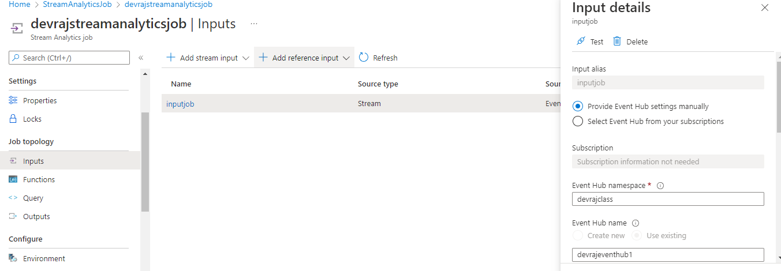

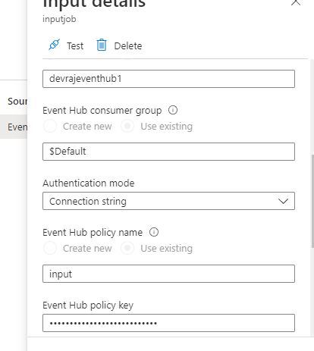

OutputJobs

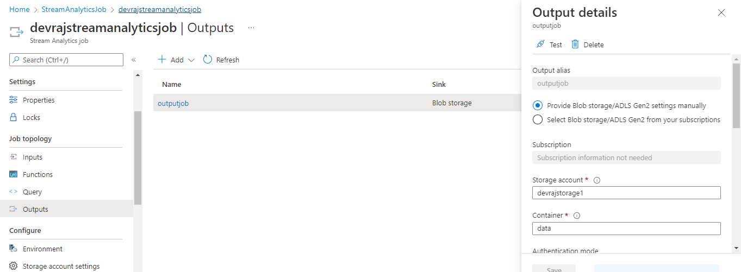

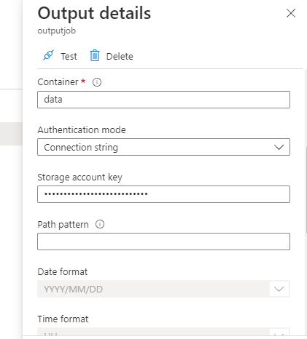

Once InputJob and Output Jobs are done Goto query:

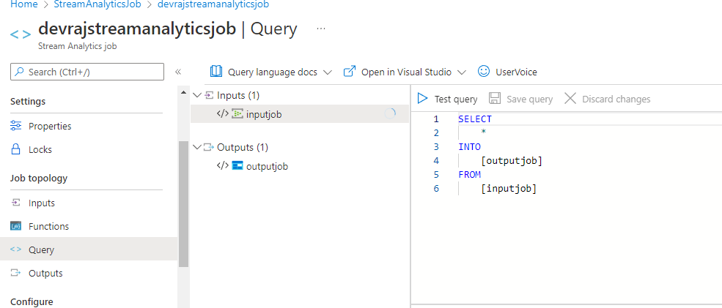

Now run the stream analytics job

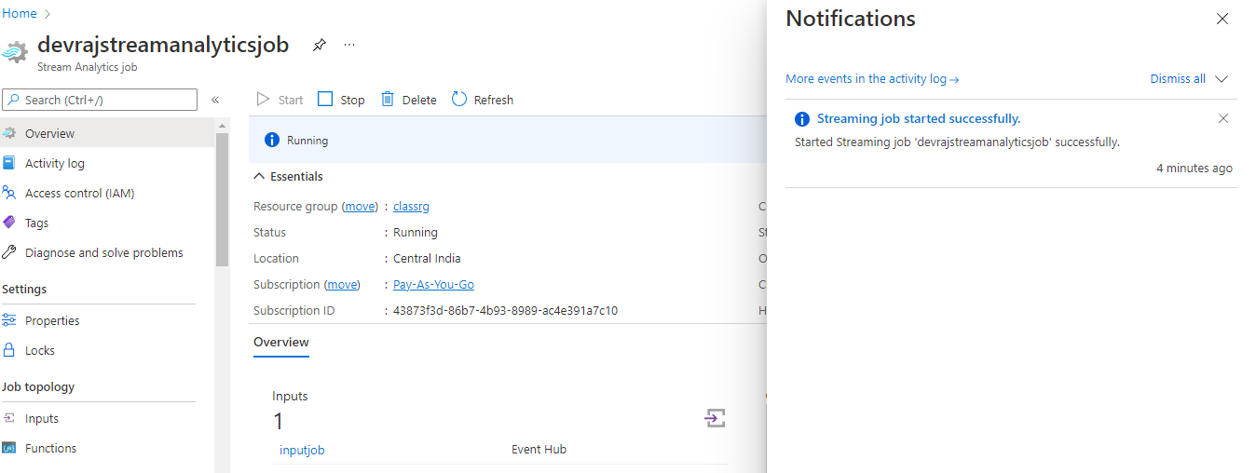

Now send event ( run program )

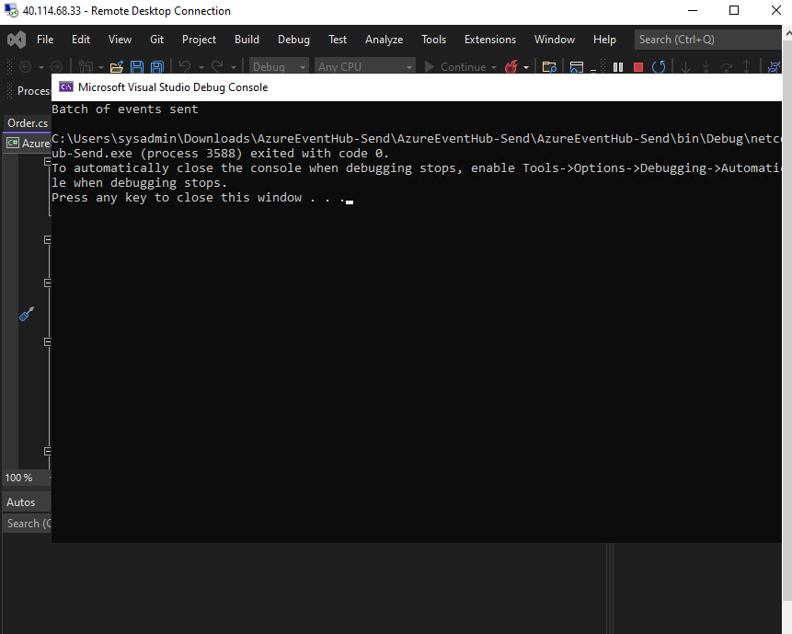

Now Test query

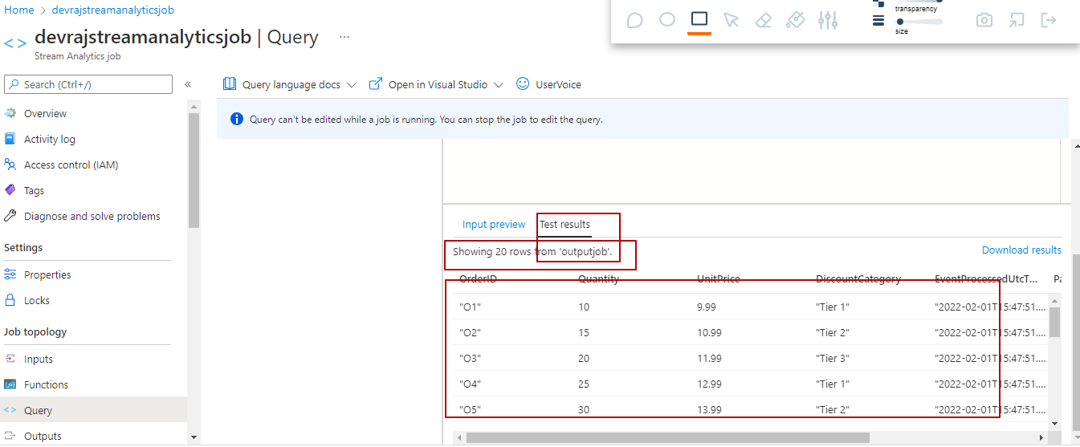

Now check data from containers under storage account

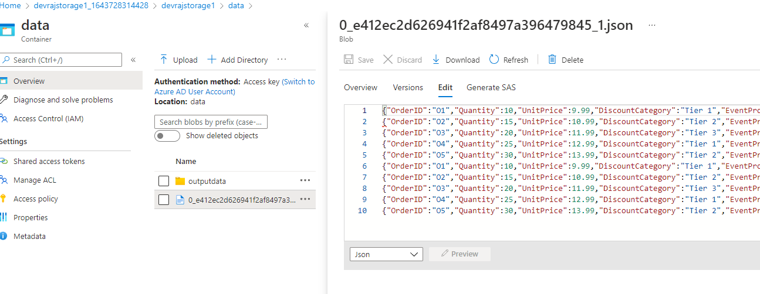

Total process is send some event via send program from VM > capture data in event hub > Run Stream Analytics job > get data to blob storage ( as defined in output jobs in Stream analytics job )

Once done stop stream analytics job.

