**Get data: Download the sample**

1. Download the AdventureWorks Sales sample Excel workbook.
2. Open Power BI Desktop.
3. In the **Data** section of the **Home** ribbon, select **Excel**.
4. Navigate to where you saved the sample workbook, and select **Open**.

**Prepare your data**

In the Navigator pane, you have the option to *transform* or *load* the data. The Navigator provides a preview of your data so you can verify that you have the correct range of data. Numeric data types are italicized. In this tutorial, we're going to transform the data before loading.

Select all tables, and choose **Transform Data**. Make sure not to select the sheets (labeled *_data*).

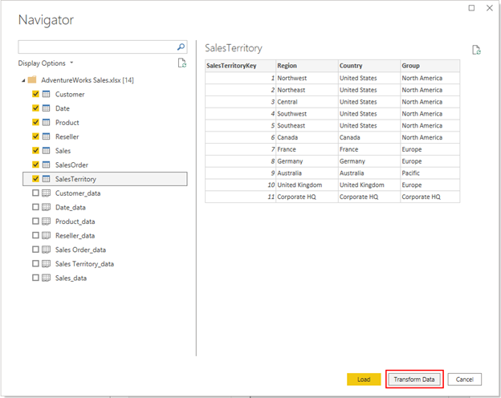

Check that the data types of the columns match those in the following table. To let Power BI detect data types for you, select a query, then select one or more columns. On the **Transform** tab, select **Detect Data Type**. To make any changes to the detected data type, on the **Home** tab, select **Data Type**, then select the appropriate data type from the list.

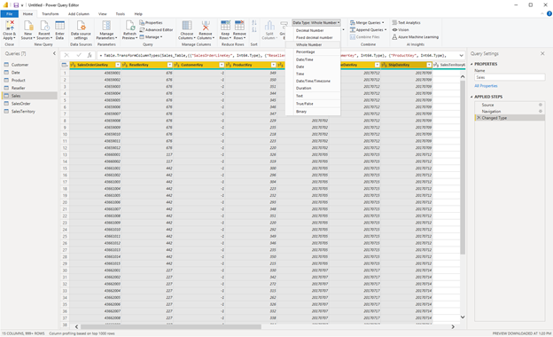

| **Query** | **Column** | **Data type** |
| --- | --- | --- |
| Customer | CustomerKey | Whole Number |
| Date | DateKey | Whole Number |
|  | Date | Date |
|  | MonthKey | Whole Number |
| Product | ProductKey | Whole Number |
|  | Standard Cost | Decimal Number |
|  | List Price | Decimal Number |
| Reseller | ResellerKey | Whole Number |
| Sales | SalesOrderLineKey | Whole Number |
|  | ResellerKey | Whole Number |
|  | CustomerKey | Whole Number |
|  | ProductKey | Whole Number |
|  | OrderDateKey | Whole Number |
|  | DueDateKey | Whole Number |
|  | ShipDateKey | Whole Number |
|  | SalesTerritoryKey | Whole Number |
|  | Order Quantity | Whole Number |
|  | Unit Price | Decimal Number |
|  | Extended Amount | Decimal Number |
|  | Unit Price Discount Pct | Percentage |
|  | Product Standard Cost | Decimal Number |
|  | Total Product Cost | Decimal Number |
|  | Sales Amount | Decimal Number |
| SalesTerritory | SalesTerritoryKey | Whole Number |
| SalesOrder | SalesOrderLineKey | Whole Number |

Back on the **Home** tab, select **Close & Apply**.

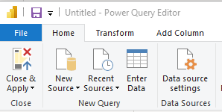

**Model your data**

The data you loaded is almost ready for reporting. Let’s inspect the data model and make some changes.

Select **Model View** on the left.

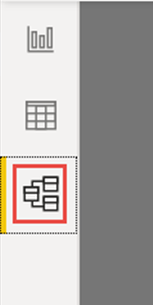

Your data model should look like the following image, with each table in a box.

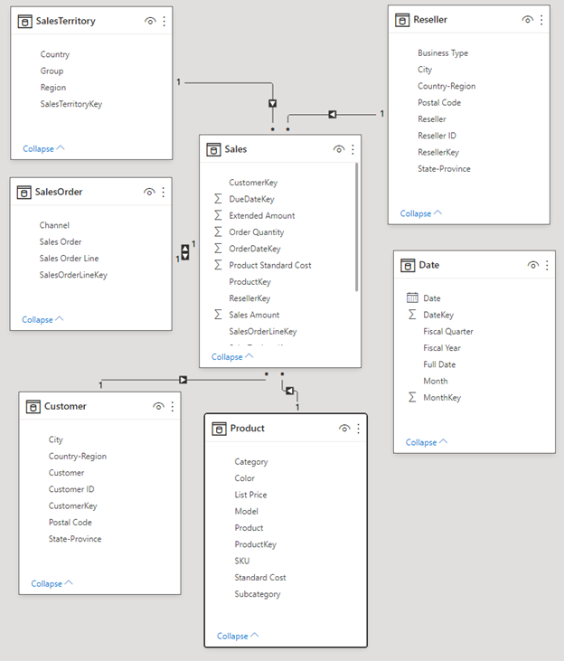

**Create relationships**

This model is a typical *star schema* that you might see from data warehouses: It resembles a star. The center of the star is a Fact table. The surrounding tables are called Dimension tables, which are related to the Fact table with relationships. The Fact table contains numerical information about sales transactions, such as Sales Amount and Product Standard Cost. The Dimensions provide context so you can, among other things, analyze:

* What Product was sold...
* to which Customer..
* by which Reseller...
* in which Sales Territory.

If you look closely, you notice that all Dimension tables are related to the Fact with a Relationship, except for the Date table. Let’s add some relationships to Date now. Drag the DateKey from the Date table to OrderDateKey on the Sales table. You've created a so-called "one-to-many" relationship from Date to Sales, as indicated by the **1** and the asterisk * (many) at the two ends of the line.

The relationship is "one-to-many" because we have one or more Sales orders for a given Date. If each date had only one Sales order, the relationship would be "one-to-one". The little arrow in the middle of the line indicates the "cross-filtering direction." It indicates that you can use values from the Date table to filter the Sales table, so the relationship allows you to analyze when a Sales order was placed.

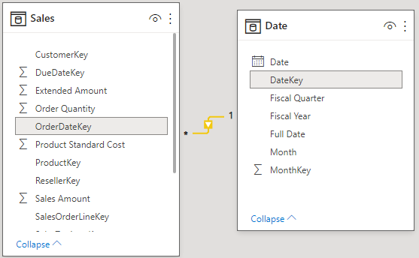

The Sales table contains more information about dates related to Sales orders, such as Due Date and Ship Date. Let’s add two more relationships to the Date table by dragging:

* DateKey to DueDateKey
* DateKey to ShipDateKey

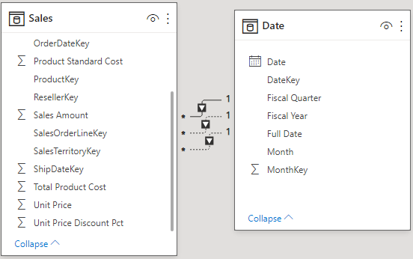

You notice that the first relationship, on OrderDateKey, is active, shown by the continuous line. The other two are inactive, shown by the dashed lines. Power BI uses the active relationship by default to relate Sales and Date. Hence, a sum of SalesAmount is calculated by Order Date, not Due Date or Ship Date. You can influence this behavior.

**Hide key columns**

The typical star schema contains several keys that hold the relationships between Facts and Dimensions. Normally we don't want to use any key columns in our reports. Let’s hide the key columns from view, so the Fields List shows fewer fields, and the data model is easier to use.

Go over all tables and hide any column whose name ends with *Key*:

Select the **Eye** icon next to the column and choose **Hide in report view**.

Visible column with Eye icon.

You can also select the **Eye** icon next to the column in the Properties pane.

Hidden fields have this icon, an eye with a line through it.

Field with the hidden Eye icon.

Hide these fields.

| **Table** | **Column** |
| --- | --- |
| Customer | CustomerKey |
| Date | DateKey |
|  | MonthKey |
| Product | ProductKey |
| Reseller | ResellerKey |
| Sales | CustomerKey |
|  | DueDateKey |
|  | OrderDateKey |
|  | ProductKey |
|  | ResellerKey |
|  | SalesOrderLineKey |
|  | SalesTerritoryKey |
|  | ShipDateKey |
| SalesOrder | SalesOrderLineKey |
| SalesTerritory | SalesTerritoryKey |

Your data model should now look like this data model, with relationships between Sales and all the other tables, and all the key fields hidden:

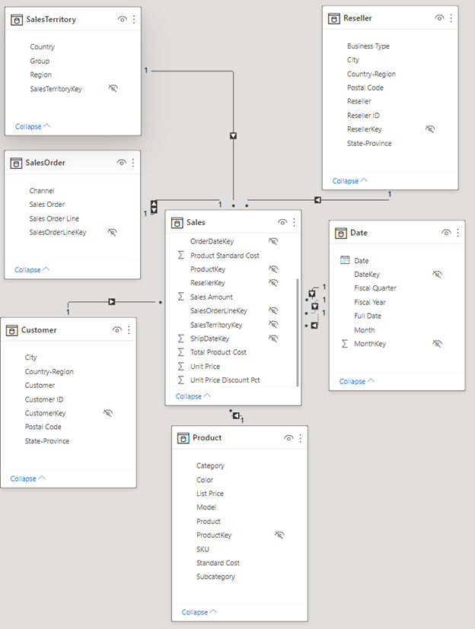

**Create hierarchies**

Now that our data model is easier to consume because of the hidden columns, we can add a few *hierarchies* to make the model even easier to use. Hierarchies enable easier navigation of groupings. For example, cities are in a State or Province, which is in a Country or Region.

Create the following hierarchies.

1. Right-click the highest level, or the least granular, field in the hierarchy and choose **Create hierarchy**.
2. In the **Properties** pane, set the **Name** of the hierarchy and set the levels.
3. Then **Apply Level Changes**.

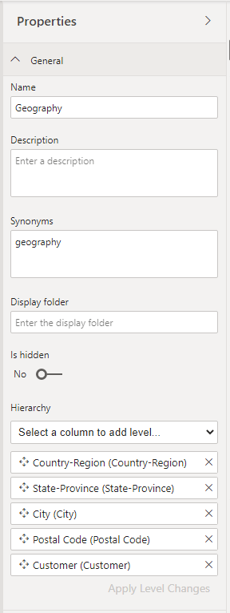

You can also rename levels in a hierarchy in the Properties pane after you add them. You'll need to rename the Year and Quarter level of the Fiscal hierarchy in the Date table.

Here are the hierarchies you need to create.

| **Table** | **Hierarchy name** | **Levels** |
| --- | --- | --- |
| Customer | Geography | Country-Region |
|  |  | State-Province |
|  |  | City |
|  |  | Postal Code |
|  |  | Customer |
| Date | Fiscal | Year (Fiscal Year) |
|  |  | Quarter (Fiscal Quarter) |
|  |  | Month |
|  |  | Date |
| Product | Products | Category |
|  |  | Subcategory |
|  |  | Model |
|  |  | Product |
| Reseller | Geography | Country-Region |
|  |  | State-Province |
|  |  | City |
|  |  | Postal Code |
|  |  | Reseller |
| SalesOrder | Sales Orders | Sales Order |
|  |  | Sales Order Line |
| SalesTerritory | Sales Territories | Group |
|  |  | Country |
|  |  | Region |

Your data model should now look like the following data model. It has the same tables, but each dimension table contains a hierarchy:

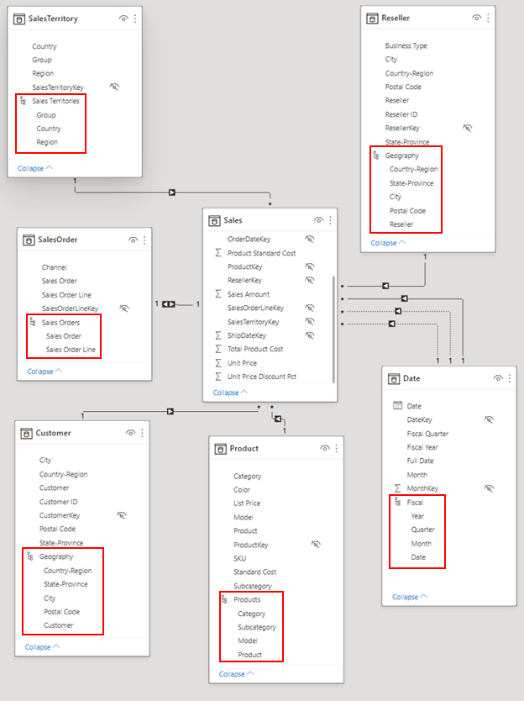

**Rename tables**

To finish modeling, let's rename the following tables in the Properties pane:

| **Old table name** | **New table name** |
| --- | --- |
| SalesTerritory | Sales Territory |
| SalesOrder | Sales Order |

This step is necessary because Excel table names can't contain spaces.

Now your final data model is ready.

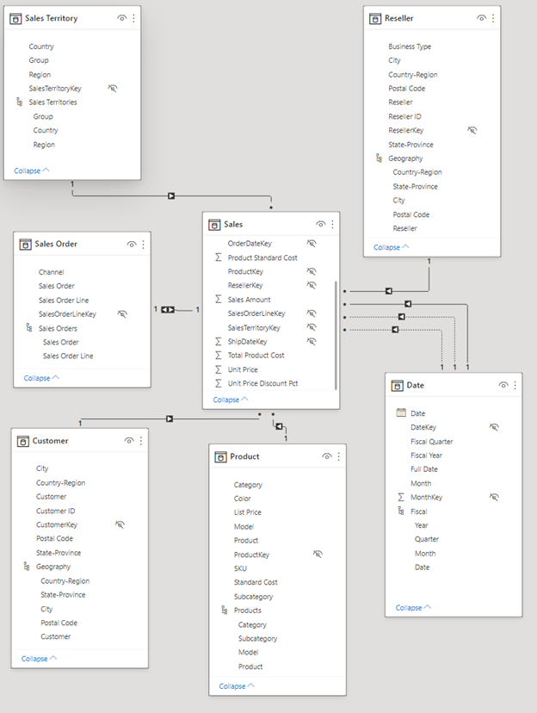

**Extra credit: Write a measure in DAX**

Writing *measures* in the DAX formula language is super powerful for data modeling. For now, let's write a basic measure that calculates the total sales amount by due date on the sales order instead of the default order date. This measure uses the USERELATIONSHIP function to activate the relationship between Sales and Date on DueDate for the context of the measure. It then uses CALCULATE to sum the Sales Amount in that context.

1. Select Data View on the left.

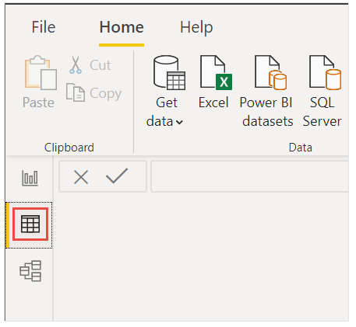

1. Select the Sales table in the Fields list.

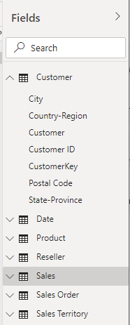

1. On the **Home** ribbon, select **New Measure**.
2. Select or type this measure to calculate the total sales amount by due date on the sales order instead of the default order date:

DAXCopy

Sales Amount by Due Date = CALCULATE(SUM(Sales[Sales Amount]), USERELATIONSHIP(Sales[DueDateKey],'Date'[DateKey]))

1. Select the check mark to commit.

Select the check mark to commit the DAX measure.

**Build your report**

Now that you’ve modeled your data, it's time to create your report. Go to Report View. In the Fields pane on the right, you see the fields in the data model you created.

Let’s build the final report, one visual at a time.

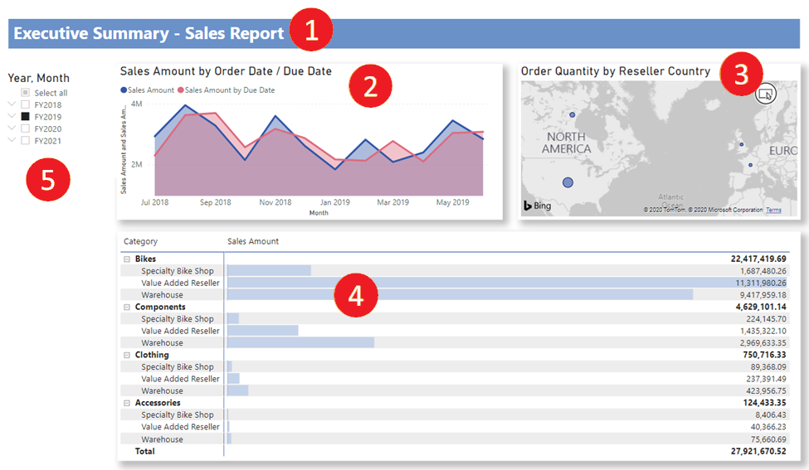

**Visual 1: Add a title**

1. On the **Insert** ribbon, select **Text Box**. Type "Executive Summary – Sales Report".
2. Select the text you typed. Set the font size to **20** and **Bold**.

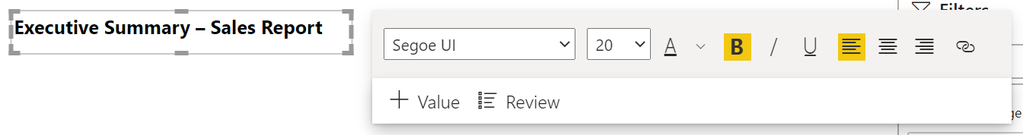

1. In the Visualizations pane, toggle the **Background** to **Off**.
2. Resize the box to fit on one line.

**Visual 2: Sales Amount by Date**

Next you create a line chart to see which month and year had the highest sales amount.

1. From the Fields pane, drag the **Sales Amount** field from the **Sales** table to a blank area on the report canvas. By default, Power BI displays a column chart with one column, Sales Amount.
2. Drag the **Month** field from the **Fiscal** hierarchy in the **Date** table and drop it on the column chart.

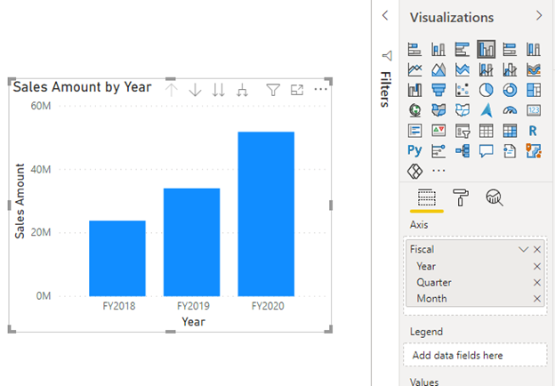

1. In the **Fields** section of the Visualizations pane, remove the **Year** and **Quarter** fields:

In the Fields section of the Visualizations pane, remove the Year and Quarter fields.

1. In the Visualizations pane, change the visualization type to **Area Chart**.

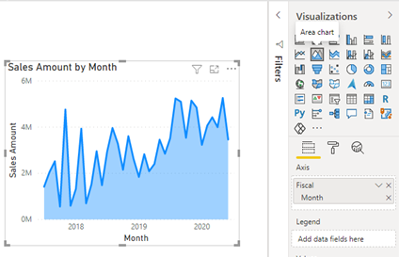

1. If you added the DAX measure in the extra credit above, add it to **Values** as well.
2. Open the Format pane, open Data colors and change the color of **Sales Amount by Due Date** to a more contrasting color, such as red.

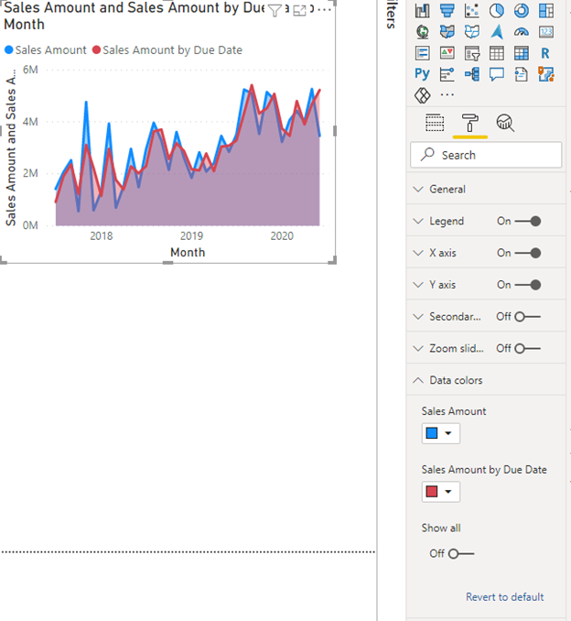

As you can see, Sales Amount by Due Date trails slightly behind Sales Amount. This proves that it uses the relationship between the Sales and Date tables that uses DueDateKey.

**Visual 3: Order Quantity by Reseller Country**

Now we'll create a map to see in which Country the Resellers have the highest Order Quantity Amount.

1. From the Fields pane, drag the **Country-Region** field from the **Reseller** table to a blank area on your report canvas. Power BI creates a map.
2. Drag the **Order Quantity** field from the **Sales** table and drop it on the map. Make sure **Country-Region** is in the **Location** well and **Order Quantity** in the **Size** well.

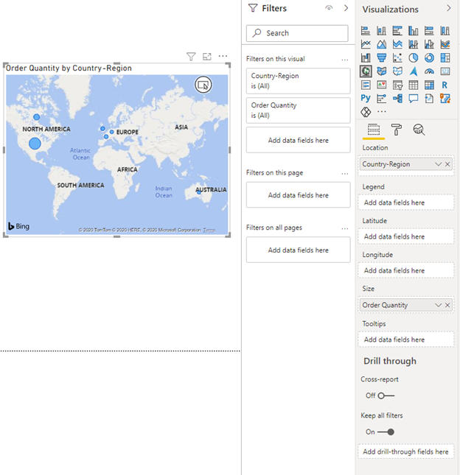

**Visual 4: Sales Amount by Product Category and Reseller Business type**

Next we create a column chart to investigate which products are sold by what type of reseller business.

1. Drag the two charts you've created to be side by side in the top half of the canvas. Save some room on the left side of the canvas.
2. Select a blank area in the lower half of your report canvas.
3. In the Fields pane, select **Sales Amount** from **Sales**, **Product Category** from **Product**, and **Business Type** from **Reseller**. 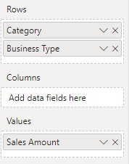

Power BI automatically creates a clustered column chart. Change the visualization to a **Matrix**:

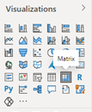

1. With the matrix still selected, in the Filters pane, under **Business Type**, **Select all**, then clear the **[Not Applicable]** box.

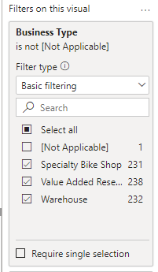

1. Drag the matrix so it's wide enough to fill the space under the two upper charts.

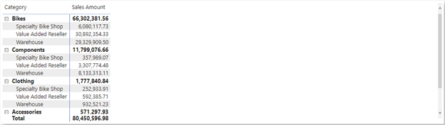

1. In the Formatting pane for the matrix, open the **Conditional formatting** section and turn on **Data bars**. Select **Advanced controls** and set a lighter color for the positive bar. Select **OK**.
2. Increase the width of the Sales Amount column so it covers the whole area by dragging the matrix.

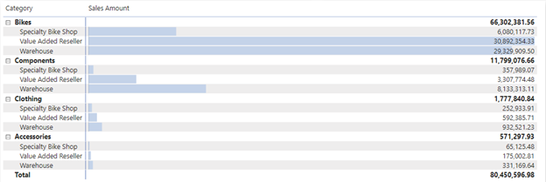

It looks like Bikes have a higher Sales Amount overall and the Value Added Resellers sell the most, closely followed by Warehouses. For Components, the Warehouses sell more than the Value Added Resellers.

**Visual 5: Fiscal calendar slicer**

Slicers are a valuable tool for filtering the visuals on a report page to a specific selection. In this case, we can create a slicer to narrow in on performance for each month, quarter, and year.

1. In the Fields pane, select the **Fiscal** hierarchy from the **Date** table and drag it to the blank area on the left of the canvas.
2. In the Visualizations pane, choose **Slicer**.

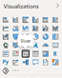

1. In the Fields section of the Visualizations pane, remove **Quarter** and **Date** so only **Year** and **Month** are left.

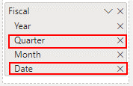

Now if your manager asks to see data only for a specific month, you can use the slicer to switch between years or specific months in each year.