Moodle

# Aim: To analyze Moodle using Dev Tools.

# Elements Tab

This tab contains HTML & CSS code of the webpage. The different elements form a tree hierarchy structure. 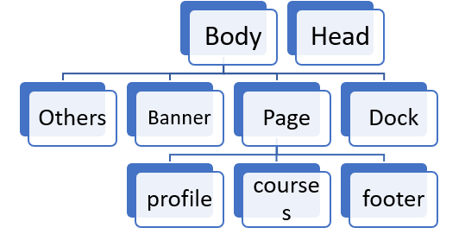

Playing around with the code and styling, we can see real time changes in the website.

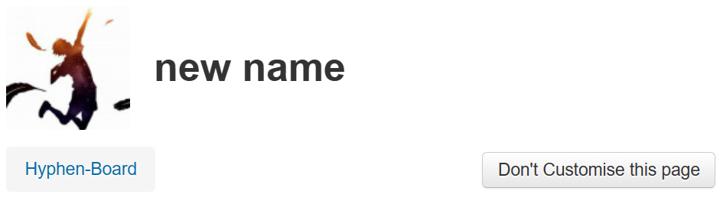

# Console Tab

I found a CSS selector from the Elements tab and used commands on the console to extract data from it.

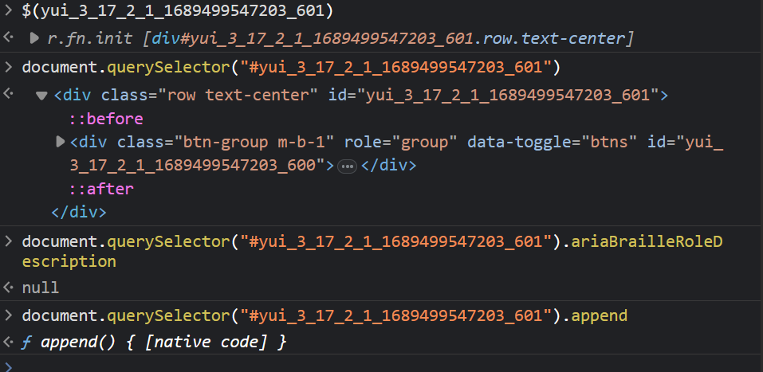

# Network Tab

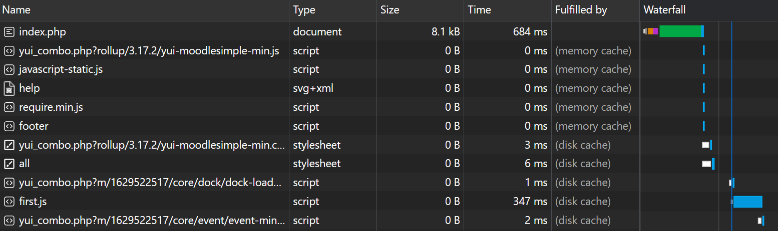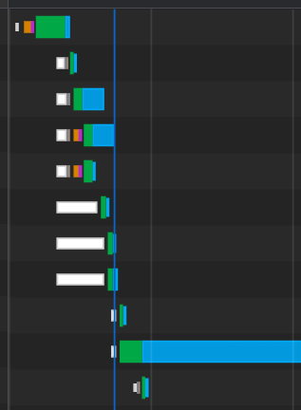

In the network tab, we can see every click, every request made on the website, starting with loading all elements of the page. Most of them loaded with cache, so disabling cache slowed down the process a lot. Also, varying the throttling affects the time taken to load a bit.